Assessing Risk and Accessibility to Search and Rescue Teams

# Introduction

## Problem

Which areas within the Ouachita National Forest, Arkansas, and surrounding area are classified as high risk to rescuers searching for someone lost or injured, and which areas are more than 30 minutes from a hospital?

Many agencies, organizations, and companies have been realizing the value of geographic information system (GIS) technology for a wide range of applications. Recently, search and rescue (SAR) teams have used GIS to evaluate accessibility in national forests and other areas where recreation is popular. The job of SAR teams is to locate people in need of rescue and return them and the team to a safe environment. GIS is a good tool for assessing risk to search and rescue teams and analyzing the time it is likely to take to get an injured victim to a hospital. These types of assessments help SAR teams plan and prepare for efficient, effective, and safe rescues.

## Location

This lab is focused on the Ouachita National Forest and surrounding area in northern Arkansas. The Ouachita National Forest comprises roughly 5,800 square kilometers, mostly in Garland, Logan, Montgomery, Polk, Saline, Scott, and Yell counties.

## Time to complete the lab

Completion of the lab will take approximately one and a half to two hours.

## Prerequisites

This lab is intended for intermediate or advanced GIS students with background knowledge of geoprocessing and map layouts.

## Data used in this lab

* Land cover
* Digital elevation
* Roads
* Cities
* Ouachita National Forest boundaries

All the above files can be acquired from Arkansas Geostor ([http://www.geostor.arkansas.gov](http://www.geostor.arkansas.gov/)).

Projection Information

* Geographic coordinate system: GCS_North_American_1983
* Datum: D_North_American_1983
* Projection: Transverse Mercator
* Name: NAD_1983_UTM_Zone_15N

Note: You must have the ArcGIS® Spatial Analyst and Network Analyst extensions to complete this lab.

# Student activity

As the GIS expert for a search and rescue team responsible for covering the Ouachita National Forest in northern Arkansas, you are asked to provide a risk map indicating areas of high risk to rescuers searching for someone lost or injured. Based on previous data and experience, the team has developed a relative risk score (on a scale of 0–100, 100 being highest risk) for different land-cover classes and slopes. For instance, rocky outcrops have a risk score of 90 (high risk) due to the difficulty of traversing such terrain. Openings such as fields have a much lower risk score (10), because visibility is greater in openings than in forested areas. Gently sloping terrain has a lower risk score than terrain that's extremely steep (> 25 degrees).

In addition to distinguishing areas of high risk, the team would like to know which areas in the national forest are more than 30 minutes from a hospital. In these areas, a helicopter or alternative means of transportation would have to be used.

Your job is critical to the SAR team. Without prior knowledge of risk and accessibility, the job of the SAR team would be more dangerous. Your job helps ensure safety and success of the rescuers by helping them plan and prepare rescue strategies and tactics. Keep in mind that the motto of the National Association for Search and Rescue is ". . . that others may live."

## Tasks

* Model risk to a search and rescue team in the Ouachita National Forest.
* Determine areas accessible and inaccessible to an ambulance within a 30-minute drive from a hospital (following speed limits).
* Create an 11" x 17" map layout illustrating risk and ambulance accessibility for your team.

### Criteria

There is some initial information that you will need to understand before you begin this lab. Keep in mind that the SAR team is primarily interested in understanding two things: risk and accessibility. Therefore, before you begin, you must understand the criteria used to determine risk and accessibility.

#### Task 1: Model risk to SAR teams in the Ouachita National Forest

Risk is measured on a scale of 1–100, 100 being highest risk. The following risk scores for various land-cover classes and slope categories were developed based on previous research and experience of SAR personnel:

|  |  |  |  |  |  |
| --- | --- | --- | --- | --- | --- |
| Land-cover category | Risk score |  | Slope (degrees) | Description | Risk score |
| Coniferous forest1 | 50 |  | 0–6 | Gently sloping | 10 |
| Deciduous forest2 | 40 |  | 6.1–10 | Moderately sloping | 40 |
| Mixed decid./conif. | 60 |  | 10.1–20 | Moderately steep | 50 |
| Opening | 10 |  | 20.1–25 | Steep | 90 |
| Rock | 90 |  | > 25 | Extremely steep | 100 |
| Shrub/Young forest | 70 |  |  |  |  |
| Urban | 0 |  |  |  |  |
| Water | 100 |  |  |  |  |

1Coniferous forests include pine and cedar.  
2Deciduous forests include oak, hickory, and lowland hardwoods.

##### Risk model

The following risk model was developed to provide an index of relative risk. The overall risk score will determine areas of high risk but is not intended to be an exact quantitative measure.

In a moving window with a 0.24-kilometer search radius,

Land cover risk = the AVERAGE risk score

Slope risk = the MAJORITY risk score

Overall risk = [(land cover risk) + 5 * (slope risk)] / 6

#### Task 2: Determine areas accessible to an ambulance within a 30-minute drive from a hospital (following speed limits)

"Cost" of driving = time (in units of minutes)

Time = distance/speed

Speed is determined in the attribute table of the roads shapefile in units of miles per hour.

1 hour = 60 minutes

Task 1. Model risk to a search and rescue team in the Ouachita National Forest

You know that risk is defined according to the search and rescue team based on its experience and past research with land cover and slope. You also know that the information needs to be in a spatial form. So, the first step would be to get the risk scores into a spatial dataset.

Start with land cover.

Reclassify land-cover categories according to risk

Getting the risk scores in a spatial format is relatively straightforward. Land cover is a raster dataset; therefore, all you have to do is simply reclassify the land-cover classes according to their associated risk scores. There are various ways to reclassify a raster dataset.

1. Start ArcMap and add land_cover using the Add Data button.
2. Reclassify the provided land-cover data using the Reclassify tool in the ArcToolbox: click Spatial Analyst Tools » Reclass » Reclassify, or you can search Reclassify in the search panel.
3. Apply the values from the Criteria section above. You can see the land cover names in the attribute table.
4. Add NoData for Old values classified as No Data.
5. Name the new raster layer *risk_score.*

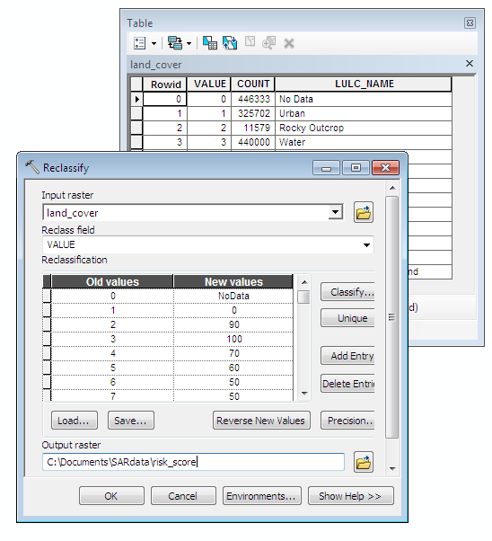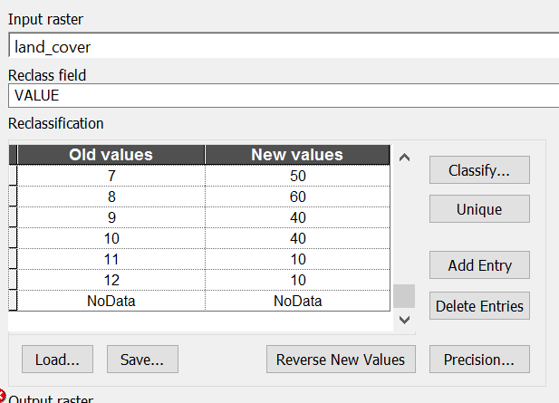

Lower part of the reclassification table

## Answer Question 1

Calculate slope

Now you need to create a map of risk according to slope. Unfortunately, you do not have a raster file for slope, but you can create a file using the elevation data provided. So, the first step is to calculate slope. The next step is to reclassify the slope file according to the appropriate risk score (provided in the Criteria section above).

1. Add the elevation data to the map document (elev_ouach).
2. To calculate slope, use the Slope tool within the Surface toolset in Spatial Analyst: click Spatial Analyst Tools » Surface » Slope. Or you can simply search Slope in the Search box.

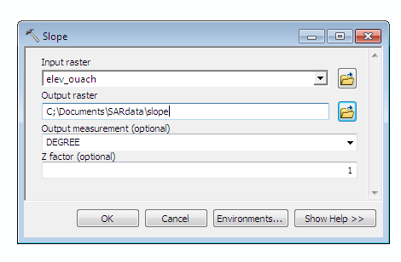

This procedure will create a slope file in units of degrees.

|  |  |  |
| --- | --- | --- |
| Elevation |  | Slope |

Reclassify slope according to risk

Now, use the same reclassification tool specified above to reclassify the slope file according to the risk scores.

1. Open a Reclassify tool (from ArcToolbox or Search).

There is an additional step, however. Land cover is a discrete nominal attribute, but slope is a continuous attribute. Therefore, you cannot reclassify slope according to unique values like you did for land cover. But there is another way you can specify classes and breaks.

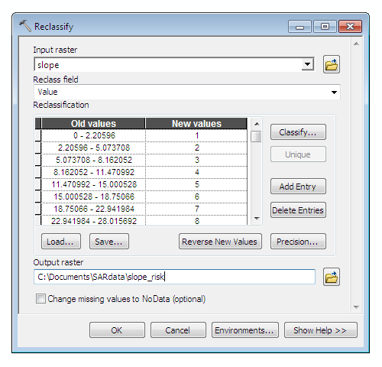

1. Click Classify.

A new box pops up that allows you to specify the number of classes/breaks you would like to have in your dataset by deleting or inserting breaks. Please refer to the Criteria above to set the breaking points of the classification. You can right click on a breaking line or click in an empty position to add a breaking line. We only need 6 categories of slope, so we need 6 breaking lines at 0, 6, 10, 20, 25, 90. You can also type in numbers in the Break Value list (on the right of the window).

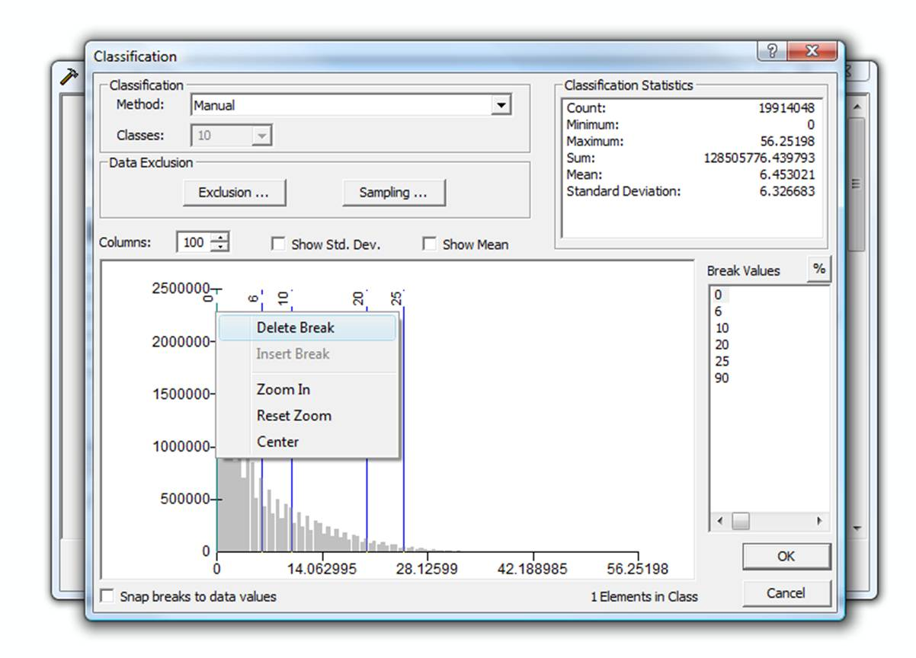

You're not done yet. All you did was create the categories that are necessary for reclassification. The next step is to actually reclassify the slope data to the risk scores.

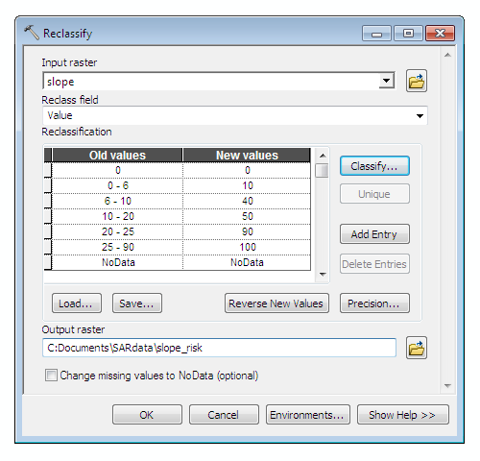

## Answer Question 2

Apply moving windows

Now that the land-cover and slope files have been reclassified according to risk, you need to combine the two files to create an overall risk map. There are two parts to creating the final risk map. First, you need to run moving windows on the land-cover risk file and the slope risk file. A "moving window" is one that moves throughout a grid and assigns the center pixel a value according to criteria specified by the user. Applying the “moving window” can smooth the two risk rasters by removing noise in them. After that, you will combine both files according to the model equation specified in the “Criteria” section above.

Start with land cover risk. The model indicates that land-cover risk is equivalent to the AVERAGE risk score within a 0.24-kilometer search radius (equivalent to 8 cells). Moving windows in ArcMap are run with focal statistics. To calculate a focal statistic (e.g., average cell value) within a specified neighborhood (e.g., search radius), you need to use the Spatial Analyst tools again.

1. 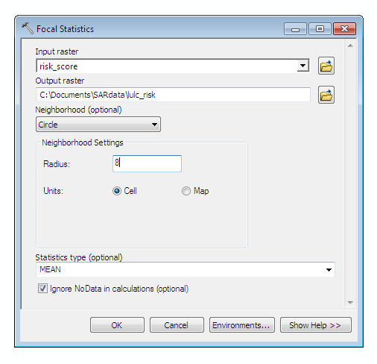Navigate to the Neighborhood toolset and select Focal Statistics (Spatial Analyst Tools » Neighborhood » Focal Statistics). Note: Make sure you select Units: Map before you type in the radius. Otherwise, your radius units will be automatically altered by the GIS program.

Specify a circular neighborhood for the search radius.

Specify a neighborhood value equal to 0.24 km. Remember, each cell is 30 m.

Specify that you would like to calculate the MEAN (i.e., average) of all cells within the window.

The focal statistics may take several minutes to run. In the end, your output map of land-cover risk should look like this (purple = high and light blue = low):

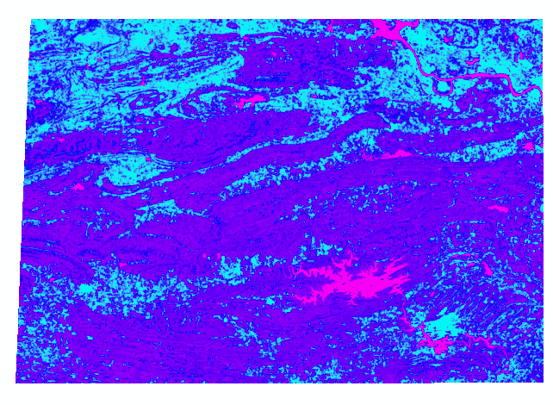

Now, you have to repeat the same procedure to get the final risk map for slope.

1. Continue to use a circular neighborhood with a radius of 0.24 kilometers, but make sure you specify the statistics type as MAJORITY instead of the mean.

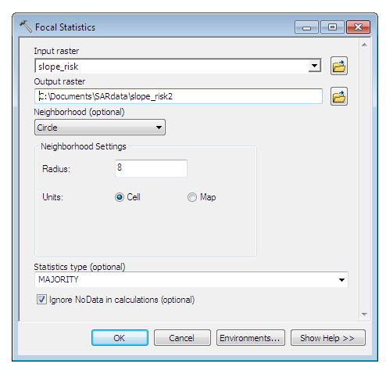

Specify that you would like to calculate the MAJORITY of all cells within the window.

Your slope risk map should resemble this (yellow = high and blue = low):

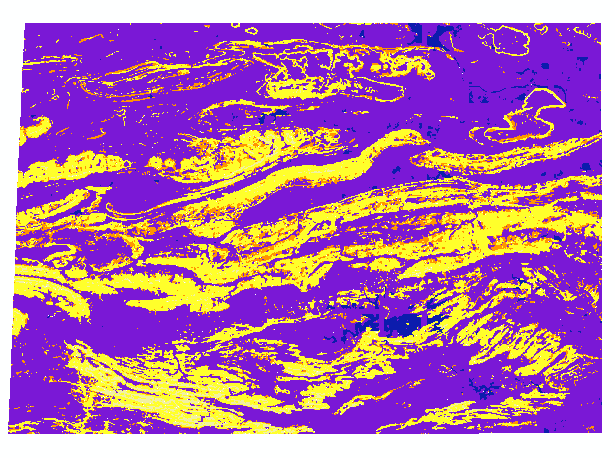

Combine the risk maps

Task 1 is almost complete. The final step is to combine the two risk maps according to the overall risk model:

Overall risk = [(land cover risk) + 5 * (slope risk)] / 6

## Answer Question 3

To do this, you must use the Raster Calculator. The Raster Calculator is found by navigating to Spatial Analyst Tools » Map Algebra » Raster Calculator.

Note: If items on the toolbar are unavailable, you need to start the Spatial Analyst extension.

1. Once the Raster Calculator is open, type the formula indicated in the figure below, and click OK.

|  |  |  |
| --- | --- | --- |
|  |  |  |

## Answer Question 4

Task 2. Determine areas accessible to an ambulance within a 30-minute drive from a hospital (following speed limits)

This is a network problem. You need to delineate areas that are accessible to an emergency vehicle within a specific time and traveling at designated speeds. So take a look at the data you have.

Solutions to a network problem require some sort of a network dataset. You have roads to use for the network, but it is not yet a network dataset. You'll create one later. Attributes of the road shapefile include road type and speed limit. You also have a point shapefile of cities. The information provided in the lab indicated that you can assume an emergency vehicle can leave from a station at or near each point.

Add the road and cities shapefiles to the map document.

Calculate times for road segments

The first step is to determine how long it would take to drive the length of each road segment. This can be done easily enough directly in the attribute table. From physics, you know that time equals distance divided by speed. But the attribute table does not provide distance. It's a good thing distance (i.e., length) is a geometric property; you can calculate it yourself. So, add a new field and name it Miles.

Add and name a new field

1. Add the roads_ouachita shapefile to ArcMap. Right-click and click Open Attribute Table.
2. Click the Table Options drop-down menu in the top right corner and select Add Field.
3. Name the new field Miles and specify Type as Float (because you will have decimals).
4. Under Field Properties, specify the precision as 10 and the scale as 2 (precision refers to the width of the field, and scale indicates the number of decimal places).

Calculate geometry

Once the new field has been created, you can calculate the length of each road segment by using the Calculate Geometry function.

1. Right-click the Miles field and select Calculate Geometry. You will get a warning message; click Yes to continue.

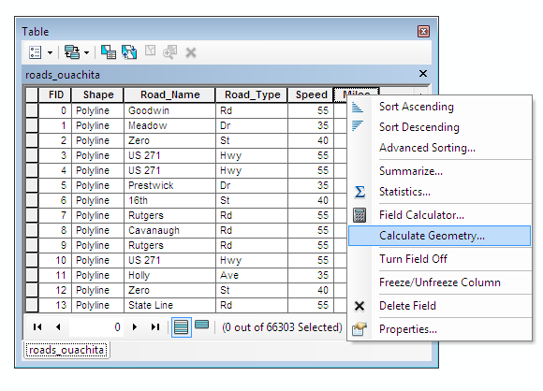

1. Specify the geometric property as Length and the units as Miles US. Click OK.

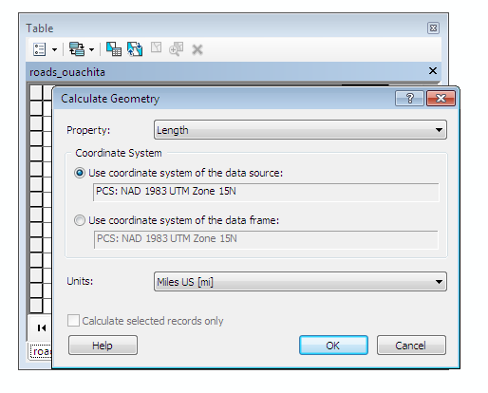

Calculate time with the Field Calculator

Now you have to calculate time. So, add a new field using the procedure outlined above and name it Minutes in Float data type. Use the Field Calculator to calculate time (in minutes) from the distance and speed fields.

1. Right-click the Minutes field and select Field Calculator.
2. Make sure your equation indicates Minutes = (Miles/Speed) * 60. (You have to multiply by 60 to convert time in hours to minutes.)

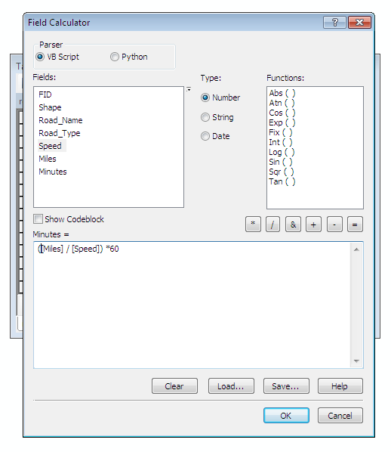

Create a network dataset

Creating a network dataset is not difficult, but there are some steps involved. You must use ArcCatalog to do this.

1. Start ArcCatalog and navigate to the area where you have stored the files for this lab.
2. Right-click the roads_ouachita shapefile and select New Network Dataset.

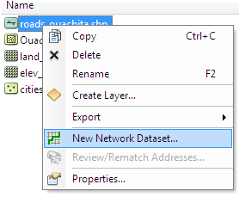

1. Name the file roads_ouachita_ND. Click Next.
2. You want to model turns in this network because an emergency vehicle can turn anywhere. Click Next.
3. Use the default for connectivity. Click Next.
4. You do NOT want to model connectivity with elevation field data. Click Next.
5. Choose None for the “Model the elevation” step, and click Next.
6. Notice that the Miles and Minutes attributes appear as possible cost attributes. Use Minutes as the default attribute. Click Next*.*

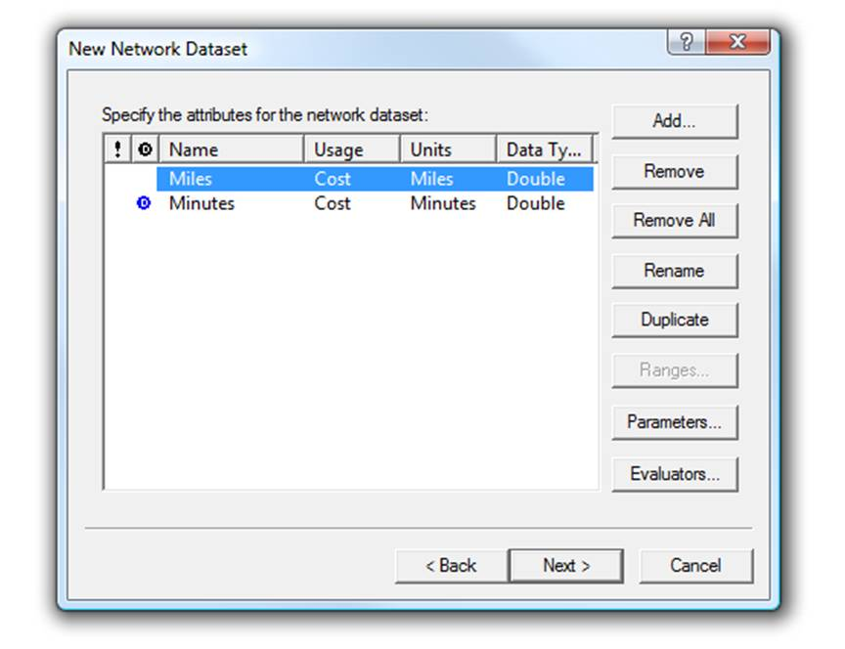

1. Ignore the Travel Mode window, and click Next.
2. You do NOT want to establish driving directions. Click Next.
3. Click Finish.
4. Click Yes in the final box to build the network dataset.

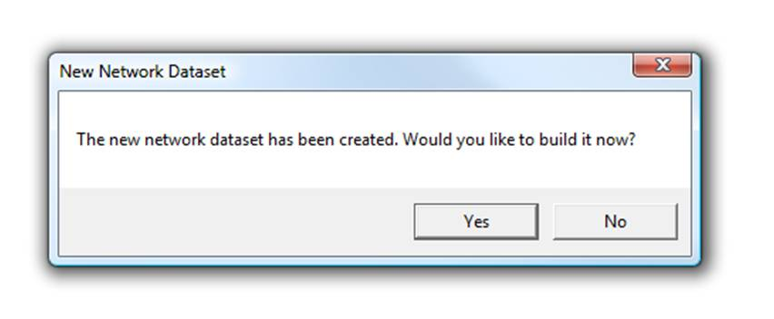

There will be two files: an edge file and a junction file. The edge file is what you need to bring back into ArcMap.

When asked if you would like to add all feature classes that participate in the network dataset, select No.



Only bring the file with this icon

into ArcMap.

Now you can start Network Analyst. Make sure the Network Analyst toolbar is present.

1. Click Customize » Toolbars » Network Analyst.

Note: If items on the toolbar are unavailable, you need to start the Network Analyst extension.

1. Click Customize » Extensions » Network Analyst.



1. Click the Show/Hide Network Analyst Window button to display the processes you will be working on. A new window will open on the left side of the screen.
2. Select New Service Area from the Network Analyst drop-down list.

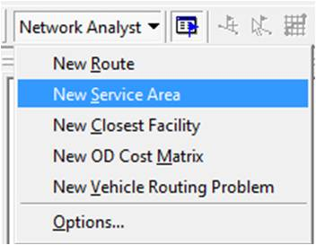

This selection will allow you to determine the areas accessible within 30 minutes by an ambulance driving (on average) at speed limits.

Input locations of facilities

In the Network Analyst window, you can input the locations of the facilities. Facilities in this case will be the cities from which an ambulance can leave.

1. In the Network Analyst window, right-click Facilities and select Load Locations.

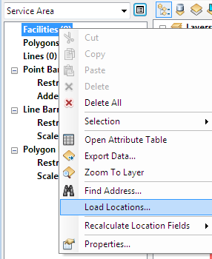

1. Navigate to and select Cities.shp for the Load from box. In the next box, under Location Position, set the search tolerance to 500 meters to ensure that city locations not directly on a road will still be included.

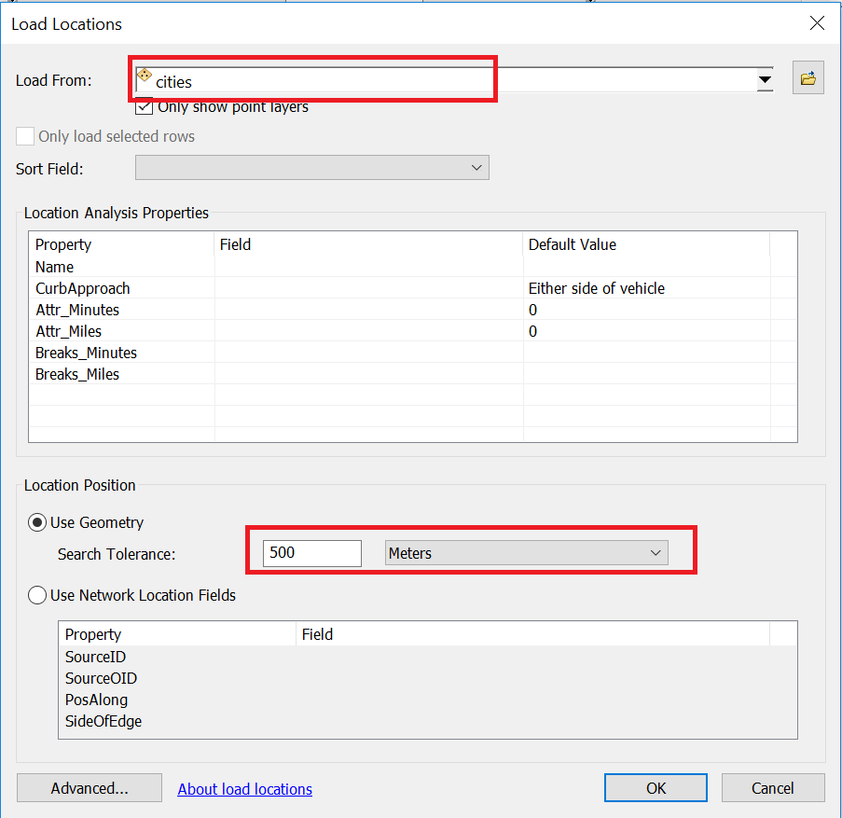

1. Select OK to load the city locations. This process can take several minutes, so be patient…

Perform network analysis

Once all 28 city locations are loaded, you can begin the analysis.

1. Click the Service Area Properties button to access the Layer Properties dialog box where you can specify parameters on the Analysis Settings tab.

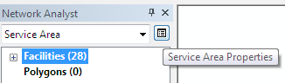

1. Make sure Impedance is Minutes; Default Breaks are 5, 10, 20, and 30; Direction is Away From Facility; and U-turns are allowed (because emergency vehicles can make U-turns anywhere they need to).

|  |  |
| --- | --- |
|  |  |

1. Click OK. Now you're ready to solve. Click the Solve button on the Network Analyst toolbar and wait for it to run. This process might take a few minutes.



You can turn off unnecessary layers to see the output more clearly.

Once your analysis is completed, change the symbology of your new spatial data to make the different service area more . Your map should resemble the ones below. Polygons are created for each time interval. You can see which areas of the national forest are inaccessible by a 30-minute drive from the city centers.

## Answer Question 5