Building Models for GIS Analysis Using ModelBuilder

In this exercise, you will perform an analysis that locates the best sites for a new wastewater treatment plant.

All site-selection analysis operations have criteria that are specific to your situation—a storefront, a park, a treatment plant, and so on. In this case, your criteria for siting a new wastewater treatment plant are as follows:

* Must be within 3,000 feet of the Cache la Poudre River
* Must be within 1 mile of the city limits
* Must be at least 300 feet from residential parcels and parks
* Must lie outside the flood plain
* Must be on vacant parcels that are 50,000 square feet or greater**s**

## Step 1: Plan your analysis

In this step, you will explore the data you have available to you in the FtCollins geodatabase and then use this data in the model.

Start ArcMap.

If necessary, open the Catalog window 

Connect to the BldgModels10_0 folder.

Expand FtCollins.gdb to view its contents.

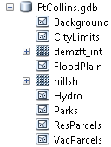

Notice that there are several feature classes and raster datasets in this geodatabase.

You will use the Buffer tool to fulfill the following criteria:

* Must be within 3,000 feet of the Cache la Poudre River
* Must be within 1 mile of the city limits
* Must be at least 300 feet from residential parcels and parks

## Step 2: Create a new custom toolbox and model

From the Catalog window in ArcMap, open ..\BldgModels10_0\SitePlant.mxd.

Set the default geodatabase to FtCollins.gdb. (Right-click FtCollins.gdb in the Catalog window and choose Make Default Geodatabase)

Setting the default geodatabase is similar to setting the application-level environment for current workspace: it is applied to all tools. In this case, all derived data will be stored in FtCollins.gdb.

* Right-click FtCollins.gdb and choose New > Toolbox.
* Name the new toolbox Site_Plant.
* Right-click the new toolbox and choose New > Model.

A blank new model opens. From the Model menu, choose Model Properties.

On the General tab, set the following properties:

* Name: WastewaterSiteSel
* Label: Wastewater Site Sel
* Check the box to store relative path names.

Note: you should use relative paths. If you share your model with another user, the model's root folder would not need to be the same for the model to run properly.

* Click Apply.
* Click the Environments tab.
* Scroll down to Workspace, expand it, and then check the Current Workspace box.
* Click Values and expand Workspace.



The Current Workspace environment setting is already set to the course folder because you have set the default geodatabase. Setting the default geodatabase is similar to setting an application-level environment for a current workspace. It will be applied to all tools you run, unless you override it by setting a tool, model, or model-process environment setting.

* Click OK to exit the Model Properties dialog
* From the Model menu, choose Diagram Properties.

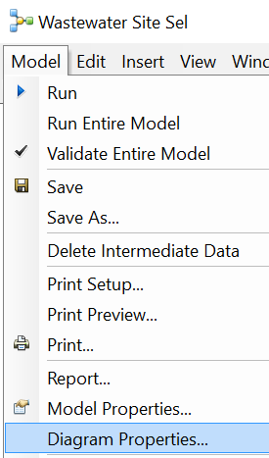

* Click the Layout tab and choose Top to Bottom. Click OK.

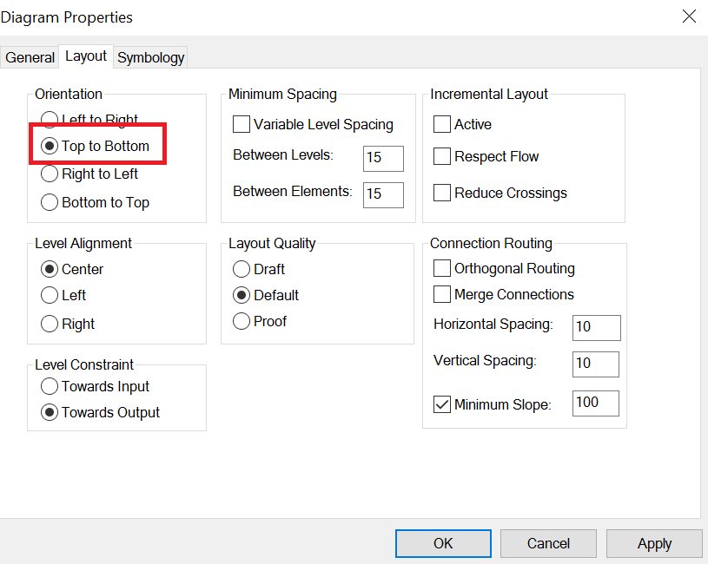

* Click Save to save the model. You should often save your model as ArcGIS often crashes.

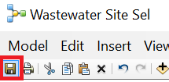

* Minimize the model

## Step 3: Select a feature using a query

Now you will select the Cache la Poudre River as the main water feature for your analysis. Because all geoprocessing tools will only run on selected sets, you can simply make a selection rather than exporting new dataset containing only the river. This operation will help you fulfill the criterion of close proximity to the river.

* First turn off all data layers

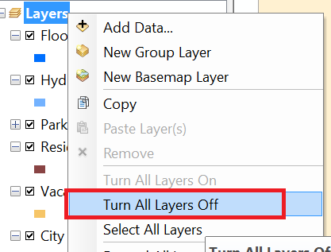

* Turn on the Hydro layer only.
* From the Selection menu, choose Select By Attributes.

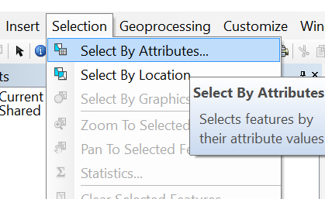

* Change the Layer to Hydro.
* Type the following expression: NAME = 'Cache La Poudre River'. Then, click OK to make the selection.

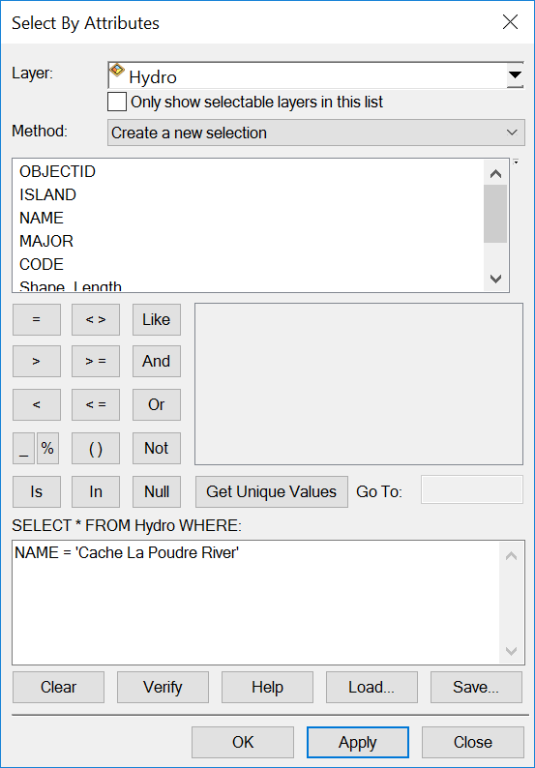

## Step 4: Create buffers

First, you will add buffer tools to the model, which will satisfy the criteria for being within 1 mile of the city limits and within 3,000 feet of the Cache la Poudre River.

* On the Standard toolbar in ArcMap, click the Search Window button .
* In the Search window, click Tools to include only tools in your search results.
* Type **buffer** and click the Search box.
* Drag **TWO** instances of the Buffer (Analysis) tool into the model.
* Arrange them as shown in this graphic.

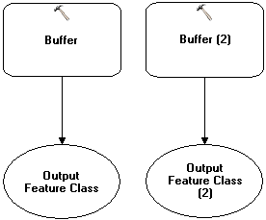

Double-click the Buffer tool to open its dialog box, and then set the following parameters.

* Input Features: Hydro
* Output Feature Class: **RiverBuf**
* Distance > Linear unit: 3000 Feet

Notice that the process elements are in color and therefore ready to run.

Open the dialog box for the second Buffer tool and set the following parameters:

* Input Features: City Limits
* Output Feature Class: **CityBuf**
* Distance > Linear unit: 1 Miles

Click the Auto Layout button  to align your elements.

You can rename model elements to make them easier to differentiate and more meaningful to your analysis. This model will have several buffers, so giving each of them a more significant name will enable you to determine what it is buffering.

* Right-click the Buffer tool that has Hydro as the input and choose Rename. Change the name to “Buffer River”.
* Rename the other Buffer tool “Buffer City”.

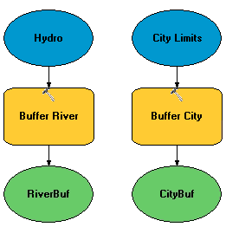

From the Model menu, choose Save, or click the Save button  in order to save the changes to the model within the Site_Plant toolbox.

## Step 5: Locate common areas of two buffers

Next, you want to locate the common areas between the two buffers (in other words, the suitable areas). This can be done in two ways: using the Clip tool or performing the Intersect overlay operation.

The Intersect overlay operation allows you to combine the attributes of these buffers. However, you do not need to do this, so you will use the Clip tool to extrapolate the common areas.

In the Search window, type **Clip** to find the Clip (Analysis) tool and add it to the model under RiverBuf and CityBuf.

Open the dialog box for Clip and set the following parameters:

* Input Features: CityBuf
* Clip Features: RiverBuf
* Output Feature Class: **MustBeIn**

Your model should resemble the following graphic. Positioning the model elements to match the graphic exactly is not required, but make sure that the elements in your model are connected as shown.

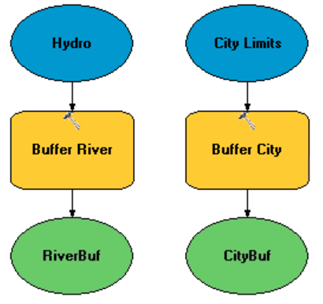

Save the model.

## Step 6: Locate initial unsuitable areas

The goal of this step is to create a new feature class containing all the unsuitable areas. You will create the new feature class in the model, using the Append geoprocessing tool to add the unsuitable areas to it.

* Search for and add two more Buffer tools to the right of the initial two (Buffer River and Buffer City).
* Open the dialog box for the new Buffer tool on the left and set the following parameters:
  + Input Features: Residential Parcels
  + Output Feature Class: ResBuf
  + Distance > Linear unit: 300 Feet
* Open the dialog box for the other new Buffer tool and set the following parameters:
  + Input Features: Parks
  + Output Feature Class: ParksBuf
  + Distance > Linear unit: 300 Feet
* Click the Auto Layout button Auto .

Next, you will create a new empty feature class for storing all unsuitable areas.

* In the Search window, type create feature class to locate the Create Feature Class (Data Management) tool, and then add it to the right of the Buffer tool for the parks in the model.
* Open the dialog box for the Create Feature Class tool and set the following parameters:
  + Feature Class Location: FtCollins.gdb
  + Feature Class Name: Unsuitable
  + Geometry Type: POLYGON

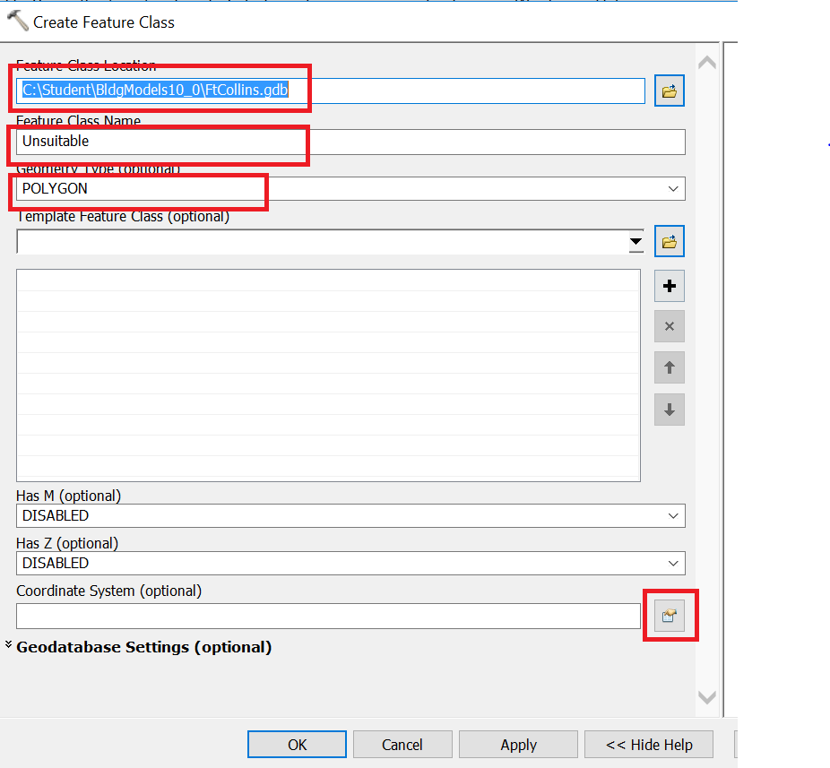

* + Coordinate System: Scroll down and click the Properties button and import the coordinate system from the ..\FtCollins.gdb\CityLimits feature class. Click OK

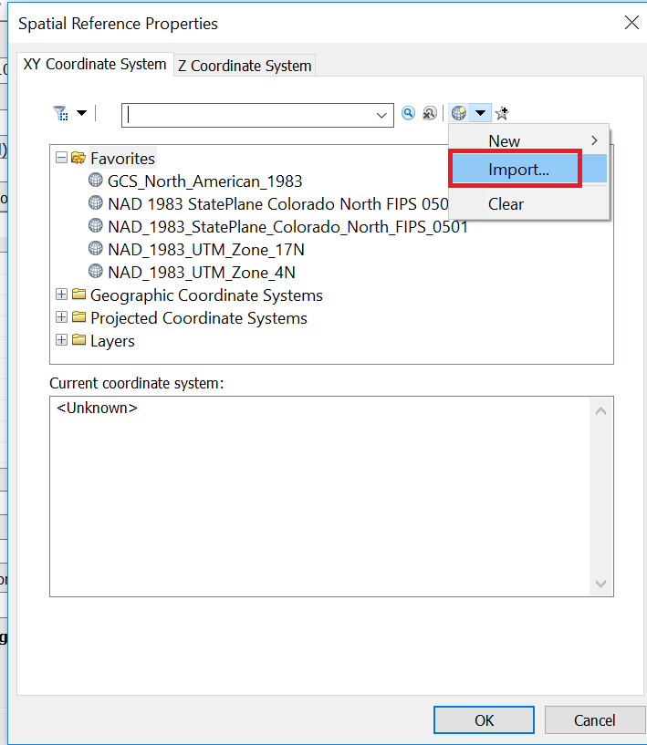

Now, your ModelBuilder should look like:

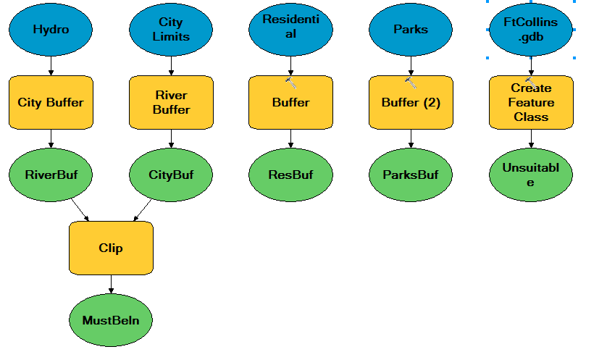

Next, you will combine all unsuitable areas into a single feature class. You can do this in one of several ways. The Union or Intersect tools are commonly used, but you are not using the attributes for the analysis at this point, so you do not need to combine them. Both Union and Intersect would take longer to run and yield more information than you need. Instead, you will use Append with the NO_TEST option, which allows you to combine datasets without worrying about the attributes.

* Search for and open the Append (Data Management) tool.
* Add the Append tool to the model under the ParksBuf output element.
* Open the dialog box for the Append tool and set the following parameters:
  + Input Datasets: ResBuf, ParksBuf, Flood Plain (*Hint*: Because Flood Plain on its own is unsuitable, no buffer is necessary.)
  + Target Dataset: Unsuitable
  + Schema Type: NO_TEST

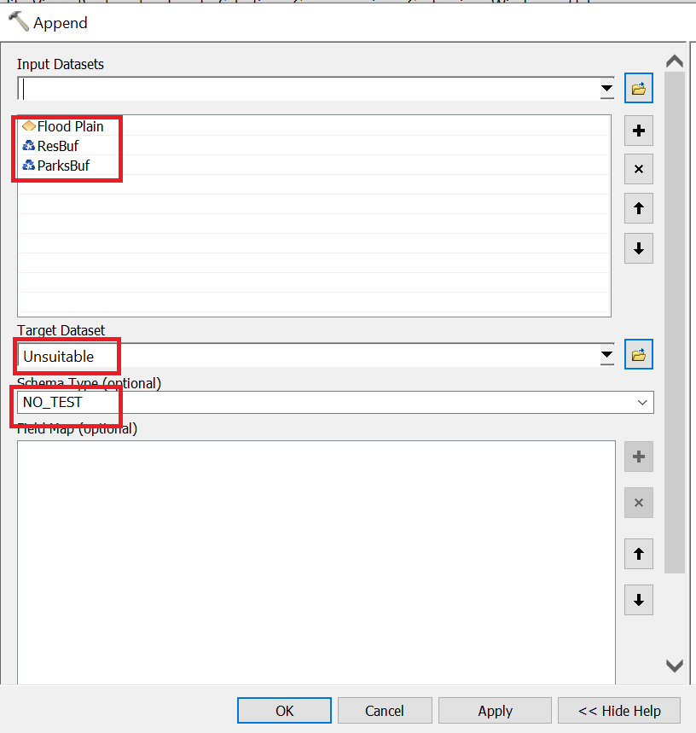

Notice that the Flood Plain dataset was added to the model as a result of being included in the Append tool as an input dataset.

* Click the Auto Layout button.
* Click the Full Extent button 

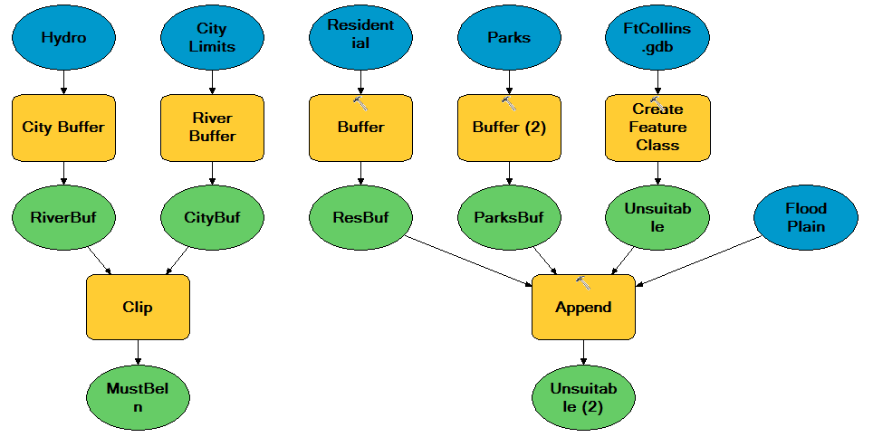

Unsuitable (2) is really the same feature class as the initial Unsuitable, but now it includes the combined features of ResBuf, ParksBuf, and Flood Plain.

**Tip:** If you want a closer look at the model element names, use the Zoom In tool in ModelBuilder.

* Save the model.

## Step 7: Exclude unsuitable areas

Next, you will use the Erase tool to eliminate all unsuitable areas.

* Search for the Erase (Analysis) tool and add it to the model directly below and centered between the MustBeIn and Unsuitable (2) elements.
* Open the dialog box for the Erase tool and set the following parameters:
  + Input Features: MustBeIn
  + Erase Features: Unsuitable (2)
  + Output Feature Class: SuitableAreas

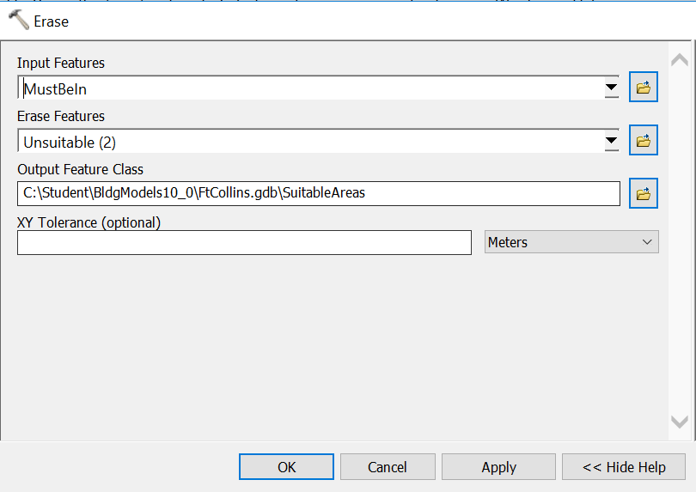

* Click the Auto Layout button, and your model should look like

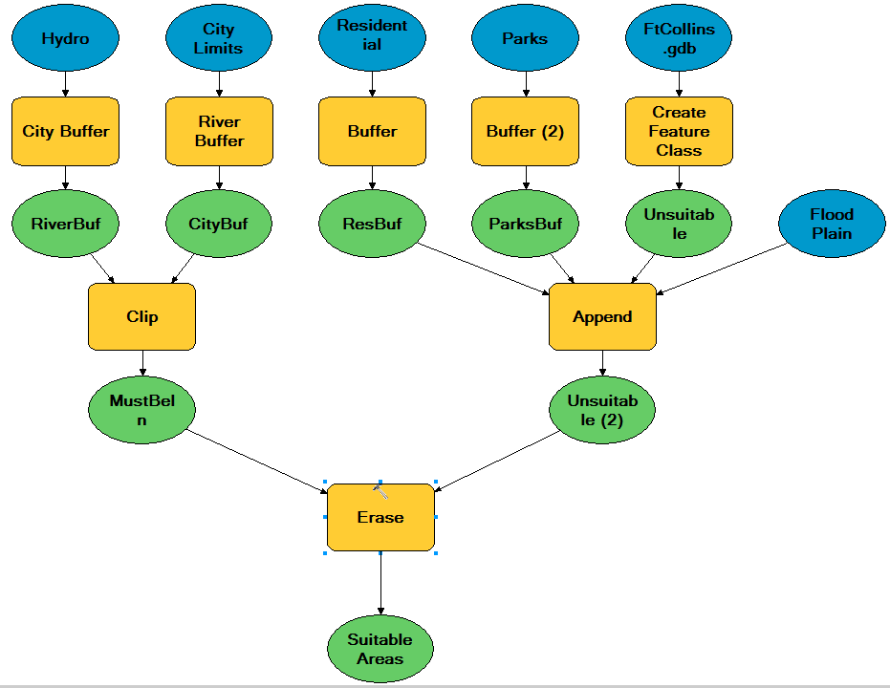

* Save the model

## Step 8: Add a clip process to the model

Now you need to include the vacant parcels because the treatment plant must be on vacant land. To do so, you could use an overlay tool or you could use the Clip tool.

* Search for and add another Clip tool below the SuitableAreas data element.
* If necessary, move the model so that you can see the table of contents.
* From the ArcMap table of contents, drag the Vacant Parcels layer into the model next to Clip (2).

**Tip**: You can add data elements in any of the following ways:

* By entering the parameters in the tool dialog box
* By dragging elements from ArcMap
* By using the Add Data button in ModelBuilder

Next, you will connect a data element to a tool.

* In ModelBuilder, click the Connect tool .
* Drag the connector from Vacant Parcels to the Clip (2) tool, and choose Input Features

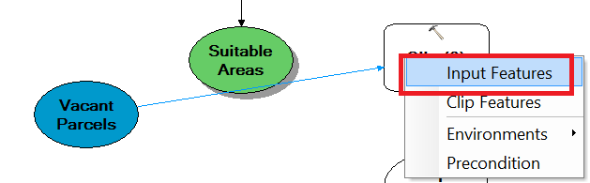

* Drag the connector from Suitable Areas to the Clip (2) tool, and choose Clip Features
* Name the output of Clip (2) VacantSuitable.
* Again, auto layout your model

Now, your model should look like:

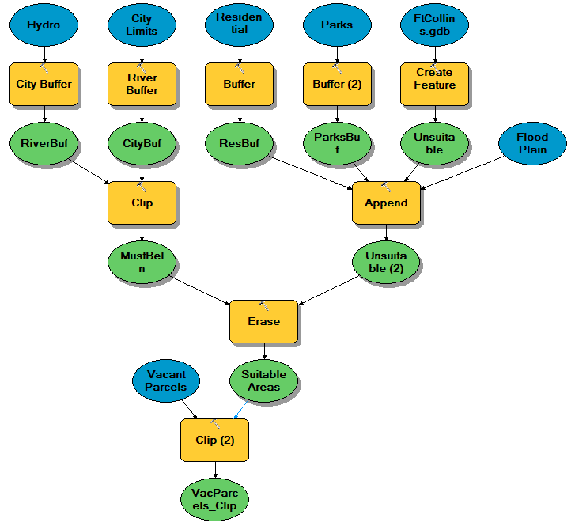

Tip: you have different ways to set input and output variables for geoprocessing tools. You can

* Open the tool dialog and set input/output in the dialog
* Drag the connector to link input/output to the tool

## Step 9: Select features that meet the size requirement

The Clip tool, which you used earlier, located all vacant parcels that meet the requirements of all criteria except area. The treatment plant must be on a vacant parcel that is 50,000 square feet or bigger. Using the Select tool, you will narrow down the suitable sites with a query.

You want to build the selection of the parcels that meet the size requirement into the model, so you will add the Select tool to the model instead of running the tool on its own.

* Search for and add the Select (Analysis) tool to the model under VacantSuitable.
* Connect VacantSuitable to the Select tool as Input Features.
* Open the Select tool's dialog box, and change the Output Feature Class name to Candidates.
* Set the expression to: Shape_Area > 50000.

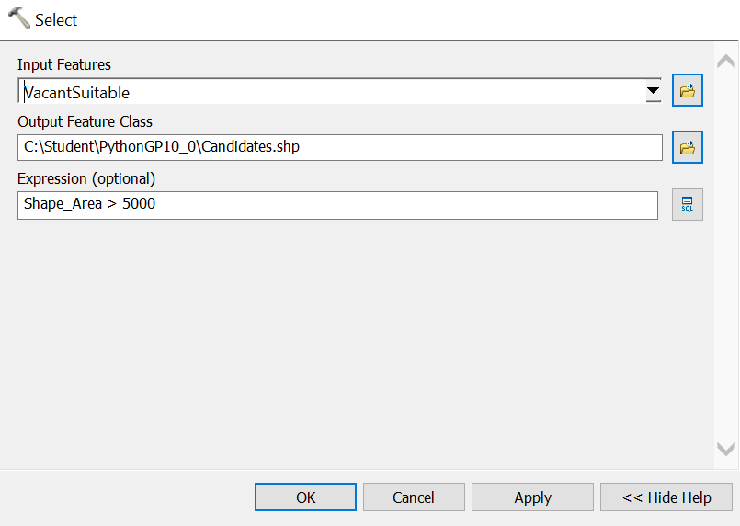

The Candidates feature class will contain the candidate parcels that meet all analysis criteria, including area.

* Click Auto Layout and zoom to the model's full extent. Your model should look like

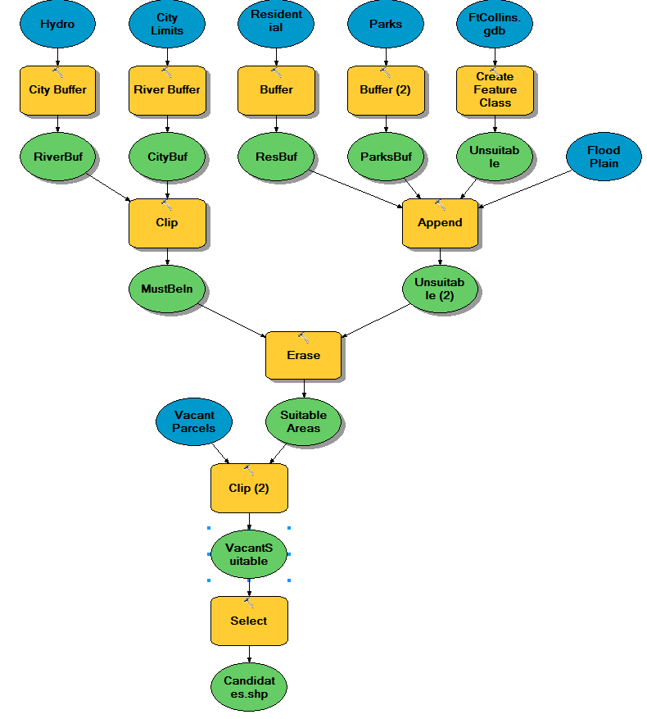

## Step 10: Run the model and view results

Before you run the model, you will import a layer file into the final result so that it is symbolized automatically when it is added into ArcMap.

* Right-click the Candidates output data element and choose Properties.
* Click the Layer Symbology tab, and then click the folder button.
* Navigate to ..\Student\BldgModels10_0, double-click Candidates.lyr, and click OK.

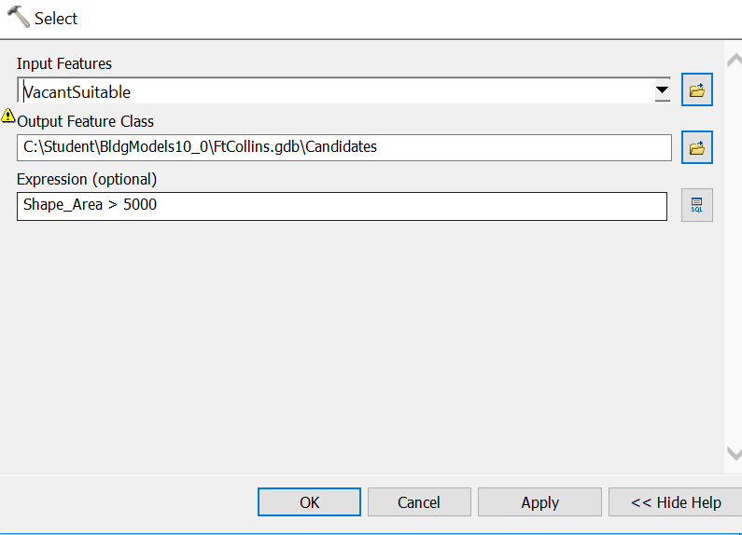

Now, when this Candidates layer is created and added to ArcMap, it will be symbolized automatically with custom symbology.

* Save the model.
* From the Model menu, choose Run Entire Model.

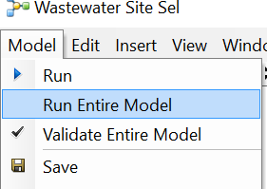

* When the model is done. Add the Candidates.lyr into ArcMap. The polygons in Candidates.lyr include suitable areas for the waste water site that meet all selection criteria introduced above.

## Answer Question 1 here.

A model can be viewed as a tool. Next, you will compare the differences between running a model from ModelBuilder and from its tool dialog box. You will also incorporate model parameters.

* In the Catalog window, locate the Wastewater Site Sel model. Here, the model you just built is the same as a geoprocessing tool, although it has many components. Double-click on it.

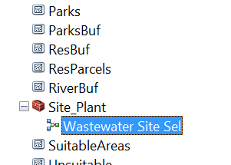

* You will see an empty tool with “This tool has no parameters”. It means the tool has no input/output variables.

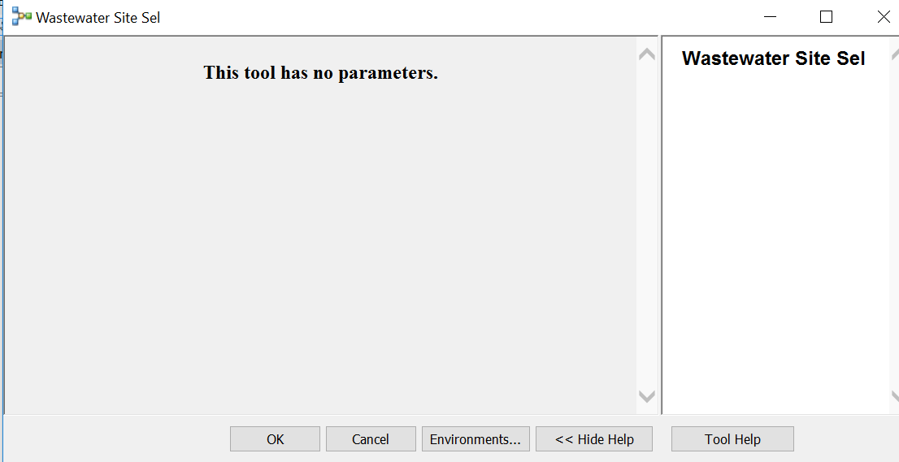

* Click Cancel.
* Right-click the Wastewater Site Sel model and choose Edit.

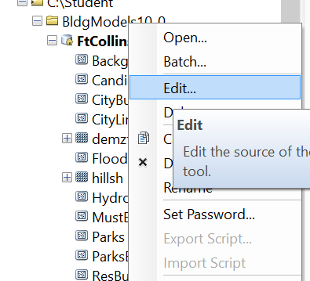

* If necessary, zoom to the model's full extent.
* Select all the five blue input data elements, and right-click on them and choose Model Parameter.

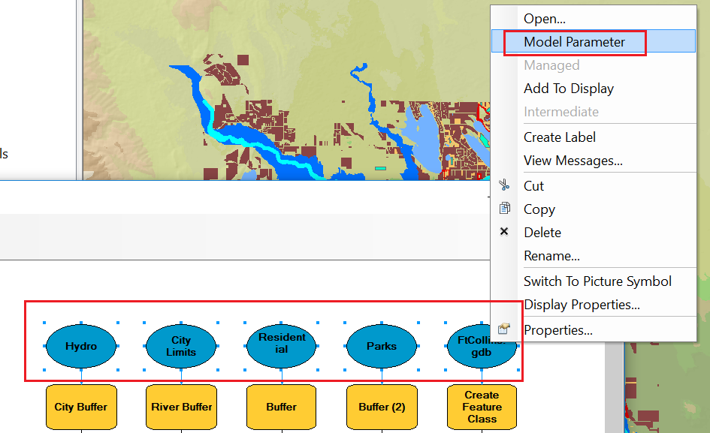

Now, each element will have a P next to its name.

* Save the model and close it.
* In the Catalog window, double-click the model again. You will see the model has five input variables now.

Running a model from its tool dialog box allows you to modify model parameters easily and enter your own data. Another advantage is that all intermediate data is deleted automatically when a model is run as a tool. When you run a model from ModelBuilder, as you did in this exercise, all intermediate data is preserved.

