**Lab #2 – Land Cover Change Analysis**

Before you begin with the exercise make sure you have downloaded all the data from: the **GIS_lab** folder in the computer **sys220**.

Unzip the files into your E drive or F drive. Remember to change file paths accordingly in the exercises.

In this exercise you will learn to use ArcGIS to detect and analyze land cover change in [Hammond City, Louisiana](https://www.google.com/maps/place/Hammond,+LA/@30.5044447,-90.5275698,12z/data=!3m1!4b1!4m5!3m4!1s0x862722b86526da5f:0xdef4bf97f4e2b2ed!8m2!3d30.5043583!4d-90.4611995). The land cover data are processed from remote sensing images, which are raster data. You will practice to use raster map algebra to analyze the data.

# Background Information

As one of the most coastal areas in the U.S., coastal Louisiana have endured multiple threats in the past years, including hurricane, flood, wetland erosion and oil spill. Hammond City is located in the north shore of Lake Pontchartrain and 60 miles away from both New Orleans and Baton Rouge, the two largest cities in Louisiana. The population of Hammond been growing rapidly in the past 20 years due to influx of immigrants from the south after Hurricane Katrina and its geographic location (e.g. adjacency to major highways). The influx of population has caused significant wetland erosion and deforestation in this region. In return, the degrading environment may intensify environmental stresses to human communities such as storm surge, flooding and sea level rise. Meanwhile, being through several major disasters, the residents in this area have adapted their way of living to reduce the risk of being hit by natural hazards. The dynamic interaction, competence, and evolvement of different environmental and human systems can be observed from land cover changes in remotely sensed images. This exercise will demonstrate how to use a time series of land cover images to analyze land cover changes and urban growth pattern near Hammond City from 1996 to 2010.

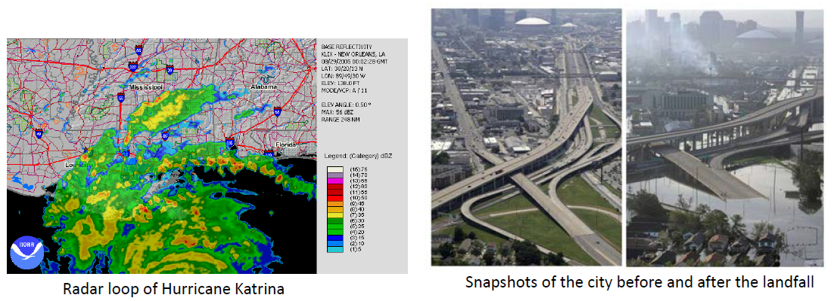



Influx of population from the affected area to other US counties.

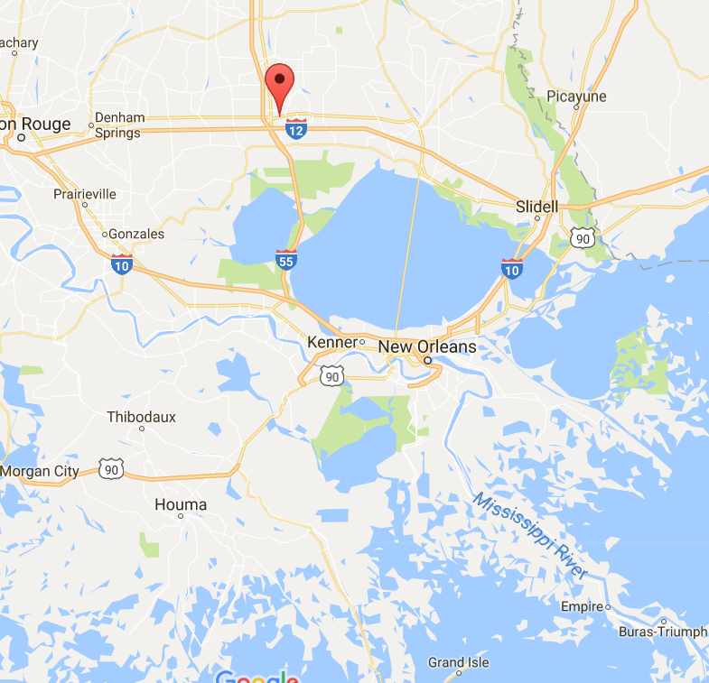

Location of Hammond City, LA

# ****Change Detection****

Open the lulc.mxd file. The lulc01, lulc06, and lulc10 are already added in the map file. These data are land use land cover data covering the Hammond City, LA. It is a categorical raster data classified from Landsat images, include 7 land cover types, including 1: urban, 2: agriculture, 3: grassland, 4: forest, 5: water, 6: wetland and 7: barren.

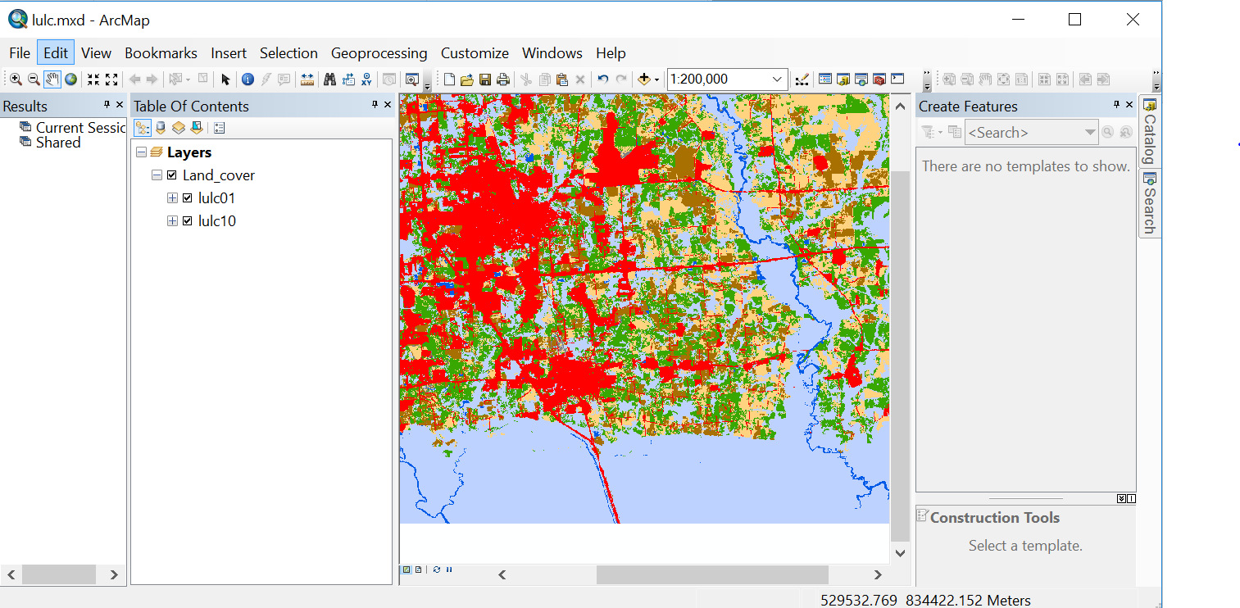

You can check and uncheck different rasters in Table of Content to visually observe the land cover changes between the years. You can also **Add a Basemap** to see where the study area is located.

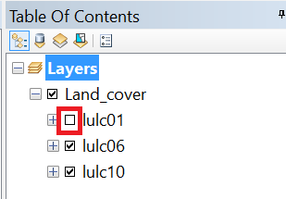

When you open the attribute table of a raster, you will see the 7 rows with **VALUE** from 1 to 7. These value represents the 7 land cover types.

The numerical values of pixels are not easy to understand. You can add a new text field of **Text** data type in the attribute table to document land cover types for different pixel values. (Do you remember how to add field?)

You can only edit the attribute table when the data is under editing mode. To edit attribute table, you should first start editing model by right-click the raster layer -> **Edit feature** -> **Start editing**.

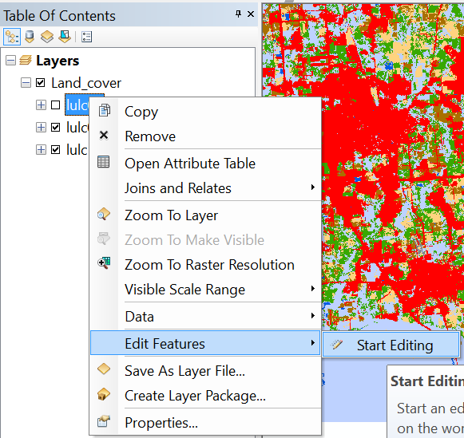

Then, edit the attribute table to input corresponding land cover types in the new field (like below). Remember to stop and save after editing. Please add the LANDCOVER field for **lulc06,** and **lulc10** layer too**.**

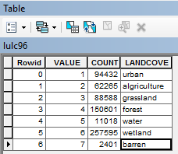

The **COUNT** field is the numbers of cells (pixels) in different category. But it doesn’t tell how much area the different land types have. You can easily convert the counts into area if you know the area (size) per pixel.

The size of raster can be found by right click the raster in **Table of Content** **-> Properties -> Source tab**, you can see the cell size is 30 meter, meaning the pixels are 30*30m squares. Now, go back to the attribute table of **lulc01**, add a new field called Area, and use **Field Calculator** to calculate the area according to the pixel counts and pixel size. Repeat the same steps to calculate the area of different land cover typesfor **lulc06 and lulc10.**

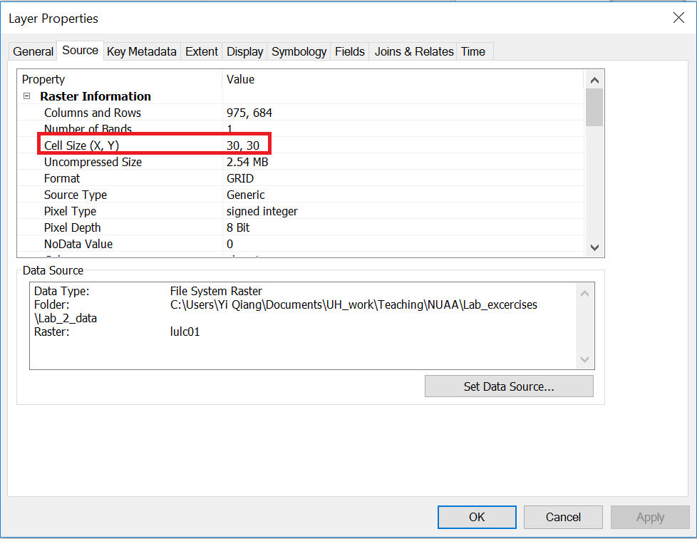

**Answer Question 1**

Click View -> Graphs -> Create Graph… in ArcMap panel.

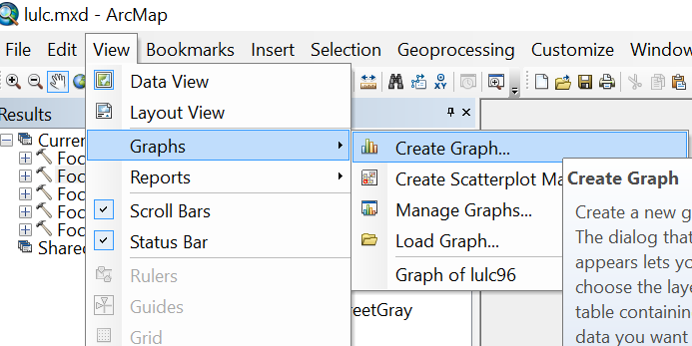

You can create a bar chart for lulc01 to show the amounts of different land cover types in 2001 (like below).

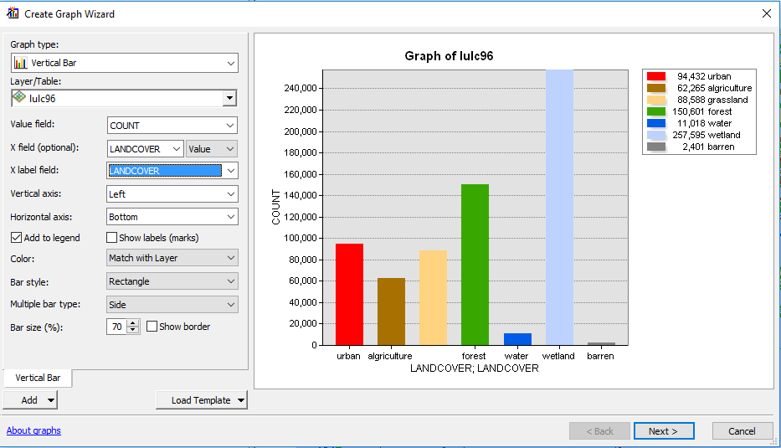

You can also compare the total areas of different land covers using a bar chart. The first step is to **Join** the attribute table of the two rasters.

Like a relational database, attribute tables of different data layers (both raster and vector) can be join using an identity key. In this case, the **VALUE** field can be the identity key to Join the two tables.

Right click on lulc01, and click ‘Joins and Relates’ – ‘Joins’. Join lulc01 with lulc16 **based on** Value field and click OK.

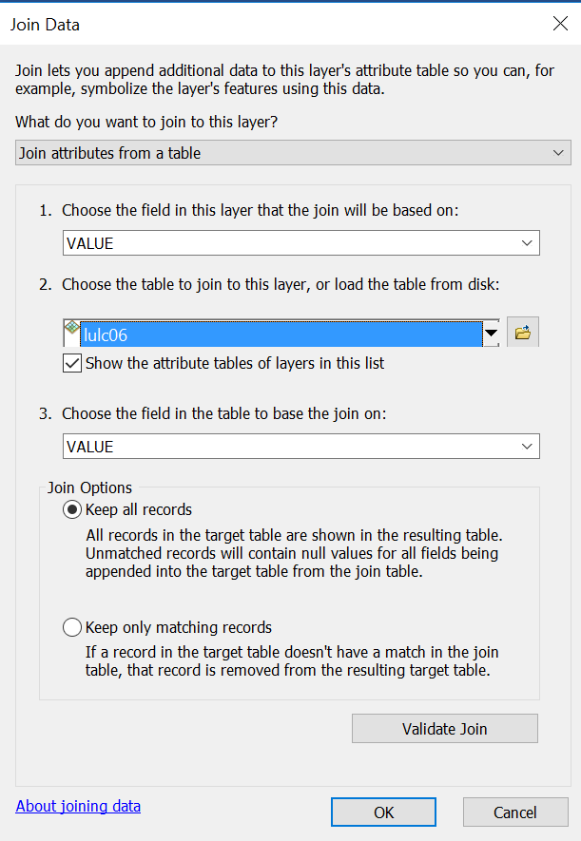

Repeat the same method to **Join** **lulc10** to **lulc01**

Then, open the attribute table of **lulc01**, you will see the attributes (.e.g COUNT, Area) of **lulc06** and **lulc10** are joined in the table.

Click **Export** in the menu.

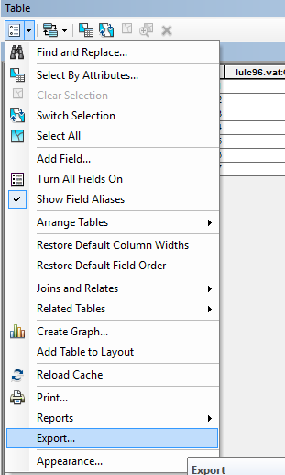

Navigate to your exercise folder and export the attribute table as a text file **joined_lulc.csv** (note the suffix is csv not txt). Now, the time series of amounts of the 7 land cover types are stored in the csv file.

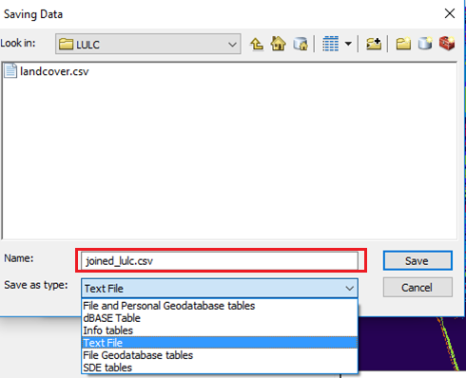

Open the exported .csv file in Excel. Create a bar chart (similar to the following chart, but use km2 as unit) to show the areas of the 7 land cover types in km2 in the two years.

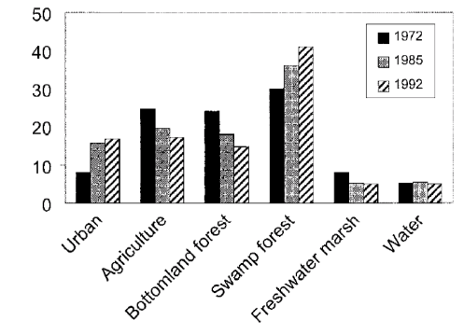

**Answer question 2.**

Now we use transition matrix to analyze land cover transitions between 2001 and 2010. The transition matrix (or called confusion matrix) shows changed areas between different land cover types.

Search ‘Combine (Spatial Analysis)’ tool in the search window of ArcGIS and open it.

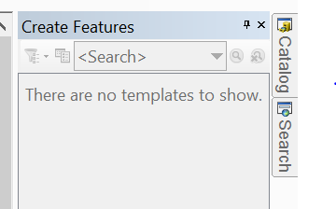

Use this tool to combine lulc01 and lulc10 into a new raster lulc0110.

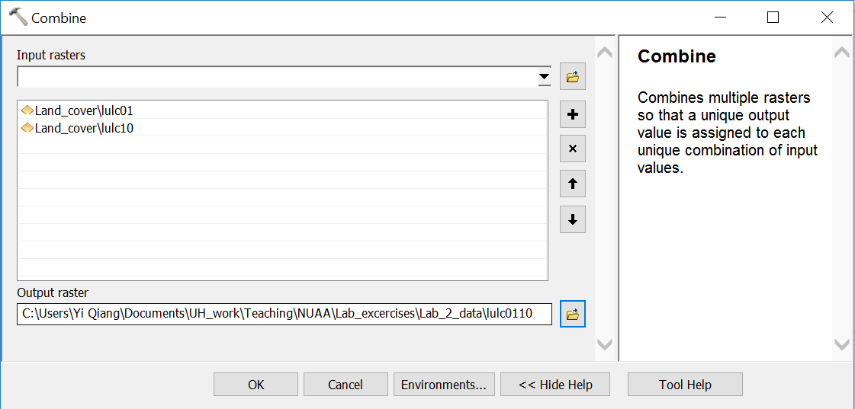

Export the attribute table of lulc0110 into lulc0110.csv. Use Excel or other tools to create a transition matrix (like below) for the land cover changes (in km2) between 2001 and 2010.  
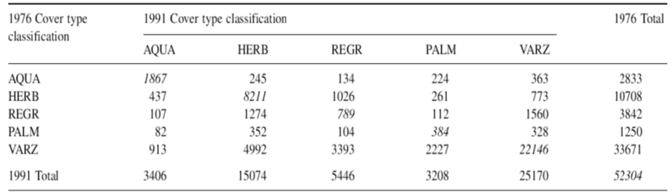

**Answer Question 3**

# Urban Growth Analysis

After analyzing transitions between different land cover types, we now focus on urban growth (i.e. non-urban pixels become urban). Unlike shapefile (vector data) where you can select features from attribute table and export the selected features to a new shapefile, you cannot export selected pixels in a raster to a new raster.

The most often used tool for raster analysis is Raster Calculator, where you can program different map algebra using very simple scripts. For example, the script in the following figure converts all non-1 (non-urban) pixels in lulc01 into 0 while keeping 1-pixels the same. Note: ‘==’ means equal to. You can always find ESRI documentation of the operators and examples from <http://pro.arcgis.com/en/pro-app/tool-reference/spatial-analyst/raster-calculator.htm>

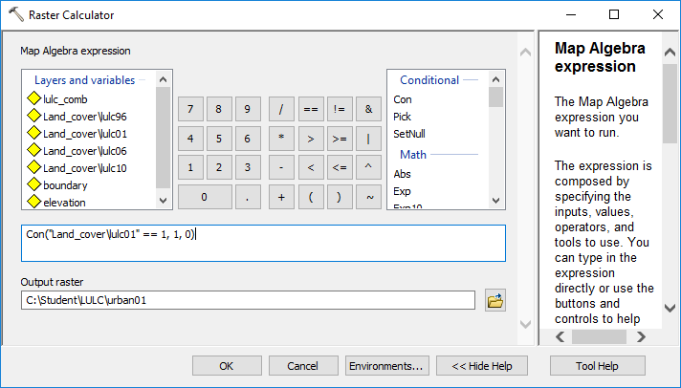

You don’t need to type the name of the raster in the expression box. You can double-click the data you want to use in the **Layers and variable** box and the variable will appear in the expression box. Run the tool to convert lulc01 into urban01 which is a binary urban/non-urban raster.

In the same way, convert lulc06 and lulc10 into urban06 and urban10. Instead of opening a new Raster Calculator and re-write the expression, you can modify from an already-run process in **Geoprocessing**->**Results**.

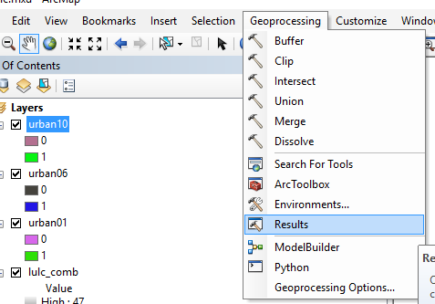

Then you will see all geoprocessing tools you previously ran in the Results window. You can double-click to open a previously run tool, modify parameters and run again. This can save your time.

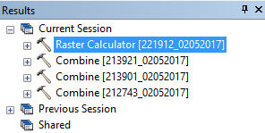

Use Raster Calculator to create urban growth (decay) rasters for the two time periods: 2001-2006 and 2006-2010. Assign 1 to urban growth pixels (other types -> urban), -1 to urban decay pixels (urban -> other types), and 0 to unchanged pixels.

*Tips: 1) You can subtract one raster from the other in Raster Calculator to detect the changes between them; 2) Names of raster files cannot be longer than 13 characters.*

**Answer Question 4**

You can also analyze the relationship of urban growth with other variables. For instance, we can compare average elevation of urban growth (1-pixels) in the two periods. First, **Add** the elevation raster from the folder, which is a digital elevation model (DEM).

***Background****: On August 29, 2005, the most destructive Hurricane in the U.S. History was landed in Gulf Coast. The Hammond city was impacted too. After the Hurricane, a large amount of residents in New Orleans (the most damaged city) have relocated in Hammond City, which boosted the urban growth there. Meanwhile, people have adapted their planning guideline and building code to make the new development less vulnerable to future storm surge and inundation. Comparing urban growth between the two periods can test a simple hypothesis: have people adapted by developing in higher elevation regions after Katrina?*

To get average elevation of urban growth, you will use urban growth pixels (1-pixels) to clip the elevation raster and then calculate the average elevation in the clipped pixels.

First, select urban growth pixels from urbgr0106 and set all other pixels to Null (no data) using Raster Calculator with the following expression, name the output urbgr0106_c. You may need to change the expression if your file has a different name. Use the same approach to select urban growth pixels in urbgr0610 and name the output urbgr0610_c.

SetNull("%urbgr0106%" , 1 , "VALUE <> 1 ")

The urban growth pixels are scattered in the map and some are too small to see (like below).

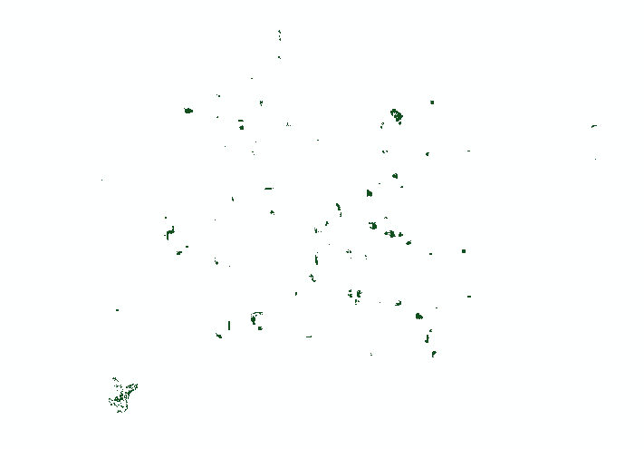

You can use a focal (neighborhood) operator to count the number of urban growth pixels around each pixel. The output can show the better show the density and clusters of urban growth pixels. Open the **Focal Statistics** tool, use a **Circle** neighborhood with radius of 25 cells.

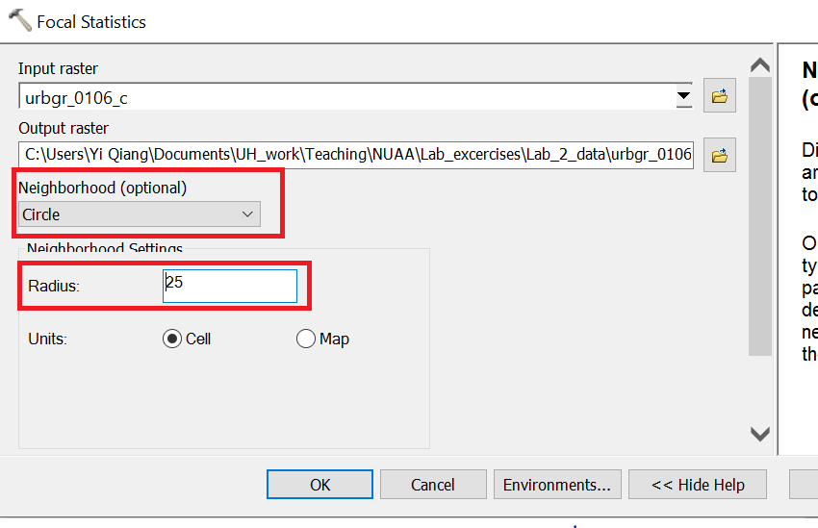

The output of Focal Statistics is like the following, in which the value of each pixel is the sum of urban growth pixels in its neighborhood of 25 cells.

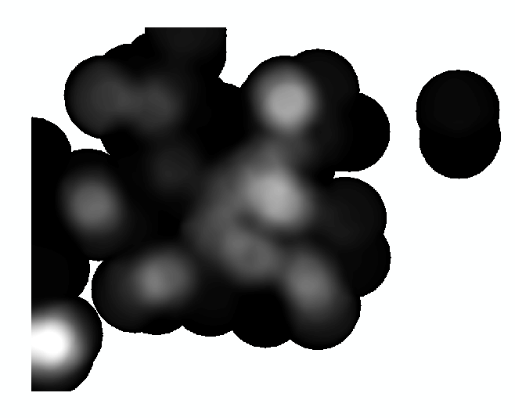

Change the color scheme by right click the output raster in **Table of Content** -> **Symbology.** Use a stretched color from blue to red.

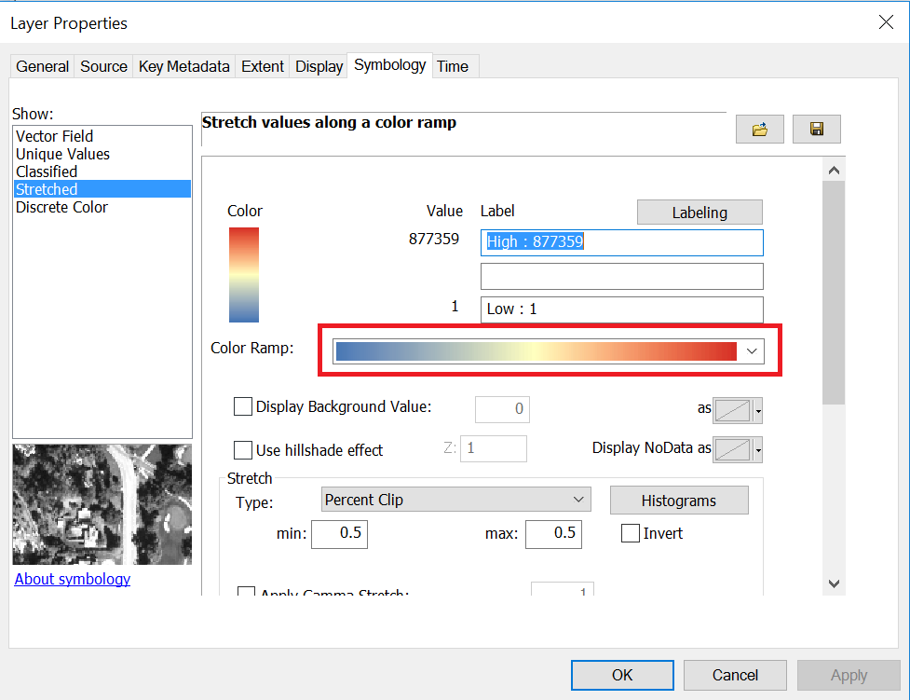

**Answer Question 5**

Next, we need to get overlay the urban growth raster with the elevation raster. There is no Clip tool for raster. Instead, you can use **Extract by Mask** tool to do the similar job. The mask raster is like the clip feature that can cut the input raster using its area. Here, **urbgr0106_c** and **urbgr0610_c** have only urban growth pixels (other pixels are coded NULL), they will cut the elevation onto the urban growth pixels.

You use **Extract by Mask** to clip the elevation raster using the two rasters of only urban growth pixels (**urbgr0106_c** and **urbgr0610_c**). Name the outputs **gr_elv0106** and **gr_elv0610** respectively.

These two rasters are urban growth pixels with elevation. In ArcMap, you can find the statistics of the two rasters in their Properties, the Source tab. Please compare their means to see how the change of average development elevation. Then, input their statistics into the following website to test if they are significantly different (assuming elevations in both periods are normally distributed).

<https://www.graphpad.com/quickcalcs/ttest1.cfm>

**Answer Question 6**