Start Eclipse, click menu “Window”-->”Preferences” and set the configurations below.

- Installed JREs, Text Editors
Input “install” to search the “Installed JREs” configuration, add the JDK you have installed.
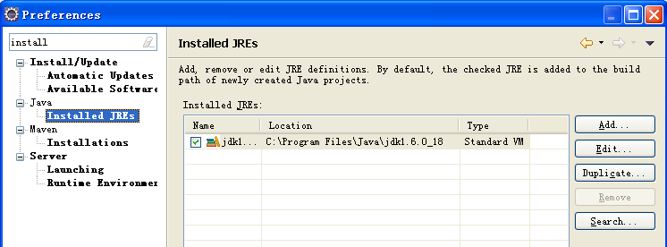

Input “text ed” to search the “Text Editors” configuration, check “Insert spaces for tabs”, “Show line numbers”, “Show whitespace characters”.
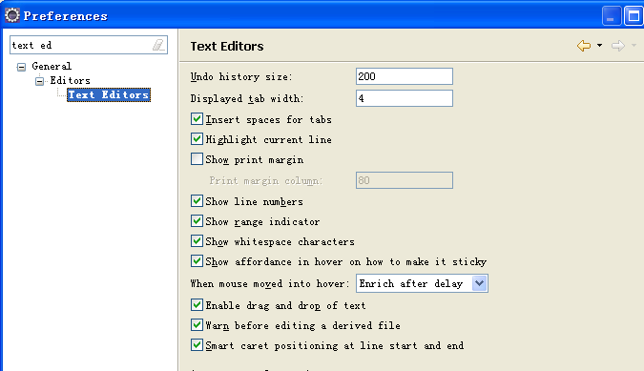

- Character encoding
Input “encoding” to search the configurations, set the encoding to UTF-8 for “Workspace”, “CSS Files”, “HTML Files”, “JSP Files” and “XML Files”.
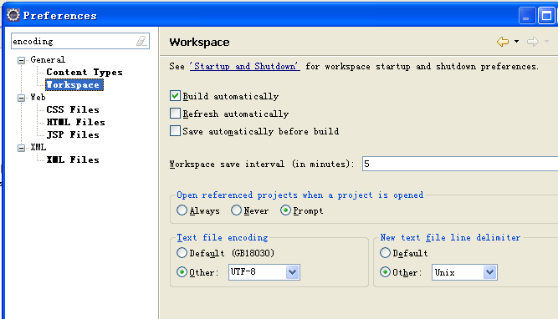
- Code format
Input “formatter” to search the configurations, select “Formatter” under Java-->Code Style. Click “New...” to new a profile. Input profile name “Training Project”. The new profile will be used to format code after you customize the code style settings.
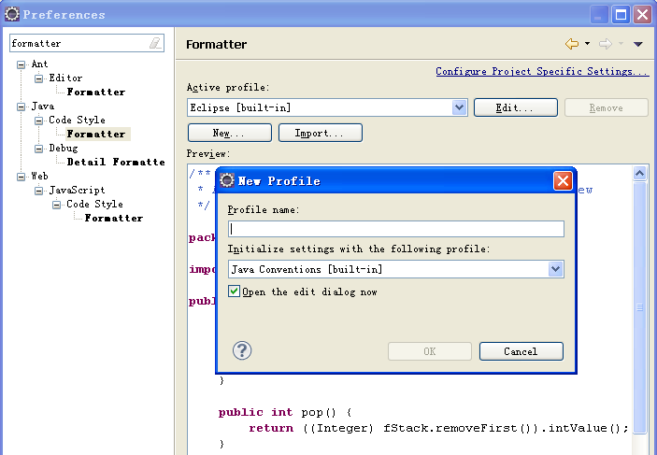

Select “Indentation” tab and select “Spaces only” for “Tab policy”.
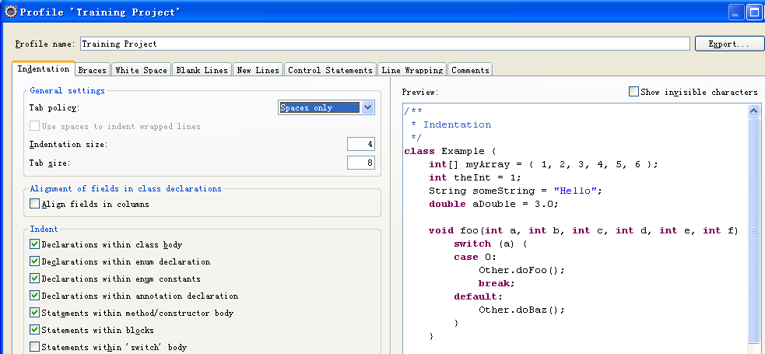
Select “Line wrapping” tab and set “Maximum line width” to 100.
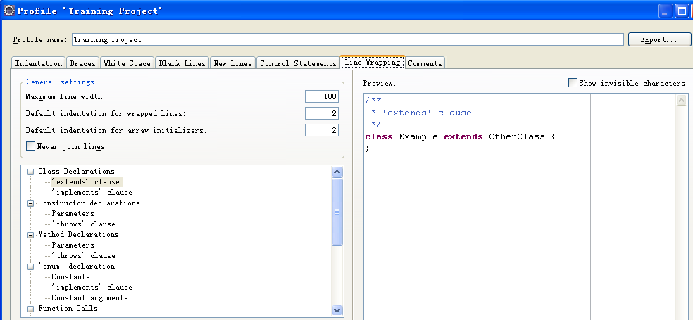

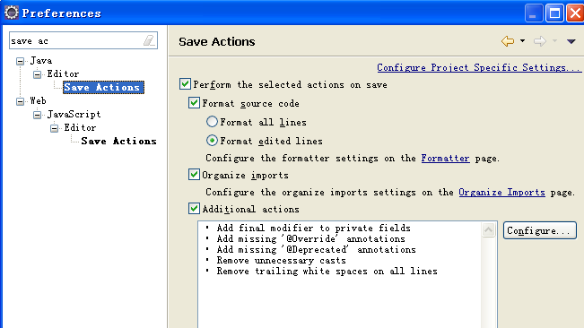
Input “save ac” to search the configurations, select “Save Actions” under Java-->Editor. Check “Perform the selected actions on save”, “Format source code”, “Format edited lines”, “Organize imports” and “Additional actions”.

Click “Configure...”, select “Code Organizing” tab and check “Remove trailing whitespace”. Select “Code Style” tab and uncheck “Use modifier ‘final’ where possible”.
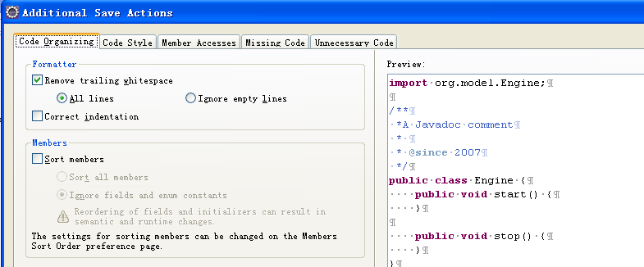
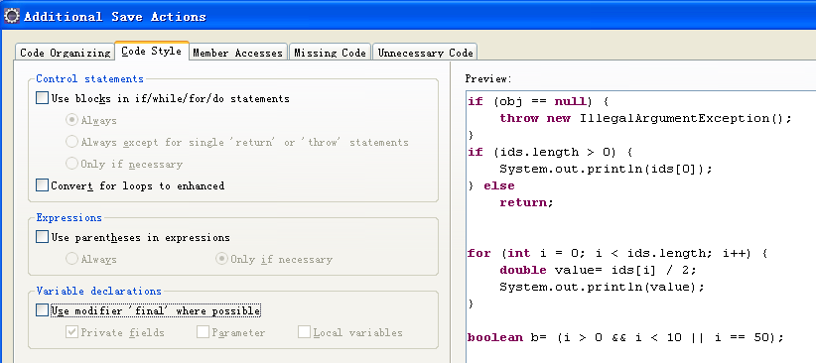

Click “OK” to save all the configurations above.

