Lucene
Document of the simple introduce
- The step of lucene
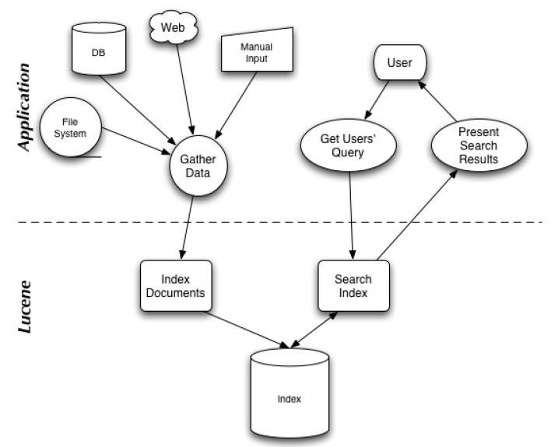
- The data store.

The processing mechanism of Lucene.

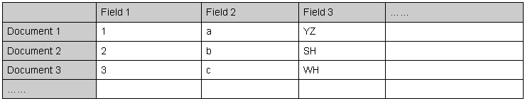
- Field is a field of data, It has three attributes. Name,Index and Store.
- Document is a data row.
- Analysis is use for falling a string to words by rules.
- Term is the smallest object of searching. Be make up by its words and the field that has the words.

- Classes
The lucene has one jar:
lucene-core-3.0.3.jar
org.apache.lucene
org.apache.lucene.analysis
org.apache.lucene.analysis.standard
org.apache.lucene.document
org.apache.lucene.index
org.apache.lucene.queryParser
org.apache.lucene.search
org.apache.lucene.search.function
org.apache.lucene.search.payloads
org.apache.lucene.search.spans
org.apache.lucene.store
org.apache.lucene.util

- API of handling index
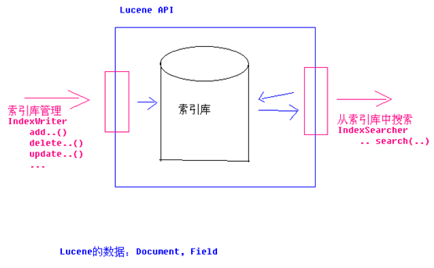
- Search
  - TermQuery
If the field contain some thing.
Term t = new Term(“content”,”java”);
Query query = new TermQuery(t);
  - BooleanQuery
If the field contain both or either some thing.
TermQuery t1 = new TermQuery(new Term(“content”,”java”));
TermQuery t2 = new TermQuery(new Term(“content”,”.net”));
BooleanQuery bq = new BooleanQuery();
bq.add(t1,BooleanClause.Occur.SHOULD);
bq.add(t2,BooleanClause.Occur.SHOULD);
It says that if the content have either java or .net.
  - WildcardQuery
The search string can have *[more words] ?[one word]
Query query = new WildcardQuery(new Term(“content”,”java*”));
It says that the content can is java book or java language an so no.
  - PhraseQuery
The search can have some words and define the limits.
PhraseQuery query = new PhraseQuery();
query.setSlop(5);
query.add(new Term(“content”,”java”));
query.add(new Term(“content”,”.net”));
It says that the content have java and .net on 5 words between them.
Java is a good software language,but .net is not. Is not in the result.
Java and .net both the good software langauge. is in the result.
  - PrefixQuery
The search can have beginning with some words.
PrefixQuery query = new PrefixQuery(new Term(“content”,”java”));
It says that the content is beginning with java.
  - FuzzyQuery
The search can hava some word is like some key word.
Query query = new FuzzyQuery(new Term(“content”,”jaua”));
It says that you may be can get result that content has both with java or jana
  - RangeQuery
Get result that between some limits.
Term tstart = new Term(“time”,”20120101”);
Term tend = new Term(“time”,”20120201”);
RangeQuery query = new RangeQuery(tstart,tend,true);
It says that the result's time between [20120101,20120201];
The true says that the limit is “[...]”.
  - QueryParser
It is use some key words relizes the other Query.

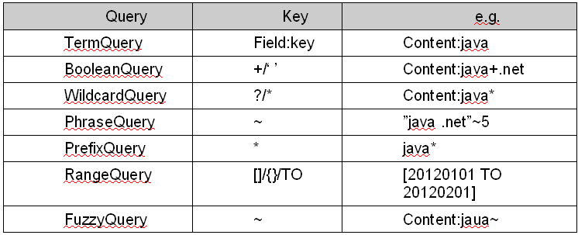
The demo is use this Query.
The code can see in the next Read and get the index.

- Filter & Sort
Search on the resultSet.
Sort on the resultSet.
Directory dir = FSDirectory.getDirectory(PATH);
IndexSearcher is = new IndexSearch(dir);
QueryParser parser = new QueryParser(“content”,new StandardAnalyzer());
Query query = parser.parse(“content:java+.net”);
//Query query = parser.parse(“+(content:java engineer:dev)+time[20120101 TO 20120202]”);
RangeFilter filter = new RangeFilter(“time”,”20120101”,”20120201”,true,true);
Sort sort = new Sort(“time”);
//Sort sort = new Sort(“time”,true);
Hits hits = is.search(query,filter,sort);
Ture says that the sort is DESC.

- Through the RAMDirectory catch writing improve performance
Directory dir = FSDirectory.getDirectory(PATH);
Directory ramDir = new RAMDirectory(dir);
Searcher searcher = new IndexSeacher(ramDir);

Document of why are we use lucene

- 为什么使用Lucene
- 索引文件格式独立于应用平台。Lucene定义了一套以8位字节为基础的索引文件格式，使得兼容系统或者不同 平台的应用能够共享建立的索引文件。
- 在传统全文检索引擎的倒排索引的基础上，实现了分块索引，能够针对新的文件建立小文件索引，提升索引速度。然后通过与原有索引的合并，达到优化的目的。
- 优秀的面向对象的系统架构，使得对于Lucene扩展的学习难度降低，方便扩充新功能。
- 设计了独立于语言和文件格式的文本分析接口，索引器通过接受Token流完成索引文件的创立，用户扩展新的语言和文件格式，只需要实现文本分析的接口。
- 已经默认实现了一套强大的查询引擎，用户无需自己编写代码即使系统可获得强大的查询能力，Lucene的查询实现中默认实现了布尔操作、模糊查询（Fuzzy Search）、分组查询等等。

Document of requirement about lucene

- The image of UI

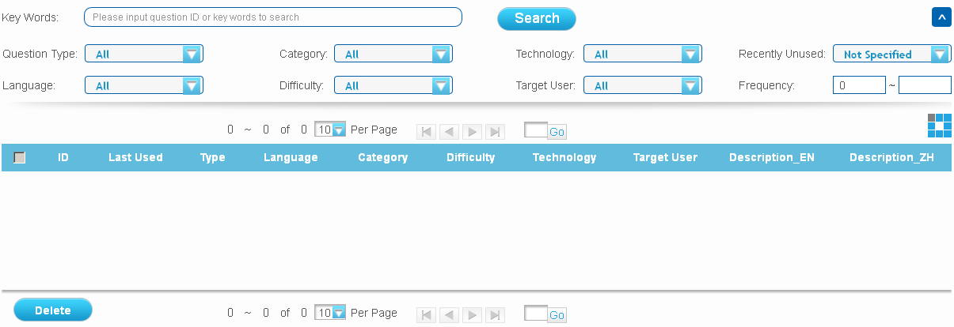
- Functions on the image
- Search by keywords and fileds,keywords are 'should' and fields are 'must'.
- Delete the documents,have select all and select some of them.
- Be paging.
- Sort by a field(Date).
- Create question or paper.

- Other functions
- Create index
- Update index
- Delete index

Document of the simple use

- Write and index.
Source is dealing after analyzer processing first, including: word segmentation, into a words: remove stopword.
Put source information into the fields of the true document, and index the field that need to be indexed, store the field that need to be stored.
Index written to the memory, the memory can be memory or disk.
Demo code is:
public static void addIndex(ResultSet rs)
throws SQLException, CorruptIndexException, IOException{
/* Instantiation a standard parsers
*/
Analyzer luceneAnalyzer
= new StandardAnalyzer();
/* Instantiate the output stream,
* true to create new all,
* false to not create.
*/
IndexWriter indexWriter
= new IndexWriter(INDEX_PATH, luceneAnalyzer, true);
/* Meaning is generating compound file,
* if establish for false,
* the index files in directory:
* .tis .tii .prx and so on,
* if set to true,
* these files will be into one file.
*/
indexWriter.setUseCompoundFile(false);
while(rs.next()){
/*
* The object of file.
*/
Document document = new Document();
/*
* Do not need index.
*/
Field qname = new Field("qname",
rs.getString("q_name"),
Field.Store.YES,
Field.Index.NO);
Field pname = new Field("pname",
rs.getString("p_name"),
Field.Store.YES,
Field.Index.NO);
/*
* Need index.
*/
Field content = new Field("content",
rs.getString("p_content")+" "+rs.getString("q_content"),
Field.Store.YES,Field.Index.TOKENIZED);
/*
* The index field added to a document.
*/
document.add(qname);
document.add(pname);
document.add(content);
/*
* Put line of information into the output stream
*/
indexWriter.addDocument(document);
}
/*
* Commit to write on the hard drive.
*/
indexWriter.optimize();
/*
* Close the output stream.
*/
indexWriter.close();

}

- Read and get the index.
The use give some key word, the Lucene get the document(s), use can get the field(s) from them.
The code is:
try {
/*
* Get the index form the path.
*/
Directory dir = FSDirectory.getDirectory(INDEX_PATH);
/*
* Put index into output stream.
*/
IndexSearcher is = new IndexSearcher(dir);
/*
* Set the search field.
* And define the true analyzer.
*/
QueryParser parser = new QueryParser("content", new StandardAnalyzer());
/*
* Put in the searching string.
*/
Query query = parser.parse("面向*");
/*
* Get the resultSet.
*/
Hits hits = is.search(query);
/*
* Iterator the reslutSet.
* And put out.
*/
for (int i = 0; i < hits.length(); i++) {
Document doc = hits.doc(i);
System.out.println(doc.get("qname") + "///"
+ doc.get("pname") + "///"
+ doc.get("content"));
}
/*
* Close the output stream.
*/
is.close();
} catch (Exception e) {
e.printStackTrace();
}

- Delete the documents
public static void deleteIndex(String[] listStr) {
try {
Directory dir = FSDirectory.getDirectory(INDEX_PATH);
IndexReader ir = IndexReader.open(dir);
for (int i = 0; i < listStr.length; i++) {
ir.deleteDocuments(new Term("id", listStr[i]));
}
ir.close();
} catch (IOException e) {
e.printStackTrace();
}
}

- Update the document
public static void updateIndex(ResultSet rs) {
try {
IndexWriter indexWriter = new IndexWriter(INDEX_PATH,new StandardAnalyzer(),false);
indexWriter.setUseCompoundFile(false);
while (rs.next()) {
Term term = new Term("id", rs.getString(1));
Document document = new Document();
Field id = new Field("id",
rs.getString(1),
Field.Store.YES,
Field.Index.TOKENIZED);
Field qname = new Field("qname",
rs.getString("q_name"),
Field.Store.YES,
Field.Index.NO);
Field pname = new Field("pname",
rs.getString("p_name"),
Field.Store.YES,
Field.Index.NO);
Field type = new Field("type",
rs.getString("q_type"),
Field.Store.YES,
Field.Index.TOKENIZED);
Field content = new Field("content",
rs.getString("p_content")+" "+rs.getString("q_content"),
Field.Store.YES,Field.Index.TOKENIZED);
document.add(id);
document.add(type);
document.add(qname);
document.add(pname);
document.add(content);
/*
调用updateDocument的方法，传给它一个新的doc来更新数据，
Term term = new Term("id","1234567");
先去索引文件里查找id为1234567的Doc,如果有就更新它(如果有多条，最后更新后只有一条)。如果没有就新
数据库更新的时候，我们可以只针对某个列来更新，而lucene只能针对一行数据更新。
*/
indexWriter.updateDocument(term, document);
}
indexWriter.close();
} catch (CorruptIndexException e) {
e.printStackTrace();
} catch (LockObtainFailedException e) {
e.printStackTrace();
} catch (IOException e) {
e.printStackTrace();
} catch (SQLException e) {
e.printStackTrace();
}
}

- Add a document
public static void createIndex(ResultSet rs)throws SQLException, CorruptIndexException, IOException{
Analyzer luceneAnalyzer = new StandardAnalyzer();
IndexWriter indexWriter = new IndexWriter(INDEX_PATH, luceneAnalyzer, false);
indexWriter.setUseCompoundFile(false);
if (rs.next()) {
Document document = new Document();
Field id = new Field("id",
rs.getString(1),
Field.Store.YES,
Field.Index.TOKENIZED);
Field qname = new Field("qname",
rs.getString("q_name"),
Field.Store.YES,
Field.Index.NO);
Field pname = new Field("pname",
rs.getString("p_name"),
Field.Store.YES,
Field.Index.NO);
Field type = new Field("type",
rs.getString("q_type"),
Field.Store.YES,
Field.Index.TOKENIZED);
Field content = new Field("content",
rs.getString("p_content")+" "+rs.getString("q_content"),
Field.Store.YES,Field.Index.TOKENIZED);
document.add(id);
document.add(type);
document.add(qname);
document.add(pname);
document.add(content);
indexWriter.addDocument(document);
}
indexWriter.optimize();
indexWriter.close();
}

- Paging the index.
public static List<Map<String, String>> processHits(Hits hits,int startIndex,int endIndex) throws Exception {
List<Map<String, String>> docs = new ArrayList<Map<String, String>>();
for (int i = startIndex;i < endIndex;i++) {
Document doc = hits.doc(i);
Map<String, String> docMap = new HashMap<String, String>();
docMap.put("id",doc.getField("id").stringValue());
docMap.put("qname",doc.getField("qname").stringValue());
docMap.put("pname",doc.getField("pname").stringValue());
docMap.put("content",doc.getField("content").stringValue());
docMap.put("type",doc.getField("type").stringValue());
docs.add(docMap);
}
return docs;
}

