Title of the Document

Luke Introduction and Application

Author: Hector.He
Last Updated:07/12/12

Document History
Date | Author | Summary of Change | Note
07月9日12年 | Hector.He | Initial version
<Table of Contents>

Luke introduction
1. What is Luke?
Luke is a third-party tools for Lucene search engine to facilitate the development and diagnostics, it can access the existing Lucene indexes and allows you to display and modify.

2. How to use Luke

1. open lukeall-3.5.0.jar.
2. chose index path
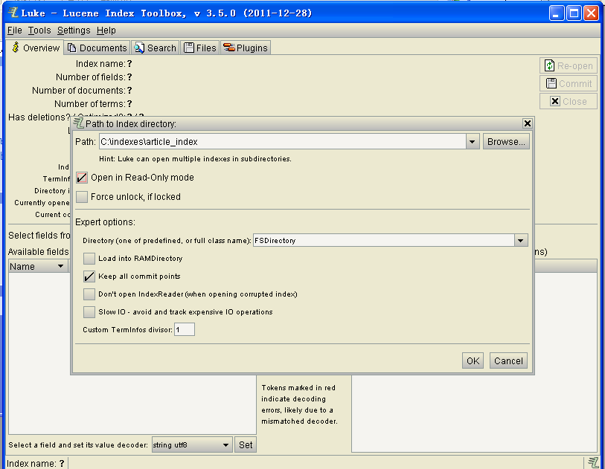

- Overview page
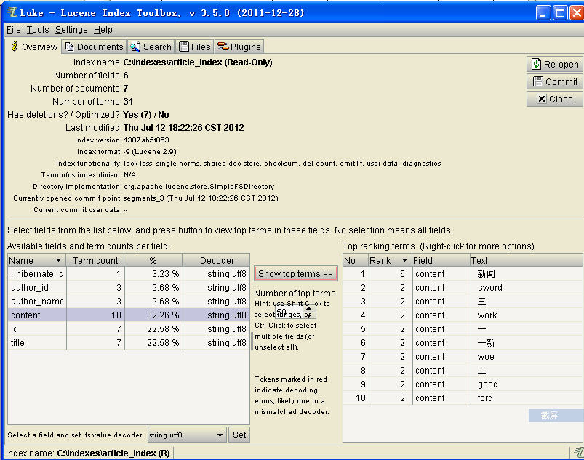
at this page, we can view index basic information. When we select a field, we could view this field's terms.

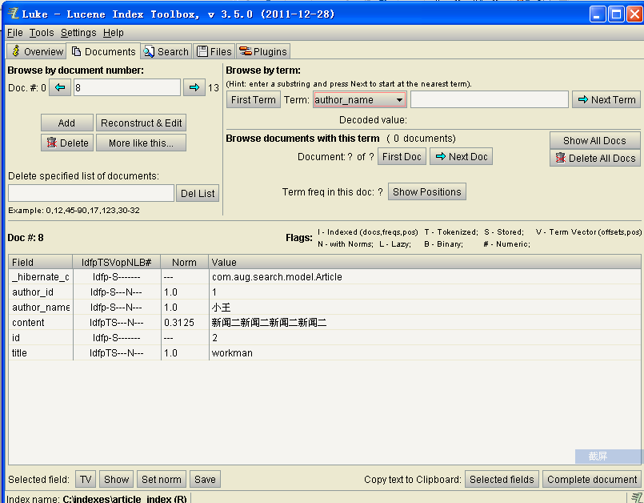
- Documents page

At this page, we could view a document by document number or a term.

- Search page
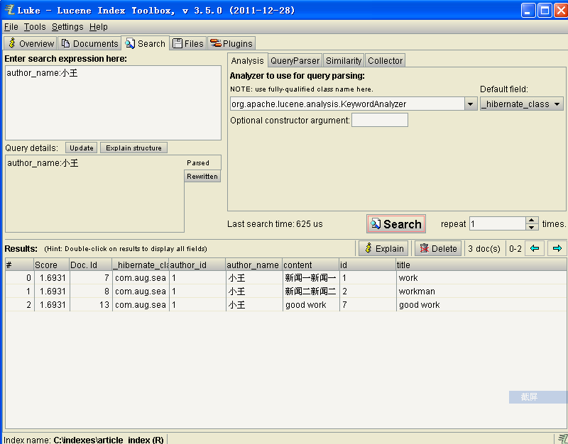
- Files page
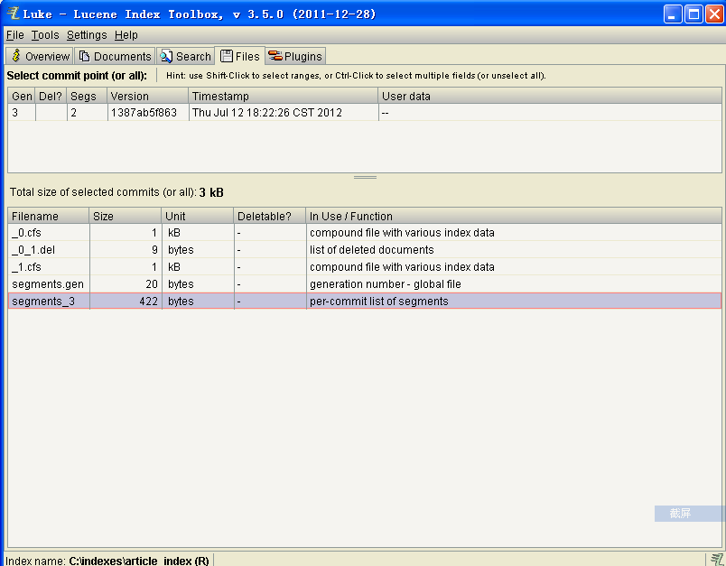
7. Plugins

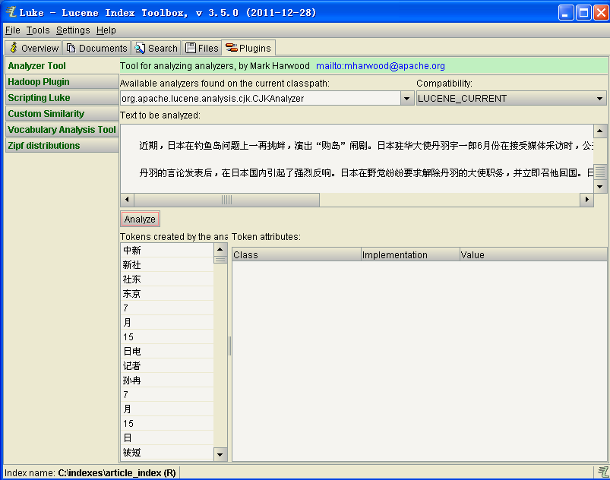
at this page, we select a analyzer. We could view the word segmentation effect by analyzer.

