AMS CAS Integration

Version History
Document Version | Author | Changes | Date
1 | Peter Li | Initial Version | 09/13/2013
2 | Peter Li | Add Explanation about web.xml | 09/16/2013

Table of Contents

1 Introduction 2
1.1 summary 2
1.2 reader 2
1.3 keywords 2
2 Preparation 2
2.1 download certificate 2
3 Integration 3
3.1 Step 1 3
3.2 Step 2 3
3.3 Step 3 3
3.4 Step 4 4
4 Accomplishing 7

1 Introduction

1.1 summary
When you first use AMS(Asset Management System), you need to take it and CAS(Central Authentication Service) integration. As a developer, you should know that our internal project should be related to CAS Server in EP(Employee Portal). And this document will tell you how to integrate AMS with CAS.

1.2 reader
Technical team

1.3 keywords

CAS

2 Preparation

2.1 download certificate
URL: \\192.168.1.19\Development\InternalApp\IAP\For APP\CAS\iapstaging.cer

3 Integration

3.1 Step 1
Put the certificate that you download from Server on any path.
Cmd order: keytool -import -keystore C:\Program Files\Java\jdk1.6.0_18\jre\lib\security\cacerts -file c:\keys\iapstaging.cer -alias iapstaging

The “C:\Program Files\Java\jdk1.6.0_18\” is JDK's installation path. The “c:\keys\iapstaging.cer ” is certificate's path. As the following picture show:

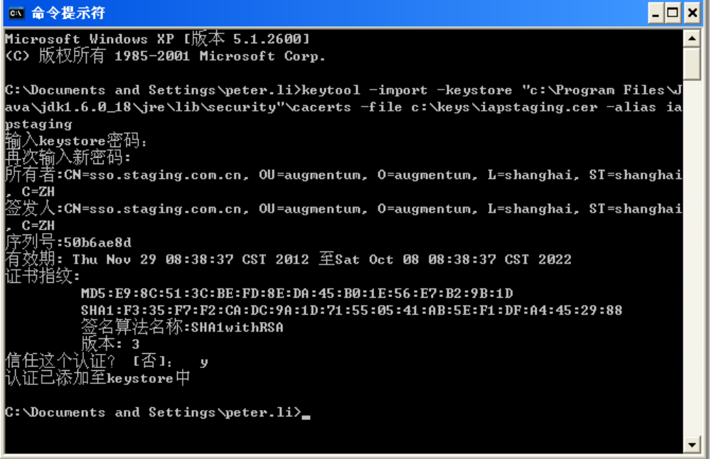

3.2 Step 2
If your environment is used for test, you should append “192.168.4.49 sso.staging.com.cn” to the file “c:/windows/system32/drivers/etc/hosts”, use “sso.staging.com.cn” as IAP domain name. Because the domain name “sso.staging.com.cn” is not registered. But if the application is already registered, you need not to change your hosts.

3.3 Step 3
Create a new filter class in AMS(This is not a must.), Its role is to detect the user login. A example filter class is:

package com.augmentum.ams.filter;

import java.io.IOException;
import javax.servlet.Filter;
import javax.servlet.FilterChain;
import javax.servlet.FilterConfig;
import javax.servlet.ServletException;
import javax.servlet.ServletRequest;
import javax.servlet.ServletResponse;
import javax.servlet.http.HttpServletRequest;
import javax.servlet.http.HttpSession;

import org.jasig.cas.client.validation.Assertion;

public class AutoSetUserAdapterFilter implements Filter {
private static final long serialVersionUID = 1L;

/** * Default constructor. */
public AutoSetUserAdapterFilter() {
}

/** * @see Filter#destroy() */
public void destroy() {
}

/**
* Filter#doFilter(ServletRequest, ServletResponse, FilterChain)
*/
public void doFilter(ServletRequest request, ServletResponse response,
FilterChain chain) throws IOException, ServletException {
HttpServletRequest httpRequest = (HttpServletRequest) request;
HttpSession session = httpRequest.getSession();
session.setAttribute("loginName", "berton.wu");
Object object = httpRequest.getSession().getAttribute("_const_cas_assertion_");
if (object != null) {
Assertion assertion = (Assertion) object;
String loginName = assertion.getPrincipal().getName();
System.out.println("The current logged in user��" + loginName);
session.setAttribute("loginName", loginName);
}
chain.doFilter(request, response);
}

@Override
public void init(FilterConfig arg0) throws ServletException {

}
}

3.4 Step 4
Now you should configure your web.xml. First, add the configuration about CAS:

<!-- Begin configure CAS →

<filter>
<filter-name>CAS Authentication Filter</filter-name>

<!--
if(url don't have ticket && session don't have the assertion made by TicketValidationFilter){
response.sendRedirect(cas server/login interface);// To generate the service parameter, added to the URL.
}
else{
do nothing
}
-->
<filter-class>com.augmentum.iaphelper.filter.AuthenticationFilter</filter-class>
<init-param>
<param-name>casServerLoginUrl</param-name>
<!--
The value of the casServerLoginUrl parameter is the CAS server login interface value. Application of web in CAS client redirect to the CAS server in the certification of the time, redirect URL is casServerLoginUrl, because redirect is the browser, so the machine you want to configure the CAS server name.
-->
<param-value>https://sso.staging.com.cn:8443/cas/login</param-value>
</init-param>
<init-param>
<param-name>serverName</param-name>
<!--
serverName parameters, CAS client will be used to generate the service parameter, and the CAS server in the ticket certification through, after verification, redirect to web application, redirect URL is the value of the service parameter. The serverName parameter can be the IP, can also be a domain name, as long as the guarantee that the browser can access to it.
-->
<param-value>http://192.168.22.66:8080</param-value>
</init-param>
</filter>

<filter>
<filter-name>CAS Validation Filter</filter-name>
<!--
if(url have ticket){
use httpclient to visit cas Server/serviceValidate interface to validate ticket, If the validation fails, display the error page, verify the success, generating user identification assertion
}
else{
do nothing
}
-->
<filter-class>org.jasig.cas.client.validation.Cas20ProxyReceivingTicketValidationFilter</filter-class>
<init-param>
<param-name>casServerUrlPrefix</param-name>
<!--
The value of the casServerUrlPrefix parameter is the CAS service access. When CAS client ticket authentication, the /serviceValidate interface to access the CAS service, the use of URL is ${casServerUrlPrefix}serviceValidate A., because the client web application to verify that the CAS certificate, the certificate the value of the CN field must be set and casServerUrlPrefix CAS server domain name remain the same, and configuring the CAS service on Web application server. Access domain.
-->
<param-value>https://sso.staging.com.cn:8443/cas</param-value>
</init-param>
<init-param>
<param-name>redirectAfterValidation</param-name>
<param-value>true</param-value>
</init-param>
<init-param>
<param-name>exceptionOnValidationFailure</param-name>
<param-value>false</param-value>
</init-param>
<init-param>
<param-name>serverName</param-name>
<param-value>http://192.168.22.66:8080</param-value>
</init-param>
<init-param>
<param-name>acceptAnyProxy</param-name>
<param-value>true</param-value>
</init-param>
<init-param>
<param-name>proxyCallbackUrl</param-name>
<!--
sso.democlient.com is your CN in your keyStore if you are not server
please use your IP, and use http, example :
http://192.168.251.44:8080/DemoAPP/proxyCallback
-->

<param-value>http://192.168.22.66:8080/AssetManagement/proxyCallback</param-value>
</init-param>
<init-param>
<param-name>proxyReceptorUrl</param-name>
<param-value>/proxyCallback</param-value>
</init-param>
</filter>

<filter>
<filter-name>CAS HttpServletRequest Wrapper Filter</filter-name>
<filter-class>org.jasig.cas.client.util.HttpServletRequestWrapperFilter</filter-class>
</filter>

<filter>
<filter-name>CAS Assertion Thread LocalFilter</filter-name>
<filter-class>org.jasig.cas.client.util.AssertionThreadLocalFilter</filter-class>
</filter>

<filter>
<filter-name>CAS Single Sign Out Filter</filter-name>
<filter-class>org.jasig.cas.client.session.SingleSignOutFilter</filter-class>
</filter>

<filter-mapping>
<filter-name>CAS Single Sign Out Filter</filter-name>
<url-pattern>/*</url-pattern>
</filter-mapping>

<filter-mapping>
<filter-name>CAS Validation Filter</filter-name>
<url-pattern>/proxyCallback</url-pattern>
</filter-mapping>

<filter-mapping>
<filter-name>CAS Authentication Filter</filter-name>
<url-pattern>/*</url-pattern>
</filter-mapping>

<filter-mapping>
<filter-name>CAS Validation Filter</filter-name>
<url-pattern>/*</url-pattern>
</filter-mapping>

<filter-mapping>
<filter-name>CAS HttpServletRequest Wrapper Filter</filter-name>
<url-pattern>/*</url-pattern>
</filter-mapping>

<filter-mapping>
<filter-name>CAS Assertion Thread LocalFilter</filter-name>
<url-pattern>/*</url-pattern>
</filter-mapping>

<listener>
<listener-class>org.jasig.cas.client.session.SingleSignOutHttpSessionListener</listener-class>
</listener>
<listener>
<listener-class>com.augmentum.iaphelper.listener.HeartBeatCheckListener</listener-class>
</listener>

<!-- End Configure CAS -->

Then, add the configuration about your filter:

<filter>
<display-name>AutoSetUserAdapterFilter</display-name>
<filter-name>AutoSetUserAdapterFilter</filter-name>
<filter-class>com.augmentum.ams.filter.AutoSetUserAdapterFilter</filter-class>
</filter>
<filter-mapping>
<filter-name>AutoSetUserAdapterFilter</filter-name>
<url-pattern>/*</url-pattern>
</filter-mapping>

4 Accomplishing
Start your server and let AMS runing. Visit AMS and if you have not login before, the page will be that:

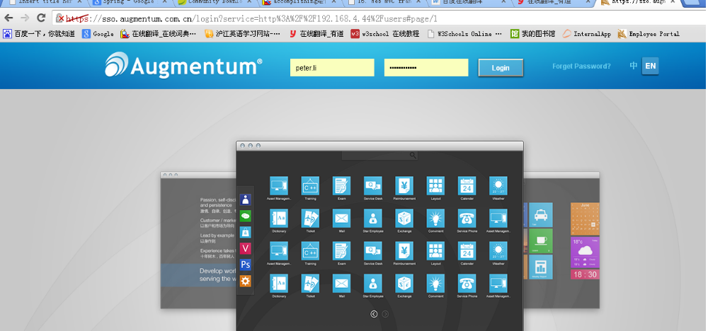

If you can login and jump to AMS, it means that you have integrated AMS with CAS. Congratulations !

