ImageNet Classification with Deep Convolutional Neural Networks

Abstract

The neural network, which has 60 million parameters and 650,000 neurons, consists of five convolutional layers, some of which are followed by max-pooling layers, and three fully-connected layers with a final 1000-way softmax. To make training faster, we used non-saturating neurons and a very efficient GPU implementation of the convolution operation. To reduce overfitting in the fully-connected layers we employed a recently-developed regularization method called “dropout” that proved to be very effective.

1 Introduction

2 The Dataset

3 The Architecture

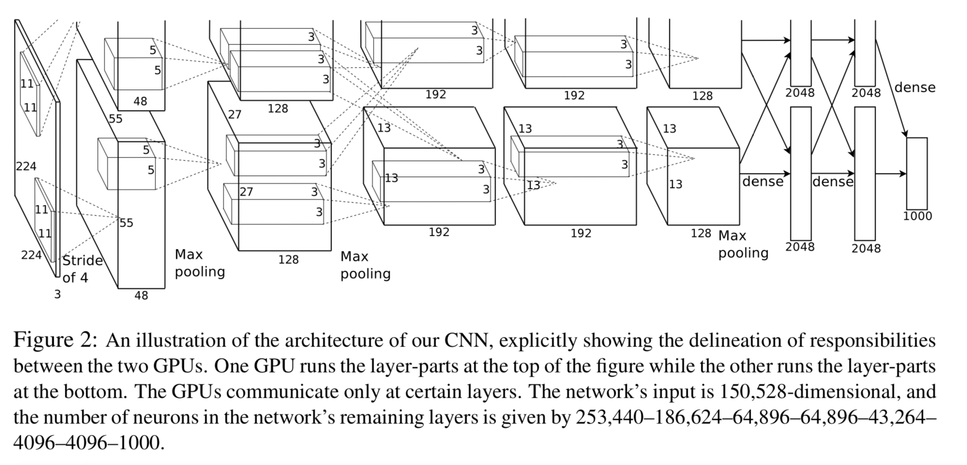

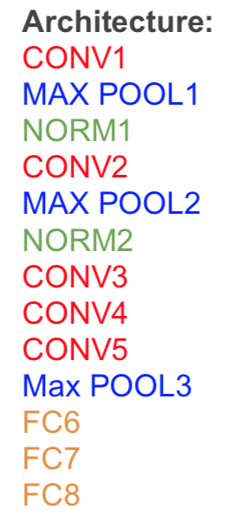

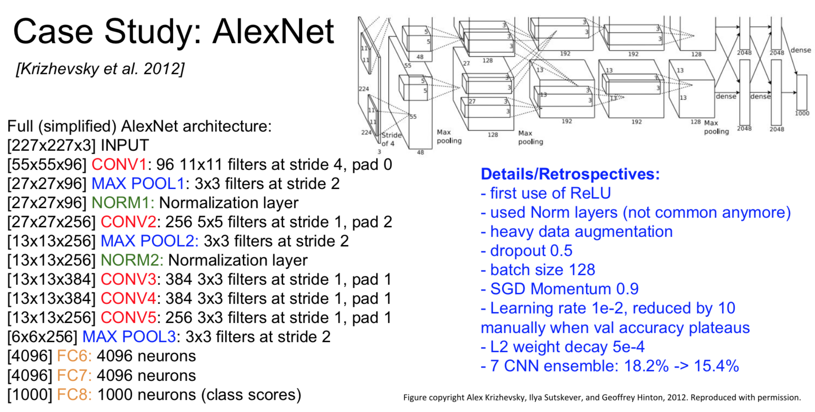

3.1 ReLU Nonlinearity

Deep convolutional neural net- works with ReLUs train several times faster than their equivalents with tanh units.

Faster learning has a great influence on the performance of large models trained on large datasets.

3.2 Training on Multiple GPUs

3.3 Local Response Normalization

3.4 Overlapping Pooling

Pooling layers in CNNs summarize the outputs of neighboring groups of neurons in the same kernel map.

3.5 Overall Architecture

The first convolutional layer filters the 224 × 224 × 3 input image with 96 kernels of size 11 × 11 × 3 with a stride of 4 pixels (this is the distance between the receptive field centers of neighboring neurons in a kernel map). The second convolutional layer takes as input the (response-normalized and pooled) output of the first convolutional layer and filters it with 256 kernels of size 5 × 5 × 48. The third, fourth, and fifth convolutional layers are connected to one another without any intervening pooling or normalization layers. The third convolutional layer has 384 kernels of size 3 × 3 × 256 connected to the (normalized, pooled) outputs of the second convolutional layer. The fourth convolutional layer has 384 kernels of size 3 × 3 × 192 , and the fifth convolutional layer has 256 kernels of size 3 × 3 × 192. The fully-connected layers have 4096 neurons each.

4 Reducing Overfitting

4.1 Data Augmentation

The easiest and most common method to reduce overfitting on image data is to artificially enlarge the dataset using label-preserving transformations.

The first form of data augmentation consists of generating image translations and horizontal reflections.

The second form of data augmentation consists of altering the intensities of the RGB channels in training images.

4.2 Dropout

The recently-introduced technique, called “dropout” [10], consists of setting to zero the output of each hidden neuron with probability 0.5. The neurons which are “dropped out” in this way do not contribute to the forward pass and do not participate in back- propagation.

5 Details of learning

We trained our models using stochastic gradient descent with a batch size of 128 examples, momentum of 0.9, and weight decay of 0.0005.

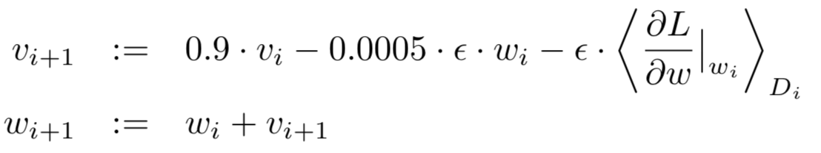

6 Results

7 Discussion