CQARank: Jointly Model Topics and Expertise in Community Question Answering

1. INTRODUCTION

(1) Poor expertise matching (2) Low-quality answers (3) Under-utilized archived questions

Our Contributions

First, to the best of our knowledge, we propose the first extensive study to jointly model topics and expertise.

Secondly, we achieve better understanding of both user topical interest and expertise by leveraging tagging and voting information.

2. METHOD OVERVIEW

User: We use user to refer to the askers and answerers in CQA.

Topical Interest: We use Topical Interest to refer to user preference for specific topics in CQA.

Topical Expertise: We use Topical Expertise to refer to their level of expertise on specific topics in CQA.

Q&A Graph: We use Q&A Graph to refer to the network based on user posting behavior in CQA.

3. TOPIC EXPERTISE MODEL

3.1 Model

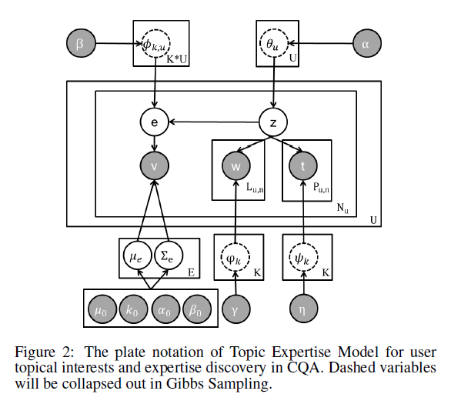

3.2 Learning and Parameter Estimation

4. CQARANK FOR TOPICAL EXPERTISE MEASURE

5. EXPERIMENTS

5.1 Data Set and Experiment Settings

5.2 TEM Results

5.2.1 Topic Analysis

5.2.2 Expertise Analysis

5.3 Recommendation for New Questions

5.3.1 Recommend Expert Users

Task: Given a question q and a set of test users U, the target is to rank all these users by their interests and expertise to answer the question q.

Baselines:

Evaluation Criteria:

Results:

5.3.2 Recommend Answers

Task: For a given question q and a set of answers A, each method needs to rank all the answers in A. Similar to expert ranking task, we score each answer by considering its similarity to the question and the expertise of the answerer.

Baselines:

Evaluation Criteria:

Results:

5.3.3 Recommend Similar Questions

Task: We observe that in CQA forum, when a user asks a new question (referred as query question hereafter), the user will often get replies from other users who provide links to other similar questions.

Baselines:

Evaluation Criteria:

Results:

5.4 Parameter Sensitivity Analysis

6. RELATED WORK.

7. CONCLUSION AND FUTURE WORK