MTNA: A Neural Multi-task Model for Aspect Category Classification

and Aspect Term Extraction On Restaurant Reviews

1 Introduction

In this paper, we consider ACC and ATE task together under a multi-task setting.

2 Model

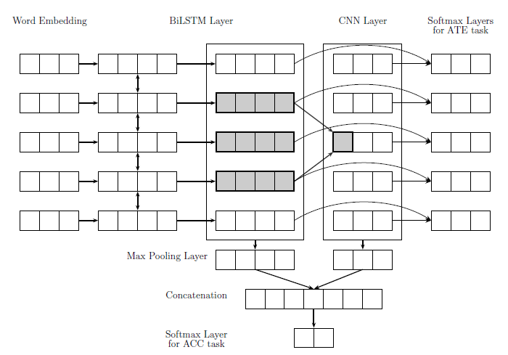

2.1 The Multi-task Learning Model

We combine BiLSTM for ATE and CNN for ACC together in a multi-task framework. The parts for ACC task can utilize extra information learned in ATE task so that convolutional layers can focus on informative features. The tag prediction at each word in ATE task can also receive the distilled n-gram features of the surrounding words via convolutional operations.

3 Experiments

3.1 Datasets

3.2 Experiment Setup

3.3 Compared methods

4 Results and Analysis

5 Related Work

6 Conclusion

We introduce two important tasks, e.g., aspect category classification and aspect term extraction in aspect based sentiment analysis. We propose a multi-task learning model based on recurrent neural networks and convolutional neural networks to solve the two tasks at the same time.