Targeted Aspect-Based Sentiment Analysis via Embedding

Commonsense Knowledge into an Attentive LSTM

Introduction

In recent years, sentiment analysis has become increasingly popular for processing social media data on online communities, blogs, wikis, microblogging platforms, and other online collaborative media.

Hence, aspect-based sentiment analysis (ABSA) extends the typical setting of sentiment analysis with a more realistic assumption that polarity is associated with specific aspects (or product features) rather than the whole text unit. For example, in the sentence “The design of the space is good but the service is horrible”, the sentiment expressed towards the two aspects (“space” and “service”) is completely opposite. Through aggregating sentiment analysis with aspects, ABSA allows the model to produce a fine-grained understanding of people’s opinion towards a particular product.

In particular, our contribution is three-fold:

1. We propose a hierarchical attention model that explicitly attends to first the targets and then the whole sentence;

2. We extend the classic LSTM cell with components accounting for integration with external knowledge;

3. We incorporate affective commonsense knowledge into a deep neural network

Related Work

Aspect-Based Sentiment Analysis

Targeted Sentiment Analysis

Targeted Aspect-Based Sentiment Analysis

Incorporating External Knowledge

Methodology

Task Definition

The task of targeted ABSA can be divided into two subtasks. Firstly, it resolves the aspect categories of *t* belonging to a predefined set. Secondly, it classifies the sentiment polarity with respect to each aspect category associated with *t*.

Overview

Our neural architecture consists of two components: the sequence encoder and a hierarchical attention component.

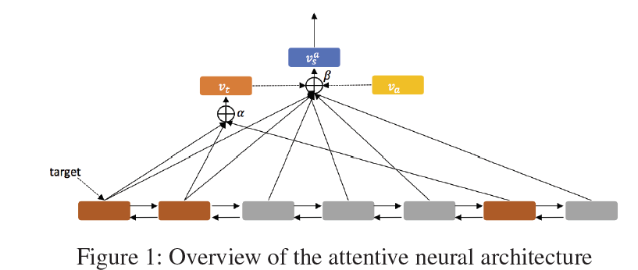

Long Short-Term Memory Network

A typical LSTM cell contains three gates: forget gate, input gate and output gate. These gates determine the information to flow in and flow out at the current time step. The mathematical representations of the cell are as follows: 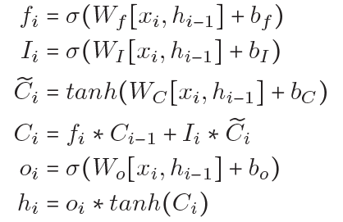

Target-Level Attention

Based on the attention mechanism, we calculate an attention vector for a target expression.

Sentence-Level Attention Model

Commonsense Knowledge

In order to improve the accuracy of sentiment classification, we use commonsense knowledge as our knowledge source to be embedded into the sequence encoder.

Sentic LSTM

Prediction and Parameter Learning

The objective to train our classier is defined as minimizing the sum of the cross-entropy losses of prediction on each target-aspect pair.

Experiments

Dataset and Resources

Experiment Setting

We evaluate our method on two sub-tasks of targeted ABSA: 1) aspect categorization and 2) aspect-based sentiment classification.

We evaluate our methods and baseline systems using both loose and strict metrics.

We report scores of three widely used evaluation metrics of multi-label classifier: Macro-F1,

Micro-F1, and strict Accuracy.

Performance Comparison

Results of Attention Model

Visualization of Attention

Conclusion