Engagement information
Entity name: | Summit Equipment
Date of financial statements: | 31 December 20X6
Engagement name: | Summit Equipment
EY Canvas data fresh as of: | N/A for this training

When and how to use this form
- Requirement for use: This form is optional for all complex audits, but supports meeting GAM requirements (non-complex audits can use the APT for documentation).
- How to use this form: Select the appropriate profiling options for the entity. In EY Canvas, create risk objects for each risk of material misstatement identified, document the financial statement/control implication and relate the risk to the relevant assertion(s). We import risks into this form to verify completeness.
Profiling questions: Select one option from each of the groups below if data is not being imported directly from EY Canvas.
Complexity:
Listed:
Group:
Audit type:
* Refers to audits conducted in the US under the auditing standards issued by the American Institute of Certified Public Accountants

Purpose
This form enables us to document our understanding of the business and assists in identifying risks of material misstatement in support of the requirements of the UTB topic.
We consider the effect of risks identified in making our combined risk assessments (refer to CRA) and in designing substantive procedures (refer to SUBSTANTIVE). In addition, we determine whether inherent risks that we identified in our understanding of the business are significant risks.

Applicable methodology
UTB highlights:
We exercise professional judgment in determining the extent of understanding the business that is required. Our primary consideration is whether we have obtained a sufficient understanding to identify and assess the risks of material misstatement (“RMM”) at the financial statement and assertion levels, whether due to fraud or error, and thereby providing a basis for designing and implementing audit procedures to respond to the assessed risks of material misstatement.
The following diagram illustrates what we understand and how this understanding of the business affects other parts of the audit. For further guidance, refer to UTB.
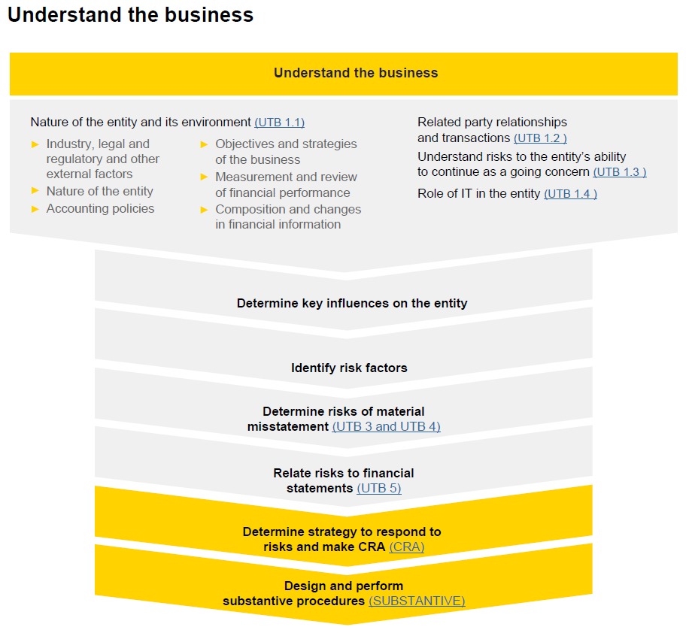
Laws and regulations, related party transactions and going concern considerations:
We document our understanding of the entity’s legal and regulatory framework, related party relationships and transactions and the risks to the entity’s ability to continue as a going concern in other relevant forms.
More information about the UTB form (UTB):
The UTB can be used in conjunction with our meeting(s) about the entity during the planning of the audit (e.g., team planning event). When we complete the UTB, we:
- Consider the use of available industry or sector knowledge (i.e., global or localized industry sector UTB and/or trend analysis)
- Customize the UTB to each audit
Recurring audits:
For recurring audits, we base our understanding of the business on prior period knowledge. We update our understanding by focusing on the significant changes in the entity and its environment in the current period and reflect those changes within the UTB brought forward from the prior period.

Conclusion:
x | We have obtained an understanding of the business sufficient to identify risks of material misstatement. Where risks have been identified, such risks have been documented in EY Canvas and incorporated into the audit plan. Additionally, the entity's accounting policies are appropriate for its business and consistent with the applicable financial reporting framework and accounting policies used in the industry in which it operates.
Additional remarks:
We sign off this form in EY Canvas to evidence the preparation, review and approval of this form at the Scope & Strategy phase of the audit as well as the completion of the following EY Canvas task:

- How to obtain our understanding (including sources of information)
We obtain an understanding of the entity and its environment by performing a combination of the following risk assessment procedures:
- Read relevant information
- Inquire of:
- Management and those responsible for financial reporting
- Appropriate individuals within the internal audit function
- Others in the entity who may have information that is likely to assist in identifying risks of material misstatement due to fraud or error
- Perform analytical procedures on financial and non-financial information
- Observation and inspection

In addition to these risk assessment procedures, we:
- Determine whether information obtained from our client and engagement acceptance and continuance procedures is relevant in identifying risk factors
- Determine whether the partner in charge of the audit has performed other engagements for the entity, including reviews of interim financial information, and if so, whether he or she considers that information obtained from those engagements is relevant in identifying risk factors
- Document the sources of information
As we document our responses below, we evidence how the above requirements have been met.

- Industry, legal and regulatory framework and other external factors
For further guidance, refer to UTB 1.1a and UTB Appendix 1.
Key market forces |  | Risk identification
General and industry/sector specific trends |  | RMM?
  Risks from EY Canvas
Summit Equipment (Summit) is a privately owned hiking and camping company that sells camp supplies, equipment and accessories. The main head office is located in Switzerland Zurich Europe. The Company is engaged in designing, marketing and retailing of clothing and equipment for outdoor, travel and adventure. It offers a range of apparels, including waterproof jackets, down jackets, thermals, fleece jackets, shirts and pants, merino apparel and thermals, and footwear and socks. It also offers equipment, including packs, bags, sleeping bags, tents, travel accessories and camping accessories. The Company's products are sold in North America, Europe and Asia. The company has reported a profit for the year amounting to around CHF 44 million (20XX: CHF 42 million).

Financial Data – The Company has a fiscal year-end of 31 December.

Competitive environment |  | RMM?
  Risks from EY Canvas
Summit’s top competitors are:

- On Top S.A.
- Mountain Co-Operative Equipment Ltd
- Higher and above Ltd

All the Companies are well established and have a good sound knowledge about the markets, products and its customers, hence creating a very competitive environment in terms of pricing and obtaining the larger customer base.
Customer information |  | RMM?
  Risks from EY Canvas
The principal customers of Summit from which they make most of the sales are from local customers.
The foreign customers are mainly from North America and Asia but all pay in local Swiss currency.
Supplier information |  | RMM?
  Risks from EY Canvas
Vendor relationships are good, with supplier price lists agreed at the start of each year and fixed for that period. As the lead times are long and the reliability and quality of the finished project is vital, Summit invests significant time in its relationships with key suppliers. Products are typically purchased from a relatively small number of specialist suppliers.
Technological developments |  | RMM?
  Risks from EY Canvas
In order for Summit to remain competitive it needs to constantly rethink the design of their major products. Summit has outsourced its research and development of its major products including tents, wires, bars, safety products etc. to Hiking Technologies Material Co which is also based in Switzerland.
Legal and regulatory framework
Refer to LAWS + REGS form.
Other external factors |  | Risk identification
In obtaining an understanding of other external factors, we consider factors, such as social, political and taxation matters. |  | RMM?
  Risks from EY Canvas
For further guidance, refer to UTB 1.1a and UTB Appendix 1. |  | RMM?
N/A for this training
Documentation:
We document below the sources of information (see requirements in section 1) from which our understanding of the nature of the industry, legal and regulatory framework and other external factors was obtained regarding the above-mentioned elements, including the names of individuals to whom we spoke.
Inquiry with management / External & Internal resources EY

- Nature of the entity
Provide a brief description of the entity’s operations, ownership, governance structure, organization’s structure, financing, and types of investments. Document here or cross-reference other documentation.
For further guidance, refer to UTB 1.1b and UTB Appendix 2.
 |  | Risk identification
Operations (e.g., products and services manufactured and/or sold) |  | RMM?
  Risks from EY Canvas
Summit’s key products include the following:

Apparels:
Jackets
Shells
Pants
Bibs
Rock-climbing equipment:
Carabiners
Protection devices
Harnesses
Belay devices
Helmets
Ice-climbing gear
Technical backpacks and high-end day packs
Tents
Trekking poles
Headlamps and lanterns
Gloves and mittens
Skis
Ski poles
Ski bindings
Ski skins
Ski safety products
Avalanche airbag systems
Avalanche transceivers
Shovels
Probes
Ownership and governance structures |  | RMM?
  Risks from EY Canvas
A group of mountaineers founded Summit Equipment in 19XX. It remains privately held today, with the aim to allow the board to focus on the long-term interests of the Company and its’ numerous of owners. The Company’s ownership is broken up into small ownership percentages comprised mainly of customers that shop at Summit. A professional management team and staff operate Summit, and a board of directors selected from Summit’s ownership oversees the company. The board can have a maximum of 13 members. Directors are determined by the Company’s owners and serve staggered three-year terms. The Company’s President and CEO is a member of the board by virtue of the position. Each year, one of the outside directors is elected to serve as the board's chair.

As required by the bylaws, the board’s Nominating and Governance Committee is responsible for the process of identifying, recruiting and recommending diverse, highly-qualified candidates to be placed on the yearly ballot.
Types of investments (e.g., acquisitions and disposals, special purpose entities, non-consolidated entities, joint ventures) |  | RMM?
  Risks from EY Canvas
Summit recently acquired new warehouse for storing its products and for expansion purposes. An analyst commented that “management's intense focus on this matter” seems to be generating results, with the company having resumed adequate sales levels and achieved improved product quality testing.
Organization’s structure and financing |  | RMM?
  Risks from EY Canvas
The head office is located in Europe.

A group of mountaineers founded Summit Equipment in 19XX. It remains privately held today, with the aim to allow the board to focus on the long-term interests of the Company and its numerous owners. The Company’s ownership is broken up into small ownership percentages comprised mainly of customers that shop at Summit. A professional management team and staff operate Summit, and a board of directors selected from Summit’s ownership oversees the company. The board can have a maximum of 13 members. Directors are determined by the Company’s owners and serve staggered three-year terms. The Company’s President and CEO is a member of the board by virtue of the position. Each year, one of the outside directors is elected to serve as the board's chair.
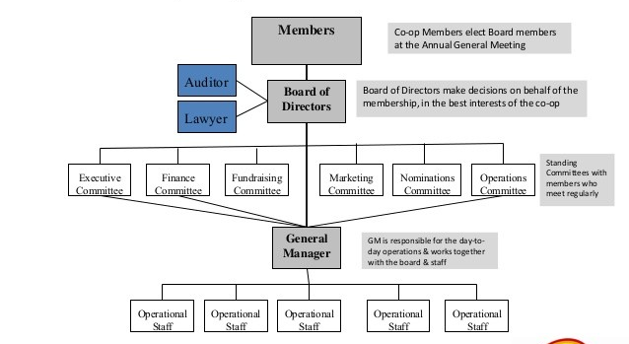
As of December 31, 20X5 and June 30, 20X6, the Company has not issued any debt. The combination of revenue growth and profitable operations typically results in operating activities that generate positive cash flows.
Documentation:
We document below the sources of information (see requirements in section 1) from which the understanding of the nature of the entity was obtained regarding the above-mentioned elements, including the names of individuals to whom we spoke.
Inquiry with management (May 10, 20X6)
Accountant - David Andrews
Finance Manager – James Lee
CFO – Warren Evans
External & Internal resources EY
InfoGator
Company website

- The entity’s selection and application of accounting policies
We obtain an understanding of the entity’s selection and application of accounting policies, in particular those accounting policies for which judgment is used in their application (i.e., estimates), as well as policies for recording revenue.
We understand the reasons for changes to accounting policies.
We evaluate whether the entity’s accounting policies are appropriate for its business and consistent with the applicable financial reporting framework and accounting policies used in the industry in which the entity operates.
For further guidance, refer to UTB 1.1c. The entity’s selection and application of accounting policies.
Provide a brief description of management’s selection and application of accounting policies |  |  |  | Risk identification
Describe Policy |  |  |  | RMM?
  Risks from EY Canvas
 | 1. | Property and equipment consists of leasehold improvements, furniture, fixtures, equipment and is stated at cost, less accumulated depreciation and amortization. Furniture, fixtures, and equipment are depreciated using the straight-line method over the estimated useful lives of the assets, which range from three to seven years. Leasehold improvements are depreciated using the straight-line method over the shorter of the estimated useful lives of the assets or the lease term.
Note: for demonstrative purposes of this learning, only the PP&E policy has been shown. Based on the company’s background and information included within this UTB, in a real life environment, we would expect the company to have additional accounting policies.
Documentation:
We document below the sources of information (see requirements in section 1) from which the understanding the entity’s selection and application of accounting policies was obtained regarding the above-mentioned elements, including the names of individuals to whom we spoke .
Prior year experience with the client
Inquiries with management on May 10, 20X6
Accountant - David Andrews
Finance Manager – James Lee
CFO – Warren Evans

- The entity’s objectives, strategies and business risks
Objectives and strategies |  |  | Risk identification
Document below our understanding of the entity’s objectives and strategies and those business risks that may result in risks of material misstatement. Consider whether inconsistencies between objectives and strategies or the lack of objectives that are responsive to known risks and opportunities, give rise to risks of material misstatement. |  |  | RMM?
  Risks from EY Canvas
For further guidance, refer to UTB1.1d and UTB Appendix 3. |  |  | RMM?
Achievement of budget targets and forecasts - Goal, to provide a high quality reliable product/service (Customer first, Quality Always)
Objectives:
Cash management, cost improvement and productivity improvements

Strategies:
Leveraging its strength in core business areas and expertise in its products to broaden market share.
Key stakeholder influences  List stakeholders, or unified stakeholder groups, whose expectations or actions (or inactions) can significantly influence management or affect the business objectives and strategies (and/or the ability of the business to meet its objectives and strategies). |  |  | RMM?
  Risks from EY Canvas
Summit’s focus is on the long-term goals of the ownership base, financial viability and continuity of the company, achievement of targets and increasing profitability.
Critical success factors  Critical success factors are the key results identified and monitored by management, generally few in number that must be achieved to conclude that a strategy has been implemented successfully.  Document below our understanding of the entity’s critical success factors for the entity’s most important business strategies, and those business risks that may result in risks of material misstatement. |  |  | RMM?
  Risks from EY Canvas
Critical success factors
- Decrease in the average collection period of trade receivables
- Excellent customer relationships
- Growth in sales
- Sustainability of products
- Expansion of the business in new markets
Business risks |  |  | Risk identification
Entities face business risks throughout the performance of their operations. Such risks may arise from change, complexity or failure to recognize the need for change. |  |  | RMM?
  Risks from EY Canvas
Understanding the entity's business risks increases the likelihood of identifying risks of material misstatement. However, we do not have a responsibility to identify or assess every business risk because they do not all cause a risk of material misstatement to the financial statements. Document below those business risks that may result in risks of material misstatement, if not already documented elsewhere in this template. |  |  | RMM?
Risks of not identifying needs within the market to broaden its market share and result in sales growth.
Documentation:
We document below the sources of information (see requirements in section 1) from which the understanding of the entity’s objectives, strategies and business risks was obtained regarding the above-mentioned elements, including the names of individuals to whom we spoke.
Inquiry with management on May 10, 20X6
Accountant - David Andrews
Finance Manager – James Lee
CFO – Warren Evans
External & Internal resources EY
InfoGator
Company website

- Measurement and review of financial performance
 | Risk identification
We obtain an understanding of how management measures and reviews financial performance which allows us to determine its effect on our identification of RMM. This enabler helps us to determine whether management is under pressure to achieve targets, which may increase risks of material misstatement, including those due to fraud. In addition, if our inquiries of management indicate there are no processes to measure and review financial performance, the likelihood of material misstatements not being detected and corrected increases.  We document our inquiries with respect to:  - The financial performance measures they monitor  - Other areas of financial performance that are of emphasis  We consider the effect on management's measures that may arise from our understanding of key stakeholders' expectations/needs. | RMM?
  Risks from EY Canvas
For further guidance, refer to UTB 1.1e and UTB Appendix 4. | RMM?
Monthly meetings are conducted and the financial results are reviewed. Action plan is prepared for the matters to be followed up and the matters which are of urgent nature being actioned within a time frame.
For listed entities, we document our understanding of analysts’ expectations of the entity’s financial statements. | RMM?
  Documented in EY Canvas? | Risk type & name
N/A
Documentation:
We document below the sources of information (see requirements in section 1) from which the understanding of management’s measurement and review of financial performance was obtained regarding the above-mentioned elements, including the names of individuals to whom we spoke.
Inquiry with management on May 10, 20X6
Accountant - David Andrews
Finance Manager – James Lee
CFO – Warren Evans
External & Internal resources EY
InfoGator
Company website

- Composition and changes in financial information
We read the entity’s financial information and perform analytical procedures, considering non-financial information, to look for indicators of risk of material misstatement. |  | RMM?
  Risks from EY Canvas
For further guidance, refer to UTB 1.1f Composition and changes in financial information. |  | RMM?
Refer to financial statement extracts. No indicators of material misstatement were identified based on our review of the Company’s non-financial information.

- The role of IT in the entity
In understanding the entity and its environment, we obtain an understanding of the role of IT in the entity, including IT complexity.
For further guidance, refer to IT 1.
Consider cross referring to the 230-IT planning memorandum form and 260-Team planning event form.
Summit has a fully implemented SAP for its accounting and reporting purpose. The financial reporting structure in SAP is determined by codes with each code corresponding to a unique product or service. SAP is preconfigured with document types for purchase orders, customer invoices, good receipts and many other transactions. Monetary authorization limits for journal entries, cash discounts, payment or receipts differences are defined by the document types and users. The ability to create, change, delete and reverse journal entries are restricted to limited authorized employees.

Further, Summit uses a separate IT system to record and account for its property, plant & equipment. The system maintains a complete listing of all fixed assets held for use and depreciates them according to appropriate accounting, tax, and regulatory requirements set up in the system. Once an asset’s cost is capitalized, it will be depreciated on a straight line basis over the estimated useful life of the asset. This system establishes uniform guidelines for the collection of information necessary to properly capitalize the cost of assets and provide for consistent capitalization of all assets held by the Company as required for internal, external, and regulatory reporting.

Source of information
Inquiry with management on May 10, 20X6
Accountant - David Andrews
Finance Manager – James Lee
CFO – Warren Evans
External & Internal resources EY
InfoGator
Company website

*** Do not edit or delete anything below this point in the document! ***

