# Flowchart Activity — Part 1

### Objective:

* Complete a flow chart to document your understanding of a SCOT.

### Time: 25 minutes.

### Instructions:

1. Work in pairs.
2. As instructed by your senior, complete the flowchart of Summit Equipment’s SCOT for the addition of plant and equipment SCOT.
3. Refer to:

* PM 4.2: PP&E process narrative.
* PM 4.3: PP&E process map.

1. Use common flowchart symbols, shown in the table on the next page to chart the process.
2. Compare PM 4.2 to PM 4.3, noting anything that requires further discussion with the senior (if any).
3. Using the shapes provided, complete the boxed in section of the flowchart.

### Tips:

Brainstorm and think about the critical path of the SCOT before beginning your final flowchart.

### Common flowchart symbols:

|  |  |
| --- | --- |
|  | This symbol marks the beginning or ending of the process. |
|  | This is the most common symbol. It is used for most process steps. |
|  | This symbol represents a decision in the flow chart. Usually an arrow that flows from this symbol is noted as a “Yes” or “No” decision. |
|  | This symbol represents a document created or prepared as part of the process (e.g., a report). |
| Database | This symbol represents a physical storage device for data such as a hard drive. The focus of this symbol is the media, (i.e., “where to store.”). |
|  | An arrow indicates the direction of the flow. |

### Example flowchart:

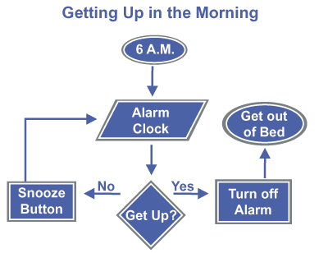

|  |  |
| --- | --- |
| Event | Asset Received  Asset Back to Vendor  Start |
| Requesting Department | Requestor  Creates Purchase Requisition in SAP    Department Manager Approval  Approval Email |
|  | Cancel Order  Vendor Follow Up & Complaint  Goods Received Note |
| Warehouse Department | Damaged or  Delivery Issue  PO  Discrepancy  Asset Received  PO is changed to “Delivered”  Record PP&E in the GL  Visual Inspection  Goods Received Note |
| Accounts Payable Department | Invoice Received  Invoice Payment  Accounts Payable Process |
| PP&E Department | PP&E Data  End  Monthly Reporting |

# Flowchart activity — Part 2

### Objective:

* Update the flowchart of the significant class of transactions (SCOT) to include what can go wrongs for PP&E additions.

### Time: 15 minutes

### Instructions:

1. Refer to HO 4.2: Flowchart activity — Part 1 answers.
2. As instructed by your senior, map the PP&E WCGWs listed below to your flowchart.
3. Work in pairs again.

### WCGW listing:

* SE PP&E WCGW 1: The Classification of an Asset Purchase is Incorrect (i.e., operating or capital)
* SE PP&E WCGW 2: The GL Coding of an Asset Purchase is Incorrect / Not Performed
* SE PP&E WCGW 3: A Fraudulent or Duplicate Vendor is Created in SAP
* SE PP&E WCGW 4: Assets are Purchased without Proper Approval / Supporting Documentation
* SE PP&E WCGW 5: Fictitious / Incorrect Assets are Recorded
* SE PP&E WCGW 6: Assets are recorded in the incorrect period
* SE PP&E WCGW 7: Assets are recorded incorrectly in the GL
* SE PP&E WCGW 8: The PP&E Subledger does not agree to the General Ledger

### Tips:

The same WCGW can occur in multiple places.