# Walkthrough activity — Part 1

### Objective:

* Demonstrate the ability to perform an effective walkthrough, by asking appropriate questions and gathering audit evidence

**Time:** 20 minutes

### Instructions:

1. Work individually.
2. Open Canvas and review the process narrative, process map, flowchart and controls related to PP&E to familiarize yourself with the process in advance of the walkthrough.

* Use the information included in these sources:
* PM 4.2: PP&E process narrative
* PM 4.3: PP&E process map
* PM 5.2 PP&E additions listing
* PM 5.3: Walkthrough of a SCOT
* HO 5.1: Flowchart Activity – Part 3 Answer

1. Prepare a list of questions for an interview with the PP&E process owner of Summit Equipment.

Consider the following:

1. What questions will you ask to confirm your understanding of Summit Equipment’s PP&E SCOT?
   1. How would you confirm where the process begins and how information is moved through the process?
   2. For which portions of the process will you inquire verses observe?
2. What questions will you ask so that you can appropriately understand and document the PP&E SCOT?
3. What supporting audit evidence will you need to request so that you can complete the walkthrough?

# Walkthrough Activity — Part 2

### Objective:

* Practice interviewing and obtain the documents required to complete a walkthrough

**Time:** 30 minutes

### Instructions:

Work in your assigned group (Group A or Group B).

* **Group A**: Interview the “client” (the facilitator(s) acts as the client).

The objective of the interview is to:

* Validate and (if necessary) update the information in the narrative and/or flowchart
* Obtain the necessary information to complete the walk-through documented in the Walkthrough of a SCOT (PM 5.3)
* Confirm your understanding of the SCOT and obtain the necessary documents to complete a walk-through
* Conduct the interview as you would an actual interview
* Practice what you have learned about how to conduct an interview
* **Group B**:Your role is to evaluate the interviewing skills of Group A.
* Read through the following criteria, watch the interview conducted by the other group and complete the following interview checklist to provide feedback:

|  |  |
| --- | --- |
| **Group:** |  |

| **Observations** | **Yes** | **No** |
| --- | --- | --- |
| **BEHAVIOR** |  |  |
| Did the interviewer use jargon/abbreviations which could confuse the interviewee? |  |  |
| Did the interviewer stay calm when treated unpleasantly? |  |  |
| Did the interviewer behave and speak in a professional manner? |  |  |
| Was the interviewer confident? |  |  |
| Did the interviewer show interest in the interviewee’s message by maintaining eye contact, nodding his or her head (body language in general)? |  |  |
| Did the interviewer take notes during the interview? |  |  |
|  |  |  |
| **PREPARATION** |  |  |
| Did the interviewer identify the purpose of her or his visit? |  |  |
| Did the interviewer have an agenda/plan/discussion points for the interview? |  |  |
| Did the interviewer have sufficient tools (notepads, pens) to conduct the interview? |  |  |
| Did the interviewer make an appointment for the meeting, and then did he or she arrive on time? |  |  |
| **EFFECTIVENESS IN RECEIVING INFORMATION** |  |  |
| Did the interviewer ask open questions, without trying to guess or suggest the answer? |  |  |
| Were the questions focused and to the point, without wandering off track? |  |  |
| Did the interviewer take notes? |  |  |
| Did the interviewer summarize the meeting, action items and findings to provide feedback and confirm his or her understanding? |  |  |
| Did the interviewer ask for further explanations when he or she seemed to not understand the answer? |  |  |
| **CLOSING THE INTERVIEW** |  |  |
| Did the interviewer thank the interviewee for the meeting? |  |  |
| Did the interviewer summarize the meeting and the findings to provide feedback and confirm his or her understanding? |  |  |
| Did the interviewer leave open the possibility to follow up? |  |  |

### Tip:

Part of the walkthrough documented in the SCOTs form has already been completed. You can use this to help guide you on the extent and types of questions you may ask in order to complete the SCOTs form.

# Walkthrough activity — Part 3

### Objective:

* Practice performing procedures to document a SCOT

**Time:** 30 minutes

### Instructions:

1. Now that the interviews are complete, update and finalize the PP&E Walkthrough of a SCOT (PM 5.3) for the additions portion of the process as necessary.
2. Document your work individually. Document the walkthrough and other procedures performed and your conclusions within the form.
3. Perform appropriate sign-off as preparer and hand-off your work to your reviewer to ensure your senior performs a timely review of the work performed.
4. To sign off evidence:

* Click on the evidence, select “Open Drawer.”

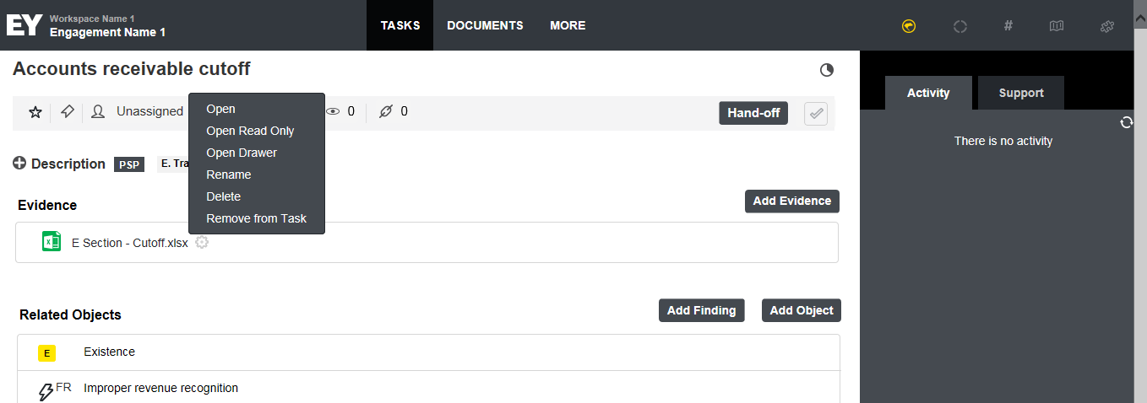

* Click “P” to sign off as preparer.

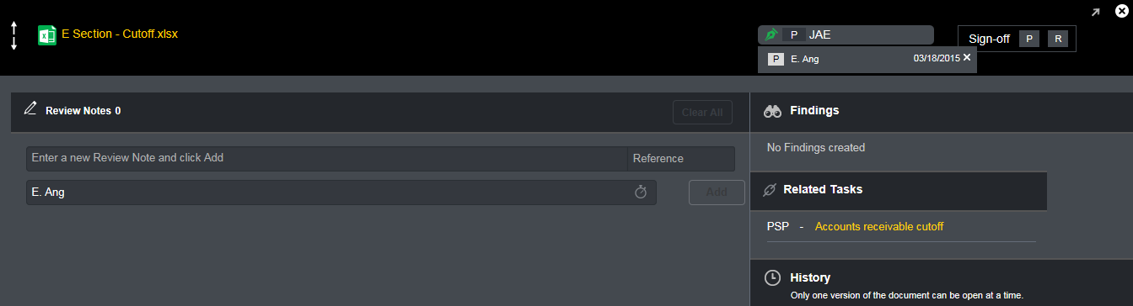

* Your initials will appear on the bar. When you click on it, it will show the date of sign-off.
* Your sign-off will also appear beside the document.

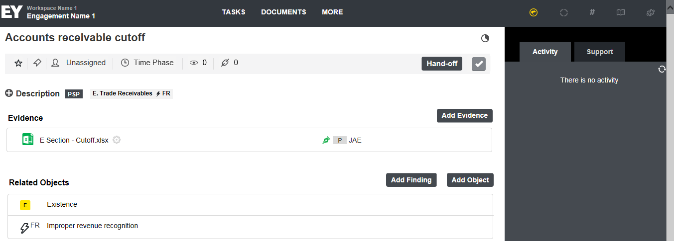

* Once signed off, you should ‘Hand Off’ your completed tasks to a supervisor for review.

