# Walkthrough activity — Part 3

### Objective:

* Practice performing procedures to document a SCOT

**Time:** 30 minutes

### Instructions:

1. Now that the interviews are complete, update and finalize the PP&E Walkthrough of a SCOT (PM 5.3) for the additions portion of the process as necessary.
2. Document your work individually. Document the walkthrough and other procedures performed and your conclusions within the form.
3. Perform appropriate sign-off as preparer and hand-off your work to your reviewer to ensure your senior performs a timely review of the work performed.
4. To sign off evidence:

* Click on the evidence, select “Open Drawer.”

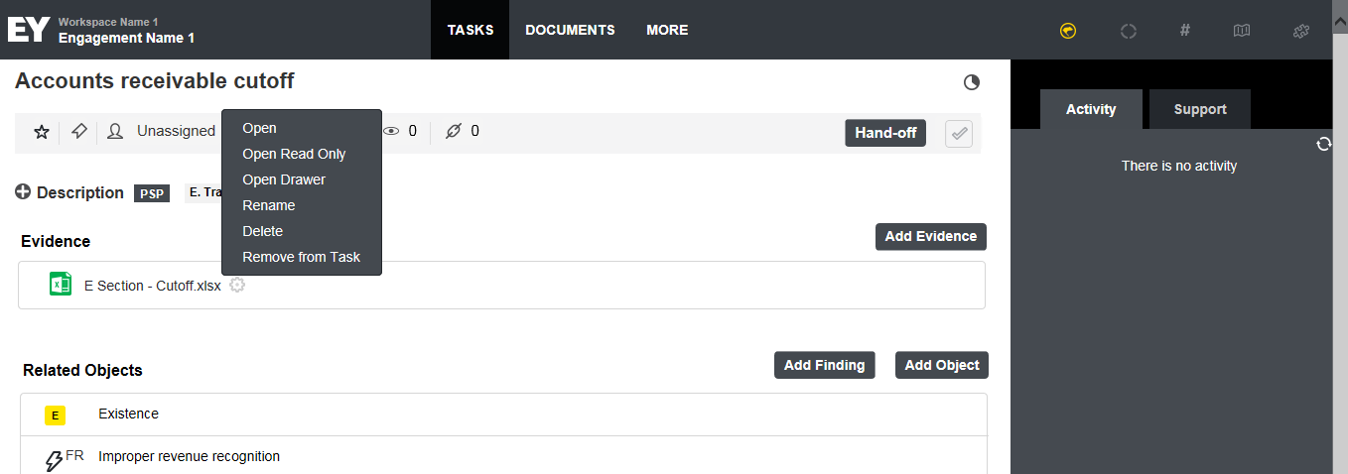

* Click “P” to sign off as preparer.

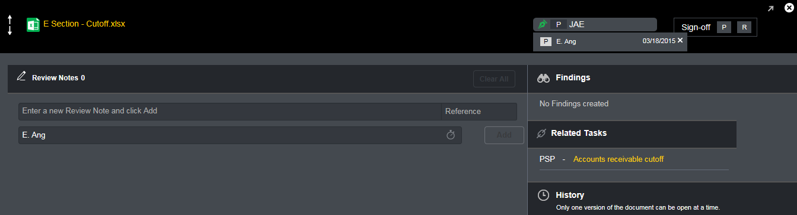

* Your initials will appear on the bar. When you click on it, it will show the date of sign-off.
* Your sign-off will also appear beside the document.

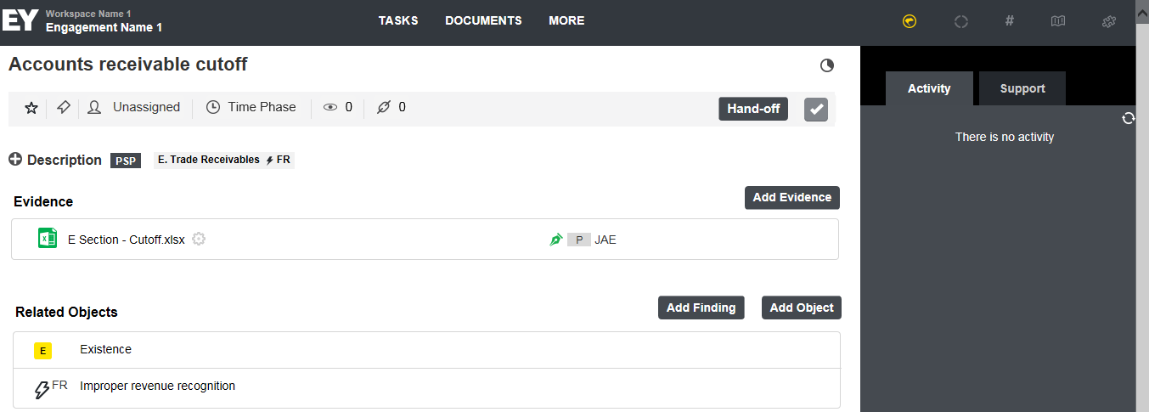

* Once signed off, you should ‘Hand Off’ your completed tasks to a supervisor for review.

