**Explanation for Wireframe**

In my assignment 1 solutions, I lost a couple of point in the section of the Wireframe. My previous wireframe is like as below:

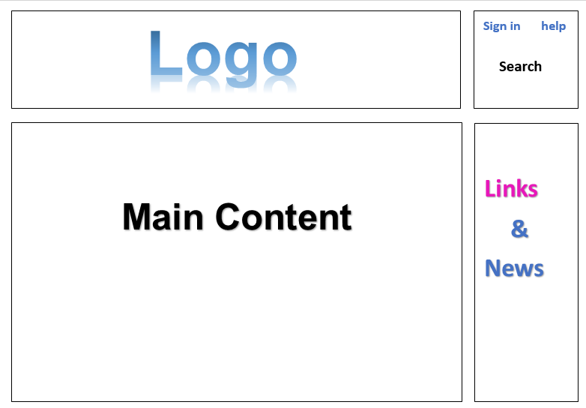

After reading the feedback, I noticed that my previous wireframe is lacking specific elements. I need to break down main content and links & news. Another issue is that I only provide one of the two wireframes.

In order to continue the assignment 2 and others, I redesign the wireframes. The two web pages are the same with those in assignment one. What I did in this redesign is to break down the concreate contents.

**A1.3**

**Website Wireframe Design and Justify.**

**A & B**  create a wireframe (base on the C.R.A.P design principles)

I choose “Halifax Waterfront” in the assignment 1, the web site address is: <http://my-waterfront.ca/>. The first web page is its home page. The second web page is Halifax Waterfront, the web page address is: <http://my-waterfront.ca/waterfront/halifax/>.

**Wireframe for page one**

Stay connected

Icons of Facebook Twitter and YouTube

Web site name

Home

Waterfronts

Halifax

Bedford

Dartmouth

Lunenburg

Sea & Do

Events

Experiences

Dining

Wi-Fi

News

About

Privacy Statement

Contact information

Important news picture

(With link)

Important news title (With link)

Text with link

Picture with link

Subtitle with link

Text with link

Picture with link

Subtitle with link

Text with link

Picture with link

Subtitle with link

Text with link

Current events

Showing 3 pictures alternatively

Title of the above current picture with link

LOGO

**Wireframe for page two**

Privacy Statement

Contact Information

Footer

Facebook, Twitter and YouTube icons

Marine Activities

Text with links

Explore Projects

Text with links

Parking Information

Text with links

Halifax Waterfront (text for the above image with link)

Dining Information (icon)

Text with links

A big image for Halifax waterfront

(With link)



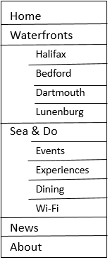

**C** justify the design

My design is following four different concepts, which called CRAP principle, they are contrast, repetition, alignment, and proximity. So, let`s getting start to talk about the first concept, contrast. If the element is not the same, let them distinct. To avoid some similar elements on the page, I used different font, color, size and shape to divide each element. For example, the font size of title should be large enough because it need to catch users` eyes. Compare with title, the news and advertisement should be much smaller because user don’t need to read every single word carefully. In general, the fundamental purpose of contrast is not only enhanced page effect but also help to organize information.

The second concept is repetition. To make the visual elements of the design is repeated throughout the work, I keep every word which in same parts to be same font, size and color, and all of wireframes shape are rectangle or square. This kind of layout can unify and enhance the visual effect, and it also easier for user to read and even look through. For example, if my website theme is about saving water, and the color of my website logo is blue, then the color of my paragraphs of text and title should be blue as well. It can increase the clarity and will not make user feels unexpected. Consider about that, repetition for multi-page document design is more important.

The next concept is alignment. Just like the golden ratio, people always pursue the aesthetic feeling involuntarily, nothing can easily be placed on a page. I`m not going to make the layout of my website become very delicate, but at least it should be generous and decent. In addition, I don’t want to make my website looks too traditional, like a newspaper, so I tried to not make all of text information centered. For the row and column, all the wireframes have aligned each other, this is what the concept requires and it is also what I want.

The last concept is proximity. To make the information placed with better structure, I grouped the related information points together. I had concerned that put some short and brief information, such as weather, date, Register or login windows, all together in the blank corner before I read the CRAP principle, but now I abandon that idea. Just imagine that, if a user is interested in the website that design by me. However, he/she can easily find the login windows, but cannot find where the registration window is, and finally, he/she find it at a small corner and near by the electronic calendar. This would be resulting in poor user experience, and I would lose one customer because of that. So, I grouped the related information to the same part, and these information is eventually divided into four different parts, logo, main content, link & news and service area. That is all justify for my design, most of design concepts are following the CRAP principle. Admittedly, I learned lots of useful skills with the CRAP principle.