**Assignment 2.1**

**Student Name: Jiaming Han**

**ID: B00726481**

**A2.1**

In this section, I will use the wireframe for those two web pages selected in Assignment 1, and identify the key HTML elements.

**Analysis result for home page.**

The home page can be split to four parts as below:

* Header: blue frame
* Navigation bar: red frame
* Content: green frame
* Footer: pink frame

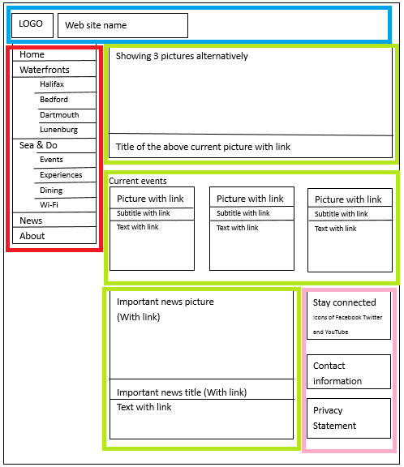

**Header: blue frame**



There are two elements in header part. The first is tag: <img> which will be used for showing the logo picture.The second is tag :< h1> which will be used for showing the web site name.

**Navigation bar: red frame**

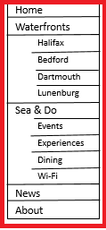

Firstly, the navigation bar should be inside a tag: <aside> because the aside element represents a section of a page that consist of content that is tangentially related to the content around the aside element, and which could be considered separate from that content according to the definition from w3 at <https://www.w3.org/TR/2014/REC-html5-20141028/sections.html#the-aside-element>.

Inside the tag <aside>, there will be a tag <nav> because the nav element represents a section of a page that links to other pages or to parts within the page according to the definition from w3 at <https://www.w3.org/TR/2014/REC-html5-20141028/sections.html#the-nav-element>.

Since the navigation bar is a cascade menu, inside the <nav> tag, the <ul> and <li> elements should be used according to the introduction in class.

As a result, the structure should be as below:

<aside>

<nav>

<ul>

<li>...</li>

<li>

<ul>

<li>...</li>

<li>...</li>

<li>...</li>

</ul>

</li>

</ul>

</nav>

</aside>

**Content: green frame**

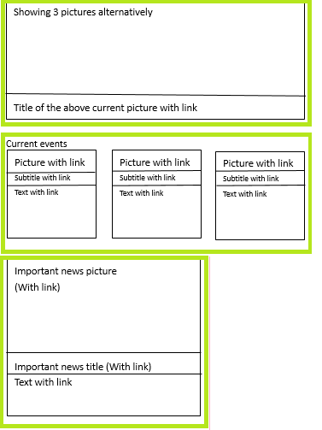

In order to show the three images alternatively, we need a container: <div> to wrap the <img> tags. According to the introduction in class, the content part should be a group of <article> tags. Each <article> tag should have some <section> tags. Especially, the <p> tag will be used for the paragraph text, the <h1> will be used for tiles, and the <img> tag can be used for showing images.

**Footer: pink frame**

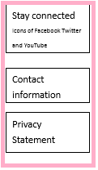

As for the footer part, three <section> elements should be used. In each <section> tag, <h4> can be used for showing sub-titles and <img> should be used for showing images. For example, in order to show Facebook, Twitter and YouTube icons.

Notes: in my assignment, all of the images is made by myself except the icons of Facebook, Twitter and YouTube, these three icon files come from their own official web sties.

**Analysis result for page2: Halifax Waterfront web page**

The page 2 can be split to four parts as well:

* Header: blue frame
* Navigation bar: red frame
* Content: green frame
* Footer: pink frame

The header, navigation bar and footer parts are the same with the home page.

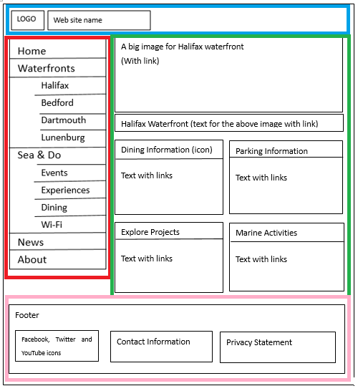

The content part will be split into two sub-elements:

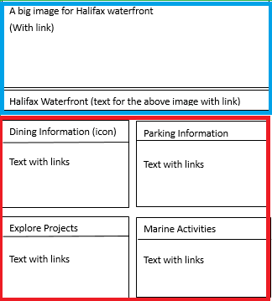

The first element is blue frame which will show three pictures but only one image will be visible. The whole element is a <article> tag, inside this, <img> will be used for showing images, and <h1> tag will be used for showing the current image’s title.

The second element is red frame which includes four articles. So, the while element will be <article> tag, inside this, there are four <section> tags. Inside the <section> tag, <img> will be used for showing image, <strong> will be used for sub-titles, and <p> ca be used for showing paragraphs.