**Assignment 3.1**

**StyleScheme**

**Student Name: Jiaming Han**

**ID: B00726481**

In this document, according to the assignment requirements, I will describe my style scheme and how can I design for the elements on my web pages. I will use the main web page as an example to describe the above parts. The second web page is the same design.

Firstly, the CSS design bases on the wireframe in assignment 1 and HTML elements developed in assignment 2.

**Review of wireframe for main web page**

In my assignment 1, the wireframe for the main web page is as follows:

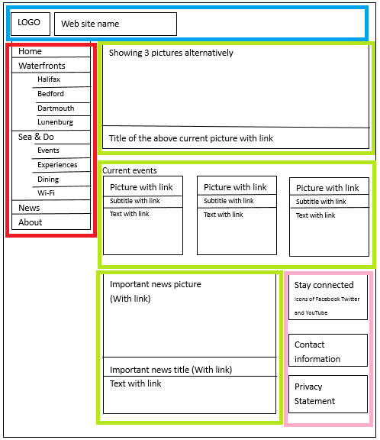

According to the business logic I thought, the home page can be split to four parts:

Header: blue frame

Navigation bar: red frame

Content: green frame

Footer: pink frame

**Review of HTML for main web page**

In assignment 2, I convert the above wireframe to HTML elements, the screen shot of main page is follows:

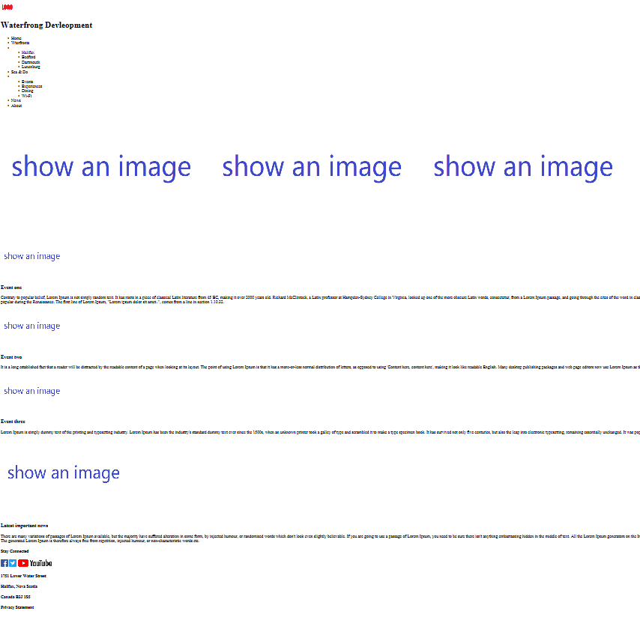

The issue of the above HTML is that the alignment of the elements are incorrect.

**High level design for CSS**

The first design for CSS is the layout of the main web page. In assignment, the whole web page has been split to four elements. Further, in the assignment 2, the four elements have been implemented by different HTML elements.

For example, the head part in wireframe has been defined as <header> tag in html file. The navigation bar part in wireframe has been defined as <aside> tag in html file. The content part in wireframe has been defined as <div> tag, and the footer part has been defined as <footer> tag.

As a result, in my CSS file, I use the position:absolute to set the position of each element. I made a survey at <https://www.w3schools.com/cssref/pr_class_position.asp> in order to lean the CSS position property. For example, in order to build layout and position content on a page, there are a handful of different techniques to use. I choose the position:absolute because I found that absolutely positioned elements are removed entirely from the document flow, as a result I can set the elements position using a relative simple way. This is due to my lack of background knowledge about the document flow. From the documents from [www.w3.org](http://www.w3.org), maybe other property of position is more useful in real web page design world.

So, my finally design with CSS is as follows:

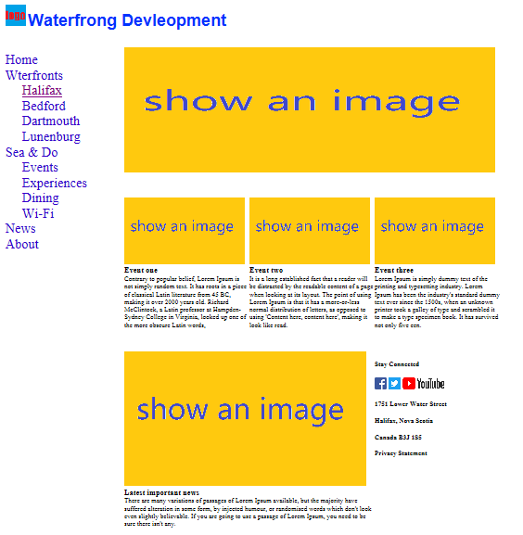

**Design for font size and colour:**

The first thing needs to be considered is font size. Generally px is an absolute unit of measurement in CSS. The drawback of px is because it is an absolute measurement, px units do not scale according to the width of the browser window. As a result, sometimes it will not adapt to the width of the browser.

Then, I found em on <https://www.w3schools.com/css/css_font.asp>. It is a unit that is relative to the currently chosen font size. It means that using em can control the size of something to depend on the current font size.

In my work, the title of web page has been set with 2.5 em.



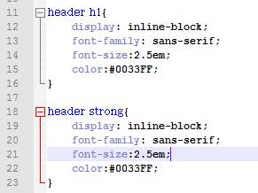

It’s similar with the navigation menu as follows:

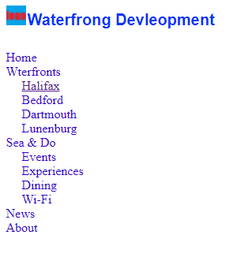

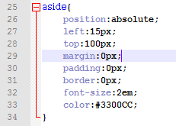

**Design for margins**

According to the introduction on <https://www.w3.org/TR/CSS2/box.html>. When considering the margins, we need to know the Box Model in CSS.

The CSS box model is essentially a box that wraps around every HTML element. It consists of: margins, borders, padding, and the actual content. The image below illustrates the box model (comes from <https://www.w3.org/TR/CSS2/box.html>):

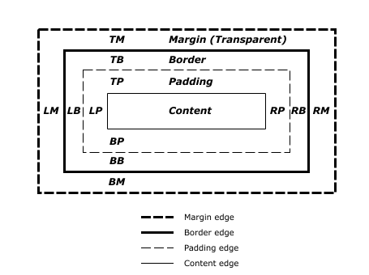

In order to simplify the design for this assignment, I set the whole margin, border and padding as zero in order to let the layout design easier.

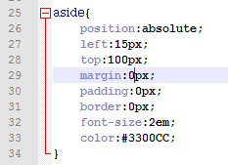

Considering this is an assignment, so these settings work well, but in a real web site, the margin, border and padding needs to be set separately.

**Design for Positions**

According to the introduction from <https://www.w3schools.com/css/css_inline-block.asp>. In CSS, display can have values of inline and inline-block. Generally, inline elements cannot have a width and height set and allow other elements to sit to their left and right. Block elements force a line break after the block element.

An example for display:block, display:inline and display:inline-block is as follows:

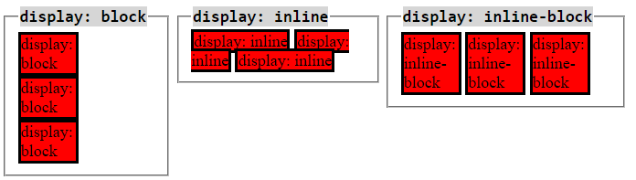

The above image come from <http://dustwell.com/div-span-inline-block.html>.

**Changes notes for HTML files**

According to the assignment requirements, I must use the same HTML files submitted for assignment 2, and apply the CSS. Changes to the HTML are accepted only if they if any errors in HTML/ required re-aligning elements.

I did change the HTML files submitted in assignment 2, but just for re-aligning elements, no design changes. Since I validated my HTML files on @eC Validation service (<https://validator.w3.org/#validate_by_input>). There is no any errors or warnings with my web page source code. What I changed is just add some <div> tags and assign class name for different tags, such as <article>, <section>, <img> and others.

Generally, the design do not change, the layout does not change. I’ve re-validated these two web pages and attach the validated report in assignment 3.