**Chrome screen shot:**

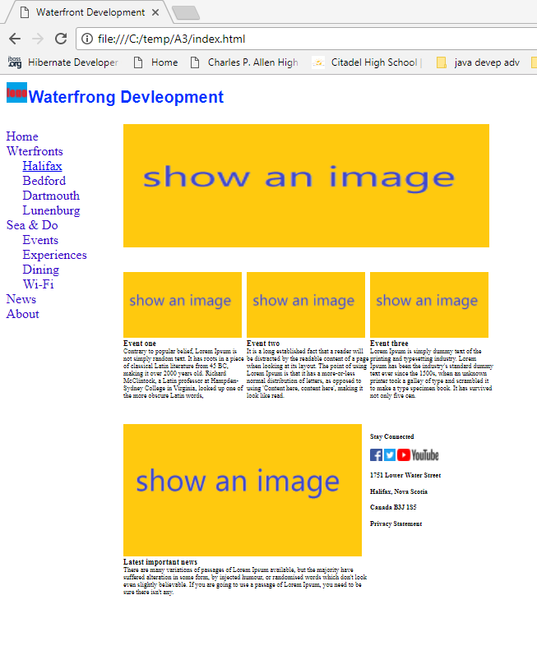

**Internet Explorer 11 screen shot:**

