**How to implement a slider**

In order to shown more than images in a slider, after my self-study and survey, there are two ways:

1. Using Java Script to control when to show one image.
2. Using CSS 3 transform property.

I selected the second way.

Firstly, I need to learn what this property is and how to use it in the CSS with my website’s webpages. I got the basic knowledge from: <https://www.w3schools.com/cssref/css3_pr_transform.asp>.

Basically, the transform property includes translate, scale, rotate, skew, matrix and etc. I focus on how to use translate in order to move the image from virtual position: more than 100% into current correct position. The basic idea is set the container div’s width with 500% in order to put all of the 5 images. And move one of them into visible position using translate.

As a result, the key CSS is as follows:

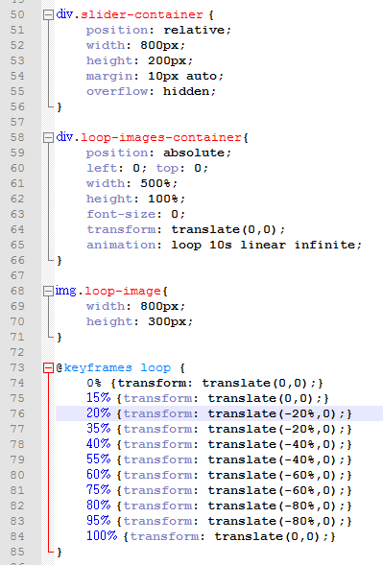

**How to use HTML 5 tags**

According to the introduction in the class and the experience I got from the assignment, I use a couple of HTML 5 tags in this course project.

Firstly, the main navigation menu is implemented with a nav tag as follows:

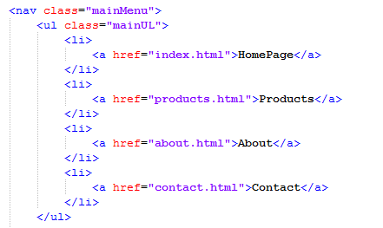

The content in the different webpages are implemented with an article tag as follows:

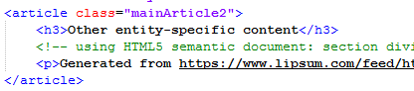

In order make the website available in different devices: PC, mobile or pad, the width property are set with percentage rather than with absolute positions as follows:

