**How to respect to Quesenbery’s 5 E’s of design**

**Effective**

In my understanding, the effective means that the end user could get the information quickly and correctly. One examples how to implement this principle. Under the main navigation menu bar, there is a sliders in which will show the most important notifications for the end user. For example, the most popular movies, the latest popular promotions.

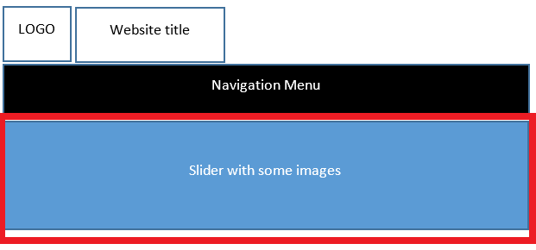

**Efficient**

The end user can get the correct information from our website, the next point needs to be considered is about efficient. It means that there will not be a couple of deep web links for the end user in order to get somewhere. One example about how to implement this principle is a quick access link list in the home page as follows:

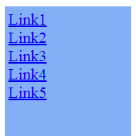

**Engaging**

In my understanding, a good design for one website means that the end user will like this website immediately after open it in internet explorers. One example about how to implement this principle is as follows:

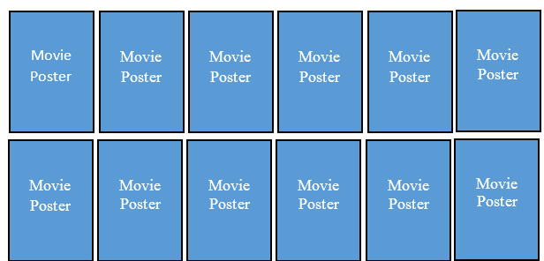The current movies will be organized with posters rather than with texts. With this way, the end user will find the actors, the classical scenarios in one movie.

**Error Tolerant**

If the end user click the wrong web link which is not their want, this website provide a top navigation menu bar in each webpage:

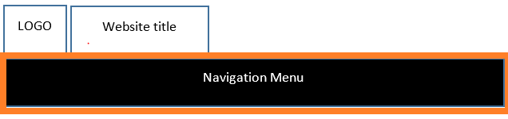

With this design, the end user will return to homepage or other resource lists quickly.

**Easy to Learn**

In order to help our end user to learn how to use our website quickly, the design use a common, popular design layout, this means that if end user has experience with internet, they will find the correct information in a short time.