How t0 Replace the LEDs on a Roccat Ryos Keyboard

**Kaiwen Lu**

Course Number: CSCI2100

Instructor: **Dr. Christopher Grundke**

4th November, 2017

How to Replace LEDs on Roccat Ryos Keyboard

**Summary**

All of the Roccat Ryos keyboards have LED lights that indicate the status of toggle keys such as NUM LOCK and CAPS LOCK. Generally, the lights are located on the right-top corner of the keyboard. You can get the details about how the LEDs work through the website (http://www.roccat.org) if you are unsure if they do not work.

Before replacing the LEDs please press CAPS LOCK to see if that key’s indicator light goes on or off. If the lights associated with each key do not turn on and off when you press them, the first method you should do is restart your computer. If rebooting your machine still does not seem to solve the issue, please follow this instruction to replace the LEDs.

This instruction is designed to replace LEDs only on Roccat Ryos keyboards, please check the keyboard model and serial number before the change. If there is any uncertain thing you can get more help from Roccat Ryos web site.

**Tools & Materials**

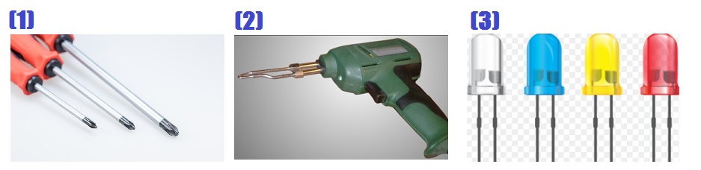

Figure 1. The tools and materials. The images come from http://search.creativecommons.org/

1. A double-slot screw driver with blade width of 2.4 mm.

(2) A soldering gun;

(3) 3mm replacement LED

Notes:

The model of LEDs is dedicated for different model of keyboards, so you must check the model of LEDs before the replacement through the Roccat Ryos’s official web site.

**Steps**

These instructions are based on information and images from wikiHow to Change LEDs on Roccat Ryos, <https://www.wikihow.com/Change-LEDs-on-Roccat-Ryos>. Retrieved 3rd November

1. **Before you begin**

* Turn off the computer, disconnect the keyboard by unplugging the USB cord.
* Do not connect to computer until you complete the replacement.

1. **Opening up the keyboard**

There are 20 total screws on the back of the keyboard. You must unscrew all of them.

Using screw driver to unscrew the screws, you can find the positions of these screws on follows:

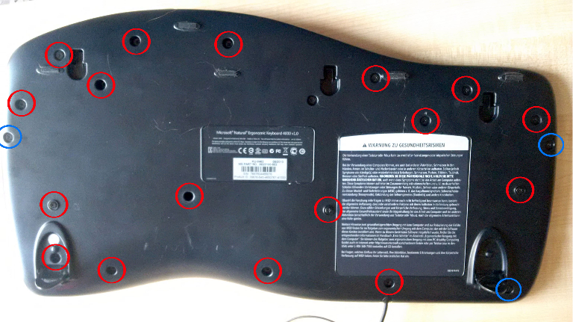

Figure 2. Image from https://www.zufallsheld.de/2015/03/21/repairing-keyboard/

1. **Lifting the cover off**

After unscrew all of the screws, you can lift the front edge of the keyboard until you have access in inside-board.

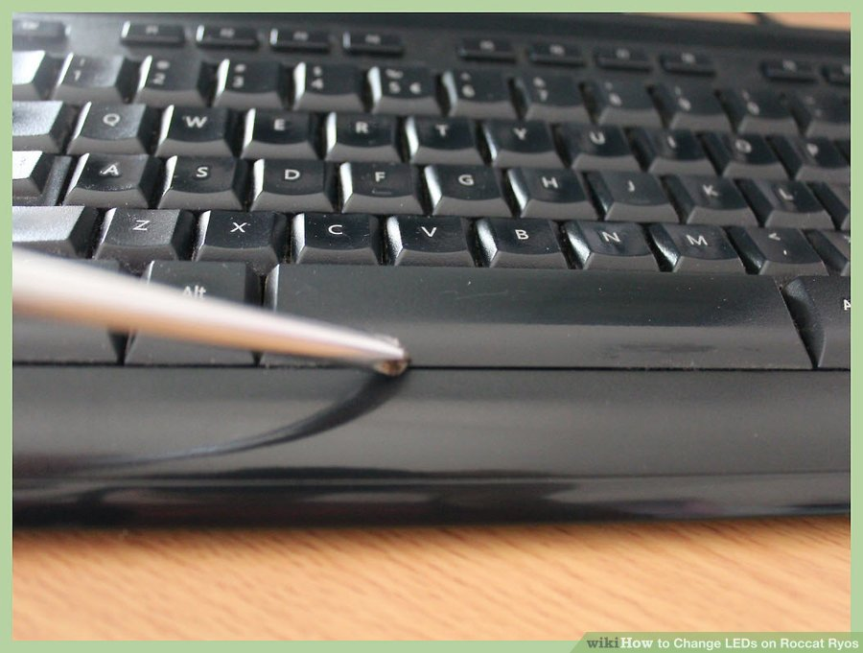

Figure 3. Image from https://www.wikihow.com/Change-LEDs-on-Roccat-Ryos

1. **Getting the inside-board out**

After removing the cover, you can find the inside-board, an example image is as follows:

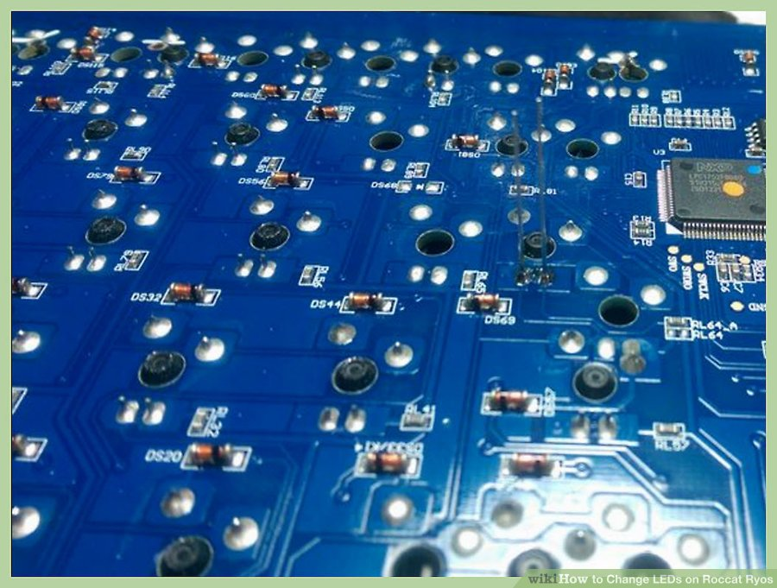

Figure 3. Image from https://www.wikihow.com/Change-LEDs-on-Roccat-Ryos

On this inside-board, there are 6 screws in order to fix the inside board to the rear cover. After unscrew all of these 6 screws and disconnect the data cable, lift the center piece up and flip it over.

1. **Replacing the dead LEDs**

* Find the position of your dead LEDs, then unsolder the bad LED using soldering pump. LED should just fall off right away.
* Before putting the new LED in, make sure the polarity is correct. You can use mustimeter or just touch the terminal with LED pins to check.
* Put the Led in the slot and solder them using soldering pump to fix it. You should make sure that the gap between LED and button is right, you can just put a piece of tissue paper under the board to push the LED towards the board.

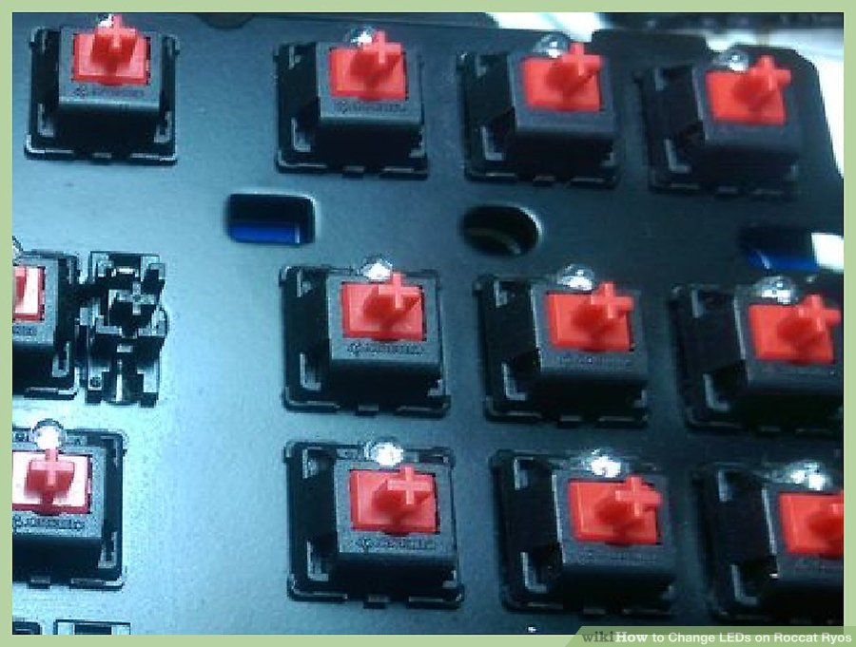

Figure 3. Image from https://www.wikihow.com/Change-LEDs-on-Roccat-Ryos

1. **Replacing thumb keys**

The process is the same with the replacement of LEDs, the only difference is the size.

Before change the old one, you should polarity first.

Unsolder old ones, put the new one in. you can just melt both solder simultaneously them throw the LED on it.

1. **Putting stuff back**

Reverse the above steps.

Finally, connect the ground wire before install the front cover.

**References**

How to Change LEDs on Roccat Ryos. Retrieved 3rd November, 2017, from <https://www.wikihow.com/Change-LEDs-on-Roccat-Ryos>

Repairing a Microsoft ergonomic keyboard. Retrieved 3rd November, 2017, from <https://www.zufallsheld.de/2015/03/21/repairing-keyboard>

Images in figure 1. Retrieved 3rd November, 2017, from <http://search.creativecommons.org/>