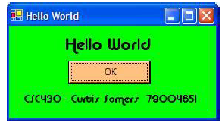 Please put your name and student number there instead of mine. Your name is a text field, as is the "HELLO WORLD" part. The OK is a push-button with a single "End" instruction that exits the program when pushed. Feel free to embellish the thing with any selection of ugly fonts, colors, bitmaps, wallpapers, animations, other language Unicode characters, sounds or other features that you think will make it interesting (no viruses please). Have fun and be creative. Doing the above should take about 2 minutes or less after visual Studio power-up and shows how VB.NET can be used for ridiculously quick development. It’s sure a heck of a lot easier than LISP or C to create a UI.

Create a "Split Time Stopwatch" program application. The stopwatch should show time to 100's of seconds and use start, stop, clear and exit functions. The app could look something like this:

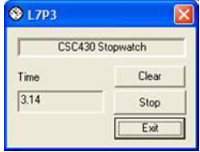

The format for Format should be two digits for hour, minute, seconds and thousands of seconds, zero filled, formatted two digits past the decimal. Note that the stop button has two purposes. One click changes the caption from stop to start (because you want it to start next time you click it) and pauses the counter (pauses the timer). The second click will change the caption from start to stop and resume the counter where it left off. The Clear button will reset the timer, regardless if we are stopped or started. Note the timer will likely have to count by two or more and do some mod functions to keep correct time, depending upon how fast your CPU is. You can have more fun if you want. For example, here’s a transparent version with no border that floats around the screen.

The objective is to create a Simple calculator that will operate like the “CALC” in windows. You don’t need to program all the keys, just the ones shown below. It is your choice to use keypress, focus, validate, change methods or even a simple button click (easiest) to do the operations. Remember check for division by zero and overflows (try/catch works well for capturing NaN). If you want to get fancy, try and replicate the way that Windows CALC actually handles repeated presses of the equals button (for example “1+1===” produces a result of 4). Also feel free to try and remap the keyboard so “Esc” does the same thing the “C” button, “Del” does the same thing the “<<” button, and “enter” does the same thing as the “=” button.

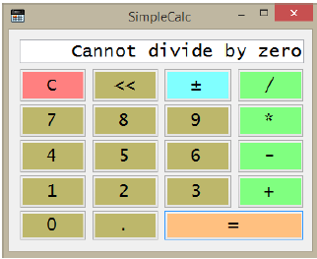

Try and get as close to the behavior of the windows calc program as possible.