**CSCI 3430.1 - Principles of Programming Languages**

**Assignment # 10**

**Solutions**

**Question 1**

1. In this Assignment # 10, I re-wrote this game using Java with the same features of assignment 8 and 9

2. The original idea comes from

http://www.dreamincode.net/forums/topic/39686-creating-a-fully-functional-pong-game/.

But more functions are added according the assignment requirements.

3. When one side or the other gets to 15, a sound is played. This is implemented by using: Toolkit.getDefaultToolkit().beep(); in Java.

4. A Alert will appear to ask the user if try or quit

5. The player’s paddle is controlled by mouse

6. More details please see the comments in source code

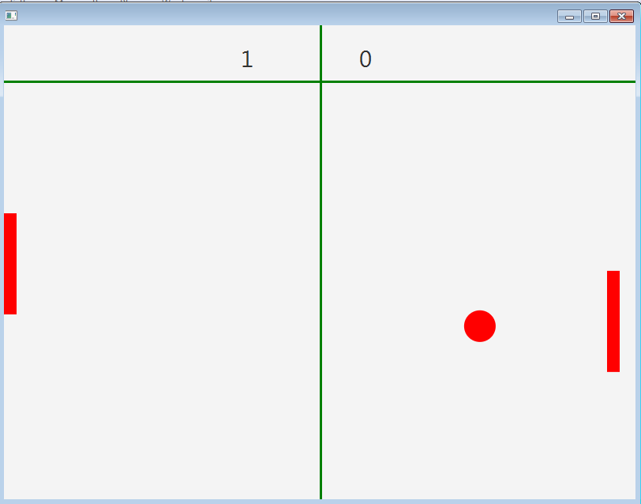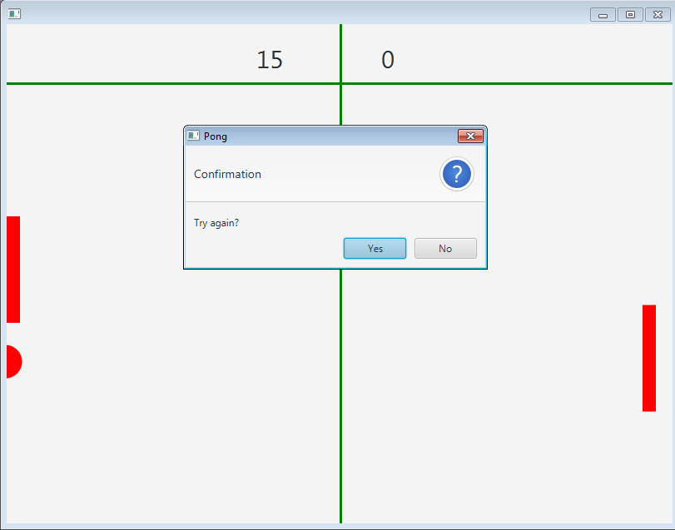

**Question 2**

The first language is Java version 1.8.131.

The second language is C language using Cygwin 32 in windows 7 platform.

In the Java language, checking the input, the C language do the operation.

The screen shot are as follows, more details can be found in source code files.









