**CSCI 3430.1 - Principles of Programming Languages**

Solution for Assignment 9

**Background**

My python environment is Python 2.7 in Windows environment

All of the questions in this assignment are developed in separate python source code. t1.py, t2.py, t3.py, t4.py and t5.py

In this solution, I post the screen shot the source code and sample output for each questions. The details of source code can be found in attached.

**Question 1:**

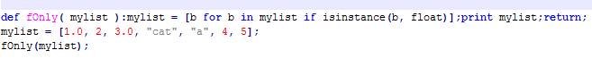

Sample output:



**Question 2:**

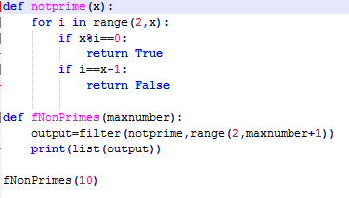

Sample output:



**Question 3:**

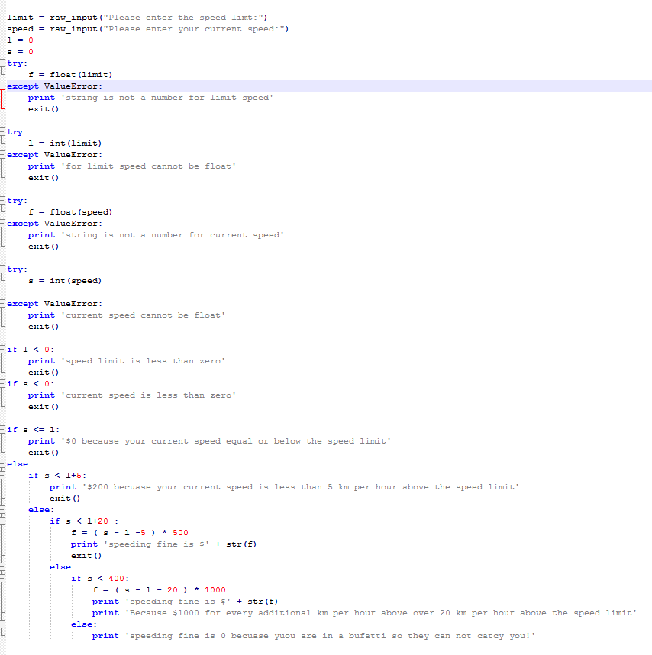

Sample output:

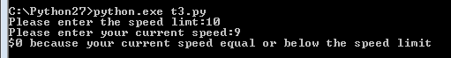

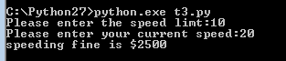

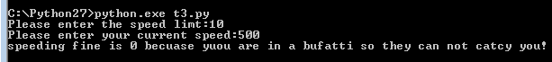

**Question 4:**

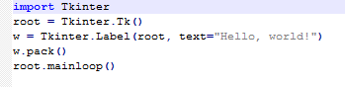

In this question, I use Tkinter

Sample output:



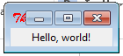

**Question 5:**

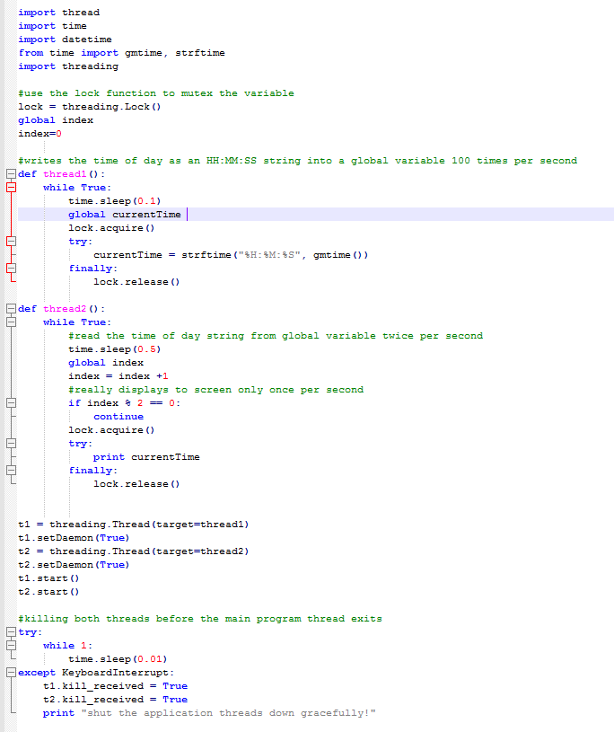

Sample output:

