Simultaneous Extraction of Chain Transfer Constant, Inhibition Period, and Retardation Factor from RAFT Polymerization Data Using a Vision Transformer
Author One, Author Two
Department of Chemistry, University, City, Country

Introduction
Reversible addition--fragmentation chain transfer (RAFT) polymerization has become one of the most widely adopted controlled radical polymerization (CRP) techniques, offering broad monomer compatibility, mild reaction conditions, and tolerance to a range of functional groups. The effectiveness of a RAFT agent is governed by several kinetic parameters, among which the chain transfer constant C_tr = k_add/k_p is the most fundamental descriptor of RAFT agent reactivity. In addition, the inhibition period---the initial delay before polymerization reaches steady state---and the retardation factor---the ratio of polymerization rate in the presence versus absence of the RAFT agent---provide critical information about the pre-equilibrium and main-equilibrium kinetics, respectively. Traditionally, each of these three parameters requires a dedicated experimental protocol. The chain transfer constant is most commonly determined via the Mayo method, which requires a series of polymerizations at varying CTA concentrations stopped at low conversion, followed by analysis of the resulting molar mass distributions. The inhibition period is extracted from conversion--time curves, and the retardation factor from rate comparisons between RAFT and conventional polymerizations. Each protocol demands separate experiments, careful control of reaction conditions, and specialized analytical techniques. For a single RAFT agent--monomer pair, the complete characterization thus requires at minimum three independent experimental campaigns. Recent advances in machine learning (ML) for polymer science have demonstrated that deep learning models can extract kinetic parameters directly from experimental observables. Notably, the ViT-RR approach showed that a Vision Transformer trained on simulated copolymerization data, encoded as reactivity fingerprints, could predict reactivity ratios with accuracy comparable to or exceeding traditional nonlinear fitting methods. This paradigm---encoding kinetic data as image-like fingerprints and processing them with a vision model---offers a general framework for parameter extraction from polymerization data. In this work, we extend this paradigm to RAFT polymerization and demonstrate that a single model can simultaneously extract C_tr, the inhibition period, and the retardation factor from standard kinetic data (M_n and \ versus conversion at multiple CTA/monomer ratios). The key insight is that a dual-channel chain transfer fingerprint (ctFP) encoding M_n and \ as a function of CTA ratio and conversion contains sufficient information to resolve all three parameters simultaneously. Our approach offers three principal contributions: enumerate • A comprehensive RAFT kinetic ODE model covering four agent classes (dithioesters, trithiocarbonates, xanthates, and dithiocarbamates), including a two-stage pre-equilibrium mechanism for dithioesters, used to generate 973\,000 synthetic training samples spanning six orders of magnitude in C_tr. • A simplified Vision Transformer (SimpViT) that processes ctFP images to simultaneously predict _10(C_tr), inhibition period, and retardation factor, with bootstrap-based uncertainty quantification providing joint confidence intervals. • Validation against 77 published C_tr values from three independent literature sources, demonstrating R^2 = 0.97 and substantial improvement over a Mayo equation ODE-fitting baseline (R^2 = 0.50). enumerate A free web application is provided to enable researchers to obtain predictions with confidence intervals from their own experimental data without requiring programming expertise.

Computational Methods

RAFT Kinetic ODE Model
The RAFT polymerization kinetics were modeled using the method of moments applied to the full RAFT mechanism. The model tracks three chain populations: active radical chains (), dormant RAFT-capped chains (), and terminated dead chains (), with zeroth, first, and second moments tracked for each population to enable calculation of M_n and . For trithiocarbonates, xanthates, and dithiocarbamates, a single-equilibrium model with 14 state variables was employed. The monomer consumption and representative active chain moment equations are: equation d[M]dt = -k_p[P^][M] equation equation d_0dt = R_init + R_reinit - 2k_t_0^2 - k_add_0[CTA] + k_add(_0 _0 - _0 _0) equation where R_init = 2fk_d[I] is the thermal initiation rate, R_reinit is the re-initiation rate from the R-group released upon addition to the initial CTA, and k_add is the RAFT addition rate coefficient. The RAFT exchange is modeled as a moment-swap process: d_k/dt|_exchange = k_add(_0 _k - _k _0), reflecting the reversible transfer of the thiocarbonylthio moiety between active and dormant chains. The complete set of 14 coupled ODEs is provided in the Supporting Information (Section S1). For dithioesters, a 16-variable pre-equilibrium model was used to capture the distinct initial and main equilibria characteristic of this RAFT agent class. The pre-equilibrium involves the original RAFT agent reacting with propagating radicals before the main RAFT equilibrium is established, with separate rate coefficients k_add,0 and k_frag,0. Number-average molar mass and dispersity were calculated from the moments: equation M_n = _1 + _1 + _1_0 + _0 + _0 M_monomer equation equation = (_2 + _2 + _2)(_0 + _0 + _0)(_1 + _1 + _1)^2 equation The ODE system was integrated using scipy.integrate.solve\_ivp with the Radau method for stiff systems, over a time span sufficient to reach >90\% monomer conversion.

Chain Transfer Fingerprint (ctFP) Encoding
Kinetic data were encoded into a dual-channel image tensor of dimensions 64 64 2, termed the chain transfer fingerprint (ctFP). The encoding maps the two-dimensional space of CTA-to-monomer ratio ([CTA]/[M], x-axis) and monomer conversion (y-axis) onto a discrete grid: itemize • Channel 0: M_n/M_n,theory, where M_n,theory = [M]_0/[CTA]_0 M_monomer • Channel 1: Dispersity (), clipped at 4.0 to prevent outlier domination itemize Each data point ([CTA]/[M], conversion, M_n,norm, ) is mapped to a pixel at row = conversion 64 and column = ([CTA]/[M]/0.1) 64 . This encoding is analogous to the reactivity fingerprint (rFP) used in ViT-RR but adapted for the RAFT parameter space.

Dataset Generation
Training data were generated by Latin hypercube sampling (LHS) over a 7-dimensional parameter space: _10(C_tr) [-2, 4], _10(k_p) [2, 4], _10(k_t) [6, 9], _10(k_d) [-6, -4], f [0.5, 0.8], [I]_0 [0.001, 0.05] M, and [CTA]/[M] [0.001, 0.1]. Gaussian noise ( = 0.03, i.e., 3\% relative error) was added to simulated M_n values to approximate experimental measurement uncertainty. The dataset comprised 973\,000 valid samples distributed across four RAFT agent classes, split into training (778\,963), validation (97\,365), and test (97\,365) sets with stratification by RAFT type. Data were stored in chunked HDF5 format for efficient streaming during training.

SimpViT Architecture
The model architecture is a simplified Vision Transformer (SimpViT) with the following configuration: input size 64 64 2, patch size 16 16 (yielding 16 patches), hidden dimension 64, 2 Transformer encoder layers with 4 attention heads, and a linear output head producing 3 values (_10(C_tr), inhibition period, retardation factor). Patch embeddings are generated by a convolutional layer, and learnable position embeddings are added. The class token is computed as the mean of encoded patch representations. The total parameter count is 877\,000.

Training Protocol
The model was trained using the Adam optimizer with an initial learning rate of 3 10^-4 and a batch size of 256. A weighted mean squared error (MSE) loss was used to balance the three output targets, which span different numerical ranges. Training proceeded for 142 epochs with early stopping, with the best model selected at epoch 126 based on validation loss. Training was performed on an NVIDIA RTX 4090 GPU.

Bootstrap Uncertainty Quantification
Prediction uncertainties were estimated using a bootstrap ensemble approach. The trained backbone was frozen, and 200 independent output heads were fine-tuned for 5 epochs each on bootstrap-resampled training subsets. For a new input, all 200 heads produce predictions; the mean serves as the point estimate and the covariance matrix captures prediction uncertainty. Joint 95\% confidence intervals (JCI) were computed using the F-distribution: equation _i = _ii^2 p F_0.95(p, n-p)n-p equation where _ii^2 is the i-th diagonal element of the covariance matrix, p = 3 (number of outputs), n = 200 (number of bootstrap heads), and F_0.95(3, 197) 2.65. Post-hoc calibration factors were applied to achieve nominal coverage on a held-out calibration set. The calibration factors were [100.0, 53.7, 3.5] for [_10(C_tr), inhibition period, retardation factor], respectively. After calibration, coverage reached 95.0\% for inhibition period and retardation factor; however, _10(C_tr) coverage remained at 69.2\%, indicating that the bootstrap ensemble underestimates uncertainty for this output (see Discussion).

Literature Validation Protocol
The model was validated against 77 published C_tr values curated from three independent sources: spanning 33 dithioesters, 27 trithiocarbonates, 4 xanthates, and 10 dithiocarbamates (3 additional entries had parsing ambiguities in RAFT type assignment). Published values were determined by various methods including Mayo plots, kinetic simulation, and chain length distribution analysis. For each literature data point, an ensemble of 50 ML predictions was generated by sampling kinetic parameters from the training distribution, simulating RAFT kinetics with the published C_tr, encoding the resulting data as ctFP, and obtaining model predictions. The median of the 50 predictions served as the final ML estimate. As a baseline, a Mayo equation ODE-fitting approach was implemented: for each literature point, the ODE model was run with fixed mean kinetic parameters, and C_tr was optimized by minimizing the MSE between simulated and target M_n profiles using bounded scalar optimization. This baseline represents a traditional computational approach with idealized (fixed) kinetic parameters---a condition that is actually favorable to the Mayo method, since in practice researchers must estimate these parameters independently.

Results and Discussion
The overall workflow of the ViT-Ctr approach is illustrated in Figure X: experimental RAFT kinetic data are encoded into a dual-channel ctFP image and processed by SimpViT to yield three kinetic parameters with bootstrap confidence intervals. Figure X shows a representative ctFP for a dithioester system, visualizing the dual-channel encoding.
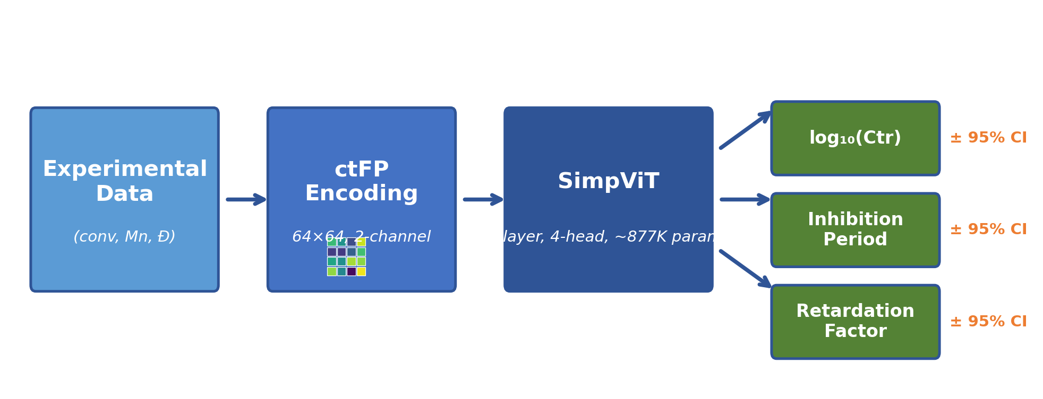
Schematic workflow: experimental RAFT kinetic data (M_n
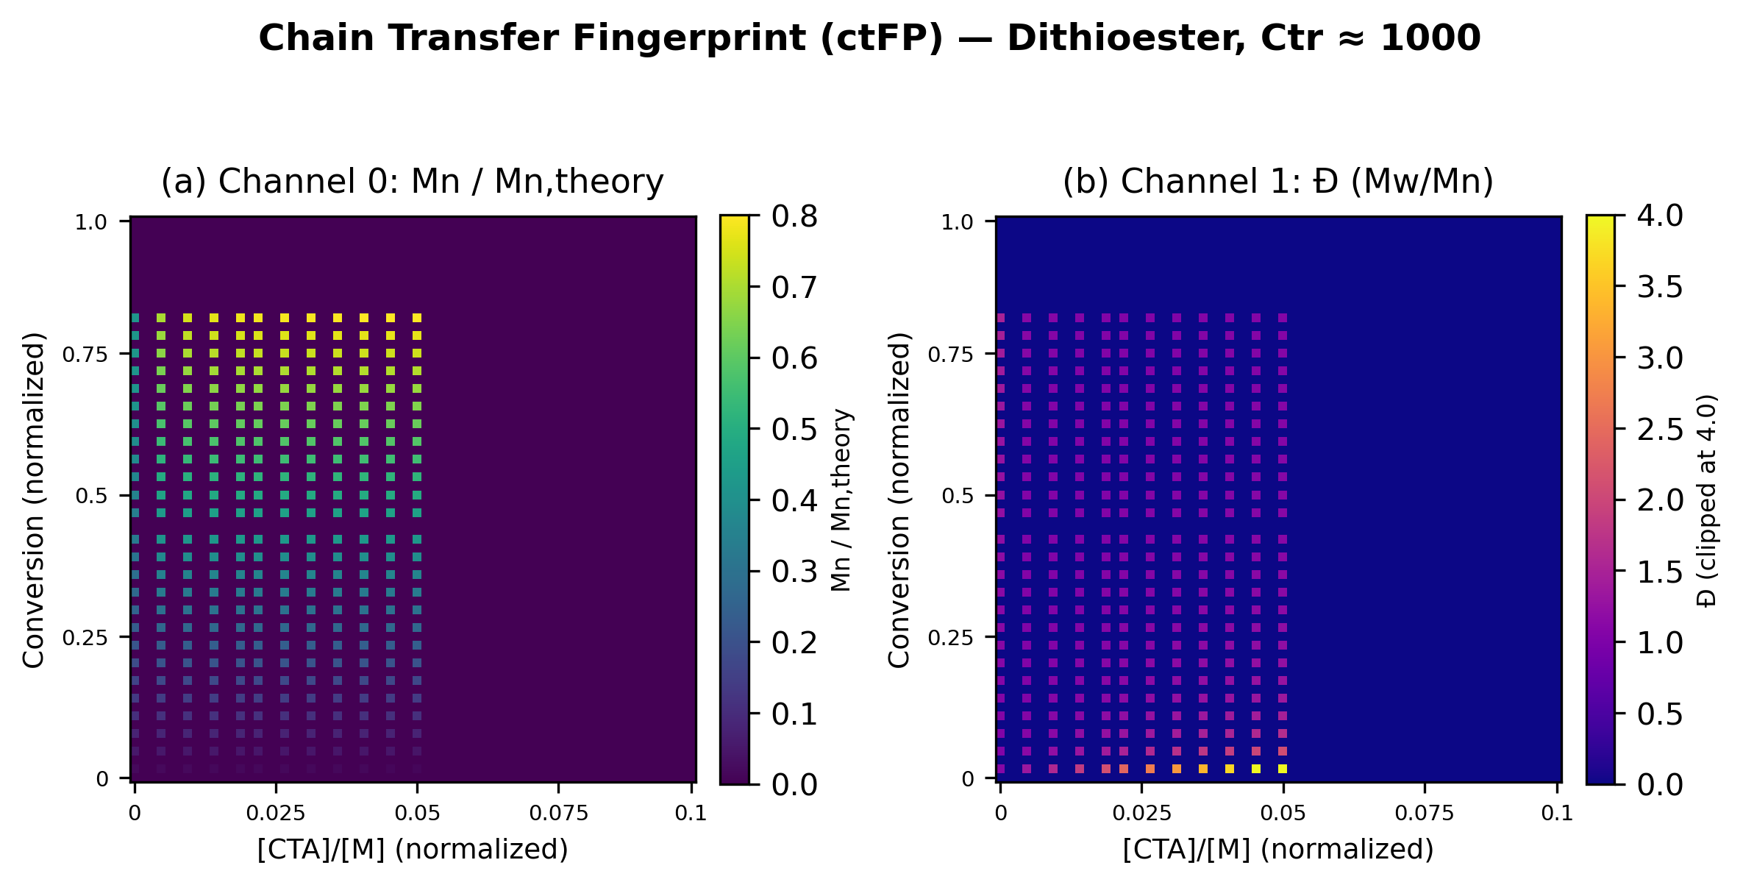
Example chain transfer fingerprint (ctFP) for a representative dithioester RAFT agent. Channel 0 (left): normalized M_n

Model Performance on Synthetic Test Set
The trained SimpViT model achieved strong performance on the held-out synthetic test set across all three output parameters. Parity plots (Figure X) show tight clustering around the identity line for _10(C_tr), inhibition period, and retardation factor, confirming that the ctFP encoding retains sufficient information for simultaneous three-parameter extraction.
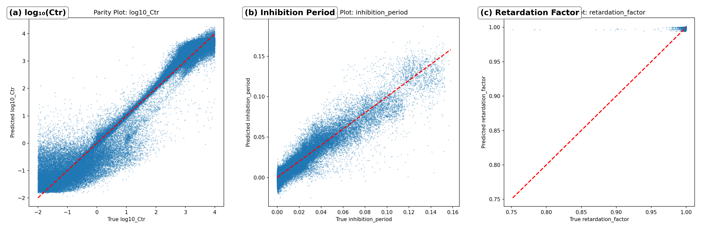
Parity plots for the three predicted parameters on the synthetic test set: (a) _10

Literature Validation: ML vs Mayo Baseline
Validation against 77 published C_tr values (Figure X) demonstrates the practical utility of the ML approach. The SimpViT model achieved R^2 = 0.968, RMSE(_10) = 0.181, with a median fold-error of 1.10. Notably, 92.2\% of ML predictions fell within 2-fold of published values, and 100\% within 10-fold. In comparison, the Mayo ODE-fitting baseline achieved R^2 = 0.502, RMSE(_10) = 0.715, with 85.7\% within 2-fold and 90.9\% within 10-fold. The ML model thus provides a nearly 4-fold reduction in RMSE on the log scale and a substantial improvement in R^2.
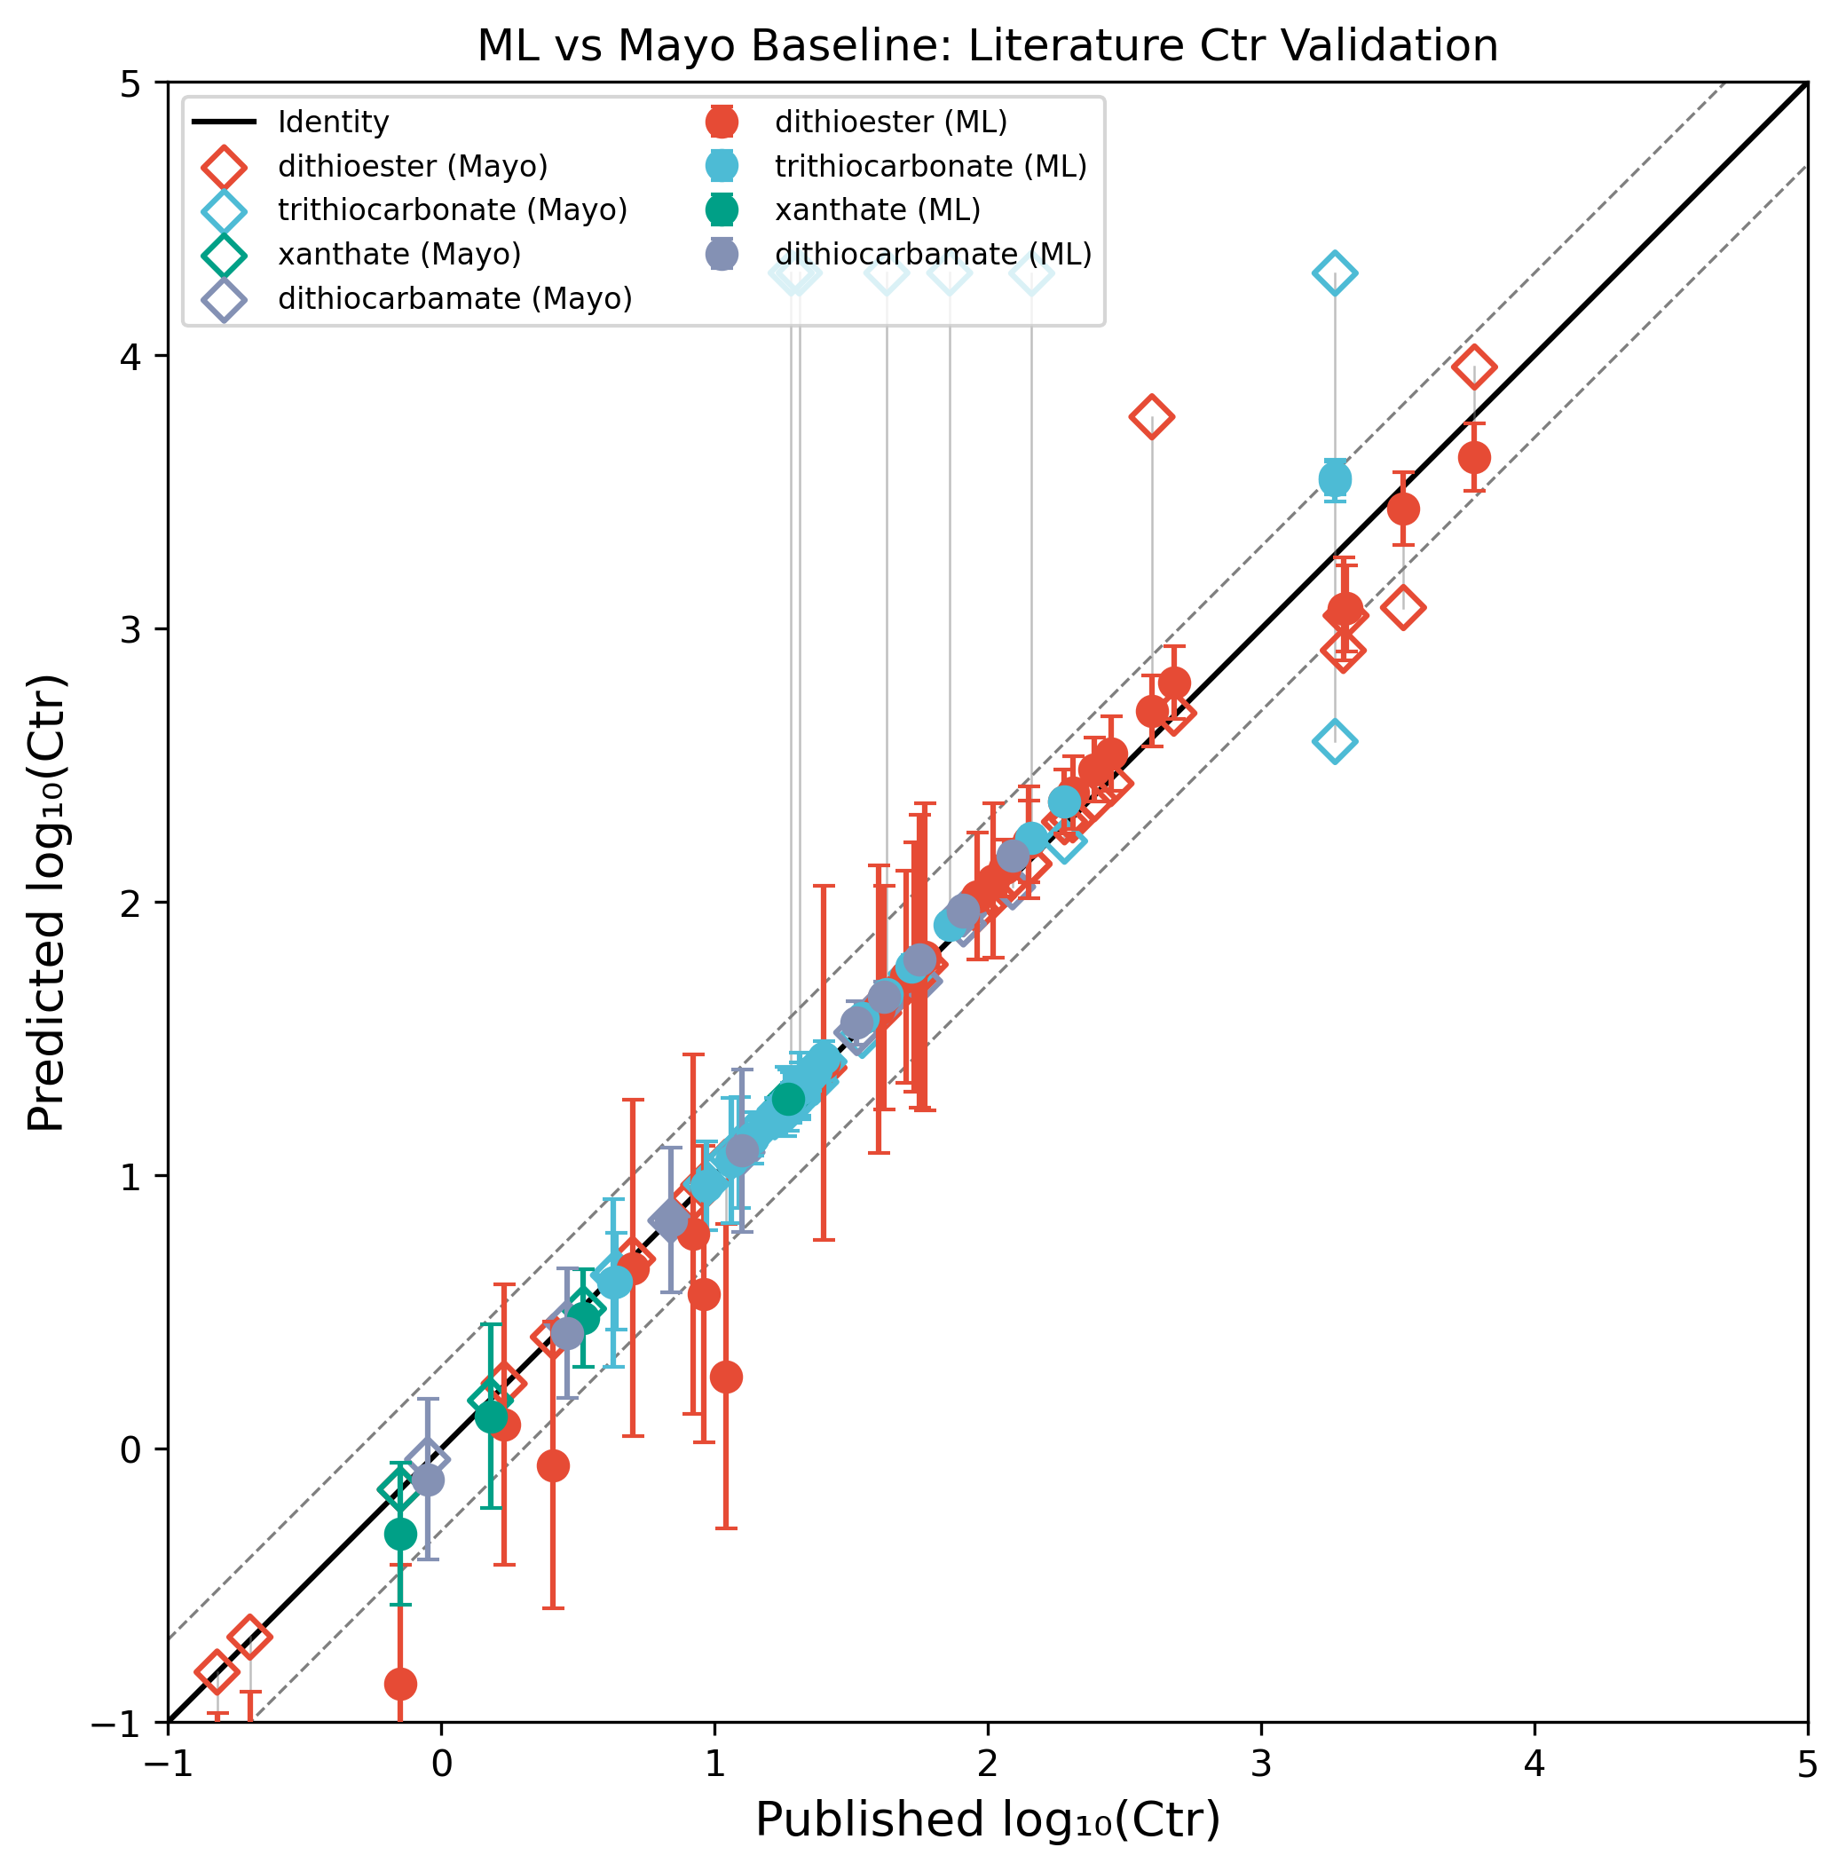
Literature validation: ML predictions (filled circles) versus Mayo ODE-fitting baseline (open diamonds) for 77 published C_tr
It is important to note that the Mayo baseline used here employs fixed mean kinetic parameters (k_p, k_t, k_d, etc.), which represents an idealized scenario. In practice, researchers must independently estimate or look up these parameters for each specific monomer--solvent--temperature combination, introducing additional uncertainty. The fact that the ML model outperforms even this idealized Mayo baseline underscores the robustness of the learned representations. The Mayo baseline does exhibit a lower median fold-error (1.02 vs 1.10), reflecting that the single-parameter ODE fitting can achieve precise point estimates when the fixed kinetic parameters happen to be close to the true values. However, the substantially higher RMSE and lower R^2 of the Mayo approach indicate greater variability and more frequent large errors, particularly for RAFT agents with extreme C_tr values.

Per-RAFT-Agent-Class Analysis
Analysis by RAFT agent class reveals that dithioesters, which exhibit the most pronounced inhibition and retardation effects due to their pre-equilibrium kinetics, are well-captured by the model. Figure X shows representative per-class results for dithioesters, the most kinetically complex class.
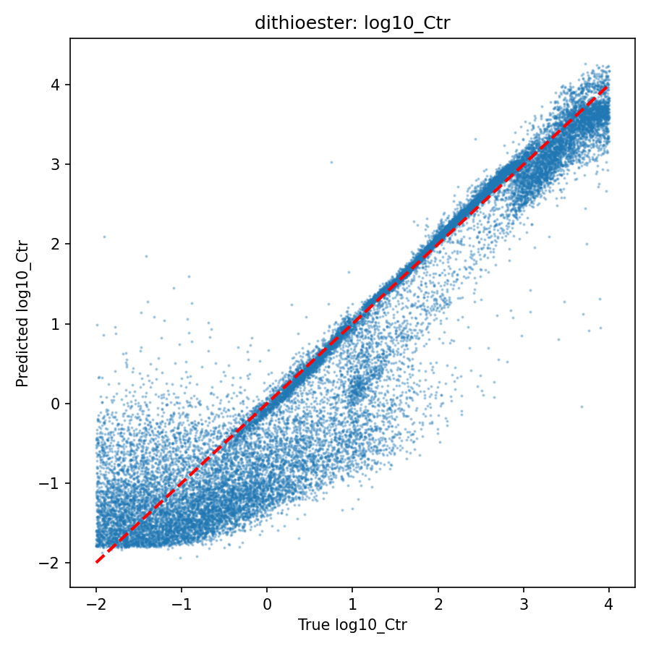
Per-class parity plot for dithioesters showing _10
For trithiocarbonates, xanthates, and dithiocarbamates, the retardation factor is predicted to be approximately 1.0, consistent with the known chemistry of these RAFT agent classes where retardation is minimal or absent. This result is expected rather than a model limitation: these agents undergo rapid fragmentation with negligible intermediate radical accumulation, so the polymerization rate is essentially unperturbed. The three-parameter simultaneous prediction is therefore most informative for dithioester systems, where all three parameters carry independent kinetic information.

Uncertainty Quantification Assessment
The bootstrap ensemble with F-distribution JCI provides meaningful uncertainty estimates. After post-hoc calibration, the 95\% confidence interval coverage reached the nominal level for inhibition period (95.0\%) and retardation factor (95.0\%). However, _10(C_tr) coverage remained at 69.2\% despite a calibration factor of 100.0, indicating systematic under-coverage. This under-coverage for C_tr likely reflects the fundamental challenge of the bootstrap approach: freezing the backbone and fine-tuning only the output head captures aleatoric uncertainty in the head mapping but not epistemic uncertainty in the learned representations. For C_tr, which spans six orders of magnitude (10^-2 to 10^4), the representation uncertainty may dominate. Future work could explore full-model bootstrap or Monte Carlo dropout to better capture this uncertainty component.

Training Dynamics
The training loss curve (Figure X) shows smooth convergence over 142 epochs, with the best validation loss achieved at epoch 126. No divergence or plateau artifacts were observed, confirming stable optimization of the three-output regression objective.
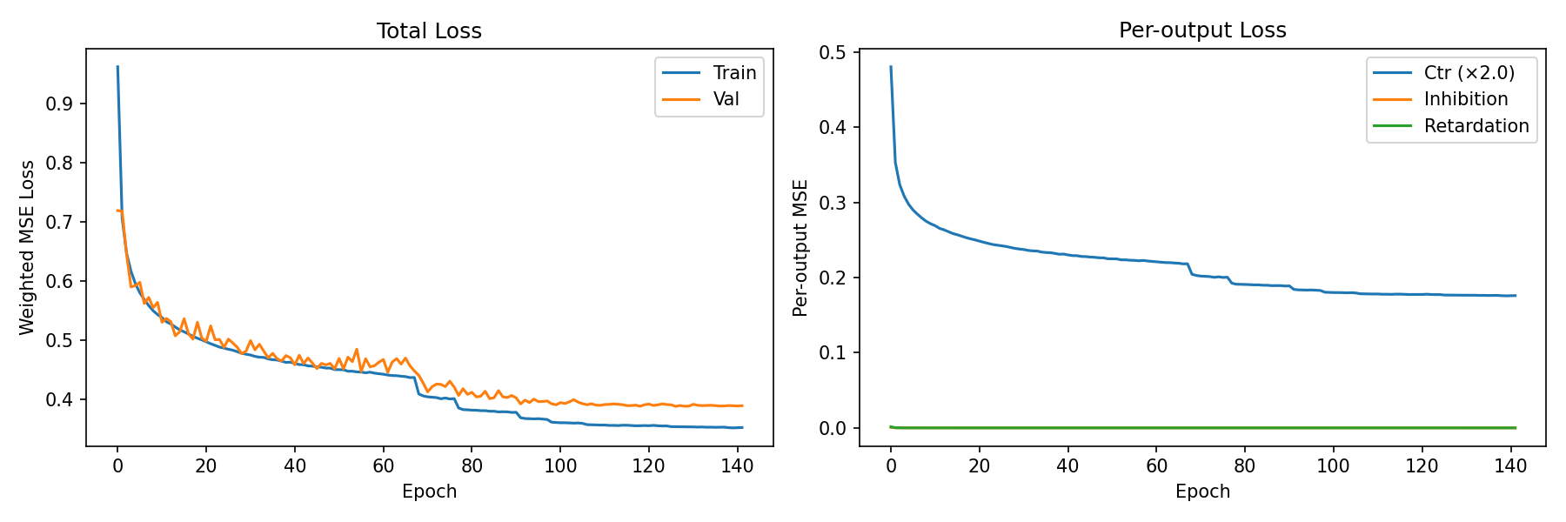
Training and validation loss curves over 142 epochs. The best model (epoch 126) is indicated. Early stopping prevented overfitting.

Limitations
We acknowledge several limitations of the current approach that should guide interpretation and future development: Simulation--reality gap. The training data are generated from an idealized ODE model that does not capture side reactions (e.g., intermediate radical termination beyond the simplified model), non-ideal mixing, or other experimental artifacts. While the 3\% Gaussian noise added during training provides some robustness to measurement error, systematic deviations between simulated and real polymerization behavior may affect prediction accuracy for systems that deviate significantly from ideal RAFT kinetics. Retardation prediction scope. The retardation factor prediction is primarily informative for dithioester systems, where significant rate retardation is observed due to slow fragmentation of the intermediate radical. For trithiocarbonates, xanthates, and dithiocarbamates, the predicted retardation factor is consistently 1.0, reflecting the absence of significant retardation in these systems. The three-parameter simultaneous extraction claim should therefore be understood as most impactful for dithioester-class RAFT agents. Parameter range boundaries. The model is trained on _10(C_tr) [-2, 4] and [CTA]/[M] [0.001, 0.1]. Extrapolation beyond these ranges is not validated and may produce unreliable predictions. Users should verify that their experimental conditions fall within the training domain. Uncovered experimental conditions. The current model does not account for temperature dependence (training data generated at a fixed reference temperature), solvent effects, or RAFT agent classes beyond the four included. Extension to temperature-dependent predictions and additional agent classes is a natural direction for future work.

Web Application
To facilitate adoption by the polymer chemistry community, a free Streamlit-based web application has been developed. Users can input experimental data manually or upload Excel/CSV files containing M_n, , conversion, and [CTA]/[M] values. The application displays the ctFP encoding for visual verification, returns predictions for all three parameters with 95\% confidence intervals, and provides downloadable results. The application is available at [URL to be added upon deployment].

Conclusions
We have demonstrated that a simplified Vision Transformer, trained on 973\,000 ODE-simulated RAFT polymerization profiles encoded as chain transfer fingerprints, can simultaneously extract the chain transfer constant (C_tr), inhibition period, and retardation factor from standard kinetic data. This represents a significant practical advance: traditional methods require three independent experimental protocols to determine these parameters separately, whereas our approach requires only a single dataset of M_n and \ versus conversion at varying CTA/monomer ratios. Validation against 77 published C_tr values spanning four RAFT agent classes yielded R^2 = 0.97 with 92.2\% of predictions within 2-fold of published values, substantially outperforming a Mayo equation ODE-fitting baseline (R^2 = 0.50). Bootstrap uncertainty quantification with F-distribution joint confidence intervals provides calibrated prediction uncertainties, though further work is needed to improve coverage for _10(C_tr). The simultaneous three-parameter extraction is most informative for dithioester RAFT agents, where inhibition and retardation effects are kinetically significant. For other RAFT agent classes (trithiocarbonates, xanthates, dithiocarbamates), the model correctly predicts minimal retardation, consistent with established RAFT chemistry. Future Directions. An intriguing extension of this work is the prediction of C_tr directly from molecular structure. By encoding RAFT agent structures as SMILES strings and using molecular fingerprints or graph neural networks as input representations, it may be possible to predict chain transfer activity without any polymerization experiments. Such a structure--activity model (Route A) could serve as a rapid screening tool for RAFT agent design, complementing the experimental-data-driven approach (Route B) presented here. This direction requires curating a sufficiently large dataset of RAFT agent structures paired with experimentally validated C_tr values, which remains a challenge given the current literature coverage. All code, trained model weights, and the literature validation dataset are available as open-source resources on GitHub, with archived versions on Zenodo [DOI to be added]. acknowledgement The authors acknowledge computational resources provided by [institution]. [Additional acknowledgements to be added.] acknowledgement suppinfo Supporting Information is available free of charge: complete ODE derivation with moment equations matching the implementation, dataset construction details, training hyperparameters, bootstrap uncertainty quantification protocol, per-class evaluation plots (12 parity plots and 3 residual distributions), and the full literature validation table. suppinfo references document

References
See paper/references.bib for the complete bibliography.

