**Anaconda with Python 3.7 is installed, call cmd in search bar**

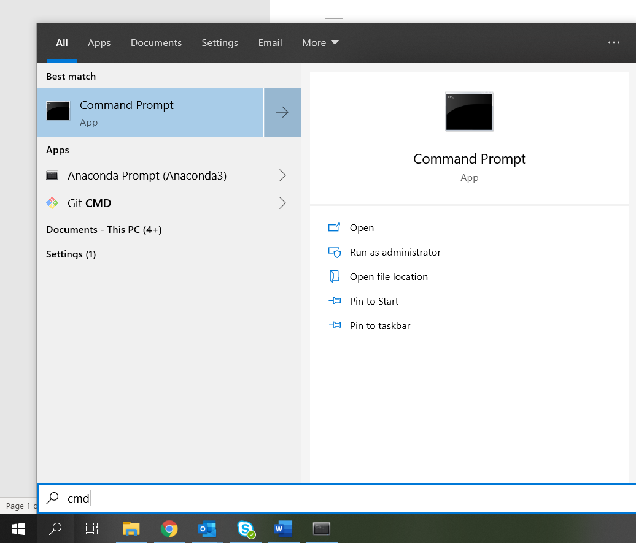

Type in: python, then see Python 3.7 pop up as below, which means python is executable.

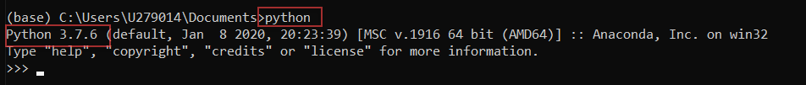

After checking, type exit() to exit python application. Back to directory --- Important

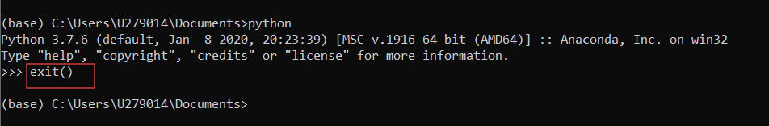

**Now we can start to run model solver >>>>**

**Check the 2 py files are saved under directory >>>>>**

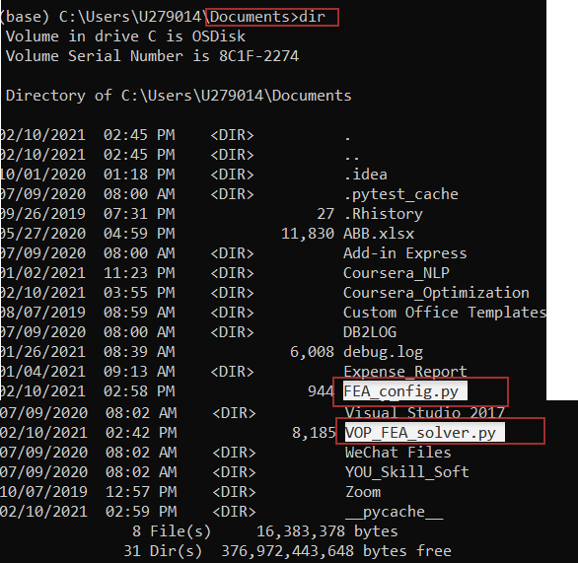

Type in one line: ***python VOP_FEA_solver.py*** will run the model.

Tips: command does automatic fulfill, so type VOP_ + ‘keyboard-Tab’ will fulfill file for running

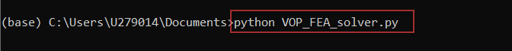

**Steps for adjusting uploading file name and parameter**

Step 1. Select: **UPLOAD_FILE_PATH & RESULT_SAVE_PATH**

Usually, leaves it as default

Ensure the solver reads file from correct folder

Separates FEA algorithm and Defense Algorithm

Step 5. Check cmd script running shows: >>> Successful. process completed

Then all completed, and go to share drive for output data as: (result)_xxxxxxxxx.xlsx

Step 4. Check PRICING_BREAK & FINANCIAL_RATE

Program use the parameters defaulted in the py file, FEA and Defense should not have frequent change relevant to these parameters

If there has changes in uploading formatted file, the parameters here also need to be updated

Step 3. Update result file name: **RESULT_FILE_NAME**

Usually, file name always gets changed for each run

This name COULD be same as file formatted and save under path: UPLOAD_FILE_PATH

The program automatically adds prefix: (result)_ to the file name provided

Step 2. Update input file name: **UPLOAD_FILE_NAME**

Usually, file name always gets changed for each run

This name should be same as file formatted and save under path: UPLOAD_FILE_PATH