彩屏字模提取说明

1、打开软件“航太电子资料\5.常用软件\取字模软件\PCtoLCD2002.exe”，点开选项，进行如下配置：

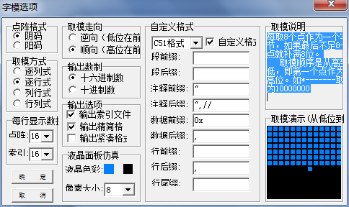

2、配置完成后即可输入需要的汉字或英文，点击生成字模生成下面的数组

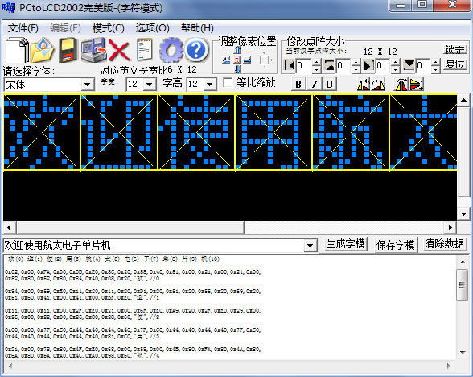

3、复制生成的数组到工程文件 “ch_enlib.c”的结构体数组 struct CnCharType code cn_char[] 下面如下所示：

struct CnCharType code cn_char[] =

{

0x02,0x00,0xFA,0x00,0x0B,0xE0,0x8C,0x20,0x58,0x40,0x51,0x00,0x21,0x00,0x21,0x00,

0x52,0x80,0x52,0x80,0x84,0x40,0x08,0x20,"欢",//0

0x84,0x00,0x59,0xE0,0x11,0x20,0x11,0x20,0xD1,0x20,0x51,0x20,0x55,0x20,0x59,0x20,

0x51,0x60,0x41,0x00,0x41,0x00,0xBF,0xE0,"迎",//1

0x11,0x00,0x11,0x00,0x2F,0xE0,0x21,0x00,0x6F,0xE0,0xA9,0x20,0x2F,0xE0,0x29,0x00,

0x25,0x00,0x22,0x00,0x25,0x80,0x28,0x60,"使",//2

0x00,0x00,0x7F,0xC0,0x44,0x40,0x44,0x40,0x7F,0xC0,0x44,0x40,0x44,0x40,0x7F,0xC0,

0x44,0x40,0x44,0x40,0x44,0x40,0x81,0xC0,"用",//3

0x21,0x00,0x78,0x80,0x4F,0xE0,0x68,0x00,0x58,0x00,0x4B,0x80,0xFA,0x80,0x4A,0x80,

0x6A,0x80,0x5A,0xA0,0x4C,0xA0,0x98,0x60,"航",//4

0x04,0x00,0x04,0x00,0x04,0x00,0xFF,0xE0,0x04,0x00,0x0A,0x00,0x0A,0x00,0x12,0x00,

0x11,0x00,0x29,0x00,0x44,0x80,0x80,0x60,"太",//5

0x08,0x00,0x08,0x00,0xFF,0x80,0x88,0x80,0x88,0x80,0xFF,0x80,0x88,0x80,0x88,0x80,

0xFF,0x80,0x88,0x20,0x08,0x20,0x07,0xE0,"电",//6

0x00,0x00,0x3F,0x80,0x01,0x00,0x02,0x00,0x04,0x00,0x04,0x00,0xFF,0xE0,0x04,0x00,

0x04,0x00,0x04,0x00,0x04,0x00,0x1C,0x00,"子",//7

0x20,0x80,0x11,0x00,0x7F,0xC0,0x44,0x40,0x7F,0xC0,0x44,0x40,0x7F,0xC0,0x04,0x00,

0xFF,0xE0,0x04,0x00,0x04,0x00,0x04,0x00,"单",//8

0x01,0x00,0x21,0x00,0x21,0x00,0x21,0x00,0x3F,0xE0,0x20,0x00,0x20,0x00,0x3F,0x80,

0x20,0x80,0x40,0x80,0x40,0x80,0x80,0x80,"片",//9

0x20,0x00,0x27,0x80,0x24,0x80,0xF4,0x80,0x24,0x80,0x74,0x80,0x6C,0x80,0xA4,0x80,

0x24,0x80,0x24,0xA0,0x28,0xA0,0x30,0x60,"机",//10

0x00,0x00,0x00,0x00,0x00,0x00,0x00,0x00,0x00,0x00,0x00,0x00,0x00,0x00,0x00,0x00,

0x00,0x00,0x00,0x00,0x00,0x00,0x00,0x00," ",//空字符

};

4、在后面即可直接使用该汉字了，本字模是12*12大小的，用户可以根据实际需要，参考demo程序，改成其他大小的字模。

5、注意：建议英文字模和中文字模放在两个不同的数组里，取英文字模时，把设置里的双引号改成单引号，具体请参考demo程序。