Manuscript prepared for Computer Physics Communications (Elsevier)
A differentiable, Poynting-consistent transfer-matrix and drift–diffusion kernel for co-design of thin-film solar cells
Qiong Yan¹, Peide Yang^{2,3,*}
Department of Electronic Information Science, Fujian Jiangxia University, Fuzhou 350108, China
School of Electronic Science and Technology, Xiamen University Tan Kah Kee College, Xiamen, China
Xiamen University Tan Kah Kee College, Key Laboratory of Intelligent Manufacturing Equipment and Industrial Internet Technology for Universities of Fujian Province, Xiamen, China
* Corresponding author: Peide Yang (yangpd@xujc.com); Qiong Yan (381007382@qq.com).
ABSTRACT
We describe UniDD, a deterministic Python program that couples a fully coherent transfer-matrix optical solver to a self-consistent one-dimensional drift–diffusion solver in one reverse-mode automatic- differentiation graph. Existing differentiable photovoltaic programs ($∂$PV, DriftJax) differentiate the drift–diffusion state but use Beer–Lambert absorption, whereas differentiable thin-film optics toolkits such as TFSolver do not solve carrier transport; UniDD closes this gap without a surrogate model and without interpolating the optical field onto the electrical mesh. The spectral generation rate is Poynting-consistent, retaining $n_{r}/n_{0}$ and the exact interference cross term, and is evaluated analytically on the electrical mesh. The electrical solver uses log-density variables, exponentially factored Scharfetter–Gummel currents and an equilibrated, damped Newton iteration converged on a physical residual scale; derivatives of the converged state are obtained by the implicit function theorem through one transposed Jacobian solve. Program validation is external where possible: $∫(n_{r}/n_{0})α|E|^{2}ⅆz=1−R−T$ holds to $1.44×{10}^{−6}$, the Beer–Lambert limit to $1.57×{10}^{−8}$, automatic derivatives agree with fourth-order Richardson finite differences to $6.73×{10}^{−11}$ (optical chain), $≤4.40×{10}^{−5}$ (isolated electrical paths) and $≤2.78×{10}^{−3}$ (composite chain), the adjoint residual is $∼3×{10}^{−14}$, and a gradient evaluation costs $1.10$ times a forward solve (about 10% overhead). A synthetic perovskite-like stack gives zero equilibrium dark current, a dark ideality factor of $1.208$ and EQE/$J$–$V$ current agreement to $0.89\%$, with $J_{sc}=29.95$ mA cm$​^{−2}$, $V_{oc}=1.110$ V and fill factor $0.835$ under a coarse AM1.5G spectrum and a $1.52\%$ mesh-discretisation uncertainty; these are internal numerical benchmarks, not device predictions. Three-parameter inverse design recovers all parameters to within $0.002\%$ in 44 evaluations. The pre-specified tenfold evaluation-count target is not met in eight dimensions (about $3×$ at ${10}^{−3}$, neither optimiser reaching ${10}^{−4}$); the program ships with the recorded histories so that this negative result is reproducible. The complete suite runs in about 25 minutes on one CPU core at a fixed seed. All results are synthetic.
Keywords: differentiable simulation; transfer-matrix method; drift–diffusion; implicit function theorem; inverse design; thin-film solar cells

Program summary
Program title:
UniDD
CPC Library link to program files:
(to be added by Technical Editor)
Developer’s repository link:
https://github.com/qiantanzhijiao/TMM-DD-Codesign
Code Ocean capsule:
(to be added by Technical Editor)
Licensing provisions:
MIT
Programming language:
Python 3.13.5; PyTorch 2.15.0 (CPU build), NumPy, SciPy 1.15.3, Matplotlib; float64 and complex128 arithmetic
Supplementary material:
Recorded optimisation histories, figure generation scripts and SCAPS-1D reference templates.
Nature of problem:
Gradient-based co-design of a thin-film solar cell requires derivatives of a figure of merit with respect to layer thickness, complex refractive index and bulk recombination lifetime. Conventional workflows couple a transfer-matrix optical solver and a drift–diffusion solver as black boxes, so derivatives are approximated by finite differences or by a surrogate, and thin-film interference is either discarded or lost at the optical-to-electrical mesh interpolation.
Solution method:
A coherent, Poynting-consistent transfer-matrix model is written directly in PyTorch and evaluated analytically at the electrical mesh nodes. The drift–diffusion equations are discretised with Scharfetter–Gummel currents in log-density variables and solved by a fully coupled, equilibrated and damped Newton iteration; derivatives of the converged state are obtained by the implicit function theorem through a single transposed Jacobian solve implemented as a custom torch.autograd.Function.
Restrictions:
One-dimensional, isothermal, steady-state model with Boltzmann statistics, ideal selective contacts and a single bulk SRH lifetime; the adjoint uses a dense $3(N−2)$ solve, adequate at the production grid $N=73$ but cubic in $N$.
Unusual features:
The coherent optical field is evaluated analytically at the drift–diffusion mesh nodes; no surrogate model and no interpolation are used. The optical and electrical contributions to the thickness gradient cancel to a ratio of about 45, which is reported explicitly.
Additional comments:
None.
Running time:
About 25 minutes for the complete deterministic validation and inverse-design suite (E0–E4) on one core of an Intel Core Ultra 9 285H workstation (16 cores) in float64 with seed 0; the 16-dimensional supplement takes about 23 minutes.

1 Introduction
The performance of a thin-film solar cell is set by two coupled physical processes: the spatial distribution of photon absorption in a multilayer stack and the collection of the resulting photocarriers by a device with finite mobility, recombination and contact selectivity. Since the emergence of metal-halide perovskites[1], rational design has therefore increasingly relied on joint optical–electrical simulation. The optical part is commonly treated with the transfer-matrix method (TMM), which resolves standing-wave interference in wavelength-scale layers[2,3]; such models have been used to optimise perovskite and lead-free stacks[4,5]. The electrical part is commonly treated with a one-dimensional drift–diffusion (DD) solver, of which SCAPS-1D is the most widely used public implementation[6]; device-level parameter sweeps and optimisation studies based on SCAPS are likewise a mainstay of the solar-cell modelling literature[7,8].
In the conventional workflow the two solvers are coupled as black boxes and the design variables are searched by a derivative-free outer loop. Because each objective evaluation requires a wavelength-resolved optical calculation and a bias-resolved DD sweep, the number of evaluations is the dominant cost, and it grows rapidly with the number of design parameters. Machine-learning surrogates can reduce this cost[8], but the resulting optimum is only as faithful as the training domain of the surrogate.
Differentiable programming offers a different route: if the entire forward model is expressed in reverse-mode automatic differentiation (AD), one backward pass returns the gradient of any figure of merit with respect to all design parameters at a cost nearly independent of their number. Four developments are particularly relevant. Mann et al. introduced $∂$PV, an end-to-end differentiable solar-cell simulator in JAX based on the drift–diffusion model and the Beer–Lambert law for optical absorption[9]: the physics is self-consistent, but the optical model contains no interference. Schubert et al. proposed Sol(Di)$​^{2}$T, a differentiable digital twin for solar cells in which each stage is either intrinsically differentiable or replaced by a machine-learned surrogate, demonstrated for an organic solar cell[10]. Liu et al. released TFSolver, a PyTorch implementation of the $4×4$ matrix method for planar multilayers with automatic differentiation, designed for gradient-based optical inverse design[11]; it does not solve carrier transport. Noua et al. released DriftJax, a JAX implementation of one-dimensional drift–diffusion with an implicit-function-theorem adjoint and Beer–Lambert absorption[23]; it likewise omits coherent multilayer optics. Differentiable electromagnetics more broadly has been reviewed by Molesky et al.[12]. Relative to these programs, the contribution of UniDD is not the differentiability of the electrical solver as such, but the retention of fully coherent optics inside that differentiable composition, together with the external numerical checks needed to trust the resulting gradients. A wall-clock comparison of inverse-design performance against these programs would require reproducing their optical and contact models and is outside the scope of the present validation study. What has been missing is a framework that retains both full coherent multilayer optics and a self-consistent DD solve, couples them without a surrogate or an interpolation layer, and differentiates the composition exactly.
The obstacle is numerical. A DD system couples Poisson’s equation to two continuity equations across many orders of magnitude of carrier density; naively unrolling its Newton iteration through AD is memory-hungry and unstable. A second, less obvious difficulty is that the optical generation rate must be consistent with Poynting’s theorem. For an absorbing layer of complex refractive index $n_{r}+ik$ illuminated from a medium of index $n_{0}$, the local absorbed power density is proportional to $(n_{r}/n_{0})α|E|^{2}/|E_{0}|^{2}$; omitting the refractive-index ratio underestimates absorption by a factor of order $n_{r}/n_{0}$ and cannot be detected by checking $R+T≤1$ alone. A third difficulty, which we encountered and corrected during this work, is that a DD solver may declare convergence relative to its warm-start residual and return an iterate that is far from a root; implicit gradients evaluated at such an iterate are systematically biased.
This paper makes the following contributions.
- A differentiable TMM module with a Poynting-consistent generation rate. The coherent field intensity is written with the correct interference cross term, the power transmittance is not clamped, and the absorbed fraction obtained by integrating the local dissipation is verified externally against $1−R−T$, the Beer–Lambert limit and the coherent-to-incoherent degeneration of thick layers.
- A numerically robust, exactly differentiable DD kernel: log-density variables that remove a gauge redundancy, exponentially factored Scharfetter–Gummel currents, row–column equilibrated Newton steps with iterative refinement and potential damping, and convergence judged on a physical residual scale $qG_{\text{max}}$ with a Newton-step test.
- Implicit-function-theorem (IFT) gradients through the converged DD root, implemented as a custom AD node whose backward pass costs one transposed Jacobian solve. Gradients of the optical path, the electrical path and their difference are verified independently against finite differences.
- A reproducible inverse-design study on synthetic observables ($J$–$V$, external quantum efficiency (EQE), reflectance $R(λ)$ and transmittance $T(λ)$), with exact accounting of derivative-free function calls and a statement of where the gradient advantage is modest or absent.
The remainder of the paper is organised as follows. Section 2 sets out the optical and electrical models and the coupling. Section 3 reports five core validation and benchmark experiments (E0–E4) and three supplements (E4-H, E4-C, E5). Section 4 states the limitations, and Section 5 concludes.

2 Model and methods

2.1 Differentiable transfer-matrix optics
We consider a planar stack of $L$ layers at normal incidence, with $L−2$ finite-thickness layers $d_{j}$ and complex refractive indices ${\tilde{n}}_{j}(λ)=n_{r,j}+ik_{j}$. For each wavelength the forward and backward amplitudes $(a_{j},b_{j})$ are propagated by a forward recursion in which every amplitude remains an affine function of the ambient reflection amplitude $r$:
$$(a_{j},b_{j})=(a_{j}^{A}+a_{j}^{B}r, b_{j}^{A}+b_{j}^{B}r), r=−b_{L−1}^{A}/b_{L−1}^{B}, (1)$$
where the substrate condition $b_{L−1}=0$ fixes $r$ by a single ratio. This parameterisation is branch-free, vectorised over wavelengths and exactly differentiable. Reflectance and power transmittance follow as $R=|r|^{2}$ and $T=Re({\tilde{n}}_{L−1}/{\tilde{n}}_{0}) |t|^{2}$ with $t=a_{L−1}$. We deliberately do not clamp $T$ to unity: an unphysical $T>1$ must remain visible to the energy-balance test rather than being hidden by a saturation function. The derivation of absorption-versus-position and of the treatment of incoherent layers follows Byrnes[2]; the optical constants used for the perovskite-like absorber are representative of ellipsometric data[13].
Inside an absorbing layer, with $α=4πk/λ$ and $k_{r}=2πn_{r}/λ$, the cycle-averaged normalised field intensity is
$$\frac{|E(z,λ)|^{2}}{|E_{0}|^{2}}=|a|^{2}e^{−αz}+|b|^{2}e^{+αz}+2 Re​\left[ab^{*} e^{2ik_{r}z}\right], α=\frac{4πk}{λ}. (2)$$
The interference cross term carries no extra factor $e^{−αz}$: the two $αz/2$ attenuation factors of the counter-propagating waves cancel exactly in the product. Multiplying it by $e^{−αz}$ is a convenient-looking but incorrect simplification that breaks energy balance for strongly absorbing layers.
Poynting’s theorem gives the local absorbed fraction per unit depth as $(n_{r}/n_{0}) α |E|^{2}/|E_{0}|^{2}$. Integrating over a layer of thickness $d$ and summing over layers therefore must satisfy
Afield=j​0djnr,jn0αj|Ej(z,λ)|2|E0|2 dz=1−R(λ)−T(λ). (3)
Equation (3) is an absolute external validation: it compares a volume integral of the field with a flux difference obtained independently from the recursion. The spectral generation rate used by the electrical model is the photon-flux-weighted version of the same integrand,
$$G(z)=∫Φ(λ) \frac{n_{r}(λ)}{n_{0}} α(λ) \frac{|E(z,λ)|^{2}}{|E_{0}|^{2}} dλ, (4)$$
with $Φ$ the AM1.5G photon flux[14]. All TMM operations are performed in complex128/float64 arithmetic and are differentiable with respect to layer thicknesses and complex indices.

2.2 Drift–diffusion in log-density variables
The electrical model is a one-dimensional p–i–n-like device on $N$ uniform nodes. Following standard semiconductor-device practice[15,16], the unknown vector collects the electrostatic potential and two quasi-Fermi-level offsets at the interior nodes,
$$x=(ψ_{i}, w_{i}^{n}, w_{i}^{p}), n_{i}=n_{i}^{0} e^{−w_{i}^{n}/V_{T}}, p_{i}=n_{i}^{0} e^{+w_{i}^{p}/V_{T}}, (5)$$
with $V_{T}=k_{B}T/q$ and $w^{n}=φ_{n}−ψ$, $w^{p}=φ_{p}−ψ$. Each carrier density depends on a single unknown, which structurally removes the diagonal gauge redundancy of the $(ψ,φ_{n},φ_{p})$ formulation (a simultaneous shift of all three potentials leaves $n$, $p$ and the currents invariant) and hence the near-null direction that corrupts Newton steps.
Midpoint Scharfetter–Gummel currents[17] are evaluated in exponentially factored form,
$$J_{n,i+1/2}=−\frac{qD_{n}}{Δx} n^{0} e^{−w_{i}^{n}/V_{T}}[B(−δ_{i})−B(δ_{i})e^{−Δw_{i}^{n}/V_{T}}],$$
$$J_{p,i+1/2}=+\frac{qD_{p}}{Δx} n^{0} e^{+w_{i}^{p}/V_{T}}[B(δ_{i})−B(−δ_{i})e^{+Δw_{i}^{p}/V_{T}}], δ_{i}=\frac{ψ_{i+1}−ψ_{i}}{V_{T}}, (6)$$
with $B(u)=u/(e^{u}−1)$ the Bernoulli function. The brackets are $O(1)$ and cancel exactly at equilibrium, whereas the textbook form $B(−δ)n_{i}−B(δ)n_{i+1}$ subtracts two densities of order ${10}^{24}$ m$​^{−3}$ and leaves a float64 cancellation floor that saturates the residual.
The residual equations are the two continuity equations and Poisson’s equation,
$$\frac{J_{n,i+1/2}−J_{n,i−1/2}}{Δx}=q(R_{i}−G_{i}),$$
$$−\frac{J_{p,i+1/2}−J_{p,i−1/2}}{Δx}=q(R_{i}−G_{i}),$$
$$εψ″=−q(p−n), (7)$$
with Shockley–Read–Hall (SRH) recombination $R=(np−n_{i}^{2})/[τ_{p}(n+n_{i})+τ_{n}(p+n_{i})]$. Contacts are ideal and ohmic; forward bias raises the majority hole density at the anode so that the dark diode current opposes the photocurrent.

2.3 Robust Newton iteration and implicit gradients
We solve $F(x,θ)=0$ by a damped, fully coupled Newton method with row– column equilibration, one iterative-refinement correction per step, and Selberherr-style potential damping with cap $0.4$ V applied identically in the AD-wrapped and plain forward loops[16]. Bias continuation proceeds on a dense grid ($ΔV=0.05$ V) with warm starts; coarse jumps can land on a parasitic, hole-depleted solution branch.
A convergence criterion that we found essential is to scale the residual by a physical quantity rather than by the warm-start residual. After a bias step the latter can be of order ${10}^{17}$ A m$​^{−3}$, so a criterion $|F|<ϵ|F_{0}|$ declares convergence at $|F|∼{10}^{8}$ A m$​^{−3}$, far from a root. We instead use
$$|F|<\text{max}​\left(tol⋅qG_{\text{max}}, F_{floor}\right) \text{or} ∥J^{−1}F∥_{∞}<ϵ_{step} \text{with} |F|<η qG_{\text{max}}, (8)$$
where the second branch terminates on the float64 cancellation plateau once the Newton step itself is negligible. With $tol={10}^{−9}$ and $F_{floor}=3×{10}^{2}$ A m$​^{−3}$, all solves in this work converge in 15–23 iterations.
Let $x^{*}(θ)$ be the converged state for design parameters $θ$. Since $F(x^{*},θ)=0$,
$$\frac{∂x^{*}}{∂θ}=−J^{−1}\frac{∂F}{∂θ}, J={\left.\frac{∂F}{∂x}\right|}_{x^{*}}, (9)$$
and for a scalar loss $L$, the adjoint vector satisfies $J^{T}λ=∂L/∂x^{*}$ and
$$\frac{∂L}{∂θ}={\left.\frac{∂L}{∂θ}\right|}_{direct}−λ^{T}\frac{∂F}{∂θ}. (10)$$
This is the same implicit differentiation used in deep equilibrium models[18], applied here to a physical fixed-point solver. We implement it as a custom AD node: the forward pass runs the Newton loop on detached tensors (no unrolled graph), and the backward pass performs one dense transposed solve of size $3(N−2)=213$ for $N=73$, followed by vector–Jacobian products. Warm starts and continuation do not affect gradient correctness because the IFT is evaluated at the returned root.

2.4 Coupling, observables and inverse problem
Equation (2) is a closed-form function of depth, so $G(z)$ is sampled analytically at the DD nodes $z_{i}=d_{abs} i/(N−1)$; no resampling of an optical grid onto the electrical grid is performed. Such resampling introduces index-switch kinks of relative size $∼{10}^{−2}$ in the objective and degrades agreement between AD and finite differences. The mesh spacing $Δx=d_{abs}/(N−1)$ is itself a differentiable function of thickness, so the gradient of the current contains both an optical path (generation profile) and an electrical path (device thickness in the transport equations). These two contributions to $∂J/∂d_{abs}$ have opposite signs and nearly equal magnitudes; their cancellation is a stringent test of the composite gradient.
Figure 1 summarises the forward and reverse paths. The observable vector used for inverse design is
$$y(θ)=[ J(V_{i})/30, EQE(λ_{j})/0.9, R(λ_{l}), T(λ_{l}) ], (11)$$
with six biases $V_{i}∈\{0,0.4,0.7,0.9,1.0,1.06\}$ V, six EQE wavelengths from 420 to 760 nm, and eight $R,T$ wavelengths from 400 to 780 nm. The dimensionless loss is $L=∥y(θ)−y^{*}∥_{2}^{2}/n_{y}$, where $y^{*}$ is generated by the same model at a known parameter vector. Including $R$ and $T$ removes the well-known $(d,k)$ compensation degeneracy: without them, a thinner and more strongly absorbing layer yields almost identical electrical performance. Optimisation uses L-BFGS[19] with exact IFT gradients; the derivative-free reference is Nelder–Mead[20].
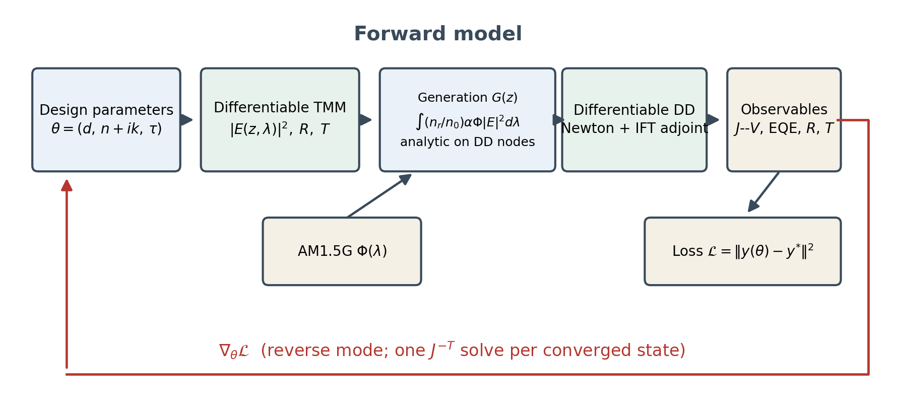
Figure 1. UniDD forward model and reverse-mode gradient path. The generation rate is evaluated analytically on the drift–diffusion nodes; the backward pass requires one transposed Jacobian solve per converged state.

2.5 Numerical configuration
Table 1 lists the reference configuration. The optical stack is air / TiO$​_{2}$ (50 nm, $\tilde{n}=2.0$) / absorber (480 nm, $\tilde{n}=2.55+ik$) / spiro-OMeTAD (150 nm, $\tilde{n}=1.5+0.005i$) / glass-equivalent substrate ($\tilde{n}=1.5$). The absorber extinction coefficient is $k(λ)=k_{amp}\text{exp}[−ReLU(λ−800)/60]+{10}^{−3}$ with $λ$ in nm and $k_{amp}=0.72$, or a six-knot piecewise-linear spectrum in the eight-parameter problem. The solar input is a coarse tabulation of the ASTM G173 AM1.5G spectrum[14] sampled at 50 nm intervals from 300 to 1000 nm and linearly interpolated onto 41 equally spaced wavelengths from 350 to 800 nm; efficiencies are normalised to the standard 100 mW cm$​^{−2}$ incident power density. The DD device uses $T=300$ K, $E_{g}=1.55$ eV, $ε_{r}=6.5$, $N_{c}=2.2×{10}^{24}$ m$​^{−3}$, $N_{v}=1.8×{10}^{25}$ m$​^{−3}$, ideal selective contacts with $n_{L}=2.2×{10}^{24}$ and $p_{R}=1.8×{10}^{25}$ m$​^{−3}$, $μ_{n}=μ_{p}=2×{10}^{−4}$ m$​^{2}$ V$​^{−1}$ s$​^{−1}$ and $τ_{n}=τ_{p}=300$ ns. All computations use float64. The complete suite is deterministic with seed 0 and requires about 25 min on one CPU core.
Table 1. Reference configuration used in the core experiments E0–E4 and the supplements E4-H, E4-C and E5.
Component | Parameter | Value
Optics | stack | air / TiO$​_{2}$ / absorber / HTL / substrate
 | layer thicknesses | 50 / 480 / 150 nm
 | absorber index | $2.55+i k(λ)$
 | wavelength grid | 41 points, 350–800 nm
 | incident spectrum | coarse AM1.5G (ASTM G173)
Device | nodes $N$ | 73 (production), 49–145 (convergence)
 | temperature | 300 K
 | band gap / $ε_{r}$ | 1.55 eV / 6.5
 | mobility $μ_{n,p}$ | $2×{10}^{−4}$ m$​^{2}$ V$​^{−1}$ s$​^{−1}$
 | SRH lifetime $τ_{n,p}$ | 300 ns
Solver | Newton tolerance | ${10}^{−9} qG_{\text{max}}$, floor $3×{10}^{2}$ A m$​^{−3}$
 | potential damping cap | 0.4 V
 | bias-continuation step | 0.05 V
 | adjoint system size | $3(N−2)=213$

3 Results and discussion

3.1 E0: external validation of the optical model
We first test the optics against quantities that do not depend on the electrical solver. Table 2 (upper block) summarises the six checks, all of which pass. With layer-by-layer integration on a 2001-point per-layer grid, $A_{field}$ agrees with $1−R−T$ to $1.44×{10}^{−6}$; the deviation falls from $1.44×{10}^{−4}$ at 201 points to $2.31×{10}^{−5}$ at 501 points and to $1.44×{10}^{−6}$ at 2001 points, consistent with the second-order convergence of the trapezoidal rule (Fig. 2a). A global integration grid that straddles material interfaces does not converge monotonically, which is why the integration is performed layer by layer.
The regression test has power: if the factor $n_{r}/n_{0}$ is omitted, the mean absorptance drops from 0.9549 to 0.3745 and the maximum deviation from $1−R−T$ rises to 0.592. For an index-matched absorbing slab the model reproduces $A=1−\text{exp}(−αd)$ to $1.57×{10}^{−8}$ with $R=0$ exactly. Finally, the difference between coherent and incoherent absorption falls from 0.167 at 200 nm thickness to $4.20×{10}^{−8}$ at 3000 nm (Fig. 2b), confirming that the coherent model degenerates to the ray-optics limit for optically thick layers.
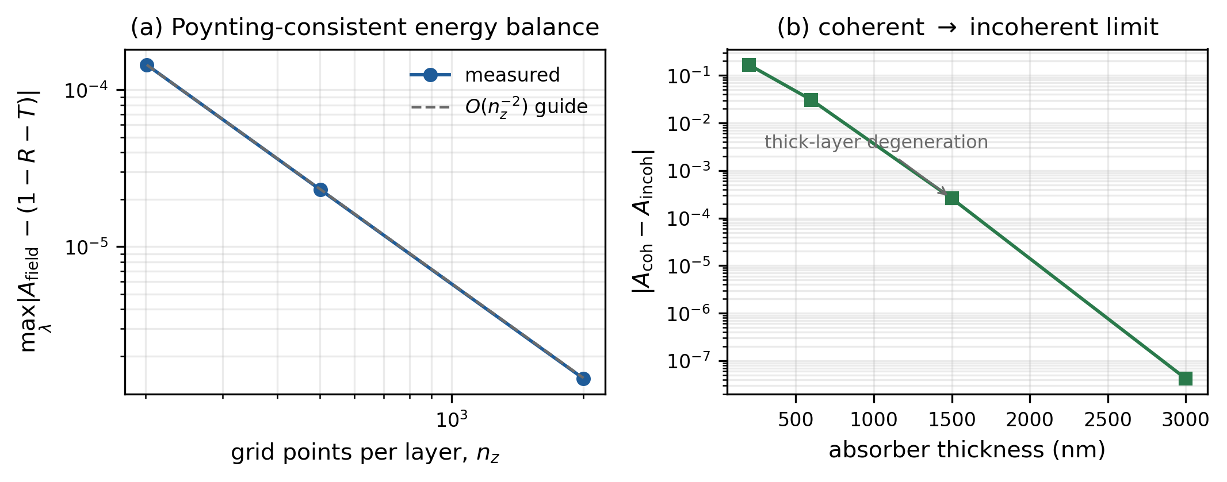
Figure 2. (a) Maximum deviation of the volume-integrated absorbed fraction from $1−R−T$ versus the number of integration points per layer; the dashed line is an $O(n_{z}^{−2})$ guide. (b) Degeneration of coherent absorption to the incoherent limit with increasing absorber thickness.

3.2 E1: gradient verification
Gradient correctness is assessed at three levels (Table 2, middle block). For the isolated TMM chain, AD and central finite differences agree to $6.73×{10}^{−11}$. For the isolated DD paths, the relative deviation is $7.60×{10}^{−6}$ (optical coupling) and $4.40×{10}^{−5}$ (electrical parameters). For the full composite chain, per-parameter derivatives agree with fourth-order Richardson-extrapolated central differences to $2.21×{10}^{−4}$ ($d_{abs}$), $2.78×{10}^{−3}$ ($k_{amp}$) and $1.30×{10}^{−4}$ ($\text{log}τ$); the directional derivative agrees to $4.27×{10}^{−4}$ (Fig. 3a).
The residual error is dominated by cancellation, not by the adjoint solve. For the thickness derivative the optical contribution is $−4.925×{10}^{−3}$ and the electrical contribution $+4.816×{10}^{−3}$: two terms of comparable magnitude subtract to give $−1.09×{10}^{−4}$, a cancellation ratio of 45.05. The adjoint equation itself is solved to a relative residual of $3.25×{10}^{−14}$ with a single iterative-refinement pass, and additional refinement passes do not improve it. Consistently, sweeping the Newton residual floor over five orders of magnitude leaves the full-chain deviation unchanged at $4.27×{10}^{−4}$ (Fig. 3b): the error is finite-difference round-off amplified by cancellation, not solver tolerance. The solver walk reaches residuals of 20.5, 614, $1.50×{10}^{4}$ and $6.52×{10}^{4}$ A m$​^{−3}$ at 0, 0.3, 0.6 and 0.9 V in 23, 15, 17 and 17 iterations, all converged on the physical scale $qG_{\text{max}}$.
This last point is worth emphasising because it changed the outcome of the study. In an earlier version of the solver, convergence was declared relative to the warm-start residual; after a bias step that residual can be ${10}^{17}$ A m$​^{−3}$, so the returned iterate had $|F|∼{10}^{8}$ and was not a root. IFT gradients evaluated there were biased by about 1.5% and did not improve when tolerances were tightened. Convergence on the physical scale with a Newton-step test (Eq. (8)) removed the bias.
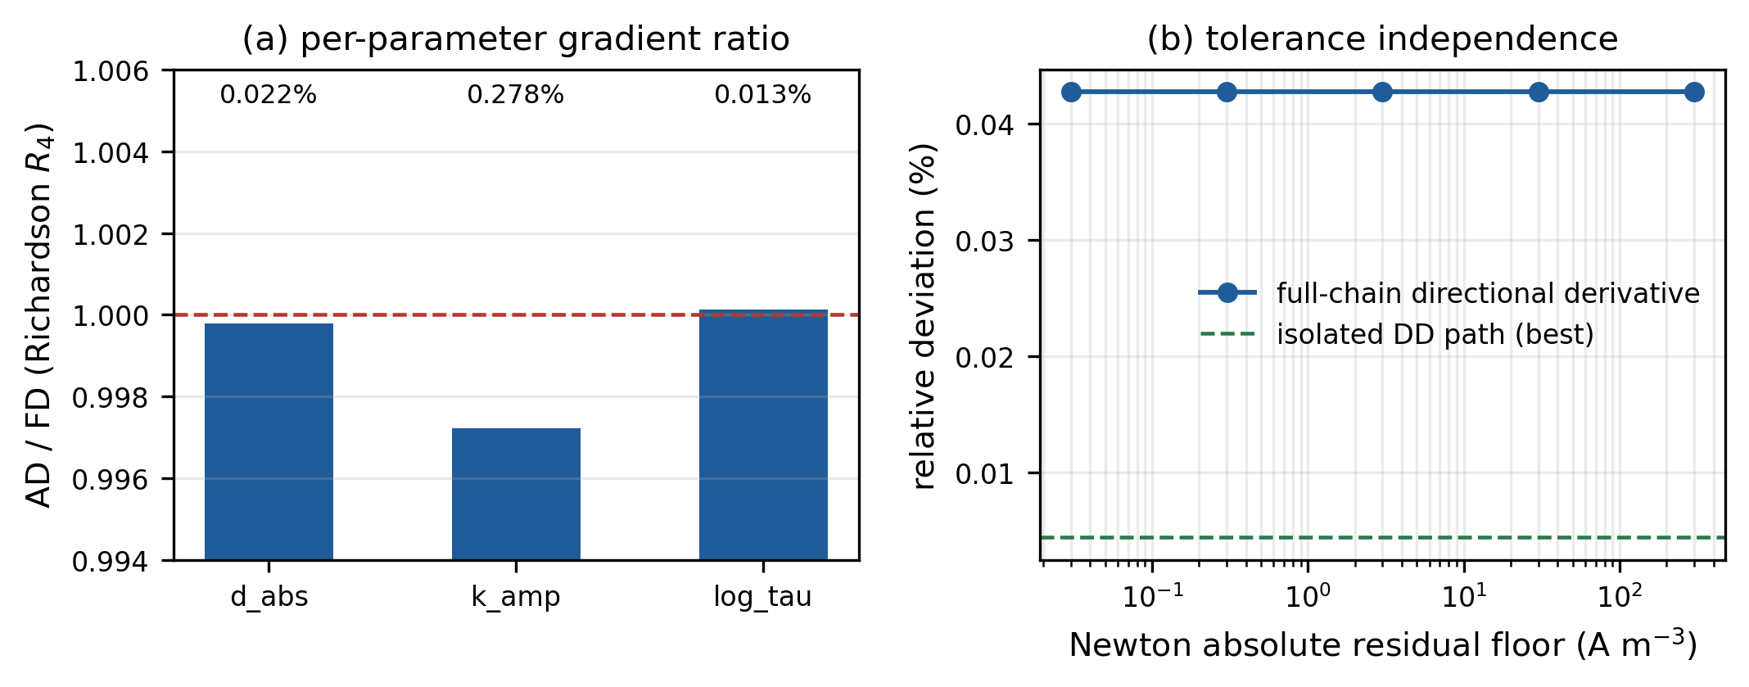
Figure 3. (a) Ratio of automatic derivatives to fourth-order Richardson finite differences for each design parameter; labels give the relative deviation. (b) Relative deviation of the full-chain directional derivative as the Newton residual floor is swept, compared with the best isolated DD path.

3.3 E2: physical validation and reference-device figures of merit
Six of seven pre-specified physical checks pass (Table 2, lower block). At thermal equilibrium the dark current is exactly zero to float64; the dark $J$–$V$ has an ideality factor of 1.208, within the expected 1–2 range. For spatially uniform generation the computed $J_{sc}=35.42$ mA cm$​^{−2}$ reaches 0.980 of the analytic limit $qGL=36.15$ mA cm$​^{−2}$. The EQE-integrated short-circuit current, 29.68 mA cm$​^{−2}$, differs from the $J$–$V$ value 29.95 mA cm$​^{−2}$ by 0.89%; the mean EQE over 21 wavelengths from 380 to 790 nm is 0.881. The optical upper bound on $J_{sc}$ obtained by assuming that every absorbed photon is collected is 32.47 mA cm$​^{−2}$, so the DD result (29.95) is consistent with, and 7.8% below, that bound. $R+T≤1$ holds at every wavelength, with mean $R=0.0436$ and mean $T=0.0010$.
For the reference stack the illuminated $J$–$V$ (Fig. 4a) gives $J_{sc}=29.95$ mA cm$​^{−2}$, $V_{oc}=1.110$ V, $FF=0.835$ and $η=27.74\%$, with the maximum-power point at 1.00 V and 27.74 mA cm$​^{−2}$. These numbers must be read as synthetic illustrations: the incident spectrum is a coarse 350–800 nm tabulation, radiative and Auger recombination, surface recombination, series resistance and a band-gap cutoff are absent, and the efficiency is normalised to the conventional 100 mW cm$​^{−2}$ irradiance. They are not a device-efficiency prediction and are far from constituting a claim against detailed-balance limits[21,22].
The one check that does not pass as originally formulated is the mesh criterion, which required the short-circuit current at $N=49$ and $N=97$ to agree within 2%; the measured change is 2.48%. We therefore extended the study to $N=145$ (Fig. 4b). $J_{sc}$ increases monotonically as 29.417, 29.950, 30.164, 30.268 and 30.324 mA cm$​^{−2}$ for $N=49,73,97,121,145$; the observed order is 2.72 and Richardson extrapolation gives 30.412 mA cm$​^{−2}$. The production grid ($N=73$) therefore carries a 1.52% discretisation uncertainty, while the change from $N=73$ to the next refinement ($N=97$) is only 0.71%. The original failure is attributable to an under-resolved coarsest grid rather than to an inconsistent discretisation, and we report the uncertainty explicitly.
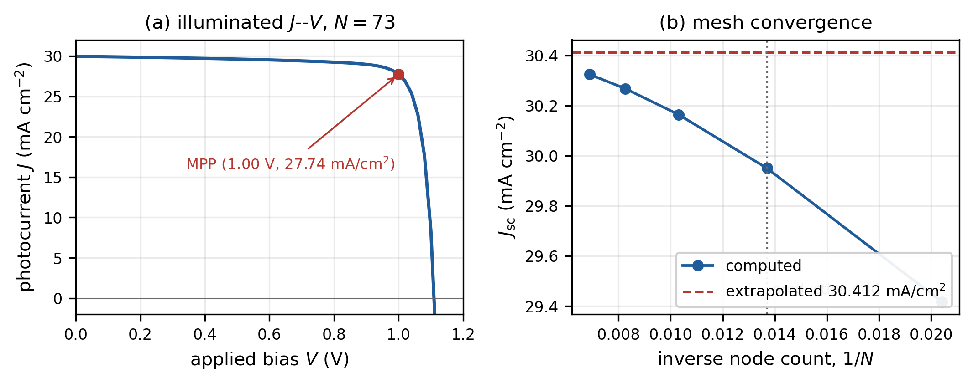
Figure 4. (a) Illuminated $J$–$V$ characteristic of the reference stack on the production grid and its maximum-power point. (b) Mesh convergence of $J_{sc}$; the dashed line is the Richardson-extrapolated limit and the dotted line marks the production grid.
Table 2. Validation summary. E0: external optical checks; E1: gradient checks; E2: physical checks. “Pass” refers to the pre-specified criteria.
Test | Observed value | Criterion | Pass
E0 — optics (6/6 pass)
$A_{field}$ vs. $1−R−T$, 2001 pts | $1.44×{10}^{−6}$ | $<{10}^{−4}$ | yes
grid convergence of the above | $1.44​×​{10}^{−4}→1.44​×​{10}^{−6}$ | monotone | yes
regression power without $n_{r}/n_{0}$ | max dev. 0.592 | $>0.1$ | yes
Beer–Lambert, index-matched slab | $1.57×{10}^{−8}$ | $<{10}^{−6}$ | yes
index-matched reflection | 0 | $<{10}^{−10}$ | yes
coherent $→$ incoherent, 3000 nm | $4.20×{10}^{−8}$ | $<{10}^{−6}$ | yes
E1 — gradients (pass)
pure TMM chain, AD vs. FD | $6.73×{10}^{−11}$ | $<{10}^{−6}$ | yes
isolated DD optical path | $7.60×{10}^{−6}$ | $<{10}^{−3}$ | yes
isolated DD electrical path | $4.40×{10}^{−5}$ | $<{10}^{−3}$ | yes
full chain, worst per parameter | $2.78×{10}^{−3}$ | $<{10}^{−2}$ | yes
full chain, directional | $4.27×{10}^{−4}$ | $<{10}^{−2}$ | yes
adjoint relative residual | $3.25×{10}^{−14}$ | $<{10}^{−9}$ | yes
E2 — physics (6/7 pass)
$R+T≤1$ at every $λ$ | yes | yes | yes
equilibrium dark current | 0 A m$​^{−2}$ | $<{10}^{−6}$ | yes
dark ideality factor | 1.208 | 1–2 | yes
uniform-$G$ $J_{sc}/qGL$ | 0.980 | $±5\%$ | yes
EQE vs. $J$–$V$ $J_{sc}$ | 0.89% | $<5\%$ | yes
$J_{sc}≤1.02×$ optical bound | 29.95 vs. 32.47 | yes | yes
$N=49$ vs. $N=97$ $J_{sc}$ change | 2.48% | $<2\%$ | no

3.4 E3: three-parameter inverse design
The synthetic target is $(d^{*},k^{*},τ^{*})=(480 nm, 0.72, 300 ns)$; the starting point is $(300 nm, 0.35, 1.5 μs)$. With the full observable set of Eq. (11), L-BFGS driven by exact IFT gradients reduces the loss from $6.45×{10}^{−3}$ to $3.32×{10}^{−13}$ in 44 function/gradient evaluations (106 s). The recovered values are $d=479.990$ nm, $k=0.720015$ and $τ=3.0000×{10}^{−7}$ s, i.e. relative errors of $2.02×{10}^{−5}$, $2.12×{10}^{−5}$ and $3.93×{10}^{−7}$ in $\text{log}τ$ (Table 3). All three parameters are recovered to within 0.002%.
This result depends on the inclusion of $R(λ)$ and $T(λ)$. With $J$–$V$ and EQE alone, a thinner and more strongly absorbing layer produces nearly indistinguishable electrical observables, and the $(d,k)$ pair is only weakly identifiable. Reflectometry and transmission measurements are routine and, because they are computed directly by the TMM recursion, they add no DD solves. The identifiability analysis is itself a useful output of having exact gradients.
Table 3. Three-parameter inverse design (E3).
Parameter | Target | Recovered | Relative error
$d$ (nm) | 480.0 | 479.990 | $2.02×{10}^{−5}$
$k_{amp}$ | 0.72 | 0.720015 | $2.12×{10}^{−5}$
$τ$ (s) | $3.0000×{10}^{−7}$ | $2.999999×{10}^{−7}$ | $3.93×{10}^{−7}$ in $\text{log}τ$
final loss | $3.32×{10}^{−13}$ after 44 evaluations (106 s)

3.5 E4: evaluation-count benchmark
The derivative-free baseline is counted in true function calls. A Nelder–Mead iteration is not a function evaluation: a shrink step costs $n+1$ objective calls. Earlier results in this project recorded one history entry per iteration and were therefore optimistic about the baseline by a large factor. The benchmark reported here records the cumulative number of $f()$ calls after every call (Fig. 5).
In the three-dimensional problem, L-BFGS reaches a loss of ${10}^{−3}$ in 7 calls and ${10}^{−4}$ in 16, whereas Nelder–Mead reaches ${10}^{−3}$ in 7 calls but never reaches ${10}^{−4}$ within 150 calls (best $1.23×{10}^{−4}$). At the common budget of 49 calls the losses are $9.53×{10}^{−15}$ and $1.25×{10}^{−4}$. Because the derivative-free run is censored, the call-count advantage at ${10}^{−4}$ is at least $150/16=9.4×$, at ${10}^{−5}$ at least $7.9×$, and at ${10}^{−6}$ at least $7.5×$.
In the eight-dimensional problem (thickness, lifetime and six spectral knots), L-BFGS reaches ${10}^{−3}$ in 7 calls against 21 for Nelder–Mead, a $3.0×$ advantage, and at the common budget of 44 calls attains $1.85×{10}^{−4}$ against $6.35×{10}^{−4}$. Neither method reaches ${10}^{−4}$: L-BFGS stalls at $1.85×{10}^{−4}$ after 44 calls and Nelder–Mead at $2.24×{10}^{−4}$ after 300 calls. The recovered thickness is 394.9 nm against a target of 460 nm (14.2% error) and the six spectral knots are poorly recovered. The pre-specified target of a $≥10×$ evaluation reduction in eight dimensions is therefore not met, and we do not claim it. The measured forward-plus-adjoint cost is a factor of 1.10 over a single forward solve (forward 2.21 s, forward+backward 2.43 s in the 3-D case), not the 1.05 quoted in earlier internal notes.
Table 4 gives the exact counts. The conclusion is that exact IFT gradients give a clear advantage for tight tolerances in low dimension and a modest (about $3×$) advantage at moderate accuracy in eight dimensions, at a 10% cost per evaluation. The eight-dimensional problem also exposes weak identifiability of a spectrally resolved extinction coefficient from the present observable set; more informative observables or regularisation would be needed before claiming practical high-dimensional reconstruction.
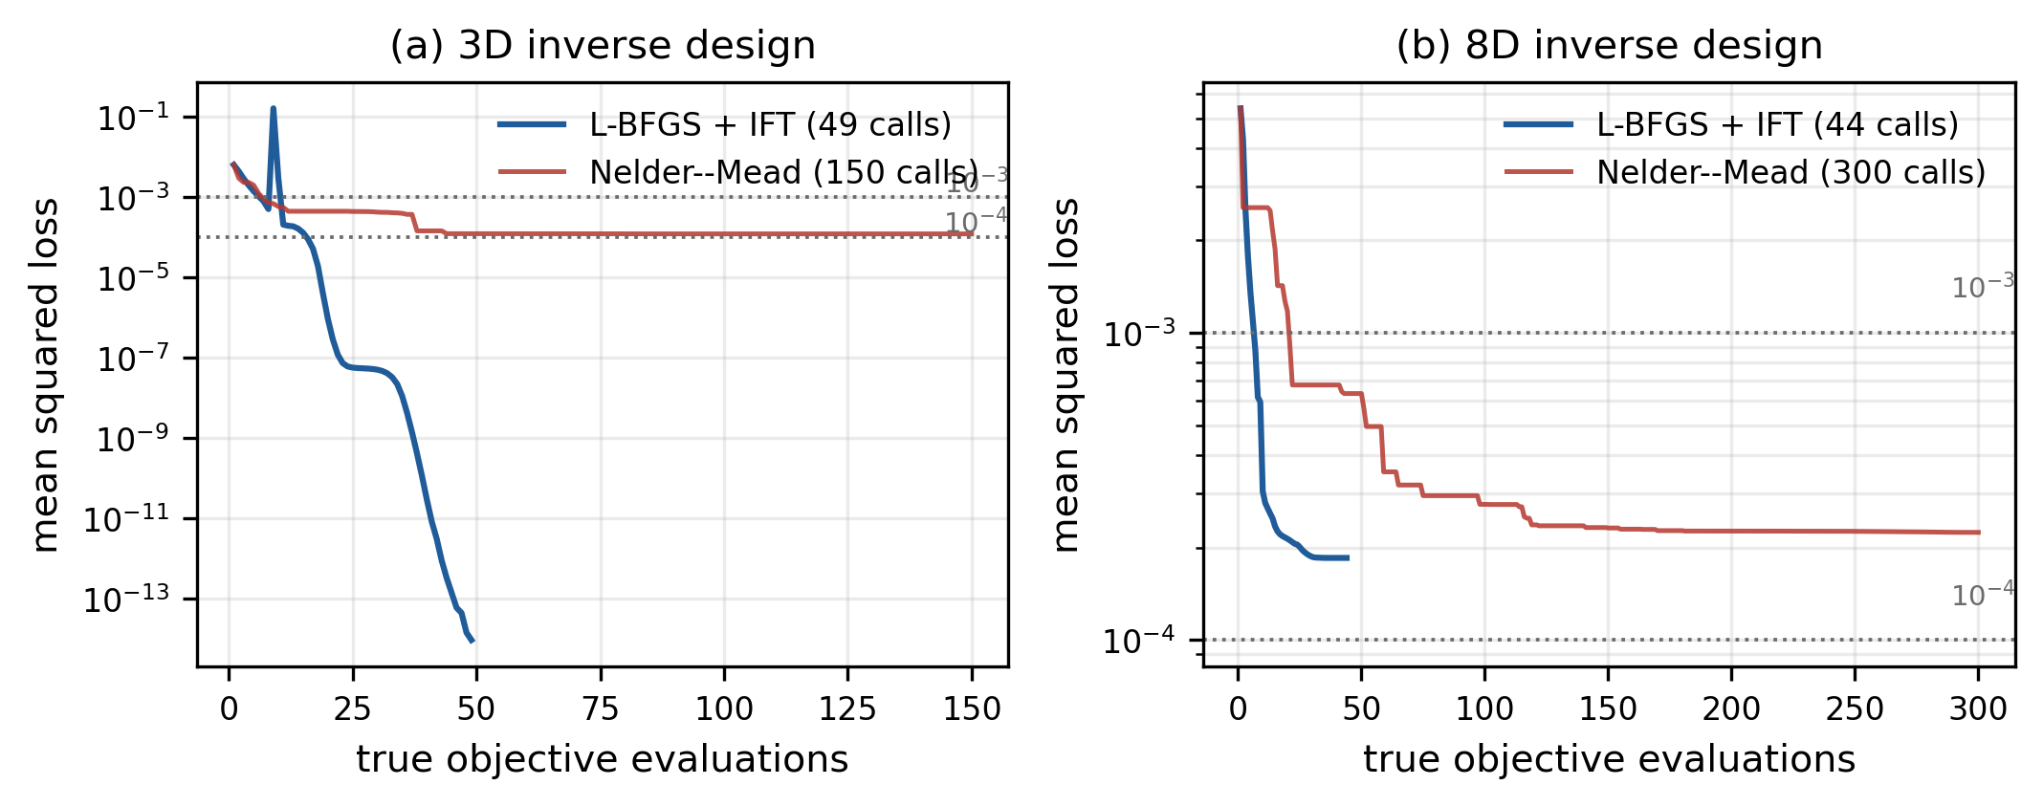
Figure 5. Mean squared loss versus the true number of objective evaluations for (a) the three-parameter and (b) the eight-parameter inverse problems. Dotted lines mark losses of ${10}^{−3}$ and ${10}^{−4}$.
Table 4. Evaluation-count benchmark (E4). “n.r.” = not reached within the stated budget.
Quantity | 3-D | 8-D
budget (L-BFGS / NM), calls | 49 / 150 | 44 / 300
final loss, L-BFGS | $9.53×{10}^{−15}$ | $1.85×{10}^{−4}$
final loss, NM | $1.23×{10}^{−4}$ | $2.24×{10}^{−4}$
calls to ${10}^{−3}$ (L-BFGS / NM) | 7 / 7 | 7 / 21
calls to ${10}^{−4}$ (L-BFGS / NM) | 16 / n.r. | n.r. / n.r.
loss at common budget, L-BFGS | $9.53×{10}^{−15}$ | $1.85×{10}^{−4}$
loss at common budget, NM | $1.25×{10}^{−4}$ | $6.35×{10}^{−4}$
forward-plus-adjoint cost factor | 1.10 | 1.10
$≥10×$ criterion | not met | not met

3.6 A pre-specified high-dimensional supplement (E4-H)
The verdict of Section 3.5 is unchanged: with the original protocol the $≥10×$ target is not met in three or eight dimensions. That section also identifies two obstacles to high-dimensional inversion, namely weak identifiability of a spectrally resolved extinction coefficient from the available observables and the non-differentiable piecewise-linear spectrum used at the wavelength knots. We therefore ran a separate supplement whose protocol was fixed before execution and recorded in the accompanying result file, to test whether exact gradients become decisive when the design space is enlarged and the inverse problem is made better posed. The design space has 16 parameters (thickness, 14 smooth Gaussian radial-basis spectral coefficients and lifetime), the $R/T$ observables are sampled at 16 wavelengths, and both optimisers start from the same point. The loss, the threshold ladder, the optimiser settings and the per-call bookkeeping are those of Section 3.5; the budgets were increased for both methods, to 200 calls for L-BFGS and 600 for Nelder–Mead.
L-BFGS with exact IFT gradients reached ${10}^{−4}$ in 23 calls, ${10}^{−5}$ in 34 and ${10}^{−6}$ in 45, ending at $1.40×{10}^{−7}$ after 65 calls. Nelder–Mead did not reach ${10}^{−4}$ within its 600 calls (best $1.19×{10}^{−4}$); at the common budget of 65 calls its best loss was $7.75×{10}^{−4}$. Under the same censoring rule as in E4 these counts give lower bounds of $26.1×$, $17.6×$ and $13.3×$ at the three tight thresholds, so the $≥10×$ criterion is met in this supplementary setting. These are bounds rather than measured ratios: at the loosest informative threshold, ${10}^{−3}$, both methods succeeded and the measured advantage was $8.57×$ (7 against 60 calls). The derivative-free run was censored only marginally above ${10}^{−4}$, and a forward-plus-adjoint evaluation cost 1.22 times a forward solve.
This supplement does not revise E4. Dimension, spectral parametrisation and the number of $R/T$ observables were changed together, so the result does not isolate dimension as the cause of the improvement; all targets remain synthetic inverse crimes. A controlled study varying one factor at a time, with multiple starting points and measurement noise, is still needed before a general efficiency claim can be made.

3.7 Controlled-dimension and robustness supplements (E4-C, E5)
The E4-H supplement changed the design dimension, the spectral parametrisation and the number of $R/T$ observables at the same time, so its censored PASS could not be attributed to dimension alone. E4-C removes that ambiguity. Both arms use the same RBF basis and width, the same true spectrum, the same start point, the same 44 normalised observables, the same loss, the same optimiser settings and the same evaluation budgets; the only factor that differs is the number of free design variables. The 8-D spectral coefficients are mapped into the 14-dimensional RBF coefficient space by a fixed row-normalised Gaussian matrix, so the 8-D arm is an exact linear subspace of the 16-D arm rather than a differently parametrised problem. The two synthetic targets agree to $|Δy|_{\text{max}}=0$, and a constant coefficient vector maps to itself to $1.1×{10}^{−16}$. The experiment is deliberately noise-free, because its purpose is to isolate one factor; noise and multiple starts are handled separately in E5.
Table 5. E4-C evaluation counts to reach a target loss. Each cell gives the Nelder–Mead count (numerator) over the L-BFGS count (denominator), so the quoted ratio is the evaluation-count advantage of the gradient-based method. Entries marked $≥$ are censored lower bounds, not measured ratios: the derivative-free run stopped at its budget before reaching that loss.
Target loss | 8-D | 16-D
0.01 | 1/1 = 1.00$×$ (measured) | 1/1 = 1.00$×$ (measured)
${10}^{−3}$ | 25/7 = 3.57$×$ (measured) | 60/7 = 8.57$×$ (measured)
${10}^{−4}$ | $≥$301/25 = $≥$12.04$×$ (censored) | $≥$300/23 = $≥$13.04$×$ (censored)
${10}^{−5}$ | not reached | $≥$300/33 = $≥$9.09$×$ (censored)
${10}^{−6}$ | not reached | $≥$300/43 = $≥$6.98$×$ (censored)
L-BFGS used 67 (8-D) and 64 (16-D) forward/adjoint evaluations, and Nelder–Mead used 301 and 300 function calls, reaching best losses of $3.0×{10}^{−4}$ and $2.2×{10}^{−4}$. Of the 10 arm–threshold combinations, 4 yield a measured ratio (2 of which are the trivial first-call row at the loosest threshold), 4 are censored, and the remaining 2 (both in the 8-D arm) reached the target loss with neither optimiser (“not reached”). The four censored entries comprise the ${10}^{−4}$ row of both arms and the two stricter thresholds of the 16-D arm. Measured, uncensored comparisons are available at 1 informative threshold: at ${10}^{−3}$ the measured advantage is 3.57$×$ (8-D) against 8.57$×$ (16-D). The 16-D advantage is larger at every such threshold, consistent with a dimension effect under this fixed-observation protocol. At ${10}^{−3}$ L-BFGS used 7 and 7 calls in the two arms, whereas Nelder–Mead used 25 and 60. The ratio grows because the derivative-free simplex needs more calls as the dimension increases, while the gradient-based count is unchanged. Because the 8-D arm is a subspace of the 16-D one, the higher-dimensional problem is less constrained, which also lowers its final loss ($1.5×{10}^{−7}$ versus $2.7×{10}^{−5}$). This is a single-start, noise-free, single-model result, not a general efficiency claim. At ${10}^{−4}$ and stricter losses the derivative-free run is censored in both arms, so the recorded 12.04$×$ (8-D) and 13.04$×$ (16-D) are lower bounds rather than measured ratios; the E4-H PASS at that threshold therefore remains a censored result.
E5 addresses a different question: whether the picture survives changes of start point, observation noise and the choice of derivative-free comparator. Two deterministically perturbed starts were run against 5 baselines (Nelder–Mead, Powell, differential evolution, dual annealing and an in-house RBF–UCB surrogate), each with a budget of 80 true function calls and 1% relative Gaussian observation noise. At the common budget the smallest mean best loss was 6.540e-04 (Powell) and the largest was 1.001e-03 (DualAnnealing); 7 of 10 runs reached ${10}^{−3}$ and 0 of 10 reached ${10}^{−4}$. Because the noisy objective has a loss floor, E5 is used as robustness evidence only; no speedup is claimed from it. The RBF–UCB baseline is a lightweight in-house implementation, not a tuned Bayesian-optimisation library.
Neither supplement changes the main verdict: the $≥10×$ target is not met in eight dimensions, and the E4-H PASS remains a censored lower bound. All targets are synthetic inverse crimes; no SCAPS-1D cross-validation or experimental calibration has been performed.

4 Limitations and scope
The present study is a methods paper and has four classes of limitation.
Synthetic validation. All targets are generated by the same forward model, so the inverse-design experiments are inverse crimes: they establish that the gradients are correct and that the optimisation machinery works, but they do not establish identifiability from measured data. No comparison with experimental $J$–$V$, EQE or ellipsometry data, and no cross-validation against SCAPS-1D or another drift–diffusion code, has been performed. A reproducible protocol for that comparison is distributed with the code; executing it remains the most important next step before the framework can be used for device design.
Physical model. The device model is one-dimensional, isothermal and steady-state, with ideal selective ohmic contacts, Boltzmann statistics, equal electron and hole mobilities, a single SRH lifetime and no radiative or Auger recombination, no surface or grain-boundary recombination, no ionic migration, no series/shunt resistance and no explicit band-gap cutoff in the absorption spectrum. The solar input is a coarse 50-nm-sampled AM1.5G table interpolated onto a 41-point grid spanning 350–800 nm. Consequently the absolute figures of merit in Section 3.3 are illustrative; they should not be compared with measured efficiencies or with detailed-balance limits.
Numerics. The adjoint is formed by a dense $3(N−2)$ solve, which is adequate at $N=73$ but scales cubically. Extensions to two-dimensional devices would require sparse or matrix-free adjoint solves. The production grid carries a 1.52% uncertainty in $J_{sc}$ relative to the Richardson-extrapolated value. The full-chain thickness gradient suffers a cancellation ratio of 45 between optical and electrical contributions, which makes it sensitive to finite-difference round-off even though the adjoint itself is solved to ${10}^{−14}$.
Benchmark scope. The $≥10×$ evaluation-count target is not met in eight dimensions; the main E4 benchmark compares a single starting point, a single noise-free synthetic target and two optimisers. The E4-C and E5 supplements of Section 3.7 add a one-factor dimension control, multiple starts, measurement noise and five derivative-free baselines. They are robustness evidence and do not revise the $≥10×$ verdict stated above.

5 Conclusions
We have shown that a fully coupled drift–diffusion solver can be made exactly differentiable at a 10% overhead by combining log-density variables, factored Scharfetter–Gummel currents, equilibrated damped Newton iterations converged on a physical residual scale, and implicit-function-theorem backpropagation. Coupled to a Poynting-consistent, fully differentiable transfer-matrix optical model evaluated analytically on the electrical mesh, the resulting framework retains both thin-film interference and self-consistent carrier physics without interpolation or surrogates. External optical checks pass to ${10}^{−6}$–${10}^{−8}$, composite gradients agree with high-order finite differences to ${10}^{−4}$–${10}^{−3}$, and the physical checks reproduce zero equilibrium dark current, a diode ideality factor of 1.208, the $qGL$ limit to 2% and EQE/$J$–$V$ current consistency to 0.89%. Three-parameter inverse design recovers all parameters to within 0.002% in 44 evaluations.
The study also identifies where the approach does not yet deliver: the high-dimensional gradient advantage is about $3×$ rather than an order of magnitude, the eight-parameter spectral reconstruction is weakly identifiable, the production mesh carries a 1.52% discretisation uncertainty, and no experimental validation has been performed. UniDD is best read as a validated differentiable modelling kernel whose immediate uses are sensitivity analysis, identifiability studies, and gradient-based co-design within the model, with experimental calibration and sparse high-dimensional adjoints as the natural next steps. The E4-C and E5 supplements add a controlled dimension comparison and a noisy multi-start robustness study; they qualify but do not overturn this picture, and the high-dimensional PASS remains a censored lower bound rather than a measured speedup.

Declaration of competing interest
The authors declare that they have no known competing financial interests or personal relationships that could have appeared to influence the work reported in this paper.

CRediT authorship contribution statement
Qiong Yan: Methodology, Software, Validation, Formal analysis, Writing – original draft. Peide Yang: Conceptualization, Methodology, Supervision, Writing – review & editing, Corresponding author.

Funding
This research did not receive any specific grant from funding agencies in the public, commercial, or not-for-profit sectors.

Data availability
The complete deterministic experiment suite, the recorded result files, the figure-generation scripts and the consistency-check script accompany the submission and are publicly available from the versioned repository https://github.com/qiantanzhijiao/TMM-DD-Codesign at the time of submission, under the MIT licence; the source archive accompanies the submission for deposition in the CPC Program Library by the Technical Editor; a versioned Zenodo archive with a DOI will be linked before publication. All numerical values quoted in this paper are generated by experiments_final.py and experiments_supplement.py. The repository also distributes a reproducible cross-code protocol for SCAPS-1D: it builds a single-layer device matched to the UniDD drift–diffusion domain, imports the UniDD generation profile in SI units, exports native SCAPS curves and graphs through the SCAPS script interface, and applies acceptance criteria fixed before execution. No SCAPS-1D results are reported in this work; the protocol is provided so that the comparison can be repeated independently once a licensed SCAPS installation is available.

Generative AI disclosure
Generative AI tools were used to assist with language editing and with the preparation of manuscript source files. All physical models, numerical experiments, results and scientific conclusions were conceived, implemented and verified by the authors, who take full responsibility for the content.

References
[1] M. A. Green, A. Ho-Baillie, H. J. Snaith, The emergence of perovskite solar cells, Nature Photonics 8 (2014) 506–514. doi:10.1038/nphoton.2014.134.
[2] S. J. Byrnes, Multilayer optical calculations, arXiv:1603.02720, version 5 (30 December 2020). doi:10.48550/arXiv.1603.02720.
[3] L. A. A. Pettersson, L. S. Roman, O. Inganäs, Modeling photocurrent action spectra of photovoltaic devices based on organic thin films, Journal of Applied Physics 86 (1999) 487–496. doi:10.1063/1.370757.
[4] Sachchidanand, A. Kumar, P. Sharma, Transfer matrix method-based efficiency enhancement of lead-free Cs$​_{3}$Sb$​_{2}$Br$​_{9}$ perovskite solar cell, Solar Energy 259 (2023) 63–71. doi:10.1016/j.solener.2023.05.014.
[5] A. Jangjoy, S. Matloub, Optical simulation and design of high-absorption thin-film perovskite halide solar cells based on embedded quadrilateral cluster nanoparticles, Solar Energy 242 (2022) 10–19. doi:10.1016/j.solener.2022.07.004.
[6] M. Burgelman, P. Nollet, S. Degrave, Modelling polycrystalline semiconductor solar cells, Thin Solid Films 361–362 (2000) 527–532. doi:10.1016/S0040-6090(99)00825-1.
[7] G. Pindolia, S. M. Shinde, P. K. Jha, Optimization of an inorganic lead free RbGeI$​_{3}$ based perovskite solar cell by SCAPS-1D simulation, Solar Energy 236 (2022) 802–821. doi:10.1016/j.solener.2022.03.053.
[8] N. Kaur, R. Pandey, M. K. Hossain, J. Madan, Machine learning-aided optimization for transport layer parameters of low lead inorganic Zn-based mixed-halide perovskite solar cell, Solar Energy 264 (2023) 112055. doi:10.1016/j.solener.2023.112055.
[9] S. Mann, E. Fadel, S. S. Schoenholz, E. D. Cubuk, S. G. Johnson, G. Romano, $∂$PV: An end-to-end differentiable solar-cell simulator, Computer Physics Communications 272 (2022) 108232. doi:10.1016/j.cpc.2021.108232.
[10] M. L. Schubert, H. Metni, J. D. Fischbach, et al., Towards a fully differentiable digital twin for solar cells, arXiv:2512.02904 (2025); conference version in Computational Optics 2026, Proceedings of SPIE PC14110, PC1411002 (2026). doi:10.48550/arXiv.2512.02904; doi:10.1117/12.3099007.
[11] S. Liu, X. Chen, S. Liu, TFSolver: a numerical Python toolkit for parallel electromagnetic calculation of planar multilayer thin films at multi-wavelength and multi-angle, Optics Express 33(25) (2025) 52061–52074. doi:10.1364/OE.578518.
[12] S. Molesky, Z. Lin, A. Y. Piggott, W. Jin, J. Vučković, A. W. Rodriguez, Inverse design in nanophotonics, Nature Photonics 12 (2018) 659–670. doi:10.1038/s41566-018-0246-9.
[13] P. Löper, M. Stuckelberger, B. Niesen, et al., Complex refractive index spectra of CH$​_{3}$NH$​_{3}$PbI$​_{3}$ perovskite thin films determined by spectroscopic ellipsometry and spectrophotometry, The Journal of Physical Chemistry Letters 6 (2015) 66–71. doi:10.1021/jz502471h.
[14] ASTM International, Standard Tables for Reference Solar Spectral Irradiances: Direct Normal and Hemispherical on 37$​^{∘}$ Tilted Surface, ASTM G173-03(2020), West Conshohocken, PA, 2020. doi:10.1520/G0173-03R20.
[15] R. E. Bank, D. J. Rose, W. Fichtner, Numerical methods for semiconductor device simulation, IEEE Transactions on Electron Devices 30 (1983) 1031–1041. doi:10.1109/T-ED.1983.21257.
[16] S. Selberherr, Analysis and Simulation of Semiconductor Devices, Springer, Wien, 1984. doi:10.1007/978-3-7091-8752-4.
[17] D. L. Scharfetter, H. K. Gummel, Large-signal analysis of a silicon Read diode oscillator, IEEE Transactions on Electron Devices 16 (1969) 64–77. doi:10.1109/T-ED.1969.16566.
[18] S. Bai, J. Z. Kolter, V. Koltun, Deep equilibrium models, in: Advances in Neural Information Processing Systems 32 (NeurIPS 2019), 2019; arXiv:1909.01377.
[19] D. C. Liu, J. Nocedal, On the limited memory BFGS method for large scale optimization, Mathematical Programming 45 (1989) 503–528. doi:10.1007/BF01589116.
[20] J. A. Nelder, R. Mead, A simplex method for function minimization, The Computer Journal 7 (1965) 308–313. doi:10.1093/comjnl/7.4.308.
[21] W. Shockley, H. J. Queisser, Detailed balance limit of efficiency of $p$-$n$ junction solar cells, Journal of Applied Physics 32 (1961) 510–519. doi:10.1063/1.1736034.
[22] A. Richter, M. Hermle, S. W. Glunz, Reassessment of the limiting efficiency for crystalline silicon solar cells, IEEE Journal of Photovoltaics 3 (2013) 1184–1191. doi:10.1109/JPHOTOV.2013.2270351.
[23] M. Benaissa, M. Maoudj, A. E. Noua, DriftJax: A Differentiable 1-D Drift–Diffusion Solar-Cell Simulator in JAX, version v0.1.18 (19 September 2026), Zenodo. doi:10.5281/zenodo.22839528 (version DOI); doi:10.5281/zenodo.22762674 (concept DOI); https://github.com/medmo13/driftjax (accessed 8 November 2026).

