ADSP Debugging Guideline

Version: 1.2
Release date: 2025-04-23

MediaTek Confidential A

Version History
Version | Date | Description
1.0 | 2022-06-16 | Official release
1.1 | 2023-06-12 | Add case study part for common issues and debug method reference
1.2 | 2025-04-23 | Add RV debug information at 5.Exception dump extractor  Add Task Monitor/Heap Memory Usage phase out information
MediaTek Confidential A

Table of Contents
Version History 2
Table of Contents 3
1 Preface 6
2 Logging 7
2.1 Overview 7
3 Task Monitor 8
3.1 DSP Loading Profiling and SW Activities 8
3.2 Task Status Monitor by Logging 8
4 Heap Memory Usage 9
4.1 Monitor Heap Memory along with Task Monitor Log 9
4.2 Detailed Information of Allocated Memory 9
5 Exception Dump Extractor 10
5.1 ADSP EE log 10
5.2 Exception Dump Analysis (Hifi) 12
5.2.1 Exception Vector 12
5.2.2 Exception Cause Table 13
5.2.3 Exception Register 14
5.2.4 Exception Flow and Assertion Implementation 14
5.3 Exception Dump Analysis (RV) 16
5.3.1 Exception Cause Table (RV) 16
5.3.2 Exception Register (RV) 17
6 Case Study 18
6.1 Performance Issue Overview 18
6.2 Heap Malloc Fail 18
6.3 ADSP MPU Exception 20
6.4 IPI Message Queue Overflow 22
6.5 WDT ISR Trigger EE 24
6.6 Stack Overflow 25
6.7 Device APC Violation 27
6.8 EMIMPU Violation 28
6.9 DMA Transfer Timeout 29
6.10 ADSP EE Trigger HAL Lock Timeout 30
6.11 Insufficient ADSP System Ram Size 30
7 Issue Feedback to MTK 33

List of Figures
Figure 3-1. Example of Task Status Monitor 9
MediaTek Confidential A
Figure 4-1. Example Task Heap Memory Usage Monitor 10
Figure 4-2. Example of Detailed Information of Allocated Memory 10
Figure 5-1. Example of ADSP Dump Extraction Result 11
Figure 5-2-2 Example of ADSP Dump Extraction Result (RV) 12
Figure 5-3. Example of ADSP Exception in adsp log 13
Figure 5-4. Exception Cause Procedure 14
Figure 5-5. Exception Flow - ADSP 15
Figure 5-6. Exception Flow – ADSP Core A Exception Example 16
Figure 5-7. Assertion implementation 16
Figure 5-8 Example of ADSP(RV) Exception in adsp log 17
Figure 6-1. Heap Malloc Fail Example Log 19
Figure 6-2. Malloc Fail Debug reference 20
Figure 6-3. Example of Memory Selection Algorithm 20
Figure 6-4. GDB Tool for Heap Analysis 20
Figure 6-5. Memory Leakage Example Log 21
Figure 6-6. ADSP MPU Exception Example Log 21
Figure 6-7. ADSP MPU Violation Debug reference 22
Figure 6-8. GDB Tool for Backtrace 22
Figure 6-9. ADSP MPU Table Dump Example 23
Figure 6-10. Message Queue Overflow Example Log 23
Figure 6-11. Queue Overflow Debug reference 24
Figure 6-12. Phone Call Scenario Runtime Profile by Ftrace 24
Figure 6-13. WDT Timeout Example Log - 1 25
Figure 6-14. WDT Timeout Example Log - 2 25
Figure 6-15. WDT Timeout Debug reference 25
Figure 6-16. Stack Overflow Example Log 26
Figure 6-17. Stack Overflow Issue Debug reference 26
Figure 6-18. GDB Tool for Stack Overflow Analysis 27
Figure 6-19. Example of adsp_analysis.txt 27
Figure 6-20. Example of adsp_heap_info.txt 27
Figure 6-21. Example of pxStack 27
Figure 6-22. Device APC Violation Example Log 28
Figure 6-23. Device APC Violation Debug reference 28
Figure 6-24. EMIMPU Violation Example Log 29
Figure 6-25. Example of EMIMPU Backtrace in out.json 29
Figure 6-26. Example of emi_mpu_output 29
Figure 6-27. DMA Transfer Timeout Example Log 30
Figure 6-28. HAL Lock Timeout Example Log 31
Figure 6-29. HAL Lock Timeout Root Cause Reference 31
Figure 6-30. Example of HAL Query ADSP State 31
Figure 6-31. Insufficient ADSP Sysram Size Example Log 32
Figure 6-32. Reference Solution of Insufficient ADSP Sysram 32
Figure 6-33. ADSP Image Size Example Log 32

List of Tables

Table 2-1. Log Level 8
Table 5-1. Exception Vector 14
Table 5-2. Exception Cause Table 14
Table 5-3. Exception Register Table 15
Table 5-4 Exception Cause Table (RV) 17
Table 5-5 Exception Register Table (RV) 18
Table 6-1. ADSP Secure Region Permission and AID Reference 30

Preface
- To enable the functionality for detailed debug info, we need to enable some configurations, they’re usually located in
  - project\mt6xxx\HIFI3_A\platform\platform.mk ##HiFi3 DSP A
  - project\mt6xxx\HIFI3_B\platform\platform.mk ##HiFi3 DSP B
  - project\mt6xxx\HIFI3_A\platform\platform.mk ##HiFi5 DSP A
  - project\mt6xxx\HIFI3_B\platform\platform.mk ##HiFi5 DSP B
  - project\mt6xxx\HIFI3_A\platform\inc\FreeRTOSConfig.h ##HiFi3 DSP
  - project\mt6xxx\HIFI5_A\platform\inc\FreeRTOSConfig.h ##HiFi5 DSP
  - project\mt6xxx\RV55_A\platform\platform.mk ##RV55 DSP A
  - project\mt6xxx\RV55_B\platform\platform.mk ##RV55 DSP B
  - project\mt6xxx\RV55_A\platform\inc\FreeRTOSConfig.h ##RV55 DSP
- Please remember to enable all DSP core configurations if you want to enable the debug function in all DSP cores

Logging

Overview
- UART log
  - Port
    - 23P: please use UART3
    - Other platforms: please use UART2
  - Baudrate: 921600
  - Configuration
    - CFG_UART_SUPPORT = yes
    - HIFI Series
      - project\mt6xxx\HIFIx_A\platform\platform.mk ## DSP A
      - project\mt6xxx\HIFIx_B\platform\platform.mk ## DSP B
    - RV Series
      - project\mt6xxx\RVx_A\platform\platform.mk ## DSP A
      - project\mt6xxx\RVx_B\platform\platform.mk ## DSP B
    - default disable for performance concern
  - Notice that if you want to enable UART log in all DSP cores in a multiple DSP Core platform, please remember to set the config in all cores
- Runtime Enable/Disable ADSP UART log (ADSP should be active to received command)
  - ADSP Core A Enable
    - adb shell "echo 1 > /sys/class/misc/adsp_0/ipi_test"
  - ADSP Core A Disable
    - adb shell "echo 0 > /sys/class/misc/adsp_0/ipi_test"
  - ADSP Core B Enable
    - adb shell "echo 1 > /sys/class/misc/adsp_1/ipi_test"
  - ADSP Core B Disable
    - adb shell "echo 0 > /sys/class/misc/adsp_1/ipi_test"
- Mobile log
  - Integrated in MTK logger
  - Path: /sdcard/mtklog/mobilelog/adsp_log_xxx
- Log Level
  - With printf function, AUD_LOG_V will not print log
Table 2-1. Log Level
System print | Audio Feature print
PRINTF_D | AUD_LOG_D
PRINTF_I | AUD_LOG_I
PRINTF_W | AUD_LOG_W
PRINTF_E | AUD_LOG_E

Task Monitor

DSP Loading Profiling and SW Activities
Please refer to ADSP_Profiling_Guideline.docx

Task Status Monitor by Logging
- Phase out starting from DX1
- Enable
  - Set CFG_TASK_MONITOR=yes
  - Notice that if you want to log task status in all DSP cores in a multiple DSP platform, please remember to set the config in all cores
- Task Status
  - The log will show the following task status: [name] [state] [priority] [stack usage] [id]
    - State
      - B – Blocked
      - R – Ready
      - D – Detected (waiting clean up)
      - S - Suspended, or Blocked without a timeout
    - Stack
      - Available stack size, The lower number the less free space.
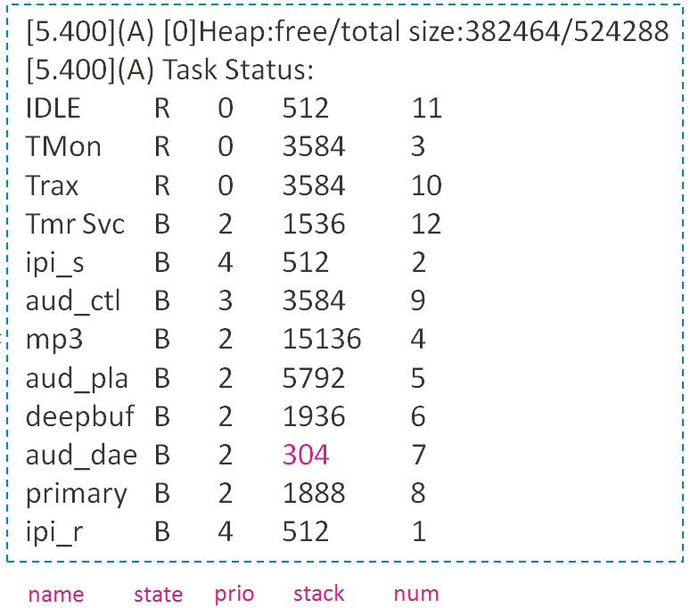
Figure 3-1. Example of Task Status Monitor

Heap Memory Usage

Monitor Heap Memory along with Task Monitor Log
- Phase out starting from DX1
- Enable
  - Set CFG_TASK_MONITOR=yes in platform.mk
  - #define configUSE_MALLOC_MEMORY_USAGE in FreeRTOSConfig.h
  - Notice that if you want to monitor heap usage in task status in all DSP cores in a multiple DSP platform, please remember to set the config in all cores
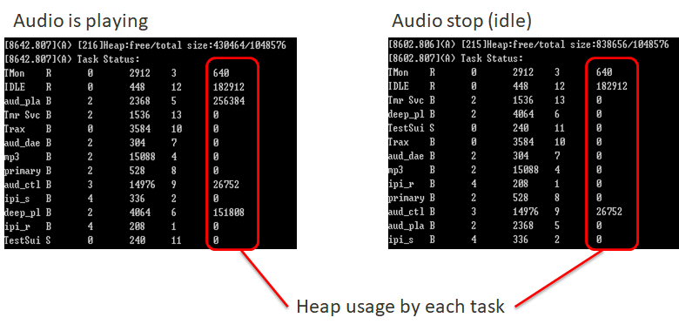
Figure 4-1. Example Task Heap Memory Usage Monitor

Detailed Information of Allocated Memory
- Enable
  - #define configUSE_MALLOC_MEMORY_USAGE in FreeRTOSConfig.h
  - #define configUSE_MALLOC_DEBUG_MSG_LEN 32 in FreeRTOSConfig.h
  - Then we can get the detailed heap memory information (size, by which task, program position)
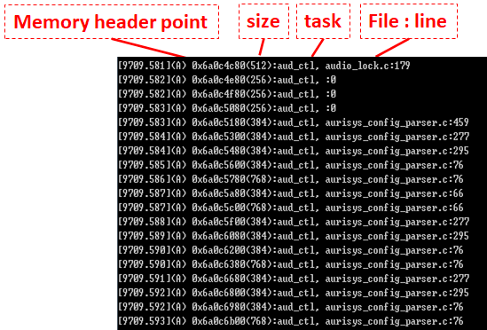
Figure 4-2. Example of Detailed Information of Allocated Memory

Exception Dump Extractor

ADSP EE log
Hifi Series
- Trigger Exception by user command
  - echo 238 > sys/class/misc/adsp_0/ipi_test
- When system exception happens (EE & Kernel API)
  - Assertion
    - If the exception is caused by ASSERT, the filename and line information will be shown in aee screen and __exp_main.txt in db.
  - Other cause
    - Setup the exception dump extraction tool first,
      - [HIFI] please refer to TOOL\GDB_DUMP\GDB Tool for ADSP Guide of aurisys package
    - Find SYS_ADSP_DUMP and the elf file of your current codebase
      - cd hifi_debug/adsp_debug_tool
      - Put the correspond hifiX_X.elf and SYS_ADSP_DUMP
      - ./debug_adsp.sh ${platform} ${elf_path}
      - Ex
        - ./debug_adsp.sh mt6983 hifi3_a.elf ;# debug mt6983 hifi a
        - ./debug_adsp.sh mt6983 hifi3_b.elf ;# debug mt6983 hifi b
        - ./debug_adsp.sh mt6985 hifi5_a.elf ;# debug mt6985 hifi a
        - ./debug_adsp.sh mt6985 hifi5_b.elf ;# debug mt6985 hifi b
    - Then you can get backtrace information like this
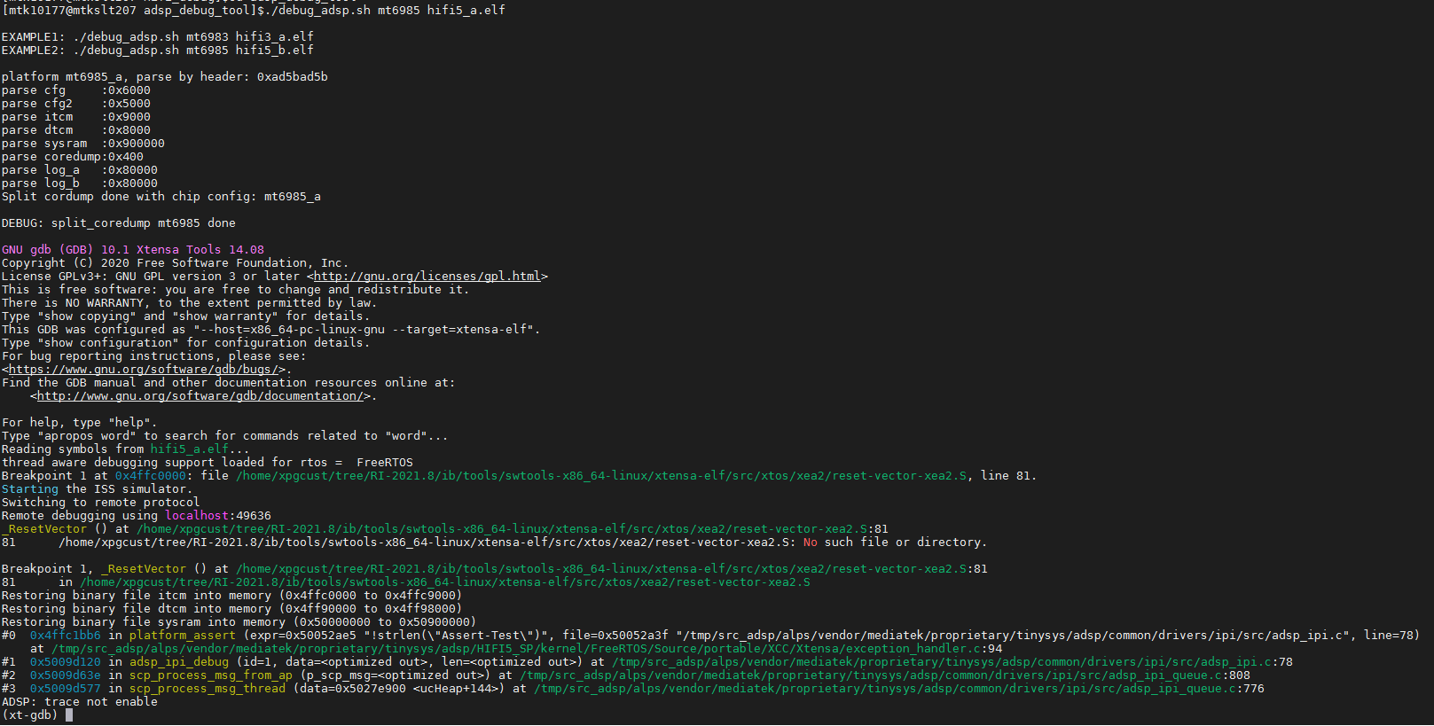
Figure 5-1. Example of ADSP Dump Extraction Result

RV Series
- Trigger Exception by user command
  - echo 238 > sys/class/misc/adsp_0/ipi_test
- Preparation:
Put these to the "${alps}/prebuilts/clang/md32rv/linux-x86/lldb_v4/" folder
  - SYS_ADSP_DUMP :
    - decompress the db.EE file, copy out the "SYS_ADSP_DUMP"
  - Matches ELF file :
    - ${alps}\out_vext\target\product\${project}\obj\TINYSYS_OBJ\tinysys-adsp_intermediates\RV55_A\rv55_a.elf
    - ${alps}\out_vext\target\product\${project}\obj\TINYSYS_OBJ\tinysys-adsp_intermediates\RV55_B\rv55_b.elf
For MDSP_PDK, please refer to MDSP toolchain release.
- How-to-Use
- On “linux” server and cd "${alps}/prebuilts/clang/md32rv/linux-x86/lldb_v4/"
- Example for platform mt6993
$module load MDSP_PDK/1.16.0
$ ./coredump_cmd_adsp.sh mt6993 rv55_a.elf SYS_ADSP_DUMP cmd; # debug of rv55 (core 0)
$ ./coredump_cmd_adsp.sh mt6993 rv55_b.elf SYS_ADSP_DUMP cmd; # debug of rv55 (core 1)

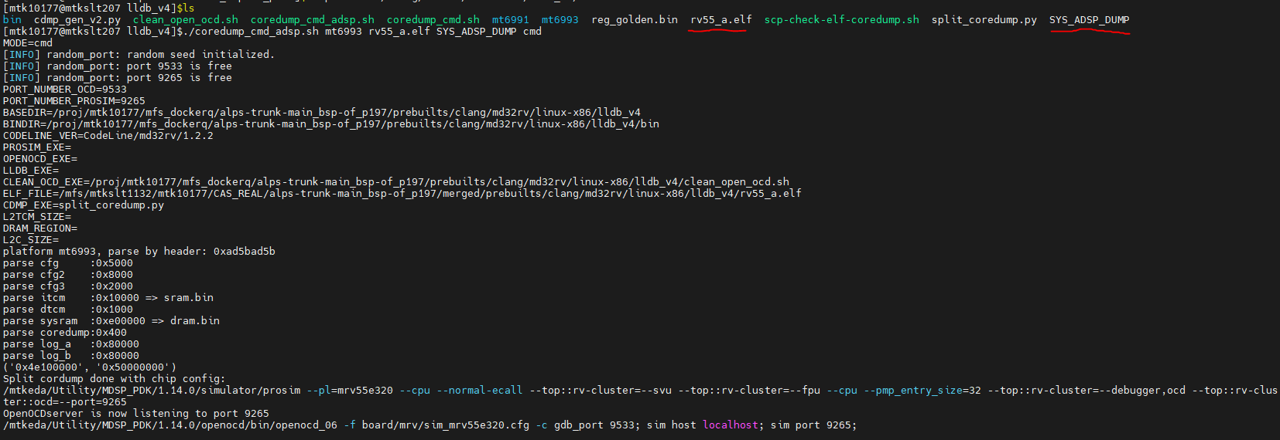
Figure 5-2-2 Example of ADSP Dump Extraction Result (RV)

- For checking backtrace, you need to check the freertos awareness report of the last running task.
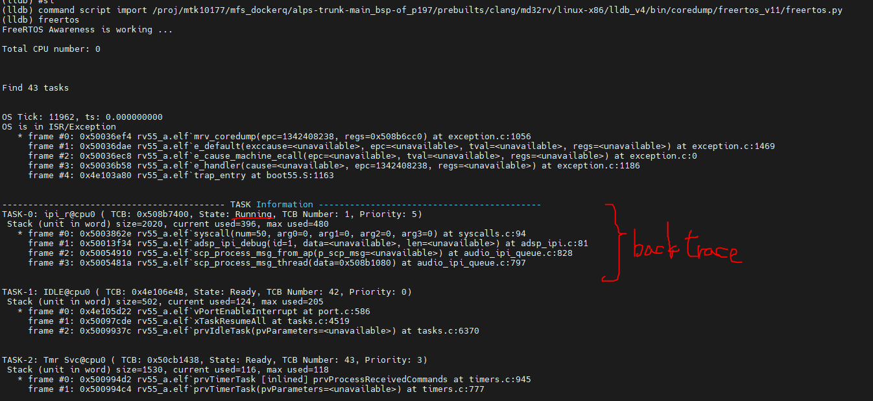

Exception Dump Analysis (Hifi)

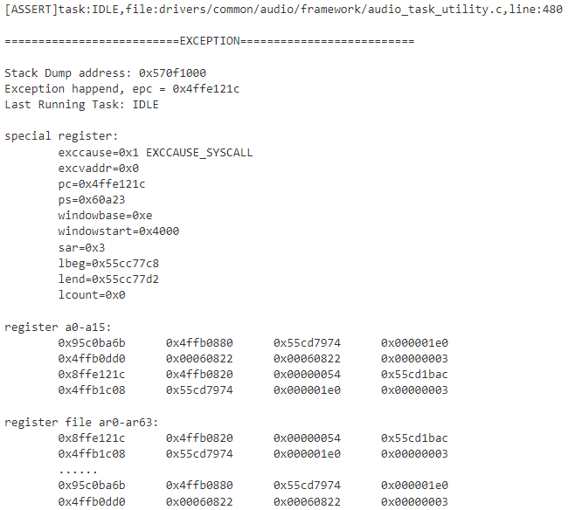
Figure 5-3. Example of ADSP Exception in adsp log

Exception Vector
Similar to the interrupt, when DSP encounters error behaviors during executing, there would be exception happens. Then the program would jump to the Exception Vector.
Table 5-1. Exception Vector
Vector | Main Cause | Description
UserExceptionVector | EXCCAUSE | operating modes: user vector mode
KernelExceptionVector | EXCCAUSE | operating modes: kernel vector mode
DoubleExceptionVector | EXCCAUSE | exception when handling exceptional condition
PS – Process Status Register, it’s used to record the process status (please find isa_rm.pdf in xtensa tools to get more information).
EXCCAUSE register is used to record the exception id, we can check the exception cause table in next section to find what issue happened.

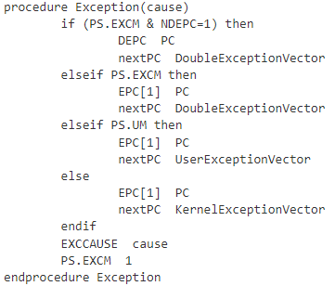
Figure 5-4. Exception Cause Procedure

Exception Cause Table
Common exception cause are listed in the following table. You can find more information in isa_rm.pdf in xtensa tools.
Table 5-2. Exception Cause Table
EXCAUSE | Cause Name | Cause Description | Example
0 | IllegalInstructionCause | Illegal instruction | The Instruction on behalf of the execution does not exist, there may be a problem with the fetch instruction
1 | SyscallCause | SYSCALL instruction
4 | Level1InterruptCause | Level-1 interrupt as indicated by set level-1 bits in the INTERRUPT register | Level 1 interrupt is treated as an exception, which will lead to the subsequent Interrupt handler [it’s a normal behavior]
6 | IntegerDivideByZeroCause | QUOS, QUOU, REMS, or REMU divisor operand is zero | division by zero exception  This is also currently used as a method to trigger the assertion forcibly by developer.
9 | LoadStoreAlignmentCause | Load or store to an unaligned address | This happens when the pointer is set to a certain data but in the MPU, because the value does not have address align, an exception will be triggered
20 (0x14) | InstFetchProhibitedCause | An instruction fetch referenced a page mapped with an attribute that does not permit instruction fetch | Execute a non-MPU protected space instruction, usually a null function pointer will trigger
28 (0x1c) | LoadProhibitedCause | A load referenced a page mapped with an attribute that does not permit loads | Read a non-MPU protected space, usually triggered by using a Null pointer
29 (0x1d) | StoreProhibitedCause | A store referenced a page mapped with an attribute that does not permit stores | Read a non-MPU protected space, usually triggered by using a Null pointer

Exception Register
Table 5-3. Exception Register Table
Register | Width (bits) | Register Name | Comment
EPC[1] | 32 | Exception program counter | Program Counter of Exception
EXCCAUSE | 3 | Cause of last exception | Cause of Exception
EXCVADDR | 32 | Virtual address that caused last fetch, load, or store exception | The Address position that is being operated when Exception occurs, usually a Memory-related Exception
EXCSAVE[1] | 32 | Save location for last exception | The temporary storage location to reserve information when exception happens
DEPC | 32 | Double exception PC | Used to reserve the PC value when double exception happens

Exception Flow and Assertion Implementation
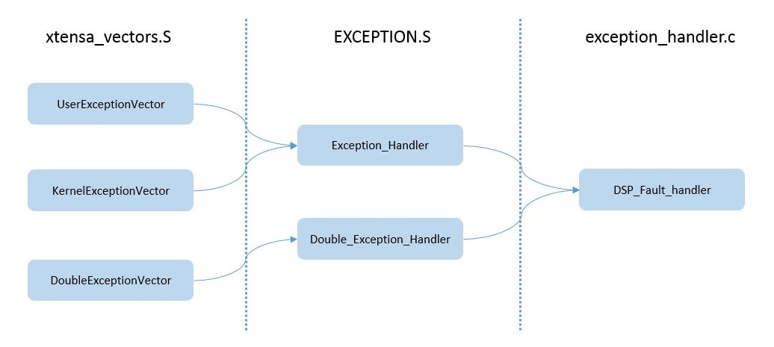
Figure 5-5. Exception Flow - ADSP

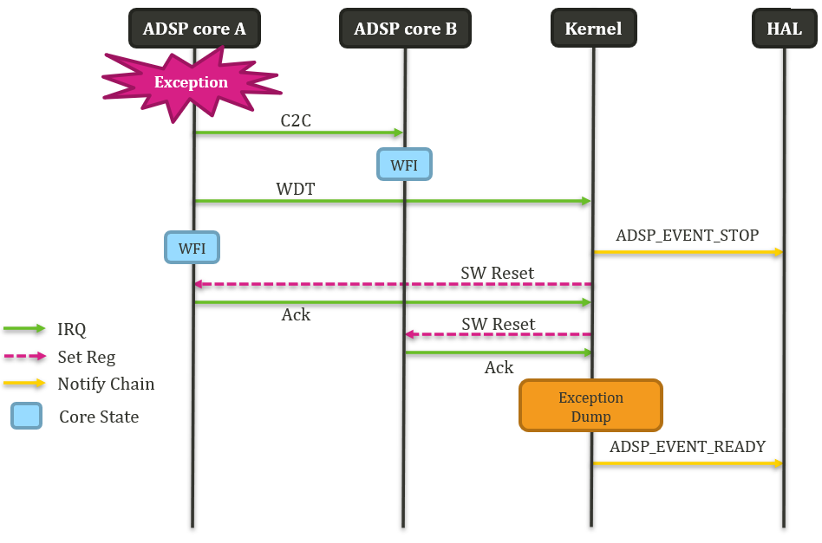
Figure 5-6. Exception Flow – ADSP Core A Exception Example

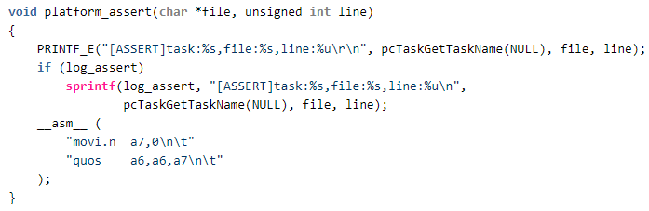
Figure 5-7. Assertion implementation

Exception Dump Analysis (RV)

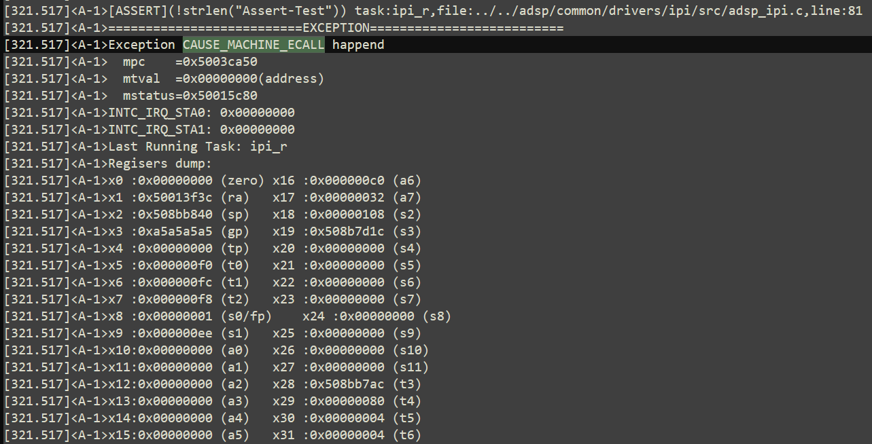
Figure 5-8 Example of ADSP(RV) Exception in adsp log

Exception Cause Table (RV)
- Common exception cause is listed in the following table.
Table 5-4 Exception Cause Table (RV)
EXCAUSE | Cause Name | Cause Description | Example
0x0 | CAUSE_MISALIGNED_FETCH | Instruction address misaligned
0x1 | CAUSE_FAULT_FETCH | Instruction access fault | Run the address without write permission (non-cache)
0x2 | CAUSE_ILLEGAL_INSTRUCTION | Illegal instruction
0x4 | CAUSE_MISALIGNED_LOAD | Load address misaligned
0x5 | CAUSE_FAULT_LOAD | Load access fault | Read the address without write permission (non-cache)
0x6 | CAUSE_MISALIGNED_STORE | Store address misaligned
0x7 | CAUSE_FAULT_STORE | Store access fault | Write the address without write permission (non-cache)
0xb | CAUSE_MACHINE_ECALL | Environment call from M-mode | Assertion happens by user
0xc | CAUSE_FETCH_PAGE_FAULT | Instruction page fault | Run the address without write permission (cache)
0xd | CAUSE_LOAD_PAGE_FAULT | Load page fault | Read the address without write permission (cache)
0xf | CAUSE_STORE_PAGE_FAULT | Store page fault | Write the address without write permission (cache)

Exception Register (RV)
Table 5-5 Exception Register Table (RV)
Register | Register Name | Comment
mepc | Machine Exception Program Counter | Program Counter of Exception
mcause | Machine Cause Register | Cause of Exception, check by table
mtval | Machine Trap Value Register | The Address position that is being operated when Exception occurs, usually a Memory-related Exception

Case Study

Performance Issue Overview
If there is a performance issue (underflow, timeout, etc.), please check the following items:
- Check adsp log
  - Check adsp log first to check if there is blocking events.
  - Mtk log path: adb pull /storage/sdcard0/debuglogger/
  - Exception db path: adb pull /data/vendor/aee_exp
- Raise the DSP clock rate
  - Just modify the feature MCPS table with a bigger value so that the DSP would run in a higher clock rate.
  - If it works in a higher clock rate, we need to check if there is unexpected blocking or high loading tasks.
- Task runtime profile
  - Use task runtime profile to check the overall task runtime.
  - For detailed usage, please refer to TOOL/ADSP_FTRACE
- Cycle Counter
  - Use cycle counter to check how many cycles consumed in a specified region

Heap Malloc Fail
As shown in Figure 6-1. Heap Malloc Fail Example Log, if there is a heap malloc fail issue, you can see the word “malloc fail” directly in ADSP log. Once malloc fail issue happens, please check the following items:
- Example log
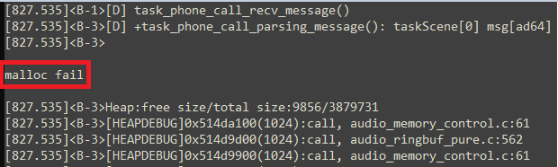
Figure 6-1. Heap Malloc Fail Example Log
- Debug reference
The remaining free heap size and total size should be checked first, and you can find this information in ADSP log as shown in Figure 6-1. Heap Malloc Fail Example Log. In most malloc fail cases, the requested size is larger than the remaining free size.
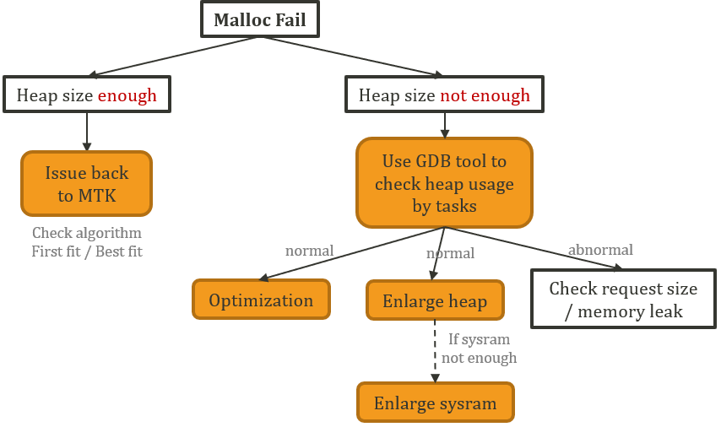
Figure 6-2. Malloc Fail Debug reference

Issue back to MTK: please refer to DMA Transfer Timeout
As shown in Figure 6-27. DMA Transfer Timeout Example Log, if there is a DMA timeout issue, you can see the word "DMA transfer timeout" directly in adsp log. Once a DMA timeout issue happens, please check the following items:
- Example log
Figure 6-27. DMA Transfer Timeout Example Log
- Debug reference
  - Check which task caused exception
    - In most DMA timeout cases, the task is aud_a2d which is related to UART. If you confirm that this is not a problem caused by your changes, please seek assistance from DRI for uart / bt owner’s help.

ADSP EE Trigger HAL Lock Timeout
As shown in Figure 6-28. HAL Lock Timeout Example LogFigure 6-24. EMIMPU Violation Example Log, if there is a HAL lock timeout issue, you can see the word “AUD_WARNING(lock timeout!!)” directly in main log. HAL lock timeout will trigger system API dump. Once a HAL lock timeout issue happens, please check the following items:
- Example log
Figure 6-28. HAL Lock Timeout Example Log
- Debug reference
  - As shown in Figure 6-29. HAL Lock Timeout Root Cause Reference, there are many reasons for HAL lock timeout, and ADSP EE is just one of them. ADSP EE may cause PCM open fail, thus result in HAL lock timeout. This chapter only discusses the situation caused by ADSP EE. Therefore, once there is a HAL lock timeout issue, please check whether there is any ADSP EE recently. If yes, please debug from this ADSP EE direction (ex. GDB tool).

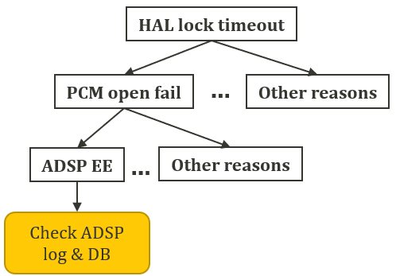
Figure 6-29. HAL Lock Timeout Root Cause Reference

  - From Figure 6-30. Example of HAL Query ADSP State, in this PCM open fail case, we can infer that the reason is ADSP system not ready. Please turn to ADSP log and DB for more debug information.
Figure 6-30. Example of HAL Query ADSP State
  - As for the recovery detail, please refer to Figure 5-6. Exception Flow – ADSP Core A Exception Example.

Insufficient ADSP System Ram Size
At software development stage, because the libraries used by MTK may be different from that of the customers, customers may encounter the problem of insufficient ADSP ram. As shown in Figure 6-31. Insufficient ADSP Sysram Size Example LogFigure 6-24. EMIMPU Violation Example Log, if ADSP system ram size is not enough, you can see “sramx_reg overflowed by xx bytes” directly at build time. Once ADSP system ram size is not enough, please check the following items:
- Example log
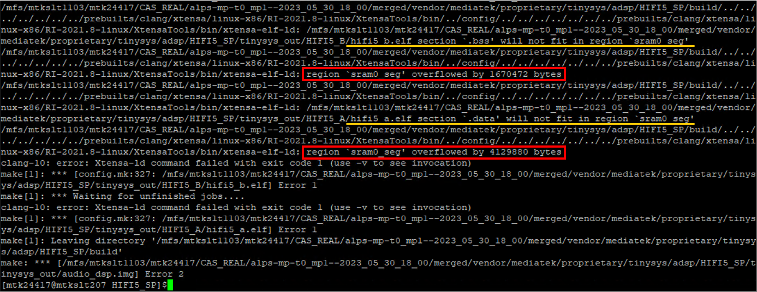
Figure 6-31. Insufficient ADSP Sysram Size Example Log
- Debug reference
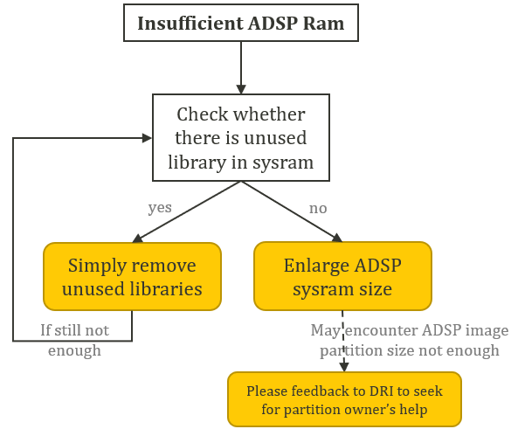
Figure 6-32. Reference Solution of Insufficient ADSP Sysram
  - Enlarge ADSP sysram size
    - Please refer to DOC\AudioDSP_Development_Tutorial.docx – Memory Configuration part for detail.
    - Get current sysram size from lk log at bootup stage
      - Take Figure 6-33. ADSP Image Size Example Log as an example, this size includes ADSP dual core itcm, dtcm and sysram
        - For each core
          - Itcm: 256 KB (0x40000 bytes)
          - Dtcm: 32 KB (0x8000 bytes)
          - Sysram: 10 MB (0xa00000 bytes)
          - Total = 2 * (0x40000 + 0x8000 + 0xa00000) = 0x1490000
Figure 6-33. ADSP Image Size Example Log

    - May encounter ADSP image partition size not enough
      - Such issue may cause bootup fail problem.
      - Please feedback to MTK DRI and seek for partition’s help.

  - Issue Feedback to MTK
    - Check memory algorithm: SELECT_MEMBLOCK_BY_ALGORITHM
      - If SELECT_MEMBLOCK_BY_ALGORITHM is defined as BEST_FIT_ALGO, then it will choose the best fit memory block; otherwise, it will use first fit algorithm.
        - First-fit: more efficiently but may result in memory fragmentation
        - Best-fit: better use of the whole memory
      - File: project/mtxxxx/HIFIX_A/platform/inc/FreeRTOSConfig.h

Figure 6-3. Example of Memory Selection Algorithm
  - Use GDB tool to check heap usage by task:
    - Usage:
      - Command: (xt-gdb) mtk_adsp_heap
      - Output: adsp_heap_info.txt
    - Example:
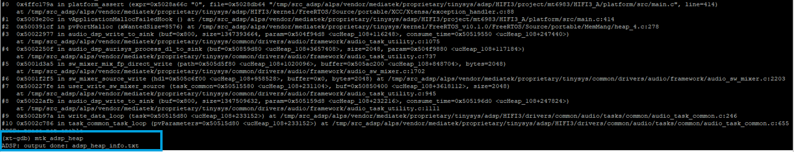
Figure 6-4. GDB Tool for Heap Analysis
  - Optimization: check if there is unused memory.
  - Enlarge system ram / heap size:
    - If all tasks request memory normally, you may consider increasing the heap size.
    - For detailed SOP, please refer to Memory Configurations part in AudioDSP_Development_Tutorial.docx
  - Memory leak:
    - Memory leak occurs when programmers create a memory in heap and forget to delete it.
    - As shown in Figure 6-5. Memory Leakage Example Log, in this malloc fail case, memory leakage issue happens in callsub task. If similar log pattern appears in adsp_heap_info.txt (the same task keeps requesting memory repeatedly as you can see the cycle between audio_messenger_ipi.c and audio_task_phone_call.c), we suggest that you can check whether memory is free successfully when process end.
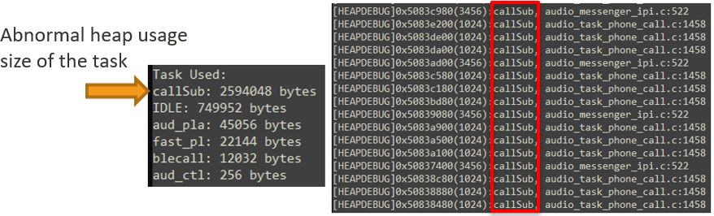
Figure 6-5. Memory Leakage Example Log

ADSP MPU Exception
Xtensa processor configurations enabling the Memory Protection Unit (MPU), for example,
have the ability to restrict the access rights of arbitrary memory regions. If there is a ADSP MPU exception issue, the exccause may be 0x1c (load prohibited) or 0x1d (store prohibited). Once such issue happens, please check the following items:
- Example log
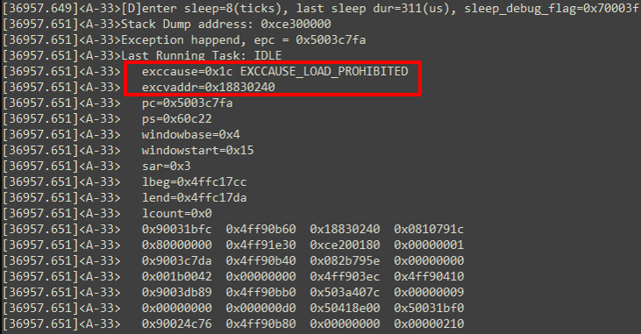
Figure 6-6. ADSP MPU Exception Example Log
- Debug reference
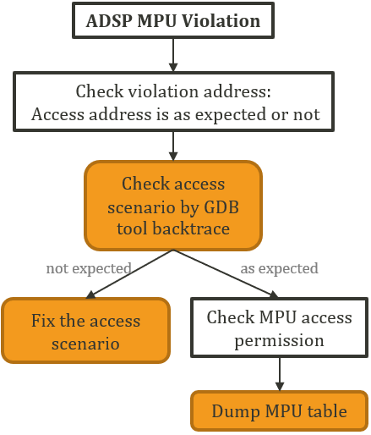
Figure 6-7. ADSP MPU Violation Debug reference

  - Use GDB tool to get backtrace information
    - To check the violation scenario
    - Command: (xt-gdb) bt
    - Example:
      - Double confirmed the last pc by using command: (xt-gdb) list *$pc.
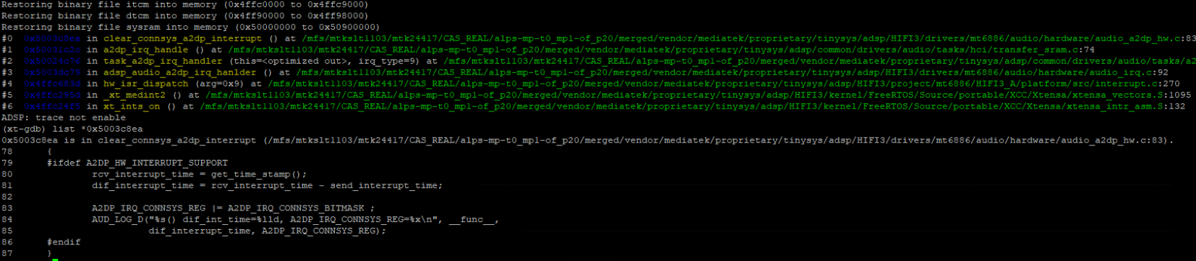
Figure 6-8. GDB Tool for Backtrace
  - Dump MPU table to check memory region permission
    - Command: adb shell "echo mpu_dump > sys/kernel/debug/audiodspX; cat sys/kernel/debug/audiodspX"
    - Result:
      - The MPU table dump format: address/access right/memory type
      - As shown in Figure 6-9. ADSP MPU Table Dump Example, here we take address 0x1e0000c4 for an example. The desired address is located between entry#12 0x1e000000 & entry#13 0x4d000000. Thus, 0x1e0000c4 has the same access right and memory type as entry#12 0x1e000000.
      - For detailed access right and memory type, please refer to Xtensa document.
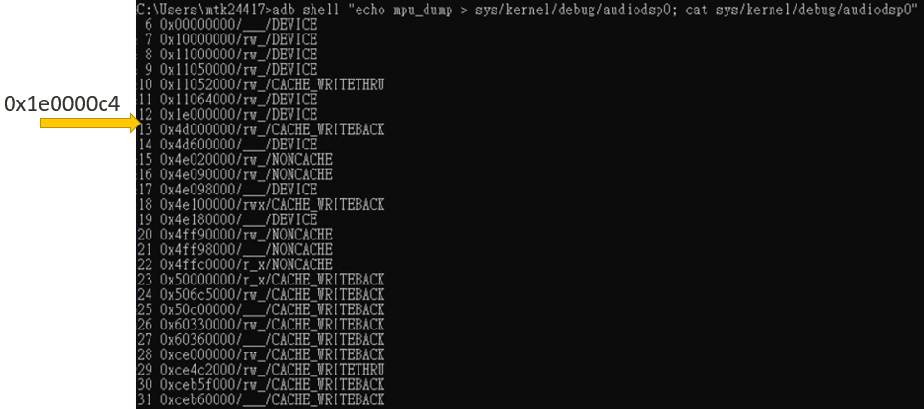
Figure 6-9. ADSP MPU Table Dump Example
    - For most cases, the address you would like to access has read and write permission. However, if the address has no permission, please use MPU API in mpu.c to set region permission.
mpu_set_region_attribute(void *vaddr,
uint32_t size,
int32_t accessRights,
int32_t memoryType)

IPI Message Queue Overflow
If there is a queue overflow issue, please check the following items:
- Example log
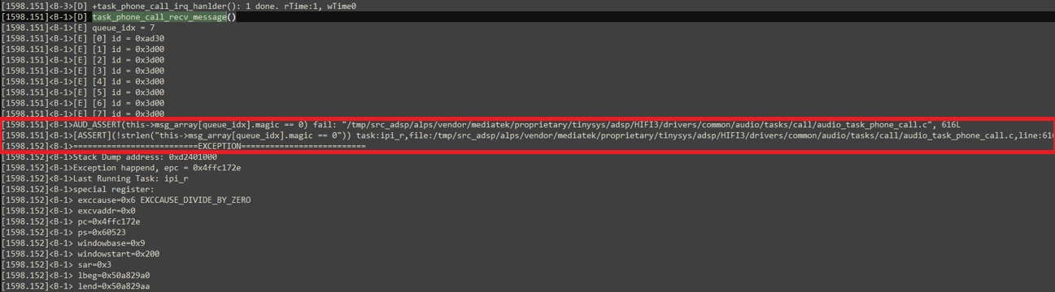
Figure 6-10. Message Queue Overflow Example Log
- Debug reference
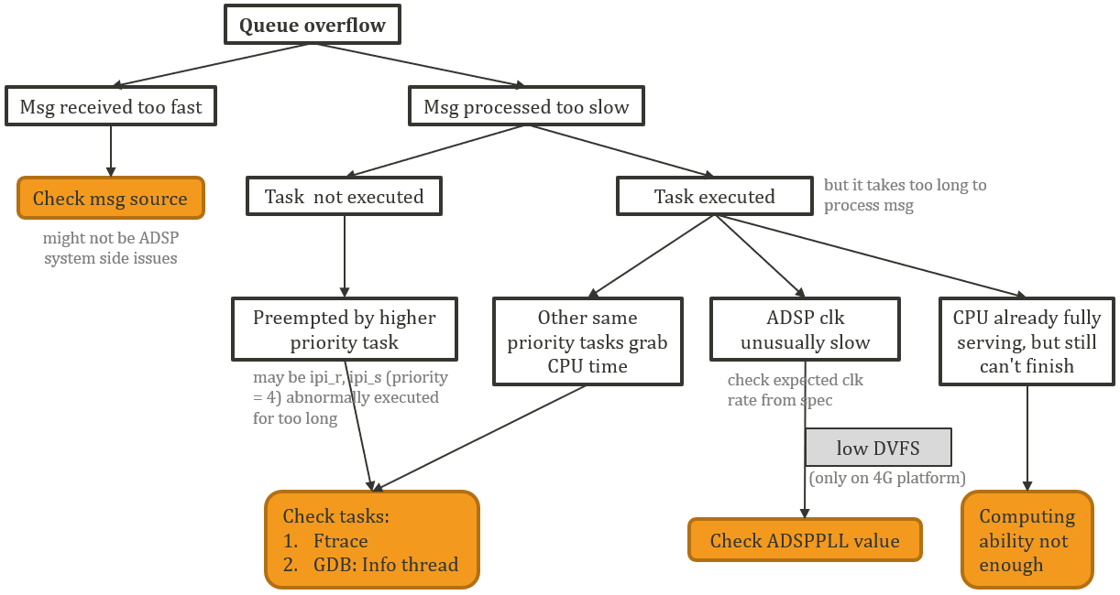
Figure 6-11. Queue Overflow Debug reference

  - If message received too fast:
    - Check the message source first because it may not belong to ADSP system issue.
  - If message processed too slow:
    - To check whether the task is executed properly or not, you can use Ftrace tool.
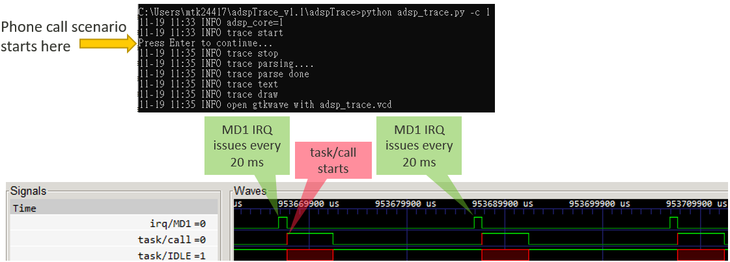

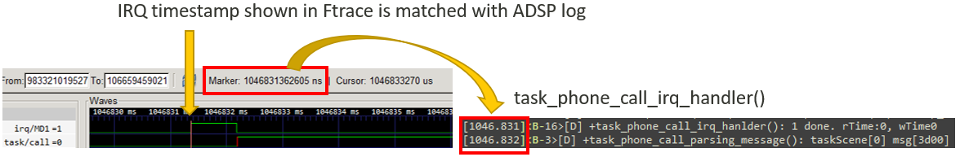
Figure 6-12. Phone Call Scenario Runtime Profile by Ftrace

WDT ISR Trigger EE
The general WDT is triggered in purpose to notify AP that ADSP has an exception. However, if the WDT is triggered without any exception, probably it’s because the tick cannot update (xPortSysTickHandler) for some reason. Then it cannot kick the WDT, and finally results in WDT timeout. If there is a WDT issue, please check the following items:
- Example log
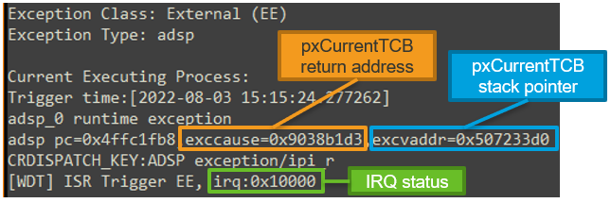
Figure 6-13. WDT Timeout Example Log - 1
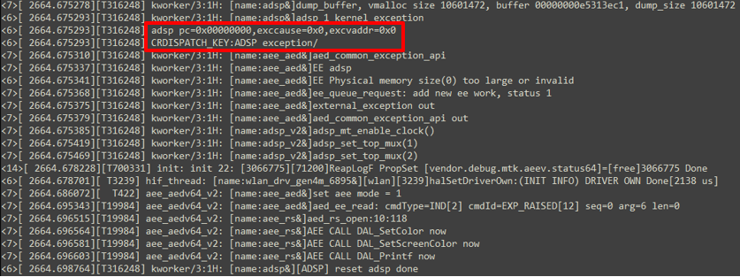
Figure 6-14. WDT Timeout Example Log - 2

- Debug reference
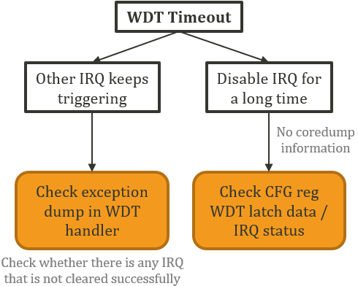
Figure 6-15. WDT Timeout Debug reference
  - Other IRQ keeps triggering:
    - If other IRQ with higher priority than tick keeps triggering, the tick handler won’t be served and finally results in WDT timeout.
    - Example log is shown in Figure 6-13. WDT Timeout Example Log - 1. The exccause is the return address of pxCurrentTCB; while the excvaddr is the stack point of pxCurrentTCB. Also, the irq status may be shown if the irq is not successfully cleared.
  - Disable IRQ for a long time:
    - Because IRQ is disabled in such case, WDT handler can’t be executed. Thus, there is no such coredump information to refer to.
    - Example log is shown in Figure 6-14. WDT Timeout Example Log - 2. You can check config register WDT latch data and IRQ status register.

Stack Overflow
As shown in Figure 6-16. Stack Overflow Example Log, if there is a stack overflow issue, you can see the word “stack overflow” directly in ADSP log. If stack overflow issue happens, please check the following items:
- Example log
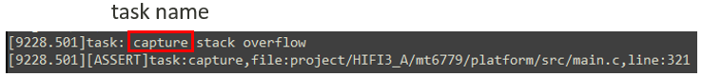
Figure 6-16. Stack Overflow Example Log
- Debug reference
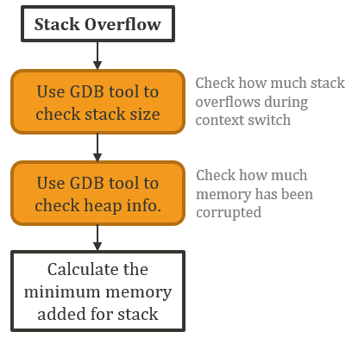
Figure 6-17. Stack Overflow Issue Debug reference
  - Use GDB tool to check stack size
    - You can confirm how much the current stack exceeds the stack during the context switch. However, it does not mean that you can confirm how much the current stack exceeds during execution. As for the solution, please refer to the next step.
    - Usage:
      - Command: (xt-gdb) mtk_adsp_debug
      - Output: adsp_analysis.txt
    - From Figure 6-19. Example of adsp_analysis.txt, we can infer to this result:
      - pxTopOfStack – pxStack = -16 (bytes)
Figure 6-18. GDB Tool for Stack Overflow Analysis

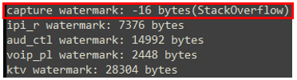
Figure 6-19. Example of adsp_analysis.txt
  - Use GDB tool to check heap size
    - A stack overflow issue usually results in memory corruption issues. Thus, you can use the heap information to confirm how much memory has been corrupted.
    - Usage:
      - Command: (xt-gdb) mtk_adsp_heap
      - Output: adsp_heap_info.txt
    - From Figure 6-20. Example of adsp_heap_info.txt,
  - Calculate the minimum memory added for stack
    - From the information in Figure 6-20. Example of adsp_heap_info.txt and Figure 6-21. Example of pxStack, it can be observed that the stack has stepped over from the original address 0x55dd2380 to at least 0x55dd2200, because 0x55dd2200 cannot correctly point to the next memory block. Therefore, a conservative estimate is to increase 0x55dd2380 - 0x55dd2100 = 640 bytes
    - Note that the FreeRTOS stack unit is 4 bytes, so the increased stack size should be 640/4 = 160. The number is just the minimum space that should be increased, and you can increase more to ensure that stack overflow will not happen frequently.
    - The amount of stack is usually affected by the flow of the algorithm, and we suggest that you can reserve a larger stack size in the early stage of development. Until the later stage, you can use watermark to evaluate the overall space used and check whether there is a possibility of reduction.

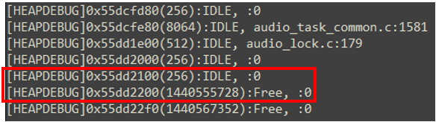
Figure 6-20. Example of adsp_heap_info.txt

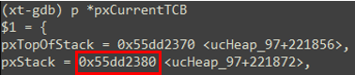
Figure 6-21. Example of pxStack

Device APC Violation
Each sub-system has its own DEVice Access Permission Control (DEVAPC/DAPC) to handle the security and data protection scheme of its own modules. As shown in Figure 6-22. Device APC Violation Example Log, if there is a devapc violation issue, you can see the word “[DEVAPC] Violation” directly in SYS_KERNEL_LOG from DB. Devapc violation will trigger Kernel Exception (KE), thus no ADSP core dump for GDB tool. Once a devapc violation issue happens, please check the following items:
- Example log
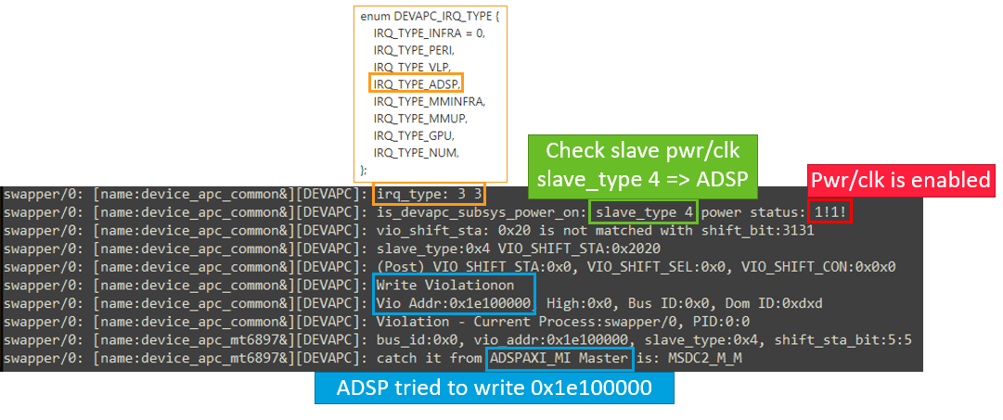
Figure 6-22. Device APC Violation Example Log
- Devapc violation scope
  - Permission denied
  - Power/clock is not enabled
  - Unalignment / out of bound / way_en
  - Decode / slave error
- Debug reference
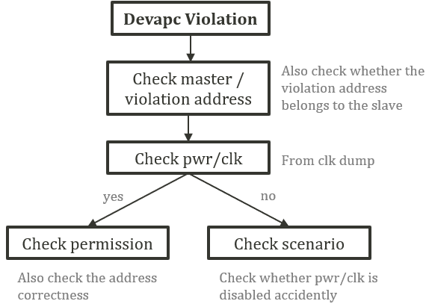
Figure 6-23. Device APC Violation Debug reference
  - Check master / violation address
    - Confirm that this address is the one you expected to access
    - Check the violation address belongs to the slave (it does in most cases)
  - Check power/clock
    - Once the devapc violation triggers, devapc mechanism will check slave pwr/clk.
  - Check permission
    - Permissions are set in devapc_adsp.h, devapc_infra, devapc_peri, … in TF-A
    - In most cases, the addresses that are expected to be used have already been authorized
  - Check scenario
    - Please check where to access the address accidently from the scenarios

EMIMPU Violation
Although ADSP MPU cannot block invalid DMA transactions, it can still be protected by EMIMPU. As shown in Figure 6-24. EMIMPU Violation Example Log, if there is an EMIMPU violation issue, you can see the word “EMI_MPU_Violation” directly in out.json and emi_mpu_output file from DB. EMIMPU violation will trigger kernel API dump. Once an EMIMPU violation issue happens, please check the following items:
- Example log
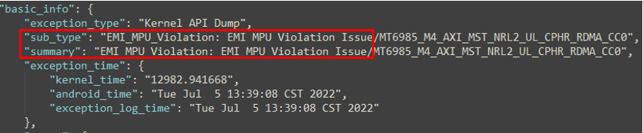
Figure 6-24. EMIMPU Violation Example Log

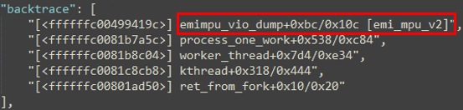
Figure 6-25. Example of EMIMPU Backtrace in out.json
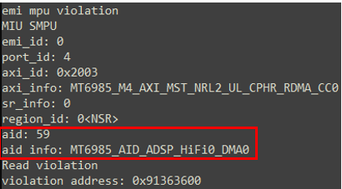
Figure 6-26. Example of emi_mpu_output
- Debug reference
  - Check AID from emi_mpu_output
    - AID means the master who accesses the violation address.
    - For the same master, secure and non-secure access are separate AID.
    - Please refer to Table 6-1. ADSP Secure Region Permission and AID Reference for detailed AID description.
  - Check the violation address from emi_mpu_output
    - Check whether the address is as expected or not (the address you want to access) as well as the permission.
  - Check violation scenario
    - To narrow down where the transaction happens.
  - Check ADSP behaviors from ADSP log
Table 6-1. ADSP Secure Region Permission and AID Reference
Module | ADSP ROM (SR 28) | ADSP share (SR 29)
AID permission | - secure ADSP-HiFi0 & DMA0  - AID = 29*2+0 = 58  - permission=RW  - non-secure ADSP-HiFi0 & DMA0  - AID = 29*2+1 = 59  - permission=RW  - secure ADSP-HiFi1 & DMA1  - AID = 30*2+0 = 60  - permission=RW  - non-secure ADSP-HiFi1 & DMA1  - AID = 30*2+1 = 61  - permission=RW  - secure CPU  - AID=120*2+0=240  - permission=RW  - non-secure CPU  - AID=120*2+1=241  - permission=R | - secure ADSP-Audio  - AID = 26*2+0 = 52  - AID = 27*2+0 = 54  - AID = 28*2+0 = 56  - permission=RW  - non-secure ADSP-Audio  - AID = 26*2+1 = 53  - AID = 27*2+1 = 55  - AID = 28*2+1 = 57  - permission=RW  - secure ADSP-HiFi0 & DMA0  - AID = 29*2+0 = 58  - permission=RW  - non-secure ADSP-HiFi0 & DMA0  - AID = 29*2+1 = 59  - permission=RW  - secure ADSP-HiFi1 & DMA1  - AID = 30*2+0 = 60  - permission=RW  - non-secure ADSP-HiFi1 & DMA1  - AID = 30*2+1 = 61  - permission=RW  - secure CPU  - AID=120*2+0=240  - permission=RW  - non-secure CPU  - AID=120*2+1=241  - permission=RW

DMA Transfer Timeout
As shown in Figure 6-27. DMA Transfer Timeout Example Log, if there is a DMA timeout issue, you can see the word "DMA transfer timeout" directly in adsp log. Once a DMA timeout issue happens, please check the following items:
- Example log
Figure 6-27. DMA Transfer Timeout Example Log
- Debug reference
  - Check which task caused exception
    - In most DMA timeout cases, the task is aud_a2d which is related to UART. If you confirm that this is not a problem caused by your changes, please seek assistance from DRI for uart / bt owner’s help.

ADSP EE Trigger HAL Lock Timeout
As shown in Figure 6-28. HAL Lock Timeout Example LogFigure 6-24. EMIMPU Violation Example Log, if there is a HAL lock timeout issue, you can see the word “AUD_WARNING(lock timeout!!)” directly in main log. HAL lock timeout will trigger system API dump. Once a HAL lock timeout issue happens, please check the following items:
- Example log
Figure 6-28. HAL Lock Timeout Example Log
- Debug reference
  - As shown in Figure 6-29. HAL Lock Timeout Root Cause Reference, there are many reasons for HAL lock timeout, and ADSP EE is just one of them. ADSP EE may cause PCM open fail, thus result in HAL lock timeout. This chapter only discusses the situation caused by ADSP EE. Therefore, once there is a HAL lock timeout issue, please check whether there is any ADSP EE recently. If yes, please debug from this ADSP EE direction (ex. GDB tool).

Figure 6-29. HAL Lock Timeout Root Cause Reference

  - From Figure 6-30. Example of HAL Query ADSP State, in this PCM open fail case, we can infer that the reason is ADSP system not ready. Please turn to ADSP log and DB for more debug information.
Figure 6-30. Example of HAL Query ADSP State
  - As for the recovery detail, please refer to Figure 5-6. Exception Flow – ADSP Core A Exception Example.

Insufficient ADSP System Ram Size
At software development stage, because the libraries used by MTK may be different from that of the customers, customers may encounter the problem of insufficient ADSP ram. As shown in Figure 6-31. Insufficient ADSP Sysram Size Example LogFigure 6-24. EMIMPU Violation Example Log, if ADSP system ram size is not enough, you can see “sramx_reg overflowed by xx bytes” directly at build time. Once ADSP system ram size is not enough, please check the following items:
- Example log
Figure 6-31. Insufficient ADSP Sysram Size Example Log
- Debug reference
Figure 6-32. Reference Solution of Insufficient ADSP Sysram
  - Enlarge ADSP sysram size
    - Please refer to DOC\AudioDSP_Development_Tutorial.docx – Memory Configuration part for detail.
    - Get current sysram size from lk log at bootup stage
      - Take Figure 6-33. ADSP Image Size Example Log as an example, this size includes ADSP dual core itcm, dtcm and sysram
        - For each core
          - Itcm: 256 KB (0x40000 bytes)
          - Dtcm: 32 KB (0x8000 bytes)
          - Sysram: 10 MB (0xa00000 bytes)
          - Total = 2 * (0x40000 + 0x8000 + 0xa00000) = 0x1490000
Figure 6-33. ADSP Image Size Example Log

    - May encounter ADSP image partition size not enough
      - Such issue may cause bootup fail problem.
      - Please feedback to MTK DRI and seek for partition’s help.

Issue Feedback to MTK
Please provide the following debug information once issue happens:
- Issue basic information
  - Platform
  - Load version
  - Repeat ratio
  - Scenario
    - Feature side: phone call / VoIP / playback / …
    - System side: bootup / suspend / resume / …
  - Patch
    - Please confirm whether the issue happens only if you add your patch
- Mtk log including adsp log (Audio DSP has an independent logging file)
- DSP coredump
  - Please refer to \TOOL\GDB_DEBUG of the released Aurisys_exe_xx.xxxx.xx. You can extract the dump by xt-gdb to check the exception cause.
- Memory map file (hifi3_a.elf) to decode coredump. Its location:
  - A0 Structure
    - If using default image: /vendor/mediatek/proprietary/tinysys/freertos/adsp_lib
    - If local build: /vendor/mediatek/proprietary/tinysys/freertos/source/tinysys-scp_out
  - B0 Structure
    - If using default image: /vendor/mediatek/proprietary/tinysys/adsp/adsp_imgs
    - If local build: /vendor/mediate/proprietary/tinysys/adsp/HIFI3/tinysys_out
- Configurations
  - HiFi3 A0 Structure
    - tinysys_config.h (Auto generated file to log the configurations of the specified project)
      - default image: /vendor/mediatek/proprietary/tinysys/freertos/adsp_lib
      - local build: /vendor/mediatek/proprietary/tinysys/freertos/source/tinysys-scp_out
    - platform.mk
      - vendor/mediatek/proprietary/tinysys/freertos/source/project/HIFI3_A/[platform]
    - ProjectConfig.mk
      - vendor/mediatek/proprietary/tinysys/freertos/source/project/HIFI3_A/[platform]/[project]
  - HiFi3 B0 Structure
    - tinysys_config.h (Auto generated file to log the configurations of the specified project)
      - default image: /vendor/mediatek/proprietary/tinysys/adsp/adsp_imgs
      - local build: /vendor/mediate/proprietary/tinysys/adsp/HIFI3/tinysys_out
    - platform.mk
      - vendor/mediate/proprietary/tinysys/adsp/HIFI3/project/[platform]/HIFI3_X/platform
    - Project.mk
      - vendor/mediate/proprietary/tinysys/adsp/HIFI3/project/[platform]/HIFI3_X/platform/[project]
  - HiFi5 Structure
    - tinysys_config.h (Auto generated file to log the configurations of the specified project)
      - default image: /vendor/mediatek/proprietary/tinysys/adsp/adsp_imgs
      - local build: /vendor/mediate/proprietary/tinysys/adsp/HIFI5/tinysys_out
    - platform.mk
      - vendor/mediate/proprietary/tinysys/adsp/HIFI5/project/[platform]/HIFI5_X/platform
    - Project.mk
      - vendor/mediate/proprietary/tinysys/adsp/HIFI5/project/[platform]/HIFI5_X/platform/[project]

