ADSP Profiling Guideline

Version: 1.2
Release date: 2026-05-21

MediaTek Confidential A

Version History
Version | Date | Description
1.0 | 2022-06-06 | Official release
1.1 | 2024-01-23 | Add Task loading Important note. (2.1)  Add Compatibility information of (2.2), (2.3)
1.2 | 2024-08-07 | Update Ftrace sections (2.2)
1.3 | 2026-05-21 | Update DX-3/4/5 platform information in Table 1.1 DSP Clock Rate and Suggested Memory Latency Settings
MediaTek Confidential A

Table of Contents
Version History 2
Table of Contents 3
1 SW Lib Profiling on Simulator (Xtensa Tool) 4
1.1 Overview 4
1.2 Settings 4
1.2.1 Memory Latency 4
1.2.2 DSP Clock Rate and Suggested Memory Latency Settings 5
1.3 Pre-Fetch Options 5
1.4 Profile Output 6
1.4.1 MCPS 6
1.4.2 Memory Profile 6
2 Profiling on Target 8
2.1 Task Loading Monitor 8
2.1.1 Command and Step 8
2.2 FTrace 9
2.2.1 Environment Requirement 9
2.2.2 Trace & Parse data 9
2.2.3 Tool of Visualization 10
2.2.4 How to profile 12
2.3 Cycle Counter 14

List of Figures
Figure 1.2.1-1. Profile Configurations 4
MediaTek Confidential A
Figure 2.1.1-1. Task Loading Profiling Result 8
Figure 2.2.3-1 Navigation of Perfetto 10
Figure 2.2.3-2 Visualization by Perfetto 11
Figure 2.2.3-3 Visualization by Gtkwave 11
Figure 2.2.3-4 The State of waveform 11
Figure 2.2.4-1 Sheet of Result All 13
Figure 2.2.4-2 Sheet of Result by 100ms 13
Figure 2.2.4-3 the profile result show in adsp_profile UI 14

List of Tables

Table 1-1. DSP Clock Rate and Suggested Memory Latency Settings 5

SW Lib Profiling on Simulator (Xtensa Tool)

Overview
To better allocate DSP resources and choose configurations, we need to learn the resource requirements of each program executes on the DSP. Such as how much time spent and how many data transferred during the executions.
Tensilica provides Xtensa instruction set simulator (ISS) which can directly generate the profile data. In this document, we’ll provide memory settings (including memory access latency and pre-sfetch options) on the Xtensa ISS. Please follow the setting and provide the results to MTK so that we can analyze the profiling data and then find the best configurations.
The detailed information of the Xtensa ISS can be found in the reference document provided by Tensilica: “gnu_profiler_ug.pdf”.

Settings
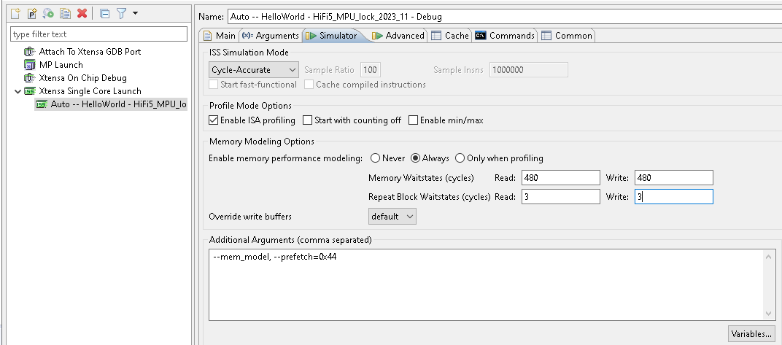
Figure 1.2.1-1. Profile Configurations

Memory Latency
In out DSP system, if the program is executed on DDR, there would be an access latency when cache miss happens:
- The memory waitstate cycles in the figure above
  - When cache miss happens, the DSP would issue a request to the Bus to get the desired data
  - The memory waitstate cycles means how many DSP cycles it needs to wait until it can get the first data into cache from the Bus.
- The repeat block waitstate in the figure above
  - When the 1st data starts to be transmitted, there still a memory latency during the transmission
  - It is due to the DSP clock rate is higher than the Bus clock, the latency is repeat block waitstate
Generally, if the clock rate is M MHz, and the average cache miss latency is N us, then the memory waitstate cycles would be M x N DSP cycles. We usually want to know the ZWS and w/ memory latency condition. The ZWS (Zero-Wait-State) means there is not any memory latency, it indicates how many computing resource required by the algorithm itself.
- Zero-Wait-State
  - 1. Setting:
    - Memory Waitstates: both read & write: 0
    - Repeat Block Waitstates: both read & write: 0
  - 2. Command line Mode:
    - --mem_model --mlatency=0 --blockrepeat=0 --write_delay=0 --write_repeat=0
- With Memory Latency
  - 1. Setting:
    - Memory Waitstates: both read & write: DSP clock rate(M MHz) * memory latency (N us)
    - Repeat Block Waitstates: both read & write: 4
  - 2. Command line Mode:
--mem_model --mlatency=MxN --blockrepeat=4 --write_delay=MxN --write_repeat=4

DSP Clock Rate and Suggested Memory Latency Settings
Table 1-1. DSP Clock Rate and Suggested Memory Latency Settings
Platform | Clock Rate | Memory Latency
DX-1, DX-2, DX-P, DX-3, DX-4 | 800 MHz | 0.75 us
DX-5 | 800 MHz | 0.8 us
D1200, NextA2, 22H | 750 MHz | 0.75 us
NextA, NextD | 750 MHz | 1 us

Pre-Fetch Options
Tensilica DSP provides prefetch aggressiveness options. The more aggressive, the more memory bandwidth. On the contrary, we can reduce the computation resources.
- Setting
  - As the above figure, use additional argument (such as command line mode)
    - --mem_model --prefetch=0x48
      - The first number “4” is aggressiveness of ICache, while the 2nd number “8” is aggressiveness of DCache;
      - The default aggressiveness value is 4, and the max value is 8
- To Profile
  - Default (0x44)
  - --prefetch=0x48
  - --prefetch=0x84
  - --prefetch=0x88

Profile Output
Please provide the following information based on the configurations above or provide the complete logs.

MCPS
- Required Information
  - Average MCPS
  - Peak MCPS
  - Total Frames
Frames per Second
- Example:
  - 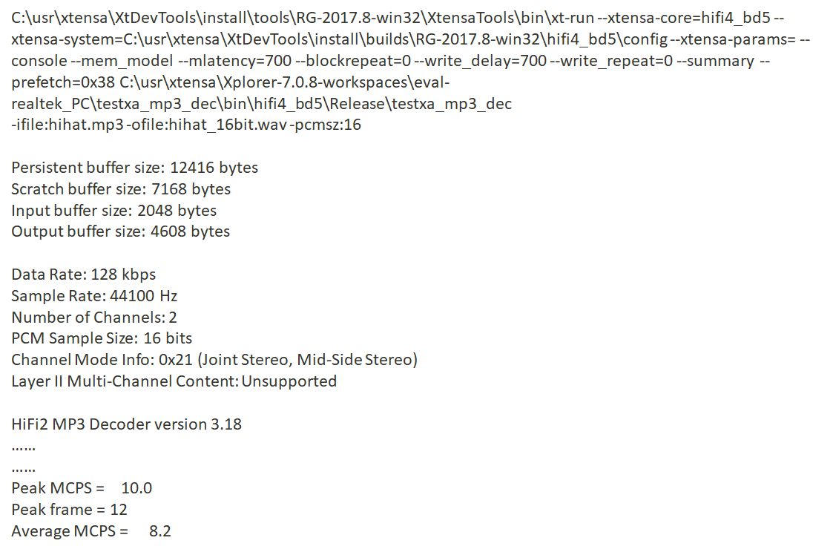

Memory Profile
By the memory access profile logs, we can calculate the total memory bandwidth required by the algorithms. The total bandwidth would be total PIFs x 8 bytes. Then you can calculate the memory bandwidth (MB/s) according how many frames you sampled. For example, if we profile a decoder with 5 frames which is 20ms per frame, and the total data transferred is 100MB. Then the memory access bandwidth would be 100/(5*0.020) = 1000 MB/s
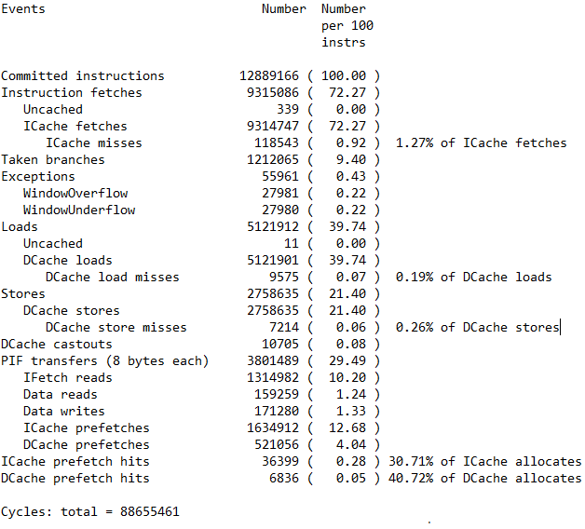
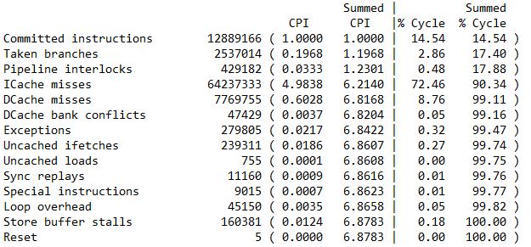

Profiling on Target

Task Loading Monitor
To monitor the loading of each task.
IMPORTANT NOTE: it is normal if it causes pop noise when call “runtime_status_stop” command because this command parse information to memory. It may block the others task and generate pop noise.

Command and Step
- Enable the scenario you want to profile
  - For example, if you want to profile the phone call scenario, just setup a phone call and starts to talk.
- Configurations: Set the period per profiling sample (50ms~10000ms)
  - adb shell "echo runtime_status_set_period 1000 > sys/kernel/debug/audiodsp0"
    - period 1000 means 1000ms per sample
    - audiodsp0 means the DSP of single DSP platform or the DSP 0 of multiple DSP platform
  - adb shell "echo runtime_status_set_period 1000 > sys/kernel/debug/audiodsp1"
    - audiodsp1 means the DSP 1 of multiple DSP platform
- Configurations: Set the samples (5 samples~200 samples)
  - adb shell "echo runtime_status_set_samples 100 > sys/kernel/debug/audiodsp0"
    - samples 100 means total profiling samples is 100
  - adb shell "echo runtime_status_set_samples 100 > sys/kernel/debug/audiodsp1"
- Start to profile
  - adb shell "echo runtime_status_start > sys/kernel/debug/audiodsp0"
  - adb shell "echo runtime_status_start > sys/kernel/debug/audiodsp1"
- Stop recording
  - adb shell "echo runtime_status_stop > sys/kernel/debug/audiodsp0”
  - adb shell "echo runtime_status_stop > sys/kernel/debug/audiodsp1
- Showing the profiling results
  - adb shell “cat sys/kernel/debug/audiodsp0"
  - adb shell “cat sys/kernel/debug/audiodsp1"
The result would be:
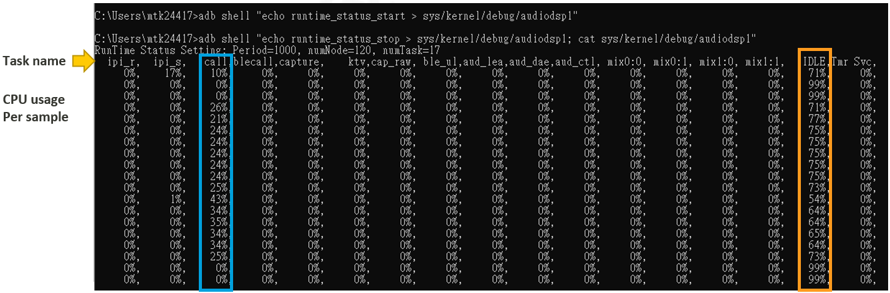
Figure 2.1.1-1. Task Loading Profiling Result

FTrace
Ftrace is a highly recommended tool for performance analysis, it records complete CPU scheduling and logs the current state of each task. There are currently two versions available. The new version (Ver.2) primarily supports platforms after DX4. For earlier platforms, please use the older Ver.1 version.

The main difference between the two is that the new version uses Google's Perfetto tool for visual representation and can record files up to 1GB in size, allowing for over a minute of recording. The old version uses the gtkwave tool for visualization and can record up to a maximum of 10 seconds.

Limitation: The debug feature is only enabled in engineering and user-debug builds. It is not enabled by default in user builds due to security reasons.

Compatibility: This tool only for ADSP(HIFI) series. The Ver.2 is supported on “Android V (vendor) + kernel 6.6”.

Environment Requirement
- Python 3.X (https://www.python.org/downloads/)
- Python Package
  - V1: pyvcd (https://pypi.org/project/pyvcd/)
  - V2: pandas

Trace & Parse data
Note: The tool includes an 'ADSP Tracer & Profile Quick Guide.pptx' file that provides a Quick Guide.

- General Step-By-Step
  - Insert the USB and ensure adb is usable.
  - Run start_adsp_tracer.bat. (Run start_adsp1_tracer.bat , if another core1)
  - Execute the scenario that needs profiling.
  - Follow the command prompt to stop tracing.
  - For the old version: Generates adsp_trace.vcd and automatically opens gtkwave.
For the new version: Generates adsp_ftrace.json, which needs to be imported into the Perfetto UI tool for analysis.
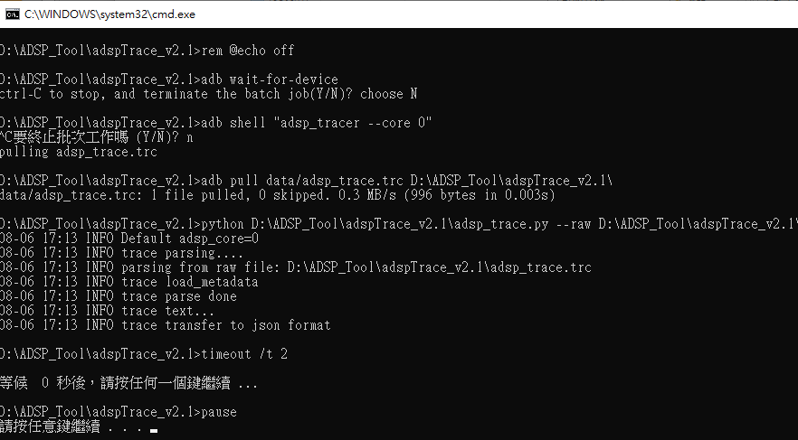
Figure 2.2.2-1. Run start_adsp_tracer.bat
- For ADSP Another Core, please use the corresponding other batch file within the tool.
- The Ver.2 includes a batch file specifically for the 'unplug USB' scenario.

Tool of Visualization
- Perfetto UI (Ver.2)
  - Open url by Brower (https://ui.perfetto.dev/)
  - Open Trace File of “adsp_ftrace.json” which generated from previous step.
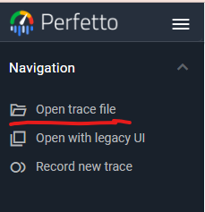
Figure 2.2.3-1 Navigation of Perfetto
  - Use keyboard “W”/“S” to zoom in/out, and keyboard “A”/“D” to pan left/right
  - Use keyboard “?” to get help for more Perfetto keyboard shortcuts.
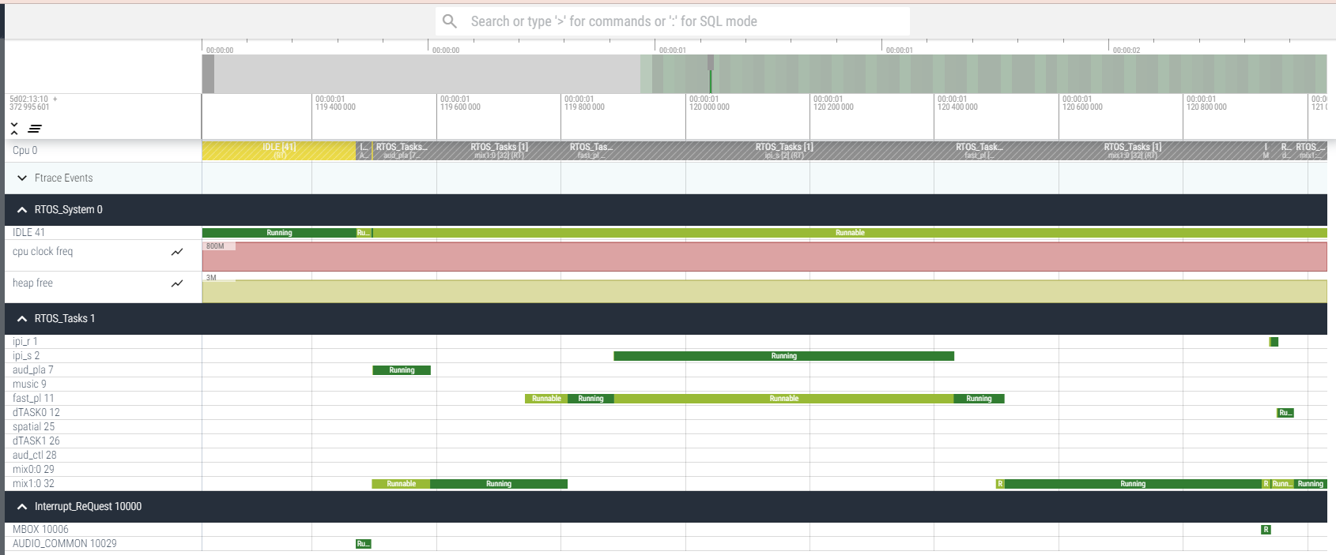
Figure 2.2.3-2 Visualization by Perfetto
- Gtkwave (Ver.1)
  - Automatically opens after parsing data
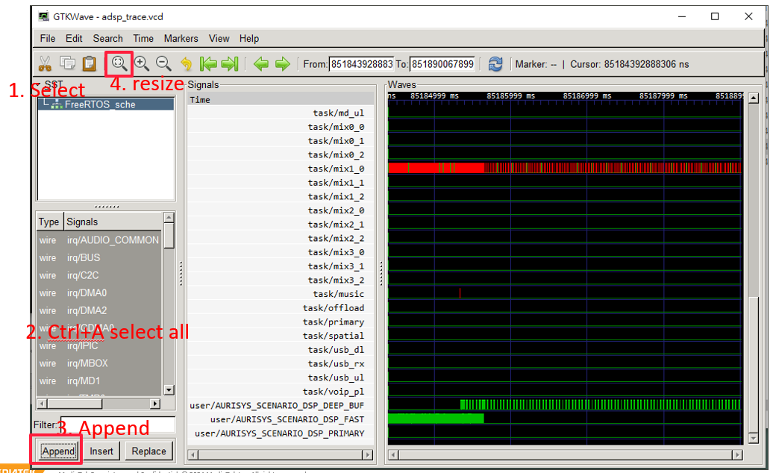
Figure 2.2.3-3 Visualization by Gtkwave
- 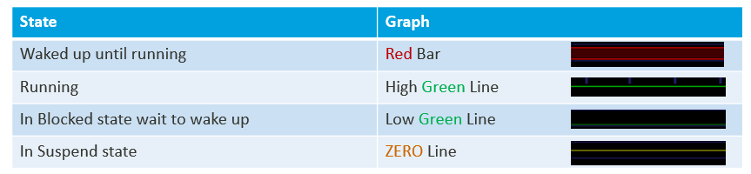
Figure 2.2.3-4 The State of waveform

How to profile
- Perfetto UI (Ver.2)
  - Get the start time & end time from Perfetto.
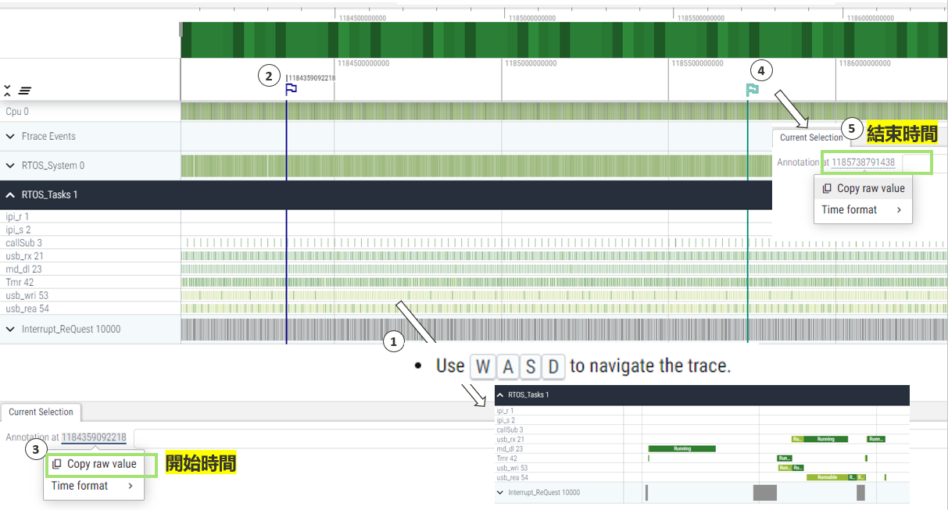
  - Replace the time in Peffetto_SQC.txt and copy to Perfetto SQC command.
  - Keyboard “Ctrl + Enter” to run query and show in Query result.
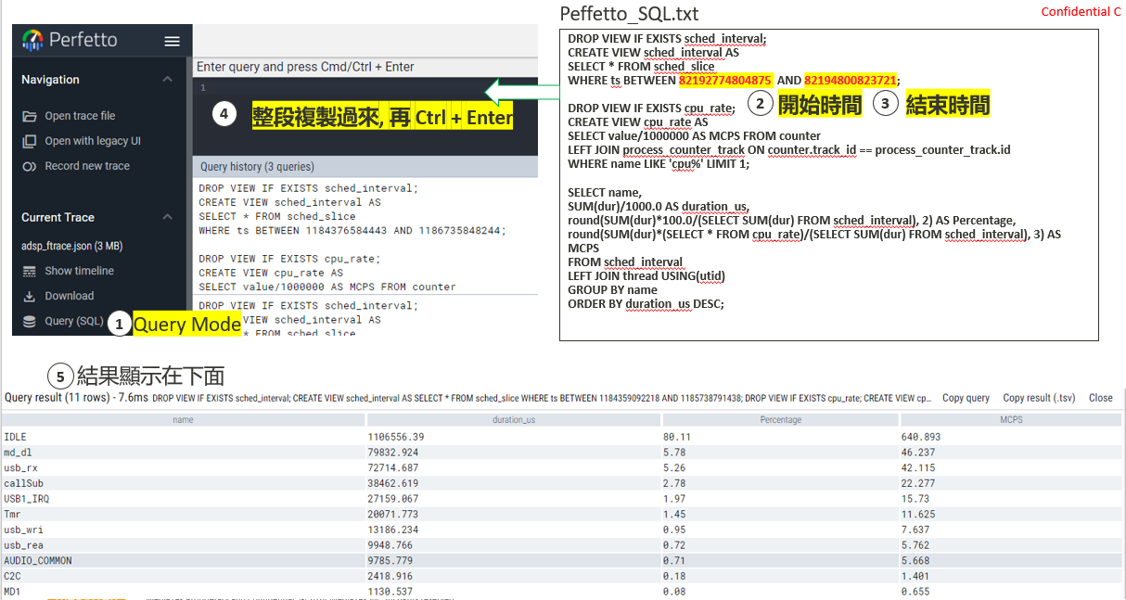

- Python Script (Ver.2)
  - This script needs ”adsp_trace.txt” file which generate from previous step.
  - Run start_adsp_profile_by_tracetxt.bat (or drag adsp_trace.txt to batch)
  - Output file is “profile_result.xlsx”
    - The "Result All" sheet shows the percentage of occupancy and MCPS over the entire period.
    - The "Result_by_100ms" sheet displays the percentage of each task at every 100ms interval.
  - You can use Excel tools to create various types of charts for presentation.
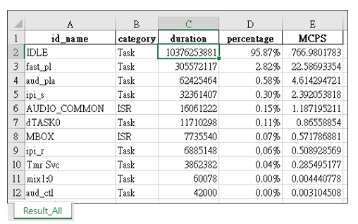
Figure 2.2.4-1 Sheet of Result All
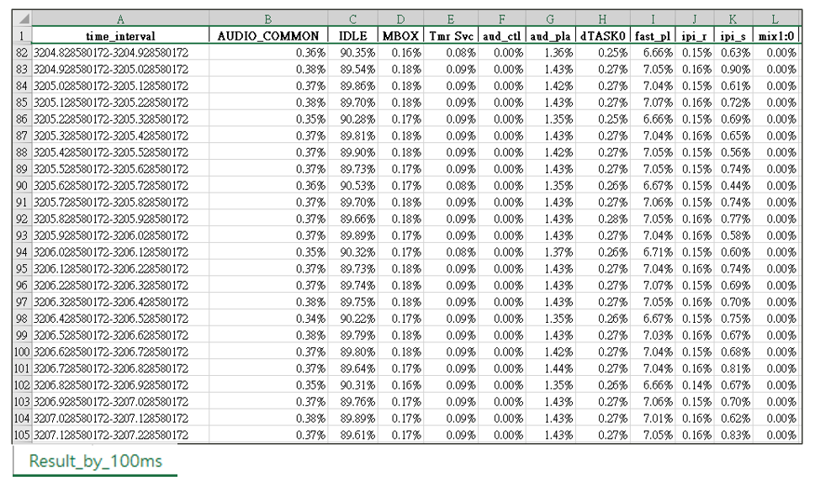
Figure 2.2.4-2 Sheet of Result by 100ms

- Python Script (Ver.1)
  - This script needs ”adsp_trace.txt” file which generate from previous step.
  - Run start_adsp_profile_by_tracetxt.bat (or drag adsp_trace.txt to batch)
  - It will open the ADSP Profile UI, where you can enter the time segment you want to observe and press GO. The results will be displayed in the UI and automatically copied to the clipboard.
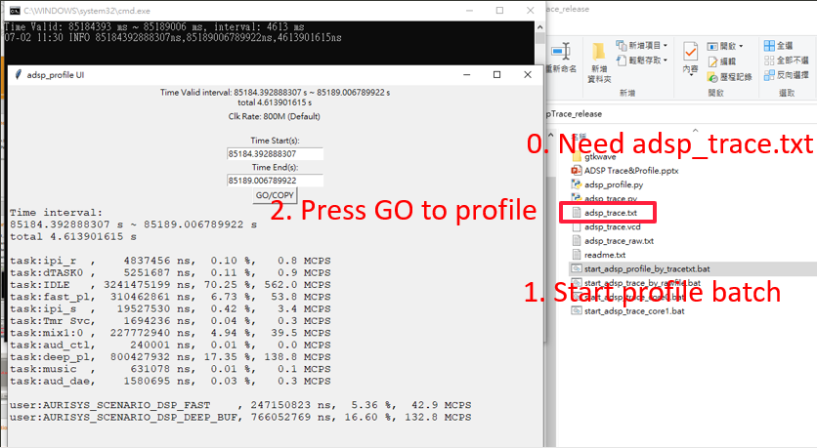
Figure 2.2.4-3 the profile result show in adsp_profile UI

Cycle Counter
Compatibility: This tool only for ADSP(HIFI) series

Use cycle counter to check how many cycles consumped in a specified region. Note that if there is context witch happens, the counter is still accumulated. If possible, use critical section to avoid context switch so that the cycle count would be precise.
- start_ccount = xthal_get_ccount(); (get the cycle count in beginning of the region)
- stop_ccount = xthal_get_ccount(); (get the cycle count in end of the region)
Print stop_ccount – start_ccount in adsp log

