

Audio DSP Capability

Version: 1.0
Release date: 2026-05-22

© 2014 - 2026MediaTek Inc.
This document contains information that is proprietary to MediaTek Inc.
Unauthorized reproduction or disclosure of this information in whole or in part is strictly prohibited.

Specifications are subject to change without notice.

Document Revision History

Date | Author | Description
2018/8/20 | Doug Wang | Add P90 Audio DSP Capability
2019/02/26 | Doug Wang | Rename P80 to P90 and Add G90
2019/08/25 | Doug Wang | Add 5G-L/H Audio DSP Capability
2019/10/31 | Doug Wang | Update available MCPS
2019/12/20 | Doug Wang | Add the suggested feature set of each project  Add 5G-A/A+ Audio DSP Capability
2019/03/19 | Doug Wang | Add 5G-B Audio DSP Capability
2020/10/07 | Celine Liu | Add Next-D/D+ Audio DSP Capability
2021/05/21 | Doug Wang | Add G96 DSP Capability
2021/06/14 | Doug Wang | Add DX-1 and Next A2 DSP Capabilities
2021/10/29 | Celine Liu | Add DX-P Capability
2022/11/18 | Yuying Lin | Add DX-2 Capability and update toolchain version
2023/03/01 | Yuying Lin | Update 22H Capability
2023/11/07 | Jung-wei Chen | Update 23P and DX-3 Capability
2024/05/20 | Jung-wei Chen | Update 24M and DX-4 Capability
2024/07/16 | Jung-wei Chen | Update DX-4 MCPS spec
2025/04/16 | Wei-Hau Chen | Update DX-4 MCPS spec
2025/05/19 | Jung-wei Chen | Update DX-5 Capability
2025/07/07 | Wei-Hau Chen | Update DX-5 MCPS spec
2026/05/19 | Celine Liu | Add 24Ms and 26M Capability
2026/05/21 | Jung-wei Chen | Update 26M MCPS spec

Table of Contents
Document Revision History 2
Table of Contents 2
1 Overview 5
1.1 Hardware Classification 5
1.2 Memory Config (per Core) 6
1.3 Software Feature Capability 7
1.4 HW IP Capability 7
2 Cadence HiFi Series 8
2.1 Overview 8
2.2 P90 9
2.2.1 Structure 9
2.2.2 Hardware Spec 9
2.2.3 Software Capability 10
2.3 G90/G96 11
2.4 5G-L / 5G-H / 5G-H+ / Next-D / Next-D+ 12
2.4.1 Structure 12
2.4.2 Hardware Spec 13
2.4.3 Software Capability 13
2.5 5G-A / 5G-A+ 14
2.6 5G-B / Next-A / Next-A2 / 22H 15
2.7 23P / 24P 16
2.8 DX-1/ DX-P 16
2.9 DX-2 / DX-3 / DX-4 16
2.9.1 Structure 19
3 MTK In-house RV Series 21
3.1 DX-5 21
3.1.1 Structure 21
3.1.2 Hardware Spec 21
3.1.3 Software Capability 22
3.2 24M 24
3.2.1 Structure 24
3.2.2 Hardware Spec 25
3.2.3 Software Capability 25
3.2.1 Hardware Spec 28
3.2.2 Software Capability 28
3.3 25Ms/ 26M 31
Structure 31
3.3.1 31
3.3.2 Hardware Spec 31
3.3.3 Software Capability 32

Lists of Tables and Figures

找不到圖表目錄。
Figure 2-1. P90 HiFi3 DSP Structure 7
Figure 2-2. 5G-L/H HiFi3 DSP Structure 11
Figure 2-3. DX-2 HiFi5 DSP Structure 19
Figure 2-4. DX-4 HiFi5 DSP Structure with NNE 19
Figure 3-1 DX-5 RV DSP Structure with TinyDLA 23

Overview

Hardware Classification
DSP | Core Number | Power Domain | Project
HiFi3 | Single Core | VCore  (If the DSP is not under low power mode, the voltage of VCore would be raised; since there’re other modules also locate in VCore, the power loss would be considerable) | - P90  - G90  - G96
HiFi3 | Single Core | Independent Power Domain | - 5G-B  - Next-A, Next-A2  - 22H
HiFi3 | Dual Core  (not support SMP, only AMP) | Independent Power Domain | - 5G-L / 5G-H / 5G-H+  - 5G-A / 5G-A+  - Next-D / Next-D+  - 23P  - DX-1/ DX-P
HiFi5 | Dual Core  (not support SMP, only AMP) | Independent Power Domain | - DX-2 / DX-3 / DX-4
RV55V | Dual Core  (not support SMP, only AMP) | Independent Power Domain | - DX-5
RV55 | Single Core | VLP, under the same subsys with SCP | - 24M
RV55 | Single Core  (Dual-core SMP affinity with SCP) | VSCP | - 25Ms, 26M

Memory Config (per Core)
I-Cache (KB) | D-Cache (KB) | L2Cache (KB) | I-TCM (KB) | D-TCM (KB) | L2TCM (KB) | Project
32 | 64 | N/A | 36 | 32 | N/A | - P90 / G90  - 5G-A / 5G-A+ / 5G-B / 5G-L /5G-H / 5G-H+  - Next-D / Next-D+ / Next-A
16 | 64 | N/A | 36 | 32 | N/A | - G96
64 | 128 | N/A | 36 | 32 | N/A | - Next-A2/ DX-P / 22H / 23P
64 | 128 | N/A | 256 | 32 | N/A | - DX-1
64 | 128 | N/A | 36 | 32 | 512 | - DX-2
64 | 128 | N/A | 36 | 64  (32 for NNE) | 768 | - DX-3 / DX-4
64 | 64 | 512 | N/A | N/A | 896 | - DX-5
32 | 32 | 128 | N/A | N/A | 1024 | - 24M
32 | 32 | 256  (shared with SCP) | N/A | N/A | 1024 | - 25Ms, 26M

Software Feature Capability
Project | Speech Enhancement | SmartPA | Audio Effect | Concurrency
5G-L/H/H+  5G-A/A+  Next-D/D+  DX-1/DX-P/DX-2/DX-3/DX-4/DX-5 | 3-mic Speech Enhancement | 2 x SmartPA | Yes | Concurrency of speech and Audio Effect
P90/G90/G96  5G-B  Next-A/Next-A2  23P | 2-mic Speech Enhancement | 1 x SmartPA | Yes | No concurrency of speech and Audio Effect
24M/25Ms/26M | 2-mic Speech Enhancement | 1 x SmartPA | No | No concurrency of speech and Audio Effect

HW IP Capability
The following table only lists the HW capability for the Cadence HiFi series. For the HW capability of MTK In-house RV series, please contact MTK MDSP RV team for details.
 |  | HiFi3 | HiFi5
Load/Store |  | Single 64bit | Dual 128bit
VLIW Slots |  | 3 | 5
Fixed Point MAcs | 32x32 | 2 | 8
Fixed Point MAcs | 32x16 | 4 | 16
Fixed Point MAcs | 16x16 | 4 | 16
Fixed Point NN MACs | 16x16 | None | 16
Fixed Point NN MACs | 16x8, 16x4, 16x2, 8x8 | None | 32
Floating-Point MAcs | Single Precision | 2-way | Dual 4-way
 | Half Precision | None | Dual 8-way

Cadence HiFi Series

Overview
The HiFi Series Audio DSP features improved DSP performance onpost/pre-processing kernels.The 3-issue architecture is very efficient, using the three slotsonly when necessary and avoiding the bloat of traditional VLIWarchitectures. It supports standard 32-bit C code and direct support for common ITUoperations for even simpler programming.
  - 4 MAC 24 and dual 32 bit architecture
    - Four MACs operate as four 24x24, four 32x16,two 32x32, or two 32x24 depending on that’s required for thealgorithm
  - 64-bit load/store unit
  - 3 VLIW slots
  - Integrated 2- way SIMD VFPU

P90

Structure
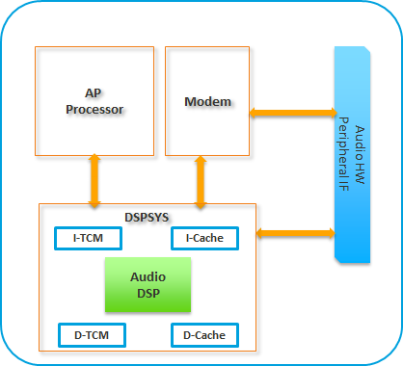
Figure 2-1. P90 HiFi3 DSP Structure

Hardware Spec
The basic information about the P90 Audio DSP is summarized as follows:
- TCM (Tight-Coupled Memory, Internal Memory)
  - I-TCM (Instruction): 36KB
  - D-TCM (Data): 32KB
  - The TCM is used for RTOS and system service. So it is not allowed for the use of Audio/Voice algorithm.
- Cache
  - I-Cache: 32KB, 2-way Associativity
  - D-Cache: 64KB, 4-way Associativity
  - Cache Line Size: 128 Bytes
- Clock Rate
  - Low Power Mode: 466 MHz
  - Normal Mode: 700 MHz
- Programmable DMA (burst of 16-bit) for DSP supported to transfer data to/from external memory
  - Support 4 DMA channels, that we can start 4 DMA transactions simultaneously
  - We’ve provided an API to trigger DMA
- External Memory and Devices
  - DRAM: it can access data on DRAM by DMA or by CPU directly (through Cache).
  - AudioSys: it is through a dedicated BUS, which don’t need to go through EMI. The DSP can access hardware registers and SRAM of the AudioSys without constrains.

Software Capability

RTOS and System Services
- RTOS
  - Free-RTOS
- DVFS
  - Scenario Based. We’ve established a MCPS table for each feature, once a feature is enabled, the required MCPS will be added. Then we’ll choose a suitable DSP frequency to execute the features.
- Debug Tools
  - Logging – UART log, and MTK Logger
  - Coredump Extractor
  - Audio Dump– capture PCM dump before/after processing. (we’ve provided an API to add a PCM dump in the designated position
  - PMU
    - Performance Monitor Unit. It can be used to monitor the information cache miss rate, cache hit rate, and pipeline relay, etc,.
    - Number of Performance Counters– 8
  - Heap Monitor – To monitor current heap usage by each task
- Cadence Xtensa
  - Tool Chain Version - RG2017.6(Android P); RI.2018.0 (Android Q and later version)
  - C Libraries - Xtensa C Library

Audio Features
Supported Audio Features:
- Speech/Voice
  - Speech enhancement during VOIP call (8k~48k)
  - Speech enhancement during Voice call (8k/16k/32k)
  - Recording enhancement
- Audio Playback
  - Audio Effect
  - SmartPA
MCPS:
Generally,we need to reserve at least 10% headroom for buffer copy, system overhead, access external devices, and interaction between APMCU. Besides, in voice call case, the voice codec is processed in Modem side and the speech enhancement is processed in the Audio DSP. The timing should be aligned to avoid increasing round trip delay, so we need to reserve more headroom in voice call case. However, If the library can’t meet the requirement, there is two solutions:
- We need to delay 1 frame to process the data. There would be 20ms increment in the round trip delay.
- Increase the clock rate of Audio DSP or Modem, it would have more power consumption.
- Other than voice call
  - Low Power Mode:419MHz
  - Normal Mode: 630 Mhz
- Voice call
  - If we add 20ms round trip latency; the available MCPS (for total MCPS of UL+DL)would be the same as other applications
Codec | Scenario | Uplink available MCPS |  | DL available MCPS
Codec | Scenario | Low Power Mode | Normal Mode | Low Power Mode | Normal Mode
EVRCB | C2K | 169.45 | 254.55 | 31.77 | 47.73
AMR | 3G | 254.18 | 381.82 | 42.36 | 63.64
AMR-WB | 3G | 254.18 | 381.82 | 42.36 | 63.64
AMR-WB | VoLTE | 307.14 | 461.36 | 116.50 | 175.00
EVS-SWB | VoLTE | 264.77 | 397.73 | 158.86 | 238.64

  - Since we have a hard real time constrain, if there is other task being executed at the same time, the available MCPS of speech enhancement would be reduced. For example, in hand-free mode, if we also support SmartPA. The available MCPS would be:

Codec | Scenario | Uplink available MCPS |  | DL available MCPS
Codec | Scenario | Low Power Mode | Normal Mode | Low Power Mode | Normal Mode
EVRCB | C2K | 169.45 - 0.5X | 254.55 - 0.5X | 31.77 - 0.25X | 47.73 - 0.25X
AMR | 3G | 254.18 - 0.75X | 381.82 - 0.5X | 42.36 - 0.25X | 63.64 - 0.25X
AMR-WB | 3G | 254.18 - 0.75X | 381.82 - 0.5X | 42.36 - 0.25X | 63.64 - 0.25X
AMR-WB | VoLTE | 307.14 - 0.75X | 461.36 - 0.5X | 116.50 - 0.5X | 175.00 - 0.5X
EVS-SWB | VoLTE | 264.77 - 0.75X | 397.73 - 0.5X | 158.86 - 0.5X | 238.64 - 0.5X
Note:
- X = MCPS of SmartPA
- We assume it’s 5ms per frame of SmartPA, and speech enhancement is 20ms per frame. If we encounter one SmartPA frame during speech enhancement, the available MCPS should be reduced by 0.25 x SmartPA MCPS.

G90/G96
The specification of G90/G96 is the same with P90. The only difference is the toolchain version. We upgrade the toolchain because RG2017.6 does not support 64-bit build environment.
- Cadence Xtensa
  - Tool Chain Version - RI2018.0
  - C Libraries - Xtensa C Library

5G-L / 5G-H / 5G-H+ / Next-D / Next-D+

Structure
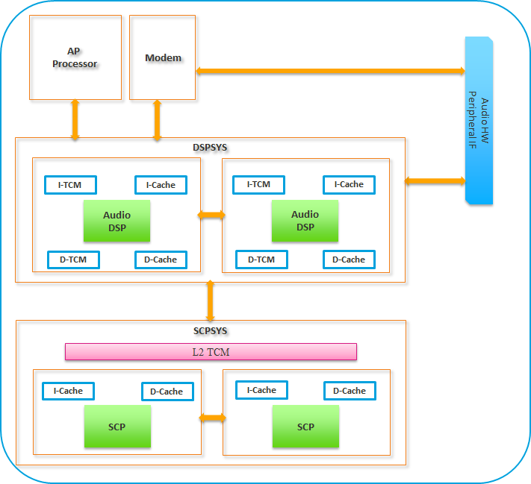
Figure 2-2. 5G-L/H HiFi3 DSP Structure
In 5G-L/H, we have two HiFi3 DSP inside, thus we can support rich feature sets. However, we don’t support SMP structure so that we need to pre-define which feature should be executed in which DSP core. Generally, the audio features are in one DSP core while speech features are in the other one. For example, speech noise reduction maybe in one DSP core, and speaker protecion is executed in the other. In this condition, there is data exchange between the two DSP:
- There is core to core IPC support
- Both of the DSP can access external DDR, so they can exchange data through the EMI
- The DSP can access the TCM of the other DSP

Hardware Spec
The basic information of each Audio DSP is summarized as follows:
- TCM (Tight-Coupled Memory, Internal Memory)
  - I-TCM (Instruction): 36KB
  - D-TCM (Data): 32KB
  - The TCM is used for RTOS and system service. So it is not allowed for the use of Audio/Voice algorithm.
- Cache
  - I-Cache: 32KB, 2-way Associativity
  - D-Cache: 64KB, 4-way Associativity
  - Cache Line Size: 128 Bytes
- Clock Rate
  - Fix 700 MHz
- Programmable DMA (burst of 16-bit) for DSP supported to transfer data to/from external memory
  - Support 4 DMA channels, that we can start 4 DMA transactions simultaneously
  - We’ve provided an API to trigger DMA
  - The 4 ch DMA are shared by the dual DSP cores
- External Memory and Devices
  - DRAM: it can access data on DRAM by DMA or by CPU directly (through Cache).
  - AudioSys: it is through a dedicated BUS, which don’t need to go through EMI. The DSP can access hardware registers and SRAM of the AudioSys without constrains.

Software Capability

RTOS and System Services
Note that the toolchain version is RI.2018.0

Audio Features
The supported audio features are the same with P90/G90. The dual core structure allows us to support more features at the same time and make it possible to support 3-mic noise reduction.
MCPS Available: (10% for system and data overhead)
- Other than voice call
  - 630 Mhz of each DSP core
- Voice call
  - If we add 20ms round trip latency; the available MCPS (for total MCPS of UL+DL)would be the same as other applications
Codec | Scenario | No Delay 20ms  Modem Side Normal Power |  | No Delay 20ms  Modem Side High Power MODE |  | Delay 20ms
Codec | Scenario | UL Available MCPS | DL Available MCPS | UL Available MCPS UL | DL Available MCPS | UL Available MCPS | DL Available MCPS
EVRCB | C2K | 239.4 | 44.1 | 302.4 | 81.9 | 585.9 | 44.1
AMR | 3G | 365.4 | 59.85 | 412.65 | 66.15 | 570.15 | 59.85
AMR-WB | 3G | 318.15 | 96.65 | 365.4 | 113.4 | 570.15 | 59.85
AMR-WB | VoLTE (1cc) | 444.15 | 160.65 | 507.15 | 96.65 | 532.25 | 97.65
EVS-WB | VoLTE (1cc) | 365.4 | 239.4 | 381.15 | 223.65 | 532.25 | 97.65
EVS-SWB | VoLTE (1cc) | 381.15 | 223.65 | 343.35 | 286.65 | 500.85 | 129.15
EVS-SWB | VoLTE (4cc) | 381.15 | 223.65 | 343.35 | 286.65 | 500.85 | 129.15

Note:
- Modem side high power mode means to use higher voltage so that the Modem DSP can be executed in a faster clock rate. Thus, the execution time of decoding/encoding of speech codec would be reduced. Then we can get more budget to execute speech enhancement in the Audio DSP. However, the power consumption would be higher.
- In delay 20ms case, the proportion of available MCPS for UL/DL is adjustable.
- Since we have dual core, we assume that there is no task would be excuted with phone call enhancement at the same time in a core.

5G-A / 5G-A+
The specification of 5G-A is the same with 5G-L/H/H+. The only difference is that the clock rate can be up to 750MHz.
- Clock Rate
  - Fix 750 MHz
- Memory Config
  - I-Cache 32KB, D-Cache 64KB, I-TCM 36KB, D-TCM 32KB: 5G-A / 5G-A+
- MCPS Available:
  - Other than voice call
    - 675 Mhz of each DSP core
  - Voice call
Codec | Scenario | No Delay 20ms  Modem Side Normal Power |  | No Delay 20ms  Modem Side High Power MODE |  | Delay 20ms
Codec | Scenario | UL Available MCPS | DL Available MCPS | UL Available MCPS UL | DL Available MCPS | UL Available MCPS | DL Available MCPS
EVRCB | C2K | 256.50 | 47.25 | 324.00 | 87.75 | 627.75 | 47.25
AMR | 3G | 391.50 | 64.13 | 442.13 | 70.88 | 610.88 | 64.13
AMR-WB | 3G | 340.88 | 103.55 | 391.50 | 121.50 | 610.88 | 64.13
AMR-WB | VoLTE (1cc) | 475.88 | 172.13 | 543.38 | 103.55 | 570.27 | 104.63
EVS-WB | VoLTE (1cc) | 391.50 | 256.50 | 408.38 | 239.63 | 570.27 | 104.63
EVS-SWB | VoLTE (1cc) | 408.38 | 239.63 | 367.88 | 307.13 | 536.63 | 138.38
EVS-SWB | VoLTE (4cc) | 408.38 | 239.63 | 367.88 | 307.13 | 536.63 | 138.38

5G-B / Next-A / Next-A2 / 22H
The structure is the same with 5G-A, however, there is only one dsp core. (You can treat it as remove one DSP core from 5G-A).
- Toolchain Version
  - 5G-B / Next-A / Next-A2
    - the toolchain version is RI.2019.1
  - 22H
    - the toolchain version is RI.2021.8
- Clock Rate
  - 5G-B / Next-A / Next-A2
    - Fix 750 MHz
  - 22H
    - Fix 800 MHz
- Memory Config:
  - I-Cache 32KB, D-Cache 64KB: 5G-B / Next-A
  - I-Cache 64KB, D-Cache 128KB: Next-A2 / 22H
  - Generally, due to cache size increase in Next-A2, the performance would be around 7% better than Next-A (the same IP requires fewer MCPS in Next-A2)
- MCPS Available:
  - Other than voice call
    - 675 Mhz of each DSP core
  - Voice call
Codec | Scenario | No Delay 20ms  Modem Side Normal Power |  | No Delay 20ms  Modem Side High Power MODE |  | Delay 20ms
Codec | Scenario | UL Available MCPS | DL Available MCPS | UL Available MCPS UL | DL Available MCPS | UL Available MCPS | DL Available MCPS
EVRCB | C2K | 256.50 -0.5X | 47.25 - 0.25X | 324.00 – 0.5X | 87.75 – 0.25X | 627.75 | 47.25
AMR | 3G | 391.50 – 0.75X | 64.13 – 0.25X | 442.13 – 0.75X | 70.88 – 0.25X | 610.88 | 64.13
AMR-WB | 3G | 340.88 – 0.5X | 103.55 – 0.25X | 391.50 – 0.75X | 121.50 – 0.25X | 610.88 | 64.13
AMR-WB | VoLTE (1cc) | 475.88 –  0.75X | 172.13 – 0.25X | 543.38 – 0.75X | 103.55 – 0.25X | 570.27 | 104.63
EVS-WB | VoLTE (1cc) | 391.50 – 075X | 256.50 – 0.5X | 408.38 – 0.75X | 239.63 – 0.5X | 570.27 | 104.63
EVS-SWB | VoLTE (1cc) | 408.38 – 0.75X | 239.63 – 0.5X | 367.88 – 0.5X | 307.13 – 0.5X | 536.63 | 138.38
EVS-SWB | VoLTE (4cc) | 408.38 – 0.75X | 239.63 – 0.5X | 367.88 – 0.5X | 307.13 – 0.5X | 536.63 | 138.38
- X = MCPS of SmartPA
- We assume it’s 5ms per frame of SmartPA, and speech enhancement is 20ms per frame. If we encounter one SmartPA frame during speech enhancement, the available MCPS should be reduced by 0.25 x SmartPA MCPS.
- In delay 20ms case, the proportion of available MCPS for UL/DL is adjustable; total MCPS of UL+DL+SmartPA should be less than 675

23P / 24P
The structure is the same with 5G-A, but the clock rate is 800M, and it has a larger I-Cache and D-Cache.
- Toolchain Version
  - 23P / 24P
    - the toolchain version is RI.2021.8
- Clock Rate
  - 23P / 24P
    - Fix 800 MHz
- Memory Config:
  - I-Cache 64KB, D-Cache 128KB: 23P / 24P
  - Generally, due to cache size increase in 23P/24P, the performance would be around 7% better than Next-A (the same IP requires fewer MCPS in 23P/24P)

DX-1/ DX-P
The specification of DX-1/ DX-P is the same with 5G-L/H/H+. The difference is memory config and the clock rate can be up to 800MHz.
- Toolchain Version
  - the toolchain version is RI.2019.1
- Clock Rate
  - Fix 800 MHz
- Memory Config
  - I-Cache 64KB, D-Cache 128KB, I-TCM 256KB, D-TCM 32KB: DX-1
  - I-Cache 64KB, D-Cache 128KB, I-TCM 36KB, D-TCM 32KB: DX-P
  - Generally, due to cache size increase in DX-1/DX-P, the performance would be around 7% better than 5G-A (the same IP requires fewer MCPS in DX-1/DX-P); besides, the 256KB I-TCM in DX-1 can be used for reducing dram access and can be used for critical functions.

DX-2 / DX-3 / DX-4
The platform use dual HiFi5 DSP core which has 32 8x8 NNMACs capability so that it can support advanced NN algorithm techniques.
- Toolchain Version
  - DX-2
    - the toolchain version is RI.2021.8
  - DX-3 / DX-4
    - the toolchain version is RI.2023.11
- Clock Rate
  - DX-2 / DX-3 / DX-4
    - Fix 800 MHz
- Memory Config
  - DX-2
    - I-Cache 64KB, D-Cache 128KB, I-TCM 36KB, D-TCM 32KB, L2-TCM 512KB
  - DX-3 / DX-4
    - I-Cache 64KB, D-Cache 128KB, I-TCM 36KB, D-TCM 32KB, L2-TCM 768KB
- MCPS Available:
  - Voice call
    - DX-2
Codec | Scenario | Normal Mode |  | Delay 20ms
Codec | Scenario | UL Available MCPS | DL Available MCPS | UL Available MCPS | DL Available MCPS
EVRCB | C2K | 273.6 -0.5X | 50.4 - 0.25X | 720 | 50.4 - 0.25X
AMR | 3G | 417.6 – 0.75X | 68.4 – 0.25X | 720 | 68.4 – 0.25X
AMR-WB | 3G | 363.6 – 0.5X | 111.6– 0.25X | 720 | 111.6– 0.25X
AMR-WB | VoLTE (1cc) | 507.6– 0.75X | 183.6– 0.25X | 720 | 183.6– 0.25X
EVS-WB | VoLTE (1cc) | 417.6 – 075X | 273.6 – 0.5X | 720 | 273.6 – 0.5X
EVS-SWB | VoLTE (1cc) | 435.6 – 0.75X | 255.6 – 0.5X | 720 | 255.6 – 0.5X
EVS-SWB | VoLTE (4cc) | 435.6 – 0.75X | 255.6 – 0.5X | 720 | 255.6 – 0.5X

    - DX-3
 | RCV
 | MCPS SPEC (W/o SmartPA) |  | MCPS SPEC (W/o SmartPA) |  | MCPS SPEC (W/o SmartPA)
 |  |  | UL Delay One Frame |  | DL Delay One Frame
 | UL | DL | UL | DL | UL | DL
NB (8K) | 280.8 | 50.4 | 669.6 | 50.4 | 280.8 | 439.2
WB (16K) | 385.2 | 68.4 | 651.6 | 68.4 | 385.2 | 334.8
SWB (32K) | 446.4 | 190.8 | 529.2 | 190.8 | 446.4 | 273.6
 | SPK
 | MCPS SPEC (With SmartPA) |  | MCPS SPEC (With SmartPA) |  | MCPS SPEC (With SmartPA)
 |  |  | UL Delay One Frame |  | DL Delay One Frame
 | UL | DL | UL | DL | UL | DL
NB (8K) | 280.8 - 0.50x | 50.4 - 0.25x | 669.6 - x | 50.4 - 0.25x | 280.8 - 0.50x | 439.2 - x
WB (16K) | 385.2 - 0.50x | 68.4 - 0.25x | 651.6 - x | 68.4 - 0.25x | 385.2 - 0.50x | 334.8 - x
SWB (32K) | 446.4 - 0.75x | 190.8 - 0.25x | 529.2 - x | 190.8 - 0.25x | 446.4 - 0.75x | 446.4 - 0.75x
- Implementation of the 'Delay one frame' feature requires Phonecall Driver support and incurs an additional round-trip delay (RTD) of 20ms.

    - DX-4
MTK DX-4 Phone Call MCPS SPEC (for Customer)
Release Version: v1.1, Date: 2025/04/16
Release note :
- Normal case: handset, 3.5mm earphone, Classic BT(CVSD, mSBC)
- Different output device: Smart PA, USB offload and BLE cases
  - Must consider the concurrency scenario
  - Variable “X” is the MCPS of a specific concurrency
  - USB (245) and BLE (170) numbers belongs to MTK driver profiling
    - Include system driver MCPS
  - SmartPA:
    - Algorithm MCPS : N (depends on customer decision)
    - Driver : 10
- UL delay-one-frame:
  - More available MCPS compared to “Default”
  - Requires extra 20ms delay in UL
- DL delay-one-frame:
  - More available MCPS compared to “Default”
  - Requires extra 20ms delay in DL
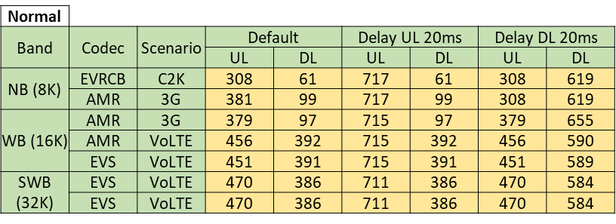

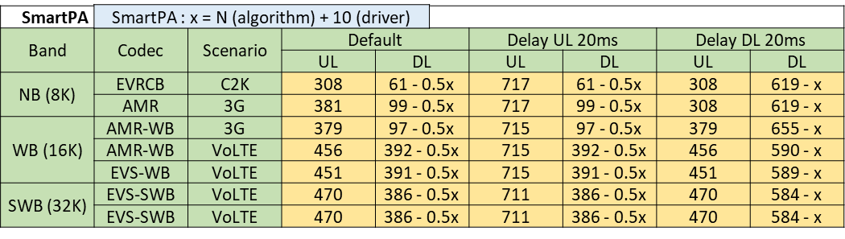
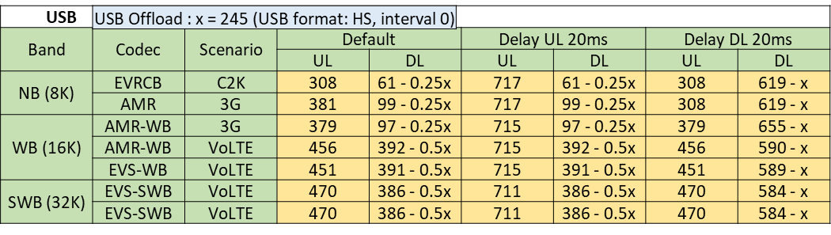
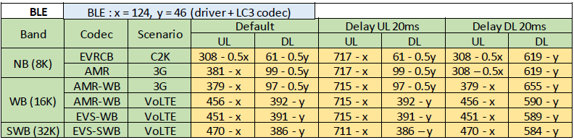

Structure
In DX-2 / DX-3, we have dual HiFi5 DSP inside, it supports 4x MACs compared with HiFi3 and support 32 8x8 NN MACs. Thus, to support advanced NN algorithms is possible in DX-2 / DX-3.
Besides, there is a L2TCM can be used for algorithms to reduce memory access latency and data bandwidth to DRAM. The MCPS and power consumption would be reduced if the L2TCM is used properly.

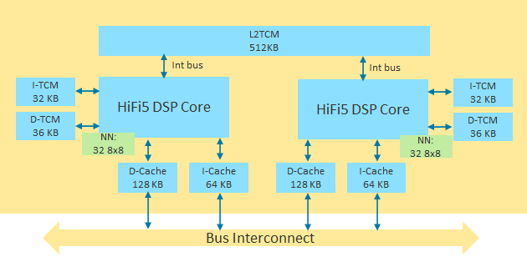
Figure 2-3. DX-2 HiFi5 DSP Structure
In DX-4, there is an NNE (Neural Network Engine) connected with the UL processing core, it supports acceleration to Neural Network computations. With the NNE, the performance of NN algorithms can be further improved in DX-4.
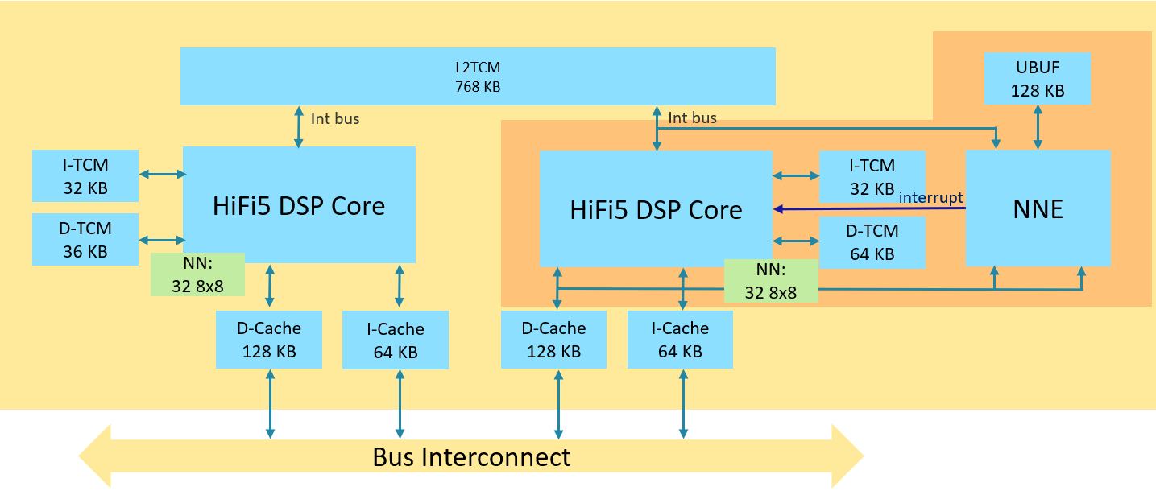
Figure 2-4. DX-4 HiFi5 DSP Structure with NNE

MTK In-house RV Series

DX-5

Structure
In DX-5, we have dual RV55 cores inside, it supports thirty-two 8*8, sixteen 16*16, or eight 32*32 NN MACs. Thus, to support advanced NN algorithms is possible in DX-5. In addition, DX-5 also supports the TinyDLA which can further accelerate NN computations.
Besides, there is a L2TCM can be used for algorithms to reduce memory access latency and data bandwidth to DRAM. The MCPS and power consumption would be reduced if the L2TCM is used properly.
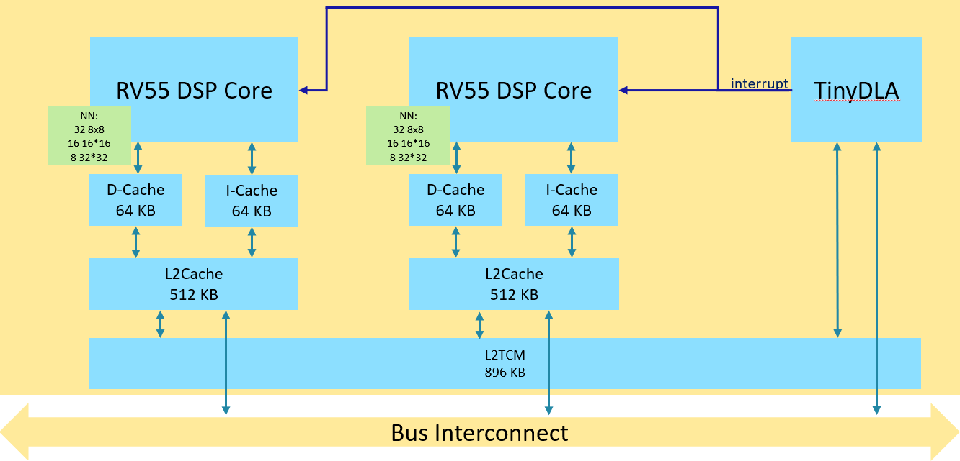
Figure 3-1 DX-5 RV DSP Structure with TinyDLA

Hardware Spec
The basic information about Audio DSP is as below,
- Processor:
  - MTK in-house RV55 cores with RISC-V architecture
  - Single-precision floating point
  - Compressed instruction
  - DSP ISA for voice acceleration
- TCM (Tight-Coupled Memory, Internal Memory)
  - 896KB for both Program and data
  - The TCM is used for RTOS and system service. So, it only has 736KB left for the use of Audio/Voice algorithm.
- Cache
  - L1 Cache
    - I-Cache: 64KB, 2-way Associativity
    - D-Cache: 64KB, 2-way Associativity
    - Cache Line Size: 128 Bytes
  - L2 cache: 512KB, 8-way Associativity
- Clock Rate
  - DVFS OPP 400MHz and 800MHz
- Programmable DMA (burst of 16-bit) for DSP supported to transfer data to/from external memory
  - Support 4 DMA channels, that we can start 4 DMA transactions simultaneously
  - We’ve provided an API to trigger DMA
- External Memory and Devices
  - DRAM: it can access data on DRAM by DMA or by CPU directly (through Cache).
  - AudioSys: ADSP can access AudioSys through the internal bus without going through the infra bus. So, ADSP cores can access hardware registers and SRAM of the AudioSys without constrains.

Software Capability

RTOS and System Services
- RTOS
  - Free-RTOS
- DVFS
Scenario | 400MHz | 800MHz
Screen On +  Singal stream offload or Deep +  Singal output device SPK or A2DP(sbc/aac) or Headphone | O | X
Other audio scenes | X | O
- Debug Tools
  - Please refer to the ADSP_Debugging_Guideline.docx for more detail about ADSP debug tools.
- MDSP PDK
  - CoreTracer – MDSP IDE for development
  - C Libraries - Standard C Library

Audio Features
The supported audio features are the same with DX-4. The dual core structure allows us to support more features at the same time and make it possible to support 3-mic noise reduction.
MCPS:
MTK DX-5 Phone Call MCPS SPEC (for Customer)
Release Version: v1.0, Date: 2025/07/07
Release note :
- Normal case : handset, 3.5mm earphone, Classic BT(CVSD, mSBC)
- Different output device: Smart PA, USB offload and BLE cases
  - Must consider the concurrency scenario
  - Variable “X” is the MCPS of a specific concurrency
  - USB (133) and BLE (181) numbers belongs to MTK driver profiling
    - Include system driver MCPS
  - SmartPA:
    - Algorithm MCPS : N (depends on customer decision)
    - Driver : 20
- UL delay-one-frame:
  - More available MCPS compared to “Default”
  - Requires extra 20ms delay in UL
- DL delay-one-frame:
  - More available MCPS compared to “Default”
  - Requires extra 20ms delay in DL

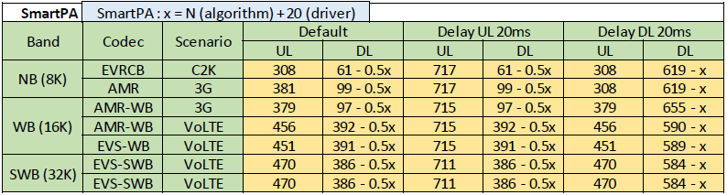
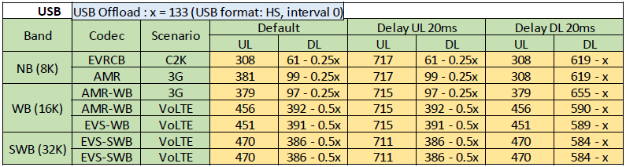
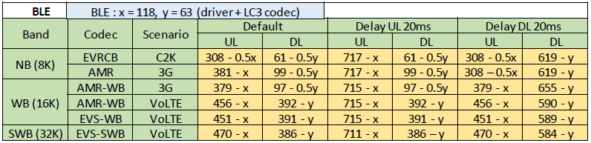

24M

Structure
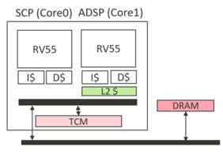
In 24M, the SCP subsystem has 2 RV55 cores, one is for SCP legacy features, such as sensor/ VoW/ Ultrasound, and another one is for the audio feature, which used to be executed on a standalone ADSP subsystem. For Audio offload, we can support both DL/UL feature sets in a single core.
Figure 3-2 24M RV DSP Structure

Hardware Spec
In this section, we focus on the spec of 24M Audio DSP, instead of the whole SCP subsys. If you are interested in the capability of the whole SCP subsystem, please find the document MT6878_SCP_Development_Guide.docx via DMS release.
The basic information about the 24M Audio DSP is as follows,
- Processor:
  - MTK in-house RV55 single core with RISC-V architecture
  - Single-precision floating point
  - Compressed instruction
  - DSP ISA for voice acceleration
- TCM (Tight-Coupled Memory, Internal Memory)
  - 1MB for both the program and data
  - The TCM is shared between SCP and Audio DSP, but used for RTOS, system service and SCP always on feature (Sensor, VoW, and Ultrasound). So it is not allowed for the use of Audio/Voice algorithm.
- Cache
  - L1 Cache
    - I-Cache: 32KB, 4-way Associativity
    - D-Cache: 32KB, 4-way Associativity
    - Cache Line Size: 128 Bytes
  - L2 cache: 128KB only for Audio DSP
- Clock Rate
- DVFS OPP from 200MHz to 800MHz
- Programmable DMA (burst of 16-bit) for DSP supported to transfer data to/from external memory
  - Support 8 DMA channels, that we can start 4 DMA transactions simultaneously
  - We’ve provided an API to trigger DMA
- External Memory and Devices
  - DRAM: it can access data on DRAM by DMA or by CPU directly (through Cache).
  - AudioSys: there is no dedicated BUS on 24M. The DSP can access hardware registers and SRAM of the AudioSys without constrains.

Software Capability

RTOS and System Services
- RTOS
  - Free-RTOS
- DVFS
  - Fixed DSP frequency 800MHz is selected when any audio feature on Audio DSP.
- Debug Tools
  - Logging – UART log, and MTK Logger
  - Coredump Extractor
  - Audio Dump– capture PCM dump before/after processing. (we’ve provided an API to add a PCM dump in the designated position
  - PMU
    - Performance Monitor Unit. It can be used to monitor the information cache miss rate, cache hit rate, and iostall rate etc.
    - Number of Performance Counters– 5
  - PBFR flight recorder – to provide task/ ISR/ event trace
- MDSP PDK
  - CoreTracer – MDSP IDE for development
  - C Libraries - C Library

Audio Features
Supported Audio Features:
- Speech/Voice
  - Speech enhancement during VOIP call (8k/16k/32k)
  - Speech enhancement during Voice call (8k/16k/32k)
  - Recording enhancement
- Audio Playback
  - SmartPA
MCPS:
Generally, we need to reserve at least 10% headroom for buffer copy, system overhead, access external devices, and interaction between APMCU. Besides, in voice call case, the voice codec is processed in Modem side and the speech enhancement is processed in the Audio DSP. The timing should be aligned to avoid increasing round trip delay, so we need to reserve more headroom in voice call case. However, If the library can’t meet the requirement, there is two solutions:
- We need to delay 1 frame to process the data. There would be 20ms increment in the round trip delay.
- Increase the clock rate of Audio DSP or Modem, it would have more power consumption.

  - 24M
Normal
Band | Codec | Scenario | Default |  | Delay UL 20ms |  | Delay DL 20ms
Band | Codec | Scenario | UL | DL | UL | DL | UL | DL
NB (8K) | EVRCB | C2K | 282 | 51 | 639 | 51 | 282 | 75
NB (8K) | AMR | 3G | 381 | 69 | 601 | 69 | 381 | 113
WB (16K) | AMR | 3G | 379 | 67 | 599 | 67 | 379 | 111
WB (16K) | AMR | VoLTE | 456 | 193 | 467 | 193 | 456 | 221
WB (16K) | EVS | VoLTE | 427 | 234 | 462 | 234 | 427 | 249
SWB (32K) | EVS | VoLTE | 441 | 185 | 485 | 185 | 441 | 226
SWB (32K) | EVS | VoLTE | 441 | 185 | 485 | 185 | 441 | 226

SmartPA | SmartPA : X = N (algorithm) + 20 (driver)
Band | Codec | Scenario | Default |  | Delay UL 20ms |  | Delay DL 20ms
Band | Codec | Scenario | UL | DL | UL | DL | UL | DL
NB (8K) | EVRCB | C2K | 282 - 0.5x | 51 - 0.5x | 639 - x | 51 - 0.5x | 282 - 0.5x | 75 - 0.5x
NB (8K) | AMR | 3G | 381 - x | 69 - 0.5x | 601 - x | 69 - 0.5x | 381 - x | 113 - 0.5x
WB (16K) | AMR-WB | 3G | 379 - x | 67 - 0.5x | 599 - x | 67 - 0.5x | 379 - x | 111 - 0.5x
WB (16K) | AMR-WB | VoLTE | 456 - x | 193 - 0.5x | 467 - x | 193 - 0.5x | 456 - x | 221 - 0.5x
WB (16K) | EVS-WB | VoLTE | 427 - x | 234 - 0.5x | 462 - x | 234 - 0.5x | 427 - x | 249 - 0.5x
SWB (32K) | EVS-SWB | VoLTE | 441 - x | 185 - 0.5x | 485 - x | 185 - 0.5x | 441 - x | 226 - 0.5x
SWB (32K) | EVS-SWB | VoLTE | 441 - x | 185 - 0.5x | 485 - x | 185 - 0.5x | 441 - x | 226 - 0.5x

USB | USB Offload : X = 17 ~ 277
  USB format | FS, interval 0 | HS, interval 0 | HS, interval 1 | HS, interval 2 | HS, interval 3
  MCPS | 157 | 277 | 152 | N/A | 158
Band | Codec | Scenario | Default |  | Delay UL 20ms |  | Delay DL 20ms
Band | Codec | Scenario | UL | DL | UL | DL | UL | DL
NB (8K) | EVRCB | C2K | 282 - 0.5x | 51 - 0.25x | 639 - x | 51 - 0.25x | 282 - 0.5x | 75 - 0.25x
NB (8K) | AMR | 3G | 381 - 0.75x | 69 - 0.25x | 601 - x | 69 - 0.25x | 381 - 0.75x | 113 - 0.25x
WB (16K) | AMR-WB | 3G | 379 - 0.75x | 67 - 0.25x | 599 - x | 67 - 0.25x | 379 - 0.75x | 111 - 0.25x
WB (16K) | AMR-WB | VoLTE | 456 - x | 193 - 0.5x | 467 - x | 193 - 0.5x | 456 - x | 221 - 0.5x
WB (16K) | EVS-WB | VoLTE | 427 - 0.75x | 234 - 0.5x | 462 - x | 234 - 0.5x | 427 - 0.75x | 249 - 0.5x
SWB (32K) | EVS-SWB | VoLTE | 441 - 0.75x | 185 - 0.5x | 485 - x | 185 - 0.5x | 441 - 0.75x | 226 - 0.5x
SWB (32K) | EVS-SWB | VoLTE | 441 - 0.75x | 185 - 0.5x | 485 - x | 185 - 0.5x | 441 - 0.75x | 226 - 0.5x

BLE | BLE : X = 120 (driver + LC3 codec)
Band | Codec | Scenario | Default |  | Delay UL 20ms |  | Delay DL 20ms
Band | Codec | Scenario | UL | DL | UL | DL | UL | DL
NB (8K) | EVRCB | C2K | 282 - 0.5x | 51 - 0.5x | 639 - x | 51 - 0.5x | 282 - 0.5x | 75 - 0.5x
NB (8K) | AMR | 3G | 381 - x | 69 - 0.5x | 601 - x | 69 - 0.5x | 381 - x | 113 - 0.5x
WB (16K) | AMR-WB | 3G | 379 - x | 67 - 0.5x | 599 - x | 67 - 0.5x | 379 - x | 111 - 0.5x
WB (16K) | AMR-WB | VoLTE | 456 - x | 193 - 0.5x | 467 - x | 193 - 0.5x | 456 - x | 221 - 0.5x
WB (16K) | EVS-WB | VoLTE | 427 - x | 234 - 0.5x | 462 - x | 234 - 0.5x | 427 - x | 249 - 0.5x
SWB (32K) | EVS-SWB | VoLTE | 441 - x | 185 - 0.5x | 485 - x | 185 - 0.5x | 441 - x | 226 - 0.5x
SWB (32K) | EVS-SWB | VoLTE | 441 - x | 185 - 0.5x | 485 - x | 185 - 0.5x | 441 - x | 226 - 0.5x

25Ms/ 26M

Structure
In 25Ms and 26M, the SCP and ADSP are merged into a single RV55 Dual-Core subsystem. The core affinity strategy for Audio and SCP features remains the same as it was for the 24M platform. One is for SCP legacy features, such as sensor/ VoW/ Ultrasound, and another one is for audio features. The only change is the transition from a dual-core AMP architecture to a dual-core SMP (Symmetric Multi-Processing) architecture, which provides greater flexibility for future load balancing.
Figure 3-3 25Ms&26M RV DSP Structure

Hardware Spec
The basic information about the 25Ms/26M Audio DSP/SCP subsystem is listed below,
- Processor:
  - MTK in-house RV55 Dual-Core (SMP) with RISC-V architecture
    - Single-precision floating point
    - Compressed instruction
    - DSP ISA for voice acceleration
- TCM (Tight-Coupled Memory, Internal Memory)
  - 1.25MB for both the program and data
  - The TCM is shared between SCP and Audio DSP, but used for RTOS, system service and SCP always on feature (Sensor, VoW, and Ultrasound). So it is not allowed for the use of Audio/Voice algorithm.
- Cache
  - L1 Cache
    - I-Cache: 32KB, 4-way Associativity
    - D-Cache: 32KB, 4-way Associativity
    - Cache Line Size: 128 Bytes
  - L2 cache: 256KB unified across Audio DSP and SCP
- Clock Rate
  - 25Ms
    - DVFS OPP supports 200MHz, 400MHz, 800MHz and 1GHz
    - Audio DSP is restricted to 800MHz and 1GHz only.
  - 26M
    - DVFS OPP supports 200MHz, 400MHz, 800MHz and 1.092GHz
    - Audio DSP is restricted to 800MHz and 1.092GHz only.
- Programmable DMA (burst of 16-bit) for DSP to transfer data to/from external memory
  - Support 8 DMA channels, so that we can start 4 DMA transactions simultaneously
  - We’ve provided an API to trigger DMA
- External Memory and Devices
  - DRAM: It can access data on DRAM by DMA or by CPU directly (through Cache).
  - AudioSys: There is no dedicated BUS between DSP subsystem and AudioSys. The DSP can access the hardware registers and SRAM of the AudioSys without constraints.

Software Capability

RTOS and System Services
- RTOS
  - FreeRTOS 11.0.0 (from 10.1.0.1)
- Scheduling
  - SMP Affinity to support audio feature on a dedicated core for performance stability.
- DVFS
  - Support distinct DVFS gears at audio basic and high frequencies to optimize audio feature execution speed vs. power consumption.
    - Basic frequency is 800MHz for both 25Ms and 26M
    - High frequency is 1GHz for 25Ms, and 1.092GHz for 26M
Scenario | Basic Frequency | High Frequency
Single scenario, such as playback/ VoIP/ Phone call | O | X
Cascaded scenario, which is customer-definable | X | O

- Debug Tools
  - Logging – UART log, and MTK Logger
  - Coredump Extractor
  - Audio Dump– capture PCM dump before/after processing. (we’ve provided an API to add a PCM dump in the designated position
  - PMU
    - Performance Monitor Unit. It can be used to monitor the information cache miss rate, cache hit rate, and iostall rate etc.
    - Number of Performance Counters– 5
  - ADSP tracer – provide task/ ISR/ event trace
- MDSP PDK
  - CoreTracer – MDSP IDE for development
  - C Libraries - C Library

Audio Features
25Ms and 26M ADSP roughly align with 24M ADSP in audio features, but support additional BT codec offloads.
- Speech/Voice
  - Speech enhancement during VOIP call (8k/16k/32k/48k)
  - Speech enhancement during Voice call (8k/16k/32k)
  - Recording enhancement
- Audio Playback
  - SmartPA
MCPS:
Generally, we need to reserve at least 10% headroom for buffer copy, system overhead, accessing external devices, and interaction between APMCU. Besides, in voice call case, the voice codec is processed in Modem side and the speech enhancement is processed in the Audio DSP. The timing should be aligned to avoid increasing round-trip delay, so we need to reserve more headroom in voice call case. However, If the library can’t meet the requirement, there are two solutions:
- We need to delay 1 frame to process the data. There would be 20ms increment in the round-trip delay.
- Increase the clock rate of Audio DSP or Modem, it would result in more power consumption.

- 25Ms
All data is standardized to the DSP’s maximum frequency of 1 GHz. For scenarios requiring 800 MHz, values can be converted by dividing by a factor of 1.25.
Normal
Band | Codec | Scenario | Default |  | Delay UL 20ms |  | Delay DL 20ms
Band | Codec | Scenario | UL | DL | UL | DL | UL | DL
NB (8K) | AMR-NB | 3G | 477 | 124 | 752 | 124 | 477 | 142
NB (8K) | AMR-WB | 3G | 474 | 121 | 749 | 121 | 474 | 139
WB (16K) | AMR-WB | VoLTE | 570 | 293 | 584 | 293 | 570 | 305
WB (16K) | EVS-WB | VoLTE | 564 | 293 | 577 | 293 | 564 | 311
WB (16K) | EVS-SWB | VoLTE | 593 | 264 | 606 | 264 | 593 | 282
SWB (32K) | EVS-SWB | VoLTE | 593 | 264 | 606 | 264 | 593 | 282
SWB (32K) | AMR-NB | 3G | 477 | 124 | 752 | 124 | 477 | 142

SmartPA | SmartPA : X = N (algorithm) + 20 (driver)
Band | Codec | Scenario | Default |  | Delay UL 20ms |  | Delay DL 20ms
Band | Codec | Scenario | UL | DL | UL | DL | UL | DL
NB (8K) | AMR | 3G | 477 - 0.5x | 124 - 0.5x | 752 - x | 124 - 0.5x | 477 - 0.5x | 142 - 0.5x
WB (16K) | AMR-WB | 3G | 474 - 0.5x | 121 - 0.5x | 749 - x | 121 - 0.5x | 474 - 0.5x | 139 - 0.5x
WB (16K) | AMR-WB | VoLTE | 570 - x | 293 - 0.5x | 584 - x | 293 - 0.5x | 570 - x | 305 - 0.5x
WB (16K) | EVS-WB | VoLTE | 564 - x | 293 - 0.5x | 577 - x | 293 - 0.5x | 564 - x | 311 - 0.5x
SWB (32K) | EVS-SWB | VoLTE | 593 - x | 264 - 0.5x | 606 - x | 264 - 0.5x | 593 - x | 282 - 0.5x
SWB (32K) | EVS-SWB | VoLTE | 593 - x | 264 - 0.5x | 606 - x | 264 - 0.5x | 593 - x | 282 - 0.5x

USB | USB Offload: X = 200
Band | Codec | Scenario | Default |  | Delay UL 20ms |  | Delay DL 20ms
Band | Codec | Scenario | UL | DL | UL | DL | UL | DL
NB(8K) | AMR | 3G | 477 - 0.5x | 124 - 0.25x | 752 - 0.75x | 124 - 0.25x | 477 - 0.5x | 142 - 0.25x
WB (16K) | AMR-WB | 3G | 474 - 0.5x | 121 - 0.25x | 749 - 0.75x | 121 - 0.25x | 474 - 0.5x | 139 - 0.25x
WB (16K) | AMR-WB | VoLTE | 570 - 0.75x | 293 - 0.5x | 584 - 0.75x | 293 - 0.5x | 570 - 0.75x | 305 - 0.5x
WB (16K) | EVS-WB | VoLTE | 564 - 0.75x | 293 - 0.5x | 577 - 0.75x | 293 - 0.5x | 564 - 0.75x | 311 - 0.5x
SWB (32K) | EVS-SWB | VoLTE | 593 - 0.75x | 264 - 0.5x | 606 - 0.75x | 264 - 0.5x | 593 - 0.75x | 282 - 0.5x
SWB (32K) | EVS-SWB | VoLTE | 593 - 0.75x | 264 - 0.5x | 606 - 0.75x | 264 - 0.5x | 593 - 0.75x | 282 - 0.5x

BLE | BLE : X = 160 (driver + LC3 codec)
Band | Codec | Scenario | Default |  | Delay UL 20ms |  | Delay DL 20ms
Band | Codec | Scenario | UL | DL | UL | DL | UL | DL
NB (8K) | AMR | 3G | 477 - 0.5x | 124 - 0.5x | 752 - x | 124 - 0.5x | 477 - 0.5x | 142 - 0.5x
WB (16K) | AMR-WB | 3G | 474 - 0.5x | 121 - 0.5x | 749 - x | 121 - 0.5x | 474 - x | 139 - 0.5x
WB (16K) | AMR-WB | VoLTE | 570 - x | 293 - 0.5x | 584 - x | 293 - 0.5x | 570 - x | 305 - 0.5x
WB (16K) | EVS-WB | VoLTE | 564 - x | 293 - 0.5x | 577 - x | 293 - 0.5x | 564 - x | 311 - 0.5x
SWB (32K) | EVS-SWB | VoLTE | 593 - x | 264 - 0.5x | 606 - x | 264 - 0.5x | 593 - x | 282 - 0.5x
SWB (32K) | EVS-SWB | VoLTE | 593 - x | 264 - 0.5x | 606 - x | 264 - 0.5x | 593 - x | 282 - 0.5x

  - 26M
All data is standardized to the DSP’s maximum frequency of 1.092 GHz. For scenarios requiring 800 MHz, values can be converted by dividing by a factor of 1.365.
Normal
Band | Codec | Scenario | Default |  | Delay UL 20ms |  | Delay DL 20ms
Band | Codec | Scenario | UL | DL | UL | DL | UL | DL
NB (8K) | AMR-NB | 3G | 520 | 135 | 821 | 135 | 520 | 155
WB (16K) | AMR-WB | 3G | 517 | 132 | 818 | 132 | 517 | 152
WB (16K) | AMR-WB | VoLTE | 623 | 320 | 637 | 320 | 623 | 333
WB (16K) | EVS-WB | VoLTE | 616 | 320 | 630 | 320 | 616 | 340
SWB (32K) | EVS-SWB | VoLTE | 647 | 288 | 662 | 288 | 647 | 308
SWB (32K) | EVS-SWB | VoLTE | 647 | 288 | 662 | 288 | 647 | 308

SmartPA | SmartPA:X = N(algorithm) + 20(Driver)
Band | Codec | Scenario | Default |  | Delay UL 20ms |  | Delay DL 20ms
Band | Codec | Scenario | UL | DL | UL | DL | UL | DL
NB (8K) | AMR-NB | 3G | 520 - x | 135- 0.5x | 821 - x | 135 – 0.5x | 520 – x | 155 – 0.5x
WB (16K) | AMR-WB | 3G | 517- x | 132- 0.5x | 818 – x | 132 – 0.5x | 517 – x | 152 – 0.5x
WB (16K) | AMR-WB | VoLTE | 623- x | 320- 0.5x | 637 – x | 320 – 0.5x | 623 – x | 333 – 0.5x
WB (16K) | EVS-WB | VoLTE | 616- x | 320- 0.5x | 630 – x | 320 – 0.5x | 616 – x | 340 – 0.5x
SWB (32K) | EVS-SWB | VoLTE | 647- x | 288- 0.5x | 662 – x | 288 – 0.5x | 647 – x | 308 – 0.5x
SWB (32K) | EVS-SWB | VoLTE | 647- x | 288- 0.5x | 662 - x | 288 – 0.5x | 647 – x | 308 – 0.5x

USB | USB: X = 200
Band | Codec | Scenario | Default |  | Delay UL 20ms |  | Delay DL 20ms
Band | Codec | Scenario | UL | DL | UL | DL | UL | DL
NB (8K) | AMR | 3G | 520 – 0.75x | 135 – 0.25x | 821 - x | 135 – 0.25x | 520 – 0.75x | 155 – 0.25x
WB (16K) | AMR-WB | 3G | 517 – 0.75x | 132 – 0.25x | 818 – x | 132 – 0.25x | 517 – 0.75x | 152 – 0.25x
WB (16K) | AMR-WB | VoLTE | 623 – 0.75x | 320 – 0. 5x | 637 – 0.75x | 320 – 0. 5x | 623 – 0.75x | 333 – 0.5x
WB (16K) | EVS-WB | VoLTE | 616 – 0.75x | 320 – 0. 5x | 630 – 0.75x | 320 – 0. 5x | 616 – 0.75x | 340 – 0.5x
SWB (32K) | EVS-SWB | VoLTE | 647 – 0.75x | 288 – 0. 5x | 662 – 0.75x | 288 – 0. 5x | 647 – 0.75x | 308 – 0.5x
SWB (32K) | EVS-SWB | VoLTE | 647 – 0.75x | 288 – 0. 5x | 662 – 0.75x | 288 – 0. 5x | 647 – 0.75x | 308 – 0.5x

BLE | BLE: X = 160
Band | Codec | Scenario | Default |  | Delay UL 20ms |  | Delay DL 20ms
Band | Codec | Scenario | UL | DL | UL | DL | UL | DL
NB (8K) | AMR | 3G | 520 –x | 135 – 0.5x | 821 - x | 135 – 0.5x | 520 –x | 155 – 0.5x
WB (16K) | AMR-WB | 3G | 517 –x | 132 – 0.5x | 818 – x | 132 – 0.5x | 517 –x | 152 – 0.5x
WB (16K) | AMR-WB | VoLTE | 623 –x | 320 – 0.5x | 637 – x | 320 – 0.5x | 623 –x | 333 – 0.5x
WB (16K) | EVS-WB | VoLTE | 616 –x | 320 – 0.5x | 630 – x | 320 – 0.5x | 616 –x | 340 – 0.5x
SWB (32K) | EVS-SWB | VoLTE | 647 –x | 288 – 0.5x | 662 – x | 288 – 0.5x | 647 –x | 308 – 0.5x
SWB (32K) | EVS-SWB | VoLTE | 647 –x | 288 – 0.5x | 662 - x | 288 – 0.5x | 647 –x | 308 – 0.5x

