

Audio DSP Development Tutorial
User Manual
Customer Support

N/A
V1.27
2026-05-11

Doc No:
Version:
Release date:
Classification:

© 2016 - 2026MediaTek Inc.
This document contains information that is proprietary to MediaTek Inc.
Unauthorized reproduction or disclosure of this information in whole or in part is strictly prohibited.

Specifications are subject to change without notice.

Keywords
User Manual

MediaTek Inc.
Postal address
No. 1, Dusing 1st Rd. , Hsinchu Science Park, Hsinchu City, Taiwan 30078
MTK support office address
No. 1, Dusing 1st Rd. , Hsinchu Science Park, Hsinchu City, Taiwan 30078
Internet
http://www.mediatek.com/

Document Revision History
Revision | Date | Author | Description
V0.8 | 2018/08/31 | Doug Wang | Initial Draft
V0.9 | 2019/01/08 | Doug Wang  Danny Hung | Add Debug and MCPS measurement method  b) Add Audio Effect
V1.0 | 2019/11/04 | Doug Wang | a) Refine description of hwcfg and config
V1.10 | 2020/01/22 | Doug Wang | Add b0 file structure  b) Add aurisys development flow
V1.11 | 2020/2/22 | Doug Wang | Add enable UART method  b)Add b0 structure description for debug sop
V1.12 | 2020/4/20 | Doug Wang  Danny Hung  Celine | Add Integration Guideline Chapter  Aurisys Porting Guideline  Reserved Memory Configurations
V1.13 | 2021/01/06 | Danny | Add guideline to add Aurisys scenario
V1.14 | 2022/09/06 | Yuying Lin | a) Add note for aurisys_config_hifi3.xml  b) Update tool chain part:  - Modify DX-2 & 22H param/hwcfg file path  - Add libhal description for on target building HiFiX
V1.15 | 2022/10/13 | Rui-yang Weng | a) How to allocate working buffer for library?  - aurisys allocate buffer control flow  - aurisys API usage
V1.16 | 2022/12/21 | Rui-yang Weng | a) How to allocate working buffer for library? (aurisys interface after V1.8.0)
V1.17 | 2023/04/18 | Yuying Lin  Jung-wei chen | a) Add note for re-building link scripts  b) Update tool chain part:  - Modify 23P param/hwcfg/libhal.a file path
V1.18 | 2023/05/12 | Yuying Lin  Chipeng chang | a) Update compiler part 1.2.5  b) Add DX-3 param/hwcfg/libhal file path
V1.19 | 2023/08/11 | Danny Hung | Add SCP Aurisys porting guide
V1.20 | 2024/01/26 | Celine Liu | a) Add file structure for RV55 platform  b) Updatform description for 24M RV55 platform
V1.21 | 2024/05/17 | Jung-wei chen | a) Update DX-3 libhal.a for NNE  b) Add DX-4 param/hwcfg/libhal.a file path
V1.22 | 2024/07/16 | Jung-wei chen | a) Add 24P param/hwcfg/libhal.a file path
V1.23 | 2024/11/05 | Jung-wei chen | a) Add ADSP system DTS description
V1.24 | 2025/02/27 | Rui-yang Weng | a) Update Aurisys bypass lib process
V1.25 | 2025/05/16 | Jung-wei Chen | a) Add DX-5 configurations
V1.26 | 2025/09/05 | Jung-wei Chen | a) Update 3rd-party library recommended build flags
V1.27 | 2026/05/11 | Jung-wei Chen | a) Add 26M configurations
V1.27 | 2026/05/21 | Celine Liu | a) Add 25Ms configurations

Table of Contents
Document Revision History 3
Table of Contents 4
Lists of Tables 7
Lists of Figures 8
1 Getting Start 9
1.1 File Structure 9
1.1.1 A0 and B0 structure 9
1.1.2 DSP Source Code 9
1.1.3 APMCU 12
1.2 Compile Cadence DSP/HiFi3 & /HiFi5 13
1.2.1 Configurations 13
1.2.2 Default Image 14
1.2.3 Tool Chain 14
1.2.4 Tool Chain Version 21
1.2.5 Compiler 21
1.2.6 Build Command 21
1.2.7 Suggested Library Build Flags 22
1.2.8 3rd Party Libraries 22
1.3 Compile MTK In-house DSP/RV55 – shared SCP software 23
1.3.1 Configuration 23
1.3.2 Default Image 24
1.3.3 Tool Chain 24
1.3.4 Build Command 24
1.3.5 Suggested Library Build Flags 24
1.3.6 3rd Party Libraries 25
1.4 Compile MTK In-house DSP/RV55V & /RV55 – Standalone ADSP software 25
1.4.1 Configuration 25
1.4.2 Default Image 26
1.4.3 Tool Chain 26
1.4.4 Build Command 26
1.4.5 Suggested Library Build Flags 27
1.4.6 3rd Party Libraies 27
1.5 Download by Flashtool 27
2 Software Architecture 29
2.1 Free-RTOS 29
2.1.1 Heap Size 29
2.2 Audio Framework 30
2.3 Aurisys 31
2.3.1 Abstract 31
2.3.2 Aurisys Aims 31
2.3.3 Development Flow 32
3 Software Development Guidance 33
3.1 Scenario Based DVFS 33
3.2 Audio Effects 35
3.2.1 ACF Working Flow on DSP 35
3.2.2 Audio Loudness Working Flow on DSP 40
4 Debug SOP 43
4.1 Issue Feedback to MTK 43
4.2 Performance Issue 43
4.3 Enable UART log 43
5 Integration Guideline 44
5.1 Get the Development Tools 44
5.1.1 Apply for an Account 44
5.1.2 Download the Released Software to the Device 45
5.2 Integration 47
5.2.1 Environment 47
5.2.2 Feature Distribution 48
5.3 Aurisys Porting Guide 49
5.3.1 AP Side Parsing Library 49
5.3.2 DSP/SCP Side Process Library 49
5.3.3 Aurisys Config 51
5.3.4 New Aurisys Scenario 53
5.3.5 How to allocate working buffer for library? (aurisys interface before V1.8.0) 56
5.3.6 How to allocate working buffer for library? (aurisys interface after V1.8.0) 60
5.3.7 Bypass the Aurisys process by configuring the xml 63
5.3.8 Aurisys Q&A 65
5.4 Memory Configurations 66
5.4.1 Memory Profile 66
5.4.2 Approach 66
5.5 ADSP system DTS Properties 72
5.5.1 ADSP system DTS property description 72

Lists of Tables
找不到圖表目錄。

Lists of Figures
Figure 1-1. HiFiX Tool Chain Path 12
Figure 1-2. Example of Makefile Non-support 17
Figure 1-3. Example of Makefile Non-support – Replace by User 17
Figure 1-4. Example of Makefile Support – Replace by Makefile 17
Figure 2-1. Audio Framework 22
Figure 2-2. Concept of Aurisys 23
Figure 2-3. Aurisys Development Flow 23
Figure 3-1. Scenario Based DVFS flow (P80 as example) 24
Figure 3-2. MCPS Lookup Flow 24
Figure 3-3. Register a callback function 25
Figure 3-4. MCPS Look up Callback Function Example 26
Figure 3-5.DRC Working at HIFI3 overview 32
Figure 3-6. DRC Working at HIFI3Flow 33
Figure 5-1. Account Application Guilde Step 1 36
Figure 5-2. Account Application Guilde Step 2 37
Figure 5-3. Account Application Guilde Step 3 37
Figure 5-4. MOL Example 37
Figure 5-5. Modem Image Description in Scatter File 38
Figure 5-6. Aurisys Control Flow 48
Figure 5-7. Aurisys Control Flow 52

Getting Start

File Structure

A0 and B0 structure
Currently, we have two file structures in DSP: A0 and B0. The file structure of P90/G90 is called A0 structure, and the structure of other projects is called B0 structure. We’ve reorganized the file structure of SCP and Audio DSP in B0 and created independent repo for SCP, Audio DSP, and common modules. After P90/G90, we’ll adopt B0 for all projects.
Projects | Structure
P90/G90 | A0 structure
Other projects | B0 structure

DSP Source Code

A0 Structure
- Repo Structure
Repo | Release Policy | Description
vendor/mediatek/proprietary/tinysys/freertos/source | Release | DSP Source code
vendor/mediatek/proprietary/tinysys/freertos/adsp_3rd_party_lib | Remove | DSP default images with 3rd party functionality (internal QC use)
vendor/mediatek/proprietary/tinysys/freertos/adsp_lib | Release | DSP Default Image without 3rd party functionality (release to customers)
vendor/mediatek/proprietary/tinysys/adsp/license/prebuilt/HIFI3/3rd_party | Remove | 3rd party libraries  (please license them from 3rd party lib and place them here)
prebuilts/xcc/linux-x86/xtensa/RG-2017.6-linux | Remove | Cadence HiFi DSP toolchain (Please license it from Cadence and place it here)

- File Structure
The DSP source code is located at alps/vendor/mediatek/proprietary/tinysys/freertos.
Directory | Sub Directory | Files | Description
/ | - | Android.mk | Makefile and Project Config
/ | - | Makefile | Makefile and Project Config
/build | - | clear_vars.mk | Build script
/build | - | config_common.mk | Build script
/build | - | config_hifi3.mk | Build script
/build | - | definitions.mk | Build script
/build | - | env_hifi3.mk | Build script
/build | - | main.mk | Build script
/drivers/HIFI3_A | - | * | Audio HW Driver code
/drivers/common/ | /audio | * | Audio Framework
/drivers/common/ | /dma/v03 | * | Common peripheral driver code with SCP
/drivers/common/ | /sem/v02 | * | Common peripheral driver code with SCP
/drivers/common/ | /uart/v01 | * | Common peripheral driver code with SCP
/drivers/common/ | /ipi/common | * | IPI Driver
/kernel/service/HIFI3 | - | * | kernel service (wakelock, printf functions)
/kernel/FreeRTOS/Source | - | croutine.c | FreeRTOS Source
/kernel/FreeRTOS/Source | - | event_groups.c | FreeRTOS Source
/kernel/FreeRTOS/Source | - | list.c | FreeRTOS Source
/kernel/FreeRTOS/Source | - | queue.c | FreeRTOS Source
/kernel/FreeRTOS/Source | - | tasks.c | FreeRTOS Source
/kernel/FreeRTOS/Source | - | timers.c | FreeRTOS Source
/kernel/FreeRTOS/Source | - | readme.txt | FreeRTOS Source
/kernel/FreeRTOS/Source/include | - | * | FreeRTOS header
/kernel/FreeRTOS/Source/portable | /XCC | * | FreeRTOS, porting layer for HiFi3 DSP
/kernel/FreeRTOS/Source/portable | /MemMang | * | FreeRTOS, porting layer for HiFi3 DSP
/middleware/lib/audio | /hifi3 | * | Audio libraries and wrapper
/middleware/lib/audio | /common | * | Audio libraries and wrapper
/project/HIFI3_A | - | * | Platform.mk of HiFi3 DSP
/middleware/lib/ | /audio_utility | * | Audio framework utility funcitons and aurisys
/middleware/lib/ | /aurisys | * | Audio framework utility funcitons and aurisys

B0 Structure
We categorize the DSPs on the MTK platform into two types: Cadence HiFi DSP and MTK in-house RV DSP. The MTK in-house RV DSP can be further divided into two types based on whether the ADSP is in the same subsystem as the SCP, namely SCP/ADSP Co-subsys and Standalone ADSP. Hence, there are four different DSP architectures used in MTK platforms, please refer to the following table:

Projects | DSP Type | DSP Architecture
DX-2, DX-3, DX-4 | Cadence DSP/HiFi5 | Standalone ADSP Software
5G-L/H/H+, 5G-A, 5G-B, 5G-C,  Next D, Next A, Next A2, 22H, 23P, 24P,  DX-1 DX-1 Pro, DX-P | Cadence DSP/HiFi3 | Standalone ADSP Software
24M, 25Ms, 26M | MTK in-house DSP/RV55 | Shared SCP Software
DX-5, DX-6 | MTK in-house DSP/RV55V | Standalone ADSP Software

Both HiFi3 and HiFi5 repo structures are listed as below:
- HiFi3 Repo Structure
Repo | Release Policy | Description
alps/vendor/mediatek/proprietary/tinysys/adsp/HIFI3 | Release | DSP HiFi3 source code
alps/vendor/mediatek/proprietary/tinysys/adsp/common | Release | DSP HiFi series common source code
alps/vendor/mediatek/proprietary/tinysys/adsp/adsp_imgs_3rd_party | Remove | DSP default images with 3rd party functionality (internal QC use)
alps/vendor/mediatek/proprietary/tinysys/adsp/adsp_imgs/HIFI3 | Release | DSP Default Image without 3rd party functionality (release to customers)
alps/vendor/mediatek/proprietary/tinysys/adsp/license/prebuilt/HIFI3/3rd_party | Remove | 3rd party libraries  (please license them from 3rd party lib and place them here)
alps/vendor/mediatek/proprietary/tinysys/adsp/license/prebuilt/HIFI3/lc3 | Remove | lc3 licensed libraries  (Please license it from mediatek and place them here)
alps/prebuilts/xcc/linux-x86/xtensa | Remove | Cadence HiFi DSP toolchain (Please license it from Cadence and place it here)
alps/prebuilts/clang/xtensa/linux-x86 | Remove | Cadence HiFi DSP toolchain (Please license it from Cadence and place it here)
alps/vendor/mediatek/proprietary/common | Release | Common code with tinysys SCP
alps/vendor/mediatek/proprietary/kernel | Release | FreeRTOS

- HiFi3 File Structure
The file structure of DSP source code is the same with A0 structure. The only difference is that the DSP source code is located at alps/vendor/mediatek/proprietary/tinysys/adsp/HIFI3.
- HiFi5 Repo Structure
Repo | Release Policy | Description
alps/vendor/mediatek/proprietary/tinysys/adsp/HIFI5_SP | Release | DSP HiFi5 source code
alps/vendor/mediatek/proprietary/tinysys/adsp/common | Release | DSP HiFi series common source code
alps/vendor/mediatek/proprietary/tinysys/adsp/adsp_imgs_3rd_party | Remove | DSP default images with 3rd party functionality (internal QC use)
alps/vendor/mediatek/proprietary/tinysys/adsp/adsp_imgs/HIFI5 | Release | DSP Default Image without 3rd party functionality (release to customers)
alps/vendor/mediatek/proprietary/tinysys/adsp/license/prebuilt/HIFI5/3rd_party | Remove | 3rd party libraries  (please license them from 3rd party lib and place them here)
alps/vendor/mediatek/proprietary/tinysys/adsp/license/prebuilt/HIFI5/lc3 | Remove | lc3 licensed libraries  (Please license it from mediatek and place them here)
alps/prebuilts/xcc/linux-x86/xtensa | Remove | Cadence HiFi DSP toolchain (Please license it from Cadence and place it here)
alps/prebuilts/clang/xtensa/linux-x86 | Remove | Cadence HiFi DSP toolchain (Please license it from Cadence and place it here)
alps/vendor/mediatek/proprietary/tinysys/common | Release | Common code with tinysys SCP
alps/vendor/mediatek/proprietary/tinysys/kernel/FreeRTOS_v10.1.0 | Release | FreeRTOS

- HiFi5 File Structure
The file structure of DSP source code is the same with A0 structure. The only difference is that the DSP source code is located at alps/vendor/mediatek/proprietary/tinysys/adsp/HIFI5_SP.
- RV55 SCP/ADSP Co-subsys Repo Structure
Repo | Release Policy | Description
alps/vendor/mediatek/proprietary/tinysys/scp | Release | DSP RV55 source code
alps/vendor/mediatek/proprietary/tinysys/adsp/license/prebuilt/RV55/3rd_party | Remove | 3rd party libraries  (please license them from 3rd party lib and place them here)
alps/vendor/mediatek/proprietary/tinysys/adsp/license/prebuilt/RV55/lc3 | Remove | lc3 licensed libraries  (Please license it from mediatek and place them here)
alps/prebuilts/clang/md32rv/linux-x86 | Release | RV DSP toolchain
alps/vendor/mediatek/proprietary/tinysys/common | Release | Common code for both tinysys ADSP and tinysys SCP
alps/vendor/mediatek/proprietary/tinysys/kernel/[FreeRTOS_v10.1.0.1|FreeRTOS_v11.0.0] | Release | FreeRTOS

- RV55 Standalone ADSP Repo Structure
Repo | Release Policy | Description
alps/vendor/mediatek/proprietary/tinysys/adsp/riscv | Release | DSP RV55 source code
alps/vendor/mediatek/proprietary/tinysys/adsp/license/prebuilt/RV55/3rd_party | Remove | 3rd party libraries  (please license them from 3rd party lib and place them here)
alps/vendor/mediatek/proprietary/tinysys/adsp/license/prebuilt/RV55/lc3 | Remove | lc3 licensed libraries  (Please license it from mediatek and place them here)
alps/prebuilts/clang/md32rv/linux-x86 | Release | RV DSP toolchain
alps/vendor/mediatek/proprietary/tinysys/common | Release | Common code for both tinysys ADSP and tinysys SCP
alps/vendor/mediatek/proprietary/tinysys/kernel/FreeRTOS_v11.0.0 | Release | FreeRTOS

APMCU
Directory | Description
kernel-x.xx\drivers\misc\mediatek\adsp | Kernel Drivers for standalone Audio DSP
kernel-x.xx\drivers\misc\mediatek\audio_ipi | IPI means Inter-Processor-Interrupt, and it is used to do handshake with the DSP. The audio_ipi is designed with a message queue
Kernel-x.xx\sound\soc\mediatek\audio_scp | Kernel Drivers for platforms shared SCP software.
kernel-x.xx\sound\soc\mediatek\audio_dsp | ALSA Kernerl Driver to read/write PCM data to Audio DSP

Compile Cadence DSP/HiFi3 & /HiFi5

Configurations
Feature | Option | Location
Audio DSP (main switch of DSP) | MTK_AUDIODSP_SUPPORT | ProjectConfig.mk
Offload Codec | MTK_AUDIO_TUNNELING_SUPPORT | ProjectConfig.mk
Voice Call Speech Enhancement in Audio DSP | MTK_AURISYS_PHONE_CALL_SUPPORT | ProjectConfig.mk
Offload VOIP/Record | VIR_VOIP_RECORD_AUDIODSP_SUPPORT

- Build Server
  - Cadence recommended to use Red Hat Enterprise (officially supported platform), if you don’t have RHEL, you can use CentOS instead.
  - While they do not officially support Ubuntu, we are able to install Xtensa tools on Ubuntu Linux14.04 without issues.
- Makefile Locations:
  - Android: device\mediatekprojects
  - Kernel:
  - HifI3
    - A0: vendor\mediatek\proprietary\tinysys\freertos\source\project\HIFI3_(X)
    - B0: vendor\mediatek\proprietary\tinysys\adsp\HiFi3\project\HIFI3_(X)
  - HifI5: vendor\mediatek\proprietary\tinysys\adsp\HiFi5\project\HIFI5_SP_(X)
- Audio DSP (The main switch of Audio DSP)
  - Configuration Check
    - We have an inspection mechanism that the configurations of Android, Kernel, and DSP should be matched.
  - AP Configuration: MTK_AUDIODSP_SUPPORT
  - Kernel Configuration: CONFIG_MTK_AUDIODSP_SUPPORT
  - DSP Configuration: CFG_MTK_AUDIODSP_SUPPORT
- Voice Call Speech Enhanement
  - Note
    - An Inspection mechanism to check consistency of Android, Kernel, and DSP configurations
    - The speech enhancement would be executed in the Modem side if we disable the option.
  - AP Configuration: MTK_AURISYS_PHONE_CALL_SUPPORT
  - Kernel Configuration: CONFIG_MTK_AURISYS_PHONE_CALL_SUPPORT
  - DSP Configuration: CFG_MTK_AURISYS_PHONE_CALL_SUPPORT
- VOIP/Recording
  - Note
    - DSP option is always on
    - Use VIR_VOIP_RECORD_AUDIODSP_SUPPORT defined in the XML to enable/disable the DSP feature
- 3rd party Library
  - Note
    - The 3rd party library should be released by the 3rd party. MTK will verify 3rd party library internally and remove them before release
    - To enable the functionalities the 3rd party library, the user should add the 3rd party library to a specified folder and enable the related option.
  - DSP Configuration: CFG_3RDPARTY_PROJECT

Default Image
Building ADSP image requires a license. To support developers and customers without ADSP toolchain use platform-based default ADSP image instead of build from source, we provide ADSP default images with all supported features enabled so that customers can still use DSP features. You can still disable the DSP path and use APMCU solution by disable APMCU configurations.
The default image path are listed as below:
- HiFi3 (A0): alps/vendor/mediatek/proprietary/tinysys/freertos/adsp_lib
- HiFi3 (B0): alps/vendor/mediatek/proprietary/tinysys/adsp/adsp_imgs/HIFI3
- HiFi5 (B0): alps/vendor/mediatek/proprietary/tinysys/adsp/adsp_imgs/HIFI5

Tool Chain
- P90, G90
  - RG-2017.6
The licensed tool chain path: alps/prebuilts/xcc/linux-x86/xtensa/RG-2017.6-linux
After licensing, please place the tool chain in the path above.
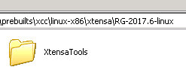
Figure 1-1. HiFiX Tool Chain Path
  - RI-2018.0
    - For RI-2018.0, please place your toolchain in the following path:
      - A0: alps/prebuilts/xcc/linux-x86/xtensa/RG-2017.6-linux/RI-2018.0-linux/XtensaTools
      - B0: alps/prebuilts/xcc/linux-x86/xtensa/RI-2018.0-linux/XtensaTools

- Hwcfg
The hwcfg would be released with our codebase in Android P Version. In Android Q and later version, the hwcfg won’t be released with our codebase. It will be released by file exchange server / aurisys package, and please copy the hwcfg to the following path.
Due to license issue, the folder vendor/mediatek/proprietary/tinysys/adsp/license/prebuilt/HIFIX/3rd_party is removed when you receive the codebase. Please create the folder yourself.
  - RG-2017.6-linux (P90, Android P)
    - vendor/mediatek/proprietary/tinysys/freertos/source/project/HIFI3_A/mt6779/platform/hwcfg/RG-2017.6-linux/
  - RI-2018.0-linux
    - v1 (P90, Android Q and after; G90)
      - /vendor/mediatek/proprietary/tinysys/adsp/license/prebuilt/HIFI3/3rd_party/hwcfg/RI-2018.0-linux/
    - v2 (5G L/H/H+/A/A+)
      - /vendor/mediatek/proprietary/tinysys/adsp/license/prebuilt/HIFI3/3rd_party/hwcfg/RI-2018.0-linux/
  - RI-2019.1-linux
    - v1 (5G B/Next-A)
      - /vendor/mediatek/proprietary/tinysys/adsp/license/prebuilt/HIFI3/3rd_party/hwcfg/RI-2019.1-linux/
    - v2 (DX-1/Next-A2/DX-P)
      - /vendor/mediatek/proprietary/tinysys/adsp/license/prebuilt/HIFI3/3rd_party/hwcfg/RI-2019.1-linux-H/
  - RI-2021.8-linux
    - v1 HiFi5 (DX-2)
      - /vendor/mediatek/proprietary/tinysys/adsp/license/prebuilt/HIFI5/3rd_party/hwcfg/RI-2021.8-linux/
    - v1 HiFi3 (22H)
      - /vendor/mediatek/proprietary/tinysys/adsp/license/prebuilt/HIFI3/3rd_party/hwcfg/RI-2021.8-linux/
    - v2 HiFi3 (23P)
      - /vendor/mediatek/proprietary/tinysys/adsp/license/prebuilt/HIFI3/3rd_party/hwcfg/RI-2021.8-linux-H/
    - v2 HiFi3 (24P)
      - /vendor/mediatek/proprietary/tinysys/adsp/license/prebuilt/HIFI3/3rd_party/hwcfg/RI-2021.8-linux-H/
  - RI-2023.11-linux
    - v1 HiFi5 (DX-3/DX-4)
      - NNE (HiFi5_NNE_2023_11_linux)
        - /vendor/mediatek/proprietary/tinysys/adsp/license/prebuilt/HIFI5/3rd_party/hwcfg/RI-2023.11-linux-E/
      - Non-NNE (HiFi5_MPU_lock_2023_11_linux)
        - /vendor/mediatek/proprietary/tinysys/adsp/license/prebuilt/HIFI5/3rd_party/hwcfg/RI-2023.11-linux-H/
- Config
To build HiFiX on target, you need to add mtxxxx-param and update the libhal.a file. However, since Android T version, which DX-2, DX-3, DX-4, & 22H are included, the above action is done in makefile.
Makefile not support (before Android T)
There are parameter files in aurisys_exe, and the source path is listed below. Please copy the corresponding param file into the toolchain. For example, if you are using G90, please copy mt6785-params to XtensaTools/config. If you are using DX-P, please copy mt6895-params to XtensaTools/config. The detailed project mapping and file path is described in CONFIG/Readme.

Makefile support (since Android T)
To build DX-2, DX-3, DX-4, 22H and later projects, users don't need to copy mtxxxx-param and libhal.a file by themselves. The mtxxxx-param and libhal.a are released in /vendor/mediatek/proprietary/tinysys/adsp/HIFIX/build/patch/mtxxxx, and makefile will help to copy these files to destination before building mtxxxx project. To confirm whether your codebase contains this change, you can check:
- Patch folder exists in this path:
  - /vendor/mediatek/proprietary/tinysys/adsp/HIFIX/build/patch/mtxxxx
- Target ADSP_TOOLCHAIN_UPDATE exists in makefile:
  - /vendor/mediatek/proprietary/tinysys/adsp/HIFIX/build/Makefile
If your codebase doesn't contain this change, please consult with DRI.
  - RG-2017.6-linux (P90, Android P)
    - Source: /CONFIG/HiFi3/Linux/RG-2017.6-linux/v1/RG-2017.6-linux
    - Destination: /prebuilts/xcc/linux-x86/xtensa/RG-2017.6-linux/XtensaTools/config/
  - RI-2018.0-linux
    - v1 (P90, Android Q and after; G90)
      - Source: /CONFIG/HiFi3/Linux/RI-2018.0-linux/v1/RI-2018.0-linux
      - Destination: /prebuilts/xcc/linux-x86/xtensa/RG-2017.6-linux/RI-2018.0-linux/XtensaTools/config
    - v2 (5G L/H/H+/A/A+)
      - Source: /CONFIG/HiFi3/Linux/RI-2018.0-linux/v2/patch/
      - Destination: /prebuilts/xcc/linux-x86/xtensa/RI-2018.0-linux/XtensaTools/config/
  - RI-2019.1-linux
    - v1 (5G B/Next-A)
      - Source: /CONFIG/HiFi3/Linux/RI-2019.1-linux/v1/RI-2019.1-linux
      - Destination: /prebuilts/xcc/linux-x86/xtensa/RI-2019.1-linux/XtensaTools/config/
    - v2 (DX-1/Next-A2/DX-P)
      - Source: /CONFIG/HiFi3/Linux/RI-2019.1-linux/v2/patch/
      - Destination: /prebuilts/xcc/linux-x86/xtensa/RI-2019.1-linux/XtensaTools/config/
  - RI-2021.8-linux
    - v1 (DX-2)
      - Source: /CONFIG/HiFi5/Linux/RI-2021.8-linux/v1/patch/
      - Destination: /prebuilts/clang/xtensa/linux-x86/RI-2021.8-linux/XtensaTools/config/
    - v1 (22H)
      - Source: /CONFIG/HiFi3/Linux/RI-2021.8-linux/v1/patch/
      - Destination: /prebuilts/clang/xtensa/linux-x86/RI-2021.8-linux/XtensaTools/config/
    - v2 (23P)
      - Source: /CONFIG/HiFi3/Linux/RI-2021.8-linux/v2/patch/
      - Destination: /prebuilts/clang/xtensa/linux-x86/RI-2021.8-linux/XtensaTools/config/
    - v2 (24P)
      - Source: /CONFIG/HiFi3/Linux/RI-2021.8-linux/v2/patch/
      - Destination: /prebuilts/clang/xtensa/linux-x86/RI-2021.8-linux/XtensaTools/config/
  - RI-2023.11-linux
    - v1 (DX-3/DX-4)
      - Source: /CONFIG/HiFi5/Linux/RI-2023.11-linux/v1/patch/
      - Destination: /prebuilts/clang/xtensa/linux-x86/RI-2023.11-linux/XtensaTools/config/
- Libhal.a
To support low power feature, hal library libhal.a needs to be replaced. As mentioned in Config part, before Android T version, users need to replace libhal.a by themselves.
Makefile not support (before Android T)
The new libhal.a is released under CONFIG\{HIFIX}\Linux\{Toolchain Version}-linux\{Sub Version}\patch. Please replace the corresponding libhal.a file under the destination path shown as below by the new one released in patch folder.
Makefile support (since Android T)
Since Android T version, which DX-2, DX-3, DX-4, & 22H are included, the above action is done in makefile. Users who want to build DX-2, DX-3, DX-4, 22H and later projects don't need to update mtxxxx-param & libhal.a by themselves. The libhal.a are released in /vendor/mediatek/proprietary/tinysys/adsp/HIFIX/build/patch/mtxxxx, and makefile will help to copy file to destination before building HiFiX. To check whether your codebase version already includes this patch or not, you can refer to Config part first or consult with DRI.
  - RG-2017.6-linux (P90, Android P)
    - No need to update. The libhal.a in tool chain is already updated.
  - RI-2018.0-linux
    - v1 (P90, Android Q and after; G90)
      - No need to update. The libhal.a in tool chain is already updated.
    - v2 (5G L/H/H+/A/A+)
      - Source: /CONFIG/HiFi3/Linux/RI-2018.0-linux/v2/patch/libhal.a
      - Destination: /vendor/mediatek/proprietary/tinysys/adsp/license/prebuilt/HIFI3/3rd_party/hwcfg/RI-2018.0-linux/xtensa-elf/arch/lib/libhal.a
  - RI-2019.1-linux
    - v1 (5G B/Next-A)
      - No need to update. The libhal.a in tool chain is already updated.
    - v2 (DX-1/Next-A2/DX-P)
      - Source: /CONFIG/HiFi3/Linux/RI-2019.1-linux/v2/patch/libhal.a
      - Destination: /vendor/mediatek/proprietary/tinysys/adsp/license/prebuilt/HIFI3/3rd_party/hwcfg/RI-2019.1-linux-H/xtensa-elf/arch/lib/libhal.a
  - RI-2021.8-linux
    - v1 HiFi5 (DX-2)
      - Source: /vendor/mediatek/proprietary/tinysys/adsp/HIFI5_SP/build/patch/mt6985/libhal.a
      - Destination: /vendor/mediatek/proprietary/tinysys/adsp/license/prebuilt/HIFI5/3rd_party/hwcfg/RI-2021.8-linux/xtensa-elf/arch/lib/libhal.a
    - v1 HiFi3 (22H)
      - Source:/vendor/mediatek/proprietary/tinysys/adsp/HIFI3/build/patch/mt6886/libhal.a
      - Destination: /vendor/mediatek/proprietary/tinysys/adsp/license/prebuilt/HIFI3/3rd_party/hwcfg/RI-2021.8-linux/xtensa-elf/arch/lib/libhal.a
    - v2 HiFi3 (23P)
      - Source: /vendor/mediatek/proprietary/tinysys/adsp/HIFI3/build/patch/mt6897/libhal.a
      - Destination: /vendor/mediatek/proprietary/tinysys/adsp/license/prebuilt/HIFI3/3rd_party/hwcfg/RI-2021.8-linux-H/xtensa-elf/arch/lib/libhal.a
    - v2 HiFi3 (24P)
      - Source: /vendor/mediatek/proprietary/tinysys/adsp/HIFI3/build/patch/mt6899/libhal.a
      - Destination: /vendor/mediatek/proprietary/tinysys/adsp/license/prebuilt/HIFI3/3rd_party/hwcfg/RI-2021.8-linux-H/xtensa-elf/arch/lib/libhal.a
  - RI-2023.11-linux
    - v1 HiFi5 (DX-3)
      - NNE
        - Source: /vendor/mediatek/proprietary/tinysys/adsp/HIFI5_SP/build/patch/mt6989_b/libhal.a
        - Destination: /vendor/mediatek/proprietary/tinysys/adsp/license/prebuilt/HIFI5/3rd_party/hwcfg/RI-2023.11-linux-E/xtensa-elf/arch/lib/libhal.a
      - NON-NNE
        - Source: /vendor/mediatek/proprietary/tinysys/adsp/HIFI5_SP/build/patch/mt6989_a/libhal.a
        - Destination: /vendor/mediatek/proprietary/tinysys/adsp/license/prebuilt/HIFI5/3rd_party/hwcfg/RI-2023.11-linux-H/xtensa-elf/arch/lib/libhal.a
    - v1 HiFi5 (DX-4)
      - The libhal.a for DX-3 and DX-4 are the same. If the destination path already has DX-3's libhal.a, there is no need to move DX-4's libhal.a.
      - NNE
        - Source: /vendor/mediatek/proprietary/tinysys/adsp/HIFI5_SP/build/patch/mt6991_b/libhal.a
        - Destination: /vendor/mediatek/proprietary/tinysys/adsp/license/prebuilt/HIFI5/3rd_party/hwcfg/RI-2023.11-linux-E/xtensa-elf/arch/lib/libhal.a
      - NON-NNE
        - Source: /vendor/mediatek/proprietary/tinysys/adsp/HIFI5_SP/build/patch/mt6991_a/libhal.a
        - Destination: /vendor/mediatek/proprietary/tinysys/adsp/license/prebuilt/HIFI5/3rd_party/hwcfg/RI-2023.11-linux-H/xtensa-elf/arch/lib/libhal.a

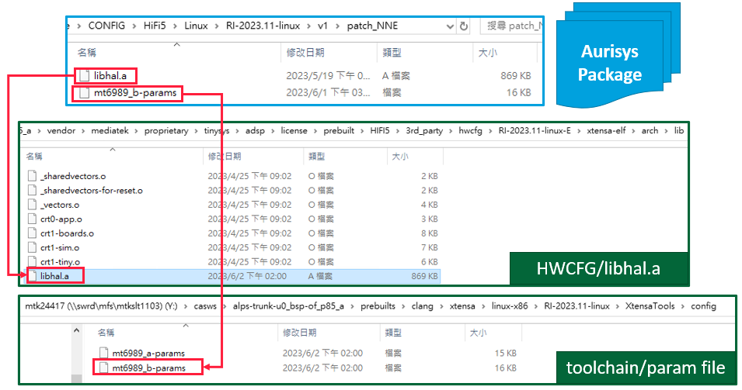
Figure 1-2. Example of Makefile Non-support

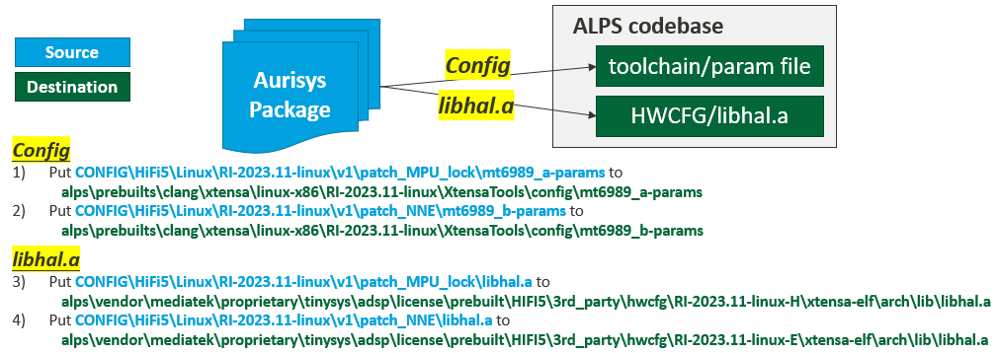
Figure 1-3. Example of Makefile Non-support – Replace by User

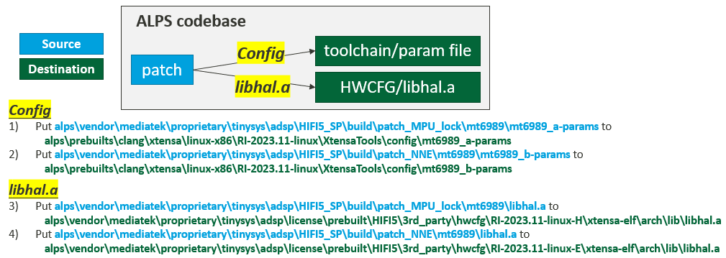
Figure 1-4. Example of Makefile Support – Replace by Makefile

Tool Chain Version
Toolchain Ver. | Platform
RG-2017.6 | P90 (AndroidP)
RI-2018.0 | P90(Android Q~), G90, 5G_L/H/H+, 5G_A/A+
RI-2019.1 | 5G_B/Next-A/DX-1/Next-A2/DX-P
RI-2021.8 | DX-2/22H/23P/24P
RI-2023.11 | DX-3/DX-4

Compiler
The compiler version are listed by toolchain and shown as below:
Toolchain Ver. | Compiler
RG-2017.6 / RI-2018.0 / RI-2019.1 | XCC
RI-2021.8/RI.2023.11 | XT-CLANG

The RI-2021.8 release does not include the legacy Xtensa C/C++ compiler (XCC). As Cadence previously announced, new versions of XCC won’t be released in the future, and Xtensa Software Tools will not include XCC. Cadence will develop new compiler features and support for new language standards exclusively on the XT-CLANG compiler.
For the optimization policy, XT-CLANG tends to apply function inlining more aggressively than XCC according to Cadence’s statement. Programs with many small, non-static functions may see a performance boost, but more aggressive inlining may also lead to an increase in code size.

Build Command
The Android full build command will bypass building the HiFiX DSP. We can build the HiFiX DSP by the following commands:
- Android Full Build with HiFiX DSP
  - BUILD_WITH_XTENSA=yes mosesq make -j40 -k 2>&1 | tee b.log (remove mosesq if you don’t support this command)
  - output folder: {out}/target/product/{project_name}/
- Bulid Tinysys (Both HiFiX and SCP) (A0 structure only)
  - BUILD_WITH_XTENSA=yes vendor/mediatek/proprietary/tinysys/freertos/source/tools/build_tinysys.sh -j24 2>&1 | tee adsp.log
  - output folder: {out}/target/product/{project_name}/
- Build ADSP only
  - Path
    - HiFi3 A0: $cd vendor/mediatek/proprietary/tinysys/freertos/source
    - HiFi3 B0: $cd vendor/mediatek/proprietary/tinysys/adsp/HIFI3
    - HiFi5: $cd vendor/mediatek/proprietary/tinysys/adsp/HIFI5_SP
  - PROJECT={project_name} make clean; BUILD_WITH_XTENSA=yes PROJECT={project_name} make adsp -j24 2>&1 | tee adsp.log
  - output folder:
    - HiFi3 A0: vendor/mediatek/proprietary/tinysys/freertos/source/tinysys-scp_out/
    - HiFi3 B0: vendor/mediatek/proprietary/tinysys/adsp/HIFI3/tinysys_out
    - HiFi5: vendor/mediatek/proprietary/tinysys/adsp/HIFI5_SP/tinysys_out

Suggested Library Build Flags
-O3 -Wall -mcoproc -Werror -mlongcalls -LNO:simd -ffunction-sections -Wno-error=format -fdata-sections

3rd Party Libraries
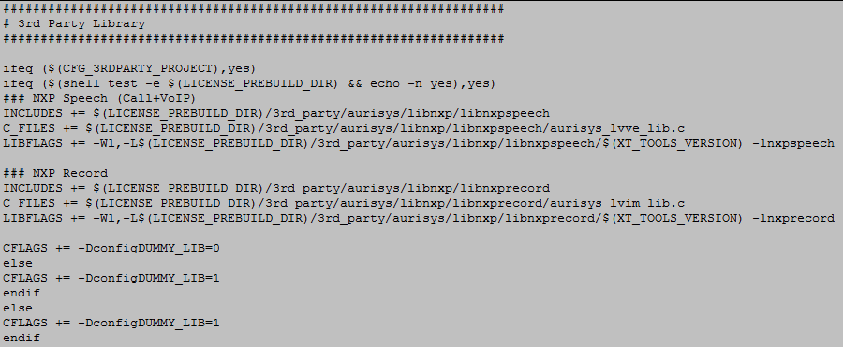
Figure 1-3. 3rd party library configurations
To enable 3rd party library functionalities, please set CFG_3RDPARTY_PROJECT as “yes”, and add a 3rd party library to a specified path. Otherwise, it will use a dummy library (just bypass the sound processing). Besides, It will also use dummy lib if the specified path doesn’t exist even if the option is enabled.
There is no limitation on the folder path. You can decide the path by yourself and just modify the specified path on the Makefile:
- INCLUDES, C_FILES, and LIBFLAGS
- Folder existence check command: ifeq ($(shell test -e $(LICENSE_PREBUILD_DIR) && echo -n yes),yes)
Or you can just follow our folder structure, create a folder as the following: (this repo will be removed before release to customer, which is used to place 3rd party libraries.)
/vendor/mediatek/proprietary/tinysys/adsp/license/prebuilt/HIFI3/3rd_party/aurisys
/vendor/mediatek/proprietary/tinysys/adsp/license/prebuilt/HIFI5/3rd_party/aurisys
The CFG_3RDPARTY_PROJECT is only set as yes in MTK's Internal test. The default released dsp image will be compiled without setting CFG_3RDPARTY_PROJECT. This is because MTK doesn't have the rights to release 3rd party library to customers directly. You don't need to follow MTK's rule. You can just set CFG_3RDPARTY_PROJECT as no and modify the platform.mk to assign the library path directly. However, we suggest to follow the same folder structure so that you don't need to modify platform.mk everytime when there's a new patch release which contains the platform.mk.

Compile MTK In-house DSP/RV55 – shared SCP software

Configuration
For platforms shared SCP software, there is no standalone ADSP subsystem; the option MTK_AUDIODSP_SUPPORT is configured to no. But configure adsp_type to RV55 in kernel DTS and CFG_SCP_AUDIO_FW_SUPPORT in tinysys SCP to indicate that audio offload is supported on the SCP subsystem.
Feature | Option | Location
Audio DSP merged in SCP subsys | CFG_SCP_AUDIO_FW_SUPPORT | platform.mk in SCP
Offload Codec | MTK_AUDIO_TUNNELING_SUPPORT | ProjectConfig.mk
Voice Call Speech Enhancement in Audio DSP | MTK_AURISYS_PHONE_CALL_SUPPORT | ProjectConfig.mk
Offload VOIP/Record | VIR_VOIP_RECORD_AUDIODSP_SUPPORT

- Build Server
  - Cadence recommended to use Red Hat Enterprise (officially supported platform), if you don’t have RHEL, you can use CentOS instead.
  - While they do not officially support Ubuntu, we are able to install Xtensa tools on Ubuntu Linux14.04 without issues.
- Makefile Locations:
  - Android: device\mediatekprojects
  - Kernel: N/A
  - RV55: vendor\mediatek\proprietary\tinysys\scp
- Audio DSP
  - AP Configuration: MTK_TINYSYS_SCP_SUPPORT
  - Kernel Configuration: CONFIG_ MTK_TINYSYS_SCP_SUPPORT
  - DSP Configuration: CFG_SCP_AUDIO_FW_SUPPORT
  - Note:
    - DSP configuration is the main switch of Audio DSP on platforms shared SCP software.
- Voice Call Speech Enhanement
  - Note
    - An Inspection mechanism to check consistency of Android, Kernel, and DSP configurations
    - The speech enhancement would be executed in the Modem side if we disable the option.
  - AP Configuration: MTK_AURISYS_PHONE_CALL_SUPPORT
  - Kernel Configuration: CONFIG_MTK_AURISYS_PHONE_CALL_SUPPORT
  - DSP Configuration: CFG_MTK_AURISYS_PHONE_CALL_SUPPORT
- VOIP/Recording
  - Note
    - DSP option is always on
    - Use VIR_VOIP_RECORD_AUDIODSP_SUPPORT defined in the XML to enable/disable the DSP feature
- 3rd party Library
  - Note
    - The 3rd party library should be released by the 3rd party. MTK will verify 3rd party library internally and remove them before release
    - Compare to Cadence HiFi series, no DSP configuration is needed for MTK In-house RV DSP platform to enable the functionalities the 3rd party library.

Default Image
Compare to Cadence HiFi series, no additional license is required to build DSP images on MTK In-house RV DSP platform. DSP source code is built along with alps project build.

Tool Chain
MDSP PDK version v1.10.0 and later for platforms shared SCP software. Please contact MTK MDSP team to get the suitable version of PDK for the product line.

Build Command
The Android full build and SCP partial build are both available to build MTK In-house RV DSP image from source code. For SCP partial build, you can use the following commands,
- Build SCP only
  - Path
    - $cd vendor/mediatek/proprietary/tinysys/scp
  - PROJECT={project_name} TARGET_BOARD_PLATFORM={platform} BUILD_TYPE=debug make -j 36 2>&1 | tee scp.log
  - Output folder:
    - vendor/mediatek/proprietary/tinysys/scp/tinysys_out

Suggested Library Build Flags
-O3 -Wall -mcoproc -Werror -mlongcalls -LNO:simd -ffunction-sections -Wno-error=format -fdata-sections -funwind-tables
- -funwind-tables tells the compiler to generate .eh_frame which is used in runtime backtrace. It starts to be supported from CodeLine version 300.
- Please note that if the build flag does not include the -funwind-tables flag, it will not be possible to resolve the backtrace within the library at runtime. However, if only the -g flag is added, although the backtrace cannot be resolved at runtime, it can still be analyzed in lldb.

3rd Party Libraries
There is no limitation on the folder path. You can decide the path by yourself and just modify the specified path on the Makefile:
- INCLUDES, C_FILES, and LIBFLAGS
- Folder existence check command: ifeq ($(shell test -e $(LICENSE_PREBUILD_DIR) && echo -n yes),yes)
Or you can just follow our folder structure, create a folder as the following: (this repo will be removed before release to customer, which is used to place 3rd party libraries.)
/vendor/mediatek/proprietary/tinysys/adsp/license/prebuilt/RV55/3rd_party/aurisys

Compile MTK In-house DSP/RV55V & /RV55 – Standalone ADSP software

Configuration
For platforms using MTK In-house RV DSP (standalone ADSP), features and options are the same as the platforms using Cadence Hifi DSP.
Feature | Option | Location
Audio DSP (main switch of DSP) | MTK_AUDIODSP_SUPPORT | ProjectConfig.mk
Offload Codec | MTK_AUDIO_TUNNELING_SUPPORT | ProjectConfig.mk
Voice Call Speech Enhancement in Audio DSP | MTK_AURISYS_PHONE_CALL_SUPPORT | ProjectConfig.mk
Offload VOIP/Record | VIR_VOIP_RECORD_AUDIODSP_SUPPORT

- Build Server
  - The Ubuntu 16.04 is recommended for MTK In-house RV SDK tools. Other environment requirements please refer to the document Mediatek DSP – MRV Platform SDK User Manual.pdf from DMS release.
- Makefile Locations:
  - Android: device\mediatekprojects
  - Kernel:
  - RV55: vendor\mediatek\proprietary\tinysys\adsp\riscv
- Audio DSP (The main switch of Audio DSP)
  - Configuration Check
    - We have an inspection mechanism that the configurations of Android, Kernel, and DSP should be matched.
  - AP Configuration: MTK_AUDIODSP_SUPPORT
  - Kernel Configuration: CONFIG_MTK_AUDIODSP_SUPPORT
  - DSP Configuration: CFG_MTK_AUDIODSP_SUPPORT
- Voice Call Speech Enhanement
  - Note
    - An Inspection mechanism to check consistency of Android, Kernel, and DSP configurations
    - The speech enhancement would be executed in the Modem side if we disable the option.
  - AP Configuration: MTK_AURISYS_PHONE_CALL_SUPPORT
  - Kernel Configuration: CONFIG_MTK_AURISYS_PHONE_CALL_SUPPORT
  - DSP Configuration: CFG_MTK_AURISYS_PHONE_CALL_SUPPORT
- VOIP/Recording
  - Note
    - DSP option is always on
    - Use VIR_VOIP_RECORD_AUDIODSP_SUPPORT defined in the XML to enable/disable the DSP feature
- 3rd party Library
  - Note
    - The 3rd party library should be released by the 3rd party. MTK will verify 3rd party library internally and remove them before release
    - Compare to Cadence HiFi series, no DSP configuration is needed for MTK In-house RV DSP platform to enable the functionalities the 3rd party library.

Default Image
Compare to Cadence HiFi series, no additional license is required to build DSP images on MTK In-house RV DSP platform. DSP source code is built along with alps project build.

Tool Chain
Please contact MTK MDSP team to get the suitable version of PDK for the product line.

Build Command
The Android full build and ADSP partial build are both available to build MTK In-house RV DSP image from source code. For ADSP partial build, you can use the following commands,
- Build ADSP only
  - Path
    - $cd vendor/mediatek/proprietary/tinysys/adsp/riscv
  - PROJECT={project_name} TARGET_BOARD_PLATFORM={platform} BUILD_TYPE=debug make -j 36 2>&1 | tee adsp.log
  - Output folder:
    - vendor/mediatek/proprietary/tinysys/adsp/riscv/tinysys_out

Suggested Library Build Flags
Please refer to Mediatek DSP – MRV Platform SDK User Manual.pdf from DMS release.

3rd Party Libraries
There is no limitation on the folder path. You can decide the path by yourself and just modify the specified path on the Makefile:
- INCLUDES, C_FILES, and LIBFLAGS
- Folder existence check command: ifeq ($(shell test -e $(LICENSE_PREBUILD_DIR) && echo -n yes),yes)
Or you can just follow our folder structure, create a folder as follows: (this repo will be removed before release to customer, which is used to place 3rd party libraries.)
/vendor/mediatek/proprietary/tinysys/adsp/license/prebuilt/RV55/3rd_party/aurisys

Download by Flashtool
The DSP image can be downloaded to the MTK devices using Flashtool, as shown in the following figure. For the Cadence HiFi series platform and the MTK In-house RV DSP (standalone ADSP), please select the partition name audio_dsp.img. For platforms shared SCP software, for example, 24M, please select scp.img.
In addition to replacing the adsp image, the preloader image also needs to be replaced with the DIS_SBOOT version, such as preloader_$PROJECT_DIS_SBOOT.bin. If there are two preloader images, preloader_a and preloader_b, on the Flashtool, please replace both with the DIS_SBOOT version of the image.
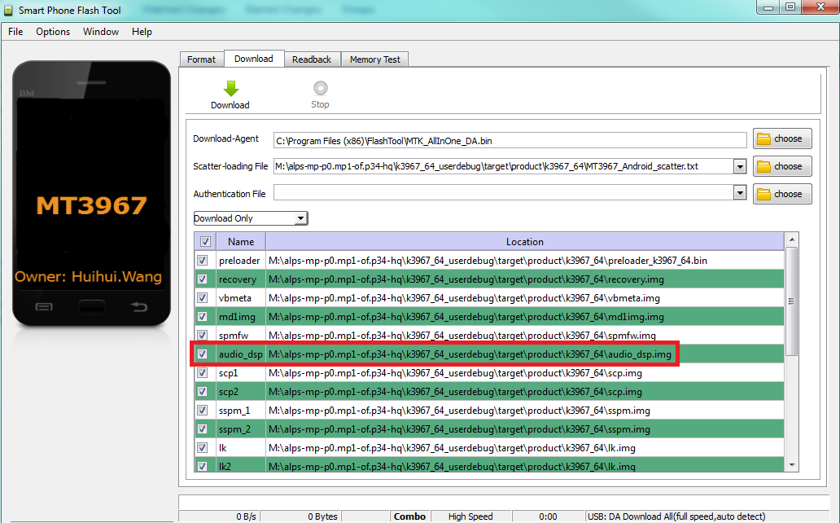
Figure 1-4. Flashtool to update Audio DSP Image
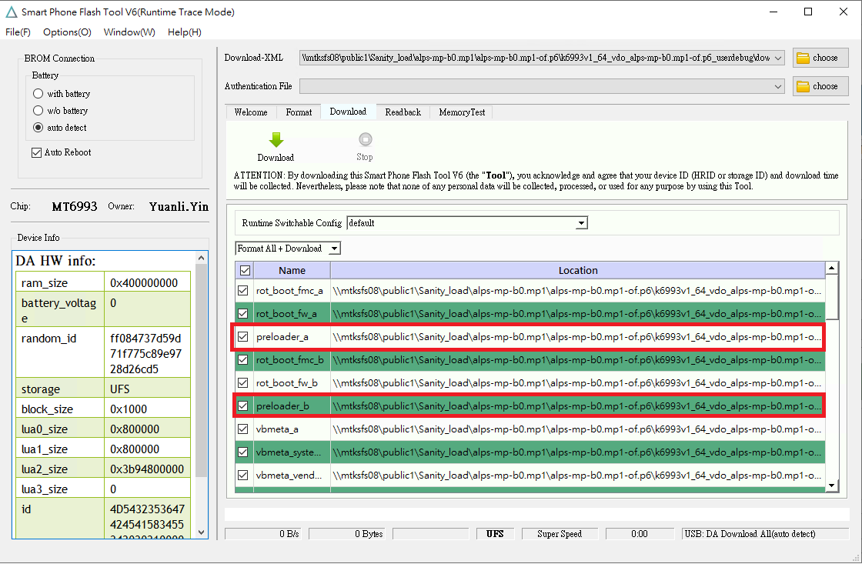
Figure 1-5 Flashtool to Update Preloader Image

Software Architecture

Free-RTOS
The current FreeRTOS version for all projects is shown in the below table. Generally, the user of Audio DSP doesn’t need to modify the code of the RTOS.
Projects | FreeRTOS version
5G-L/H/H+, 5G-A, 5G-B, 5G-C,  Next D, Next A, Next A2, 22H, 23P, 24P,  DX-1, DX-1 Pro, DX-P, DX-2, DX-3, DX-4 | 10.1.0
24M | 10.1.0.1
DX-5, 25Ms, 26M | 11.0.0

Heap Size
The heap size of Cadence HiFi DSP and MTK In-house RV DSP (standalone ADSP) is defined in:
- A0 structure:
- \vendor\mediatek\proprietary\tinysys\freertos\source\project\HIFIx_A\mtxxxx\platform\platform.mk
###################################################################
# Heap size config
###################################################################
# default heap size
CFLAGS += -DconfigTOTAL_HEAP_SIZE='( ( size_t ) ( 2 * 1024 * 1024 ) )'

- \vendor\mediatek\proprietary\tinysys\freertos\source\project\HIFIx_A\mtxxxx\platform\inc\FreeRTOSConfig.h
/* Minimal heap size to make sure examples can run on memory limited
configs. Adjust this to suit your system. */
#ifndef configTOTAL_HEAP_SIZE
#define configTOTAL_HEAP_SIZE ( ( size_t ) (256 * 1024) )
#endif

- B0 structure for Cadence HiFi DSP:
- \vendor\mediatek\proprietary\tinysys\adsp\HIFI3\project\mtxxxx\HIFI3_x \platform\platform.mk
\vendor\mediatek\proprietary\tinysys\adsp\HIFI5_SP\project\mtxxxx\HIFI5_x \platform\platform.mk
###################################################################
# Heap size config
###################################################################
# default heap size
CFLAGS += -DconfigTOTAL_HEAP_SIZE='( ( size_t ) ( 2 * 1024 * 1024 ) )'

- \vendor\mediatek\proprietary\tinysys\adsp\HIFI3\project\mtxxxx\HIFI3_x \platform\inc\FreeRTOSConfig.h
\vendor\mediatek\proprietary\tinysys\adsp\HIFI5_SP\project\mtxxxx\HIFI5_x \platform\inc\FreeRTOSConfig.h
/* Minimal heap size to make sure examples can run on memory limited
configs. Adjust this to suit your system. */
#ifndef configTOTAL_HEAP_SIZE
#define configTOTAL_HEAP_SIZE ( ( size_t ) (256 * 1024) )
#endif

- B0 structure for MTK In-house RV standalone ADSP
- \vendor\mediatek\proprietary\tinysys\adsp\riscv\project\mtxxxx\RV55_X \platform\platform.mk
###################################################################
# Heap size config
###################################################################
# default heap size
CFLAGS += -DconfigTOTAL_HEAP_SIZE='( ( size_t ) ( 4.5 * 1024 * 1024 ) )'

- \vendor\mediatek\proprietary\tinysys\adsp\riscv\project\mtxxxx\RV55_x \platform\inc\FreeRTOSConfig.h
/* Minimal heap size to make sure examples can run on memory limited
configs. Adjust this to suit your system. */
#ifndef configTOTAL_HEAP_SIZE
#define configTOTAL_HEAP_SIZE ( ( size_t ) (256 * 1024) )
#endif

The heap size of SCP is defined in:
- \vendor\mediatek\proprietary\tinysys\scp\project\RV55_A\mtxxxx\platform\platform.mk
ifeq ($(CFG_MTK_AURISYS_PHONE_CALL_SUPPORT),yes)
$(eval TOTAL_HEAP_SIZE=$(shell echo $$(($(TOTAL_HEAP_SIZE) + (2 * 1024)))))
endif

You can modify the heapsize if needed. If the heap size is defined both in platform.mk and FreeRTOSConfig.h, the value of platform.mk will be adopted.

Audio Framework
As the following figure depicts, the data path of each scenario is already defined, and the required task will be created. What the user need to do is to add or replace your audio/voice effect upon the created tasks. For example, the user can add more supported offload codec in the offload task, and add audio effect (please refer to the Aurisys Introduction.pptx)in the primary task, etc. Please contact Mediatek if you need to create a new scenario or an application with different data flow.

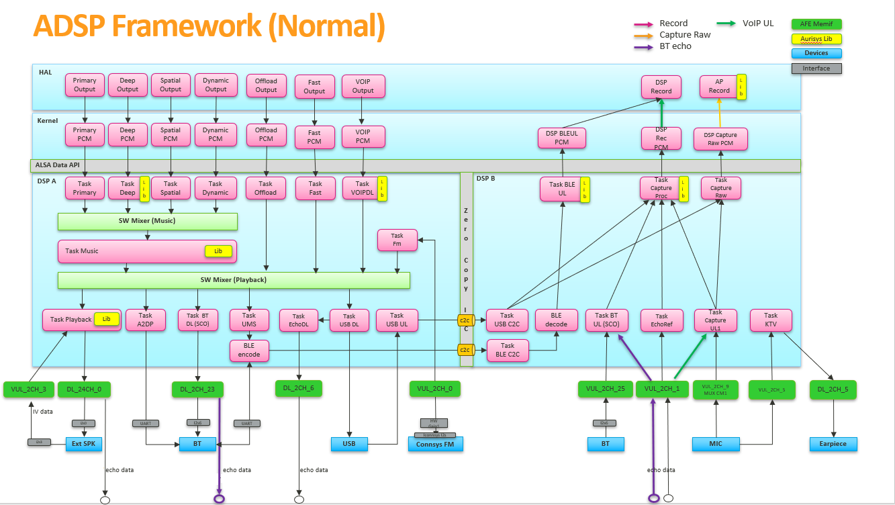
Figure 2-1. Audio Framework

Aurisys

Abstract
The requirement for sound quality enhancements that add listening pleasure has been increasing. To enrich the listening experience of using mobile devices, there is an increasing number of sound processing solutions provided by vendors.
Aurisys is introduced to facilitate the sound processing solution development and use of MTK platforms. Aurisys is a framework constructed upon Android Audio Framework. It includes standardized interfaces for sound processing and tuning, integrated DSP sound subsystem, and software debug interface.

Aurisys Aims
As the following figure depicts, our target is to make the replacement/integration of vendor IPs as convenient as possible. We defined a standardized interface to which is platform-independent, so that the software can be re-used. By following the user interface standards we create a more consistent experience for the developers. Please refer to the following document to get more detailed information: Aurisys_Introduction, Aurisys_Tuning_Guide, and Lib_Verifier_User_Guide.
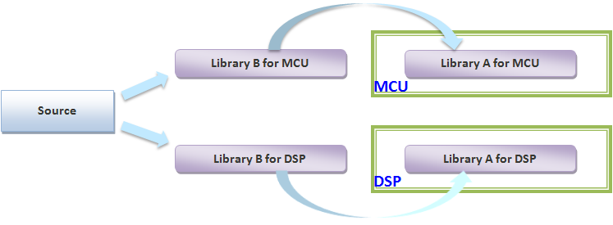
Figure 2-2. Concept of Aurisys

Development Flow
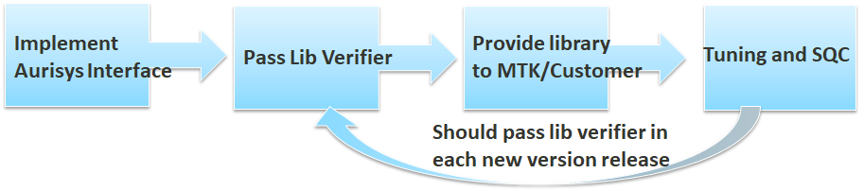
Figure 2-3. Aurisys Development Flow

Software Development Guidance

Scenario Based DVFS
We don’t have an automatic DVFS mechanism to detect current DSP loading and adjust the DSP clock rate automatically. What we do is to register a clock rate requirement table for a specified application. When the application starts, a provided API would be called to notify the system. Then the system will adjust the clock rate, according to the sum of clock rate requirement for active applications.
The clock rate requirement change would happen when an application is active, the sampling rate is changed, or the device is changed. The clock registered API should be called when these events happen.
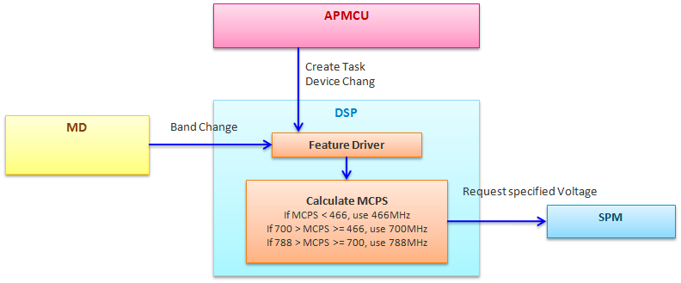
Figure 3-1. Scenario Based DVFS flow (P80 as example)
A clock rate requirement callback function should be implemented. This function is used to look up the MCPS under a specified parameter. For customization, what we need to do is to modify the MCPS table. Note that we can register several libraries to one application. For example, a playback application can have SRC, DC removal, shifter, and playback effects. Once a playback application is activated, the clock rate requirements of all libraries registered in this application would be counted.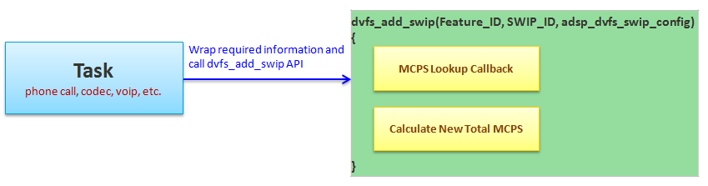
Figure 3-2. MCPS Lookup Flow
The following are the related files:
Path (HIFI3/HIFI5) | File | Description
drivers/HIFIX_A/[project]/feature_manager/inc/ | feature_manager.h | Feature ID and SWIP ID definition
drivers/HIFIX_A/[project]/feature_manager/src | feature_manager.c | Feature management; feature enable/disable API; update total MCPS information API
drivers/HIFIX_A/[project]/dvfs/inc | dvfs_config_parser.h | Declare MCPS lookup callback function and dvfs_swip_config_t
drivers/HIFIX_A/[project]/dvfs/inc | dvfs_swip_table.h | MCPS lookup callback function required definitions
drivers/HIFIX_A/[project]/dvfs/inc | dvfs.h, dvfs_common.h | DVFS driver required definitions
drivers/HIFIX_A/[project]/dvfs/src | dvfs_config_parser.c | MCPS lookup callback function implementation
drivers/HIFIX_A/[project]/dvfs/src | dvfs.c, dvfs_common.c | DVFS driver
If you want to create a new library by yourself, you need to register a callback function first as the following example. Note that the look up callback function should be registered by each library. Then we can use this API dvfs_add_swip(Feature_ID, SWIP_ID, adsp_dvfs_swip_config) to link the library (SWIP ID) and the application (Feature ID). It is allowed to link multiple libraries to an application.
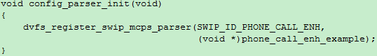
Figure 3-3. Register a callback function
Then the second step is to implement a look up callback function as follows:
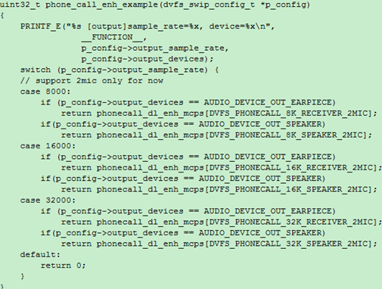
Figure 3-4. MCPS Look up Callback Function Example

Audio Effects

ACF Working Flow on DSP
Audio Compensation Filter (ACF) is used for compensating the audio quality according to physical case. ACF is applied on audio stream during audio playback. For ACF on HIFI3, ACF related configurations and control flow are controlled by AP side (e.g. IIR coefficient, ACF switch and Loudness switch), and process is on HIFI3 side .
Android
File Name | Path | Related Customizaiton
aurisys_config_hifi3.xml  aurisys_config_rv.xml  aurisys_config_adsp.xml | \vendor\mediatek\proprietary\external\aurisys  (phone path :) system\vendor\etc\ | Depicts the library’s capability and using scenario.
PlaybackACF_AudioParam.xml | \device\mediatek\common\audio_param\  (phone path :) system\vendor\etc\audio_param | High-pass IIR coefficient  Band-pass IIR coefficient  Low-pass IIR coefficient
audio_custom_exp.h | \vendor\mediatek\proprietary\custom\(%porj)\hal\audioflinger\audio | Turn on/off ACF (ENABLE_AUDIO_COMPENSATION_FILTER)
MtkAudioLoudc.c | \vendor\mediatek\proprietary\external\aurisys\libaudio  loud\  (phone path :) system\vendor\lib\libaudioloudc.so | ACF/DRC/HCF aurisys parsing librarywrapper implementation
MtkAudioLoudc.h | \vendor\mediatek\proprietary\external\aurisys\libaudioloud\ | ACF/DRC/HCF aurisys parsing librarywrapper header file
AudioCompFltCustParamc.c | \vendor\mediatek\proprietary\external\AudioCompensationFilter\ | Interact with AudioParamParser ,getting parameters from XML
AudioCompFltCustParamc.h | \vendor\mediatek\proprietary\external\AudioCompensationFilter\ | C code implementation header file for param related function.
AudioCompensationFilterc.h | \vendor\mediatek\proprietary\external\AudioCompensationFilter\3 | C code implementation header file, define audio compensation type and mode.
arsi_besloudness.c | \vendor\mediatek\proprietary\tinysys\freertos\source\middleware\lib\aurisys\lib\common\libbesloudness | ACF/DRC/HCF aurisys prosessing librarywrapper implementation
arsi_besloudness.h | \vendor\mediatek\proprietary\tinysys\freertos\source\middleware\lib\aurisys\lib\common\libbesloudness | ACF/DRC/HCF aurisys prosessing librarywrapper header file
libbesloudness.a | \vendor\mediatek\proprietary\tinysys\freertos\source\middleware\lib\audio\hifi3\libbesloudness | ACF/DRC/HCF library on HIFI3
We separate ACF working folw for two parts: paring part on AP side, and processing part on DSP side. The
post process will be triggered and done through the ARSI standard interface. Belows are the changes in our design.
- In aurisys_config_adsp.xml in vendor\mediatek\proprietary\external\aurisys
- Add BesSound libarary description on DSP
- In vendor\mediatek\proprietary\external\aurisys\libaudioloud add below files for parameter parsing
- MtkAudioLoudc.c
- MtkAudioLoudc.h
- In vendor\mediatek\proprietary\external\AudioCompensationFilter badd
- AudioCompFltCustParamc.c
- AudioCompFltCustParamc.h
- In vendor\mediatek\proprietary\tinysys\freertos\source\middleware\lib\aurisys\lib\common\
libbesloudness add below files for processing
  - arsi_besloudness.c
  - arsi_besloudness.h
- In audio hal, vendor\mediatek\proprietary\hardware\audio, we use
#define MTK_AUDIODSP_SUPPORT and MTK_AURISYS_FRAMEWORK_SUPPORT to identify the new process method.
The compile option is set in device\mediatek\{project}\ProjectConfig.mk
At the bootup stage, the ARSI framework initialize and reads the content of aurisys_config_adsp.xml, establishing the framework function links and libraries’ function links. When first running ACF, the AudioParamParser reads back the paramenters in PlaybackACF_AudioParam.xml and stores in the structure. The processing starts from AudioDspStreamManager, which send playback data to DSP for processing. Through the aurisys framework, we use the generic interface aurisys_process_dl_only on DSP as the process entry.
1.Record current scenario, output configs and library lists
2.The input buffer for library processing
3.The output buffer after library processing

aurisys_process_dl_only(
mAurisysLibManager, mAudioPoolBufDlIn, mAudioPoolBufDlOut);

The working flow is depicted as below, there are five functional blocks. Application UI, Framework, Audio HAL, Device and External hal. The Aurisys Framewok is implemented in Audio Hal and related ARSI general API and aurisys_config.xml are defined in external block.
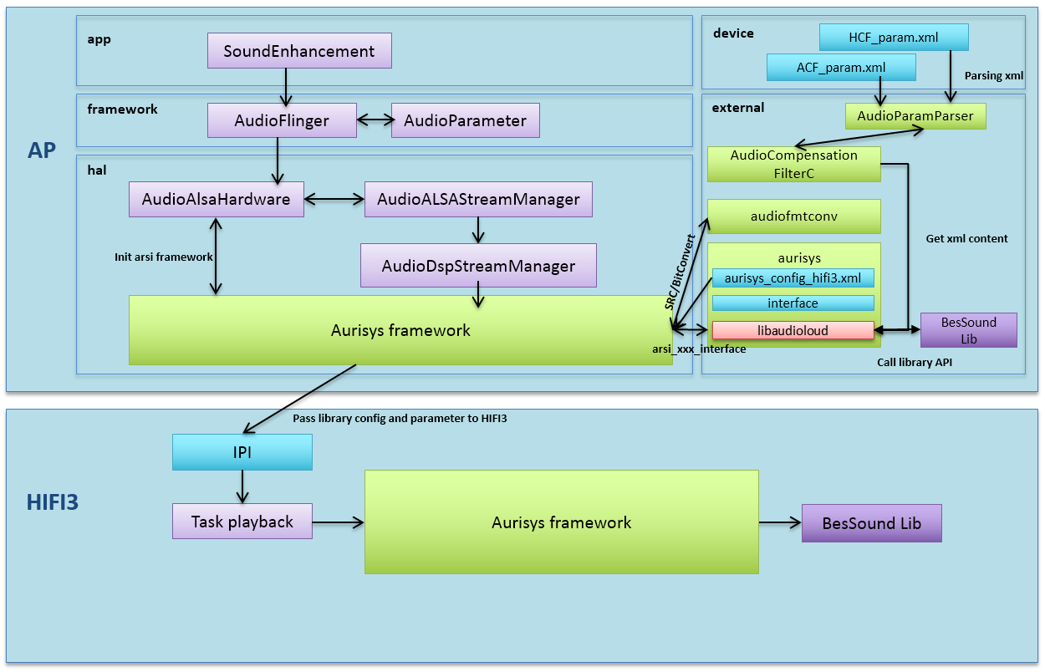
(3)
(5)
(4)
(2)
(2)
(1)
- The aurisys framework is initialized by AudioALSAHardware when audioserver start.
- During the initialization stage, the aurisys controller parse aurisys_config_adsp.xml, establishing the function callback between library and framework, and dlopen audiofmtconvlibraries (bit converter, samplerate converter.) and pass the library configuration to DSP.
For ACF library, we parse the ACF_param.xml and store the parameters into the structure. These parameters set the processing frequency and generate corresponding filtercoefficients.
- When normal or fast playback starts, we create AudioDspStreamManager to handle the mixed playback stream, and create libmanager and libhandler to handle the processing flow under this scenario. As we can retrieve the stream and hardware info, we store these information and provide to the aurisys framework. Library could use those info to parse libaray parameter.
- After parsing library parameter, aurisys framework will pass the parameter form AP to DSP.
- The post-processing is done by calling aurisys_process_dl_only() . The framework handles the data transformation and operates with libraries through ARSI generic interface. If the playback setting is not compatible to the library setting, the Aurisys Framework will trigger samplerate converter or bit converter to do the transformation. This ensure the process can be done without library modification.
There are two key points for the libray porting on DSP.
- One is to depicts the library configuration in aurisys_config_adsp.xml.
- Anothor one is to implement the wrapper between ARSI interface and library functions.
In aurisys_config_adsp.xml, we first indicate the using scenario and list the library component used. We depict the library’s attribute, such as file path, library supported samplerate, processing format, frame size, data buffer type (uplink or downlink), channel number, and debug level….etc. These attributes are compared to the input pcm data and indicate the library setting during processing. The user can change the library setting by simply modify the xml file. This enlarge the flexibility and reduce the coding effort.

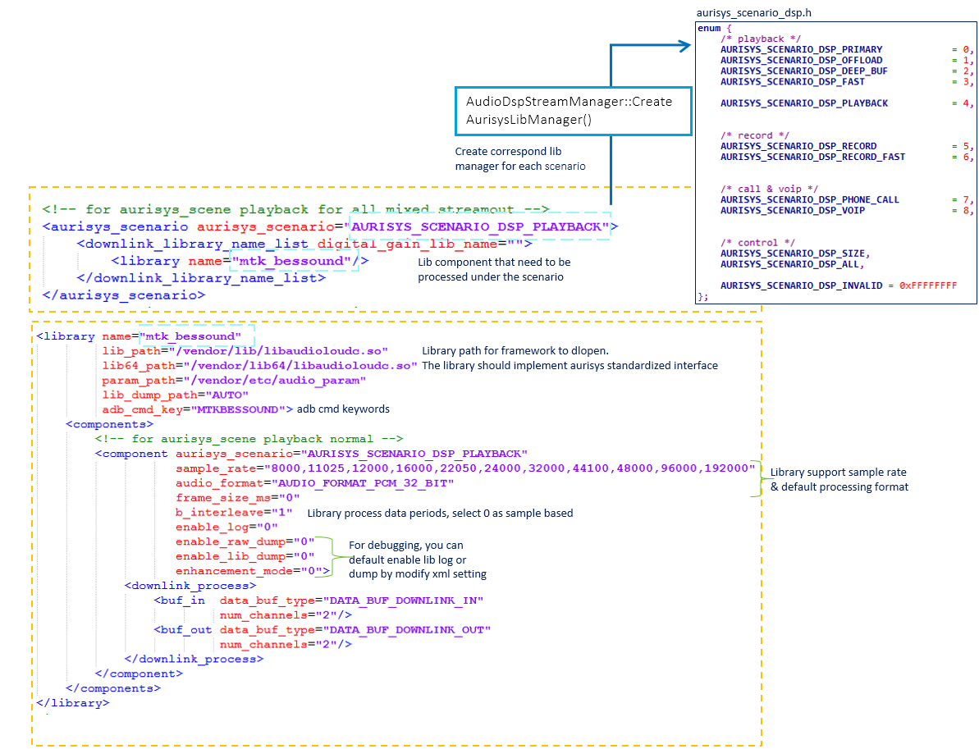
To implement the wrapper between library and ARSI interface, we comparing and mapping their functionality as the table shows.
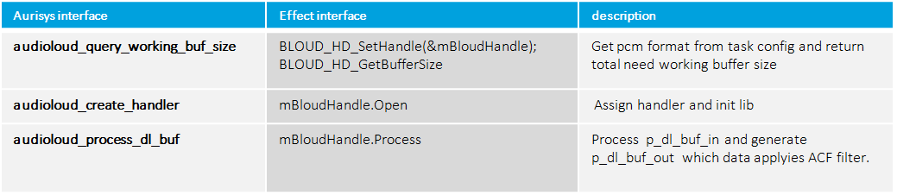
mapping the interface between ARSI and Effect

Dynamic turn on/off library log using adb command
Besides setting xml, user can runtime key in adb debug command to enable/disable library processing log in mobile log.
ON | adb shell "AudioSetParam AURISYS_SET_PARAM,DSP,PLAYBACK,MTKBESSOUND,ENABLE_LOG,1=SET"
OFF | adb shell "AudioSetParam AURISYS_SET_PARAM,DSP,PLAYBACK,MTKBESSOUND,ENABLE_LOG,0=SET"

Audio Loudness Working Flow on DSP
Loudness (DRC) is an audio post-processing technique to improve the loudness of audio signal and ringtone playback by using dynamic range control and frequency component manipulation

Android
File Name | Path | Related Customizaiton
PlaybackDRC_AudioParam.xml | \device\mediatek\common\audio_param\ | DRC related coefficient for audio and ringtone
ProjectConfig.mk | device\mediatekprojects\(%proj)\ | Is the platform support Loudness MTK_BESLOUDNESS_SUPPORT
ProjectConfig.mk | device\mediatekprojects\(%proj)\ | Is the platform support Loudness processing on HAL layer  MTK_BESLOUDNESS_RUN_WITH_HAL  (Trun on need to combine withMTK_AURISYS_FRAMEWORK_SUPPORT=yes)
DRC in HAL path
MtkAudioLoudc.c | \vendor\mediatek\proprietary\external\aurisys\libaudioloud\  (phone path :) system\vendor\lib\libaudioloudc.so | ACF/DRC/HCF aurisyswrapper implementation for library parameter parsing
MtkAudioLoudc.h | \vendor\mediatek\proprietary\external\aurisys\libaudioloud\ | ACF/DRC/HCF aurisyswrapperheader file
Android.mk | \vendor\mediatek\proprietary\external\aurisys\libaudioloud\ | Check ProjectConfig MTK_BESLOUDNESS_SUPPORT&MTK_BESLOUDNESS_RUN_WITH_HAL.  Turn on DRC apply into HAL layer
DRC in HIFI3 path
arsi_besloudness.c | \vendor\mediatek\proprietary\tinysys\freertos\source\middleware\lib\aurisys\lib\common\libbesloudness | ACF/DRC/HCF aurisys prosessing librarywrapper implementation
arsi_besloudness.h | \vendor\mediatek\proprietary\tinysys\freertos\source\middleware\lib\aurisys\lib\common\libbesloudness | ACF/DRC/HCF aurisys prosessing librarywrapper header file
libbesloudness.a | \vendor\mediatek\proprietary\tinysys\freertos\source\middleware\lib\audio\hifi3\libbesloudness | ACF/DRC/HCF library on HIFI3
Generally, the Loudness (DRC) parameters are stored in XML.
In the case, when the first time of Loudness (DRC) processing, the Loudness (DRC) parameters will be applied as the default Loudness (DRC) parameter listed in PlaybackDRC_AudioParam.xml.
Then users can modify some parameters in Audio Tool if needed.
If config MTK_BESLOUDNESS_SUPPORT = yes and MTK_BESLOUDNESS_RUN_WITH_HAL = yes and MTK_AUDIODSP_SUPPORT = yes
The HAL working flow of Loudness (DRC) will be show as the figure below:
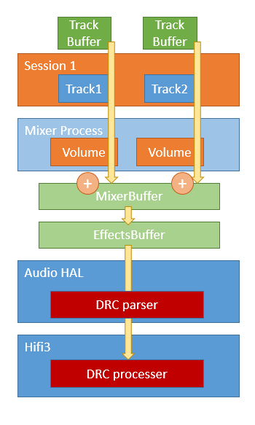
Figure 3-5.DRC Working at DSP overview
Config DRC enable
Figure 3-6. DRC Working at DSP Flow

Debug SOP

Issue Feedback to MTK
For Cadence HiFi series and MTK In-house RV (standalone ADSP) series, please refer to DOC\ADSP_Debugging_Guideline.docx for detail.
For platforms shared SCP software, please find document MTxxxx_SCP_Development_Guide.docx from DMS release.

Performance Issue
If a performance issue happens (underflow, timeout, etc,.). Please refer to DOC\ADSP_Profiling_Guideline.docx for details.

Enable UART log
- Port
  - 23P/24P: please use UART3
  - Other platforms: please use UART2
- Configurations
  - CFG_UART_SUPPORT = yes
    - For Cadence HiFi DSP
      - project\mt6xxx\HIFIx_A\platform\platform.mk ##DSP A
      - project\mt6xxx\HIFIx_B\platform\platform.mk ##DSP B
    - For MTK In-house RV DSP (Standalone ADSP)
      - project\mt6xxx\RV55_A\platform\platform.mk ##DSP A
      - project\mt6xxx\RV55_B\platform\platform.mk ##DSP B
- Adb command
  - adb shell "echo uart_en 1 > sys/kernel/debug/audiodsp0" ##DSP A
  - adb shell "echo uart_en 1 > sys/kernel/debug/audiodsp1" ##DSP B

Integration Guideline

Get the Development Tools

Apply for an Account
Please make sure you’ve sign the NDA first.
https://online.mediatek.com/_layouts/15/mol/accountprofile/account_only_for_user.aspx
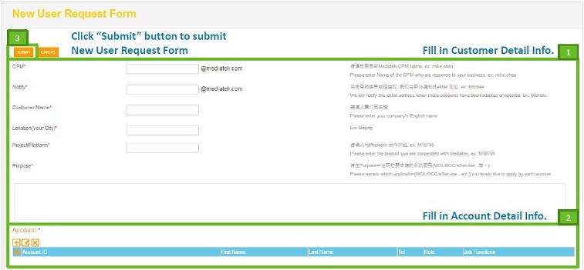
Figure 5-1. Account Application Guilde Step 1
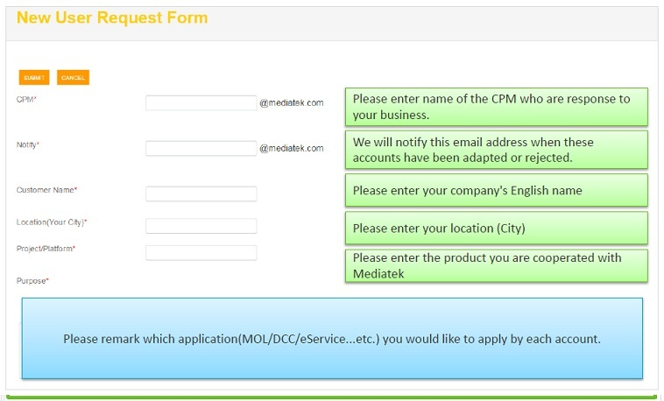
Figure 5-2. Account Application Guilde Step 2
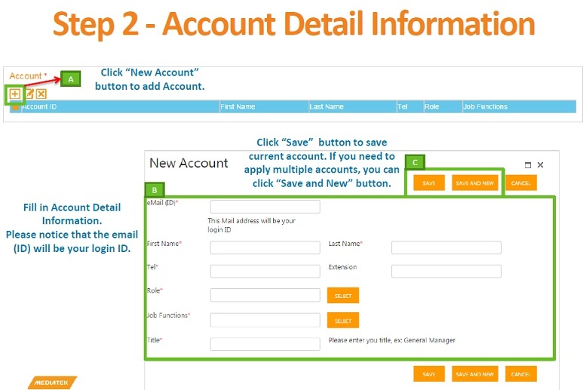
Figure 5-3. Account Application Guilde Step 3
Note that what you need is FEX (so that we can send the software release by e-mail to your account), and MOL (so that you can download the required tools on the website). Please also indicate that you need the authority of WCX SP Tool in the application form.

Download the Released Software to the Device
Then you’re allowed to search and download tools from MOL website: https://online.mediatek.com/
To downloadthe software to the device, please download flashtool in the website. You can also find the latest aurisys here.
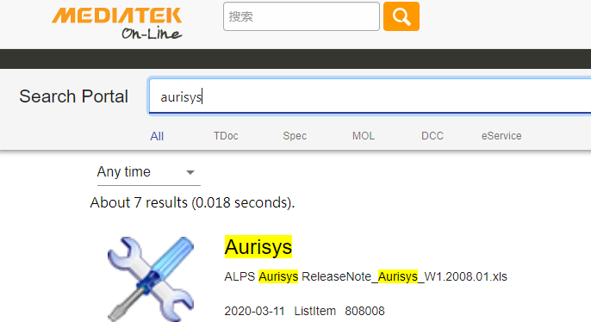
Figure 5-4. MOL Example

Scatter File
You can find the MTXXXX_Android_scatter in out_[project]/target/product/[project] folder. If you didn’t get the modem image in the software release, you need to remove the following Modem description of the scatter file:
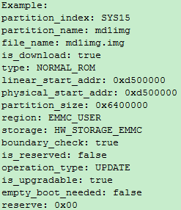
Figure 5-5. Modem Image Description in Scatter File
If it doesn’t work, please try to modify the description as follows:
- File_name: NONE
- Is_download: false

Download Whole Software Load
Please refer to Download by Flashtool. Please select “format all + download” in the first use of the device.
- Download Step
  - Load the scatter file
  - Press the download button
  - Plugin USB cable to the device (w/o battery, then the flash tool will start the download process.
- Another way is plugin the USB cable to the device first, and then press download button; finally, reboot the device.

Update DSP Only
After the full software is downloaded to the device, then you can update dsp binary when needed. Please just select and update audio_dsp, and then select download only.
To download audio dsp only, you need to disable verify boot and re-compile the android load.
- Disable Verify boot
  - vendor/mediatek/proprietary/bootable/bootloader/preloader/custom/[project_name]/[project_name].mk
    - MTK_SEC_USBDL=ATTR_SUSBDL_DISABLE
    - MTK_SEC_BOOT=ATTR_SBOOT_DISABLE

Integration

Environment
- Toolchain
  - The toolchain for MTK In-house RV DSP platforms (both SCP/ADSP Co-subsys and Standalone ADSP) is built in the alps project, so there is no need to create a path to place the toolchain.
  - MTK won’t release toolchain for Cadence HiFi DSP platforms, so the toolchain folder will be removed before we release the codebase, please create the folder and license the toolchain from Cadence.
  - Please create a folder in the following path:
    - /prebuilts/xcc/linux-x86/xtensa/[version]-linux/XtensaTools
    - /prebuilts/clang/xtensa/linux-x86/[version]-linux/XtensaTools
  - For example, If the toolchain version is RI-2019.1, please create a folder in the following path: /prebuilts/xcc/linux-x86/xtensa/RI-2019.1-linux/XtensaTools
  - Then please copy the licensed toolchain into this created folder.
- Hwcfg
  - The hwcfg for MTK In-house RV DSP platforms (both SCP/ADSP Co-subsys and Standalone ADSP) is built in the alps project, so there is no need to create a path to place the hwcfg.
  - Please refer to Aurisys_exe_Vx.xxxx.xx\CONFIG\Readme to check which version of hwcfg you should use
  - For example, if you use 5G_B, then create a folder in the following path:
/vendor/mediatek/proprietary/tinysys/adsp/license/prebuilt/HIFI3/3rd_party/hwcfg/RI-2019.1-linux/
  - Then you can find xtensa-elf, misc, and config folder in RI-2019.1-linux.rar (from Aurisys_exe_Vx.xxxx.xx\CONFIG\HiFi3\Linux\RI-2019.1-linux\v1), please copy them to the folder you just created.
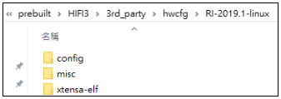
- Param
  - The param file for MTK In-house RV DSP platforms (both SCP/ADSP Co-subsys and Standalone ADSP) is built in the alps project, so there is no need to copy a param file.
  - If you use 5G_B, from Aurisys_exe_Vx.xxxx.xx\CONFIG\Readme, you should use RI-2019.1-linux. You can find mt6853.params in v1\RI-2019.1-linux.rar
  - Copy the mt6853.params to the following path: (create the folder if it doesn’t exit)
/prebuilts/xcc/linux-x86/xtensa/RI-2019.1-linux/XtensaTools/config/
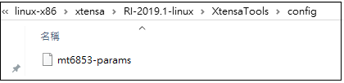
- DSP Library
  - The vendor library would also be removed before we release the codebase
    - The library path is not limited, as long as you add the specified path in the makefile.
    - The library path in MTK codebase is (please create it if it doesn’t exist) vendor/mediate/proprietary/tinysys/adsp/license/prebuilt/HIFIX/3rd_party/aurisys (for Cadence HiFi DSP)
vendor/mediate/proprietary/tinysys/adsp/license/prebuilt/RV55/3rd_party/aurisys (for MTK In-house RV DSP)
    - Please create your lib folder in above path
  - Then modify the makefile so that we can link to your lib; the makefile paths are shown below. Makefile path for MTK In-house RV DSP (SCP/ADSP Co-subsys) platforms please refer to MTxxxx_SCP_Development_Guide.docx:
    - HIFI3 A0: /tinysys/freertos/source/project/HIFI3_A/mtxxxx/platform/platform.mk
    - HIFI3 B0: /tinysys/adsp/HIFI3/project/mtxxxx/[HIFI3_X]/platform/platform.mk
    - HIFI5 B0: /tinysys/adsp/HIFI5_SP/project/mtxxxx/[HIFI5_X]/platform/platform.mk
    - riscv: /tinysys/adsp/riscv/project/mtxxxx/[RV55_X]/platform/platform.mk
  - Note that $(THIRDPARTY_LIB_DIR) indicates to tinysys/adsp/license/prebuilt/HIFIX/3rd_party
    - The macro is not applicable to MTK In-house RV DSP platforms.

Feature Distribution
If there is dual core, the feature distributions are pre-defined as follows:
DSP Core | Feature
Core A | DL (Codec/ Audio Effect/ SmartPA/ VOIP DL)
Core B | UL (VOIP UL/ Phone Call/ Record/ Ear Return)

Aurisys Porting Guide
A tipical aurisys library on ADSP has following three parts:
- AP side parser library
- DSP/SCP side process library
- Aurisys config

AP Side Parsing Library
Use foobar as example, need add or modify below files for AP side parsing library

Path | File | Description
vendor/mediatek/proprietary/external/aurisys/libfoobar | aurisys_foo_bar_parsing_lib.c | Aurisys AP parser library
vendor/mediatek/proprietary/external/aurisys/libfoobar | aurisys_foo_bar_lib _private_type.h | Aurisys AP parser library
vendor/mediatek/proprietary/external/aurisys/libfoobar | Android.mk | Make file for libfoobar.so
device/mediatek/vendor/common | device.mk | For product packages
- In vendor/mediatek/proprietary/external/aurisys/libfoobar
Put library parsing code (for example aurisys_foo_bar_parsing_lib.c and aurisys_foo_bar_lib _private_type.h) in this folder
- In device/mediatek/vendor/common
Add below line to add to package share library to vendor image (for example libfoobar).
PRODUCT_PACKAGES += libfoobar

DSP/SCP Side Process Library
Path | File | Description
vendor/mediatek/proprietary/tinysys/adsp/license/prebuilt/(HIFI3 or HIFI5 or RV55) /3rd_party/aurisys/libfoobar | aurisys_foo_bar_processing_lib.c | Aurisys DSP process lib
 | aurisys_foo_bar_lib _private_type.h | Aurisys DSP process lib
vendor/mediatek/proprietary/tinysys/private/middleware/aurisys/libfoobar | aurisys_foo_bar_lib _private_type.h | Aurisys SCP process lib
 | foo_bar_lib.a | Aurisys SCP process lib
vendor/mediatek/proprietary/tinysys/freertos/source/middleware/lib/aurisys/interface | arsi_library_entry_points.h | For A0 structure static library link
vendor/mediatek/proprietary/tinysys/common/drivers/audio/aurisys/interface | arsi_library_entry_points.h | For B0 structure and SCP static library link
vendor/mediatek/proprietary/tinysys/freertos/source/project/HIFI3_A/$platform/platform | platform.mk | For A0 structure adsp makefile
vendor/mediatek/proprietary/tinysys/adsp/(HIFI3 or HIFI5_SP) /project/$platform/HIFI3_A/platform | platform.mk | For B0 structure adsp core A makefile
vendor/mediatek/proprietary/tinysys/adsp/(HIFI3 or HIFI5_SP) /project/$platform/HIFI3_B/platform  vendor/mediatek/proprietary/tinysys/adsp/riscv/project/$platform/RV55_A/platform  vendor/mediatek/proprietary/tinysys/adsp/riscv/project/$platform/RV55_B/platform | platform.mk | For B0 structure adsp core B makefile
vendor/mediatek/proprietary/tinysys/scp/project/RV55_A/$platform/platform | platform.mk | For SCP makefile
vendor/mediatek/proprietary/tinysys/scp/project/RV55_A/$platform/$project/inc | cache_ld.h | SCP lib DRAM registration (SCP only)
- For ADSP in vendor/mediatek/proprietary/tinysys/adsp/license/prebuilt/(HIFI3 or HIFI5 or RV55)/3rd_party/aurisys/
And for SCP in vendor/mediatek/proprietary/tinysys/private/middleware/aurisys/
Put library processing code and static library here
- In
  - vendor/mediatek/proprietary/tinysys/freertos/source/middleware/lib/aurisys/interface
  - vendor/mediatek/ proprietary/tinysys/common/drivers/audio/aurisys/interface
Add below code in arsi_library_entry_points.h
void foobar_arsi_assign_lib_fp(AurisysLibInterface *lib); //for declaration
In AURISYS_LINK_LIB_NAME_TO_API add:
} else if (!strcmp(name, "foo_bar")) {\
foobar_arsi_assign_lib_fp(api); \
} /
- For Cadence HiFi DSP and MTK In-house RV DSP (Standalone ADSP) In platform.mk, add
INCLUDES += $(THIRDPARTY_LIB_DIR)/aurisys/libfoobar/
C_FILES += $(THIRDPARTY_LIB_DIR)/aurisys/libfoobar/aurisys_foo_bar_processing_lib.c
LIBFLAGS += -Wl,-L$(THIRDPARTY_LIB_DIR)/aurisys/libfoobar -lfoobar

And for MTK In-house RV DSP (SCP/ADSP Co-subsys) in platform.mk, add
INCLUDES += $(PRIVATE_DIR)/middleware/aurisys/libfoobar/
C_FILES += $(PRIVATE_DIR)/middleware/aurisys/libfoobar/aurisys_foo_bar_processing_lib.c
LIBFLAGS += -L$(PRIVATE_DIR)/middleware/aurisys/libfoobar -lfoobar
- (MTK In-house RV DSP (SCP/ADSP Co-subsys) only) For SCP in cache_ld.h, add
#define CACHE_FOOENH_TEXT \
?*/../private/middleware/aurisys/libfooobar/libfoobar_processing.a:*.o$(ENH_TEXT_SECTIONS)
#define CACHE_FOOENH_DATA \
?*/../private/middleware/aurisys/libfooobar/libfoobar_processing.a:*.o$(ENH_DATA_SECTIONS)

Aurisys Config
- Before Android W:
Path | File | Description
device/mediateksample/$project | aurisys_config_hifi3.xml | Aurisys config xml for ADSP
device/mediatekprojects/$project | aurisys_config_hifi3.xml | Aurisys config xml for ADSP
device/mediatek/$platform | aurisys_config_rv.xml | Aurisys config xml for SCP
vendor/mediatek/proprietary/external/aurisys | aurisys_config_rv.xml | Aurisys config xml for SCP
- After Android W (start from DX5 platform):
Path | File | Description
device/mediateksample/$project | aurisys_config_adsp.xml | Aurisys config xml for ADSP/SCP
device/mediatekprojects/$project | aurisys_config_adsp.xml | Aurisys config xml for ADSP/SCP
device/mediatek/$platform | aurisys_config_adsp.xml | Aurisys config xml for ADSP/SCP
vendor/mediatek/proprietary/external/aurisys | aurisys_config_adsp.xml | Aurisys config xml for ADSP/SCP
- Aurisys config hierarchy:
device/mediatekprojects/$project > device/mediateksample/$project > device/mediatek/$platform > vendor/mediatek/proprietary/external/aurisys
If any higher hierarchy folder contain aurisys config xml files, vendor image will use it as final config file.
- In aurisys_config_adsp.xml
Choose wanted scenario to put your library:
enum {
/* playback */
AURISYS_SCENARIO_DSP_PRIMARY = 0, /* for primary output */
AURISYS_SCENARIO_DSP_OFFLOAD = 1, /* for mp3/aac... offload output */
AURISYS_SCENARIO_DSP_DEEP_BUF = 2, /* for deep output */
AURISYS_SCENARIO_DSP_FAST = 3, /* for fast output (need 5ms process) */
AURISYS_SCENARIO_DSP_PLAYBACK = 4, /* last module before hardware if no samrtPA */
/* record */
AURISYS_SCENARIO_DSP_RECORD = 5, /* for record (normal record/camcorder …) */
AURISYS_SCENARIO_DSP_RECORD_FAST = 6, /* for fast record (need 5 or 10ms process) */
/* call & voip */
AURISYS_SCENARIO_DSP_PHONE_CALL = 7, /* for phone call */
AURISYS_SCENARIO_DSP_VOIP = 8, /* for VoIP call */
AURISYS_SCENARIO_DSP_CALL_FINAL = 9, /* for phone call speaker smartPA process */
AURISYS_SCENARIO_DSP_PLAYBACK_SMARTPA = 10, /* for smartPA process */
AURISYS_SCENARIO_DSP_MUSIC = 11, /* for deep + primary + offload mix stream */
AURISYS_SCENARIO_DSP_KTV = 12, /* for in-ear monitor */
AURISYS_SCENARIO_DSP_HDR_RECORD = 13, /* for HDR record */
AURISYS_SCENARIO_DSP_GAMING = 14, /* for game mode */
/* control */
AURISYS_SCENARIO_DSP_SIZE,
AURISYS_SCENARIO_DSP_ALL,
AURISYS_SCENARIO_DSP_INVALID = 0xFFFFFFFF
};
For example, if want add library for AURISYS_SCENARIO_RECORD, need to add below cofnig in aurisys_config_adsp.xml
In <aurisys_scenarios>:
library name in aurisys_scenarios must be same as lib_name in hal_librarys, digital_gain_lib_name must be one of the lib_name in that aurisys scenario. Lib define in digital_gain_lib_name means lib can apply digital gain from aurisys arsi_set_dl_digital_gain / arsi_set_ul_digital_gain APIs
<aurisys_scenario aurisys_scenario="AURISYS_SCENARIO_DSP_RECORD">
<uplink_library_name_list digital_gain_lib_name="foo_bar">
<library name="foo_bar"/>
</uplink_library_name_list>
</aurisys_scenario>

In <hal_librarys>:
Enable library log
Library supported samle rate and format
Define library name/ share library path/ parameter file path / adb_cmd_key here, library name must be the same with lib name defined in aurisys_demo_lib_private_type.h
Lib supported in/out ul process channels
Only set frame_size_ms when b_interleve = “0”
Else set frame_size_ms = “0”
<library name=" foo_bar "
lib_path="/vendor/lib/libfoobar.so"
lib64_path="/vendor/lib64/libfoobar.so "
param_path="/vendor/etc/libfoobar_param.bin"
lib_dump_path="AUTO"
adb_cmd_key="LIB_CMD_KEY">
<components>
<!-- for aurisys_scene record streamin normal -->
<component aurisys_scenario="AURISYS_SCENARIO_DSP_RECORD"
sample_rate="48000"
audio_format="AUDIO_FORMAT_PCM_16_BIT,AUDIO_FORMAT_PCM_32_BIT"
frame_size_ms="20"
b_interleave="0"
enable_log="0"
enable_raw_dump="0"
enable_lib_dump="0"
enhancement_mode="0">
<uplink_process>
<buf_in data_buf_type="DATA_BUF_UPLINK_IN"
num_channels="1,2"/>
<buf_out data_buf_type="DATA_BUF_UPLINK_OUT"
num_channels="1,2"/>
</uplink_process>
</component>
</components>
</library>
Note: The maximum number of library that can be set in aurisys_config_adsp.xml is 8. The limit could be change by revising macro MAX_TOTAL_LIB_NUM in both following files.
/vendor/mediatek/proprietary/hardware/audio/common/aurisys/framework/aurisys_config.h
/vendor/mediatek/proprietary/tinysys/common/drivers/audio/aurisys/framework/aurisys_config.h

New Aurisys Scenario
Predefined aurisys scenario may not fit your requirement (for example: gaming), below are the guidelnes to add a new aurisys scenario in ADSP. We use AURISYS_SCENARIO_DSP_GAMING as example.
Path | File | Description
vendor/mediatek/proprietary/hardware/audio/common/aurisys/framework | aurisys_scenario_dsp.h | Add AP side new scenario enum
vendor/mediatek/proprietary/tinysys/common/drivers/audio/aurisys/framework/ | aurisys_scenario_dsp.h | Add DSP B0 side new scenario enum
vendor/mediatek/proprietary/tinysys/freertos/source/middleware/lib/aurisys/framework/ | aurisys_scenario_dsp.h | Add DSP B0 side new scenario enum
vendor/mediatek/proprietary/hardware/audio/common/aurisys/utility | aurisys_utility.c | Add string and map scenario to task scene
vendor/mediatek/proprietary/external/aurisys | aurisys_config_hifi3.xml  aurisys_config_rv.xml  aurisys_config_adsp.xml | Add new scenario to configuration xml file
- In vendor/mediatek/proprietary/hardware/audio/common/aurisys/framework/aurisys_scenario_dsp.h, vendor/mediatek/proprietary/tinysys/common/drivers/audio/aurisys/framework/aurisys_scenario_dsp.h, and vendor/mediatek/proprietary/tinysys/freertos/source/middleware/lib/aurisys/framework/ aurisys_scenario_dsp.h ,
add new scenario.
enum {
…
AURISYS_SCENARIO_DSP_PLAYBACK_SMARTPA = 10, /* for smartPA process */
AURISYS_SCENARIO_DSP_MUSIC = 11, /* for deep + primary + offload mix stream */
AURISYS_SCENARIO_DSP_KTV = 12, /* for in-ear monitor */
AURISYS_SCENARIO_DSP_GAMING = 13, /* for gaming */
/* control */
AURISYS_SCENARIO_DSP_SIZE,
AURISYS_SCENARIO_DSP_ALL,
AURISYS_SCENARIO_DSP_INVALID = 0xFFFFFFFF
};

AP side and DSP side’s aurisys_scenario_dsp.h must sync, or will cause ADSP crash or Aurisys abnormal.
- In vendor/mediatek/proprietary/hardware/audio/common/aurisys/utility/aurisys_utility.c, add new string for new enum and mapping to task.
static const string_to_enum_pair_t g_s2e_aurisys_scenario_dsp[] = {
…
STRING_TO_ENUM("AURISYS_SCENARIO_DSP_PLAYBACK_SMARTPA", AURISYS_SCENARIO_DSP_PLAYBACK_SMARTPA),
STRING_TO_ENUM("AURISYS_SCENARIO_DSP_MUSIC", AURISYS_SCENARIO_DSP_MUSIC),
STRING_TO_ENUM("AURISYS_SCENARIO_DSP_KTV", AURISYS_SCENARIO_DSP_KTV),
STRING_TO_ENUM("AURISYS_SCENARIO_DSP_GAMING", AURISYS_SCENARIO_DSP_GAMING),
STRING_TO_ENUM("AURISYS_SCENARIO_DSP_ALL", AURISYS_SCENARIO_DSP_ALL)
};
uint8_t map_aurisys_scenario_to_task_scene(
…
if (core_type == AURISYS_CORE_HAL) {
…
} else if (core_type == AURISYS_CORE_HIFI3) {
…
case AURISYS_SCENARIO_DSP_VOIP:
case AURISYS_SCENARIO_DSP_GAMING: /* map to voip task for gaming */
task_scene = TASK_SCENE_VOIP;
break;
…
}
…
}
- In vendor/mediatek/proprietary/external/aurisys/aurisys_config_adsp.xml, add lib to scenario. Below example is for both UL and DL process, if only need UL or DL process, can remove redundant down/uplink_library_name_list.
<aurisys_scenarios>
…
<!-- for aurisys_scene ktv for headphone feedback process -->
<aurisys_scenario aurisys_scenario="AURISYS_SCENARIO_DSP_KTV">
<downlink_library_name_list digital_gain_lib_name="">
<library name="aurisys_demo"/>
</downlink_library_name_list>
</aurisys_scenario>
<!-- for aurisys_scene gaming for gaming process -->
<aurisys_scenario aurisys_scenario="AURISYS_SCENARIO_DSP_GAMING">
<downlink_library_name_list digital_gain_lib_name="">
<library name="aurisys_demo"/> <!-- add your lib here -->
</downlink_library_name_list>
<uplink_library_name_list digital_gain_lib_name="">
<library name="aurisys_demo"/> <!-- add your lib here -->
</uplink_library_name_list>
</aurisys_scenario>
</aurisys_scenarios>
…
To use this new scenario in ADSP, need also modify audio HAL by below steps. We also use AURISYS_SCENARIO_DSP_GAMING as example.
Path | File | Description
vendor/mediatek/proprietary/hardware/audio/common/V3/aud_drv | AudioALSAPlaybackHandlerDsp.cpp | DL / UL aurisys user
vendor/mediatek/proprietary/hardware/audio/common/V3/aud_drv | AudioALSACaptureDataProviderDsp.cpp | DL / UL aurisys user
- In AudioALSAPlaybackHandlerDsp.cpp, add AURISYS_SCENARIO_DSP_GAMING for corresponded DL scenario. (If only need UL process, need skip this step)
status_t AudioALSAPlaybackHandlerDsp::open() {
…
} else if (mStreamAttributeSource->mAudioOutputFlags & AUDIO_OUTPUT_FLAG_VOIP_RX) {
mTaskScene = TASK_SCENE_VOIP;
#ifdef MTK_AURISYS_FRAMEWORK_SUPPORT
if (is_gaming_scenario) { // need implement judgement for gaming scenario
aurisys_scenario = AURISYS_SCENARIO_DSP_GAMING; // assuming gaming run on voip
} else {
aurisys_scenario = AURISYS_SCENARIO_DSP_VOIP;
}
arsi_process_type = ARSI_PROCESS_TYPE_DL_ONLY; //ARSI_PROCESS_TYPE_UL_AND_DL;
#endif
…

- In AudioALSACaptureDataProviderDsp.cpp, add AURISYS_SCENARIO_DSP_GAMING for corresponded UL scenario. (If only need DL process, need skip this step)
status_t AudioALSACaptureDataProviderDsp::open() {
…
if (mStreamAttributeSource.mVoIPEnable || (mStreamAttributeSource.input_source == AUDIO_SOURCE_CUSTOMIZATION2)) {
//streamAttributeEchoRef = &mStreamAttributeSource;
memcpy(&mstreamAttributeEchoRef, &mStreamAttributeTargetDSP, sizeof(struct stream_attribute_t));
mstreamAttributeEchoRef.num_channels = mDsphwRefConfig.channels;
mstreamAttributeEchoRef.audio_format = AUDIO_FORMAT_PCM_8_24_BIT;
mstreamAttributeEchoRef.audio_channel_mask = AUDIO_CHANNEL_IN_STEREO;
mstreamAttributeEchoRef.sample_rate = mDsphwRefConfig.rate;
streamAttributeEchoRef = &mstreamAttributeEchoRef;
if (is_gaming_scenario) { // need implement judgement for gaming scenario
aurisys_scenario = AURISYS_SCENARIO_DSP_GAMING; // assuming gaming run on voip
} else {
aurisys_scenario = AURISYS_SCENARIO_DSP_VOIP;
}
arsi_process_type = ARSI_PROCESS_TYPE_UL_ONLY; //ARSI_PROCESS_TYPE_UL_AND_DL;
…

To verify your scenario is added and correctly used, you can check below log in ADSP log files.
[D]CreateAurisysLibManager(), manager config: aurisys_scenario 13, core_type 1, arsi_process_type 1, frame_size_ms 20, num_channels_ul 2, num_channels_dl 2, audio_format 4, sample_rate 48000 //process type 0 is for UL, 1 is for DL
[D][AURI][HDL] aurisys_arsi_create_handler(), lib_name lib_gaming_name, memory_size xxx //should show your lib_name in AURISYS_SCENARIO_DSP_GAMING defined in aurisys_config_adsp.xml

How to allocate working buffer for library? (aurisys interface before V1.8.0)
The library can allocate a working buffer through ARSI-PROC APIs, which the library must implement its implementation. Aurisys supports DRAM only and DRAM+SLB mode to allocate a working buffer. For the aurisys interface version after V1.8.0, please refer to chapter 5.3.5.
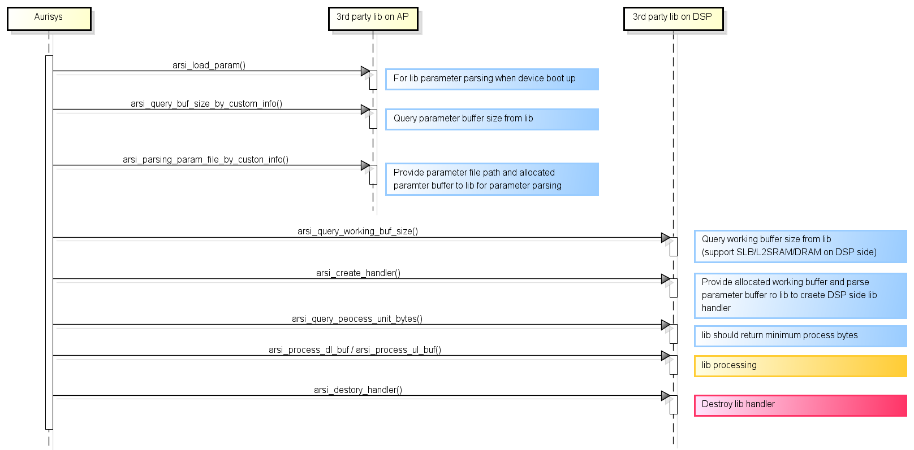
Allocate working buffer for DSP side library

Figure 5-6. Aurisys Control Flow
Use DRAM as working buffer
arsi_query_working_buffer(): This API function queries the size of the working buffer needed by the library. The desired working buffer size can be specified by assigning a value to p_working_buf_size (bytes). Aurisys framework will allocate memory on DRAM according to the chosen size.
/**
* =========================================================================
* @brief Query the size of the working buffer
*
* @param input p_arsi_task_config the task configure
* @param input p_arsi_lib_config the lib configure
* @param output p_working_buf_size the working buffer size
* @param input debug_log_fp debug print function pointer
*
* @return status_t
* =========================================================================
*/
status_t (*arsi_query_working_buf_size) (
const arsi_task_config_t *p_arsi_task_config,
const arsi_lib_config_t *p_arsi_lib_config,
uint32_t *p_working_buf_size,
const debug_log_fp_t debug_log_fp)
When the aurisys framework calls arsi_create_handler() API, the working buffer requested by the library will be passed to the library as an input parameter, namely p_working_buf.
/**
* =========================================================================
* @brief Create handler and initialize it
*
* @param input p_arsi_task_config the task configure
* @param input p_arsi_lib_config the lib configure
* @param input p_param_buf the enhancement parameters and lib related configure settings
* @param input p_working_buf the allocated buffer and the size is from arsi_create_handler()
* @param output pp_handler the handler of speech enhancement
* @param input debug_log_fp debug print function pointer
*
* @return status_t
* =========================================================================
*/
status_t (*arsi_create_handler) (
const arsi_task_config_t *p_arsi_task_config,
const arsi_lib_config_t *p_arsi_lib_config,
const data_buf_t *p_param_buf,
data_buf_t *p_working_buf,
void **pp_handler,
const debug_log_fp_t debug_log_fp);
Use SLB and DRAM as working buffer
To use System Level Buffer (SLB) as a library working buffer, one must finish the following setup:
- CFG_SLB_SUPPORT = yes (SLB must be supported on the platform, please consult MTK if not sure)
- The library needs to implement arsi_is_support_slb() API, which is meant to query whether the library wants to use slb as a working buffer, and return true through this API.
When the setting is done correctly, aurisys will allocate a working buffer through API with the suffix _with_slb. The library can then assign the preferred size of working buffer on SLB and DRAM.

arsi_is_support_slb(): The library must return true with this API to use SLB memory as a working buffer.
/**
* =========================================================================
* @brief Query lib slb support, return ture if lib support slb.
* This is a OpenDSP only api.
*
* @return bool
* =========================================================================
*/
bool (*arsi_is_support_slb) (void)
arsi_query_working_buf_size_with_slb(): Through this API, the library can get the SLB address (p_arsi_slb_buf->p_buffer) and available size (p_arsi_slb_buf->memory_size). Also, the library needs to decide the working buffer size to place on DRAM by assigning a value to p_working_buf_size.
/**
* =========================================================================
* @brief Query the size of the working buffer with slb support.
* This is a OpenDSP only api.
*
* @param input p_arsi_task_config the task configure
* @param output p_arsi_lib_config the lib configure
* @param input p_arsi_slb_buf the slb buffer
* @param output p_working_buf_size the working buffer size
* @param input debug_log_fp debug print function pointer
*
* @return status_t
* =========================================================================
*/
status_t (*arsi_query_working_buf_size_with_slb)(
const arsi_task_config_t *p_arsi_task_config,
const arsi_lib_config_t *p_arsi_lib_config,
data_buf_t *p_arsi_slb_buf,
uint32_t *p_working_buf_size,
const debug_log_fp_t debug_log_fp);
When the library chooses to use SLB, aurisys will create a handler with arsi_create_handler_with_slb(). The API input parameters contain p_working_buf and p_arsi_slb_buf, which consist of the working buffer allocated on DRAM and SLB, respectively.
/**
* =========================================================================
* @brief Create handler with slb and initialize it. This is a OpenDSP only api.
*
* @param input p_arsi_task_config the task configure
* @param input p_arsi_lib_config the lib configure
* @param input p_param_buf the enhancement parameters and lib related configure settings
* @param input p_working_buf the allocated buffer and the size is from arsi_create_handler()
* @param input p_arsi_slb_buf the slb buffer
* @param output pp_handler the handler of speech enhancement
* @param input debug_log_fp debug print function pointer
*
* @return status_t
* =========================================================================
*/
status_t (*arsi_create_handler_with_slb) (
const arsi_task_config_t *p_arsi_task_config,
const arsi_lib_config_t *p_arsi_lib_config,
const data_buf_t *p_param_buf,
data_buf_t *p_working_buf,
data_buf_t *p_arsi_slb_buf,
void **pp_handler,
const debug_log_fp_t debug_log_fp);
The demo API implementation in this chapter can be found in /API/V1.x.x/libaurisysdemo/aurisys_demo_processing_lib.c

How to allocate working buffer for library? (aurisys interface after V1.8.0)
On aurisys V1.8.0, MTK proposes a new working flow for the library to query the working buffer. In this version, we add support to L2SRAM, a lower latency memory relative to DRAM. For the aurisys interface version before V1.8.0, please refer to chapter 5.3.5.
Use SLB/L2SRAM/DRAM as working buffer
The library can allocate a working buffer through ARSI-PROC APIs, which the library must implement its implementation. Aurisys supports an integrated interface with which the library can appoint desired working buffer sizes on SLB, L2SRAM, and DRAM.
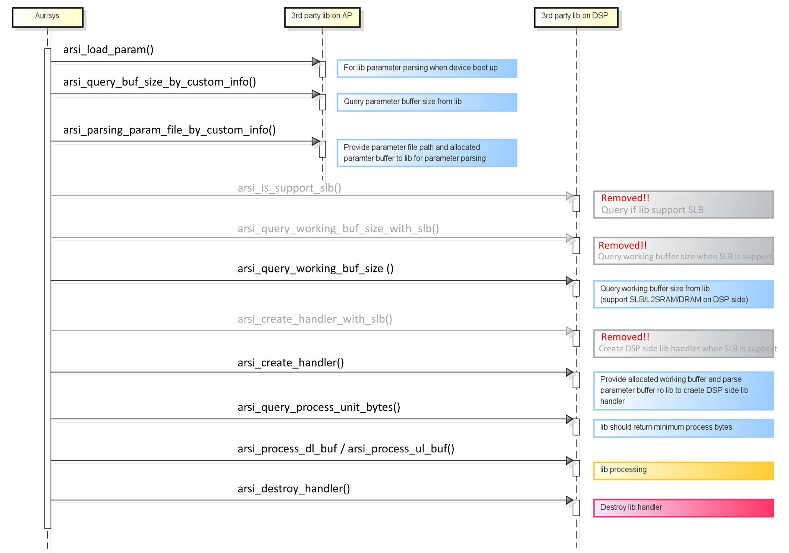
Provide buffers as library request
(support SLB/L2SRAM/DRAM on DSP side)

Query SLB/L2SRAM/DRAM size
on DSP side

Figure 5-7. Aurisys Control Flow
The following legacy API functions are removed because MTK integrates them into arsi_query_working_buf_size() and arsi_create_handler().
- arsi_is_support_slb()
- arsi_query_working_buf_size_with_slb()
- arsi_create_handler_with_slb()

arsi_query_working_buffer(): This API function queries the size of the working buffer on SLB/L2SRAM/DRAM needed by the library. The expected working buffer size can be specified by designating values to the p_work_buf_size array (in bytes), in which the element represents to corresponding memory. When choosing the working buffers’ size, the library must check the p_avail_memory_size array, which provides the available size of each memory at the point.
The library must not return a size larger than provided available size, and the default value of SLB/L2SRAM size is 0 if the library does not determine the preferred size. Aurisys framework will then allocate memory according to the chosen size.
/**
* =========================================================================
* @brief Query the size of the working buffer
*
* @param[in] p_arsi_task_config the task configure
* @param[in] p_arsi_lib_config the lib configure
* @param[out] p_work_buf should specify preferred working buffer size with this structure
* support SLB/L2SRAM/DRAM on DSP side!
* @param[in] p_avail_memory_size available size for working buffer on each memory
* @param[in] debug_log_fp debug print function pointer
*
* @return status_t
* =========================================================================
*/
status_t (*arsi_query_working_buf_size)(
const arsi_task_config_t *p_arsi_task_config,
const arsi_lib_config_t *p_arsi_lib_config,
uint32_t *p_work_buf_size,
const uint32_t *p_avail_memory_size,
const debug_log_fp_t debug_log_fp);
When the aurisys framework calls arsi_create_handler() API, the working buffers requested by the library will pass to the library as an input parameter, namely p_work_buf, which is an array containing the working buffer of each memory.
/**
* =========================================================================
* @brief Create handler and initialize it
*
* @param[in] p_arsi_task_config the task configure
* @param[in] p_arsi_lib_config the lib configure
* @param[in] p_param_buf the enhancement parameters and lib related configure settings
* @param[out] p_work_buf the allocated buffer and the size is from arsi_query_working_buf_size()
* support SLB/L2SRAM/DRAM on DSP side!
* @param[out] pp_handler the handler of speech enhancement
* @param[in] debug_log_fp debug print function pointer
*
* @return status_t
* =========================================================================
*/
status_t (*arsi_create_handler)(
const arsi_task_config_t *p_arsi_task_config,
const arsi_lib_config_t *p_arsi_lib_config,
const data_buf_t *p_param_buf,
data_buf_t *p_work_buf,
void **pp_handler,
const debug_log_fp_t debug_log_fp);
The demo API implementation in this chapter can be found in /API/V1.x.x/libaurisysdemo/aurisys_demo_processing_lib.c

Bypass the Aurisys process by configuring the xml
Purpose
In the past, when library processing was unnecessary in specific scenarios, we used the “aurisys_demo” library, which simlpy copied the input data to output. However, this still incurred additional MCPS due to the Aurisys framework’s overhead.
Starting with the DX5 platform in Android W, we introduced a new mechanism to bypass the aurisys process on ADSP. This allows us to completely avoid library processing through the Aurisys framwork, thereby optimizing ADSP MCPS usage.

How does bypass aurisys mechanism works?
When an ADSP task uses Aurisys and no library processing is needed, you can bypass the Aurisys process by configuring the aurisys_config_adsp.xml file as follows:
- Method 1. Configure the library name to ”none”
For example, to bypass the library processing of the primary task, set the library name to “none”.
<aurisys_scenario aurisys_scenario="AURISYS_SCENARIO_DSP_PRIMARY">
<downlink_library_name_list digital_gain_lib_name="">
<library name="none"/>
</downlink_library_name_list>
</aurisys_scenario>

- Method 2. Remove the specific scenario that is desired to bypass
For example, to bypass the library processing in the aud_playback task, remove AURISYS_SCNEARIO_DSP_PLAYBACK from the aurisys_scenario section. Any scenario not defined in the aurisys_scneario section will be bypassed by default.
<aurisys_scenario aurisys_scenario="AURISYS_SCENARIO_DSP_PLAYBACK_SMARTPA">
<downlink_library_name_list digital_gain_lib_name="">
<library name="aurisys_demo"/>
</downlink_library_name_list>
</aurisys_scenario>

We recommend using Method 1. Setting the library name to “none” clearly indicates that library processing is not needed, which is helpful when debugging.
Please note that the bypass mechanism is only support on ADSP, not on AP. In other words, you can only configure the bypass aurisys process in the aurisys_config_adsp.xml file, not in the aurisys_config.xml file.
How to check whether a specific scenario is bypassed?
In this section, we will compare two scenarios: playback_smartpa and deep_buf, which are bypassed and not bypassed, respectively. By analyzing the HAL and ADSP logs, we could highlight the differences between both scenarios.
- HAL log:
  - PLAYBACK_SMARTPA (with bypass)
If the scenario is bypassed, the key word “bypass aurisys” can be found in the log.
10-23 10:38:06.157961 942 1381 D AudioDspStreamManager: CreateAurisysLibManager(), scene: 10, bypass aurisys

  - DEEP_BUF (without bypass)
For normal Aurisys process, you can find that “CreateAurisysLibManager()” is processed.
10-23 10:37:36.464070 942 1381 D AudioDspStreamManager: CreateAurisysLibManager(), custom_info = SetAudioCustomScene=;, voip = 0, scene = 2
10-23 10:37:36.464125 942 1381 D aurisys_utility: lib, working fs: 48000, fmt: 0x3, frame = 0, b_interleave = 1, num_ul_ref_buf_array = 0, num_dl_ref_buf_array = 0
10-23 10:37:36.464149 942 1381 D aurisys_utility: dl in[type:2], ch: 2, ch_mask: 0x3, buf fs: 48000, buf content fs: 48000, fmt: 0x3; dl out[type:3], ch: 2, ch_mask: 0x3, buf fs: 48000, buf content fs: 48000, fmt: 0x3

- ADSP log:
  - PLAYBACK_SMARTPA (with bypass)
If the scenario is bypassed, you will not found any “CreateAurisysLibManager()” related logs.

  - DEEP_BUF (without bypass)
For normal Aurisys process, you can find the key word “CreateAurisysLibManager()” in the logs.
[133.511]<A-8>[D]CreateAurisysLibManager(), manager config: aurisys_scenario 2, core_type 1, arsi_process_type 1, frame_size_ms 20, num_channels_ul 2, num_channels_dl 2, audio_format 3, sample_rate 48000
[133.511]<A-8>[D][AURI] input dev: 0x80000004 0x0, fmt = 0x3, fs: 48000, max fs: 48000, ch: 2, max ch: 3, ch maks: 0x3, hw_info_mask: 0x0; output dev: 0x2 0x0, fmt = 0x3, fs: 48000, max fs: 48000, ch: 2, max ch: 4, ch maks: 0x3, hw_info_mask: 0xc
[133.511]<A-8>[D][AURI] task_scene: 8, audio_mode: 0, stream_type: 3 output_flags: 0x8, input_source: 0, input_flags: 0x8; enhancement_feature_mask: 0x0
[133.511]<A-8>[D][AURI][CTRL] create_aurisys_lib_manager(+), aurisys_scenario 2, heap(3940480/5033164)

Benefit profile of the bypass mechanism
We compared the MCPS uasage of the deep_pl task during 48k WAV playback between using “aurisys_demo” and bypassing the Aurisys process in the AURISYS_DSP_PLAYBACK_SMARTPA scenario. Normally, 48k WAV playback costs 70 MCPS for the deep_pl task. Bypassing PLAYBACK_SMATPA reduces this to 50 MCPS, saving approximately 20 MCPS.
Additionally, the bypass mechanism reduces heap memory usage. Normal 48k WAV playback uses 1.66MB of memory, while bypassing PLAYBACK_SMATPA uses 1.55MB. This results in a saving of 0.11MB of heap memory.

Aurisys Q&A
- Q：What APIs must be implemented?
A：Please find demo code in this development package aurisys_demo_parsing_lib.c and aurisys_demo_processing_lib.c, for APIs must be implemented, we labled in code with comment “[TODO][MUST]”. Parser library must implement “[TODO][MUST]” APIs in aurisys_demo_parsing_lib.c and likewise process library must implement “[TODO][MUST]” APIs in aurisys_demo_parsing_lib.c. There are API labeled with “[TODO][MUST] 3rd party must implement on both parsing and processing lib”, pleae implement these APIs in both parser and process library.

- Q：How to get driver information like: audio_mode, input/output flags, input_source, input/output device?
A：You can get those information form arsi_task_config_t

- Q：How to know library process sample reate, format and in/out channel numbers?
A：For now, library process sample reate, format and in/out channel numbers are choosed by Aurisys framework automatically to fit closest to device. Sample rate and format can be found in arsi_lib_config_t, and in/out channel numbers can be found in p_ul(dl)_buf_in(out)-> num_channels.

- Q：How DSP side process library can get parameter parsed form AP side parser library?
A：Aurisys framework will automatically pass the parameter buffer get form p_param_buf through arsi_parsing_param_file_by_custom_info API to DSP, and DSP side parser library can get parsed parameter from arsi_create_handler.

- Q：What is the deference between sample_rate_buffer/sample_rate_content in audio_buf_t and sample_rate in arsi_lib_config_t?
A：For now, it’s the same.

- Q：What is lib dump and how to implement it?
A：lib dump is 3rd party proprietary dump. Through lib dump, 3rd party can dump there parameter/ lib in/out buffer/etc. 3rd party also should implement a parser to parse lib dump. To implement lib dump, please follow below instructions:
- Implement API arsi_query_max_debug_dump_buf_size, and return max debug dump size in one process
- In arsi_process_ul_buf/arsi_process_dl_buf fill debug dump in p_debug_dump_buf

Memory Configurations
Memory size configured in DSP is mainly reserved for full-feature support. Refer to Feature Distribution in dual-core project, memory can also be optimized according to the feature configured. For example, if there is no uplink feature configured in DSP, the size of program and heap in core B can shrink greatly for only system usage.

Memory Profile
To profiling the memory usage, you can find the tool memory-layout-parser-release on MOL website, and get the memory layout on device. Audio DSP has two parts of reserved memory, 1) ADSP image with working memory, 2) share memory between APMCU and ADSP, which can be found from type as below,
Detail
Type | Usage | Name | Start Address | End Address | Size (KB)
adsp | image | mblock-25-mediatek,reserve-memory-adsp | 0x7a000000 | 0x7adfffff | 14336
adsp | share memory | reserve-memory-adsp_share | 0x0 | 0x0 | 9728
adsp-total |  |  |  |  | 24064

Approach
Memory configured approach is described for Cadence HiFi DSP and MTK-In-house RV (Standalone ADSP) series, for platforms shared SCP software, for example, 24M, please find SCP development document MTxxxx_SCP_Development_Guide.docx

Cadence HiFi DSP Image
- Heap Size
- Path: alps/vendor/mediatek/proprietary/tinysys/adsp/[HIFI3 or HIFI5]/project/[platform]/[core]/platform/
File: platform.mk
Example:
- System RAM Size
Since ADSP build the image with static linking, all the memory layout should be pre-defined in file in advance, and keep consistent with the description in kernel dts for memory allocation.
Please be cautious to make the memory layout consistent if the modification is needed.
- Path: alps/kernel-x.x/arch/arm64/boot/dts/mediatek
File: [project].dts
Format: system of each core = 64-bit base address, 64-bit size
Example: k6873v1_64.dts
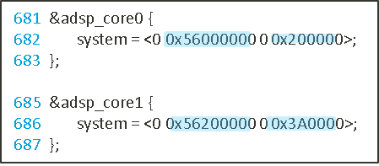
- Path: alps/vendor/mediatek/proprietary/tinysys/adsp/[HIFI3 or HIFI5]/project/[platform]/[core]/platform/
File: platform.mk
Base address of each core:CFG_HIFI3_SRAM_ADDRESS
Size of each core: CFG_HIFI3_SRAM_SIZE
Example:
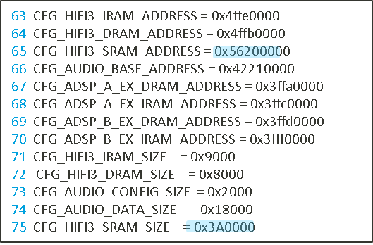
- Path: alps/vendor/mediatek/proprietary/tinysys/adsp/[HIFI3 or HIFI5]/project/[platform]/[core]/platform/[lnk-hifi3 or lnk-hifi5]/[Toolchain-Version]-linux
File: memmap.xmm
Format:
<32-bit base address>:sysram: sram: <32-bit size>
sram_0: C : <32-bit base address> - <32-bit end address>: ……
Example:
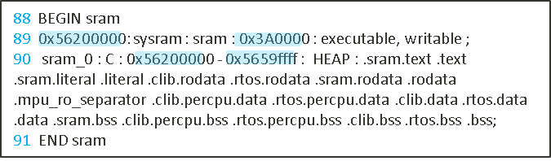
- Generate new link script
If ADSP sysram size increased, the link scripts must be modified. Either generate by linux script or directly edit link script is acceptable.
- By linux script
Excute adsp_genldscript.sh under adsp/HIFIX path to generate link script with modified memory layout. Output file will be generated in ./ldscripts
  - Preparation:
    - Patch perl into toolchain (directly provided by Cadence, excluded from MTK codebase due to license issue)​
      - xcc compiler: prebuilts/xcc/linux-x86/xtensa/RI-20XX.X-linux/XtensaTools/Tools/bin/*
      - clang compiler: prebuilts/clang/xtensa/linux-x86/RI-20XX.X-linux/XtensaTools/Tools/bin/*
    - Modify memory layout file (memmap.xmm) under lnk-hifiX folder.
  - Example:
    - $ cd vendor/mediatek/proprietary/tinysys/adsp/HIFI3
    - $ ./tool/adsp_genldscripts.sh PLATFORM=mt6873 TOOLCHAIN=RI-2018.0
  - Output:
    - New linker scripts generated in project/mt6873/HIFI3_A/platform/lnk-hifi3/RI-2018.0-linux/ldscripts
    - New linker scripts generated in project/mt6873/HIFI3_B/platform/lnk-hifi3/RI-2018.0-linux/ldscripts
- Directly edit link script
  - Files Under project/[$platform]/HIFIX_[$core]/platform/lnk-hifiX/[$toolchain_version]/ldscripts/ need to be updates:
    - elf32xtensa.x & elf32xtensa.xbn & elf32xtensa.xn
      - sram0_seg
      - _memmap_mem_sram_start
        - if core A enlarge size, the start address of core B will be affected
      - _memmap_mem_sram_end
      - _memmap_seg_sram0_start
        - if core A enlarge size, the start address of core B will be affected
      - _memmap_seg_sram0_max
      - _heap_sentry
  - Example: enlarge core A sysram size from 9M to 10M & core B from 9M to 12M
    - project/mt6985/HIFI5_A/platform/lnk-hifi5/RI-2021.8-linux/ldscripts/
      - elf32xtensa.x & elf32xtensa.xbn & elf32xtensa.xn
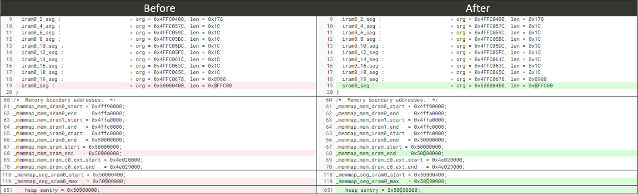
    - project/mt6985/HIFI5_B/platform/lnk-hifi5/RI-2021.8-linux/ldscripts/
      - elf32xtensa.x & elf32xtensa.xbn & elf32xtensa.xn
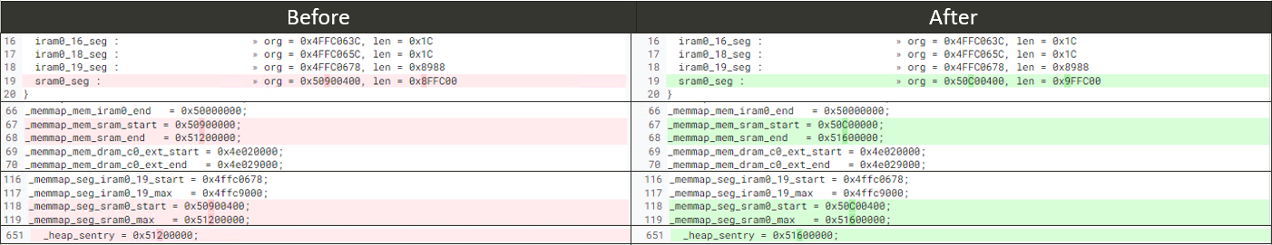

MTK In-house RV DSP (SCP/ADSP Co-subsys) imge
- DRAM Config
Path: vendor/mediate/proprietary/bootable/bootloader/lk2/platform/mediatek/common/scp/RV/scp_plat_priv.h
#if defined(MTK_MINIMUM_SCP_DRAM_SIZE)
#define SCP_DRAM_IMG_SIZE 0x080000 // 0.5MB dram image
#elif defined(PHONE_CALL_ON_SCP)
#define SCP_DRAM_IMG_SIZE 0x300000 // 3.0MB dram image -> please modify this value
#else
#define SCP_DRAM_IMG_SIZE 0x100000 // 1.0MB dram image
#endif
Path: vendor/mediatek/proprietary/tinysys/scp/project/RV55_A/$platform/platform/platform.mk
CFG_L1C_DRAM_SIZE := 0x300000 -> need to sync with upper value
For more SCP image/dram releated detail, please refer to MTxxxx_SCP_Development_Guide.

MTK In-house RV DSP (Standalone ADSP) Image
- Heap Size
- Path: alps/vendor/mediatek/proprietary/tinysys/adsp/riscv/project/[platform]/[core]/platform/
File: platform.mk
Example:
- System RAM Size
Since ADSP build the image with static linking, all the memory layout should be pre-defined in file in advance, and keep consistent with the description in kernel dts for memory allocation.
Please be cautious to make the memory layout consistent if the modification is needed.
Please note that the starting address of core1's system RAM needs to be connected to the end of core0's system RAM, which means core1 system RAM address = core0 system RAM address + core0 system RAM size.
- Path: alps/kernel-x.x/arch/arm64/boot/dts/mediatek
File: [project].dts
Format: system of each core = 64-bit base address, 64-bit size
Example: k6993v1_64.dts
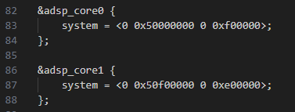
- Path: alps/vendor/mediatek/proprietary/tinysys/adsp/riscv/project/[platform]/[core]/platform/
File: platform.mk
Base address of each core:CFG_ADSP_X_DRAM_ADDRESS
Size of each core: CFG_ADSP_X_DRAM_SIZE
Example:
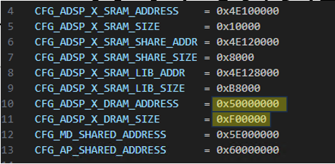
- Path: alps/vendor/mediatek/proprietary/tinysys/adsp/riscv/project/[platform]/[core]/platform/link.ld
File: link.ld
Format:
dram : ORIGIN = <32-bit base address> , LENGTH = <32-bit size>
_memmap_mem_dram_start = <32-bit base address>;
Example:
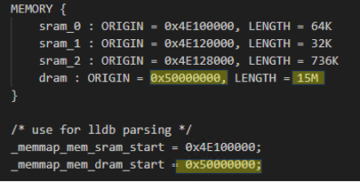

Shared memory
Shared memory is mainly used for communication between APMCU and ADSP. For system usage, the memory size is configured and we do not recommend to modify it. For audio feature usage, the total size of audio would be calculated during initial stage according to the feature configuration in dts. You only need to configure the feature via enable element, instead of the size in array.
- Path: alps/kernel-x.x/arch/arm64/boot/dts/mediatek
File: [project].dts
Format: feature = < $enable $dl_mem $ul_mem $ref_mem $size >
Example: k6873v1_64.dts
/* feature : $enable $dl_mem $ul_mem $ref_mem $size */
&snd_audio_dsp {
mtk_dsp_voip = <0x1f 0x1 0xffffffff 0xffffffff 0x30000>;
mtk_dsp_primary = <0x1f 0x0 0xffffffff 0xffffffff 0x30000>;
mtk_dsp_offload = <0x0 0x6 0xffffffff 0xffffffff 0x400000>;
mtk_dsp_deep = <0x5 0x3 0xffffffff 0xffffffff 0x30000>;
mtk_dsp_playback = <0x1 0x4 0x10 0x14 0x30000>;
mtk_dsp_music = <0x1 0xffffffff 0xffffffff 0xffffffff 0x0>;
mtk_dsp_capture1 = <0x0 0xffffffff 0xd 0x13 0x20000>;
mtk_dsp_a2dp = <0x0 0xffffffff 0xffffffff 0xffffffff 0x40000>;
mtk_dsp_dataprovider = <0x0 0xffffffff 0xf 0xffffffff 0x30000>;
mtk_dsp_call_final = <0x1 0x4 0x10 0x14 0x18000>;
mtk_dsp_fast = <0x5 0x2 0xffffffff 0xffffffff 0x5000>;
mtk_dsp_ktv = <0x0 0x8 0x12 0xffffffff 0x10000>;
mtk_dsp_ver = <0x1>;
swdsp_smartpa_process_enable = <0x1>;
mtk_dsp_mem_afe = <0x1 0x40000>; /* always enable */
};

ADSP system DTS Properties
The ADSP system DTS is mainly defined in the platform’s DTS file. If you want to make modifications, you can directly edit mtXXXX.dts. However, if you only want to modify the ADSP DTS definition for a specific project on a particular platform, you can edit the project’s DTS file, such as kXXXXv1_64.dts. Any modifications or additions made in this file will only take effect for the kXXXXv1_64 project and will not affect other projects.
- Before Kernel 6.1
  - Platform’s DTS file path:
alps/kernel-x.x/arch/arm64/boot/dts/mediatek/mtXXXX.dts
  - Project’s DTS file path:
alps/kernel-x.x/arch/arm64/boot/dts/mediatek/[project].dts
- Kernel 6.1 and later versions
  - Platform’s DTS file path:
alps/kernel/kernel_device_modules-x.x/arch/arm64/boot/dts/mediatek/mtXXXX.dts
  - Project’s DTS file path:
alps/kernel/kernel_device_modules-x.x/arch/arm64/boot/dts/mediatek/[project].dts

ADSP system DTS property description
 | Property | Modifiable | Support kernrel version | Description
adspsys | reg | X | Supported by all kernel versions | This property defines registers that would be used in the ADSP kernel driver.
adspsys | reg-names | X | Supported by all kernel versions | Names of registers.
adspsys | interrupts | X | Supported by all kernel versions | This property defines the interrupts that APMCU can receive from ADSP.
adspsys | interrupt-names | X | Supported by all kernel versions | Names of interrupts.
adspsys | hrt-ctrl-bits | X | From Kernel 6.1 | This property defines the required value for ADSP to become a HRT master.
adspsys | power-domains | X | Supported by all kernel versions | This property defines the power domains required to enable ADSP.
adspsys | clocks | X | Supported by all kernel versions | This property defines the required clock sourcse for ADSP.
adspsys | clock-names | X | Supported by all kernel versions | Names of clocks.
adspsys | slp-prot-ctrl | X | From Kernel 6.1 | This property indicates whether the ADSP kernel driver needs to control ADSP sleep protect.  A value of “1” indicates that it is required, while “0” indicates that it is not required.
adspsys | interconnects | X | From Kernel 6.1 | This property is used to register ADSP as an HRT master to the dvfsrc kernel driver.
adspsys | interconnect-names | X | From Kernel 6.1 | Names of intersections.
adspsys | system-l2sram | X | From Kernel 6.1 | This property indicates whether ADSP uses a portion of L2SRAM for system purposes.
adspsys | core-num | X | Supported by all kernel versions | This property indicates the number of cores in ADSP.
adspsys | adsp-rsv-ipidma-a | O | Supported by all kernel versions | This property defines the IPI DMA buffer size used by ADSP core 0. It is recommended to increase this property value only, decreasing it may lead to issues in high load scenarios.
adspsys | adsp-rsv-ipidma-b | O | Supported by all kernel versions, but is only used on dual-core ADSP | This property defines the IPI DMA buffer size used by ADSP core 0. It is recommended to increase this property value only, decreasing it may lead to issues in high load scenarios.
adspsys | adsp-rsv-logger-a | X | Supported by all kernel versions | This property defines the ADSP core 0 logger buffer size.
adspsys | adsp-rsv-logger-b | X | Supported by all kernel versions, but is only used on dual-core ADSP | This property defines the ADSP core 1 logger buffer size.
adspsys | adsp-rsv-c2c | X | Only supported in Kernel with dual cores ADSP | This property defines the ADSP C2C DRAM buffer size.
adspsys | adsp-rsv-dbg-dump-a | X | Supported by all kernel versions | This property shows the ADSP core 0 debug buffer size.
adspsys | adsp-rsv-dbg-dump-b | X | Supported by all kernel versions, but is only used on dual-core ADSP | This property shows the ADSP core 1 debug buffer size.
adspsys | adsp-rsv-core-dump-a | X | Supported by all kernel versions | This property shows the ADSP core 0 core dump size.
adspsys | adsp-rsv-core-dump-b | X | Supported by all kernel versions, but is only used on dual-core ADSP | This property shows the ADSP core 1 core dump size.
adspsys | adsp-rsv-pcie | X | From Kernel 5.15 | Not in use
adspsys | adsp-rsv-l2sram | X | From Kernel 6.1 | This property shows the size of the ADSP L2SRAM control buffer.
adspsys | adsp-rsv-xhci | X | From Kernel 6.1 | This property shows the buffer size shared between ADSP and USB.
adspsys | adsp-rsv-audio | X | Supported by all kernel versions | This property shows the buffer size shared between ADSP and Audio.
adspsys | adsp-slc-enable | O | From Kernel 6.12 | This property controls whether the adsp should use SLC. SLC is similar to cache on DRAM and allows the ADSP to fetch DRAM data faster. When the value is 1, the ADSP will use SLC.
adsp_core0 | reg | X | Supported by all kernel versions | This property lists the sizes of ITCM, DTCM, and L2SRAM (system usage) for ADSP core 0.
adsp_core0 | system | O | Supported by all kernel versions | This property shows the system RAM address and size used by the ADSP core 0. Only the size can be modified, and the method for modifying the size can be found in DSP Image
adsp_core0 | interrupts | X | Supported by all kernel versions | This property defines the interrupts that APMCU can receive from ADSP core 0.
adsp_core0 | mboxes | X | Supported by all kernel versions | This property lists the mailboxes used by ADSP core 0. There are two sets in total. The first set of mailboxes is used for messages sent from APMCU to ADSP core 0, while the second set is used for messages sent in the opposite direction.
adsp_core0 | feature-control | X | Supported by all kernel versions | This property lists the features supported by ADSP core 0. It is 64 bits in length, with each bit representing a feature. A bit value of 1 indicates that ADSP core 0 will activate when that feature is in operation, while a value of 0 means it will enter suspend mode. It is not recommended to modify this property as it may unnecessarily activate ADSP core 0, increasing power consumption.
adsp_core1 | reg | X | Supported by all kernel versions | This property lists the sizes of ITCM, DTCM, and L2SRAM (system usage) for ADSP core 1.
adsp_core1 | system | O | Supported by all kernel versions | This property shows the system RAM address and size used by the ADSP core 1. Only the size can be modified, and the method for modifying the size can be found in DSP Image
adsp_core1 | interrupts | X | Supported by all kernel versions | This property defines the interrupts that APMCU can receive from ADSP core 1.
adsp_core1 | mboxes | X | Supported by all kernel versions | This property lists the mailboxes used by ADSP core 1. There are two sets in total. The first set of mailboxes is used for messages sent from APMCU to ADSP core 1, while the second set is used for messages sent in the opposite direction.
adsp_core1 | feature-control | X | Supported by all kernel versions | This property lists the features supported by ADSP core 1. It is 64 bits in length, with each bit representing a feature. A bit value of 1 indicates that ADSP core 1 will activate when that feature is in operation, while a value of 0 means it will enter suspend mode. It is not recommended to modify this property as it may unnecessarily activate ADSP core 1, increasing power consumption.
adsp_slp_prot | power-domains | X | From Kernel 6.1 | This property defines the power domain that needs to control ADSP slpprot.
audio_dsp_hrt_bw | adsp-qos-scene-phone | X | From Kernel 6.1 | This property specifies the bandwidth that needs to be communicated to the dvfsrc kernel driver for the phone call scenario, with a default value of 500 Mbps.

