

Aurisys Features and Capability
Helio X20

Version: 0.9
Release date: 2015-12-08

© 2014 - 2016 MediaTek Inc.
This document contains information that is proprietary to MediaTek Inc.
Unauthorized reproduction or disclosure of this information in whole or in part is strictly prohibited.

Specifications are subject to change without notice.

Document Revision History

Revision | Date | Author | Description
0.9 | 2015/12/8 | Doug Wang | Initial Draft
1.0 | 2016/2/22 | Doug Wang | Revise Feature support table

Table of Contents
Document Revision History 2
Table of Contents 3
1 Aurisys Capability 4
1.1 Overview 4
1.2 DSP Capability 4
1.2.1 DSP Basics 4
1.2.2 DSP Feature Packages 4
1.3 Hardware Capability 5
1.4 Aurisys Features in X20 7
2 Aurisys Features 8
2.1 Voice Call 8
2.2 Recording 9

Lists of Tables and Figures

No table of figures entries found.
Figure 1-1. Possible DSP Software Packages of MTK Built-in Features 5
Figure 1-2. Aurisys Features in X20 7
Figure 2-1. Voice Call Data Path 8

Aurisys Capability

Overview
In this document, we provide the specification of Aurisys in X20 to assist with the user’s understanding of developing audio features by Aurisys. In addition to the DSP specifications, we also provide notable information on each feature.

DSP Capability

DSP Basics
The basic information about DSP is summarized as follows:
- Integrated open DSP support. The embedded processor is ARM Cortex™-M4 processor
  - Floating-Point-Unit supported
  - The internal SRAM of DSP is 512 KB
  - Maximum clock rate reaches 354 MHz
  - No cache support
- Programmable DMA (burst of 4 by 16-bit) for DSP supported to transfer data to/from external memory
  - Not suggest to access external memory by the processor directly, it may cause unexpected problems. Please use DMA for large quantity of data transfer and just use IPI (inter-processor-interrupt) for the transfers of small data volumes.
  - The DSP can access audio registers, internal memory of audio hardware, and voice data from the modem side during a voice call.
  - We’ve provided an API to trigger DMA, please use polling mode, not to use interrupt mode in X20
- FreeRTOS has been adopted as the supported operating
  - Communicate with Application processor by IPI (inter-processor-interrupt); There are 48 bytes data can be transferred by share memory by one IPI.
  - Dynamic loading of code is not supported
  - Clock rate can be switched between 110/224/354 MHz according to requirements of applications

DSP Feature Packages
Since we don’t support cache or dynamic loading of code, the feature sets supported in DSP may be limited. In X20, we provide the following built-in features: sensor hub (in X20, we use single DSP for both sensor hub and audio features), MP3 decoder, sampling rate converter, and sound trigger. Besides, the sound enhancement for voice calls is driver ready and properly maintained. Customers can add sound enhancement library of 3rd party easily.
However, the customer should select what they really want in CortexM4 since the memory size is not enough for all features. For example, the sensor feature and MP3 decoder have an application processor version. Thus, if the customer wants to add a vendor’s algorithm for voice call, they can select the application processor version of sensor/MP3 to release the memory of the DSP. Besides, even the 3rd party voice call enhancement is not adopted, we still have a MTK built-in version in modem side.
The following table shows possible feature packages of the DSP:
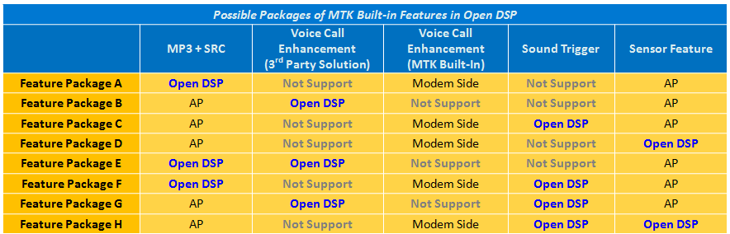
Figure 1-1. Possible DSP Software Packages of MTK Built-in Features

Hardware Capability
- MT6797 (X20)
  - Mediatek Proprietary audio interface connect to PMIC MT6351
  - Audio Playback with MTK PMIC – MT6351
    - Support 8k, 11.025k, 12k, 16k, 22.05k, 24k, 32k, 44.1k, 48k, 96kHz sample rate
  - Audio Recording with MTK PMIC – MT6351
    - Support 8k, 16k, 32k, 48k, 96kHz sample rate
  - Internal high resolution , high flexible HW gain in AFE interconnection…………………..(1)
  - 3 set Inter IC sound interface (I²S)
    - Master Output *2…………………………………………………………………………………………(2)(5)
    - Master Input * 1 ………………………………………………………………………………………….(3)
    - Master/Slave input(with SRC) ……………………………………………………………………..(4)
    - Master Mode supports 8, 11.025, 12, 16, 22.05, 24, 32, 44.1, 48, 88, 96, 176, and 192KHz sampling rate
    - Slave Mode supports 8, 11.025, 12, 16, 22.05, 24, 32, 44.1, 48KHz sampling rate
    - 16/32 bit bus width support
    - Philip standard and Left just
    - Master Output with 8ch TDM *1 …………….…………………………………………………..(11)
  - 2 set Pulse coded modulation interface(PCM)
    - Slave PCM for internal Modem*1………………………………………………………………..(6)
    - Master/Slave PCM interface for external modem * 1……………………………….…(7)
  - 1 set PCM/I2S merged interface (BTPCM + FM RX/TX I2S)..……………………………….…(8)
    - 4-pin interface for concurrently supporting I2S and PCM
    - PCM supports 8k/16k Hz sampling rate
    - I2S supports 32, 44.1, and 48 kHz sampling rate
  - BT CVSD-Removal non-RF HW in AP-side………………………...……………………………….…(9)
  - 16/24bit stereo data format support
  - Audio codecs
    - MP3, AAC, AAC+, AMR-NB, AMR-WB, OGG, WAV, APE
  - Audio Post-Processing
    - BesLoudness
    - BesSurround
    - ACF/HCF
  - 3rd support (need contact with 3rd by customer)
    - Dolby mobile
    - SRS Wow
  - Low power audio in MP3 playback, FM playback, FM record.
  - Integrated Cortex-M4 DSP, open for development………………….………………………..(10)
- MT6351
  - Mediatek proprietary audio interface connect to MT6755
  - RX processing feature
    - 4 analog output; earpiece, left and right headphone, lineout
    - Stereo DAC
    - Differential earpiece driver up to 50mW in 32ohm, 88mW in 16ohm
    - Differential SPK amplifier up to 700mW in 8ohm 3.7V VBAT
    - Stereo single-ended headphone driver up to 11.25mA in 32ohm
    - Adjustable earpiece, headphone and SPK Amp gain setting
    - Sample rate of 8K,16K,44.1K,48K
    - Best 109dB SNR in headphone output
    - Best -95dB THD
  - TX processing feature
  - SPK Amp integrated with 5V boost

Aurisys Features in X20
The following features are supported in X20 Aurisys. Note that the word “supported” means it would be driver-ready. Other features can also be implemented by utility functions, such as Proximity.
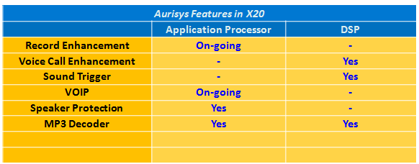
Figure 1-2. Aurisys Features in X20

Aurisys Features
We won’t introduce Aurisys features further detail here. We just focus on available resource and notable information to implement the feature.

Voice Call
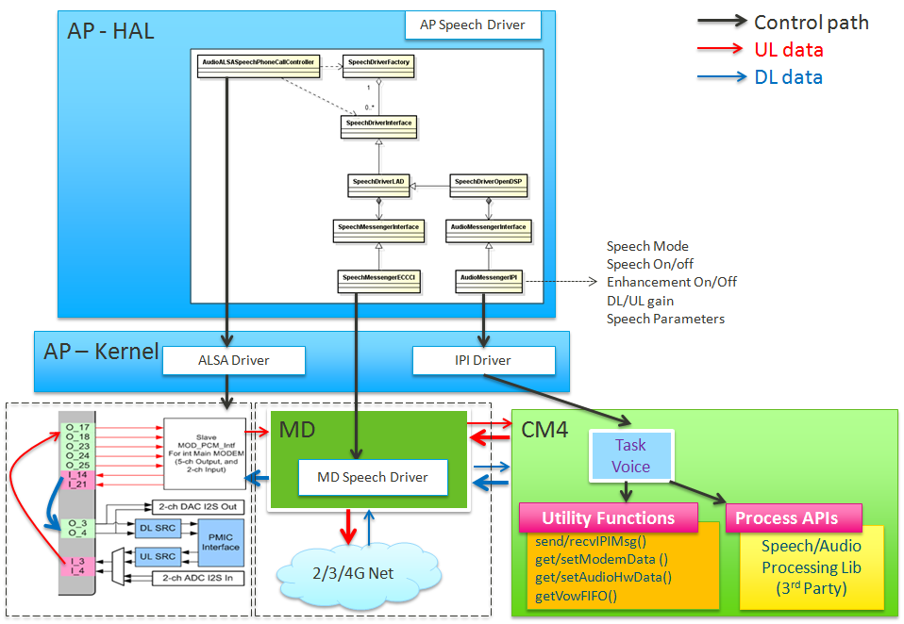
Figure 2-1. Voice Call Data Path
The voice codec is processed in modem side. We only apply voice enhancement in open DSP. Notable information is listed as follows:
- We support NB/WB.
- 20ms per frame and DL/UL separated. Modem side interrupts open DSP every 20ms to notify open DSP to receive voice UL data. For voice DL data, the interrupt period is also 20ms, and there is a shift between UL data.
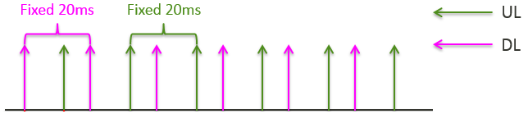
- To avoid increasing round trip delay, UL enhancement should be processed no more than 10ms and DL enhancement should be processed no more than 3ms. If the library can’t meet the requirement, we need to delay 1 frame to process the data. There would be 20ms increment in the round trip delay (because of 20ms per frame).

 | Available MCPS | Latency
DL Enhancement | 53 | No delay
UL Enhancement | 177 | No delay
DL+UL Enhancement | 354 | 20ms delay increment

- The group delay (processing buffer delay) of the library is suggested to not more than 40ms.
- Dual mic supported in X20

Recording
- Audio Recording with MTK PMIC – MT6351
  - Support 8k, 16k, 32k, 48k, 96kHz sample rate
Currently, we only support recording enhancement in the Application Processor. This is because the power savings in DSP won’t be significant unless the encoder and storage driver are also implemented in DSP.
This is on-going and the patch would be released later

