

Aurisys Development Tutorial
User Manual
Customer Support
MT6799

CS6799-XXX-UMD-V1.0EN
V1.0
2016-08-29
Internal
Doc No:
Version:
Release date:
Classification:

© 2016 MediaTek Inc.
This document contains information that is proprietary to MediaTek Inc.
Unauthorized reproduction or disclosure of this information in whole or in part is strictly prohibited.

Specifications are subject to change without notice.

Keywords
User Manual

MediaTek Inc.
Postal address
No. 1, Dusing 1st Rd. , Hsinchu Science Park, Hsinchu City, Taiwan 30078
MTK support office address
No. 1, Dusing 1st Rd. , Hsinchu Science Park, Hsinchu City, Taiwan 30078
Internet
http://www.mediatek.com/

Document Revision History
Revision | Date | Author | Description
V0.8 | 2015/12/31 | Doug Wang | First Release
V0.9 | 2016/1/21 | Doug Wang | Add code release partand modify dsp build command
V0.9a | 2016/3/28 | Doug Wang | Add Software patch table
V1.0 | 2016/08/09 | Doug Wang | Add Library integration guidance in Application Processor; Record & VOIP Applications; XML Descriptor
V1.1 | 2017/03/15 | HY | Add offload playback file sturcture

Table of Contents
Document Revision History 3
Table of Contents 4
Lists of Tables 7
Lists of Figures 8
1 Overview 9
1.1 Abstract 9
1.2 Aurisys Aims 9
1.3 Aurisys Structure 10
1.4 DSP Capability 11
1.4.1 DSP Basics 11
1.4.2 Defalut DSP Feature Packages 12
1.4.3 DSP TCM 12
2 Getting Start with Aurisys 14
2.1 Comments 14
2.2 File Structure 14
2.2.1 DSP 14
2.2.2 Application Processor 15
2.3 Step by Step Integration Guide 15
2.3.1 Integrate Software IP in DSP 15
2.3.2 Integrate Software IP in Application Processor 18
3 Software Development Guidance 21
3.1 Software Interface Overview 21
3.2 Sound Processing Task Integration Guidance 21
3.2.1 ARSI-PROC 21
3.2.2 ARSI-PROC Functions 21
3.2.3 Example 23
3.3 Parameter Tuning Guidance 24
3.3.1 ARSI-PAR Usage 24
3.3.2 Communication based on Android Debug Bridge(adb) 25
3.3.3 ARSI-PAR Functions 26
3.3.4 Example 27
4 XML Descriptor for Aurisys 29
4.1.1 Example 29
4.1.2 Elements 31
4.1.3 Deployment 34
5 Debugging 36
5.1 Logging 36
5.1.1 Inside Software IP 36
6 Applications 37
6.1 Aurisys Features in MT6799 37
6.2 Voice Call 37
6.2.1 Data Path 37
6.2.2 Basic Information 39
6.2.3 Limitations 40
6.2.4 Configurations 40
6.2.5 Software Frameworks 41
6.3 Playback 42
6.3.1 Data Path 42
6.3.2 Scenarios 43
6.3.3 AP playback with post-processing 43
6.3.4 Configurations 44
6.3.5 DSP offload playback 46
6.3.6 File Structure 47
6.3.7 Behavior 48
6.3.8 Functional Blocks 49
6.4 Sound Trigger 50
6.5 SmartPA 50
6.6 Record & VOIP 50
6.6.1 Data Path 50
6.6.2 Configurations 51
6.6.3 Application Processor Only 51
6.6.4 Class Diagram 51
6.6.5 Device Information 52
7 Appendix: Platform and Development Environments 54
7.1 Scenario Based DVFS 54
7.1.1 Implementation 54
7.2 Dynamic Objects Loading 56
7.3 DSP Binary (Build Command and Download) 57
7.3.1 Configuration 57
7.3.2 Build Command 57
7.3.3 Built Binary 57
7.4 Code Release 58
7.5 Aurisys Framework Class Diagram 59
7.6 Software Patch Note 59
7.7 FAQ 60

Lists of Tables
Table 3-1. Adb command table 25
Table 3-2.Command argument table 25

Lists of Figures
Figure 1-1. Concept of Aurisys 9
Figure 1-2. Aurisys Structure 10
Figure 1-3. MT6799 DSP Overview 12
Figure 1-4. MT6799 DSP TCM Size Configurations 13
Figure 3-1. Parameter Path 24
Figure 4-1. Relationship between Scene Handler, Scenario Descriptor, and Library Descriptor 34
Figure 6-1. Aurisys Default Features in MT6799 36
Figure 6-2. Hand-Held Mode Voice Call Data Path 37
Figure 6-3. Hand-Free Mode Voice Call Data Path 38
Figure 6-4. Software Frameworks of Voice Call 40
Figure 6-5. Offload Audio Playback 41
Figure 6-6. Functional Blocks of Offload Playback 43
Figure 6-7. Record & VOIP 44
Figure 6-8. Aurisys Class Diagram for Record & VOIP 45
Figure 7-1. MT6799 DSP Dynamic Voltage Table 48
Figure 7-2. MT6799 DSP Dynamic Loading Concept 50
Figure 7-3. Update DSP Binary by Flashtool 52
Figure 7-4. Aurisys Framework Class Diagram 53

Overview

Abstract
The requirement for sound quality enhancements that add listening pleasure has been increasing. To enrich the listening experience of using mobile devices, there is an increasing number of sound processing solutions provided by vendors.
Aurisys is introduced to facilitate the sound processing solution development and use of MTK platforms. Aurisys is a framework constructed upon Android Audio Framework. It includes standardized interfaces for sound processing and tuning, integrated DSP sound subsystem, and software debug interface. This concept of Aurisys will be briefly described in this document.

Aurisys Aims
As the following figure depicts, our target is to make the replacement/integration of vendor IPs as convenient as possible. We defined a standardized interface to which is platform-independent, so that the software can be re-used. By following the user interface standards we create a more consistent experience for the developers.
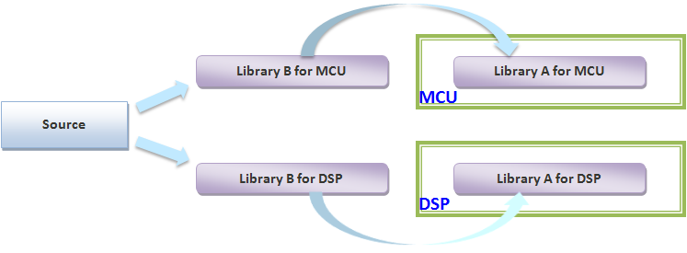
Figure 1-1. Concept of Aurisys

Aurisys Structure
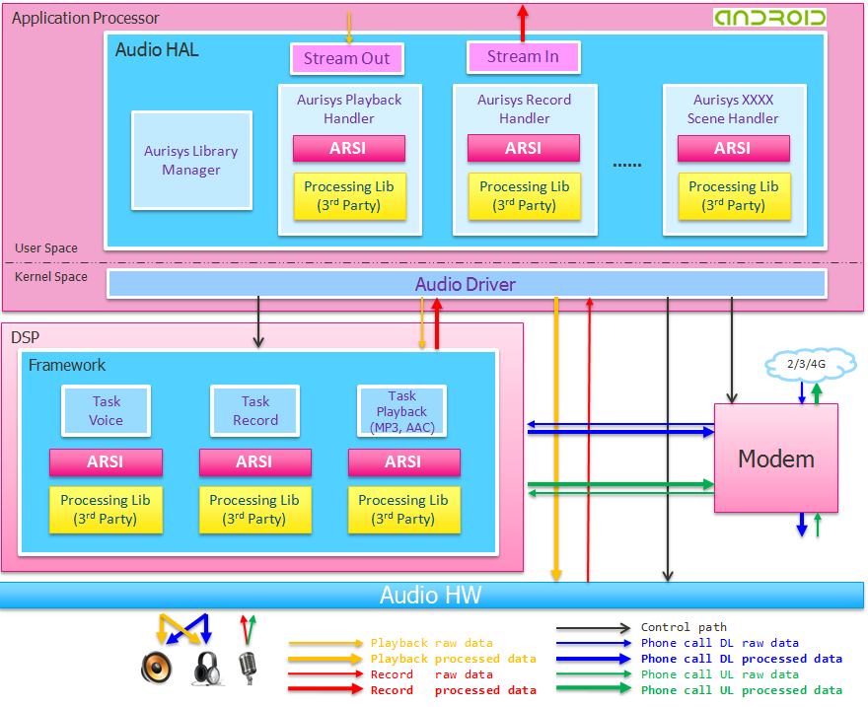
Figure 1-2. Aurisys Structure
As depicted in above figure, the Aurisys structure contains Scene Handler, Library Manager, integrated DSP framework, Modem/Audio HW subsystems, and standardized software interfaces:
- Aurisys Scene Handler (ARSH)
The Aurisys Scene Handler is created as the middleware between the audio system and the sound processing IPs. It is created scene by scene. For example, the Aurisys Playback Handler is served for playback effects in the scene of playback. It provides interfaces to call the corresponding IPs and manages the IPs.
- Aurisys Library Manager (ARLM)
The Aurisys Library Manager maintains the library information of each Aurisys Scene Handler. It contains the list and status of sound IPs.
- Aurisys Software Interface (ARSI)
ARSI is the abbreviation of Aurisys Software Interface. It is provided for interfacing with sound enhancing tasks. To process sounds, a unified interface which is portable between MTK platforms is provided. The interface to parse and transmit parameters between PC tool, APMCU, and DSP is also included. The interface is designed for ease of use while being general enough so that new algorithms can be easily added to the existing frameworks. The difference between ARSI and ARSH is that ARSI provides interface between ARSH and sound IPs; while ARSH provides interface for Android Audio HAL to request for processing sounds.
- Modem
The modem means the modem IC. The MTK internal chipset contains a DSP to process voice enhancement and voice codec. In Aurisys structure, we disable the voice enhancement, but reserve codec in modem IC so that we can just add algorithms in the integrated open DSP in the Application side.
- Audio HW
It refers to the interface between processors and HW devices to transfer sound data. The devices include speakers, microphones, earphones, BT devices, USB devices, etc.

DSP Capability

DSP Basics
The basic information about DSP is summarized as follows:
- Integrated open DSP support. The embedded processor is ARM Cortex™-M4 processor
  - Dual CortexM4 DSPs, one is for sensor hub, and the other is for audio
  - Floating-Point-Unit supported
  - The internal SRAM of DSP is 768 KB
    - Share with sensor hub DSP. The memory allocation should be terminated in compile time. For example, it we allocate 256KB for CM4_A, and 512KB for CM4_B. CM4_B can’t use the 256KB of CM4. The allocation can’t be changed run-time.
    - The memory are divided into 128KB per unit
    - CM4_A is sensor hub DSP and CM4_B is audio DSP
  - Maximum clock rate reaches 416 MHz
  - No cache support
- Programmable DMA (burst of 4 by 16-bit) for DSP supported to transfer data to/from external memory
  - Not suggest to access external memory by the processor directly, it may cause unexpected problems. Please use DMA for large quantity of data transfer and just use IPI (inter-processor-interrupt) for the transfers of small data volumes.
  - The DSP can access audio registers, internal memory of audio hardware, and voice data from the modem side during a voice call.
  - We’ve provided an API to trigger DMA, please use polling mode, not to use interrupt mode in MT6799
- FreeRTOS has been adopted as the supported operating
  - Communicate with Application processor by IPI (inter-processor-interrupt); There are 48 bytes data can be transferred by share memory by one IPI.
  - Dynamic loading of code is not supported
  - Clock rate can be switched between 82/165/330/416 MHz according to requirements of applications
  - Notice that the Free-RTOS exists in both Sensor and Audio DSPs
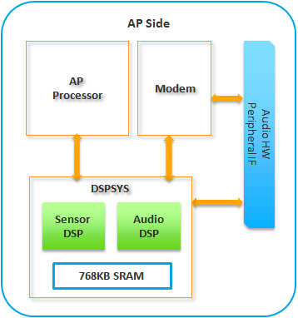
Figure 1-3. MT6799 DSP Overview

Defalut DSP Feature Packages
We don’t support cache in the DSP, so the features support in DSP may be limited due to lack of TCM(tightly coupled memory) of DSP. To reuse the TCM, we support dynamic loading of code. It adds the ability to exclusively support features. For example, the sound trigger wouldn’t be enabled during a phone call. So we can download speech enhancement to DSP TCM during a call, and download sound trigger when the call ends. However, due to the downloading spends more than 100ms, we don’t suggest to support two features in one scene and dynamic download each feature frequently.
We support mp3 decoder, sound trigger, and speech enhancement during a phone call by default. The sum of these features already exceeds the DSP TCM size. So we treat speech enhancement as one dynamic object, and mp3+sound trigger as another dynamic object (because sound trigger can be supported during mp3 playback). We download the speech enhancement object to DSP when a phone call happens and download the mp3+sound trigger object when the call ends. Customers can also replace the mp3 decoder, sound trigger library, and the speech enhancement with their own SWIPs.

DSP TCM
There's 768KB SRAM shared by the DSPs. However, the memory can't be dynamically allocated to the DSP in the run time. It must be decided in the sytem boot up time. The following table shows that the memory are divided into 128KB per unit. Besides, due to the HW limitation, the maximum is 640 KB and the minimum is 128KB for each DSP. Without sensor hub and deduct the usage of RTOS(around 50KB), we have only around 590KB for audio.
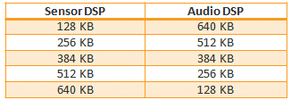
Figure 1-4. MT6799 DSP TCM Size Configurations

Getting Start with Aurisys

Comments
We annotate our code with Doxygen style comments which are used to provide documentation in-line. Before each function, we put a comment block giving at least:
- @brief: a brief description
- @param: describe all of the parameters to the function
- @return: return value
- After the return information, there is a detailed description of the function (optional).
Example:
/**
******************************************************************************
* @brief Query the size of the working buffer
*
* @param p_arsi_task_config the task configure
* @param p_working_buf_size the working buffer size.
*
* @return lib_status_t
******************************************************************************
*/
This function is used to get the working buffer size for a Software IP. p_arsi_task_config contains a particular configuration for the algorithm; p_working_buf_size updated by the Software IP indicates the required memory size under the specified configuration. The return information indicates if there is any unexpected error occurs.

File Structure

DSP
The root folder of DSP is located at vendor/mediatek/proprietary/tinysys/freertos/source.
Path | File | Description
project/CM4_B/mt6799/platform | platform.mk | Project configurations (common)
project/CM4_B/mt6799/[project] | ProjectConfig.mk | Project configurations (specific project)
project/CM4_B/mt6799/[project] | CompilerOption.mk | Project specific compile options
middleware/lib/aurisys/ interface | arsi_api.h | Aurisys Software Interface
middleware/lib/aurisys/ interface | arsi_api_version.h | Aurisys Software Interface
middleware/lib/aurisys/ interface | arsi_call_type.h | Aurisys Software Interface
middleware/lib/aurisys/ interface | arsi_library_entry_points.h | Aurisys Software Interface
middleware/lib/aurisys/ interface | arsi_type.h | Aurisys Software Interface
middleware/lib/aurisys/ interface | audio_task.h | Aurisys Software Interface
middleware/lib/aurisys/ interface | wrapped_audio.h | Aurisys Software Interface
middleware/lib/aurisys/ interface | wrapped_errors.h | Aurisys Software Interface
drivers/common/audio/task/ | audio_task_interface.h | Define audio task structure and status
drivers/common/audio/task/ | call/ audio_do_call.c | Aurisys phone call common driver
drivers/common/audio/task/ | call/ audio_shared_tcm.c | Aurisys phone call common driver
drivers/common/audio/task/ | call/ audio_shared_tcm.h | Aurisys phone call common driver
drivers/common/audio/task/ | call/ audio_speech_msg_id.h | Aurisys phone call common driver
drivers/common/audio/task/ | call/ audio_task_phone_call.h | Aurisys phone call common driver
drivers/common/audio/hardware | audio_irq.h | Header file of audio_irq.c
drivers/common/audio/hardware | audio_hw.h | Header file of Audio hw operating functions
drivers/common/audio/framework | audio_task_factory.c | Audio task service
drivers/common/audio/framework | audio_messenger_ipi.c | Interrupt handler to handle message from AP
drivers/common/audio/framework | audio.c | Audio init/de-init entry functions
drivers/CM4_B/mt6799/audio/ tasks | call / audio_task_phone_call.c | Audio phonecall platform driver
drivers/CM4_B/mt6799/audio/ hardware | audio_irq.c | Register irq handler and request irq
drivers/CM4_B/mt6799/audio/ hardware | audio_hw.c | Audio hw operating functions
drivers/CM4_B/mt6799/audio/ hardware | audio_hw_reg.h | Define platform related audio hw register

Application Processor
Path | File | description
device/mediatek/[project] | ProjectConfig.mk | Project configurations of AP
/device/mediatek/[project]/aurisys_param | *.dat | Parameter file
/vendor/mediatek/proprietary/external/aurisys | *.so, *.xml | Parser library and Processing library (if in Application processor); XML Descriptor file
Vendor/mediatek/proprietary/hardware/audio/common/aurisys | aurisys_config_parser.c/ aurisys_controller.c/ aurisys_lib_handler.c/  aurisys_lib_manager.c | Aurisys services
/vendor/mediatek/proprietary/hardware/audio/common/V3/aud_drv | AudioALSAXXXHandler.cpp | Scene Handler

Step by Step Integration Guide
Before looking deep into Aurisys, we provide step-by-step guidance on how to integrate your program into Aurisys. It can be separated into two conditions: 1) Add or replace a SWIP in DSP; 2) Add or replace a SWIP in Application processor. We’ll take the integration of a voice call SWIP as an example of adding a SWIP in DSP. Note that the addition or replacement of a SWIP is based on an existing driver-ready scene of Aurisys.

Integrate Software IP in DSP

Integration of a Voice Call SWIP (as example)
- Configurations
  - DSP Configurations
    - Common Configurations
The platform Makefile path: /project/CM4_B/[project]/platform/platform.mk
The CFG_AUDIO_SUPPORT is a compile option for audio framework, it will be enabled if there is at least one audio application is enabled.
    - Project Specific Configurations
The file “/project/CM4_B/[project]/[project]/ProjectConfig.mk” is used to enable or disable a feature for a specified project. CFG_MTK_AURISYS_PHONE_CALL_SUPPORT should be set as “yes” to enable voice call application in DSP. Besides, CompilerOption.mk is used for adding project specific compile options.
    - Heapsize Adjustment
The data memory can be managed by malloc functions. However, we need to define a appropriate heap size first. The default heap size for all projects is defined in the following file /project/CM4_B/[project]/platform/ platform.mk. Then find the follow definition
ifeq ($(CFG_MTK_AURISYS_PHONE_CALL_SUPPORT),yes)
CFLAGS += -DconfigTOTAL_HEAP_SIZE='( ( size_t ) ( 275 * 1024 ) )'
else ifeq ($(CFG_MTK_AUDIO_TUNNELING_SUPPORT),yes)
CFLAGS += -DconfigTOTAL_HEAP_SIZE='( ( size_t ) ( 165 * 1024 ) )'
else ifeq ($(CFG_MTK_SPEAKER_PROTECTION_SUPPORT),yes)
CFLAGS += -DconfigTOTAL_HEAP_SIZE='( ( size_t ) ( 165 * 1024 ) )'
else
# default heap size
CFLAGS += -DconfigTOTAL_HEAP_SIZE='( ( size_t ) ( 60 * 1024 ) )'
endif
We can also override the definition for a specific project in CompilerOption.mk mentioned above. Use the following definition to override the default heap size: CFLAGS += -DconfigTOTAL_HEAP_SIZE='( ( size_t ) ( 180 * 1024 ) )'.
  - AP Configurations
    - Projet Configurations
The file “device/mediatek/[project]/ProjectConfig.mk” is used to enable or disable a feature for a specified project of application processor. Set MTK_AURISYS_PHONE_CALL_SUPPORT as “yes”. Notice that there is an automatic compile dependency check between “PROJECT_CONFIG” of AP and “CFG_PROJECT_CONFIG” of DSP. They should be the same value.
    - Clock rate requirement
We don’t have automatic DVFS to detect current DSP loading and adjust the voltage automatically. What we do is to register a frequency requirement table for a specified application. When the application starts, a provided API should be called to notify the system. Besides, it also needs to call another API to notify the system when it is stopped. The system will adjust the voltage according to the sum of clock rate requirement for active applications. The value of clock rate requirement should be estimated precisely and then modify the corresponding valuethe following file:
kernel-4.4/drivers/misc/mediatek/scp/v02/scp_feature_table.c. Note that the feature ID: OPEN_DSP_FEATURE_ID is for voice call of Aurisys.
static scp_feature_table_t feature_table[] = {
{
……
……
{
.feature = OPEN_DSP_FEATURE_ID,
.freq = 356,
.core = SCP_B_ID,
.enable = 0,
},
…….
…….
};
- Software IP Development
  - Delveop with ARSI
Follow ARSI and implement the functions defined in arsi_api.h. The detailed description of ARSI is in the next chapter.
  - DSP Binary
    - Build Command
Notice that the Android build environment is required. The build commands is listed as follows:
- $ . build/envsetup.sh
- $ lunch full_<PROJECT>-eng
- $ mosesq make -j24 (full Android Build)
- $ mosesq make tinysys-scp -j24 (build DSP only)
- $ vendor/mediatek/proprietary/tinysys/freertos/source/tools/build_tinysys.sh clean (clean)
- vendor/mediatek/proprietary/tinysys/freertos/source/tools/build_tinysys.sh (clean build DSP)
    - Built DSP Binary Location
The built DSP binary is located in the following path:
out/target/product/[project]/tinysys-scp.bin
If build CM4_A or CM4_B individually, you can find the binary in the path:
out\target\product\[project]\obj\TINYSYS_OBJ\tinysys-scp_intermediates\freertos\source\CM4_B\
    - Push DSP Image to the Device
MTK Flashtool can be used to download a full load or update DSP binary only. There is also an open source tool “Fastboot” can be used to update DSP binary only. The command is:
- $ adb reboot bootloader (put the device in fastboot mode)
- $ flashboot.exe scp1 tinysys-scp.bin (update scp1 from local tinysys-scp.bin)
- $ flashboot.exe scp2 tinysys-scp.bin
- Parameter Management
  - Parameter File
The parameters of different modes are gathered into a file. To get the maximum flexibility of use, the format of the parameter file is defined by the 3rd Parties themselves. The file should be placed in the following path: /vendor/mediatek/proprietary/external/aurisys/. Then the parameter files are parsed by the 3rd Party parameter parsing library to get required parameters
  - Parser Library
    - Development
Follow ARSI and implement the functions defined in arsi_api.h to develop the parser library. Notice that both 32-bit library and 64-bit library are required. The built *.so would be placed in vendor/mediatek/proprietary/external/aurisys/lib_speech_enh
- Tool Development
The connection between the PC tool and the mobile device is through USB and the communication is based on adb commands. We’ve defined a series of adb commands. The software IP providers can design their own PC tools which can communicate with the mobile devices without making changes to the legacy code of the MTK platforms. The detail information can be found in the next chapter.

Brief Summary
1. Configurations
a) Enable Aurisys phone call supporting configurations in both Application processor and DSP.
b) Adjust heapsize of DSP
b) Estimate clock rate requirement and modify the value………………..reference to [7.1]
2. Software IP Development
a) Implement the functions in ARSI………………..reference to [3.2]
b) Build DSP binary only or build full load (include application processor) …reference to [ 7.3]
c) Update DSP binary by Fastboot or Flashtool, or update full Anroid load by Flashtool…reference to [ 7.3]
3. Parameter Management………………..reference to [3.3.3]
a) Define own parameter file format
b) Implement Parameter Parser Library
4. Tool Development………………..reference to [3.3.2]
a) Develop a PC tool. The communication between the device is based on adb commands

Integrate Software IP in Application Processor

Integration of a Record SWIP (as example)
- Configurations
  - AP Configurations
As mentioned above, the file “device/mediatek/[project]/ProjectConfig.mk” is used to enable or disable a feature for a specified project of application processor. To enable Auisys framework in the application processor, please set MTK_AURISYS_FRAMEWORK_SUPPORT as “yes”. If this configuration is set as “no”, we still support MTK proprietary library in the original framework. However, it doesn’t support the XML descriptor mentioned later or support aurisys interface. It will be hard to replace the proprietary library with vendor’s library.
- Processing and Parser Library
Please refer to the parser library part of integrating software IP in DSP mentioned above. The only difference is that the processing library also exists in the application processor and you can merge processing and parser capabilities in the same library.
Besides, even the integration is complete, you may still need to do some experiments. By using the adb command “adb push xxx.lib /system/lib”, It is allowed to replace the library without re-compiling the image.
- XML Description File
  - File Path: /vendor/mediatek/proprietary/external/aurisys/aurisys_config.xml
The Aurisys XML Descriptor is a simple XML-file that specifies the library version number, attribute, parameter path, and optionally other information. It contains the library descriptor and scenario descriptor. The library descriptor is used to describe the library name, path, attributes. The scenario descriptor is used to specify which libraries would be applied in that scenario. The detailed description of XML descriptor is shown in the “XML Descriptor for Aurisys” chapter.
Besides, it is worth to be mentioned that you can also replace the XML descriptor by a adb command during development stage. The command is “adb push aurisys_config.xml /system/etc”
- Aurisys Framework Modifications
  - Assign a Scenario to the Scene Handler
As mentioned above, a scenario descriptor in XML is used to describe which libraries will be applied in that scenario. Moreover, a scene handler is created as the middleware between the audio system and the sound processing IPs. For example, the record handler is served for a record scene. We need to assign a scenario to the record scene handler that the specified scenario will be applied during recording. To specify a scenario to the record scene handler, please find the following file: “vendor/mediatek/proprietary/hardware/audio/common/V3/aud_drv/ AudioALSACaptureDataClientNormal.cpp”. Then modify the scenario in the constructor:
AudioALSACaptureDataClientNormal::AudioALSACaptureDataClientNormal(……)
{
char *scenario = "xxx_record_scenario"; //the scenario name
}
  - Link library
    - All libraries should be linked first. It is required to let the system be aware of which libraries would be linked. Here used dynamic linking for separating the dependency between framewok and libraries. The library should implement the declared function pointer assignment interface in the following file: “external/aurisys/interface/arsi_libary_entry_points.h”
void dynamic_link_arsi_assign_lib_fp(AurisysLibInterface *lib);
    - To link the library by calling the unique function defined. Please depict your implemented library path in /vendor/mediatek/proprietary/external/aurisys/aurisys_config.xml
The framework will dynamically open library and link the arsi library callback function during initialization stage. The function implementation in library looks like below example :
void dynamic_link_arsi_assign_lib_fp(AurisysLibInterface *lib)
{
lib->arsi_get_lib_version = audioloud_arsi_get_lib_version;
lib->arsi_query_working_buf_size = audioloud_arsi_query_working_buf_size;
lib->arsi_create_handler = audioloud_arsi_create_handler;
…
}

  - Set a Keyword for Set/Get Parameters
As mentioned, we’ve defined a series of adb commands for tuning and updating parameters. It needs to be aware of which libraries should be called to update the parameters. Thus, we need to define the keyword first, we define the keyword in xml file, libray config part. The xml field “adb_cmd_key = XXX” indicates the using keyword for the library

Brief Summary
1. Configurations
a) Enable MTK_AURISYS_FRAMEWORK_SUPPORT configurations in the project configuration file.
2. Software IP Development and Parameter Management
a) Implement the functions in ARSI………………..reference to [3.2]
b) Define own parameter file format ………………..reference to [3.3.3]
c) Implement Parameter Parser Library
d) Place the library in vendor/mediatek/proprietary/external/aurisys and modify the related Makefile
3. XML Descriptor………………..reference to [4]
a) Add a library descriptor about the specified library
b) Add a scenario descriptor to apply the library in that scenario
4. Aurisys Framework Modifications………………..reference to [2.3.2.1]
a) Assign a scenario defined in the XML descriptor to the specified scene handler
5. Tool Development………………..reference to [3.3.2]
a) Develop a PC tool. The communication between the device is based on adb commands

Software Development Guidance

Software Interface Overview
ARSI consists of the following components: ARSI-PROC and ARSI-PPAR. ARSI-PROC defines generic interfaces for processing sounds which is portable to MTK platforms, regardless of DSP or MCU. ARSI-PAR defines API for parsing parameters. It provides programming interface to parse and transmit parameters between PC tool, APMCU, and DSP. Tuning and applying parameters by scenes can also be achieved.

Sound Processing Task Integration Guidance

ARSI-PROC
It defines generic interfaces for processing sounds which is portable to MTK platforms, regardless of DSP or MCU. The interfaces include: Updating parameters and device information; Querying IP information (such as memory usage); Changing mode; Processing sounds. The interfaces are consistent among different processors. The software could be portable to reduce the design effort significantly. They are also consistent among different activities so that they can be widely used in many applications, such as playing, recording, voice call, and sound enhancing.

ARSI-PROC Functions
Functions | Description
arsi_query_working_buf_size | Query the size of the working buffer
arsi_create_handler | Create handler and initialize it
arsi_process_ul_buf | Processing microphone/uplink data
arsi_process_dl_buf | Processing playback/downlink data
arsi_destroy_handler | Deinitialize handler and destroy it (no need to free the working buffer)
arsi_reset_handler | Reset handler to init state
arsi_update_device | Update task device info
arsi_update_param | Update speech enhancement parameters
arsi_set_ul_digital_gain | Set uplink digital gain
arsi_set_dl_digital_gain | Set downlink digital gain
arsi_set_ul_mute | Mute/unmute uplink
arsi_set_dl_mute | Mute/unmute downlink
arsi_set_ul_enhance | Enable/disable uplink enhancement function
arsi_set_dl_enhance | Enable/disable downlink enhancement function
arsi_set_debug_log_fp | Set debug log print callback function
We’ll introduce ARSI-PROC functions here and provide examples. Notice that we won’t provide detailed descriptions of all ARSI-PROC functions. Please refer to the interface document generated by doxygen.

arsi_process_ul_buf
Processing microphone/ voice uplink data
- Prototype:
lib_status_t arsi_process_ul_buf(audio_buf_t *p_ul_buf_in, audio_buf_t *p_ul_buf_out, audio_buf_t *p_aec_buf_in, const uint32_t delay_ms, void *p_handler, void *arg);
- Parameters:
Parameters | Description
*p_ul_buf_in | microphone/uplink data to be processed buffer arrangement: chunks of audio destined for different channels => mic1(1 frame sz) + ... + micN (1 frame sz)
*p_ul_buf_out | the processed microphone/uplink data
*p_aec_buf_in | the AEC reference data
delay_ms | delay time(ms) for AEC
*p_handler | handler of speech enhancement
*arg | reserved field (can be used for extension)
- Return value:
lib_status_t, the status of library

arsi_process_dl_buf
Processing playback/voice downlink data
- Prototype:
lib_status_t arsi_process_dl_buf(audio_buf_t *p_dl_buf_in, audio_buf_t *p_dl_buf_out, void *p_handler, void *arg);
- Parameters:
Parameters | Description
*p_dl_buf_in | the playback/downlink data to be Processed
*p_dl_buf_out | the processed playback/downlink data
*p_handler | handler of speech enhancement
*arg | reserved field (can be used for extension)
- Return value:
lib_status_t, the status of library

Example
Init()
{
……
arsi_create_handler(&arsi_task_config, NULL/*&param_buf*/, &working_buf,
&arsi_handler);
arsi_set_debug_log_fp(myprint, arsi_handler);

arsi_set_ul_digital_gain(0, 0, arsi_handler);
arsi_set_dl_digital_gain(0, 0, arsi_handler);
arsi_set_ul_mute(0, arsi_handler); // no bool.... 0: false, 1: true
arsi_set_dl_mute(0, arsi_handler); // no bool.... 0: false, 1: true
arsi_set_ul_enhance(1, arsi_handler); // no bool.... 0: false, 1: true
arsi_set_dl_enhance(1, arsi_handler); // no bool.... 0: false, 1: true
……
}

Process()
{
……
const uint32_t aec_delay_ms = 40;
if (modem_data_handshake == MODEM_UL_DATA) {
arsi_process_ul_buf( &ul_buf_in, &ul_buf_out, &aec_buf_in, aec_delay_ms,
arsi_handler, (void *)&extra_call_arg);
}
else if (modem_data_handshake == MODEM_DL_DATA) {
arsi_process_dl_buf( &dl_buf_in, &dl_buf_out, arsi_handler, (void *)&extra_call_arg);
}
……
}

Parameter Tuning Guidance
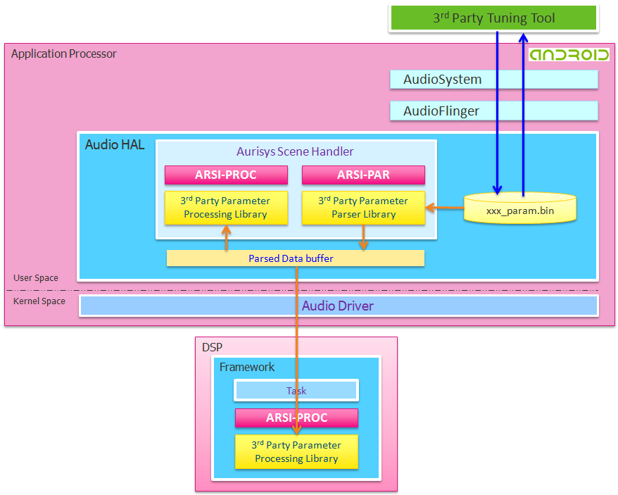
Figure 3-1. Parameter Path

ARSI-PAR Usage
For a software IP, the parameters may be variant in different scenes or situations. To ease of reference, The parameters are gathered into a file. To get the maximum flexibility of use, the format of the parameter file is defined by the 3rd Parties themselves. The ARSI-PAR is designed for parsing parameters for specified scenes. It provides the interface to transfer parameter file to the 3rd party library.
- Tool Development / Connection
The connection between the PC tool and the mobile device is through USB and the communication is based on adb commands. We define a series of adb commands which include transmitting the whole parameter file to the device, receiving whole parameter file from the device, transmitting specific data to the device, and receiving specific data from the device. The software IP providers can design their own PC tools which can communicate with the mobile devices without making changes to the legacy code of the MTK platforms.

- Parsing
To get the maximum flexibility of use, the format of the parameter file is also defined by the 3rd Parties themselves. We only provide the interface to transfer parameter file to the 3rd Party Library. Thus, the 3rd Parties need to implement the parameter parsing library.

- Tuning/Extraction
During parameters tuning, the PC tool updates the parameter file to the mobile device and then the parameter files are parsed by the 3rd Party parameter parsing library to get required parameters. The parameters will then be transferred to the 3rd Party processing library for processing sounds. Besides, when the mode changes (for example, the output device changes from headphone to speaker), we need to extract the parameters of the specified mode and the parsing library will be called.

Communication based on Android Debug Bridge(adb)
Table 3-1. Adb command table
Command | Comments
adb shell "AudioSetParam AURISYS_SET_PARAM,$target,$scene,$lib,$cmd $mode=SET” | Used to update parameter file and apply parameters to the library
adb shell “AudioSetParam AURISYS_GET_PARAM,$target,$scene,$lib,$cmd” | Used to query current parameter setting. Query the value of a specified address and query the whole parameter file are allowed.

Table 3-2.Command argument table
Argument | Example | Comments
$target | DSP, HAL | The processing API maybe either in AP or in DSP
$scene | PHONE_CALL, PLAYBACK, RECORD | Specify a scene, the information will be used as an argument of the parser function
$lib | library name | The library should be specified since there maybe several libraries added to the Aurisys
$mode | Enhancement mode | Enhancement mode. IP provider can provide different enhancement for user to select what they want. The mode should be an integer. Only used in APPLY_PARAM command
$cmd  (for URISYS_SET_PARAM) | PARAM_FILE,param_path | set parameter file path
$cmd  (for URISYS_SET_PARAM) | APPLY_PARAM | apply new param during playback/phone call/...
$cmd  (for URISYS_SET_PARAM) | ADDR_VALUE,addr,value | set “value” at the “addr” in library
$cmd  (for URISYS_SET_PARAM) | KEY_VALUE,key,value | set "value" of the "key" in library, “key” can be defined by the library itself
$cmd  (for URISYS_GET_PARAM) | PARAM_FILE | return param_path
$cmd  (for URISYS_GET_PARAM) | ADDR_VALUE,addr | return the value at the address “addr” in library
$cmd  (for URISYS_GET_PARAM) | KEY_VALUE,key | return the value at the “key” in library
The examples are listed as follows:
- adb shell "AudioSetParam AURISYS_SET_PARAM,DSP,RECORD,MyLib,PARAM_FILE,/data/d.dat=SET"
set parameter file path: /data/d.dat and establish the connection between MyLib and the parameter file
- adb shell "AudioSetParam AURISYS_SET_PARAM,DSP,PHONE_CALL,MyLib,APPLY_PARAM,2=SET"
apply new parameters for record scene, the enhancement mode is 2
- adb shell "AudioSetParam AURISYS_SET_PARAM,DSP,RECORD,MyLib,ADDR_VALUE,0x1234,0x5678=SET" set value 0x5678 at the address 0x1234 in MyLib
- adb shell "AudioSetParam AURISYS_SET_PARAM,DSP,RECORD,MyLib,KEY_VALUE,MyKey,MyVauel=SET"
set value "MyValue" to the key "MyKey" in MyLib
- adb shell "AudioSetParam AURISYS_GET_PARAM,DSP,PHONE_CALL,MyLib,PARAM_FILE"
return param_path of MyLib
- adb shell "AudioSetParam AURISYS_GET_PARAM,DSP,PHONE_CALL,MyLi,ADDR_VALUE,0x1234"
return the value at the address 0x1234 in Mylib
- adb shell "AudioSetParam AURISYS_GET_PARAM,DSP,PHONE_CALL,MyLib,KEY_VALUE,MyKey"
return the value of the key "MyKey" in Mylib

ARSI-PAR Functions
Functions | Description
arsi_query_param_buf_size | Query the buffer size to keep speech enhancement parameters(single mode), Implemented in HAL only
arsi_parsing_param_file | Parsing param file to get parameters into p_param_buf(single mode), Implemented in HAL only
arsi_set_addr_value | Set value at a specified address
arsi_get_addr_value | Get value from the specified address
arsi_set_key_value_pair | set key_value string to library
arsi_get_key_value_pair | get key_value string from library
arsi_get_lib_version | Get the library version
We’ll introduce ARSI-PAR functions here and provide examples. Notice that we won’t provide detailed descriptions of all ARSI-PAR functions. Please refer to the interface document generated by doxygen.

arsi_query_param_buf_size
Query the buffer size to keep speech enhancement parameters(single mode), Implemented in HAL only
- Prototype:
lib_status_t arsi_query_param_buf_size( const arsi_task_config_t *p_arsi_task_config, const string_buf_t *platform_name, const string_buf_t *param_file_path, const int enhancement_mode, uint32_t *p_param_buf_size);
- Parameters:
Parameters | Description
*p_arsi_task_config | the task configure
*platform_name | the platform name by "adb shell getprop ro.product.model"
*param_file_path | the speech enhancement param file (fullset)
enhancement_mode | the speech enhancement mode by apk
*p_param_buf_size | How much memory size required to keep the enhancement parameters for the specific device/mode
- Return value:
lib_status_t, the status of library

arsi_parsing_param_file
Parsing param file to get parameters into p_param_buf(single mode), Implemented in HAL only
- Prototype:
lib_status_t arsi_parsing_param_file( const arsi_task_config_t *p_arsi_task_config, const string_buf_t *platform_name, const string_buf_t *param_file_path, const int enhancement_mode, data_buf_t *p_param_buf);
- Parameters:
Parameters | Description
*p_arsi_task_config | the task configure
*platform_name | the platform name by "adb shell getprop ro.product.model"
*param_file_path | the speech enhancement param file (fullset)
enhancement_mode | the speech enhancement mode by apk
* p_param_buf | the buffer pointer of the parameters for the specific device/mode
- Return value:
lib_status_t, the status of library

Example
void *handle = dlopen(lname, RTLD_NOW);
……
arsi_query_param_buf_size_t fvsoft_arsi_query_param_buf_size =
(arsi_query_param_buf_size_t)dlsym(handle, "arsi_query_param_buf_size");
……
arsi_parsing_param_file_t fvsoft_arsi_parsing_param_file =
(arsi_parsing_param_file_t)dlsym(handle, "arsi_parsing_param_file");
……
fvsoft_arsi_query_param_buf_size(&mArsiTaskConfig, &platform_name, &file_path,
0, &param_buf_size);

memset(param_buf.p_buffer, 0, param_buf.memory_size);
fvsoft_arsi_parsing_param_file(&mArsiTaskConfig, &platform_name, &file_path,
0, &param_buf);
……
/* set speech param to SCP */
pIPI->sendIpiMsg(TASK_SCENE_PHONE_CALL,
AUDIO_IPI_DMA, AUDIO_IPI_MSG_NEED_ACK,
IPI_MSG_A2D_SPH_PARAM, param_buf.data_size, 0, (char *)param_buf.p_buffer);

dlclose(handle);

XML Descriptor for Aurisys

Example
The Aurisys XML Descriptor is a simple XML-file that specifies the library version number, attribute, parameter path, and optionally other information. We provide an example, in the following demonstrates how to describe a library and a scenario. The attributes of the MTK IIR filter library and the MTK record library are packaged in the library descriptor by <aurisyslibdescriptor> tag. Then we can use <aurisysscenario> tag to describe which library (can be multiple libraries) will be applied in this scenario.
<?xml version="1.0" encoding="UTF-8" ?>
<aurisys_config>
<!--
* =========================================================================
* table of uplink/downlink library mapping for each scenario
* =========================================================================
-->
<aurisys_scenarios>
<!-- for aurisys_scene playback normal -->
<aurisys_scenario aurisys_scenario="AURISYS_SCENARIO_PLAYBACK_NORMAL">
<downlink_library_name_list digital_gain_lib_name="">
<library name="mtk_bessound"/>
</downlink_library_name_list>
</aurisys_scenario>
<!-- for aurisys_scene low latency record -->
<aurisys_scenario aurisys_scenario="AURISYS_SCENARIO_RECORD_LOW_LATENCY">
<uplink_library_name_list digital_gain_lib_name="mtk_speech_enh">
<library name="mtk_speech_enh"/>
</uplink_library_name_list>
</aurisys_scenario>
<!--
* =========================================================================
* HAL Librarys
* =========================================================================
-->
<hal_librarys>
<!--
* =====================================================================
* MediaTek Bessound
* =====================================================================
-->
<library name="mtk_bessound"
lib_path="/vendor/lib/libaudioloudc.so"
lib64_path="/vendor/lib64/libaudioloudc.so"
param_path=""
lib_dump_path="AUTO"
adb_cmd_key="MTKBESSOUND">
<components>
<!-- for aurisys_scene playback normal -->
<component aurisys_scenario="AURISYS_SCENARIO_PLAYBACK_NORMAL"
sample_rate="8000,11025,12000,16000,22050,24000,32000,44100,48000,96000,192000"
audio_format="AUDIO_FORMAT_PCM_32_BIT"
frame_size_ms="0"
b_interleave="1"
enable_log="0"
enable_raw_dump="0"
enable_lib_dump="0"
enhancement_mode="0">
<downlink_process>
<buf_in data_buf_type="DATA_BUF_DOWNLINK_IN"
num_channels="2"/>
<buf_out data_buf_type="DATA_BUF_DOWNLINK_OUT"
num_channels="2"/>
</downlink_process>
</component>
</components>
</library>
<!--
* =====================================================================
* MediaTek IIR
* =====================================================================
-->
<library name="mtk_iir"
lib_path="/vendor/lib/lib_iir.so"
lib64_path="/vendor/lib64/lib_iir.so"
param_path=""
lib_dump_path="AUTO"
adb_cmd_key="MTKIIR">
<components>
<!-- for aurisys_scene low latency record -->
<component aurisys_scenario="AURISYS_SCENARIO_RECORD_LOW_LATENCY"
sample_rate="16000,32000,48000,96000,192000"
audio_format="AUDIO_FORMAT_PCM_16_BIT"
frame_size_ms="1"
b_interleave="0"
enable_log="0"
enable_raw_dump="0"
enable_lib_dump="0"
enhancement_mode="0">
<uplink_process>
<buf_in data_buf_type="DATA_BUF_UPLINK_IN"
num_channels="2"/>
<buf_out data_buf_type="DATA_BUF_UPLINK_OUT"
num_channels="2"/>
</uplink_process>
</component>
<!-- for aurisys_scene record w/o AEC -->
<component aurisys_scenario="AURISYS_SCENARIO_RECORD_WITHOUT_AEC"
sample_rate="16000,32000,48000,96000,192000"
audio_format="AUDIO_FORMAT_PCM_16_BIT"
frame_size_ms="20"
b_interleave="0"
enable_log="0"
enable_raw_dump="0"
enable_lib_dump="0"
enhancement_mode="0">
<uplink_process>
<buf_in data_buf_type="DATA_BUF_UPLINK_IN"
num_channels="2"/>
<buf_out data_buf_type="DATA_BUF_UPLINK_OUT"
num_channels="2"/>
</uplink_process>
</component>
<!-- for other aurisys_scenes -->
……………………………………………………………………….
……………………………………………………………………….
……………………………………………………………………….
</components>
</library>
</hal_librarys>
</aurisys_config>

Elements

Version Control
The <versioncontrol> tag is used to describes the Aurisys XML format version.
<versioncontrol value="1.01">

Library Descriptor

Library Information
- HAL Library
The <HAL library> tag is used to specify the description of libraries executed in application processor. Currently, we only support XML descriptor of libraries in the application processor.
<hal_librarys>
- Library Name
The library descriptor is used to describe the information of a library, such as library version, library path, and processing approaches. You can create a library descriptor by a <aurisyslibdescriptor> tag with an appropriate name which represents the library.
<aurisyslibdescriptor name="library_iir">
- Library Path
Specify the library path.
lib_path="/vendor/lib/libaudioloudc.so"
lib64_path="/vendor/lib64/libaudioloudc.so"
- Parameter Path
Specify the library parameter file path. The usage of library parameter has been demonstrated in the chatper “Software Development Guidance”
param_path="/vendor/etc/aurisys_param/Speech_AudioParam.xml"
- Key Parameter
When we want to modify the parameters (ex. by a tuning tool), the audio system needs a specified key to recognize which library should be applied. The key can be any string value that is unique.
adb_cmd_key="MTKBESSOUND">
- Dump Path
The lib_dump_path is used to specify the dump path of the library. If you don’t want to assign a specific path, just set it as “AUTO” and the dump will be placed in sdcard/mtklog/audio_dump
lib_dump_path="AUTO"

Attribute of Each Scene

- Library Applied Scene
Specify the library can be applied in which scenario. The attribute of the library in different scenes may be different. So we should define the attributes to be applied in each scene. The <component> tag is used to specify a scene.
  - Range of values:
AURISYS_SCENARIO_PLAYBACK_NORMAL,
AURISYS_SCENARIO_PLAYBACK_LOW_LATENCY,
AURISYS_SCENARIO_RECORD_LOW_LATENCY,
AURISYS_SCENARIO_RECORD_WITHOUT_AEC,
AURISYS_SCENARIO_RECORD_WITH_AEC,
AURISYS_SCENARIO_VOIP,
AURISYS_SCENARIO_VOIP_WITHOUT_AEC,
AURISYS_SCENARIO_PHONE_CALL,
<component aurisys_scenario="AURISYS_SCENARIO_PLAYBACK_NORMAL" </component>
- Frame Period
The supported frame period of the library. For example, 5|20 means the library support both 5ms and 20ms.
  - Range of values: an integer value
frame_size_ms="20"
If filled frame_size_ms= “0”, means we do not specify the frame buf size, thus the framework will use MAX_LIB_BUF_SIZE (128K) as the buffer size to pass the data to library, the library should handle the process data quantity itself.
- Processing Approach
The library can be interleave and framebase, frame base need to assign AurisysLibKeyFrameMs
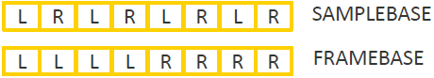
  - Range of values: 0, 1
b_interleave="0"
- Format
To specify the supported format
  - Range of values:
AUDIO_FORMAT_PCM_16_BIT, AUDIO_FORMAT_PCM_8_BIT,
AUDIO_FORMAT_PCM_32_BIT, AUDIO_FORMAT_PCM_8_24_BIT
audio_format="AUDIO_FORMAT_PCM_32_BIT"
- sample_rate
To specify the supported sampling rate
sample_rate="8000,11025,12000,16000,22050,24000,32000,44100,48000,96000,192000"
- Enhancement Mode
The default value of enhancement mode is “0”. If the library has different enhancement mode, it can be sued to specify which enhancement mode would be applied in the scenario.
enhancement_mode="0"
- Debug
To specify the debugging information. “enable_log” is used to control the debug logging of the library; “enable_raw_dump” is used to enable the dump of an input/output buffer of the library; “enable_lib_dump” is used to enable the dump generated by the library itself (if it has).
enable_log="0"
enable_raw_dump="0"
enable_lib_dump="0"

Optional Sections
- Uplink Process
  - The <uplink_process> tag is used to create the attribute describution of uplink process. You don’t need to describe the uplink process attribute if the library won’t be applied in uplink process in the scenario.
  - The <buf_in> tag is used to specify the input buffer type and channel number to the library in the scenario.
  - The <buf_out> tag is used to specify the output buffer type and channel number from the library in the scenario.
  - Range of buffer type values:
DATA_BUF_UPLINK_IN, DATA_BUF_UPLINK_OUT, DATA_BUF_DOWNLINK_IN,
DATA_BUF_DOWNLINK_OUT, DATA_BUF_ECHO_REF, DATA_BUF_IV_BUFFER, DATA_BUF_CALL_INFO
<uplink_process>
<buf_in data_buf_type="DATA_BUF_UPLINK_IN"
num_channels="2"/>
<buf_out data_buf_type="DATA_BUF_UPLINK_OUT"
num_channels="2"/>
</uplink_process>
- Downlink Process
As the <uplink_process, the <downlink_process> tag is used to create the attribute describution of downlink process. You don’t need to describe the downlink process attribute if the library won’t be applied in downlink process in the scenario.
<downlink_process>
<buf_in data_buf_type="DATA_BUF_DOWNLINK_IN"
num_channels="2"/>
<buf_out data_buf_type="DATA_BUF_DOWNLINK_OUT"
num_channels="2"/>
</downlink_process>

Scenario Descriptor
The scenario descriptor is used to specify which library would be applied in the scenario.
- The tags <aurisysscenario>, </aurisysscenario> is used to define the start and end of the scenario descriptor section. The following example shows that an MTK inhouse VOIP scenario is created.
- The <uplink_library_name_list> is used to specify the library in the uplink process, and the <downlink_libary_name_list> is used to specify the library in the downlink process.
- The tag <library name> is used to specify the processing library. Both the downlink and uplink library are set as mtk_speech_enh library. It also allows to assign multiple libraries to the downlink/uplink path. For example, <library name="mtk_speech_enh_A"/> <library name="mtk_speech_enh_B"/>.
- Since the library to do data processing and the library to handle the gain settings may be different. The tag <digital_gain_lib_name> can be used to specify the library to handle the gain settings. The data processing library and gain setting library can be the same one.
<aurisys_scenario aurisys_scenario="AURISYS_SCENARIO_VOIP">
<uplink_library_name_list digital_gain_lib_name="mtk_speech_enh">
<library name="mtk_speech_enh"/>
</uplink_library_name_list>
<downlink_library_name_list digital_gain_lib_name="mtk_speech_enh">
<library name="mtk_speech_enh"/>
</downlink_library_name_list>
</aurisys_scenario>

Deployment
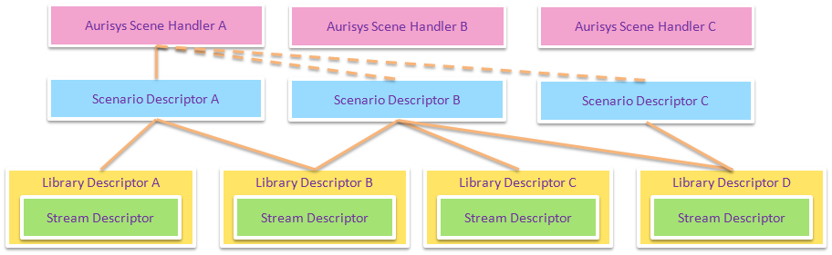
Figure 4-1. Relationship between Scene Handler, Scenario Descriptor, and Library Descriptor
Library Descriptor is used to describe the information of a library. Every applied library should be described by a library descriptor.
Scenario Descriptor is used to define which libraries would be applied in the specified scenario. Multiple libraries can be applied in one scenario. Besides, as the diagram above, a library can be applied in different scenarios.
Scene Handler, as mentioned above, is created as the middleware between the audio system and the sound processing IPs. The record handler is served for a record scene and we can assign a scenario to the record handler. If we assign the scenario A to the record handler, the library A and library B will be applied in the record scene. We can also assign scenario B or scenario C to the recording scene. However, the assignment is achieved in the program of scene handler, not in the XML descriptor.

Debugging

Logging
Programmers are used to debug by logging the execution of the program. However, it is not convenient for a binary release IP. During developing an IP, the programmer writes logging codes to check the correctness of the program. However, the logging code may be removed when it’s time to release. Moreover, the programmer may want to refine the program due to issues or improvement works. He needs to insert the logging code and recompile the code. This brings lots of work for the developer, especially when the program is binary released.
Thus, we provide an API for the developer to check the correctness of their program by logging. The API is consistent and can be used in different systems. The provided API would call the function pointer passed in the initialization. The called function is responsible for logging the required statements by calling the system-specific logging API. It can also be disabled easily by bypassing the requirements. It’s helpful for the developer which doesn’t need to remove and insert logging code anymore.

Inside Software IP
The following blocks are the statement of the information about the provided logging API:
- API
/**
******************************************************************************
* @brief set debug log print callback function
*
* @param debug_log log print function pointer
*
* @param p_handler the handler of speech enhancement
*
* @return lib_status_t
******************************************************************************
*/
lib_status_t arsi_set_debug_log_fp(const debug_log_fp_t debug_log,
void *p_handler);
- Prototype
typedef void (*debug_log_fp_t)(const char *message, ...);
- Data Structure
typedef struct arsi_task_config_t {
…
debug_log_fp_t debug_log;
…
} arsi_task_config_t;

Applications

Aurisys Features in MT6799
The following features are supported in MT6799 Aurisys. Note that the word “supported” means it would be driver-ready. Other features can also be implemented by utility functions, such as Proximity.

Aurisys Features in MT6799
 | Application Processor | DSP
Record Enhancement | Yes | -
Voice Call Enhancement | - | Yes
Sound Trigger | - | Yes
VOIP | Yes | -
Speaker Protection | Yes | -
MP3 Decoder | Yes | Yes
Playback Effect | Yes | -
Figure 6-1. Aurisys Default Features in MT6799

Voice Call

Data Path
- Hand-Held Mode
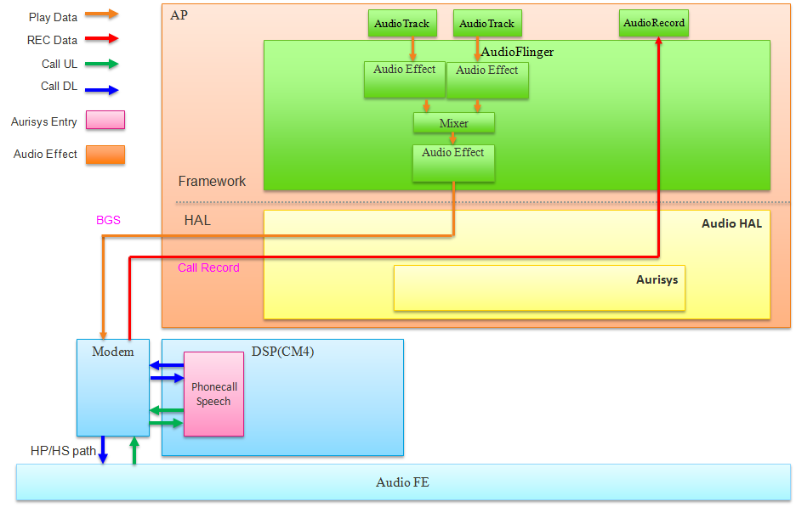
(6)
(5)
(1)
(4)
(3)
(2)
Figure 6-2. Hand-Held Mode Voice Call Data Path
- Downlink data. The data from the far-end is received in Modem IC and decoded. After decoding the codec, the Modem IC notifies the Open DSP to move the voice data to the internal memory of Open DSP. Then the vendor’s DL enhancement solution will be applied and the processed data would be moved back to Modem IC.
- The Modem IC write DL data to Audio HW.
- The voice uplink data are also received from the Modem IC.
- The Open DSP moves the data to its internal memory. After applying the vendor’s UL enhancement solution, the data will be transferred to Modem IC. The Modem IC will then encode the data and send to far end.
- The background sound is transferred to Modem IC and mixed with voice data before output to the audio hardware
- The voice data during a voice call can be saved. The DL/UL data can be saved separately.

- Hand-Free Mode
Programmers are used to debug by logging the execution of the program. However, it is not convenient for
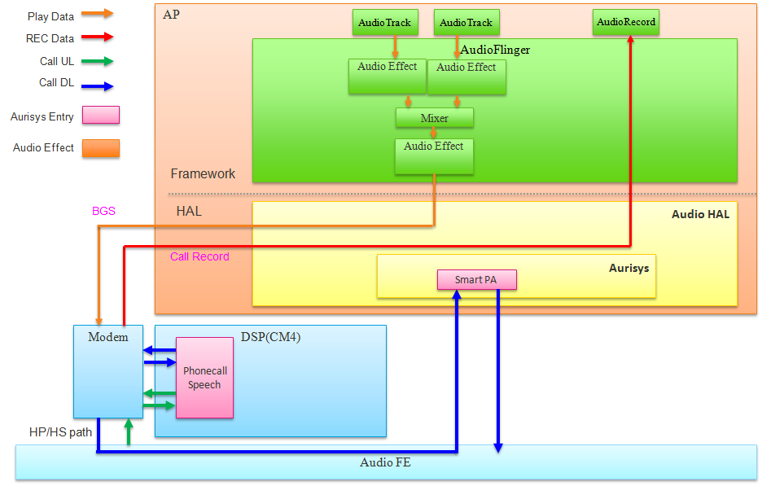
(3)
(2)
(1)
Figure 6-3. Hand-Free Mode Voice Call Data Path
- If there is no smartPA, the DL data is written to the Audio HW and output to speaker Amp directly. If there is a smartPA, the output data will be routed to the application processor first
- The smartPA algorithm will be applied. Notice that we only support smartPA algorithm by default in MT6799.
- Finally, the data will be written to the Audio HW and then output to the speaker Amp.

Basic Information
- We support NB/WB. No matter NB or WB, the data will be up-sampled to 16k sampling rate for the vendor’s IP. We’ll notify the vendor’s IP whether it’s WB or not.
- 20ms per frame and DL/UL separated. Modem side interrupts open DSP every 20ms to notify open DSP to receive voice UL data. For voice DL data, the interrupt period is also 20ms, and there is a shift between UL data.

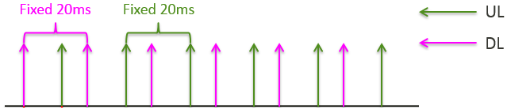
- To avoid increasing round trip delay, UL enhancement should be processed no more than 10ms and DL enhancement should be processed no more than 3ms. If the library can’t meet the requirement, we need to delay 1 frame to process the data. There would be 20ms increment in the round trip delay (because of 20ms per frame).

 | Available MCPS | Latency
DL Enhancement | 62 | No delay
UL Enhancement | 208 | No delay
DL+UL Enhancement | 416 | 20ms delay increment

- The group delay (processing buffer delay) of the library is suggested to not more than 40ms.
- 3 mic supported in MT6799

Limitations
The timing is critical for voice call, so the voice call enhancements should be run at 416 MHz. It will keep the voltage at 0.84V in MT6799. Compared with MTK proprietary voice call enhancement solution which is executed in the Modem IC, the power consumption of executing voice call enhancement executed in the Open DSP will be higher. However, the proportion of power increase would be small in the view of total power consumption of whole chip and daily of use.

Configurations
AP -- MTK_AURISYS_PHONE_CALL_SUPPORT
DSP -- CFG_ MTK_AURISYS_PHONE_CALL_SUPPORT
Notice that there is a compile dependency check. The configurations of AP and DSP should be the same or there will be a build error occurs.

Software Frameworks
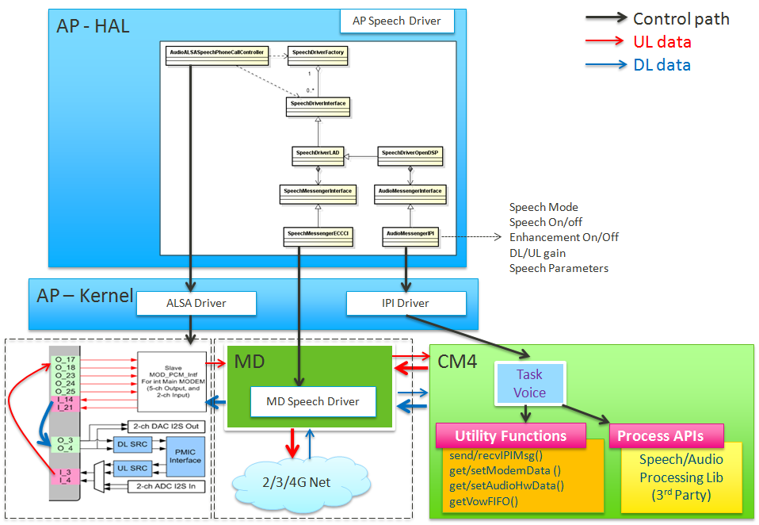
(3)
(6)
(5)
(4)
(2)
(1)
Figure 6-4. Software Frameworks of Voice Call
- UL ………………………………………..……………………………………………………….…(1)
  - The diagram shows the path how UL data received from the hardware input and sends to the Modem IC
- DL………………………………………………………………………………………………..……(2)
  - The path from the Modem IC to the audio hardware output
- Data between Modem IC and CortexM4 (Open DSP) ……………………..(3)
  - The voice data exchange between the Modem IC and CM4 is by the BUS. The DMA of CM4 can help to reduce the period of data exchange
- Source code structure
  - Audio -- /source/drivers/CM4_B/mt6799/audio
  - Aurisys Interface -- /source/middleware/lib/aurisys
  - IPI -- /source/drivers/CM4_b/mt6799/ipi/
- Task Voice ………………………………………..………………………………………………(4)
  - The initial function is placed in audio.c to initialize the IPI message handler and create the Voice Task
  - The Voice Task main functions are placed in audio_task_phone_call.c
- IPI ………………………………………..………………………………………………………..…(5)
  - Inter Processor Interrupt. The communication between the application processor and the DSP is through the IPI message. Each task has its unique IPI ID and should have implemented an IPI handler.
  - The IPI ID is defined in scp_ipi.h
  - The IPI message handler and related information can be found in audio_messenger_ipi.c, audio_speech_msg_id.h
  - Notice that the IPI message handler is in ISR level. Thus, we can’t execute enhancement directly in the IPI message handler. It is just used to signal the task Voice.
- (6) Process APIs………………………………………..……………………………………(6)
  - The software interface defined in arsi_api.h. The process APIs implemented by the vendor will be executed in the Task Voice.

Playback

Data Path
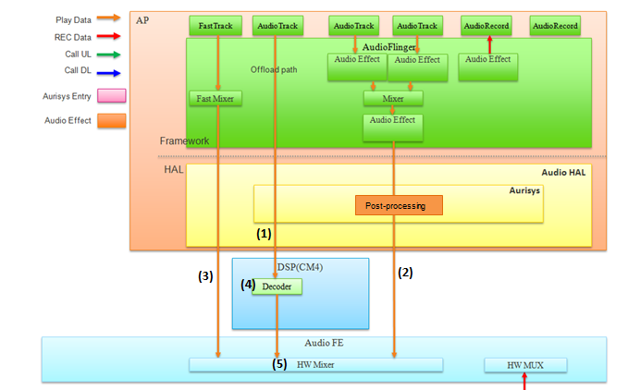
Figure 5-4. Audio Playback with Aurisys data path
- Offload stream. The audio bitstream will be decoded to DSP and the decoded PCM data will be output to the audio hardware directly.
- The normal playback stream. The audio is decoded in the application processor, and the post-processing effects applied through Aurisys Framework.
- Fast track, audio playback with lower latency.
- The decoder implemented in DSP. Currently, we only support MP3 decoder in MT799.
- The multiple streams can be mixed in the hardware directly. However, the sampling rate should be the same, so the sampling rate converter would be executed first if needed.

Scenarios
Currently, we have implemented Aurisys playback scenarios on the AP side and the DSP side.
On AP side, we implement the post-processing effect Audio compensation Filter (ACF/HCF) applied through Aurisys Framework. The user can compose the libraries under different playback scenarios by simply setting different xml configurations.
On DSP side as offload audio case, we put the mp3 decoder on DSP and write down a large amount of bitstream data into Dram to achieve lower power consuming. With the centrol control of aurisys task manager. The communications between AP driver and DSP task becomes safer and easier.
We will introduce the data and control path under this two scenarios.

AP playback with post-processing
The working flow is depicted as below, there are five functional blocks. Application UI, Framework, Audio HAL, Device and External hal. The Aurisys Framewok is implemented in Audio Hal and related ARSI general API and aurisys_config.xml are defined in external block.
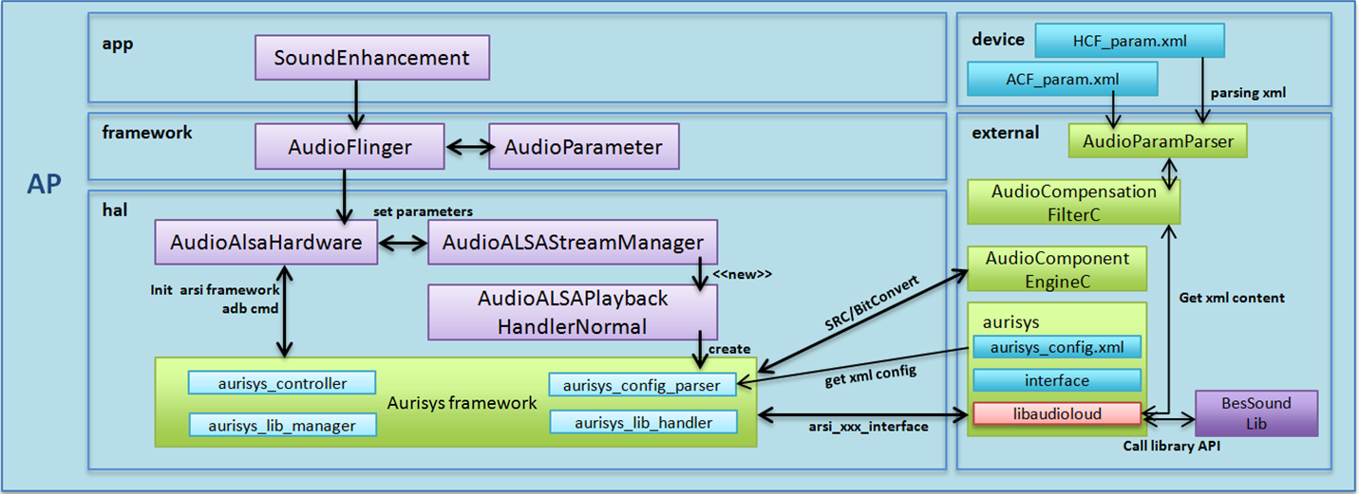
(5)
(4)
(3)
(2)
(2)
(1)
Figure 5-5. Functional Blocks of Normal Playback with ACF library
- The aurisys framework is initialized by AudioALSAHardware when audioserver start.
- During the initialization stage, the aurisys controller parse aurisys_config.xml , establishing the function callback between library and framework, and dlopen AudioComponentEngine libraries (bit converter, samplerate converter.)
For ACF library, we parse the ACF_param.xml and store the parameters into the structure. These parameters set the processing frequency and generate corresponding filter coefficients.
- When normal playback start, we create libmanager and libhandler to handle the processing flow under this scenario. As we can retrieve the stream and hardware info, we store these information and provide to the framework.
If the playback setting is not compatible to the library setting, the Aurisys Framework will trigger samplerate converter or bit converter to do the transformation. This ensure the process can be done without library modification.
- The post-processing is done by calling aurisys_process_dl_only() . The framework handles the data transformation and operates with libraries through ARSI generic interface
- The applicarion can be enabled through setparameter function.

Configurations
AP project config -- MTK_AURISYS_FRAMEWORK_SUPPORT
- Aurisys related files
  - vendor\mediatek\proprietary\hardware\audio\common\aurisys
    - Framework (framework related core files)
    - Utility (src/bitconvert/ringbuf/formatter, adb cmd, pcmdump…utility functions)
  - vendor\mediatek\proprietary\external\aurisys
    - aurisys_config.xml (defines all exist scenarios with corresponding libraries )
    - Interface (aurisys common interface for custom library to reference)
    - Libraries (the existed libraries with aurisys interface ex: libfvaudio, lib_iir…)
- ACF related files
  - vendor\mediatek\proprietary\external\aurisys\libaudioloud
    - ACF with Aurisys wrapper implementation
  - vendor\mediatek\proprietary\external\AudioCompensationFilter
    - C version file for xml parsing
  - device\mediatek\common\audio_param\
    - PlaybackACF_AudioParam.xml parameters for Audio Tunning Tool to adjust
  - \vendor\mediatek\proprietary\custom\(%porj)\hal\audioflinger\audio
    - For customer Turn on/off ACF (ENABLE_AUDIO_COMPENSATION_FILTER)
  - \vendor\mediatek\proprietary\external\bessound_HD

There are two key points for the libray porting .
One is to depicts the library configuration in aurisys_config.xml.
Anothor one is to implement the wrapper between ARSI interface and library functions.
In aurisys_config.xml, we first indicate the using scenario and list the library component used.
We depict the library’s attribute, such as file path, library supported samplerate, processing format, frame size, data buffer type (uplink or downlink), channel number, and debug level….etc. These attributes are compared to the input pcm data and indicate the library setting during processing. The user can change the library setting by simply modify the xml file. This enlarge the flexibility and reduce the coding effort.

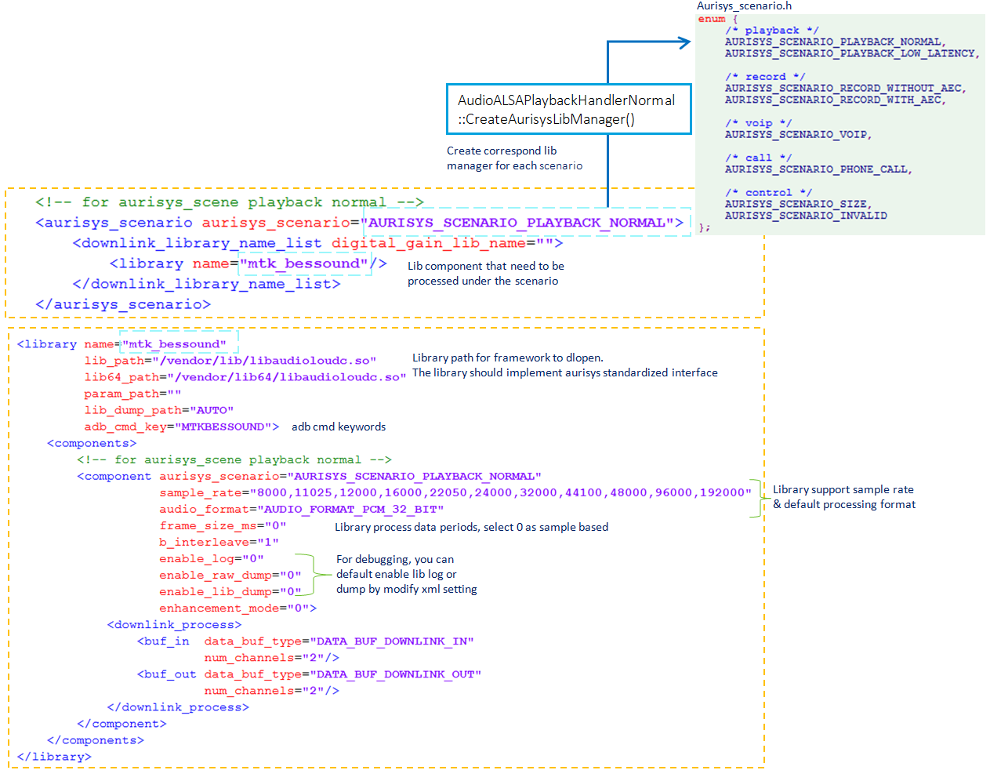
Figure 5-6.aurisys_config. xml depicts the library configurations
To implement the wrapper between library and ARSI interface, we comparing and mapping their functionality as the table shows. ARSI interface supports various library control settings which depict in section 3.2.2.
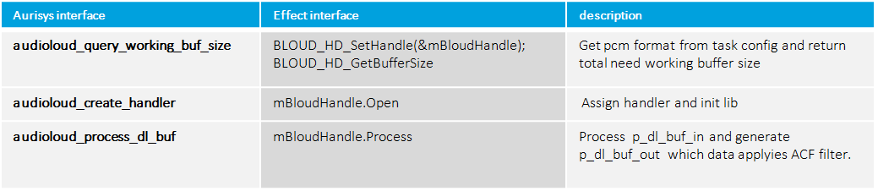
Figure 5-7.mapping the interface between ARSI and Effect
Comparing to the original post-processing path, the Aurisys path will not new the instance for every pre-defined scenario at the first loading stage. Instead, it checks the current device info by task config and create corresponding library instance. The calling interfaces changed in PlaybackHandlerNormal and uses the aurisys_process_dl_only() as the unified entry for every post-processing libray.
This means the users do not need to do extra judge or control coding when adding a new library .Once you have done the aurisys_config.xml description and implemented the wrapper. The library components can be sequentially processed.
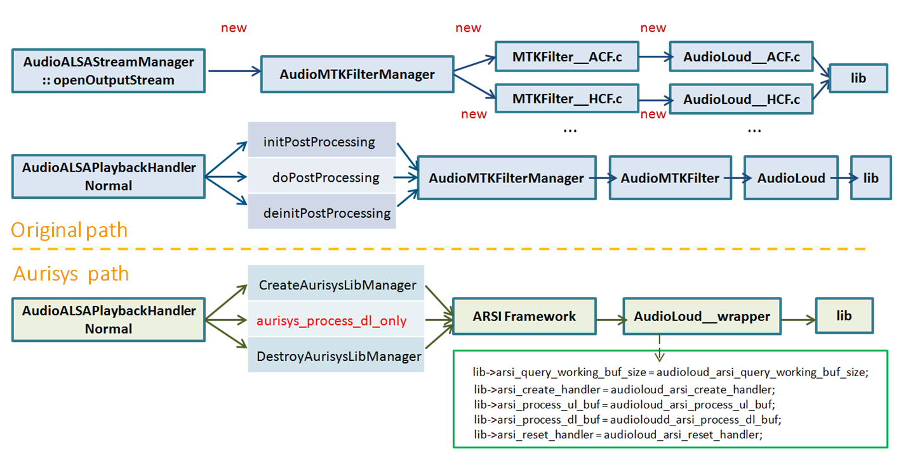 Figure 5-8.comparing the processing path

DSP offload playback
AP project config -- MTK_AUDIO_TUNNELING_SUPPORT
AP kernel config -- CFG_MTK_AUDIO_TUNNELING_SUPPORT
DSP -- CFG_MTK_AUDIO_TUNNELING_SUPPORT
audio_policy_configuration.xml –
<mixPort name="compress_offload" role="source" flags="AUDIO_OUTPUT_FLAG_COMPRESS_OFFLOAD|AUDIO_OUTPUT_FLAG_NON_BLOCKING">
<profile name="" format="AUDIO_FORMAT_MP3"
samplingRates="8000,11025,16000,22050,32000,44100,48000"
channelMasks="AUDIO_CHANNEL_OUT_STEREO"/>
</mixPort>
<route type="mix" sink="Wired Headset"
sources="primary output,fast,FM Tuner In,compress_offload"/>
<route type="mix" sink="Wired Headphones"
sources="primary output,fast,FM Tuner In,compress_offload"/>
<route type="mix" sink="Analog Dock Headset"
sources="primary output,compress_offload"/>
<route type="mix" sink="Digital Dock Headset"
sources="primary output,compress_offload"/>
audio_policy.conf (below android N version) --
compress_offload {
sampling_rates 8000|11025|16000|22050|32000|44100|48000
channel_masks AUDIO_CHANNEL_OUT_STEREO
formats AUDIO_FORMAT_MP3
devices AUDIO_DEVICE_OUT_WIRED_HEADSET|AUDIO_DEVICE_OUT_WIRED_HEADPHONE|AUDIO_DEVICE_OUT_ANLG_DOCK_HEADSET|AUDIO_DEVICE_OUT_DGTL_DOCK_HEADSET
flags AUDIO_OUTPUT_FLAG_COMPRESS_OFFLOAD|AUDIO_OUTPUT_FLAG_NON_BLOCKING
}

File Structure
Path | File | Description
Framework layer
frameworks\av\include\media | AudioParameter.h | Declare parameter keys for Offload
frameworks\av\media\libmedia | AudioParameter.cpp | We can’t attach effect on offload stream , handle effect enable flow.
frameworks\av\media\libmedia | AudioTrack.cpp
frameworks\av\media\libmedia | AudioTrackShared.cpp
frameworks\av\include\private\media | AudioTrackShared.h
frameworks\av\services\audioflinger | Threads.cpp
frameworks\av\services\audioflinger | Threads.h
frameworks\av\services\audioflinger | Track.cpp
frameworks\av\services\audiopolicy\managerdefault | AudioPolicyManager.cpp
frameworks\av\media\libmediaplayerservice\nuplayer | NuPlayerRenderer.cpp | Offload retry mechanism
frameworks\av\media\libmediaplayerservice\nuplayer | NuPlayer.cpp | Offload retry mechanism
Kernel & Hal
Kernel-4.4\sound\soc\mediatek\common_int | mtk-auddrv-offloadcommon.h | Offload kernel code
Kernel-4.4\sound\soc\mediatek\common_int | mt_soc_offload_common.c | Offload kernel code
kernel-4.4\drivers\misc\mediatek\audio_ipi\common\framework | audio_ipi_driver.c | The communication driver between AP and SCP.
kernel-4.4\drivers\misc\mediatek\audio_ipi\common\framework | audio_messenger_ipi.c | The communication driver between AP and SCP.
kernel-4.4\drivers\misc\mediatek\audio_ipi\common\framework | audio_ipi_queue.c | The communication driver between AP and SCP.
kernel-4.4\drivers\misc\mediatek\audio_ipi\common\framework | audio_task_manager.c | The communication driver between AP and SCP.
kernel-4.4\drivers\misc\mediatek\audio_ipi\common\framework | audio_ipi_message.c | The communication driver between AP and SCP.
kernel-4.4\drivers\misc\mediatek\scp\v02 | scp_ipi.c | The communication driver between AP and SCP.
vendor\mediatek\proprietary\hardware\audio\common\V3\aud_drv | AudioALSAPlaybackHandlerOffload.cpp | Offload driver main program
vendor\mediatek\proprietary\hardware\audio\common\V3\aud_drv | AudioALSAHardware.cpp
vendor\mediatek\proprietary\hardware\audio\common\V3\include | AudioALSAPlaybackHandlerOffload.h
vendor\mediatek\proprietary\hardware\audio\mt6799\aud_drv | AudioALSAStreamOut.cpp
vendor\mediatek\proprietary\hardware\audio\mt6799\aud_drv | AudioALSAStreamManager.cpp | Where create AudioALSAPlaybackHandlerOffload class
DSP
project/CM4_B/mt6799/platform | platform.mk | Project configurations (common)
project/CM4_B/mt6799/[project] | ProjectConfig.mk | Project configurations (specific project)
project/CM4_B/mt6799/[project] | CompilerOption.mk | Project specific compile options
middleware/lib/aurisys/ interface | arsi_api.h | Aurisys Software Interface
middleware/lib/aurisys/ interface | arsi_api_version.h | Aurisys Software Interface
middleware/lib/aurisys/ interface | arsi_call_type.h | Aurisys Software Interface
middleware/lib/aurisys/ interface | arsi_library_entry_points.h | Aurisys Software Interface
middleware/lib/aurisys/ interface | arsi_type.h | Aurisys Software Interface
middleware/lib/aurisys/ interface | audio_task.h | Aurisys Software Interface
middleware/lib/aurisys/ interface | wrapped_audio.h | Aurisys Software Interface
middleware/lib/aurisys/ interface | wrapped_errors.h | Aurisys Software Interface
middleware/lib/ | audio_utility/ | Audio utility API
middleware/lib/ | m3offload/ | Mp3 library
middleware/lib/ | Blisrc/ | SRC library
drivers/common/audio/task/ | audio_task_interface.h | Define audio task structure and status
drivers/common/audio/task/ | mp3/audio_task_offload_mp3.c | MP3 DSP main program
drivers/common/audio/task/ | mp3/audio_task_offload_mp3_params.h | MP3 DSP main program
drivers/common/audio/task/ | mp3/audio_task_offload_mp3.h | MP3 DSP main program
drivers/common/audio/hardware | audio_irq.h | Header file of audio_irq.c
drivers/common/audio/hardware | audio_hw.h | Header file of Audio hw operating functions
drivers/common/audio/framework | audio_task_factory.c | Audio task service
drivers/common/audio/framework | audio_messenger_ipi.c | Interrupt handler to handle message from AP
drivers/common/audio/framework | audio.c | Audio init/de-init entry functions
drivers/CM4_B/mt6799/audio/ tasks | mp3/ audio_dma_mp3.c | Audio mp3 dma platform driver
drivers/CM4_B/mt6799/audio/ hardware | audio_irq.c | Register irq handler and request irq
drivers/CM4_B/mt6799/audio/ hardware | audio_hw.c | Audio hw operating functions
drivers/CM4_B/mt6799/audio/ hardware | audio_hw_reg.h | Define platform related audio hw register

Behavior
In MT6799, We didn’t implement offloadable playback effects on DSP by default. If the playback effect is enabled, the playback will be switched to a normal stream playback. Users can implement the playback effect in DSP by themselves currently. The default package with playback effect supported in DSP will be released later.

Functional Blocks

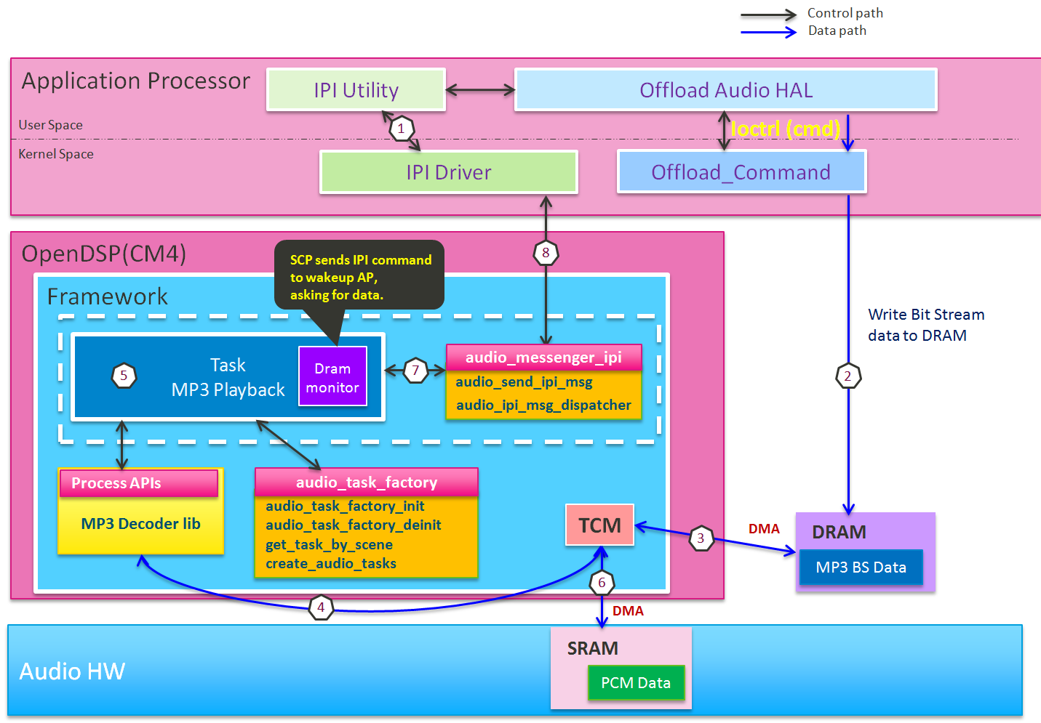

Figure 5-9. Functional Blocks of Offload Playback
- The communications between the application processor and DSP is by the IPI driver.
- The parsed MP3 bistream is reserved in DRAM. The application processor can enter sleep mode if there is sufficient MP3 bistream stored in DRAM.
- DSP will move the MP3 bitstream to its internal memory by DMA
- The mp3 bistream will be decoded by the decoder
- The decoder is executed in the Task MP3
- The output PCM data will be transferred to the audio hardware by DMA
- We need to monitor the data amount of mp3 bistream buffer
- Once the amount of mp3 bitstream is not enough for decoding, we’ll interrupt the application processor by IPI message to fill the bitstream buffer

Sound Trigger
To be released later

SmartPA
To be released later

Record & VOIP
Currently, we only support recording enhancement in the application processor. This is because the power savings in DSP won’t be significant unless the encoder and storage driver are also implemented in DSP. However, we don’t have enough memory to support encoder. Besides, the computing power is not sufficient for recording features.
As the recording case, we only support VOIP in the application processor. The power savings in DSP won’t be significant since the codec is still implemented in application processor and DDR can’t be turned off during VOIP. The computing power and memory are not sufficient for us to implement all audio scenes to the DSP.

Data Path
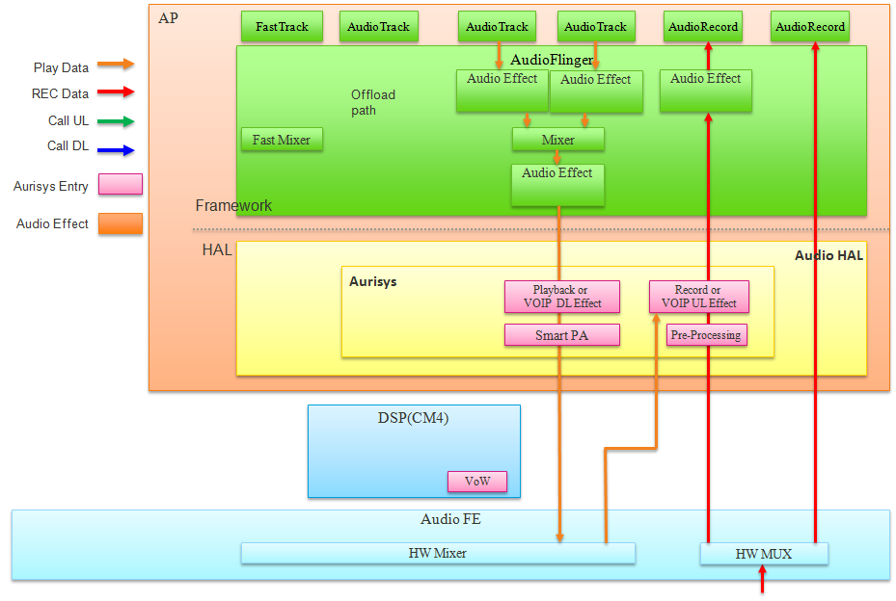
(4)
(5)
(1)
(2)
(3)
Figure 6-7. Record & VOIP
- The record(uplink) stream which contains sound data from microphones.
- We also support direct input without any processing.
- Before processing the uplink data with the recording or VOIP UL library. We provide an IIR filter ahead to do DC removal and reduce possible hardware defects. It can be bypassed by XML config if you don’t need it.
- The downlink stream which is processed with a playback or VOIP DL library.
- The DL output data will be looped back as the downlink reference stream and provided to the record or VOIP UL library.

Configurations
MTK_AURISYS_FRAMEWORK_SUPPORT
This project configuration should be set as “yes” if you want to support recording and VOIP effect in Aurisys framework. If this configuration is set as “no”, we still support MTK inside record and VOIP effect. However, we don’t support the XML descriptor mentioned above. If you want to replace the MTK library with vendor’s library, it’s suggested to set this configuration as “yes”. We can also support MTK library in Aurisys framework in the future and set this option as true by default.

Application Processor Only
Due to the lack of DSP resources (computing power and internal memory size). The recording and VOIP libraries are only allowed to be processed in the application processor.

Class Diagram
The class diagram of Aurisys record and VOIP framework is depicted as follows. It provides a reference to the actual code.
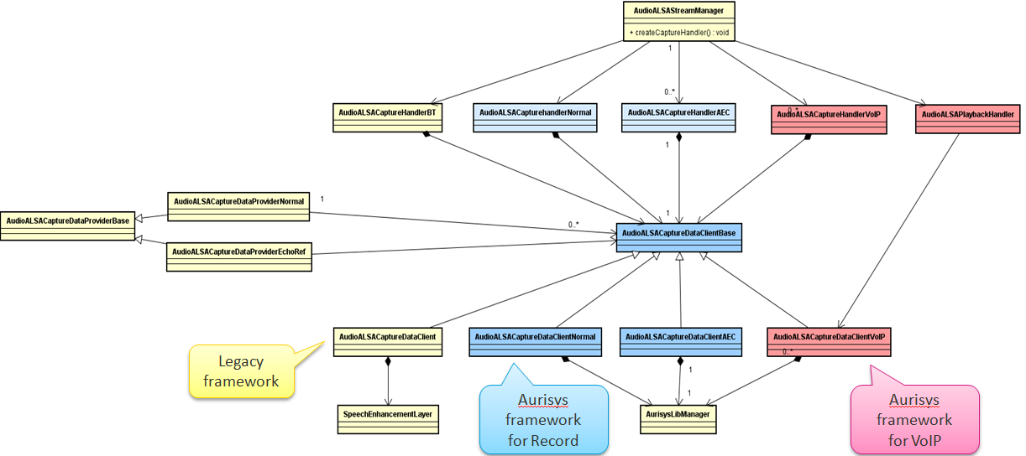
Figure 6-8. Aurisys Class Diagram for Record & VOIP

Device Information
It may be confused with the relationship between the input/output device and arguments sent to the library. We provide a comparison table in the following as a reference to implement library.

VOIP
task_scene = TASK_SCENE_VOIP
Device | Device Detail | Arguments
Handset | w/ dual-mic NR | - input_device_info = AUDIO_DEVICE_IN_BUILTIN_MIC  - output_device_info = AUDIO_DEVICE_OUT_EARPIECE  - VIR_VOIP_NORMAL_DMNR_SUPPORT enabled
Handset | w/o dual-mic NR | - input_device_info = AUDIO_DEVICE_IN_BUILTIN_MIC  - output_device_info = AUDIO_DEVICE_OUT_EARPIECE  - VIR_VOIP_NORMAL_DMNR_SUPPORT disabled
Headset | 3 pole headset | - input_device_info.devices = AUDIO_DEVICE_IN_BUILTIN_MIC  - output_device_info.devices = AUDIO_DEVICE_OUT_WIRED_HEADPHONE
Headset | 4 pole headset | - input_device_info.devices = AUDIO_DEVICE_IN_WIRED_HEADSET  - output_device_info.devices = AUDIO_DEVICE_OUT_WIRED_HEADSET  - input_device_info.num_channels = 1
Headset | 5 pole headset | - input_device_info.devices = AUDIO_DEVICE_IN_WIRED_HEADSET  - output_device_info.devices = AUDIO_DEVICE_OUT_WIRED_HEADSET  - input_device_info.num_channels = 2  - 5_POLE_HS_SUPPORT enabled  - MTK_HEADSET_ACTIVE_NOISE_CANCELLATION_SUPPORT disabled
Headset | 5 pole + ANC | - input_device_info.devices = AUDIO_DEVICE_IN_WIRED_HEADSET  - output_device_info.devices = AUDIO_DEVICE_OUT_WIRED_HEADSET  - input_device_info.num_channels = 2  - MTK_HEADSET_ACTIVE_NOISE_CANCELLATION_SUPPORT enabled
Hand-Free | w/ NR | - output_device_info = AUDIO_DEVICE_OUT_SPEAKER  - VIR_VOIP_HANDSFREE_DMNR_SUPPORT enabled
Hand-Free | w/o NR | - output_device_info = AUDIO_DEVICE_OUT_SPEAKER  - VIR_VOIP_HANDSFREE_DMNR_SUPPORT disabled
BT earphone | BT earphone | - input_device_info = AUDIO_DEVICE_IN_BLUETOOTH_SCO_HEADSET

Record
task_scene = TASK_SCENE_RECORD
The information of input device used in recording is the same with what used in VOIP. However, the library may need to be aware of which application is processed and apply different effect according to the application. The following table lists the arguments provided to the library in each application.
Application | Input Source | Notes
Sound Recording | input_source = AUDIO_SOURCE_MIC | Modes: Normal / Lecture / Meeting  (Reserve2 = 0, 1, 2 respectively)
Camera Recording | input_source = AUDIO_SOURCE_MIC | Modes: Normal / Meeting  (Reserve2 = 3, 4 respectively)
Customization1 | input_source = AUDIO_SOURCE_MIC_AEC | MagiASR need AEC (VR + AEC)
Voice Recognition & CTS | input_source = AUDIO_SOURCE_VOICE_RECOGNITION
Voice Unlock | input_source = AUDIO_SOURCE_VOICE_UNLOCK
Customization2 | input_source = AUDIO_SOURCE_VOICE_RECOGNITION_AEC | Normal record + AEC
Fast Record | According current application | frame_size_ms = 5 ms

Appendix: Platform and Development Environments

Scenario Based DVFS

Figure 7-1. MT6799 DSP Dynamic Voltage Table
We have three DSP clock rate in MT6799, if your application can be run at 82MHz, there is a large power savings for the whole system. We don’t have automatic DVFS to detect current DSP loading and adjust the voltage automatically. What we do is to register a frequency requirement table for a specified application. When the application starts, a provided API should be called to notify the system. Besides, it also needs to call another API to notify the system when it is stopped. The system will adjust the voltage according to the sum of clock rate requirement for active applications.
Since the enable and disable of a function is triggered from the application processor, the judgement of what clock rate is more suitable for current scenario is done by the application processor.

Implementation
- Registration
kernel-4.4/drivers/misc/mediatek/scp/[project]/ scp_feature_define.h
kernel-4.4/drivers/misc/mediatek/scp/[project]/scp_feature_table.c
typedef enum {
VOW_FEATURE_ID= 0,
OPEN_DSP_FEATURE_ID,
SENS_FEATURE_ID,
MP3_FEATURE_ID,
FLP_FEATURE_ID,
RTOS_FEATURE_ID,
NUM_FEATURE_ID,
} feature_id_t;

static scp_feature_table_t feature_table[] = {
{
.feature = VOW_FEATURE_ID,
.freq = 75,
.core = SCP_B_ID,
.enable = 0,
},
{
.feature = OPEN_DSP_FEATURE_ID,
.freq = 356,
.core = SCP_B_ID,
.enable = 0,
},
{
.feature = SENS_FEATURE_ID,
.freq = 84,
.core = SCP_A_ID,
.enable = 0,
},
…….
…….
};

First, the feature ID should be added to the feature id table. Then the clock rate requirement of the specified application should also be provided.

- Function Prototype
void register_feature(feature_id_t id);
void deregister_feature(feature_id_t id);
When an application is enabled to run, it must call resiger_feature function first to notify the system. The clock rate of the application will be added to the current total clock rate requirement. The system will then adjust the frequency of CPU. When the application is disabled, the deregister_feature should be called so that the system won’t consume unnecessary power.

Dynamic Objects Loading
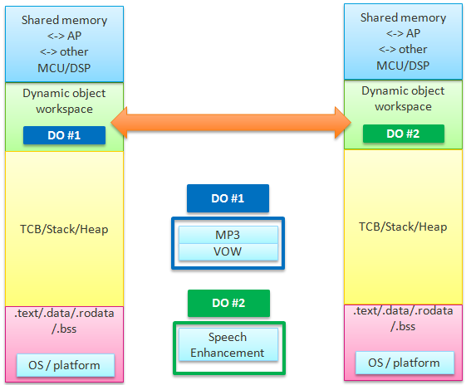
Figure 7-2. MT6799 DSP Dynamic Loading Concept
We support 3 audio features (MP3 decoder, voice wake up, and phone call speech enhancement) by default in MT6799. However, the total size required by the features has exceeded the memory size of the DSP. So we apply a dynamic download mechanism. The dynamic download is possible only when the features happen in different scenes. It is not allowed to do dynamic download frequently since the downloading requires more than 100ms. The MP3 decoder and voice wake up are grouped into a DO(dynamic objects) due to they are allowed to be executed simultaneously in the defined behavior. Besides, the total memory size of MP3 and VOW is allowed to be downloaded at the same time. In implementation, the speech enhancement is downloaded when a phone call happens. The MP3 decoder and voice wake up are downloaded when the call ends.
Since the define and arrangement of DOs is complicated. We suggest calling for ACS’s help if there is requirement of dynamic object loading.

DSP Binary (Build Command and Download)

Configuration
There is an automatic compile dependency check between “PROJECT_CONFIG” of AP and “CFG_PROJECT_CONFIG” of DSP. They should be the same value. If there is a global configuration named “FOO”, and there is a dsp configuration named “CFG_FOO”, only the following three conditions are allowed.
tinysys_config.h entry | Global ProjectConfig.mk
#define CFG_FOO | FOO = yes
/* CFG_FOO is not set */ | FOO = no
#define CFG_FOO VAL | FOO = VAL

Build Command
    - Environment Initialzation
      - $ . build/envsetup.sh…………………………………required only once
      - $ lunch full_<PROJECT>-eng………………………re-run this command to switch to other projects.
    - Full Android Build
      - $ mosesq make -j24
    - Module Build for DSP
      - $ mosesq make tinysys-scp -j24
    - Fast Module Build for DSP
      - $ vendor/mediatek/proprietary/tinysys/freertos/source/tools/build_ts.sh

Built Binary
    - Built DSP Binary Location
      - out\target\product\[project]\obj\TINYSYS_OBJ\tinysys-scp_intermediates\freertos\source\CM4_B\tinysys-scp-CM4_B.bin
      - Check the modified time of the binary if you wanna make sure the binary is updated
    - Update DSP binary by Fastboot
      - $ adb reboot bootloader ………………….. Put the device in fastboot mode
      - $ flashboot.exe scp1 tinysys-scp.bin ………………..Update scp1 from local tinysys-scp.bin
      - $ flashboot.exe scp2 tinysys-scp.bin ……………… Update scp2 from local tinysys-scp.bin
    - Update DSP binary by MTK Flashtool
      - Flashtool can be used to download Android full load or update DSP binaries only. The following figure shows how to update DSP binaries only.

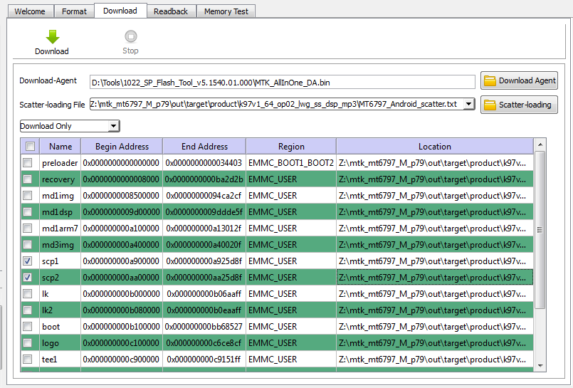
Figure 7-3. Update DSP Binary by Flashtool

Code Release
- Get Full Codebase
  - 1. Contact PM and sign an agreement
  - 2. Get a FEX account (contact with the PM)
  - 3. Request the code release
- Special Modem Image Request
  - In MT6797, if you want to use the vendor’s voice call speech enhancement, we need to disable the MTK’s speech enhancement in the Modem Image. Since the modem image is binary released. The customers need to request a modem image with the compile option: “OPEN_DSP_SPEECH_SUPPORT” first. In MT6799, the modem image can support both 3rd party’s speech enhancement in the open dsp and MTK’s speech enhancement in modem side without changing the modem image.

Aurisys Framework Class Diagram
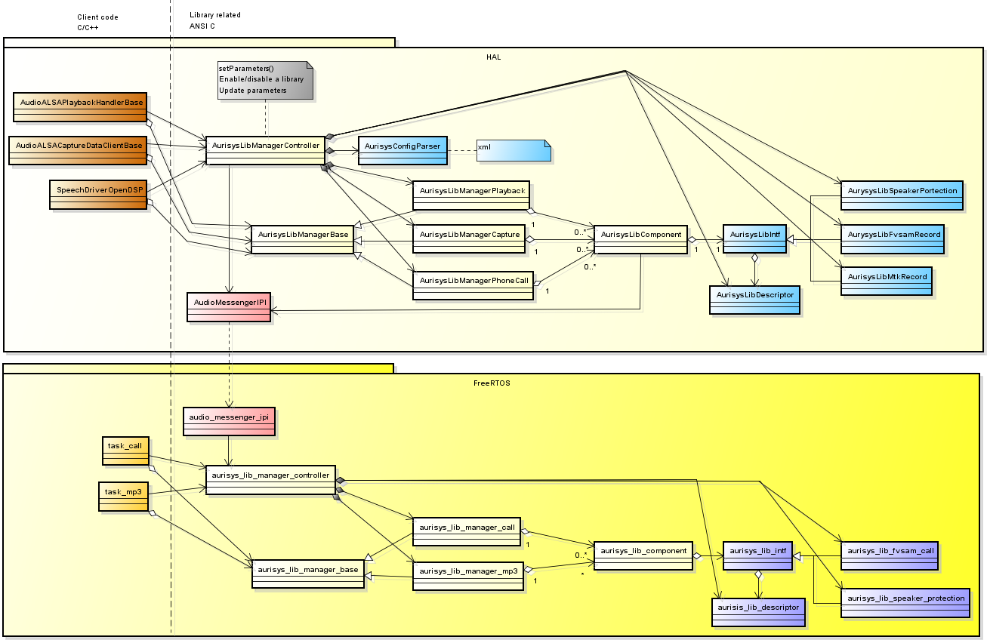
Figure 7-4. Aurisys Framework Class Diagram

Software Patch Note
The following table lists the issues and possible impacts. Please make sure you’ve applied the following patches.
Feature | ID | Description

FAQ
- SCP
  - Abbreviation of System Control Processor. It is because there is some system control tasks are run in this DSP.
- TinySys
  - Our DSP system and peripherals.

