IDE Setup Guide
—with GNU ARM Eclipse

Version: 1.0
Release date: 2015-12-28

Specifications are subject to change without notice.

MediaTek Confidential A

Document Revision History
Revision | Date | Author | Description
0.1 | yyyy-mm-dd | Full Name | Initial draft
0.2 | 2015-10-28 | Hsin-Yi Chang | Add Cycle count debug
0.3 | 2015-12-29 | Hsin-Yi Chang | Revise the API name, and code flow pic
MediaTek Confidential A

Table of Contents
Document Revision History 2
Table of Contents 3
1 About GNU ARM Eclipse 5
2 Install Steps 7
2.1 Download Eclipse CDT 7
2.2 Install Eclipse plug-ins 8
2.3 Install build toolchain(s) 10
2.4 Install the optional build tools (make & rm) for Windows 10
2.5 Install the debugging tools 11
3 New Project 12
3.1 Import Example project 12
3.2 Eclipse Tools Environmental Settings 14
3.3 Project Build Flag Settings 18
4 Build and Run on Target 20
4.1 Setup Target Board 20
4.2 Build Project 21
4.3 Debug on the Target 22
5 Example code 23
5.1 Structure and flow 23
5.2 Code Configurations 26

Lists of Tables and Figures

Figure 1.1. create a c++ project with ARM toolchain. 6
Figure 2.1. Version info in Help→Installation Details. 7
Figure 2.2. Add Repository. 8
Figure 2.3. Select required packages. 9
Figure 2.4. Select required packages. 10
Figure 2.5. Build Tools install view. 11
Figure 3.1. Import existing project. 12
Figure 3.2. Select the project and copy into the workspace. 13
Figure 3.3. Set Global Tools Path for Build Tools and Toolchain. 14
Figure 3.4. Set OpenOCD path. 15
Figure 3.5. Setup GDB openOCD Debug project file. 16
Figure 3.6. Setup GDB OpenOCD Debug project file. 17
Figure 3.7. The processor configuration menu. 18
Figure 3.8. Set Compile flag. 19
Figure 3.9. Linker flag options. 19
Figure 4.1. Board spec comparison. 20
Figure 4.2. Build project. 21
Figure 4.3. The binary files will build in the workspace/project/Debug folder. 21
Figure 4.4. Click Debug icon and select the debug name. 22
Figure 4.5. Click Debug icon and select the debug name. 22
Figure 5.1. Folder structure of our example project (compiled). 24
Figure 5.2. Example code flow. 25

About GNU ARM Eclipse
GNU ARM Eclipse plug-ins provide Eclipse CDT (C/C++ Development Tooling) extensions for
GNU ARM toolchains like GNU Tools for ARM Embedded Processors, Linaro, Mentor Sourcery CodeBench Lite, etc.

With the help of this plug-ins, we can create, build, debug and in general to manage ARM and AArch64 projects (executables and static/shared libraries, in both 32 and 64-bit versions) with the Eclipse framework. The plug-ins run on Windows, GNU/Linux and Mac OS X. In this document, we setup the IDE in Windows XP/7.

The reasons to choose GNU ARM Eclipse as our developing IDE are:
- The plug-ins provides a free ARM developing environment based on EPL (Eclipse Public License).
- The providing functionalities are sufficient for our developing requirement.
- The official website works actively and updates frequently.

Below lists the features supported in GNU ARM Eclipse:

- Features
- simplify project management (no need to create makefiles)
- support major ARM32/64 toolchains (GNU Tools for ARM Embedded, Linaro, Sourcery Lite)
- runs on Windows, GNU/Linux, Mac OS X
- peripheral registers view in debug
- ready to run STM32Fx project templates
- ready to run Kinetis KLxx project templates
- create Freescale Processor Expert projects
- full integration for J-Link JTAG/SWD probe
- SWO trace console for J-Link
- full integration for OpenOCD
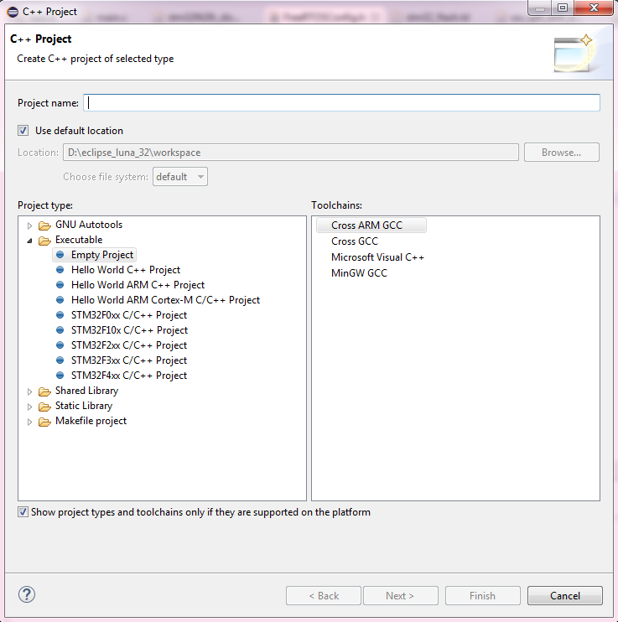
Figure 1.1. create a c++ project with ARM toolchain.

Install Steps
To setup IDE, we arrange the install steps as below.

Download Eclipse CDT
  - Need to Download Eclipse CDT First : Here
  - Current Latest Version: Luna Service Release 2 (4.4.2)
  - Windows 32bit version can work normally both in XP / Win7 (64bit version ok)

- Eclipse & CDT
The oldest Eclipse supported by the plug-ins is Eclipse 4.3 Kepler (CDT 8.3), and the recommended version is 4.4 SR2. Do not try to install them on Juno, Indigo, or older versions, since the install will fail.

- Compatibility issues
Please note that Eclipse plug-ins starting with 1.1.x, compatibility with Eclipses previous than 4.3 Kepler was no longer possible. If, for any reasons, you need a solution for older Eclipse versions, you can try the GNU ARM Eclipse Plug-in version 0.5.5, but please keep in mind that this old version is no longer maintained.

Here shows the version information used in our current project, the combination works normally.
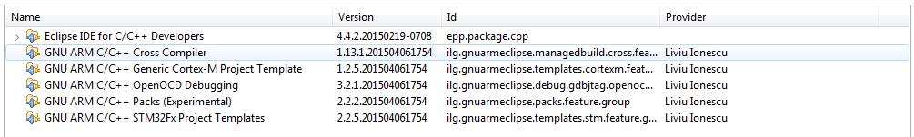
Figure 2.1. Version info in Help→Installation Details.

Install Eclipse plug-ins
  - The detail step in official site tutorial : Here

Step1. Go to eclipse IDE navigation bar, Help → Install New Software
Step2. At Work with option, select Add and type the Name /Location (see Figure 2-2)

Name: | GNU ARM Eclipse Plug-ins
Location: | http://gnuarmeclipse.sourceforge.net/updates

Step3. Press OK

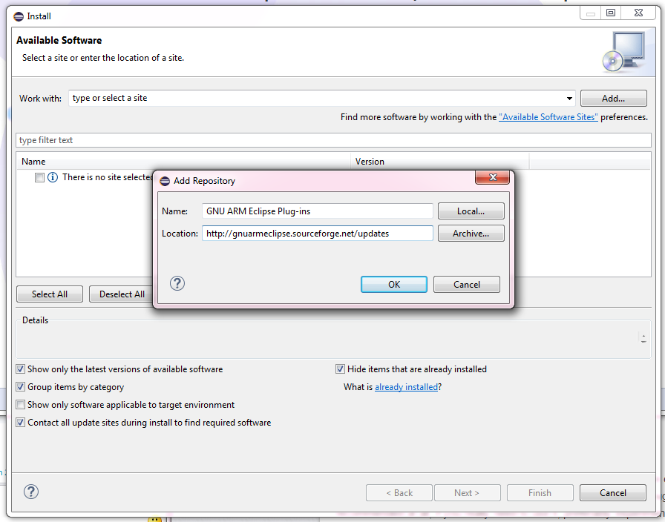
Figure 2.2. Add Repository.

Step4. You will get GNU ARM C/C++ Cross Development Tools, selecting need components.

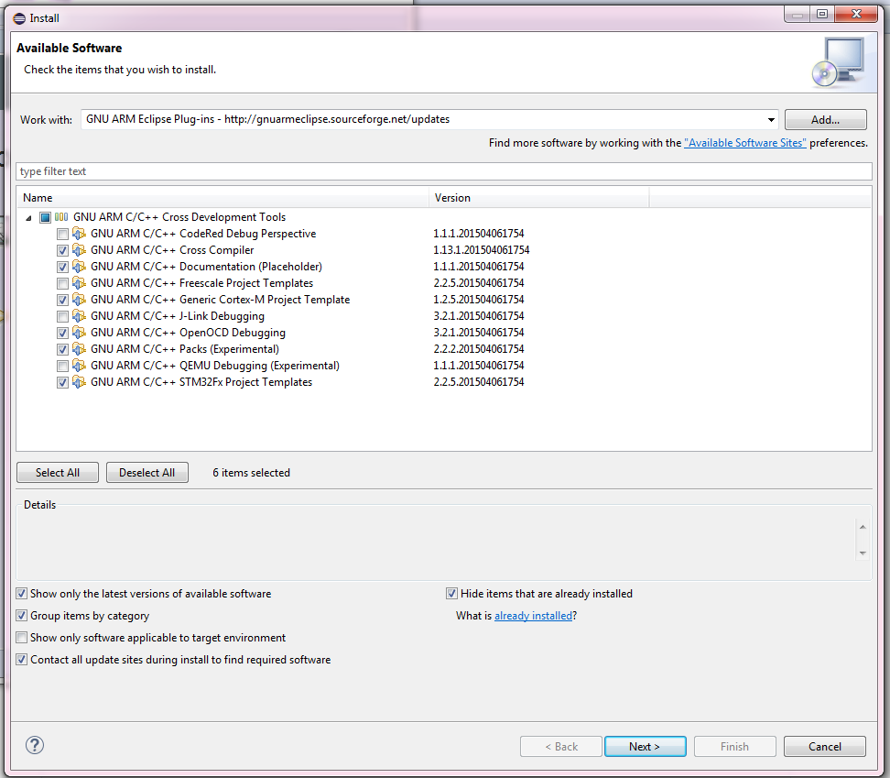
Figure 2.3. Select required packages.
(Here we select Cross Compiler/ Documentation/ Cortex-M project templates/
OpenOCD Debugging/ Packs/ STM32Fx project Templates)

Step5. After installing plug-ins, you can check About Eclipse to find ARM plug-in icon.

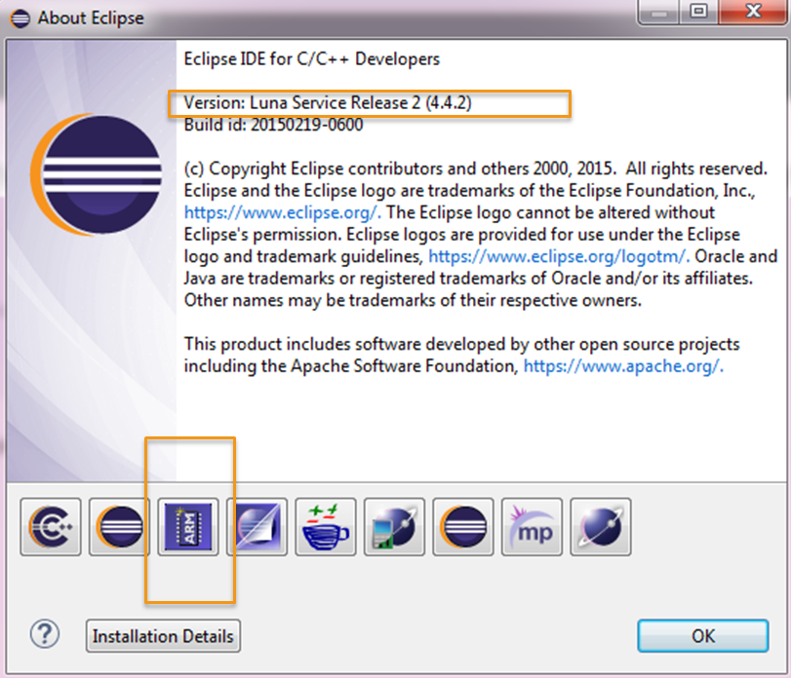
Figure 2.4. Select required packages.

Install build toolchain(s)
  - The detail step in official site tutorial : Here
  - Toolchain version: gcc-arm-none-eabi-4_8-2014q3-20140805-win32
  - Can be download : Here

Install the optional build tools (make & rm) for Windows
  - If your development platform is Windows, you need to install two additional command line programs, make and rm, required by the Eclipse external builder.
  - The detail step in official site tutorial : Here
  - Download Build Tool: Here
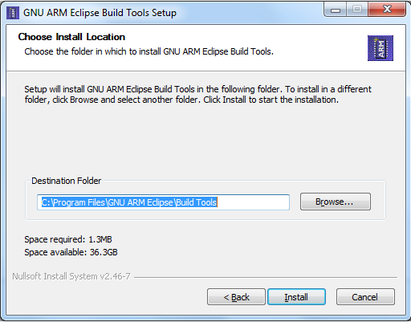
Figure 2.5. Build Tools install view.

Install the debugging tools
  - The detail step in official site tutorial : Here
  - Download OpenOCD : Here

New Project
After installing all the tools needed in IDE, we can start to build up the project.

Import Example project
To reduce the integrating and developing time, we provide the example project which is based on STMicroelectronics STM32F401RE / STM32F429DISCO development board. In the example project, the compile, link flags, and related board settings have set done. Users only need to modify the tool paths to their install folder.

File → Import → Select root directory → select template (FreeRTOS_Test)
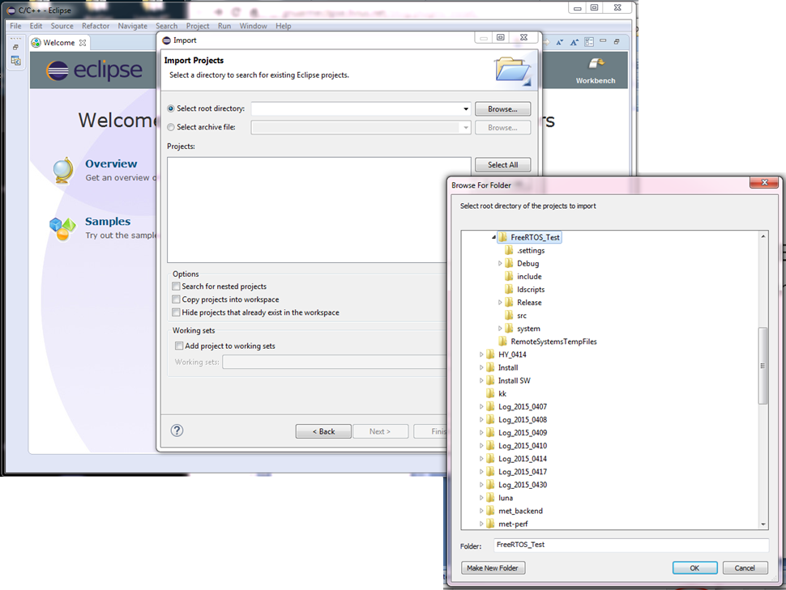
Figure 3.1. Import existing project.

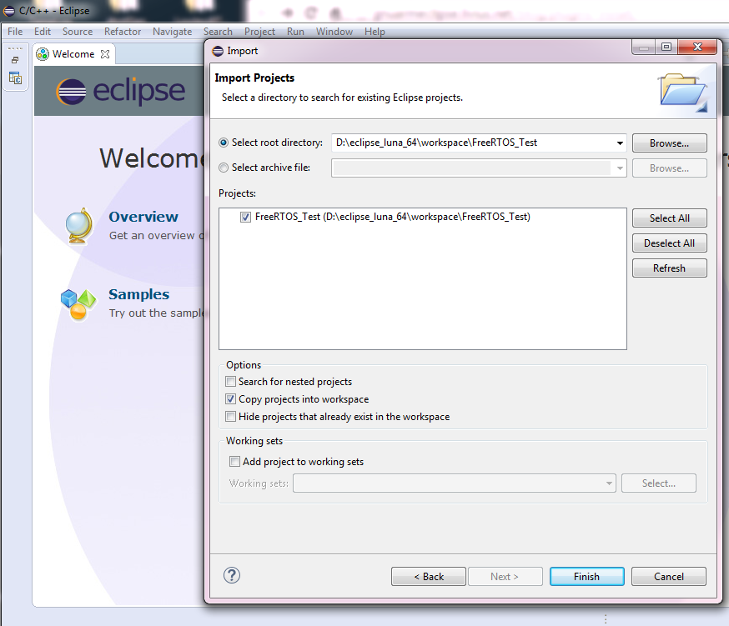
Figure 3.2. Select the project and copy into the workspace.
The selection of “Copy projects into workspace” is optional, but it makes project management more centralize to a specific workspace folder.

Eclipse Tools Environmental Settings

  - Build Tools (make & rm) and Toolchain path

Once installed the GNU ARM Eclipse plug-ins, users will find the Global Tools Paths Configuration page in Window → Preferences → Build. Here we fill up the correct tool installing path.

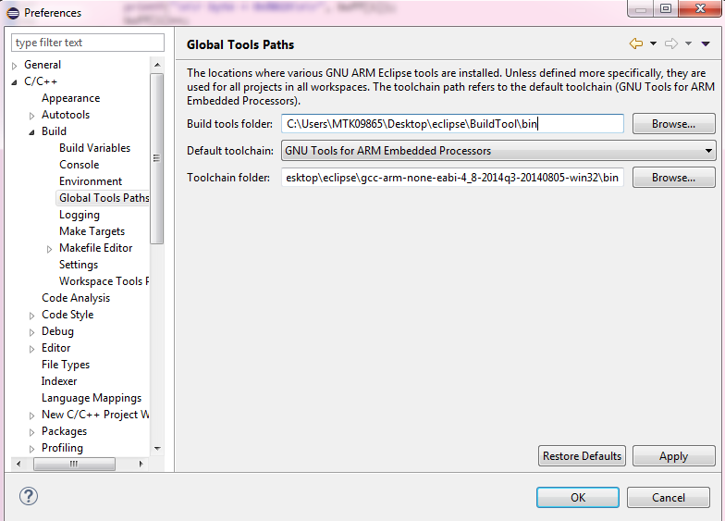
Figure 3.3. Set Global Tools Path for Build Tools and Toolchain.

Users can also set the configuration for specific project. Right click on the project and select Properties → C/C++ Build → Tools Paths.

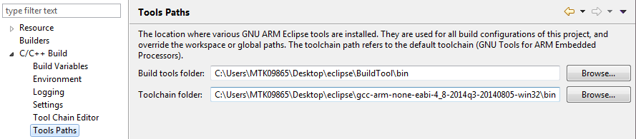

  - OpenOCD path

Window → Preferences → Run/Debug. Here we fill up the OpenOCD install path.
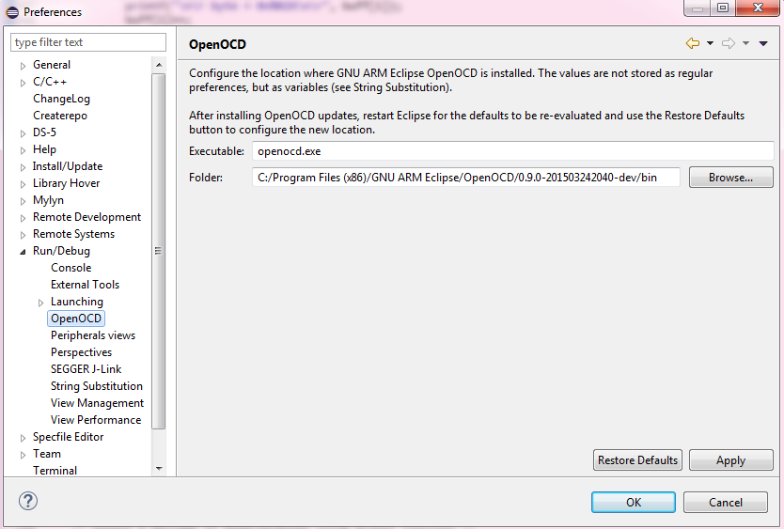
Figure 3.4. Set OpenOCD path.

  - Debug Settings

Here we use GDB OpenOCD as the debugging method. To setup the debugger, users can click on the arrow besides debug icon and select Debug Configurations.

The first time to configure the GDB OpenOCD Debugging, we have to double click on this option, and a new debug page will show as below.

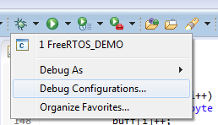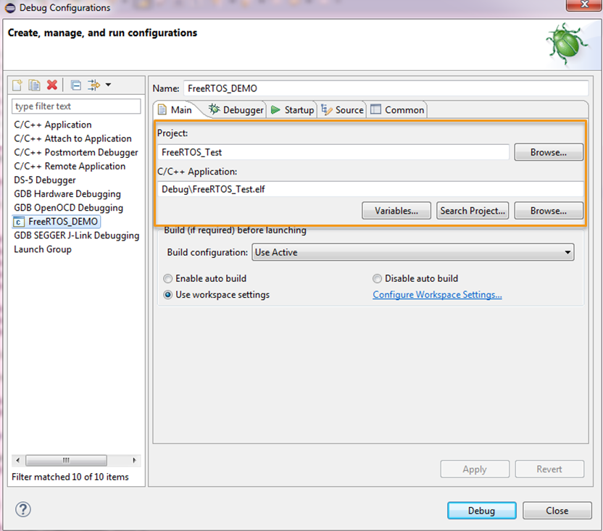
Figure 3.5. Setup GDB openOCD Debug project file.
At the Main Page, filling up the debugger name and which project file to be downloaded into the target board.

At the Debugger Page, select “Start OpenOCD locally” and set Config options which will change by different target boards (Corresponding board scripts can be found at OpenOCD\scripts\board).

Here we set for STM32F401RE as -f board/st_nucleo_f4.cfg
For STM32F429DISCO board, use -f board/stm32f429discovery.cfg

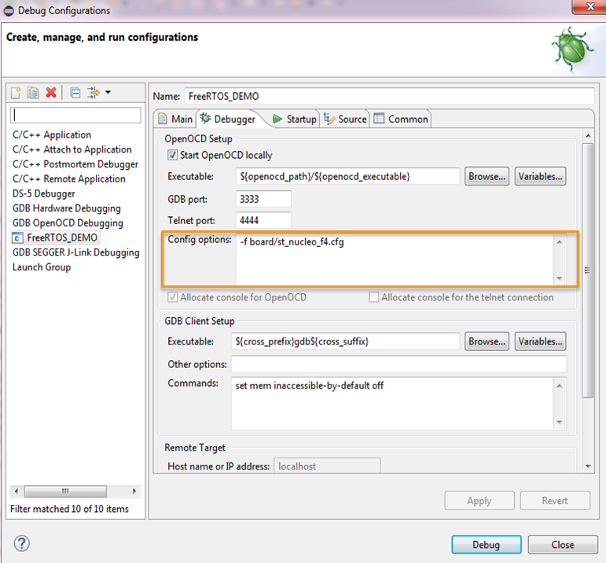
Figure 3.6. Setup GDB OpenOCD Debug project file.
After all the debug settings have done, click Apply to save the current configurations.

Project Build Flag Settings
In our example project, we have already set done the Tool Settings part.
Users don’t have to spend time on these processor/compile/linker settings only if they have extra setting requirement.

The project settings can be configured in the path list below.
Project Properties C/C++ Build Settings Tool Settings
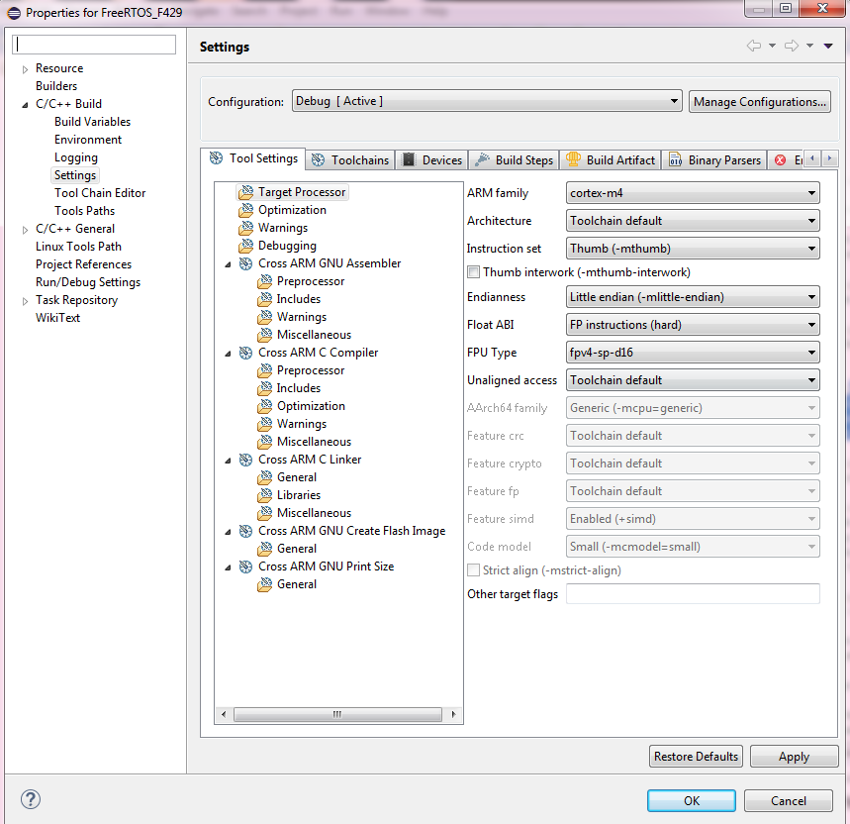
Figure 3.7. The processor configuration menu.

If you create C project, click on Cross ARM C Compiler Preprocessor, and press add icon to add Compile symbols here. Include files path can be indicated in Includes folder.

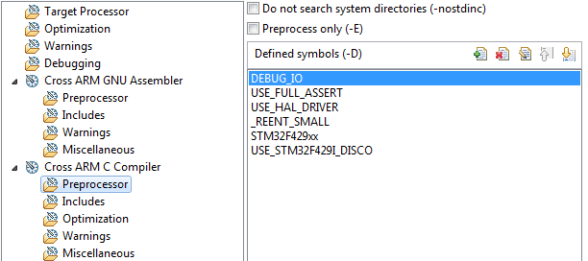
Figure 3.8. Set Compile flag.

Click on Cross ARM C Linker General to add Script files in ldscripts folder.
Cross ARM C Linker Miscellaneous to add other linker flags.

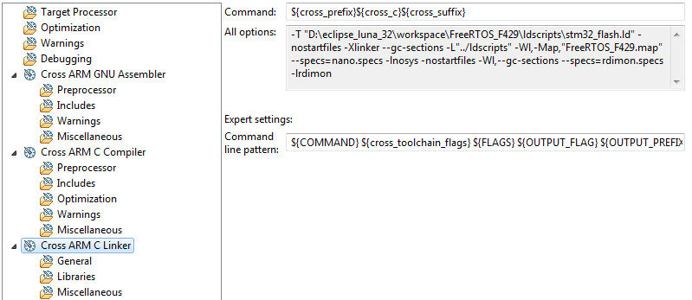
Figure 3.9. Linker flag options.

Build and Run on Target

Setup Target Board
We provide two popular evaluation boards:

STM32F401RE is with lower RAM and Flash size. If the application costs small memory size, this board is a good choice for development.

STM32F429-DISCO is the higher level board in STM32F4 series. Higher CPU rate with large RAM and Flash size, which is suitable for a completely application develop and verify.

The USB Driver can be downloaded from:

- STSW-LINK008 for Win vista & Win 7 & Win 8 : Here
- STSW-LINK009 for Win XP : Here

STM32F401RE | STM32F429-DISCO
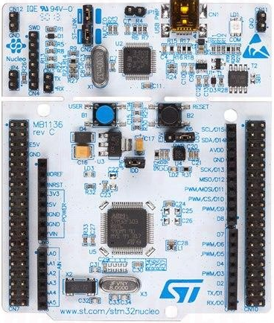 | 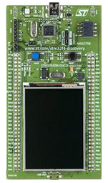
512K Flash | 2M Flash
96K RAM | 256K RAM
84Mhz | 180Mhz
None | 8M external SDRAM
~$15 USD | ~$24 USD

Figure 4.1. Board spec comparison.

Build Project
After set Toolchain and Build Tool path, now we can simply build the project by clicking on the hammer icon as the below figure shows.
If the building process is successfully, users will see the Finished Building words and the binary file’s name show on the build console.

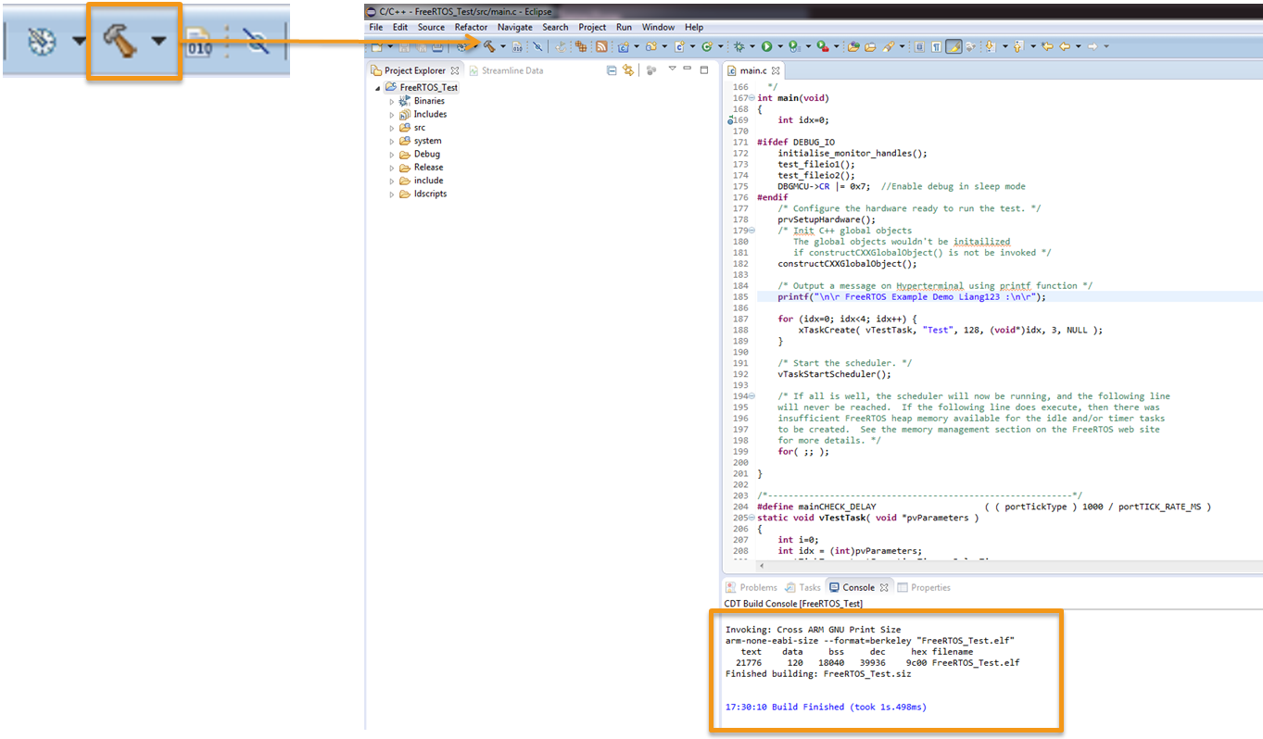
Figure 4.2. Build project.
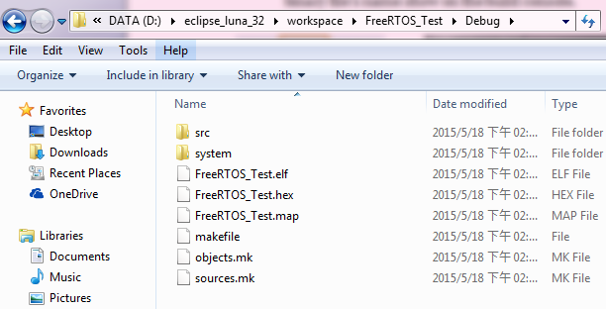
Figure 4.3. The binary files will build in the workspace/project/Debug folder.

Debug on the Target
Since we have set the debug configurations done in chapter 3.3, now we can run the program on Target board.

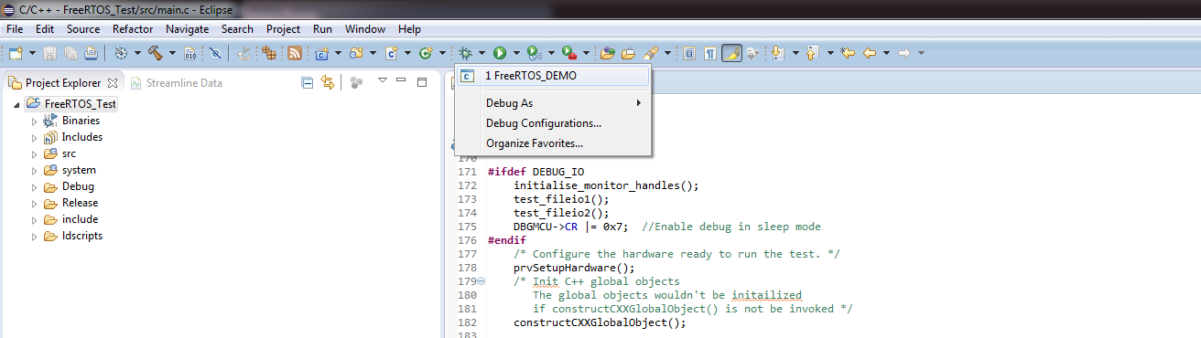

Figure 4.4. Click Debug icon and select the debug name.

Once in the Debug mode, it will switch to the debug view. Users can compare source code and disassembly by step-by-step debugging. With using semi-hosting retarget print, the program running result will show in the OpeOCD console view instead of Uart serial port.

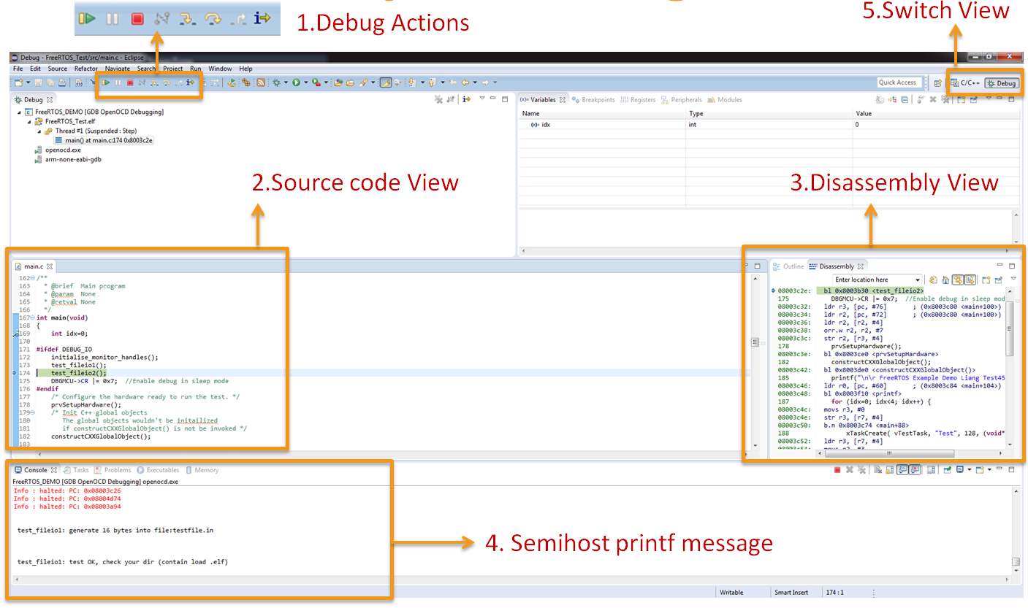
Figure 4.5. Click Debug icon and select the debug name.

Example code

Structure and flow
In this chapter, we explain the code flow of the provided example. The example code is based on FreeRTOS structure and runs on STM32F401RE/ STM32F429DISCO evb board. Users can develop their library and framework wrapper, and verify the integration correctness with our framework through the example.

After importing and building the project, you can see the folder structure as figure 5.1.
We highlight the mainly-used files here :

- Debug :
The files after building step will be generated in this folder, binary file as Project_name.elf.
- include:
arsi_api.h : Audio framework interface header file.
- src:
arsi_api.c : Audio framework interface source file.
3rd party can implement the content as the wrapper to operate with their library.
main.c : The main entry code for the example project.
- system:
freertos/cmsis/chip related code are put here.
- input/output pcm files
To verify the API implementation correctness and the process result, users can create their input file from a test PCM file, and store the result to an output PCM file. Both files are put under the project root folder.
To use read/write file function, please enable #define USE_FILE.
- ld script
The chip Memory setting file will put here.

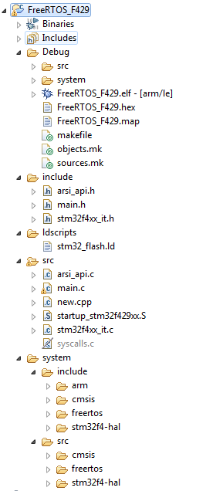
Figure 5.1. Folder structure of our example project (compiled).

The key API in main.c include:
  - init_task_config :
This function filled the basic information for the audio framework and the uplink/downlink stream.
  - arsi_query_working_buf_size
Query the size of the working buffer.
  - arsi_create_handler
Create handler and initialize it.
  - arsi_set_debug_log_fp
Since the library should not call the print function itself, we provide the log api for 3rd to use for debug .
  - arsi_process_ul_buf
Processing microphone/uplink data/aec data.
  - arsi_process_dl_buf
Processing playback/downlink data.
  - arsi_destroy_handler
De-initialize handler and destroy it.

In our main function, we create a task called vTestTask(). This function will simulate the processing method with our audio framework.

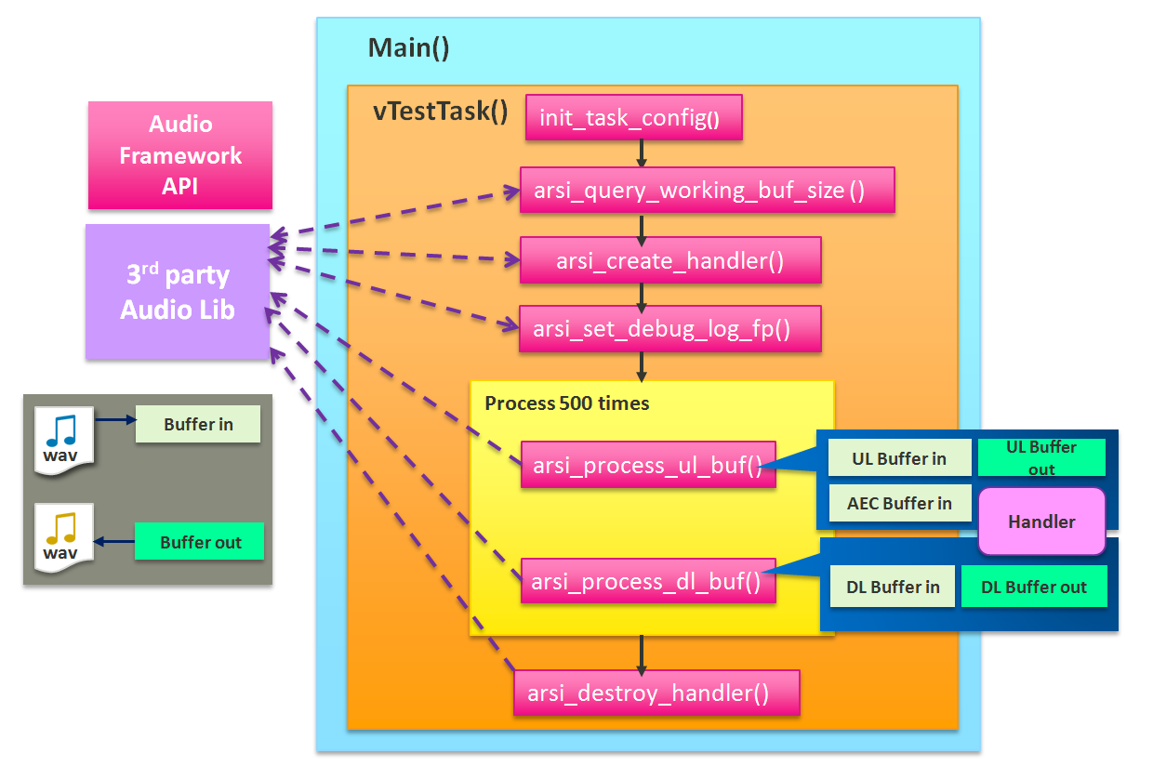
Figure 5.2. Example code flow.

As the Figure 5.2 shows, our audio framework will query 3rd party’s library, feeding the stream parameters in to get the library needed buffer size by arsi_query_working_buf_size. Allocate a working buffer and get handler address by arsi_create_handler. Register handler with the debug function by arsi_set_debug_log_fp. After creating related input/output buffers for uplink and downlink processing, the task will enter a for-loop which processes 500 frames.

In the loop we execute the main UL/DL buffer processing API. The input buffer reads data from a test wav file sequentially and sends to audio library via arsi_process_ul_buf / arsi_process_dl_buf functions. After processing done, the result will be saved as another wav file. Users can verified the result by examine the content of the file.

Once exit the processing loop, calling arsi_destroy_handler function to close the handler.

In our example code, you can enable #ifdef USE_FILE to put your own pcm data files, currently we have to put UL_Left/UL_Right/DL_IN/AEC_IN files in, and after processing, there should create DL_Out/UL_Out files.
Another config option is #ifdef USE_LIB_PARAM, here shows the API using example for Tuning library parameters. This API will not be used in DSP side, so we just bypass it here.

Code Configurations

- Heap Memory Settings

system/include/freertos/FreeRTOSConfig.h

Modified #define configTOTAL_HEAP_SIZE ( ( size_t ) ( SIZE * 1024 )
SIZE: the required heap size in example project.

Memory size that can be delcared in program will reference from the HW SRAM ability. The memory info is set in ldscripts/stm32_flash.ld. For example, the maximum SRAM size of STM32F401RE is 96K, thus the configTOTAL_HEAP_SIZE + global var size should below 96K.

During the compilation, you will see the below information, and the bss indicates the used RAM size, if the declared heap size was over the limits, an build error occurred.

text data bss dec hex filename
23036 120 93816 116972 1c8ec FreeRTOS_Test.elf

- Stack Memory Settings

Src/main.c

Modified xTaskCreate( vTestTask, "Test", usStackDepth, (void*)idx, 3, NULL );

usStackDepth : The size of the task stack specified as the number of variables the stack can hold - not the number of bytes. For example, if the stack is 16 bits wide and usStackDepth is defined as 100, 200 bytes will be allocated for stack storage.

- Calculate MCPS on ARM CortexM

If your Cortex M microcontroller have DWT (Data Watchpoint and Trace) unit, you can use its register to count the number of cycles in which some code is executed. This could be useful for performance measuring.

#include <stdint.h>
volatile int *DWT_CONTROL = (int *)0xE0001000;
volatile int *DWT_CYCCNT = (int *)0xE0001004;
volatile int *DEMCR = (int *)0xE000EDFC;
#define CPU_RESET_CYCLECOUNTER do { *DEMCR = *DEMCR | 0x01000000; \
*DWT_CYCCNT = 0; \
*DWT_CONTROL = *DWT_CONTROL | 1 ; } while(0)

void main() {
volatile uint32_t count = 0;
CPU_RESET_CYCLECOUNTER;
for(idx=0; idx < 100 ; idx++)
{
__asm volatile("nop");
}
count = *DWT_CYCCNT;
printf("\n\r 1 Cycle count %d", count);
}

