

Ok, well I’d actually like to begin by saying that there aren’t really that many things I’ve bought which I’ve been dissatisfied with, so it was kind of difficult trying to come up with something to talk about. But then I remembered some moisturizing cream I once bought which I wasn’t happy with at all, so that’s what I’m going to talk about.

And as for when I bought it, well if I remember correctly, it must have been about 2 or 3 months ago, some time around the beginning of the summer, and I got it at Watson’s.

Anyway, regarding why I bought it, well basically it was because I use moisturizing cream every day, as my skin tends to go quite dry after washing it, which I guess is normal for most people. So when I saw that I was about to run out of it at home, I went to go and get some more. However, what happened was I couldn’t find the brand that I normally use, so I decided to experiment and try out a new brand.

And with regard to why I wasn’t happy with it, well to put it simply, it was because it hardly did anything. I mean, it seemed to work for the first ten minutes or so, but after that, my skin somehow went dry again, and so I had to put more cream on. Another thing I should mention is the fact that the brand I bought was a pretty high-end one, so it wasn’t cheap by any stretch of the imagination. And compared with the brand I had been using before, the quality turned out to be a lot worse.

So considering the money I had spent, I was expecting a lot better. And because I knew there was no way I would be able to get a refund, I ended up just throwing it away and going back to my old brand.

So yeah, it was a bit of a waste of money, but at least I’ve learnt that if something’s expensive, it by no means guarantees that the quality will be good!

That’s about it then, so thanks for listening.

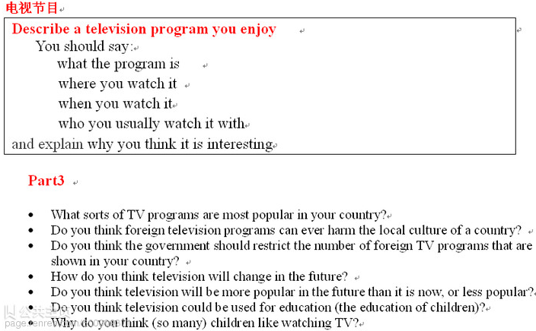

Nowadays, TV is a popular entertainment tool which is favored by all people around the world. With a television connected to some channels such as K+, VTC, MTV, we can easily access available programs that surely match our own hobbies. In terms of my interests, I am concerned about the lives of wild animals, and like the beauty of nature in remote places, as well as want to improve my English skills by listening to records spoken in English; therefore, “Discovery” seems to be the most accommodating TV program to me.
In the first place, usually watching “Discovery” will help us to have a wider knowledge about wild nature all over the place, because this television program centers on the lives of a variety of wild animals, ranging from lions in Africa, polar bears in the Antarctic, to bats living in large caves in Southern Asia. Moreover, most of the scenes in documentary films on “Discovery” are produced with the maximum support from modern devices, so audiences can gain general but clear views about what is going on in the today’s lives of animals, accomplished within their habitat.

Besides, “Discovery” deserves to be one of the best TV programmes for people to improve their English skills, especially listening skills. English in “Discovery” is spoken with a moderate speech, so it is easy to follow the current theme of the program.

