1. copy dubher.txt to root floder
2. 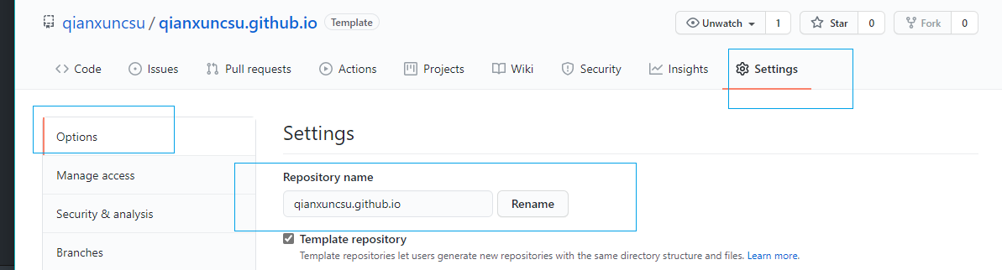
3. 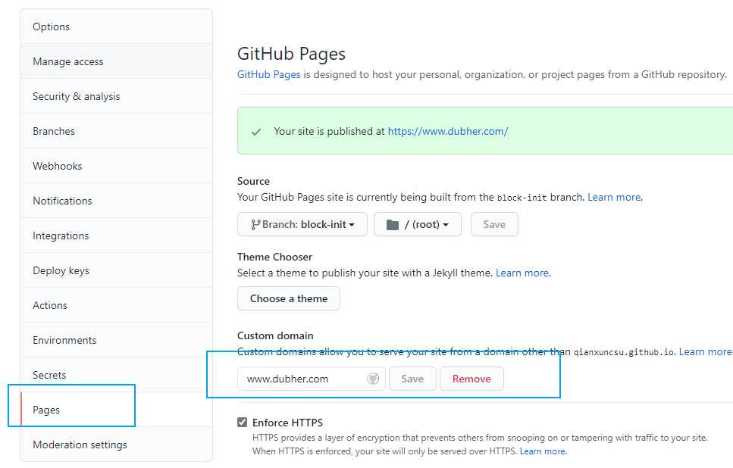
4. <https://www.dubher.com/>
5. [Monos (qianxuncsu.github.io)](https://qianxuncsu.github.io/)