CAMARADES meta-analysis shiny app user guide

## Getting started

Use the sidebar panel to select your analysis options before viewing the output in the tabs.

### Upload csv file

If you do not need the app to calculate effect size and standard error, your csv file must include following columns:

* Effect size
* SE
* True No of C
* N
* Surname
* Year
* Pub ID

If you want the app to calculate effect size by NMD or SMD method, your csv file must include following columns:

* Mean in Sham
* Number in Sham
* Standard Deviation in Sham
* Standard Error in Sham
* Mean in Control Group
* Number in Control Group
* Standard Deviation (C)
* Standard Error (C)
* Mean in Treatment Group
* Number in Treatment Group
* Standard Deviation in Treatment Group
* Standard Deviation (Rx)
* Standard Error (Rx)
* Treatment Groups per Control
* Surname
* Year
* Pub ID

If you want the app to calculate effect size for odds ratio data, your csv must includes following columns:

* Number Affected by Outcome Measure in Treatment Group
* Number in Treatment Group
* Number Affected by Outcome Measure in Control Group
* Number in Control Group
* Treatment Groups per Control
* Surname
* Year
* Pub ID

Please check whether your csv file includes the corresponding columns for your analysis. The columns’ name should be exactly same, or you need to change them by hand before you upload it. Some columns can be null and the order of the columns does not matter.

### Select comparison

Select **Analysis of model** if you are investigating the effect of model induction and your comparison includes a sham group (control) and a model group.

Select **Analysis of intervention** if you are investigating the effect of an intervention on a model and your comparison includes a model group (control) and a model group with an intervention or treatment.

### Select effect size measure

This app offers two ways to calculate effect sizes for continuous data: **normalised mean difference (NMD)** and **standardised mean difference (SMD)**. For binary outcomes, such as the number of animals that developed a disease or died, an **odds ratio** can be calculated. The details are described by [Vesterinen et al (2014)](https://www.ncbi.nlm.nih.gov/pubmed/24099992) which we recommend for further reading. If your data has included effect size and standard error, just select the option “Have calculated effect size and SE”.

#### Normalised mean difference

The effect size is calculated using

$$ES_{i}=100\%×\frac{\left({\overline{x}}_{c}-{\overline{x}}_{sham}\right)-\left({\overline{x}}_{rx}-{\overline{x}}_{sham}\right)}{\left({\overline{x}}_{c}-{\overline{x}}_{sham}\right)}$$

Where ${\overline{x}}_{c}$ and ${\overline{x}}_{rx}$ are the mean reported scores in the control and treatment group respectively and i denotes an individual study estimate. ${\overline{x}}_{sham}$ is the mean score for a normal, unlesioned and untreated animal. If there is no sham group data available, ${\overline{x}}_{sham}$ is assumed to equal zero.

The standard error is calculated using

$$SE_{i}=\sqrt{\frac{SD_{c*}^{2}}{n_{c}^{'}}+\frac{SD_{rx*}^{2}}{n_{rx}}}$$

$$n_{c}^{'}=\frac{n_{c}}{Treatment group served by one control}$$

$$SD_{c*}=100×\frac{SD_{c}}{{\overline{x}}_{c}-{\overline{x}}_{sham}}, SD_{rx*}=100×\frac{SD_{rx}}{{\overline{x}}_{c}-{\overline{x}}_{sham}}$$

Where $n_{c}$ refers to the number of animals in the control group and $n_{c}^{'}$ refers to the true number of control animals. $SD_{c*}$ and $SD_{rx*}$ are the reported standard deviations for the control and treatment group respectively. SD is converted from standard error of the mean (SEM) as necessary using

$$SD_{c}=SEM_{c}×\sqrt{n_{c}}, SD_{rx}=SEM_{rx}×\sqrt{n_{rx}}$$

#### Standardised mean difference (Hedges’ g)

The effect size is calculated using

$$ES_{i}=\frac{{\overline{x}}_{c}-{\overline{x}}_{rx}}{S_{pooled}}×\left(1-\frac{3}{4N-9}\right)×direction$$

where

$$S_{pooled}=\sqrt{\frac{\left(n_{c}^{'}-1\right)×SD_{c}^{2}+\left(n_{rx}-1\right)×SD_{rx}^{2}}{N-2}}, N=n_{c}^{'}+n_{rx}$$

The standard error is calculated using

$$SE_{i}=\sqrt{\frac{N}{n_{rx}×n_{c}^{'}}+\frac{ES_{i}^{2}}{2\left(N-3.94\right)}}$$

#### Odds ratio

For binary outcomes, data can be represented in a 2x2 table below.

|  |  |  |  |
| --- | --- | --- | --- |
| Study *i* | Event | No event | Group size |
| Treatment group | $$a_{i}$$ | $$b_{i}$$ | $$n_{t}$$ |
| Control group | $$c_{i}$$ | $$d_{i}$$ | $$n_{c}$$ |

The odds ratio and its standard error are calculated as

$${OR}_{i}=\frac{a_{i}×d_{i}}{b_{i}×c_{i}}, SE\left(\ln\left({OR}_{i}\right)\right)=\sqrt{\frac{1}{a_{i}}+\frac{1}{b_{i}}+\frac{1}{c_{i}}+\frac{1}{d_{i}}}$$

Note that where the value in any cell is zero, 0.5 is added to each cell to avoid problems with the computation of the standard error.

### Select heterogeneity analysis method

You can select stratified meta-analysis or meta-regression to explore heterogeneity. The difference will show on Heterogeneity, Heterogeneity plot and Bar plot tabs.

### Select heterogeneity estimators

This app offers seven methods to estimate $τ^{2}$: DerSimonian-Laird, Hedges, Hunter-Schmidt, Sidik-Jonkman estimator, Maximum-likelihood, Restricted (Residual) maximum-likelihood, and Empirical Bayes, see [R package 'metafor'](https://cran.r-project.org/web/packages/metafor/metafor.pdf). For a description of the various estimators, see [DerSimonian and Kacker (2007)](https://www.ncbi.nlm.nih.gov/pubmed/16807131), [Raudenbush(2009)](https://books.google.co.uk/books?hl=en&lr=&id=LUGd6B9eyc4C&oi=fnd&pg=PA295&dq=Analyzing+effect+sizes:+Random+effects+models&ots=5NFLyW2p6T&sig=3jjHC6HhJ5IDS8DBpzRcdlrWUT8#v=onepage&q=Analyzing%20effect%20sizes%3A%20Random%20effects%20models&f=false), [Viechtbauer (2005)](http://journals.sagepub.com/doi/abs/10.3102/10769986030003261), and [Viechtbauer et al. (2015)](https://www.ncbi.nlm.nih.gov/pubmed/25110905).

The default estimator is Restricted (Residual) maximum-likelihood.

The seven tabs on the right of the screen display your data, analyses and plots.

## Select data

Xxxxxx

## Meta-analysis

This tab will display global meta-analysis result and forest plot.

### Global meta-analysis

The text output includes number of studies, effect size, 95% confidence interval, z-value, p-value, tau square, Q, etc.

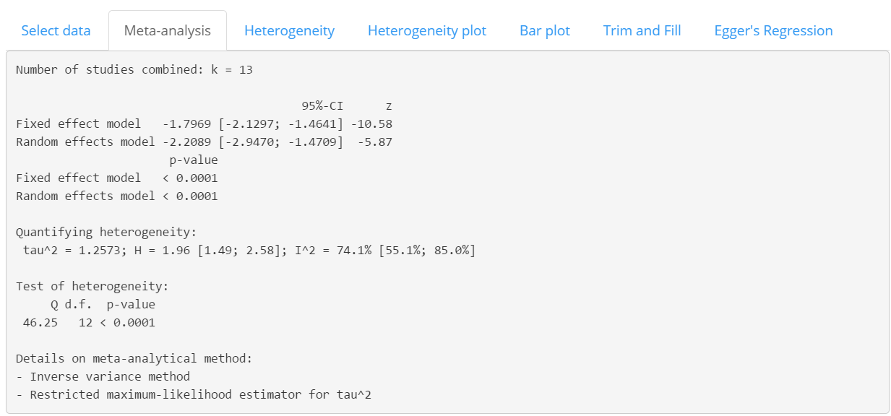

### Forest plot

You can adjust the forest plot by several widgets.

* Orders of studies: change the order of studies displayed on the forest plot, e.g., ordered by increasing (decreasing) “Year”, “Weight” or “Effect size”
* Left gap: adjusting gap between columns printed on left side of forest plot
* Right gap: adjusting gap between columns printed on right side of forest plot
* Figure height: adjusting height of the plot area; useful when there are many studies
* Plot width: adjusting width of the forest plot (to make confidence interval lines longer)
* Figure width: adjusting width of the plot area; usually adjust it together with *Plot width*
* Show weight: whether print weight of individual studies on right side of forest plot

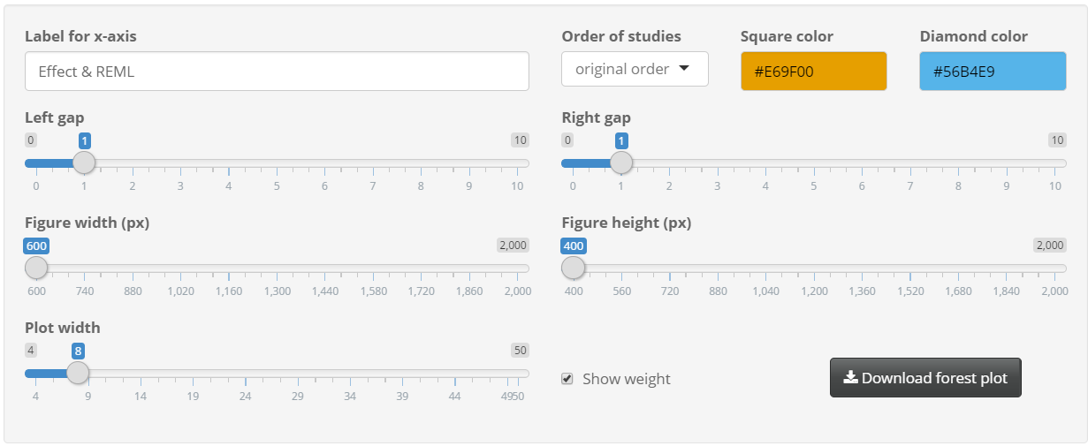

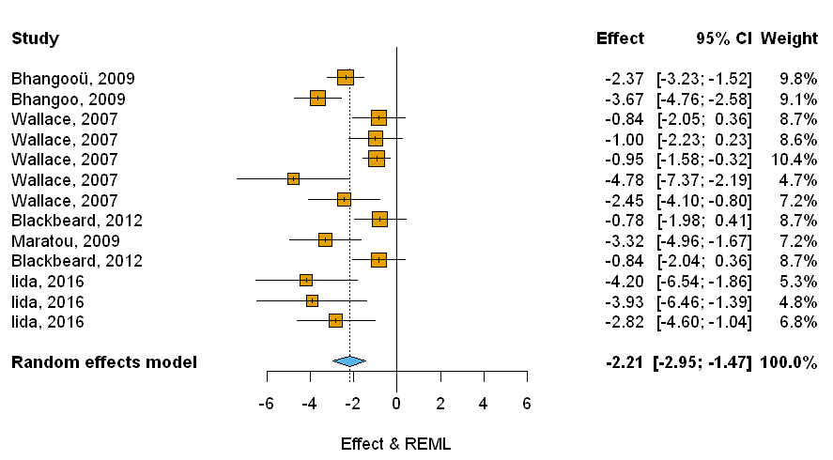

## Heterogeneity

This tab will show different analysis results for stratified meta-analysis and meta-regression.

### Stratified meta-analysis

If you want to do stratified meta-analysis, you need to select “Stratified meta-analysis” in the sidebar panel. Then the tab will show you a dropdown list. You need to select a discrete variable you want to use for subgroup analysis.

The results include global meta-analysis, subgroup meta-analysis and heterogeneity test.

The Q statistic in heterogeneity test output is the heterogeneity between group or residual heterogeneity. In the screenshots, it is 46.253 - 3.345 - 30.044 = 12.864. “chi2” is 95% upper-tail critical values of chi-square distribution with certain degrees of freedom (number of group minus 1).

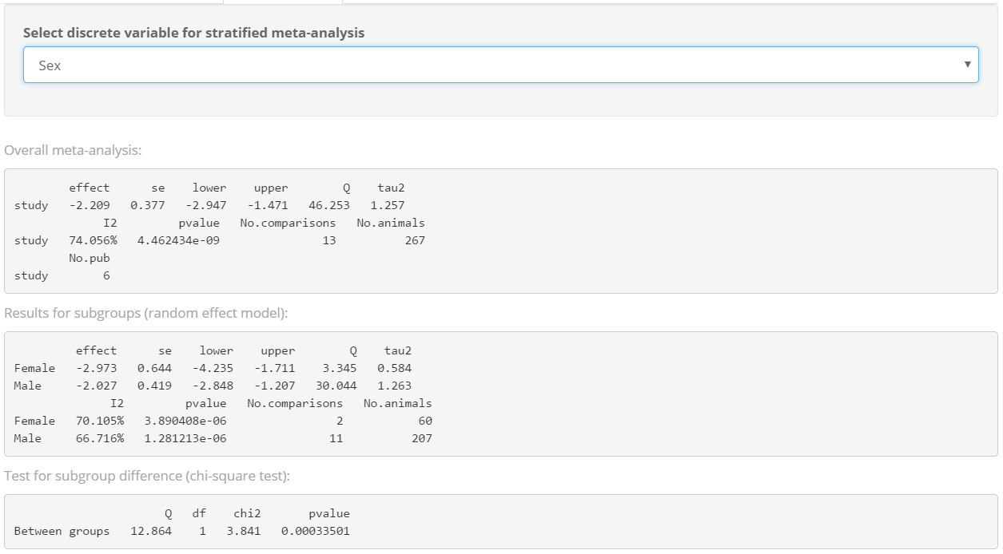

### Meta-regression

If you want to do meta-regression, you need to select “meta-regression” in the sidebar panel. Then the tab will show you two select boxes, for continuous variables and discrete variables separately. You can select multiple variables in each box by pressing “Ctrl” and clicking the variables, provided your data include enough amount of studies to do multivariate meta-regression.

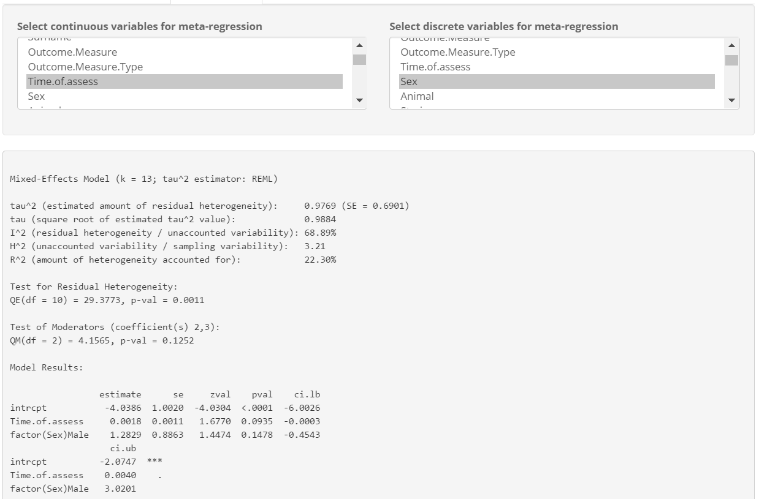

## Heterogeneity plot

### Forest plot with subgroups

This tab will display the forest plot with subgroups, based on the discrete variable you select in the dropdown list. The widgets are similar to those in Meta-analysis tab.

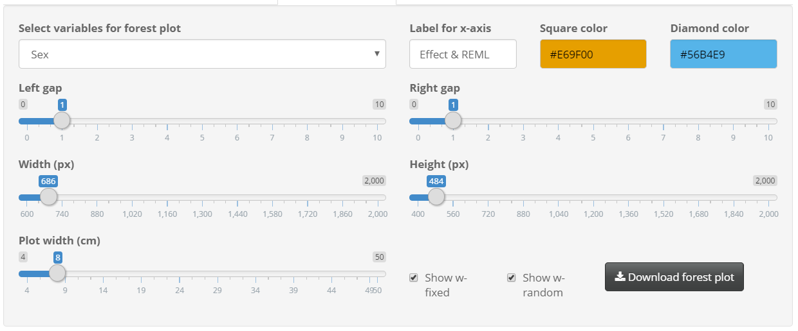

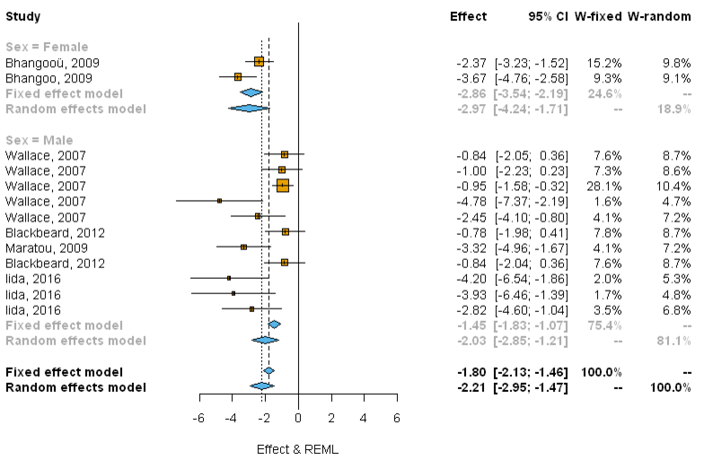

### Meta-regression plot

Select one continuous variable and get the meta-regression plot. Size of points reflect the precision of each comparison (inverse of within-study variance).

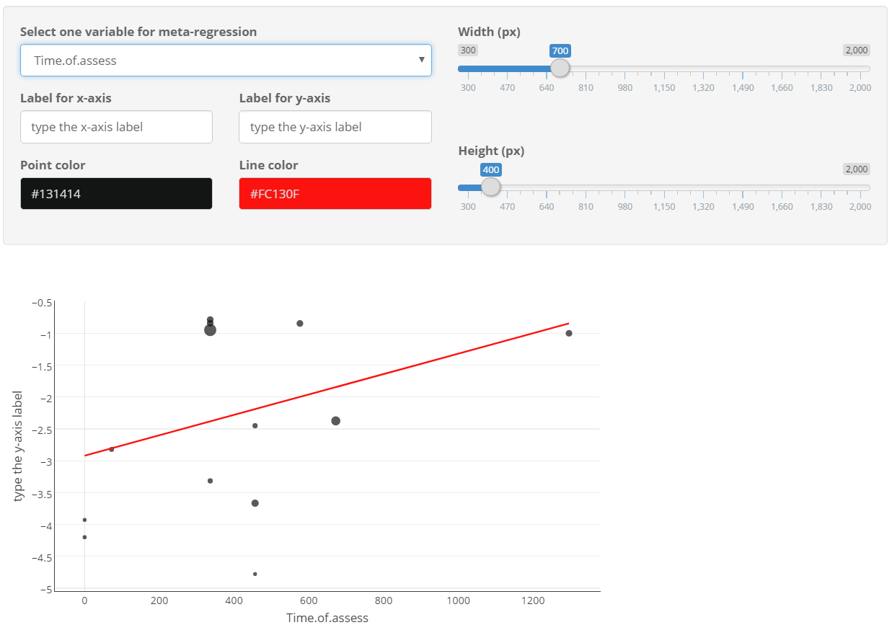

You can get basic information (effect size, standard error, author and year) for each comparison by moving the mouse over the points.

## Bar plot

Widgets panel.

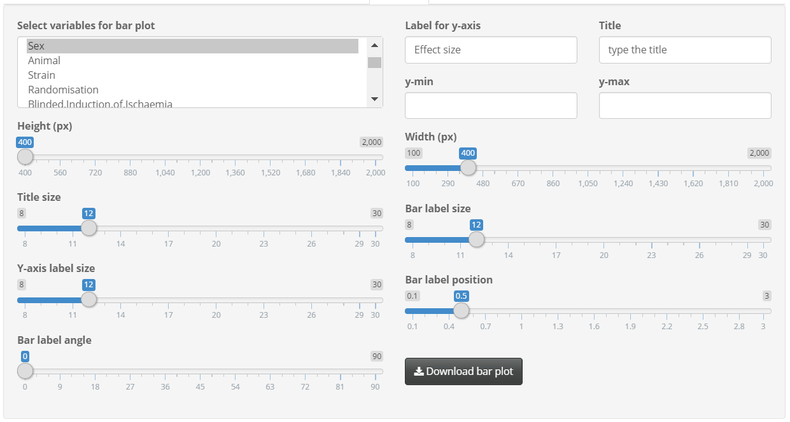

Bar plot example.

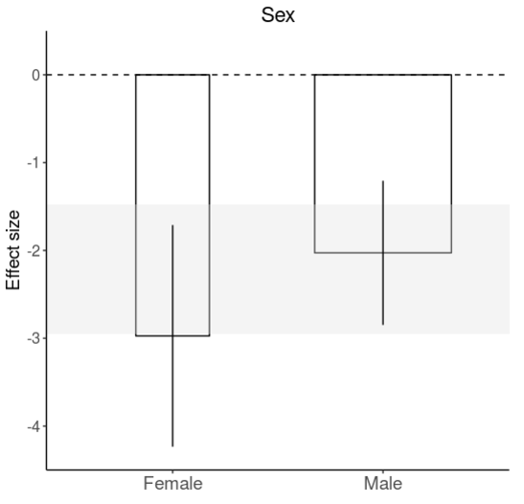

### Bar plot in stratified meta-analysis

*Shaded grey bar* represents 95% CI of global estimate efficacy. Height of each bar represents effect size within group. Width of each vertical bar reflects square root of number of animals contributing to that comparison. *Vertical error bars* represent 95% CI for estimates within each group.

### Bar plot in meta-regression

*Shaded grey bar* represents 95% CI of global estimate efficacy. Width of each vertical bar reflects square root of number of animals contributing to that comparison.

Take “Sex” as an example, in meta-regression model, we create two dummy variables to replace the categorical variable “Sex”:

|  |
| --- |
| Sex $x_{Female}$ $x_{Male}$ |
| Female 1 0 |
| Female 1 0 |
| Male 0 1 |
| Female 1 0 |
| Male 0 1 |
| ... … … |

And the regression model is like:

$$Effect size=β_{Female}x_{Female}+ β_{Male}x_{Male}$$

Height of each bar represents corresponding regression coefficient ( $β_{Female}$ and $β_{Male}$). *Vertical error bars* represent 95% CI for corresponding coefficients (95% CI for $β_{Female}$ and $β_{Male}$).

## Trim and Fill

### Trim and fill analysis

This app use ”L0” estimator for estimating the number of missing studies, see [Duval and Tweedie (2000)](https://www.ncbi.nlm.nih.gov/pubmed/10877304). You can select which side of funnel plot the missing studies should be imputed, in the widget panel.

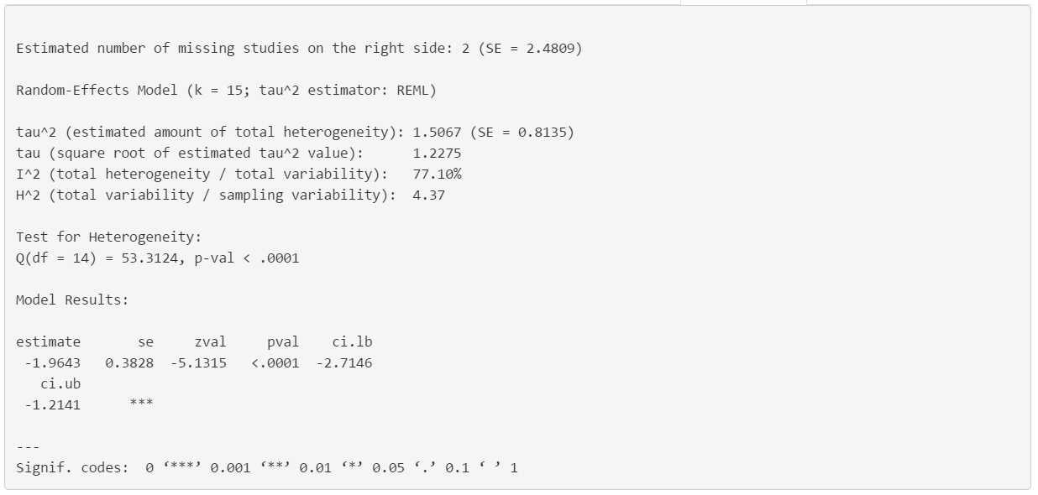

### Funnel plot

You can select what value you want to place on the y-axis, between “Inverse of the standard error” and “Inverse of the square-root sample size”.

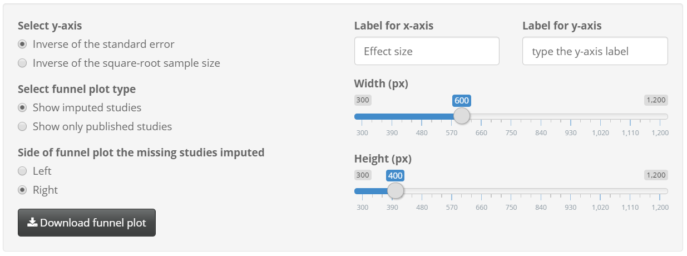

Also, you can select whether to display imputed studies on the funnel plot, like:

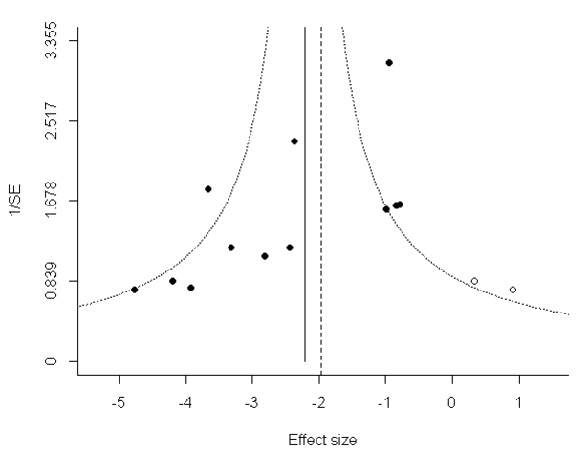 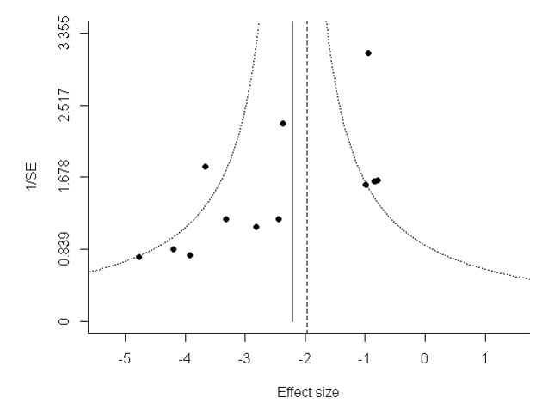

The left plot shows both original studies and imputed studies, while the right plot only shows original studies. The solid vertical line represents the overall effect size of original studies (you can find the value from Meta-analysis tab); the dashed vertical line reflects the effect size of studies including imputed ones.

## Egger’s regression

[Egger et al. (1997)](https://www.ncbi.nlm.nih.gov/pubmed/9310563) introduced a linear regression method in which the standardised effect size is regressed against its precision:

$$\frac{ES_{i}}{SE_{i}}=β_{0}+β_{1}\frac{1}{SE_{i}}$$

It should be noted that in their original report, [Egger et al. (1997)](https://www.ncbi.nlm.nih.gov/pubmed/9310563) suggested an alternative version in which the regression of ${ ES_{i}}/{SE_{i}}$ is weighted by the inverse of the variance of the effect estimate. This weighted version lacked a theoretical justification, and is no longer advocated by Egger *et al*. This app includes only the unweighted regression of standardised effect on precision.

The regression output is like:

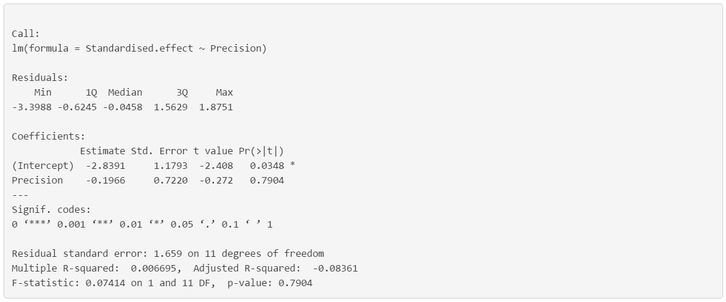

The corresponding plot displays regression line with 95% CI.

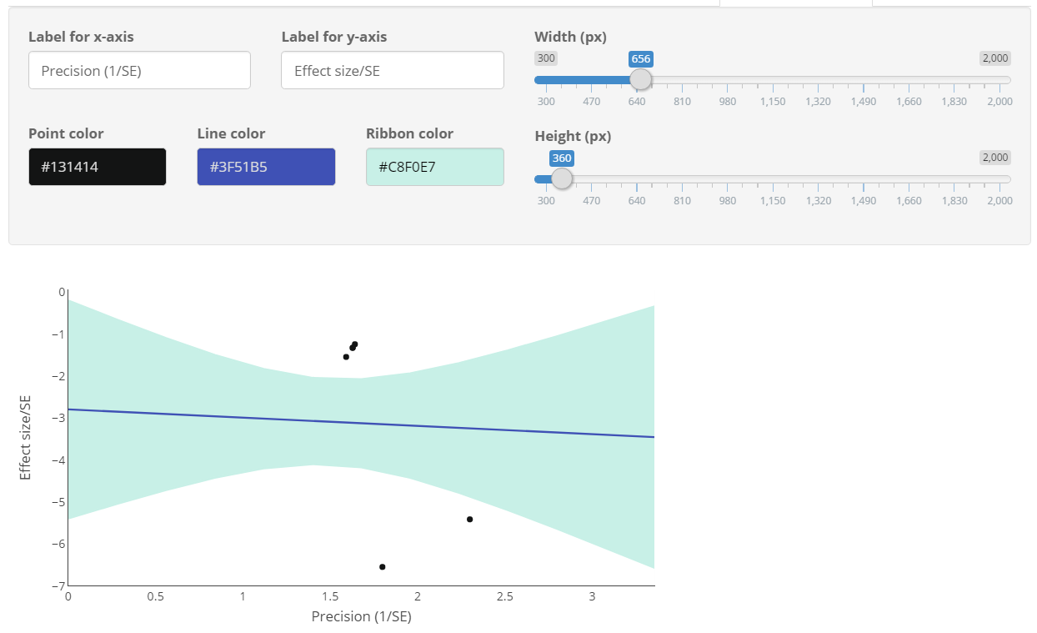

## Glossary

Sham

Model

Intervention

Etc..