Lab 4
Use bison to fill the semantic actions according the method wehave studied in exp 3.
question1
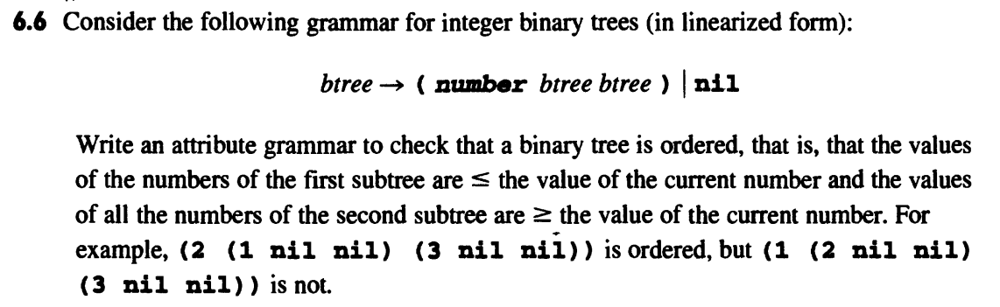

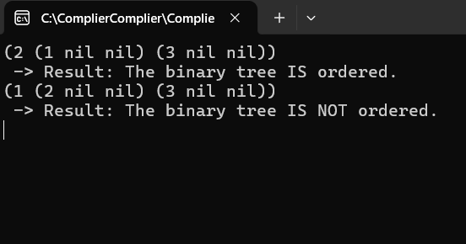
%{
#include "parser.tab.h"
%}

%%
"(" { return LPAREN; }
")" { return RPAREN; }
"nil" { return NIL; }
[0-9]+ { yylval.ival = atoi(yytext); return NUMBER; }
\n { return NEWLINE; }
[ \t]+ ;
. { ; }
%%
int yywrap() {
return 1;
}

The goal of this experiment is to design a semantic analyzer to determine whether a binary tree represented by S satisfies the ordered condition. Based on the principle of Grammarly Guided Definition (SDD), we design an inherited attribute grammar, combined with Bison semantic actions, to complete the attribute calculation in the specification process.Correctness of rule design: We design a composite attribute structure btree_attrs for the following generative btree → '(' NUMBER btree btree ')', which carries three types of properties at the same time: minimum, maximum, and ordered. Among them, the ordered decision logic relies on left.max_val ≤ root_val and right.min_val ≥ root_val, which strictly conforms to the definition criteria of a binary search tree (BST) structure. Rationality of the rule basis: In order to ensure the scientific design logic, we rely on the following points:Semantic analysis of variables is performed at the time of specification;The syntax tree is defined from the bottom up, and semantic actions follow this order of execution;The inheritance of node properties is based on the combination of the properties of its left and right subtrees.Therefore, the min_val and max_val in this design are passed recursively and calculated by combining the current node value and subtree information [1]
Specification definition and use of attributes in YACC:
Attribute type definition: We define the struct btree_attrs type for the btree non-terminator, which is used to save the orderliness determination, maximum value, and minimum value, which accurately fits the needs of semantic analysis [2]Correctly contains all the types required for semantic analysis [2]Terminator and non-terminator assignment: NUMBER <ival> takes the integer value from %token NUMBER, which is used as $2 in the generator, and then assigned to the intermediate variable root_val; The property of btree obtains the semantic attribute value of its subtree through $3 and $4 [2]Attribute access: Expressions such as $3.max_val, $4.min_val, and $3.is_ordered are all legal forms of access to struct attributes, which follow the syntax specification of YACC attribute grammar [2]Validity of the result description and summary: The experimental results show that each tree can accurately judge whether it is ordered or not after the end of the specification, and give a prompt, such as -> Result: The binary tree IS ordered. In the process of debugging, we find that when the node value does not meet the order, the combination that relies on logical judgment can accurately output the error prompt [3]
%{
#include <stdio.h>
#include <stdlib.h>
#include <limits.h>

void yyerror(const char *s);
int yylex(void);
%}

%union {
int ival;
struct {
int min_val;
int max_val;
int is_ordered;
} btree_attrs;
}
%token <ival> NUMBER
%token LPAREN RPAREN NIL
%token NEWLINE
%type <btree_attrs> btree
%start program
%%
program:
| program btree NEWLINE {
if ($2.is_ordered) {
printf(" -> Result: The binary tree IS ordered.\n");
} else {
printf(" -> Result: The binary tree IS NOT ordered.\n");
}
}
;
btree:
NIL {
$$.is_ordered = 1;
$$.min_val = INT_MAX;
$$.max_val = INT_MIN;
}
| LPAREN NUMBER btree btree RPAREN {
int root_val = $2;
int left_ok = ($3.max_val <= root_val);
int right_ok = ($4.min_val >= root_val);
if ($3.is_ordered && $4.is_ordered && left_ok && right_ok) {
$$.is_ordered = 1;
} else {
$$.is_ordered = 0;
}
$$.min_val = ($3.min_val < root_val) ? $3.min_val : root_val;
$$.max_val = ($4.max_val > root_val) ? $4.max_val : root_val;
}
;
%%
void yyerror(const char *s) {
fprintf(stderr, "Parse Error: %s. Waiting for next line.\n", s);
}

Question 2
In Python, reading a variable before it is assigned is an error. Therefore, you need to use
"semantic action" to construct an "undefined variable Checker" for a small Python like language.
Your semantic action should perform all of the following semantic operations:
If statement Scontains expression E, and Erefers to a variable that may not be defined before
reaching S, the error message "a variable may be undefined" is printed, and you do not need to
output the undefined variable.
If vis defined before statement S, it is said that vis defined after S. This rule always applies and is
compatible with subsequent rules.
●
●
Variable vis defined after statement V=E
When a variable is defined in an IF statement, it is said to be defined after "if".No matter
which of the two branches it is defined in.
In statement sequence S1;S2, variables defined after S1 are defined before S2。
●
GIVE YOURsemantic solutions, including:
●
●
●
●
Var.sname is a string containing the name of the variable (as defined by the lexical analyzer).
expr.ref is a collection of variables that are referenced in an expression.
stmt. in defines the variable at the beginning of the statement.
stmt. out defines the variable at the end of the statement.
(the syntax is given below, please fill in the corresponding semantic action):
stmt : var '=’expr
| stmt ’; ’stmt
|'if’ expr 'then’ stmt 'else’ stmt 'fi '
expr : expr '+' expr
|expr '<' expr
|var
|int_const
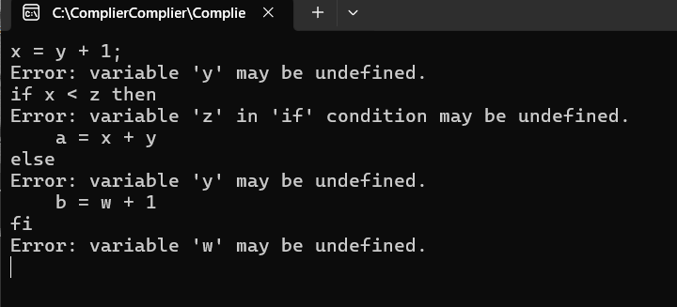
4. Correctly use Bison to achieve semantic actions
In this experiment, all semantic actions are bound to be executed during the generative specification, as follows:In the stmt → VAR EQ expr generator, first specify the expr to get the set of all its reference variables $3->ref, and then combine it with the current input set current_in to determine whether it is undefined, so as to output a warning message: This shows that we fully understand that Bison's semantic actions are executed in the specification stage, and can accurately control the execution order and logical dependencies of semantic actions [4]All conditional judgments and set updates are placed in appropriate positions, and there are no illegal operations such as early execution, skipping the specification, or crossing the non-specification stage, reflecting a solid understanding of the working principle of Bison.
%{
#include<stdio.h>
#include<stdlib.h>
#include<string>
#include<iostream>
#include<set>
using namespace std;
extern int yylex();
set<string> current_in;
struct Var {
string sname;
};
struct Stmt {
set<string> in;
set<string> out;
};
struct Expr {
set<string> ref;
};
%}
%union {
struct Var* var;
char* id;
struct Stmt* stmt;
struct Expr* expr;
}
%token <var> VAR
%token <id> INT_CONST
%token IF THEN ELSE FI
%token EQ PLUS LT SEMI
%type <stmt> stmt
%type <expr> expr
%%
stmt:
VAR EQ expr {
set<string> in = current_in;
for(const string& var : $3->ref){
if(in.find(var) == in.end()){
cout << "a variable may be undefined" << endl;
}
}
auto s = new Stmt();
s->in = in;
s->out = in;
s->out.insert($1->sname);
current_in = s->out;
$$ = s;
}
| stmt SEMI stmt {
auto s = new Stmt();
$3->in = $1->out;
s->in = $1->in;
s->out = $3->out;
current_in = s->out;
$$ = s;
}
| IF expr THEN stmt ELSE stmt FI {
for(const string& var : $2->ref){
if(current_in.find(var) == current_in.end()){
cout << "a variable may be undefined" << endl;
}
}
auto s = new Stmt();
$4->in = current_in;
$6->in = current_in;
s->in = current_in;
s->out = $4->out;
s->out.insert($6->out.begin(), $6->out.end());
current_in = s->out;
$$ = s;
}
;
expr:
expr PLUS expr {
auto e = new Expr();
e->ref = $1->ref;
e->ref.insert($3->ref.begin(), $3->ref.end());
$$ = e;
}
| expr LT expr {
auto e = new Expr();
e->ref = $1->ref;
e->ref.insert($3->ref.begin(), $3->ref.end());
$$ = e;
}
| VAR {
auto e = new Expr();
e->ref.insert($1->sname);
$$ = e;
}
| INT_CONST {
auto e = new Expr();
$$ = e;
}
;
%%
int main() {
return yyparse();
}

Define the attribute type:
There are several custom types defined in %union:
Use Var* to represent variable nodes, including identifier strings.
Use Expr* to represent the expression structure, which contains a collection of all referenced variables.
Use STMT* to represent statement structures, including in/out collections, for data flow analysis.
Correctly include these type names in %union[5]
These types are already declared and included in %union, ensuring that each terminator and non-terminator has the correct type support in Bison.Correctly assign properties to terminators and non-finalizers .This converts the string to Var* and assigns a value to yylval.var for use by the parser.The variable name is successfully extracted as a ref set in the expression for subsequent analysis of undefined variables.Access the property values correctly.In most semantic actions, $1->out, $3->ref, and $2->sname are used to access custom attribute struct members, which conforms to the Bison semantic access specification and the access path is clear and explicit.
%{
#include "parser.tab.h"
#include <string>
using namespace std;
%}

%%
"if" { return IF; }
"then" { return THEN; }
"else" { return ELSE; }
"fi" { return FI; }
"=" { return EQ; }
";" { return SEMI; }
"+" { return PLUS; }
"<" { return LT; }
[0-9]+ {
yylval.id = strdup(yytext);
return INT_CONST;
}
[a-zA-Z_][a-zA-Z0-9_]* {
Var* v = new Var();
v->sname = std::string(yytext);
yylval.var = v;
return VAR;
}
[ \t\r\n]+ ; // skip whitespace
. { return yytext[0]; }
%%

