1.
- The history of OOP:The concept of OOP first be proposed at the end of1950s,and it was appeared at Massachusetts Institute of Technology at 1960s;During 1960s to 1961s,Ivan Sutherland created Sketchpad,and then the concept ‘object’ was defined.In 1962,Kristen Nygaard designed Simula which was considered as the first language using ‘OOP’,and final it introduced class,inheritance and polymorphism.Being inspired by Simula,Alan Key created Smalltalk which influence many language such as Java,python.But until the middle of 1980s,Stroustrup introduce C into OOP,created C++.After that,OOP developed vigorously.

- The development of C++:The history of C++ dates back to 1979, when Bjarne Stroustrup was preparing his doctoral dissertation and had the opportunity to use a language called Simula. As the name suggests, the main role of the Simula language is simulation. Simula 67 is a variant of the Simula language and is recognized as the first language to support object-orientation. Stroustrup found that object-oriented thinking was very useful for software development, but it was not very practical due to the inefficiency of the Simula language.Bjarne Stroustrup's first "C with classes" compiler was called Cfront, a name derived from a C compiler called Cpre. Cfront works by translating the "C with classes" code into native C code.In 1983, the "C with Classes" language was renamed C++. The role of the "++" operator in C is to increment a variable, so we can see how Stroustrup is positioned in this new language. During this period, a number of important features were added, including virtual functions, function overloading, a referencing mechanism, the think keyword, and a single-line comment with double slashes .Then c++ updated many versions,such as 89,98,05,11,14 and so on.

2.
- Abstract: The concept of abstract has two aspects:one is data ,the other is process;ADT example:we can abstract some of our physicality into data(class which include these data) for calculating easily;process example:we can abstract our action into some easy to utter,such as playing game is 1,and studying is 0;

- Encapsulation: The concept of encapsulation is hiding the object and making the code can run ,and only publicly available interfaces.example:there is a game with a button to get the gifts,you only need to press the button,and there is no need and no way to know how it works.

3.
- information hiding and implement hiding:to protect the security of our data or we don’t want others know how our code it works,we can set some data into private in the class or using the encapsulation to hide the implement,and only offer the inference.

4.
- class:just like struct we can creat a class person { int phonenum; void print(cout<<phonenum<<endl;)}
- Object:In the illstration of class the variable quantity phonenum can be using in person ,we can define person p ;these variable quantity like p we call it object.
- Inheritance:Inheritance allows us to define a class based on another class, making it easier to create and maintain an application. This approach also achieves the effect of reusing code functionality and improving execution efficiency.
When creating a class, you don't need to rewrite new data members and member functions, just specify that the newly created class inherits the members of an existing class. This existing class is called the base class, and the newly created class is called the derived class.For example:we can create a class called father,and using another a class son to inheritance the quantity of the father;
Class father{
Public:
String name=”father”;
Int money=520;
}:
Class son:public father;
Then will get a other class has the same quantity like father;
- polymorphism:Polymorphism literally means multiple forms. Let's first think of an example of polymorphism in daily life: when buying tickets, adults pay the full price, if it's for students, it's half the price, and if it's for soldiers, they can give priority to buying tickets. Different people have different implementation methods when buying tickets, which is polymorphism.
Example:
Class adult{
Public:
Virtual void fun()
{
Cout<<”you need to pay 100$ ”<<endl;
}
};
Class student :public adult{
Public:
Virtual void fun()
{
Cout <<”you need to pay 80$”<<endl;
}
};
Void buy(person *p)
{
- >fun();
}
Int main()
{
Student st;
Adult ad;
Buy(&ad);buy(&st);
}

5.
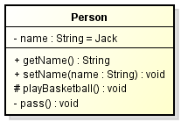
The diagram is divided into three layers: the top-level layer is the class name, the middle layer is the attribute, and the bottom layer is the method. The representation of attributes is: [visibility] [property name]: [type]={default value, optional} The representation of methods is: [visibility] [method name] ([parameter list]): [type] The visibility is the same, with "-" indicating private, "+" indicating public, and "#" indicating protected.
.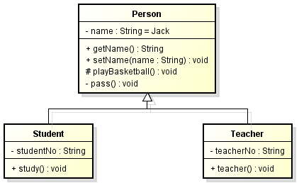
Inheritance, also known as generalization, is used to describe the relationship between parent and child classes. The parent class is also called a base class or superclass, and the subclass is also called a derived class. In UML, generalization relationships are represented by solid lines with hollow triangles
.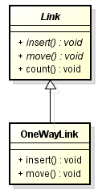
In UML, both the class name and abstract method name of an abstract class are represented in italics, as this is also an inheritance relationship. Therefore, subclasses and parents are connected by a solid line with a hollow triangle.
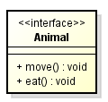
<>indicates that this is an interface. Generally, interfaces do not have properties, so there is no intermediate layer here. If there are properties, please note that they are also constants.
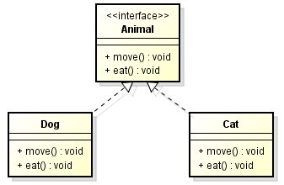
A Dog and a Cat have implemented Animal
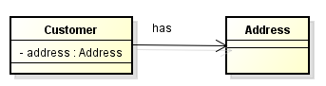
Unidirectional association relationship
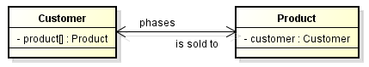
Bilateral association relationship
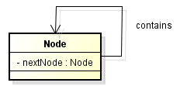
Autocorrelation relationship
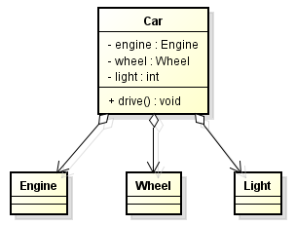
Aggregation relationship
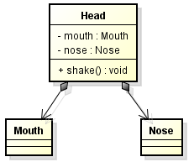
Combination
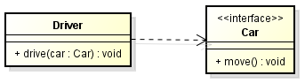
Dependency relationship

6.
Dev-c++,visual stdio;good;dev_c++;simple and clean;no,it doesn’t support c++11or c++14.

- 、
c++ has a new data type--string,and there is no need to use typedef wo rename struct,and a new function called class.
8.
a=12
b=345
c=634
d=3214

