《Introduction to Database System A》report2
contents： (DML) simple query over a single relation | lab：10-409 | Time: 2024/10/18 10:00-12:30
contents： (DML) simple query over a single relation | Instructor:liuli | studentID:2023337621159  studentName:代翔
Software Environment ：
OS(Windows,linux,macOS)+DBMS(postgresql,openGauss,Mysql)
Purpose：
to have a little taste on simple query by algebra and select statement in SQL
To understand database view; to practice on constructing/query on the view
notation：
- to query from a relation:
Select [distinct] exp₁ as a₁,…exp_{n} as a_{n}
From tablename
[Where Condition];
Key word in condition :is null,<,<=,>,>=,<>, between…and…,like,and,not,or
Example tasks and answers:
Find all movies which is produced by studio ‘MGM’
SQL ANSWER:
Select *
from movies
where studioname='MGM'
- to add a set of tuples from query result to a new table with a single comman;
Insert Into <table_name>
Select-Statement
Example tasks and answers:
Writhe a command to Find all sience movies and to add them to a new table MGMMovies as well.
SQL ANSWER:
Insert into MGMMovies
Select * from movies
Where studioname='MGM'

Experiment background:
we have set up a database “my_movies_database” to store the information about stars, movies,studios and presidents of studios etc.
Experiment Requirements:
- delete data from each tables;
- load data from the given new sql file(mydata.sql) for the database;

part1: Write SQL statements and execute each statement for the following queries(questions );
( After you have successfully execute each SQL statement, copy this SQL statement to this document in text format (not copy in picture format); paste the snapshot picture for each execution result of the SQL statement in the document if necessary;for some questions,algebrea expressions are necessary(either picture or text format are accepted));
  - Find the address of the movie star“Jane Fonda”
Algebra answer:πaddress(σname=′JaneFonda′(movieStar))
SQL ANSWER: SElECT address
FROM `movieStar`
WHERE `name`= 'Jane fonda';
RESULTING PICTURE: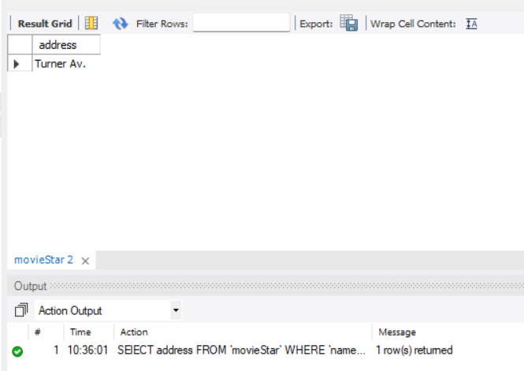
  - Find the studio(name) who issued the movie “Star Wars”
Algebra answer:πstudioname(σtitle=’Star Wars’(Movies))
SQL ANSWER: SELECT studioname
FROM `Movies`
WHERE `title`='Star Wars';
RESULTING PICTURE: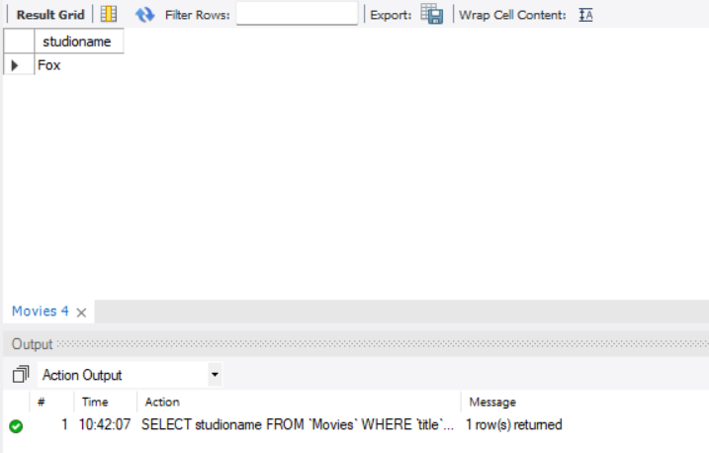
  - Find the movies with length less than 120 or as null value, return title, year and length
Algebra answer:πtitle,year,length(σlength<120 OR length=null(Movies))
SQL ANSWER: SELECT title,year,length
FROM `Movies`
WHERE `length`<120 OR `length`IS null;

RESULTING PICTURE: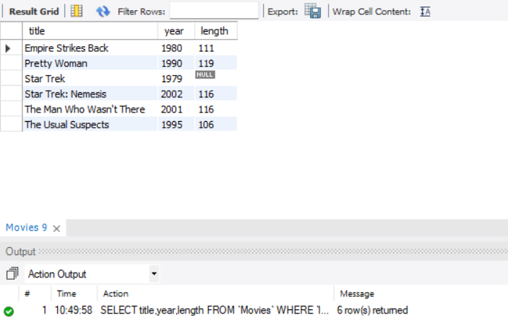
  - Find movies by returning the title, year, length in hours with a new name as duration for the column. Then produce another new column with value as ‘hrs’ and column name as inhours
SQL ANSWER: SELECT title,year,CAST(length/60 AS DECIMAL(10,2)) AS duration,'hrs' AS inhours
FROM `Movies`
RESULTING PICTURE: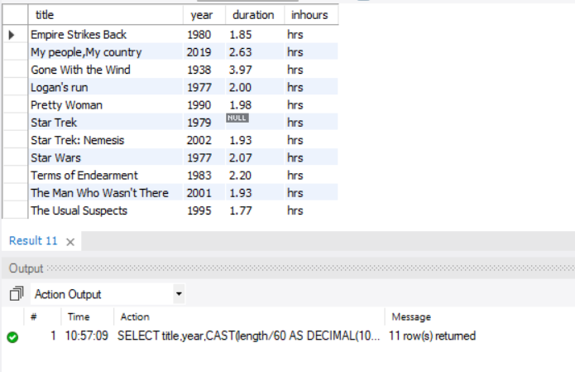
  - Find all executives worth at least $100,000,000(return values on all attributes).
SQL ANSWER: SELECT *
FROM `Movieexec`
WHERE `networth`>= 100000000;
RESULTING PICTURE: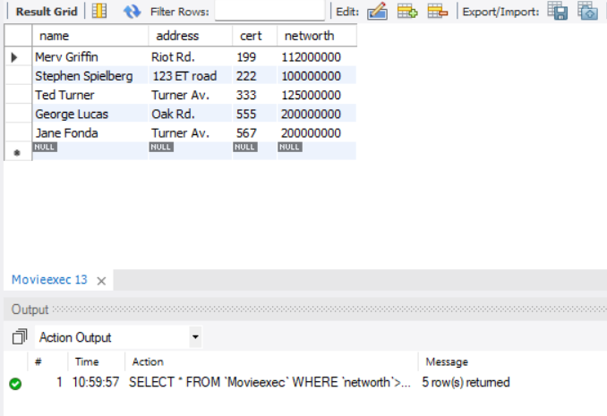
  - Find name and birthdate of movie star whose birthdate is in July.
SQL ANSWER: SELECT name,birthdate
FROM `moviestar`
WHERE EXTRACT(month from `birthdate`) = 7;
RESULTING PICTURE: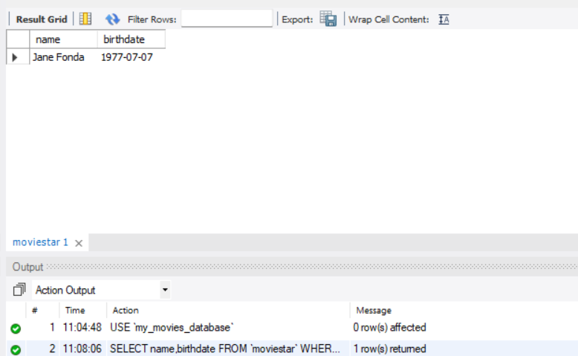
  - Return the title year ,length and studioname of movies being produced by studio Paramount and with length not null
SQL ANSWER: SELECT title,year,length,studioname
FROM `movies`
WHERE `studioname`='Paramount' AND length IS not null;
RESULTING PICTURE: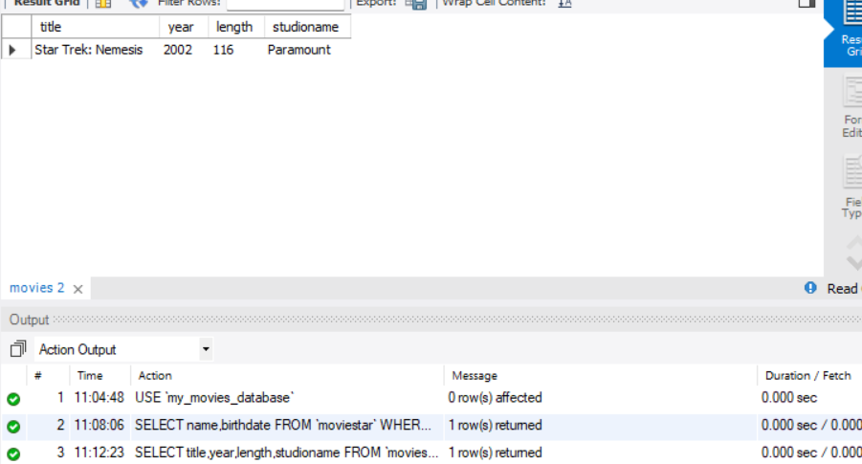
  - A movie “Star something” , what could this movie be?
SQL ANSWER: SELECT *
FROM `movies`
WHERE `title` LIKE 'Star %';
RESULTING PICTURE: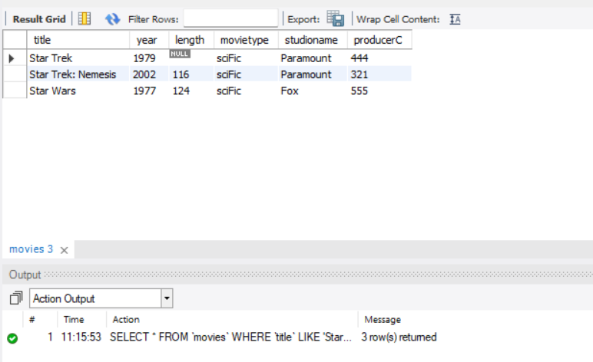
  - Return those movies with ’ s in the title
SQL ANSWER: SELECT *
FROM `movies`
WHERE `title` LIKE '%\'s%';
RESULTING PICTURE: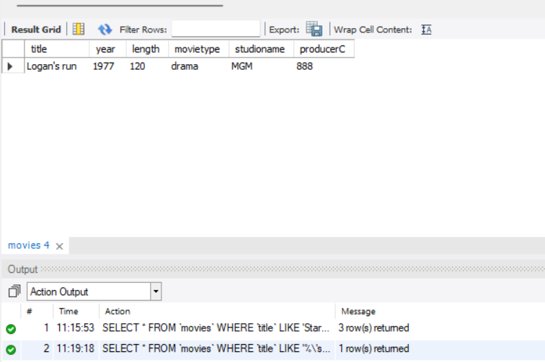
  - Return those female stars with ’er’ at the end of name
SQL ANSWER: SELECT *
FROM `moviestar`
WHERE `name` LIKE '%er' AND `gender`='F';
RESULTING PICTURE: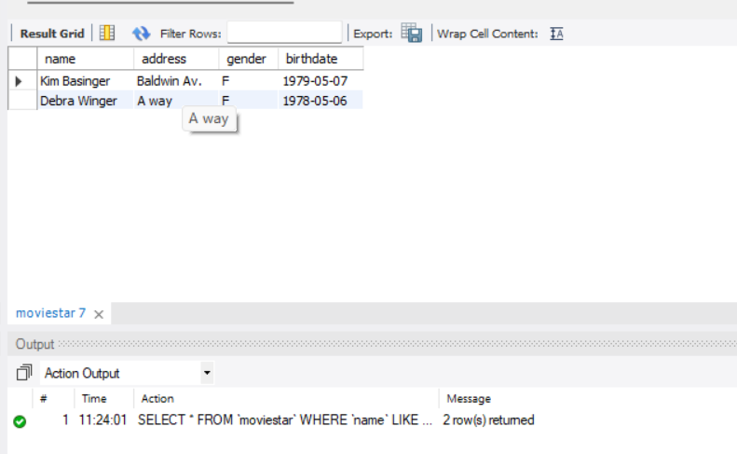
  - Find all the movies that were either made in 1977 or by ‘MGM’
SQL ANSWER: SELECT *
FROM `movies`
WHERE `year` = 1977 OR `studioname`='MGM';
RESULTING PICTURE: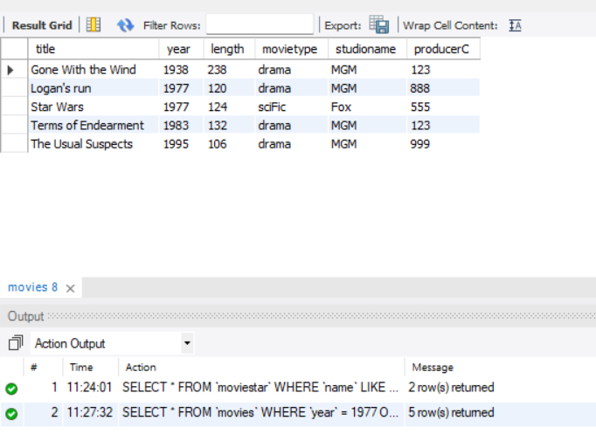
  - Find movies stars who acted in the movie “Star something” ,this something has 4 characters,return all columns.
SQL ANSWER: SELECT *
FROM `movies`
WHERE `title` LIKE 'Star ____';
RESULTING PICTURE: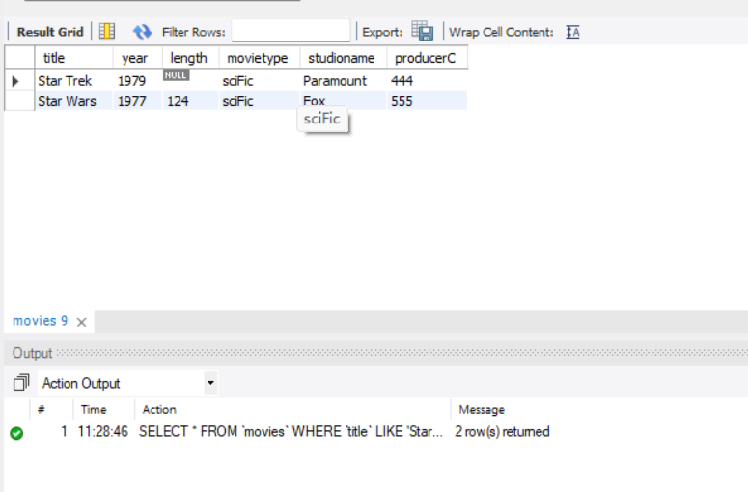
  - Find movies stars whose name after ‘Jane’
SQL ANSWER: SELECT *
FROM `moviestar`
WHERE `name` LIKE 'Jane%';
RESULTING PICTURE: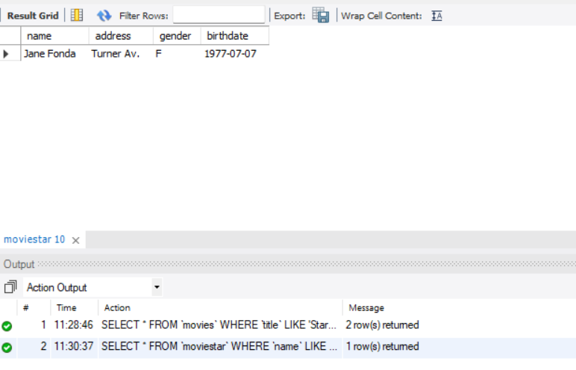
  - Find movies stars who acted in some movies not before 1980, return name uniquely
SQL ANSWER: SELECT DISTINCT starname
FROM `starsin`
WHERE `movieyear`>=1980;
RESULTING PICTURE: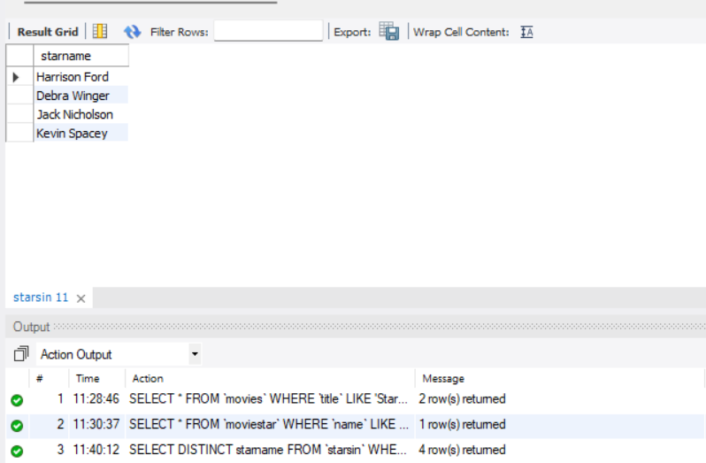

Part2: Write SQL command to define the table FoxMovies with the same schema as that in movies tables.;

  - Write one command to add all movies that were produced by Fox studio in the table movies to the new table(FoxMovies);.
SQL ANSWER: CREATE TABLE `FoxMovie`(
`title` varchar(30) ,
`year` int ,
`length` int,
`movietype` varchar(30) ,
`studioname` varchar(30) ,
`producerC` int
);

INSERT INTO `FoxMovie`
SELECT *
FROM `movies`
WHERE `studioname`='Fox';
RESULTING PICTURE(list the information from FoxMovies)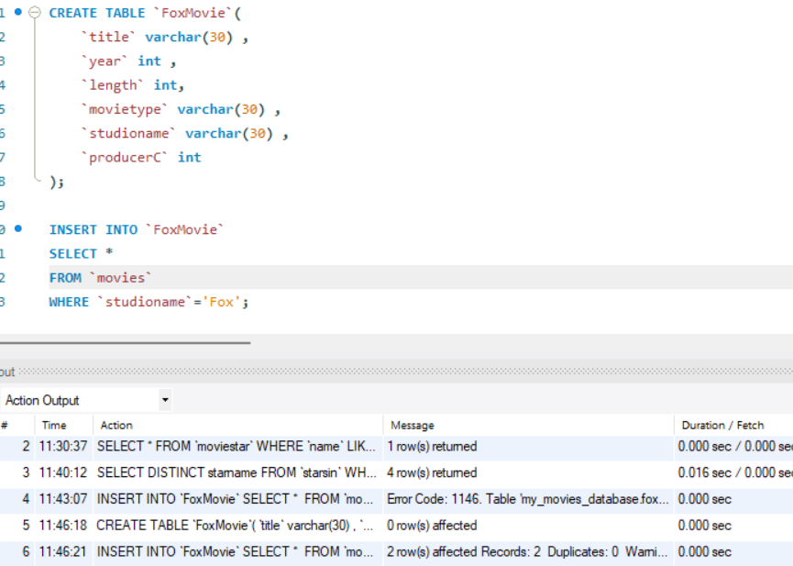
  - Find movies of sciFic type from FoxMovies table, return title, year, movitype and studioname;
SQL ANSWER: SELECT title,year,movietype,studioname
FROM `FoxMovie`
WHERE `movietype`='sciFic';
RESULTING PICTURE
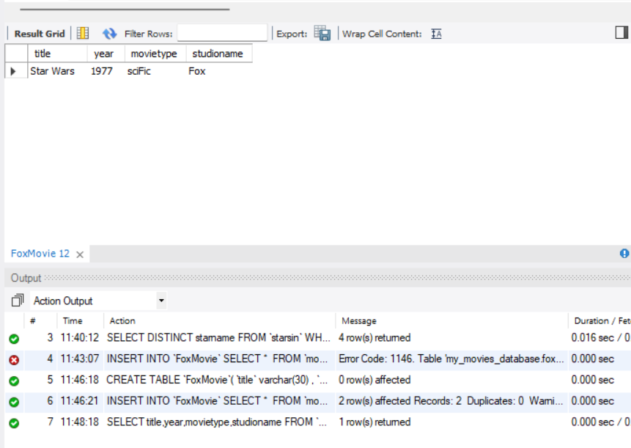
notice:
1..Hand in your answer file with the PDF format and name as exp2_ID(ID should be replaced by your own student ID);
2.The electronic version of your document should be handed in before due time in pdf format.

