在50 和 51 主机分别安装percona软件

]# rpm -ivh libev-4.15-1.el6.rf.x86_64.rpm

]# yum -y install percona-xtrabackup-24-2.4.7-1.el7.x86_64.rpm

###############RDBMS1_DAY05 innobackupex 命令的使用

1 percona软件介绍

2 安装软件

]#yum -y install /var/ftp/pub/libev-4.15-1.el6.rf.x86_64.rpm

]#yum -y install /var/ftp/pub/percona-xtrabackup-24-2.4.7-1.el7.x86_64.rpm

3innobackupex命令格式

]# innobackupex 选项

[root@host50 ~]# man innobackupex

[root@host50 ~]# innobackupex --help

常用选项介绍？

数据的完全备份与恢复

完全备份的命令格式

]# innobackupex --user root --password 密码 目录名 [--no-timestamp]

完全恢复的命令格式

]# innobackupex --apply-log 目录名 #准备恢复数据

]# innobackupex --copy-back 目录名 #拷贝数据

例子

[root@host50 ~]# innobackupex --user root --password 123qqq...A /allbak --no-timestamp

[root@host50 ~]# ls /allbak/

backup-my.cnf db3 mysql xtrabackup_binlog_info xtrabackup_logfile

bbsdb ib_buffer_pool performance_schema xtrabackup_checkpoints

db1 ibdata1 sys xtrabackup_info

[root@host50 ~]#

[root@host50 ~]# scp -r /allbak root@192.168.4.51:/opt/

在51主机恢复数据步骤如下：

停止数据库服务

清空数据库目录

准备恢复数据

拷贝数据

修改所有者和组用户为mysql

启动服务 查看数据

[root@host51 ~]# systemctl stop mysqld

[root@host51 ~]# rm -rf /var/lib/mysql/*

[root@host51 ~]# cat /opt/allbak/xtrabackup_checkpoints

backup_type = full-backuped

from_lsn = 0

to_lsn = 3039191

last_lsn = 3039200

compact = 0

recover_binlog_info = 0

[root@host51 ~]#

[root@host51 ~]# innobackupex --apply-log /opt/allbak/

[root@host51 ~]# cat /opt/allbak/xtrabackup_checkpoints

backup_type = full-prepared

from_lsn = 0

to_lsn = 3039191

last_lsn = 3039200

compact = 0

recover_binlog_info = 0

[root@host51 ~]#

[root@host51 ~]# innobackupex --copy-back /opt/allbak/

[root@host51 ~]# chown -R mysql:mysql /var/lib/mysql

[root@host51 ~]# systemctl start mysqld

[root@host51 ~]# mysql -uroot -p123qqq...A

mysql> show databases;

恢复单张表的所有数据 192.168.4.51

[root@host51 ~]# mysql -uroot -p123qqq...A

mysql> select * from db3.user;

mysql> delete from db3.user; 误删除数据

mysql> select * from db3.user;

具体步骤如下： user.idb

表空间？存储表记录的 表.ibd 文件

1 删除表空间文件 (把没有数据的.ibd文件删除）

alter table db3.user discard tablespace;

2 导出表信息（把表的信息在备份文件里导出来）

]#innobackupex --apply-log --export /opt/allbak

[root@host51 ~]# ls /opt/allbak/db3/

db.opt user.cfg user.exp user.frm user.ibd

[root@host51 ~]#

3 拷贝表信息文件到数据库目录下

]#cp /opt/allbak/db3/user.{cfg,exp,ibd} /var/lib/mysql/db3/

[root@host51 ~]# ls -l /var/lib/mysql/db3/user.*

4 修改表信息文件的所有者及组用户为mysql

[root@host51 ~]# chown -R mysql:mysql /var/lib/mysql/db3/*

5 导入表空间（把导出的表信息存储到数据库目录下的配置文件里）

mysql> alter table db3.user import tablespace;

6 删除数据库目录下的表信息文件

[root@host51 ~]# rm -rf /var/lib/mysql/db3/user.cfg

[root@host51 ~]# rm -rf /var/lib/mysql/db3/user.exp

7 查看表记录 select * from db3.user;

数据的增量备份与恢复

增量备份命令格式

]# innobackupex --user root --password 密码 --incremental /目录名 --incremental-basedir=上次备份数据存储目录 --no-timestamp

增量恢复命令格式

]# innobackupex --apply-log --redo-only 首次备份目录名 #准备恢复数据

]# innobackupex --apply-log --redo-only 首次备份目录名 --incremental-dir=备份目录名 #合并数据

]# innobackupex --copy-back 首次备份目录名 #把数据拷贝到数据库目录下

例子：

周一 首次备份 备份服务器上的所有数据（完全备份）

[root@host50 ~]# innobackupex --user root --password 123qqq...A /fullbak --no-timestamp

[root@host50 ~]# ls /fullbak

[root@host50 ~]# mysql> insert into db3.user(name)values("bob"); 多写几条

周二 增量备份

[root@host50 ~]# innobackupex --user root --password 123qqq...A --incremental /new1dir --incremental-basedir=/fullbak --no-timestamp

[root@host50 ~]# ls /new1dir/

[root@host50 ~]# mysql> insert into db3.user(name)values("tom"); 多写几条

周三 增量备份

[root@host50 ~]# innobackupex --user root --password 123qqq...A --incremental /new2dir --incremental-basedir=/new1dir --no-timestamp

[root@host50 ~]# ls /new2dir/

***数据增量备份的工作过程（难点）

[root@host50 ~]# cat /备份目录名/xtrabackup_checkpoints

怎么知道在所有数据里， 那些数据新产生的？

[root@host50 ~]# cat /备份目录名/xtrabackup_checkpoints #记录当前目录下数据的备份信息，备份数据的范围

from_lsn = 备份数据的起始范围

to_lsn = 备份数据的结束范围

last_lsn = 当前备份数据的位置标记 （书签）

事务日志文件： 对表操作时执行的sql命令

ib_logfile0 ib_logfile1 ibtmp1

LSN 日志序列号

增量恢复数据

[root@host50 ~]# scp -r /fullbak root@192.168.4.51:/root/

[root@host50 ~]# scp -r /new1dir root@192.168.4.51:/root/

[root@host50 ~]# scp -r /new2dir root@192.168.4.51:/root/

51主机恢复步骤如下：

停止数据库服务

清空数据库目录

[root@host51 ~]# systemctl stop mysqld

[root@host51 ~]# rm -rf /var/lib/mysql/*

准备恢复恢复数据

[root@host51 ~]# innobackupex --apply-log --redo-only /root/fullbak/

[root@host51 ~]# cat /root/fullbak/xtrabackup_checkpoints

backup_type = log-applied

from_lsn = 0

to_lsn = 3039191

last_lsn = 3039200

compact = 0

recover_binlog_info = 0

[root@host51 ~]#

合并数据

]# innobackupex --apply-log --redo-only /root/fullbak/ --incremental-dir=/root/new1dir

]#innobackupex --apply-log --redo-only /root/fullbak/ --incremental-dir=/root/new2dir

拷贝数据

[root@host51 ~]# innobackupex --copy-back /root/fullbak/

修改所有者和组用户为MySQL

[root@host51 ~]# chown -R mysql:mysql /var/lib/mysql

启动数据库服务

管理员登录查看数据量

122 systemctl start mysqld

123 mysql -uroot -p123qqq...A -e 'select name from db3.user'

数据的差异备份与恢复

周1 完全备份

]# innobackupex --user root --password 123qqq....A /dir1 --no-timestamp

insert into db3.user values(); 10

周二 差异备份

]# innobackupex --user root --password 123qqq....A --incremental /dir2 --incremental-basedir=/dir1 --no-timestamp

insert into db3.user values();

周三 差异备份

]# innobackupex --user root --password 123qqq....A --incremental /dir3 --incremental-basedir=/dir1 --no-timestamp

insert into db3.user values();

周四 差异备份

]# innobackupex --user root --password 123qqq....A --incremental /dir4 --incremental-basedir=/dir1 --no-timestamp

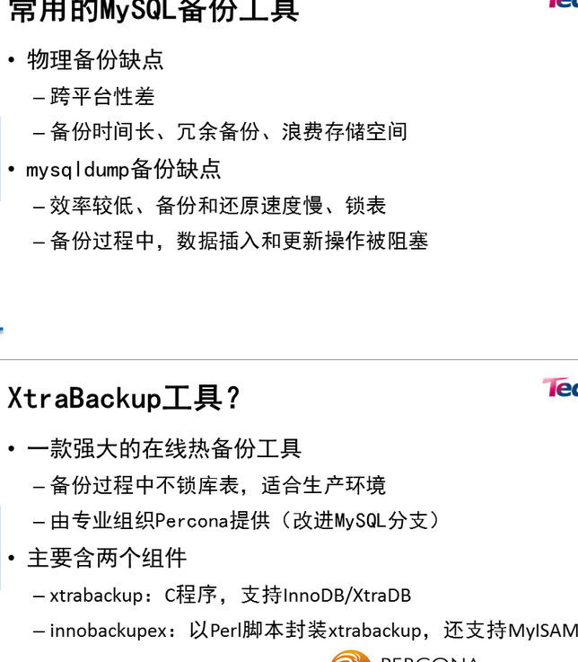

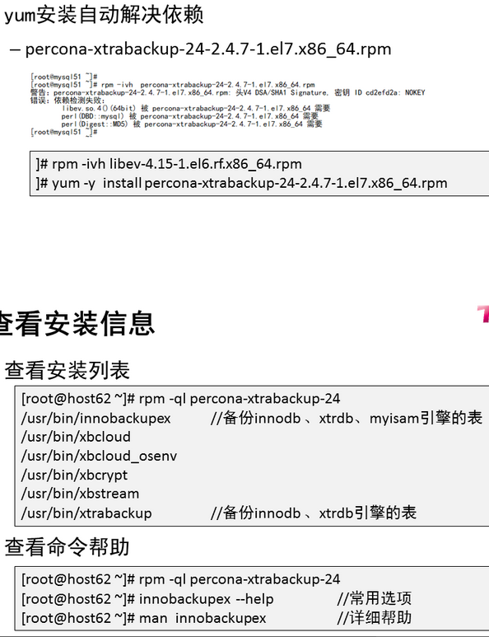

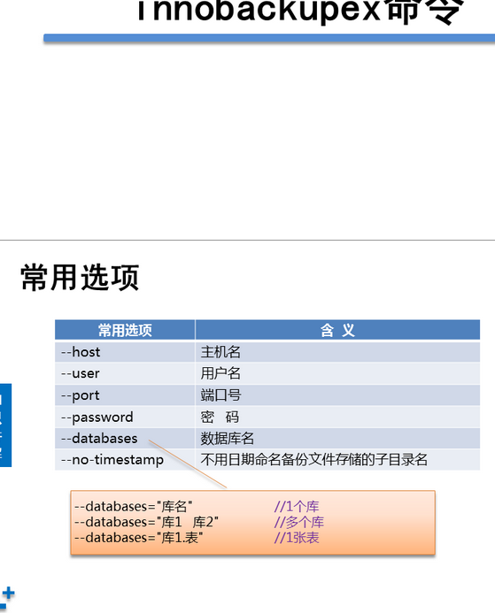

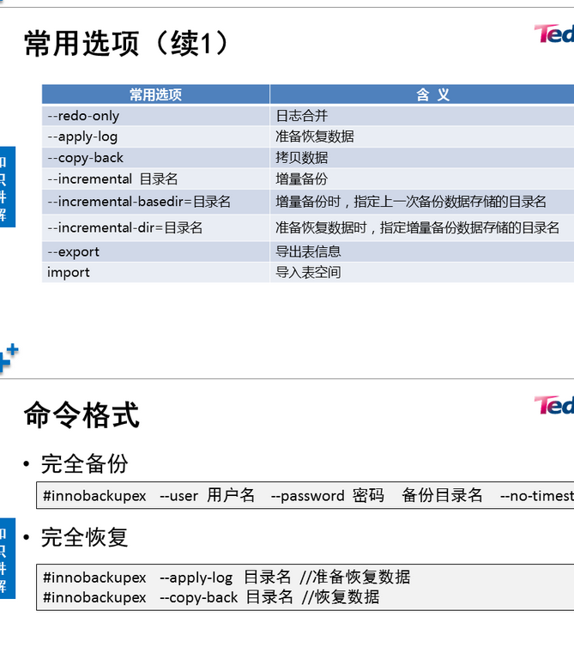

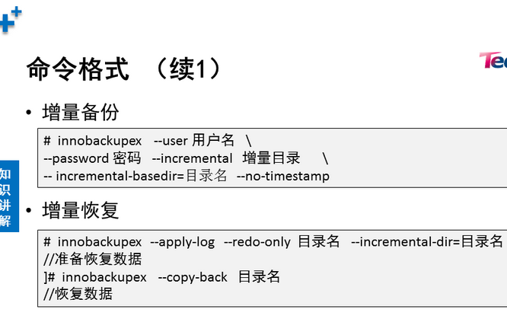

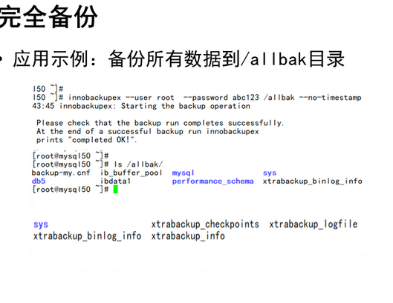

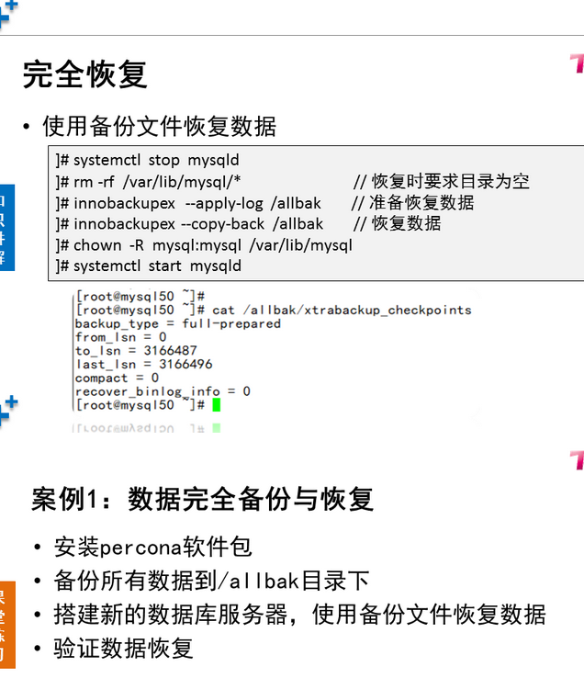

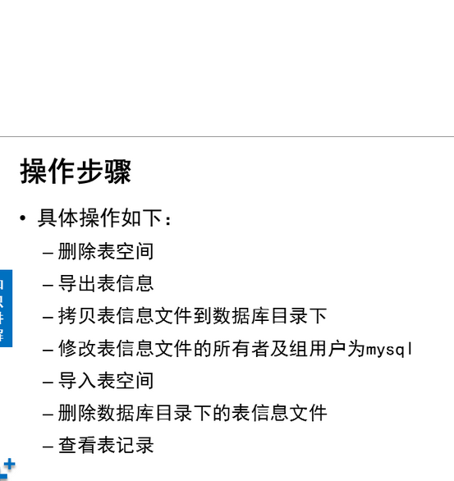

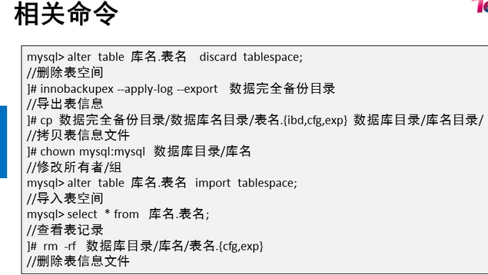

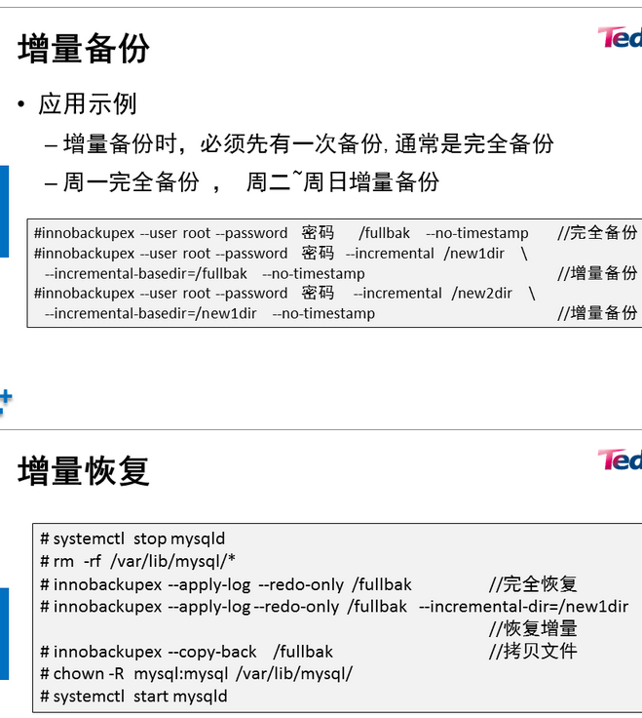

1. [案例1：数据完全备份与恢复](http://tts.tmooc.cn/ttsPage/LINUX/NSDTN202001/RDBMS1/DAY05/CASE/01/index.html#case1)
2. [案例2：恢复单张表](http://tts.tmooc.cn/ttsPage/LINUX/NSDTN202001/RDBMS1/DAY05/CASE/01/index.html#case2)
3. [案例3：增量备份与恢复](http://tts.tmooc.cn/ttsPage/LINUX/NSDTN202001/RDBMS1/DAY05/CASE/01/index.html#case3)

**1 案例1：数据完全备份与恢复**

**1.1 问题**

* 安装percona软件包
* 备份所有数据到/allbak目录下
* 搭建新的数据库服务器，使用备份文件恢复数据
* 验证数据恢复

**1.2 步骤**

实现此案例需要按照如下步骤进行。

步骤一：安装XtraBackup软件包

1）安装软件

1. [root@host50 ~]# rpm -ivh libev-4.15-1.el6.rf.x86_64.rpm
2. [root@host50 ~]# yum -y install percona-xtrabackup-24-2.4.7-1.el7.x86_64.rpm
3. 警告：percona-xtrabackup-24-2.4.6-2.el7.x86_64.rpm: 头V4 DSA/SHA1 Signature, 密钥 ID cd2efd2a: NOKEY
4. 准备中... ################################# [100%]
5. 正在升级/安装...
6. 1:percona-xtrabackup-24-2.4.6-2.el7################################# [ 33%]
7. 2:percona-xtrabackup-test-24-2.4.6-################################# [ 67%]
8. 3:percona-xtrabackup-24-debuginfo-2################################# [100%]

2）确认安装的主要程序/脚本

1. [root@host50 ~]# rpm -qa | grep -i percona
2. percona-xtrabackup-24-2.4.7-1.el7.x86_64
3. [root@host50 ~]# rpm -ql percona-xtrabackup-24
4. /usr/bin/innobackupex
5. /usr/bin/xbcloud
6. /usr/bin/xbcloud_osenv
7. /usr/bin/xbcrypt
8. /usr/bin/xbstream
9. /usr/bin/xtrabackup
10. /usr/share/doc/percona-xtrabackup-24-2.4.7
11. /usr/share/doc/percona-xtrabackup-24-2.4.7/COPYING
12. /usr/share/man/man1/innobackupex.1.gz
13. /usr/share/man/man1/xbcrypt.1.gz
14. /usr/share/man/man1/xbstream.1.gz
15. /usr/share/man/man1/xtrabackup.1.gz
16. [root@host50 ~]#
17. [root@host50 ~]# innobackupex --help //查看简单帮助
18. [root@host50 ~]#
19. [root@host50 ~]# man innobackupex //查看详细帮助
20. /usr/share/man/man1/xtrabackup.1.gz

步骤二：备份所有数据到/allbak目录下

1）备份所有数据

1. [root@host50 ~]# innobackupex --user root --password 123456 /allbak --no-timestamp //执行备份命令
2. 170425 11:05:44 innobackupex: Starting the backup operation
3. IMPORTANT: Please check that the backup run completes successfully.
4. At the end of a successful backup run innobackupex
5. prints "completed OK!".
6. Unrecognized character \x01; marked by <-- HERE after <-- HERE near column 1 at - line 1374.
7. 170425 11:05:45 Connecting to MySQL server host: localhost, user: root, password: set, port: not set, socket: not set
8. Using server version 5.7.17
9. innobackupex version 2.4.6 based on MySQL server 5.7.13 Linux (x86_64) (revision id: 8ec05b7)
10. xtrabackup: uses posix_fadvise().
11. xtrabackup: cd to /var/lib/mysql
12. xtrabackup: open files limit requested 0, set to 1024
13. xtrabackup: using the following InnoDB configuration:
14. xtrabackup: innodb_data_home_dir = .
15. xtrabackup: innodb_data_file_path = ibdata1:12M:autoextend
16. xtrabackup: innodb_log_group_home_dir = ./
17. xtrabackup: innodb_log_files_in_group = 2
18. xtrabackup: innodb_log_file_size = 50331648
19. InnoDB: Number of pools: 1
20. 170425 11:05:45 >> log scanned up to (2543893)
21. xtrabackup: Generating a list of tablespaces
22. InnoDB: Allocated tablespace ID 2 for mysql/plugin, old maximum was 0
23. 170425 11:05:45 [01] Copying ./ibdata1 to /backup/ibdata1
24. 170425 11:05:45 [01] ...done
25. 170425 11:05:46 [01] Copying ./mysql/plugin.ibd to /backup/mysql/plugin.ibd
26. 170425 11:05:46 [01] ...done
27. 170425 11:05:46 [01] Copying ./mysql/servers.ibd to /backup/mysql/servers.ibd
28. 170425 11:05:46 [01] ...done
29. 170425 11:05:46 [01] Copying ./mysql/help_topic.ibd to /backup/mysql/help_topic.ibd
30. 170425 11:05:46 [01] ...done
31. 170425 11:05:46 >> log scanned up to (2543893)
32. .. ..
33. 170425 11:06:00 [01] Copying ./sys/x@0024waits_global_by_latency.frm to /backup/sys/x@0024waits_global_by_latency.frm
34. 170425 11:06:00 [01] ...done
35. 170425 11:06:00 [01] Copying ./sys/session_ssl_status.frm to /backup/sys/session_ssl_status.frm
36. 170425 11:06:00 [01] ...done
37. 170425 11:06:00 [01] Copying ./db1/db.opt to /backup/db1/db.opt
38. 170425 11:06:00 [01] ...done
39. 170425 11:06:00 [01] Copying ./db1/tb1.frm to /backup/db1/tb1.frm
40. 170425 11:06:00 [01] ...done
41. 170425 11:06:00 Finished backing up non-InnoDB tables and files
42. 170425 11:06:00 Executing FLUSH NO_WRITE_TO_BINLOG ENGINE LOGS...
43. xtrabackup: The latest check point (for incremental): '2543884'
44. xtrabackup: Stopping log copying thread.
45. .170425 11:06:00 >> log scanned up to (2543893)
46. 170425 11:06:00 Executing UNLOCK TABLES
47. 170425 11:06:00 All tables unlocked
48. 170425 11:06:00 [00] Copying ib_buffer_pool to /backup/ib_buffer_pool
49. 170425 11:06:00 [00] ...done
50. 170425 11:06:00 Backup created in directory '/backup/'
51. 170425 11:06:00 [00] Writing backup-my.cnf
52. 170425 11:06:00 [00] ...done
53. 170425 11:06:00 [00] Writing xtrabackup_info
54. 170425 11:06:00 [00] ...done
55. xtrabackup: Transaction log of lsn (2543884) to (2543893) was copied.
56. 170425 11:06:01 completed OK

2) 确认备份好的文件数据：

1. [root@host50 ~]# ls /allbak
2. backup-my.cnf ib_buffer_pool mysql sys xtrabackup_info
3. db1 ibdata1 performance_schema xtrabackup_checkpoints xtrabackup_logfile

3）把备份文件传递给 目标服务器51

1. [root@host50 ~]#
2. [root@host50 ~]# scp -r /allbak root@192.168.4.51:/root/
3. [root@host50 ~]#

步骤三：在51主机，使用备份文件恢复数据

1）安装软件包，提供恢复命令

1. [root@host51 ~]# rpm -ivh libev-4.15-1.el6.rf.x86_64.rpm
2. [root@host51 ~]# yum -y install percona-xtrabackup-24-2.4.7-1.el7.x86_64.rpm

2）恢复数据

2. [root@host51 ~]# systemctl stop mysqld
3. [root@host51 ~]# ls /var/lib/mysql
4. [root@host51 ~]# rm -rf /var/lib/mysql/* //清空数据
5. [[root@host51](mailto:root@host51) ~]#innobackupex--apply-log --redo-only /root/allbak //恢复数据
6. 170425 11:42:19 innobackupex: Starting the apply-log operation
7. IMPORTANT: Please check that the apply-log run completes successfully.
8. At the end of a successful apply-log run innobackupex
9. prints "completed OK!".
10. innobackupex version 2.4.6 based on MySQL server 5.7.13 Linux (x86_64) (revision id: 8ec05b7)
11. xtrabackup: cd to /backup/
12. xtrabackup: This target seems to be already prepared.
13. InnoDB: Number of pools: 1
14. xtrabackup: notice: xtrabackup_logfile was already used to '--prepare'.
15. xtrabackup: using the following InnoDB configuration for recovery:
16. xtrabackup: innodb_data_home_dir = .
17. xtrabackup: innodb_data_file_path = ibdata1:12M:autoextend
18. xtrabackup: innodb_log_group_home_dir = .
19. xtrabackup: innodb_log_files_in_group = 2
20. xtrabackup: innodb_log_file_size = 50331648
21. xtrabackup: using the following InnoDB configuration for recovery:
22. xtrabackup: innodb_data_home_dir = .
23. xtrabackup: innodb_data_file_path = ibdata1:12M:autoextend
24. xtrabackup: innodb_log_group_home_dir = .
25. xtrabackup: innodb_log_files_in_group = 2
26. xtrabackup: innodb_log_file_size = 50331648
27. xtrabackup: Starting InnoDB instance for recovery.
28. xtrabackup: Using 104857600 bytes for buffer pool (set by --use-memory parameter)
29. InnoDB: PUNCH HOLE support available
30. InnoDB: Mutexes and rw_locks use GCC atomic builtins
31. InnoDB: Uses event mutexes
32. InnoDB: GCC builtin __atomic_thread_fence() is used for memory barrier
33. InnoDB: Compressed tables use zlib 1.2.7
34. InnoDB: Number of pools: 1
35. InnoDB: Not using CPU crc32 instructions
36. InnoDB: Initializing buffer pool, total size = 100M, instances = 1, chunk size = 100M
37. InnoDB: Completed initialization of buffer pool
38. InnoDB: page_cleaner coordinator priority: -20
39. InnoDB: Highest supported file format is Barracuda.
40. xtrabackup: starting shutdown with innodb_fast_shutdown = 1
41. InnoDB: Starting shutdown...
42. InnoDB: Shutdown completed; log sequence number 2544177
43. InnoDB: Number of pools: 1
44. 170425 11:42:20 completed OK!
45. [[root@host51](mailto:root@host51) ~]#
46. [[root@host51](mailto:root@host51) ~]# innobackupex --copy-back /root/allbak //拷贝数据
47. 170425 11:42:55 innobackupex: Starting the apply-log operation
48. IMPORTANT: Please check that the apply-log run completes successfully.
49. At the end of a successful apply-log run innobackupex
50. prints "completed OK!".
51. innobackupex version 2.4.6 based on MySQL server 5.7.13 Linux (x86_64) (revision id: 8ec05b7)
52. incremental backup from 2543884 is enabled.
53. xtrabackup: cd to /backup/
54. xtrabackup: This target seems to be already prepared with --apply-log-only.
55. InnoDB: Number of pools: 1
56. xtrabackup: xtrabackup_logfile detected: size=8388608, start_lsn=(2549924)
57. xtrabackup: using the following InnoDB configuration for recovery:
58. xtrabackup: innodb_data_home_dir = .
59. xtrabackup: innodb_data_file_path = ibdata1:12M:autoextend
60. xtrabackup: innodb_log_group_home_dir = /incr01/
61. xtrabackup: innodb_log_files_in_group = 1
62. xtrabackup: innodb_log_file_size = 8388608
63. xtrabackup: Generating a list of tablespaces
64. InnoDB: Allocated tablespace ID 2 for mysql/plugin, old maximum was 0
65. xtrabackup: page size for /incr01//ibdata1.delta is 16384 bytes
66. Applying /incr01//ibdata1.delta to ./ibdata1...
67. ... ...
68. 170425 11:43:09 [01] Copying /incr01/performance_schema/global_status.frm to ./performance_schema/global_status.frm
69. 170425 11:43:09 [01] ...done
70. 170425 11:43:09 [01] Copying /incr01/performance_schema/session_status.frm to ./performance_schema/session_status.frm
71. 170425 11:43:09 [01] ...done
72. 170425 11:43:09 [00] Copying /incr01//xtrabackup_info to ./xtrabackup_info
73. 170425 11:43:09 [00] ...done
74. 170425 11:43:10 completed OK!
75. [[root@host50](mailto:root@host50) ~]# chown -R mysql:mysql /var/lib/mysql //修改所有者与组

步骤四：验证数据恢复

1）启动服务

1. [root@host51 ~]# systemctl start mysqld
2. [root@host51 ~]# mysql -uroot -p123456
3. mysql> show databases;
4. mysql> select * from db3.user2;
5. mysql>select count(*) from db3.user;
6. mysql>

2）查看数据

1. [root@host51 ~]# mysql -uroot -p123456
2. mysql> show databases;
3. mysql> select * from db3.user2;
4. mysql> select count(*) from db3.user;

**2 案例2：恢复单张表**

**2.1 问题**

* 执行删除数据命令
* 使用备份目录/allbak 恢复表数据
* 验证数据恢复

**2.2 步骤**

实现此案例需要按照如下步骤进行。

步骤一：安装XtraBackup软件包

1）执行删除数据命令

1. [root@host50 ~]# mysql –uroot -p123456
2. mysql> delete from db3.user2; //误删除数据操作
3. mysql>

2) 删除表空间

1. mysql> alter table db3.user2 discard tablespace;

3) 导出表信息

1. [root@host50 ~ ]# innobackupex --apply-log --export /allbak

4) 拷贝表信息文件到数据库目录下

1. [root@host50 ~]# cp /allbak/db3/user2.{cfg,exp,ibd} /var/lib/mysql/db3/

5) 修改表信息文件的所有者及组用户为mysql

1. [root@host50 ~]# chown mysql:mysql /var/lib/mysql/db3/user2.*

6) 导入表空间

1. mysql> alter table db3.user2 import tablespace;

7) 删除数据库目录下的表信息文件

1. [root@host50 ~]# rm -rf /var/lib/mysql/db3/user2.cfg
2. [root@host50 ~]# rm -rf /var/lib/mysql/db3/user2.exp

8) 查看表记录

1. mysql> select * from db3.user2;

**3 案例3：增量备份与恢复**

**3.1 问题**

* 具体要求如下：
* 备份所有数据
* 备份新产生的数据
* 删除数据
* 使用备份文件恢复数据

**3.2 步骤**

实现此案例需要按照如下步骤进行。

步骤一：备份所有数据,在50主机执行

1）完全备份 （备份所有数据到/fullbak目录）

1. [root@host50 ~]# innobackupex --user root --password 123456 /fullbak --no-timestamp

步骤二：增量备份 （每次执行备份，值备份新数据,在50主机执行）

1) 插入新记录，并做增量备份

1. mysql> insert into db3.user2 values(5,"jack");// 插入新记录,多写几条
2. [root@host50 ~]# innobackupex --user root --password 123456 --incremental /new1dir --incremental-basedir=/fullbak --no-timestamp //第1次增量备份 ，数据存储目录/new1dir

2) 插入新记录，并做增量备份

mysql> insert into db3.user2 values(6,"jack");// 插入新记录,多写几条

[root@host50 ~]# innobackupex --user root --password 123456 --incremental /new2dir --incremental-basedir=/newdir1 --no-timestamp //第2次增量备份 ，数据存储目录/new2dir

3) 把备份文件拷贝给目标主机51

1. [root@host50 ~]# scp -r /fullbak root@192.168.4.51:/root/
2. [root@host50 ~]# scp -r /new1dir/ root@192.168.4.51:/root/
3. [root@host50 ~]# scp -r /new2dir/ root@192.168.4.51:/root/

步骤三：在主机51 恢复数据

1) 停止服务，并清空数据

1. [root@host51 ~]# systemctl stop mysqld
2. [root@host51 ~]# rm -rf /var/lib/mysql/*

2) 合并日志

1. [root@host51 ~ ]# innobackupex --apply-log --redo-only /root/fullbak //准备恢复数据
2. [root@host51 ~ ]# innobackupex --apply-log --redo-only /root/fullbak --incremental-dir=/root/new1dir //合并日志
3. [root@host51 ~ ]# innobackupex --apply-log --redo-only /root/fullbak --incremental-dir=/root/new2dir //合并日志
4. [root@host51 ~ ]# rm -rf /root/new2dir //恢复后，可以删除了
5. [root@host51 ~ ]# rm -rf /root/new1dir //恢复后，可以删除了

3) 恢复数据

1. [root@host51 ~ ]# innobackupex --copy-back /root/fullbak //拷贝文件到数据库目录下
2. [root@host51 ~ ]# chown -R mysql:mysql /var/lib/mysql //修改所有者与组用户
3. [root@host51 ~ ]# systemctl start mysqld //启动服务
4. [root@host51 ~ ]# mysql -uroot -p123456 //登录
5. mysql> select count(*) from db3.user; //查