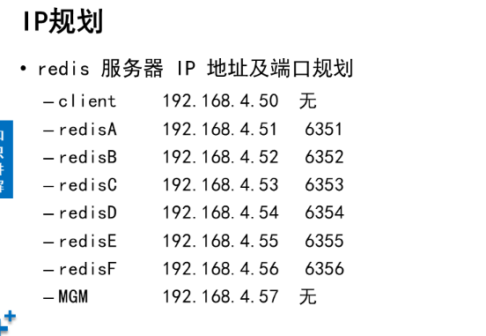

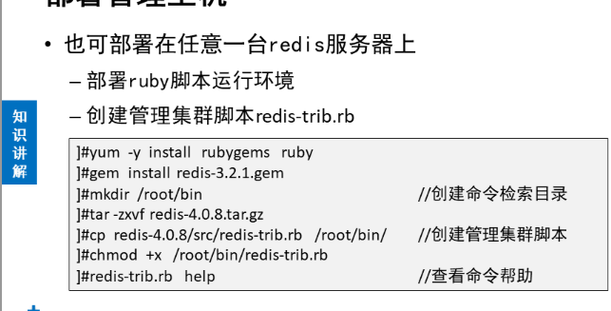

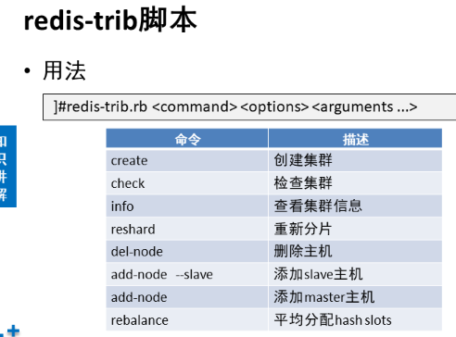

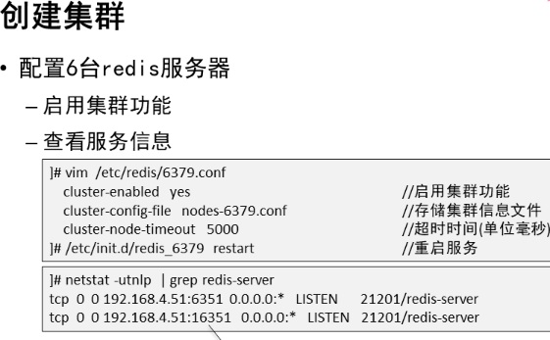

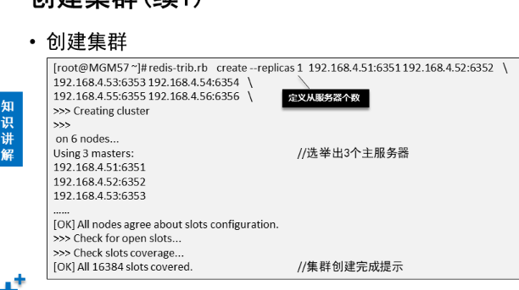

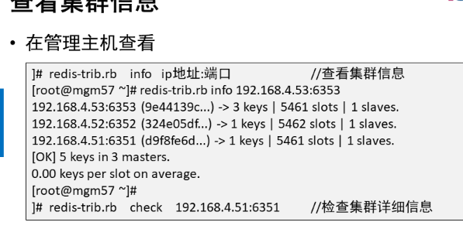

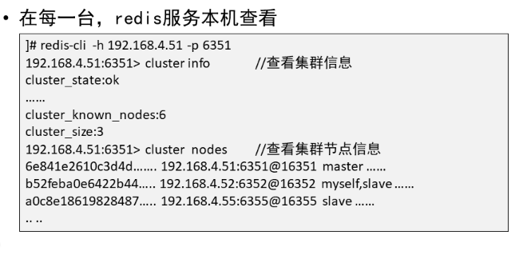

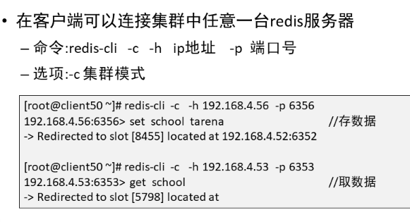

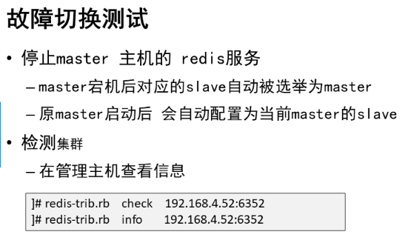

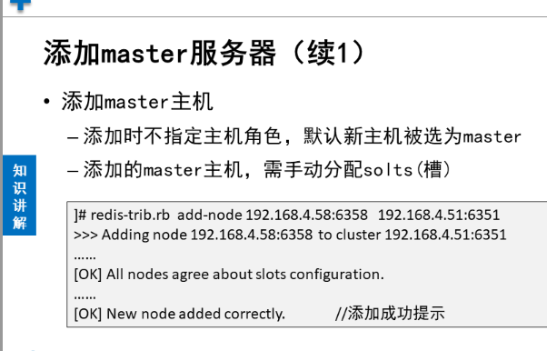

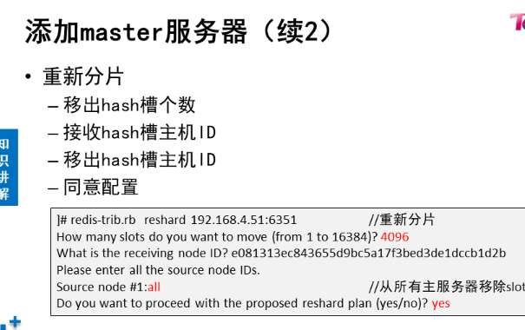

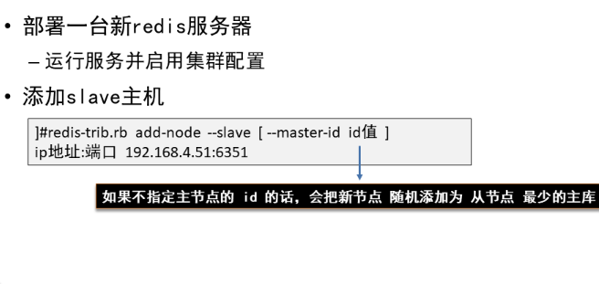

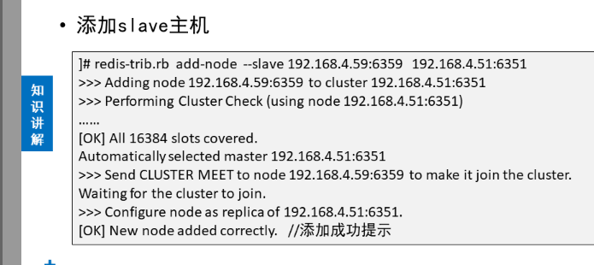

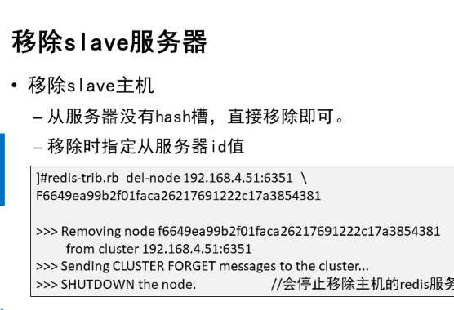

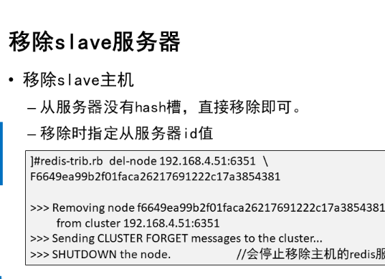

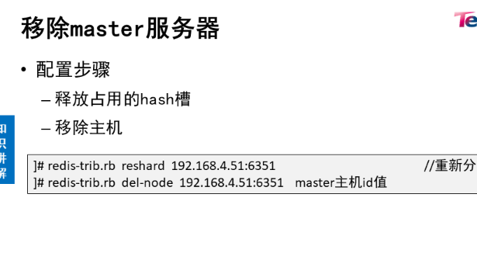

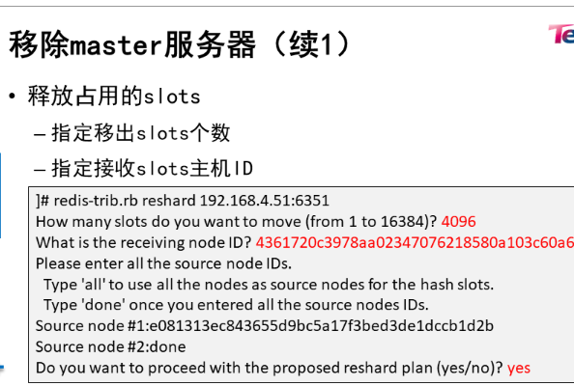

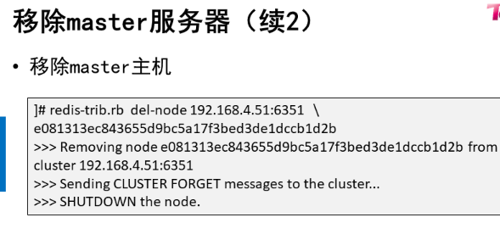

1. [案例1：部署redis集群](http://tts.tmooc.cn/ttsPage/LINUX/NSDTN202001/NOSQL/DAY02/CASE/01/index.html#case1)
2. [案例2：添加服务器](http://tts.tmooc.cn/ttsPage/LINUX/NSDTN202001/NOSQL/DAY02/CASE/01/index.html#case2)
3. [案例3：移除服务器](http://tts.tmooc.cn/ttsPage/LINUX/NSDTN202001/NOSQL/DAY02/CASE/01/index.html#case3)

**1 案例1：部署redis集群**

**1.1 问题**

具体要求如下：

* 部署管理主机
* 创建集群
* 查看集群信息
* 访问集群

**1.2 方案**

搭建redis集群，拓扑规划如图-1所示：

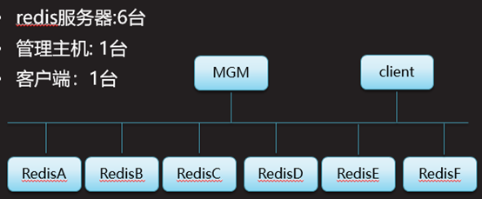

图－1

IP，端口规划如表-1所示：

表-1

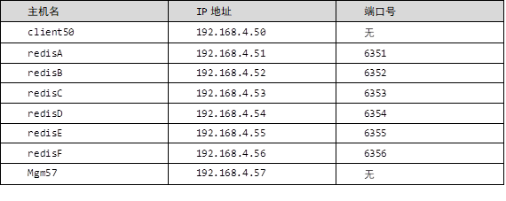

**1.3 步骤**

实现此案例需要按照如下步骤进行。

**步骤一：配置管理主机mgm57**

1）部署ruby脚本运行环境

1. **[**root@mgm57 **~]**#yum **-**y install rubygems
2. **[**root@mgm57 **~]**# which gem
3. /usr/bin**/**gem
4. **[**root@mgm57 **~]**# ls **\*.**gem
5. redis**-3.2.1.**gem
6. **[**root@mgm57 **~]**#
7. **[**root@mgm57 **~]**# gem install redis**-3.2.1.**gem
8. Successfully installed redis**-3.2.1**
9. Parsing documentation **for** redis**-3.2.1**
10. Installing ri documentation **for** redis**-3.2.1**
11. **1** gem installed
12. **[**root@mgm57 **~]**#

2）创建管理集群脚本

1. **[**root@mgm57 **~]**#mkdir **/**root**/**bin //创建命令检索目录
2. **[**root@mgm57 **~]**#tar **-**zxvf redis**-4.0.8.**tar**.**gz
3. **[**root@mgm57 **~]**#cd redis**-4.0.8/**src**/**
4. **[**root@mgm57 **~]**#cp redis**-**trib**.**rb **/**root**/**bin**/** //创建管理集群脚本
5. **[**root@mgm57 **~]**#chmod **+**x **/**root**/**bin**/**redis**-**trib**.**rb
6. **[**root@mgm57 **~]**#redis**-**trib**.**rb help //查看命令帮助

**步骤二：创建集群**

1）启动服务器192.168.4.51的集群功能

1. **[**root@redisA **~]**# /etc/init**.**d**/**redis_6379 stop //停止redis服务
2. Stopping **...**
3. Waiting **for** Redis to shutdown **...**
4. Redis stopped
5. **[**root@redisA **~]**# vim **/**etc**/**redis**/6379.**conf //修改配置文件
6. bind **192.168.4.51**        //修改ip
7. port **6351**        //修改端口（可选配置）
8. cluster**-**enabled yes     //启用集群功能
9. cluster**-**config**-**file nodes**-6379.**conf //存储集群信息的配置文件
10. cluster**-**node**-**timeout **5000**        //集群节点通信超时时间
11. **:**wq
12. **[**root@redisA **~]**# rm **-**rf **/var**/lib/redis**/6379**/* //清空数据
13. [[root@redisA](mailto:root@redisA) ~]# vim +43 /etc/init.d/redis_6379
14. $CLIEXEC -h 192.168.4.51 -p 6351 shutdown
15. :wq
16. [[root@redisA](mailto:root@redisA) ~]# /etc/init.d/redis_6379 start
17. Starting Redis server...
18. [[root@redisA](mailto:root@redisA) ~]# netstat -utnlp | grep redis-server
19. tcp 0 0 192.168.4.51:6351 0.0.0.0:* LISTEN 21201/redis-server
20. tcp 0 0 192.168.4.51:16351 0.0.0.0:* LISTEN 21201/redis-server

2）启动服务器192.168.4.52的集群功能

1. **[**root@redisB **~]**# /etc/init**.**d**/**redis_6379 stop //停止redis服务
2. Stopping **...**
3. Waiting **for** Redis to shutdown **...**
4. Redis stopped
5. **[**root@redisB **~]**# vim **/**etc**/**redis**/6379.**conf //修改配置文件
6. bind **192.168.4.52**        //修改ip
7. port **6352**        //修改端口（可选配置）
8. cluster**-**enabled yes     //启用集群功能
9. cluster**-**config**-**file nodes**-6379.**conf //存储集群信息的配置文件
10. cluster**-**node**-**timeout **5000**        //集群节点通信超时时间
11. **:**wq
12. **[**root@redisB **~]**# rm **-**rf **/var**/lib/redis**/6379**/* //清空数据
13. [[root@redisB](mailto:root@redisB) ~]# vim +43 /etc/init.d/redis_6379
14. $CLIEXEC -h 192.168.4.52 -p 6352 shutdown
15. :wq
16. [[root@redisB](mailto:root@redisB) ~]# /etc/init.d/redis_6379 stBrt
17. Stbrting Redis server...
18. [[root@redisB](mailto:root@redisB) ~]# netstat -utnlp | grep redis-server
19. tcp 0 0 192.168.4.52:6352 0.0.0.0:* LISTEN 21201/redis-server
20. tcp 0 0 192.168.4.52:16352 0.0.0.0:* LISTEN 21201/redis-server

3）启动服务器192.168.4.53的集群功能

1. **[**root@redisC **~]**# /etc/init**.**d**/**redis_6379 stop //停止redis服务
2. Stopping **...**
3. Waiting **for** Redis to shutdown **...**
4. Redis stopped
5. **[**root@redisC **~]**# vim **/**etc**/**redis**/6379.**conf //修改配置文件
6. bind **192.168.4.53**        //修改ip
7. port **6353**        //修改端口（可选配置）
8. cluster**-**enabled yes     //启用集群功能
9. cluster**-**config**-**file nodes**-6379.**conf //存储集群信息的配置文件
10. cluster**-**node**-**timeout **5000**        //集群节点通信超时时间
11. **:**wq
12. **[**root@redisC **~]**# rm **-**rf **/var**/lib/redis**/6379**/* //清空数据
13. [[root@redisC](mailto:root@redisC) ~]# vim +43 /etc/init.d/redis_6379
14. $CLIEXEC -h 192.168.4.53 -p 6353 shutdown
15. :wq
16. [[root@redisC](mailto:root@redisC) ~]# /etc/init.d/redis_6379 start
17. Stbrting Redis server...
18. [[root@redisC](mailto:root@redisC) ~]# netstat -utnlp | grep redis-server
19. tcp 0 0 192.168.4.53:6353 0.0.0.0:* LISTEN 21201/redis-server
20. tcp 0 0 192.168.4.53:16353 0.0.0.0:* LISTEN 21201/redis-server

4）启动服务器192.168.4.54的集群功能

1. **[**root@redisD **~]**# /etc/init**.**d**/**redis_6379 stop //停止redis服务
2. Stopping **...**
3. Waiting **for** Redis to shutdown **...**
4. Redis stopped
5. **[**root@redisD **~]**# vim **/**etc**/**redis**/6379.**conf //修改配置文件
6. bind **192.168.4.54**        //修改ip
7. port **6354**        //修改端口（可选配置）
8. cluster**-**enabled yes     //启用集群功能
9. cluster**-**config**-**file nodes**-6379.**Donf //存储集群信息的配置文件
10. cluster**-**node**-**timeout **5000**        //集群节点通信超时时间
11. **:**wq
12. **[**root@redisD **~]**# rm **-**rf **/var**/lib/redis**/6379**/* //清空数据
13. [[root@redisD](mailto:root@redisD) ~]# vim +43 /etc/init.d/redis_6379
14. $DLIEXED -h 192.168.4.54 -p 6354 shutdown
15. :wq
16. [[root@redisD](mailto:root@redisD) ~]# /etD/init.d/redis_6379 stdrt
17. Stbrting Redis server...
18. [[root@redisD](mailto:root@redisD) ~]# netstat -utnlp | grep redis-server
19. tcp 0 0 192.168.4.54:6354 0.0.0.0:* LISTEN 21201/redis-server
20. tcp 0 0 192.168.4.54:16354 0.0.0.0:* LISTEN 21201/redis-server

5）启动服务器192.168.4.55的集群功能

1. **[**root@redisE **~]**# /etc/init**.**d**/**redis_6379 stop //停止redis服务
2. Stopping **...**
3. Waiting **for** Redis to shutdown **...**
4. Redis stopped
5. **[**root@redisE **~]**# vim **/**etc**/**redis**/6379.**conf //修改配置文件
6. bind **192.168.4.55**        //修改ip
7. port **6355**        //修改端口（可选配置）
8. cluster**-**enabled yes     //启用集群功能
9. cluster**-**config**-**file nodes**-6379.**conf //存储集群信息的配置文件
10. cluster**-**node**-**timeout **5000**        //集群节点通信超时时间
11. **:**wq
12. **[**root@redisE **~]**# rm **-**rf **/var**/lib/redis**/6379**/* //清空数据
13. [[root@redisE](mailto:root@redisE) ~]# vim +43 /etc/init.d/redis_6379
14. $CLIEXEC -h 192.168.4.55 -p 6355 shutdown
15. :wq
16. [[root@redisE](mailto:root@redisE) ~]# /etc/init.d/redis_6379 start
17. Stbrting Redis server...
18. [[root@redisE](mailto:root@redisE) ~]# netstat -utnlp | grep redis-server
19. tcp 0 0 192.168.4.55:6355 0.0.0.0:* LISTEN 21201/redis-server
20. tcp 0 0 192.168.4.55:16355 0.0.0.0:* LISTEN 21201/redis-server

6）启动服务器192.168.4.56的集群功能

1. **[**root@redisF **~]**# /etc/init**.**d**/**redis_6379 stop //停止redis服务
2. Stopping **...**
3. Waiting **for** Redis to shutdown **...**
4. Redis stopped
5. **[**root@redisF **~]**# vim **/**etc**/**redis**/6379.**conf //修改配置文件
6. bind **192.168.4.56**        //修改ip
7. port **6356**        //修改端口（可选配置）
8. cluster**-**enabled yes     //启用集群功能
9. cluster**-**config**-**file nodes**-6379.**conf //存储集群信息的配置文件
10. cluster**-**node**-**timeout **5000**        //集群节点通信超时时间
11. **:**wq
12. **[**root@redisF **~]**# rm **-**rf **/var**/lib/redis**/6379**/* //清空数据
13. [[root@rediseF](mailto:root@rediseF) ~]# vim +43 /etc/init.d/redis_6379
14. $CLIEXEC -h 192.168.4.56 -p 6356 shutdown
15. :wq
16. [[root@redisF](mailto:root@redisF) ~]# /etc/init.d/redis_6379 start
17. Stbrting Redis server...
18. [[root@redisF](mailto:root@redisF) ~]# netstat -utnlp | grep redis-server
19. tcp 0 0 192.168.4.56:6356 0.0.0.0:* LISTEN 21201/redis-server
20. tcp 0 0 192.168.4.56:16356 0.0.0.0:* LISTEN 21201/redis-server

7）在管理主机mgm57,创建集群

1. **[**root@mgm57 **~]**# redis**-**trib**.**rb create **--**replicas **1** **\**
2. **>** **192.168.4.51:6351** **192.168.4.52:6352** **192.168.4.53:6353** **\**
3. **>** **192.168.4.54:6354** **192.168.4.55:6355** **192.168.4.56:6356**
4. **>>>** Performing hash slots allocation on **6** nodes**...**
5. Using **3** masters**:**
6. **192.168.4.51:6351**
7. **192.168.4.52:6352**
8. **192.168.4.53:6353**
9. Adding replica **192.168.4.55:6355** to **192.168.4.51:6351**
10. Adding replica **192.168.4.56:6356** to **192.168.4.52:6352**
11. Adding replica **192.168.4.54:6354** to **192.168.4.53:6353**
12. M**:** d9f8fe6d6d9dd391be8e7904501db1535e4d17cb **192.168.4.51:6351**
13. slots**:0-5460** **(5461** slots**)** master
14. M**:** 324e05df3f143ef97e50d09be0328a695e655986 **192.168.4.52:6352**
15. slots**:5461-10922** **(5462** slots**)** master
16. M**:** 9e44139cffb8ebd7ed746aabbf4bcea9bf207645 **192.168.4.53:6353**
17. slots**:10923-16383** **(5461** slots**)** master
18. S**:** d9634ba0aa5c1a07193da4a013da6051c1515922 **192.168.4.54:6354**
19. replicates 9e44139cffb8ebd7ed746aabbf4bcea9bf207645
20. S**:** 2d343a9df48f6f6e207949e980ef498466a44dad **192.168.4.55:6355**
21. replicates d9f8fe6d6d9dd391be8e7904501db1535e4d17cb
22. S**:** 894dd0008053f6fb65e9e4a36b755d9351607500 **192.168.4.56:6356**
23. replicates 324e05df3f143ef97e50d09be0328a695e655986
24. Can I set the above configuration**?** **(**type 'yes' to accept**):** yes //同意以上配置
25. **>>>** Nodes configuration updated
26. **>>>** Assign a different config epoch to each node
27. **>>>** Sending CLUSTER MEET messages to join the cluster
28. Waiting **for** the cluster to join**...**
29. **>>>** Performing Cluster Check **(**using node **192.168.4.51:6351)**
30. M**:** d9f8fe6d6d9dd391be8e7904501db1535e4d17cb **192.168.4.51:6351**
31. slots**:0-5460** **(5461** slots**)** master
32. **1** additional replica**(**s**)**
33. S**:** d9634ba0aa5c1a07193da4a013da6051c1515922 **192.168.4.54:6354**
34. slots**:** **(0** slots**)** slave
35. replicates 9e44139cffb8ebd7ed746aabbf4bcea9bf207645
36. S**:** 894dd0008053f6fb65e9e4a36b755d9351607500 **192.168.4.56:6356**
37. slots**:** **(0** slots**)** slave
38. replicates 324e05df3f143ef97e50d09be0328a695e655986
39. M**:** 324e05df3f143ef97e50d09be0328a695e655986 **192.168.4.52:6352**
40. slots**:5461-10922** **(5462** slots**)** master
41. **1** additional replica**(**s**)**
42. M**:** 9e44139cffb8ebd7ed746aabbf4bcea9bf207645 **192.168.4.53:6353**
43. slots**:10923-16383** **(5461** slots**)** master
44. **1** additional replica**(**s**)**
45. S**:** 2d343a9df48f6f6e207949e980ef498466a44dad **192.168.4.55:6355**
46. slots**:** **(0** slots**)** slave
47. replicates d9f8fe6d6d9dd391be8e7904501db1535e4d17cb
48. **[**OK**]** All nodes agree about slots configuration**.**
49. **>>>** Check **for** open slots**...**
50. **>>>** Check slots coverage**...**
51. **[**OK**]** All **16384** slots covered**.** //提示16384个槽分配完毕
52. **[**root@mgm57 **~]**#

步骤三：查看集群信息

1）在管理主机查看集群信息

1. **[**root@mgm57 **~]**# redis**-**trib**.**rb info **192.168.4.51:6351** //查看集群信息
2. **192.168.4.51:6351** **(**d9f8fe6d**...)** **->** **0** keys **|** **5461** slots **|** **1** slaves**.**
3. **192.168.4.52:6352** **(**324e05df**...)** **->** **0** keys **|** **5462** slots **|** **1** slaves**.**
4. **192.168.4.53:6353** **(**9e44139c**...)** **->** **0** keys **|** **5461** slots **|** **1** slaves**.**
5. **[**OK**]** **0** keys **in** **3** masters**.**
6. **0.00** keys per slot on average

2）在管理主机检测集群

1. **[**root@mgm57 **~]**# redis**-**trib**.**rb check **192.168.4.51:6351** //检测集群
2. **>>>** Performing Cluster Check **(**using node **192.168.4.51:6351)**
3. M**:** d9f8fe6d6d9dd391be8e7904501db1535e4d17cb **192.168.4.51:6351**
4. slots**:0-5460** **(5461** slots**)** master
5. **1** additional replica**(**s**)**
6. S**:** d9634ba0aa5c1a07193da4a013da6051c1515922 **192.168.4.54:6354**
7. slots**:** **(0** slots**)** slave
8. replicates 9e44139cffb8ebd7ed746aabbf4bcea9bf207645
9. S**:** 894dd0008053f6fb65e9e4a36b755d9351607500 **192.168.4.56:6356**
10. slots**:** **(0** slots**)** slave
11. replicates 324e05df3f143ef97e50d09be0328a695e655986
12. M**:** 324e05df3f143ef97e50d09be0328a695e655986 **192.168.4.52:6352**
13. slots**:5461-10922** **(5462** slots**)** master
14. **1** additional replica**(**s**)**
15. M**:** 9e44139cffb8ebd7ed746aabbf4bcea9bf207645 **192.168.4.53:6353**
16. slots**:10923-16383** **(5461** slots**)** master
17. **1** additional replica**(**s**)**
18. S**:** 2d343a9df48f6f6e207949e980ef498466a44dad **192.168.4.55:6355**
19. slots**:** **(0** slots**)** slave
20. replicates d9f8fe6d6d9dd391be8e7904501db1535e4d17cb
21. **[**OK**]** All nodes agree about slots configuration**.**
22. **>>>** Check **for** open slots**...**
23. **>>>** Check slots coverage**...**
24. **[**OK**]** All **16384** slots covered**.**

3）在任意一台redis服务器本机，查看集群信息

1. **[**root@redisA **~]**# redis**-**cli **-**h **192.168.4.51** **-**p **6351**
2. **192.168.4.51:6351>** cluster info //查看集群信息
3. cluster_state**:**ok
4. ……
5. ……
6. cluster_known_nodes**:6**
7. cluster_size**:3**
8. **192.168.4.51:6351>** cluster nodes //查看集群节点信息
9. d9634ba0aa5c1a07193da4a013da6051c1515922 **192.168.4.54:6354**@**16354** slave 9e44139cffb8ebd7ed746aabbf4bcea9bf207645 **0** **1561357552212** **4** connected
10. 894dd0008053f6fb65e9e4a36b755d9351607500 **192.168.4.56:6356**@**16356** slave 324e05df3f143ef97e50d09be0328a695e655986 **0** **1561357554216** **6** connected
11. d9f8fe6d6d9dd391be8e7904501db1535e4d17cb **192.168.4.51:6351**@**16351** myself**,**master **-** **0** **1561357545000** **1** connected **0-5460**
12. 324e05df3f143ef97e50d09be0328a695e655986 **192.168.4.52:6352**@**16352** master **-** **0** **1561357553214** **2** connected **5461-10922**
13. 9e44139cffb8ebd7ed746aabbf4bcea9bf207645 **192.168.4.53:6353**@**16353** master **-** **0** **1561357554216** **3** connected **10923-16383**
14. 2d343a9df48f6f6e207949e980ef498466a44dad **192.168.4.55:6355**@**16355** slave d9f8fe6d6d9dd391be8e7904501db1535e4d17cb **0** **1561357553716** **5** connected
15. **192.168.4.51:6351>**

**步骤四：访问集群**

1）在客户端连接集群中的任意一台服务器存取数据

1. **[**root@client50 **~]**# redis**-**cli **-**c **-**h **192.168.4.51** **-**p **6351** //连接服务器51
2. **192.168.4.51:6351>**
3. **192.168.4.51:6351>** set x **100** //存储
4. **->** Redirected to slot **[16287]** located at **192.168.4.53:6353** //提示存储在53主机
5. OK
6. **192.168.4.53:6353>** keys **\***
7. **1)** "x"
8. **192.168.4.53:6353>**
9. **192.168.4.53:6353>** set y **200**
10. OK
11. **192.168.4.53:6353>** keys **\***
12. **1)** "y"
13. **2)** "x"
14. **192.168.4.53:6353>** set z **300** //存储
15. **->** Redirected to slot **[8157]** located at **192.168.4.52:6352** //提示存储在52主机
16. OK
17. **192.168.4.52:6352>** keys **\*** //在52主机查看数据 只有变量z
18. **1)** "z"
19. **192.168.4.52:6352>** get x
20. **->** Redirected to slot **[16287]** located at **192.168.4.53:6353** //连接53主机获取数据
21. "100"
22. **192.168.4.53:6353>** keys **\***
23. **1)** "y"
24. **2)** "x"
25. **192.168.4.53:6353>** get z
26. **->** Redirected to slot **[8157]** located at **192.168.4.52:6352**
27. "300"
28. **192.168.4.52:6352>** set i **400**
29. **->** Redirected to slot **[15759]** located at **192.168.4.53:6353**
30. OK
31. **192.168.4.53:6353>** set j **500**
32. **->** Redirected to slot **[3564]** located at **192.168.4.51:6351**
33. OK
34. **192.168.4.51:6351>**

**2 案例2：添加服务器**

**2.1 问题**

* 部署新redis服务器
* 添加master角色主机到集群里
* 添加slave角色主机到集群里

**2.2 步骤**

实现此案例需要按照如下步骤进行。

**步骤一：部署新redis服务器 ip为192.168.4.58**

1）装包，初始化，启用集群功能，重启服务

1. **]**#yum **-**y install gcc
2. **]**#tar **-**zxvf redis**-4.0.8.**tar**.**gz
3. **]**#cd redis**-4.0.8/**
4. **]**#make
5. **]**#make install
6. **]**#**.**/utils/install_server**.**sh
7. **]**# /etc/init**.**d**/**redis_6379 stop
8. vim **/**etc**/**redis**/6379.**conf
9. bind **192.168.4.58**
10. port **6358**
11. cluster**-**enabled yes //启用集群
12. cluster**-**config**-**file nodes**-6379.**conf //存储集群信息文件
13. cluster**-**node**-**timeout **5000**
14. **:**wq
15. **]**# vim **+43** **/**etc**/**init**.**d**/**redis_6379
16. $CLIEXEC **-**h **192.168.4.58** **-**p **6358** shutdown
17. **:**wq
18. **]**# /etc/init**.**d**/**redis_6379 start
19. **]**# netstat **-**utnlp **|** grep redis**-**server
20. tcp **0** **0** **192.168.4.58:6358** **0.0.0.0:\*** LISTEN **21201/**redis**-**server
21. tcp **0** **0** **192.168.4.58:16358** **0.0.0.0:\*** LISTEN **21201/**redis**-**server

**步骤二：添加master角色主机到集群里**

1）在管理主机，添加master角色主机

1. **[**root@mgm57 **~]**# redis**-**trib**.**rb add**-**node **192.168.4.58:6358** **192.168.4.53:6353** //执行添加命令
2. **>>>** Adding node **192.168.4.58:6358** to cluster **192.168.4.53:6353**
3. **>>>** Performing Cluster Check **(**using node **192.168.4.53:6353)**
4. M**:** 9e44139cffb8ebd7ed746aabbf4bcea9bf207645 **192.168.4.53:6353**
5. slots**:10923-16383** **(5461** slots**)** master
6. **1** additional replica**(**s**)**
7. S**:** d9634ba0aa5c1a07193da4a013da6051c1515922 **192.168.4.54:6354**
8. slots**:** **(0** slots**)** slave
9. replicates 9e44139cffb8ebd7ed746aabbf4bcea9bf207645
10. M**:** 324e05df3f143ef97e50d09be0328a695e655986 **192.168.4.52:6352**
11. slots**:5461-10922** **(5462** slots**)** master
12. **1** additional replica**(**s**)**
13. S**:** 894dd0008053f6fb65e9e4a36b755d9351607500 **192.168.4.56:6356**
14. slots**:** **(0** slots**)** slave
15. replicates 324e05df3f143ef97e50d09be0328a695e655986
16. S**:** d9f8fe6d6d9dd391be8e7904501db1535e4d17cb **192.168.4.51:6351**
17. slots**:** **(0** slots**)** slave
18. replicates 2d343a9df48f6f6e207949e980ef498466a44dad
19. M**:** 2d343a9df48f6f6e207949e980ef498466a44dad **192.168.4.55:6355**
20. slots**:0-5460** **(5461** slots**)** master
21. **1** additional replica**(**s**)**
22. **[**OK**]** All nodes agree about slots configuration**.**
23. **>>>** Check **for** open slots**...**
24. **>>>** Check slots coverage**...**
25. **[**OK**]** All **16384** slots covered**.**
26. **>>>** Send CLUSTER MEET to node **192.168.4.58:6358** to make it join the cluster**.**
27. **[**OK**]** New node added correctly**.** //提示添加完成
28. **[**root@mgm57 **~]**#

2） 在管理主机，查看集群新消息

1. **[**root@mgm57 **~]**# redis**-**trib**.**rb info **192.168.4.53:6353** //查看集群信息
2. **192.168.4.53:6353** **(**9e44139c**...)** **->** **3** keys **|** **5461** slots **|** **1** slaves**.**
3. **192.168.4.52:6352** **(**324e05df**...)** **->** **2** keys **|** **5462** slots **|** **1** slaves**.**
4. **192.168.4.58:6358** **(**4fe1fa46**...)** **->** **0** keys **|** **0** slots **|** **0** slaves**.** //主服务器58
5. **192.168.4.55:6355** **(**2d343a9d**...)** **->** **3** keys **|** **5461** slots **|** **1** slaves**.**
6. **[**OK**]** **8** keys **in** **4** masters**.**
7. **0.00** keys per slot on average**.**
8. **[**root@mgm57 **~]**#

3）在管理主机，检测集群

1. **[**root@mgm57 **~]**# redis**-**trib**.**rb check **192.168.4.53:6353**    //检测集群
2. **>>>** Performing Cluster Check **(**using node **192.168.4.53:6353)**
3. M**:** 9e44139cffb8ebd7ed746aabbf4bcea9bf207645 **192.168.4.53:6353**
4. slots**:10923-16383** **(5461** slots**)** master
5. **1** additional replica**(**s**)**
6. S**:** d9634ba0aa5c1a07193da4a013da6051c1515922 **192.168.4.54:6354**
7. slots**:** **(0** slots**)** slave
8. replicates 9e44139cffb8ebd7ed746aabbf4bcea9bf207645
9. M**:** 324e05df3f143ef97e50d09be0328a695e655986 **192.168.4.52:6352**
10. slots**:5461-10922** **(5462** slots**)** master
11. **1** additional replica**(**s**)**
12. S**:** 894dd0008053f6fb65e9e4a36b755d9351607500 **192.168.4.56:6356**
13. slots**:** **(0** slots**)** slave
14. replicates 324e05df3f143ef97e50d09be0328a695e655986
15. M**:** 4fe1fa467ad237802021f5aac5f1d5b3e0db47ef **192.168.4.58:6358**
16. slots**:** **(0** slots**)** master //master服务器58 ，没有hash槽
17. **0** additional replica**(**s**)**
18. S**:** d9f8fe6d6d9dd391be8e7904501db1535e4d17cb **192.168.4.51:6351**
19. slots**:** **(0** slots**)** slave
20. replicates 2d343a9df48f6f6e207949e980ef498466a44dad
21. M**:** 2d343a9df48f6f6e207949e980ef498466a44dad **192.168.4.55:6355**
22. slots**:0-5460** **(5461** slots**)** master
23. **1** additional replica**(**s**)**
24. **[**OK**]** All nodes agree about slots configuration**.**
25. **>>>** Check **for** open slots**...**
26. **>>>** Check slots coverage**...**
27. **[**OK**]** All **16384** slots covered**.**
28. **[**root@mgm57 **~]**#

4）在管理主机，重新分配hash槽

1. **[**root@mgm57 **~]**# redis**-**trib**.**rb reshard **192.168.4.53:6353**
2. How many slots **do** you want to move **(**from **1** to **16384)?4096** //拿出4096个hash 槽给主机192.168.4.58
3. What is the receiving node ID**?** c5e0da48f335c46a2ec199faa99b830f537dd8a0 //主机192.168.4.58的id值
4. Source node #**1:**all //从当前所有master服务器获取hash槽
5. Do you want to proceed **with** the proposed reshard plan **(**yes**/**no**)?**yes //同意以上配置
6. **...**
7. Moving slot **12283** from **192.168.4.53:6353** to **192.168.4.58:6358:**
8. Moving slot **12284** from **192.168.4.53:6353** to **192.168.4.58:6358:**
9. Moving slot **12285** from **192.168.4.53:6353** to **192.168.4.58:6358:**
10. Moving slot **12286** from **192.168.4.53:6353** to **192.168.4.58:6358:**
11. Moving slot **12287** from **192.168.4.53:6353** to **192.168.4.58:6358:**

5）在管理主机，查看集群信息

1. **[**root@mgm57 **~]**# redis**-**trib**.**rb info **192.168.4.53:6353**
2. **192.168.4.53:6353** **(**9e44139c**...)** **->** **2** keys **|** **4096** slots **|** **1** slaves**.**
3. **192.168.4.52:6352** **(**324e05df**...)** **->** **1** keys **|** **4096** slots **|** **1** slaves**.**
4. **192.168.4.58:6358** **(**4fe1fa46**...)** **->** **4** keys **|** **4096** slots **|** **0** slaves**.** //hash槽4096个
5. **192.168.4.55:6355** **(**2d343a9d**...)** **->** **1** keys **|** **4096** slots **|** **1** slaves**.**
6. **[**OK**]** **8** keys **in** **4** masters**.**
7. **0.00** keys per slot on average**.**
8. **[**root@mgm57 **~]**#

**步骤三：添加slave角色主机到集群里**

1）部署新的redis服务器 192.168.4.59

1. **]**#yum **-**y install gcc
2. **]**#tar **-**zxvf redis**-4.0.8.**tar**.**gz
3. **]**#cd redis**-4.0.8/**
4. **]**#make
5. **]**#make install
6. **]**#**.**/utils/install_server**.**sh
7. **]**# /etc/init**.**d**/**redis_6379 stop
8. vim **/**etc**/**redis**/6379.**conf
9. bind **192.168.4.59**
10. port **6359**
11. cluster**-**enabled yes //启用集群
12. cluster**-**config**-**file nodes**-6379.**conf //存储集群信息文件
13. cluster**-**node**-**timeout **5000**
14. **:**wq
15. **]**# vim **+43** **/**etc**/**init**.**d**/**redis_6379
16. $CLIEXEC **-**h **192.168.4.59** **-**p **6359** shutdown
17. **:**wq
18. **]**# /etc/init**.**d**/**redis_6379 start
19. **]**# netstat **-**utnlp **|** grep redis**-**server
20. tcp **0** **0** **192.168.4.59:6359** **0.0.0.0:\*** LISTEN **21201/**redis**-**server
21. tcp **0** **0** **192.168.4.59:16359** **0.0.0.0:\*** LISTEN **21201/**redis**-**server

2）在管理主机，添加slave角色主机

1. **[**root@mgm57 **~]**# redis**-**trib**.**rb add**-**node **--**slave **192.168.4.59:6359** **192.168.4.51:6351** //执行添加命令
2. **>>>** Adding node **192.168.4.59:6359** to cluster **192.168.4.51:6351**
3. **>>>** Performing Cluster Check **(**using node **192.168.4.51:6351)**
4. S**:** d9f8fe6d6d9dd391be8e7904501db1535e4d17cb **192.168.4.51:6351**
5. slots**:** **(0** slots**)** slave
6. replicates 2d343a9df48f6f6e207949e980ef498466a44dad
7. S**:** 894dd0008053f6fb65e9e4a36b755d9351607500 **192.168.4.56:6356**
8. slots**:** **(0** slots**)** slave
9. replicates 324e05df3f143ef97e50d09be0328a695e655986
10. M**:** 2d343a9df48f6f6e207949e980ef498466a44dad **192.168.4.55:6355**
11. slots**:1365-5460** **(4096** slots**)** master
12. **1** additional replica**(**s**)**
13. M**:** 9e44139cffb8ebd7ed746aabbf4bcea9bf207645 **192.168.4.53:6353**
14. slots**:12288-16383** **(4096** slots**)** master
15. **1** additional replica**(**s**)**
16. S**:** d9634ba0aa5c1a07193da4a013da6051c1515922 **192.168.4.54:6354**
17. slots**:** **(0** slots**)** slave
18. replicates 9e44139cffb8ebd7ed746aabbf4bcea9bf207645
19. M**:** 324e05df3f143ef97e50d09be0328a695e655986 **192.168.4.52:6352**
20. slots**:6827-10922** **(4096** slots**)** master
21. **1** additional replica**(**s**)**
22. M**:** 4fe1fa467ad237802021f5aac5f1d5b3e0db47ef **192.168.4.58:6358**
23. slots**:0-1364,5461-6826,10923-12287** **(4096** slots**)** master
24. **0** additional replica**(**s**)**
25. **[**OK**]** All nodes agree about slots configuration**.**
26. **>>>** Check **for** open slots**...**
27. **>>>** Check slots coverage**...**
28. **[**OK**]** All **16384** slots covered**.**
29. Automatically selected master **192.168.4.58:6358**
30. **>>>** Send CLUSTER MEET to node **192.168.4.59:6359** to make it join the cluster**.**
31. Waiting **for** the cluster to join**.**
32. **>>>** Configure node as replica of **192.168.4.58:6358.** //提示添加完成
33. **[**OK**]** New node added correctly**.**
34. **[**root@mgm57 **~]**#

3） 在管理主机，查看集群新消息

1. **[**root@mgm57 **~]**# redis**-**trib**.**rb info **192.168.4.51:6351** //查看信息
2. **192.168.4.55:6355** **(**2d343a9d**...)** **->** **3** keys **|** **4096** slots **|** **1** slaves**.**
3. **192.168.4.53:6353** **(**9e44139c**...)** **->** **3** keys **|** **4096** slots **|** **1** slaves**.**
4. **192.168.4.52:6352** **(**324e05df**...)** **->** **2** keys **|** **4096** slots **|** **1** slaves**.**
5. **192.168.4.58:6358** **(**4fe1fa46**...)** **->** **5** keys **|** **4096** slots **|** **1** slaves**.** //有1个从服务器
6. **[**OK**]** **13** keys **in** **4** masters**.**
7. **0.00** keys per slot on average**.**
8. **[**root@mgm57 **~]**#

4）在管理主机，检测集群

1. **[**root@mgm57 **~]**# redis**-**trib**.**rb check **192.168.4.53:6353**    //检测集群
2. **[**root@mgm57 **~]**# redis**-**trib**.**rb check **192.168.4.51:6351**
3. **>>>** Performing Cluster Check **(**using node **192.168.4.51:6351)**
4. S**:** d9f8fe6d6d9dd391be8e7904501db1535e4d17cb **192.168.4.51:6351**
5. slots**:** **(0** slots**)** slave
6. replicates 2d343a9df48f6f6e207949e980ef498466a44dad
7. S**:** 7f3fa4f20c8c516d5b412ecc22550ed8e7bb8d7a **192.168.4.59:6359** //从服务器
8. slots**:** **(0** slots**)** slave
9. replicates 4fe1fa467ad237802021f5aac5f1d5b3e0db47ef //58主机的id值
10. S**:** 894dd0008053f6fb65e9e4a36b755d9351607500 **192.168.4.56:6356**
11. slots**:** **(0** slots**)** slave
12. replicates 324e05df3f143ef97e50d09be0328a695e655986
13. M**:** 2d343a9df48f6f6e207949e980ef498466a44dad **192.168.4.55:6355**
14. slots**:1365-5460** **(4096** slots**)** master
15. **1** additional replica**(**s**)**
16. M**:** 9e44139cffb8ebd7ed746aabbf4bcea9bf207645 **192.168.4.53:6353**
17. slots**:12288-16383** **(4096** slots**)** master
18. **1** additional replica**(**s**)**
19. S**:** d9634ba0aa5c1a07193da4a013da6051c1515922 **192.168.4.54:6354**
20. slots**:** **(0** slots**)** slave
21. replicates 9e44139cffb8ebd7ed746aabbf4bcea9bf207645
22. M**:** 324e05df3f143ef97e50d09be0328a695e655986 **192.168.4.52:6352**
23. slots**:6827-10922** **(4096** slots**)** master
24. **1** additional replica**(**s**)**
25. M**:** 4fe1fa467ad237802021f5aac5f1d5b3e0db47ef **192.168.4.58:6358** //主服务器
26. slots**:0-1364,5461-6826,10923-12287** **(4096** slots**)** master
27. **1** additional replica**(**s**)**
28. **[**OK**]** All nodes agree about slots configuration**.**
29. **>>>** Check **for** open slots**...**
30. **>>>** Check slots coverage**...**
31. **[**OK**]** All **16384** slots covered**.**
32. **[**root@mgm57 **~]**#
33. **[**root@mgm57 **~]**#

5）在客户端，访问从服务器59，查看数据

1. **[**root@host50 **~]**# redis**-**cli **-**c **-**h **192.168.4.59** **-**p **6359**
2. **192.168.4.59:6359>** keys **\*** //自动同步主服务器58的数据
3. **1)** "name"
4. **2)** "name2"
5. **3)** "age"
6. **4)** "y"
7. **5)** "shcool5"
8. **192.168.4.59:6359>**

**3 案例3：移除服务器**

**3.1 问题**

* 把slave服务器移除集群
* 把master服务器移除集群

**3.2 步骤**

实现此案例需要按照如下步骤进行。

**步骤一：把slave服务器移除集群**

1）在管理主机，移除slave服务器，从服务器没有槽，直接移除即可。

1. **[**root@mgm57 **~]**# redis**-**trib**.**rb del**-**node **192.168.4.51:6351** f6649ea99b2f01faca26217691222c17a3854381 //执行移除命令
2. **>>>** Removing node f6649ea99b2f01faca26217691222c17a3854381
3. from cluster **192.168.4.57:6351**
4. **>>>** Sending CLUSTER FORGET messages to the cluster**...**
5. **>>>** SHUTDOWN the node**.** //停止移除服务的Redis服务

2）在管理主机，查看集群信息

1. **[**root@mgm57 **~]**# redis**-**trib**.**rb info **192.168.4.51:6351**
2. **192.168.4.55:6355** **(**2d343a9d**...)** **->** **3** keys **|** **4096** slots **|** **1** slaves**.**
3. **192.168.4.53:6353** **(**9e44139c**...)** **->** **3** keys **|** **4096** slots **|** **1** slaves**.**
4. **192.168.4.52:6352** **(**324e05df**...)** **->** **2** keys **|** **4096** slots **|** **1** slaves**.**
5. **192.168.4.58:6358** **(**4fe1fa46**...)** **->** **5** keys **|** **4096** slots **|** **0** slaves**.**//58主机，没有从服务器
6. **[**OK**]** **13** keys **in** **4** masters**.**
7. **0.00** keys per slot on average**.**
8. **[**root@mgm57 **~]**#

**步骤二：把master服务器移除集群**

1）在管理主机,先删除master服务器占用的hash槽

1. **[**root@mgm57 **~]**# redis**-**trib**.**rb reshard **192.168.4.53:6353**
2. How many slots **do** you want to move **(**from **1** to **16384)?4096** //移除4096个数槽
3. What is the receiving node ID**?** bc5c4e082a5a3391b634cf433a6486c867cfc44b
4. //要移动给谁的id即目标主机（这里可以随机写一个master的ID）
5. Source node #**1:** c5e0da48f335c46a2ec199faa99b830f537dd8a0
6. //从谁那移动即源主机（这里写4.58的ID）
7. Source node #**2:**done         //设置完毕
8. **...**
9. Moving slot **12282** from c5e0da48f335c46a2ec199faa99b830f537dd8a0
10. Moving slot **12283** from c5e0da48f335c46a2ec199faa99b830f537dd8a0
11. Moving slot **12284** from c5e0da48f335c46a2ec199faa99b830f537dd8a0
12. Moving slot **12285** from c5e0da48f335c46a2ec199faa99b830f537dd8a0
13. Moving slot **12286** from c5e0da48f335c46a2ec199faa99b830f537dd8a0
14. Moving slot **12287** from c5e0da48f335c46a2ec199faa99b830f537dd8a0
15. Do you want to proceed **with** the proposed reshard plan **(**yes**/**no**)?**yes //提交
16. **...**
17. Moving slot **12282** from **192.168.4.58:6358** to **192.168.4.53:6353:**
18. Moving slot **12283** from **192.168.4.58:6358** to **192.168.4.53:6353:**
19. Moving slot **12284** from **192.168.4.58:6358** to **192.168.4.53:6353:**
20. Moving slot **12285** from **192.168.4.58:6358** to **192.168.4.53:6353:**
21. Moving slot **12286** from **192.168.4.58:6358** to **192.168.4.53:6353:**
22. Moving slot **12287** from **192.168.4.58:6358** to **192.168.4.53:6353:**

2）在管理主机,查看集群信息

1. **[**root@mgm57 **~]**# redis**-**trib**.**rb info **192.168.4.51:6351**
2. **192.168.4.55:6355** **(**2d343a9d**...)** **->** **3** keys **|** **4096** slots **|** **1** slaves**.**
3. **192.168.4.53:6353** **(**9e44139c**...)** **->** **3** keys **|** **4096** slots **|** **1** slaves**.**
4. **192.168.4.52:6352** **(**324e05df**...)** **->** **2** keys **|** **4096** slots **|** **1** slaves**.**
5. **192.168.4.58:6358** **(**4fe1fa46**...)** **->** **0** keys **|** **0** slots **|** **0** slaves**.** //零个槽
6. **[**OK**]** **13** keys **in** **4** masters**.**
7. **0.00** keys per slot on average**.**
8. **[**root@mgm57 **~]**#

3）在管理主机，移除master主机

1. **[**root@mgm57 **~]**# redis**-**trib**.**rb del**-**node **192.168.4.53:6353** **\**
2. c5e0da48f335c46a2ec199faa99b830f537dd8a0    //删除谁+删除的id
3. **>>>** Removing node e081313ec843655d9bc5a17f3bed3de1dccb1d2b from cluster **192.168.4.51:6351**
4. **>>>** Sending CLUSTER FORGET messages to the cluster**...**
5. **>>>** SHUTDOWN the node**.**
6. **[**root@mgm57 **~]**#

4）在管理主机,查看集群信息

1. **[**root@mgm57 **~]**# redis**-**trib**.**rb info **192.168.4.51:6351**
2. **192.168.4.55:6355** **(**2d343a9d**...)** **->** **3** keys **|** **4096** slots **|** **1** slaves**.**
3. **192.168.4.53:6353** **(**9e44139c**...)** **->** **3** keys **|** **4096** slots **|** **1** slaves**.**
4. **192.168.4.52:6352** **(**324e05df**...)** **->** **2** keys **|** **4096** slots **|** **1** slaves**.**
5. **[**OK**]** **13** keys **in** **3** masters**.** //主服务器个数3台，没有58
6. **0.00** keys per slot on average**.**
7. **[**root@mgm57 **~]**#