Vmware Workstation配置与使用

NiuBen

一、修改虚拟机网卡名称

[root@A ~]# vim /etc/default/grub #添加配置

GRUB_TIMEOUT=5

GRUB_DISTRIBUTOR="$(sed 's, release .*$,,g' /etc/system-release)"

GRUB_DEFAULT=saved

GRUB_DISABLE_SUBMENU=true

GRUB_TERMINAL_OUTPUT="console"

GRUB_CMDLINE_LINUX="crashkernel=auto rd.lvm.lv=centos/root rd.lvm.lv=centos/swap rhgb quiet **net.ifnames=0 biosdevname=0**"

GRUB_DISABLE_RECOVERY="true"

[root@A ~]# grub2-mkconfig -o /boot/grub2/grub.cfg

[root@A ~]# reboot

二、虚拟机本地Yum仓库设置，前提将系统光盘镜像文件放入虚拟光驱设备

[root@A ~]# tail -1 /etc/fstab

/dev/cdrom /dvd iso9660 defaults 0 0

[root@A ~]# ls /dvd/

CentOS_BuildTag EULA images LiveOS repodata RPM-GPG-KEY-CentOS-Testing-7

EFI GPL isolinux Packages RPM-GPG-KEY-CentOS-7 TRANS.TBL

[root@A ~]# cat /etc/yum.repos.d/dvd.repo

[dvd]

name=CentOS7

baseurl=file:///dvd

enabled=1

gpgcheck=0

[root@A ~]#

三、虚拟机网络配置

1.配置虚拟机网络类型

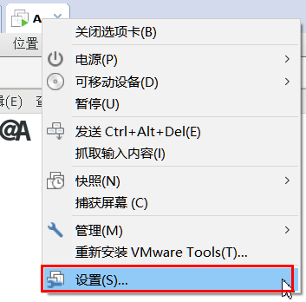

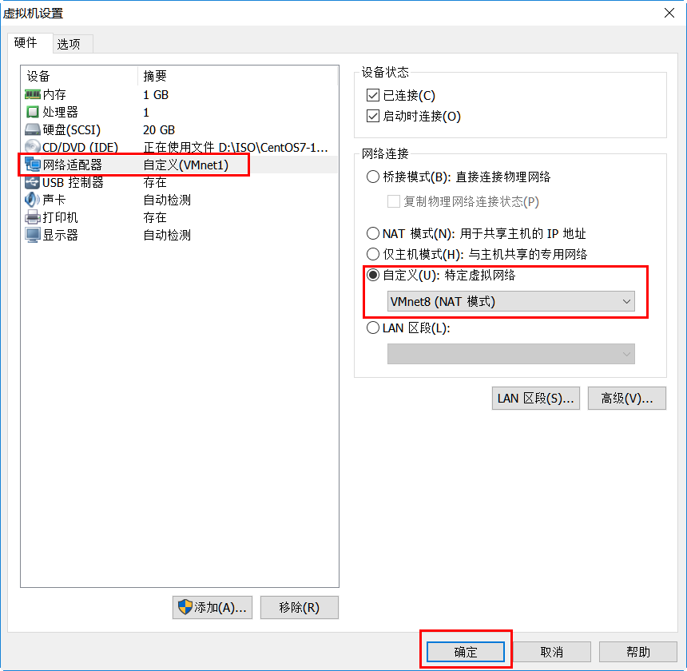

2.修改分配的网段

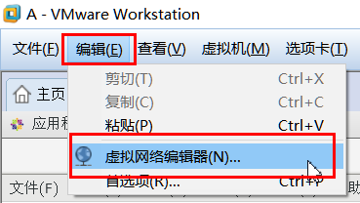

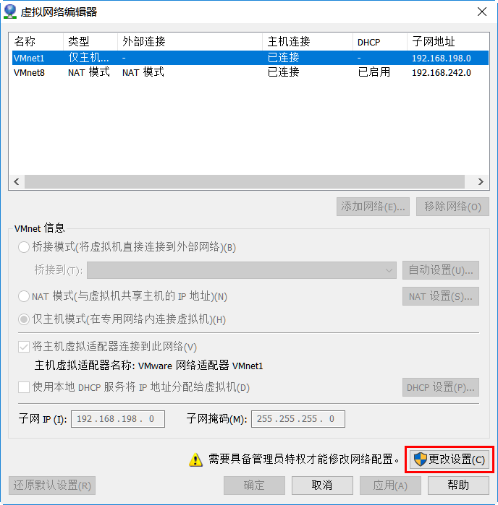

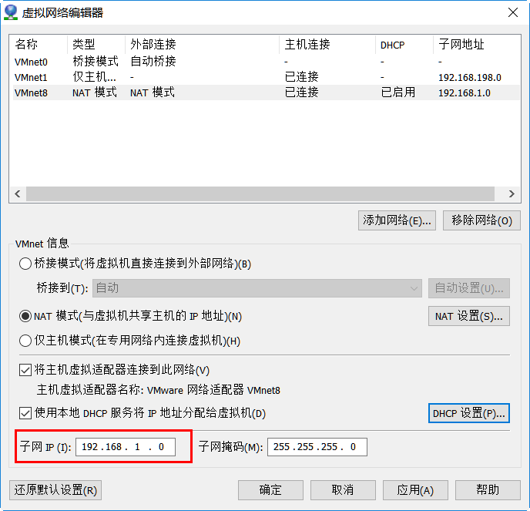

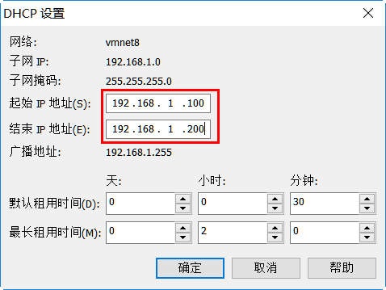

3.配置网关地址：192.168.1.254





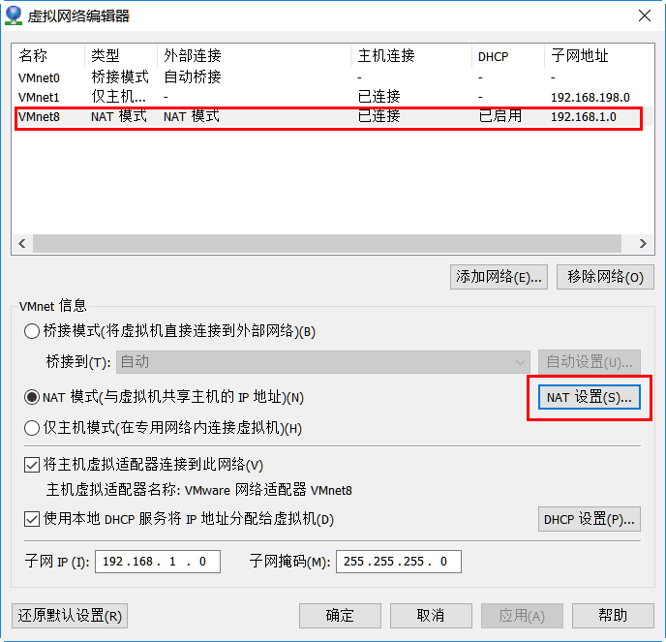

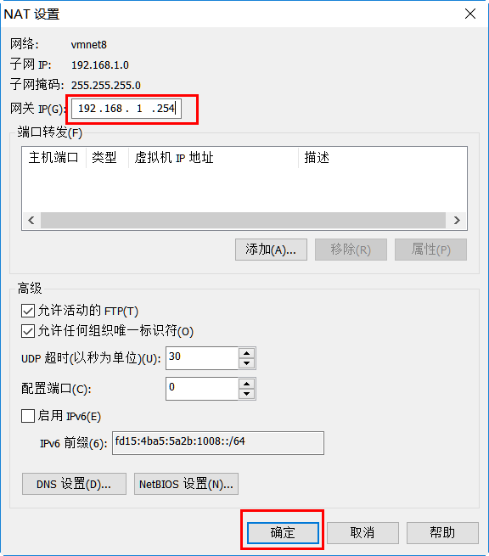

4.配置虚拟机网络配置

[root@A /]# nmcli connection delete ens33 #删除原有错误网卡

成功删除连接 'ens33'（e975f0e1-9e82-420b-a9e7-beedb5f57e03）。

[root@A /]# nmcli connection add type ethernet ifname eth0 con-name eth0 #添加网卡

连接“eth0”(7f45c94c-0785-4737-94ed-f95728954075) 已成功添加。

[root@A /]# ls /etc/sysconfig/network-scripts/

[root@A /]# nmcli connection modify eth0 ipv4.method auto autoconnect yes

[root@A /]# nmcli connection up eth0

[root@A /]# ifconfig | head -2

eth0: flags=4163<UP,BROADCAST,RUNNING,MULTICAST> mtu 1500

inet 192.168.1.100 netmask 255.255.255.0 broadcast 192.168.1.255

[root@A /]# route –n #查看网关地址

Kernel IP routing table

Destination **Gateway** Genmask Flags Metric Ref Use Iface

0.0.0.0 192.168.1.254 0.0.0.0 UG 100 0 0 eth0

192.168.1.0 0.0.0.0 255.255.255.0 U 100 0 0 eth0

192.168.122.0 0.0.0.0 255.255.255.0 U 0 0 0 virbr0

[root@A /]# ping www.baidu.com #测试通信

PING www.a.shifen.com (61.135.169.125) 56(84) bytes of data.

64 bytes from 61.135.169.125 (61.135.169.125): icmp_seq=1 ttl=128 time=4.24 ms

64 bytes from 61.135.169.125 (61.135.169.125): icmp_seq=2 ttl=128 time=3.76 ms

64 bytes from 61.135.169.125 (61.135.169.125): icmp_seq=3 ttl=128 time=5.43 ms