回顾

NAT 网络地址转换

私有ip地址分类

A 10.0.0.0~10.255.255.255

B 172.16.0.0~172.31.255.255

C 192.168.0.0~192.168.255.255

NAT使用方式

静态转换 一对一

Easy ip 多对一

NAT优点

节约公网ip地址

处理地址重叠

增加安全

VRRP 虚拟路由冗余协议

Master 主 254

Backup 备份 254

Virtual 虚拟

Icmp 英特网控制报文协议，可以反馈网络状态信息，比如数据是否可以连通目的地，到达目的地所花费的时间等

Ping -t 一直ping -l 1000 修改ping包大小

常用的查询指令

<Huawei>display current-configuration 可以查看基础配置

<Huawei>display vlan

<Huawei>display ip interface brief 查看ip地址

<Huawei>display ip routing-table | in /24 查看路由表

<Huawei>display acl all 查acl

[Huawei-Ethernet0/0/1]display this 查看某视图信息

<Huawei>display vrrp brief 查看vrrp摘要信息

实验：组建大型企业级网络

1，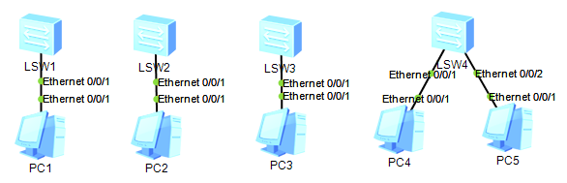

按图添加设备

2，在所有s3700交换机修改主机名为sw1~sw4

再分别创建vlan10、20、30、40

[Huawei]sysname sw1 修改主机名

[sw1]vlan batch 10 20 30 40 创建4个vlan

[sw2]vlan batch 10 20 30 40

[sw3]vlan batch 10 20 30 40

[sw4]vlan batch 10 20 30 40

3，在所有s3700配置连接设备的所属vlan

[sw1]in e0/0/1

[sw1-Ethernet0/0/1]port link-type access

[sw1-Ethernet0/0/1]port default vlan 10

[sw2]in e0/0/1

[sw2-Ethernet0/0/1]port link-type access

[sw2-Ethernet0/0/1]port default vlan 20

[sw3]in e0/0/1

[sw3-Ethernet0/0/1]port link-type access

[sw3-Ethernet0/0/1]port default vlan 30

[sw4]port-group 1

[sw4-port-group-1]group-member Ethernet 0/0/1 Ethernet 0/0/2

[sw4-port-group-1]port link-type access

[sw4-port-group-1]port default vlan 40

4，为所有s3700的上层链路配置trunk，使用g0/0/1与g/0/2接口

[sw1]port-group 1

[sw1-port-group-1]group-member GigabitEthernet 0/0/1 GigabitEthernet 0/0/2

[sw1-port-group-1]port link-type trunk

[sw1-port-group-1]port trunk allow-pass vlan all

[sw2]port-group 1

[sw2-port-group-1]group-member GigabitEthernet 0/0/1 GigabitEthernet 0/0/2

[sw2-port-group-1]port link-type trunk

[sw2-port-group-1]port trunk allow-pass vlan all

[sw3]port-group 1

[sw3-port-group-1]group-member GigabitEthernet 0/0/1 GigabitEthernet 0/0/2

[sw3-port-group-1]port link-type trunk

[sw3-port-group-1]port trunk allow-pass vlan all

[sw4]port-group 2

[sw4-port-group-2]group-member GigabitEthernet 0/0/1 GigabitEthernet 0/0/2

[sw4-port-group-2]port link-type trunk

[sw4-port-group-2]port trunk allow-pass vlan all

之后使用display vlan 检查结果

5，添加两台s5700，修改主机名为sw5、sw6，并创建vlan10、20、30、40

[Huawei]sysname sw5

[sw5]vlan batch 10 20 30 40

[sw6]vlan batch 10 20 30 40

6，为两台三层交换机向下连接的接口配置trunk

[sw5]port-group 1

[sw5-port-group-1]group-member GigabitEthernet 0/0/1 to GigabitEthernet 0/0/4

[sw5-port-group-1]port link-type trunk

[sw5-port-group-1]port trunk allow-pass vlan all

[sw6]port-group 1

[sw6-port-group-1]group-member GigabitEthernet 0/0/1 to GigabitEthernet 0/0/4

[sw6-port-group-1]port link-type trunk

[sw6-port-group-1]port trunk allow-pass vlan all

7，为两台三层交换机之间配置链路聚合

[sw5]interface Eth-Trunk 1

[sw5-Eth-Trunk1]trunkport GigabitEthernet 0/0/5 0/0/6

[sw5-Eth-Trunk1]port link-type trunk

[sw5-Eth-Trunk1]port trunk allow-pass vlan all

[sw6]interface Eth-Trunk 1

[sw6-Eth-Trunk1]trunkport GigabitEthernet 0/0/5 0/0/6

[sw6-Eth-Trunk1]port link-type trunk

[sw6-Eth-Trunk1]port trunk allow-pass vlan all

8，为两台三层交换机配置ip地址

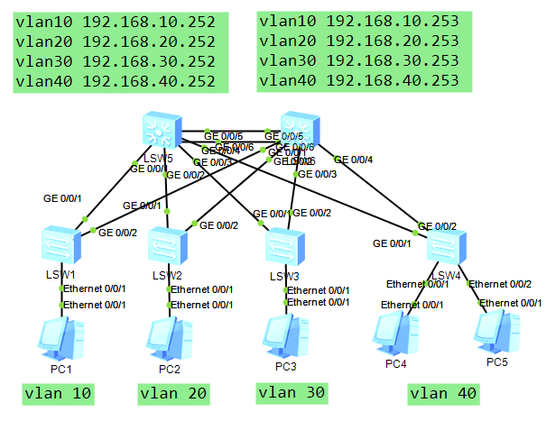

[sw5]in vlan 10

[sw5-Vlanif10]ip add 192.168.10.252 24

[sw5-Vlanif10]in vlan 20

[sw5-Vlanif20]ip add 192.168.20.252 24

[sw5-Vlanif20]in vlan 30

[sw5-Vlanif30]ip add 192.168.30.252 24

[sw5-Vlanif30]in vlan 40

[sw5-Vlanif40]ip add 192.168.40.252 24

[sw6]in vlan 10

[sw6-Vlanif10]ip add 192.168.10.253 24

[sw6-Vlanif10]in vlan 20

[sw6-Vlanif20]ip add 192.168.20.253 24

[sw6-Vlanif20]in vlan 30

[sw6-Vlanif30]ip add 192.168.30.253 24

[sw6-Vlanif30]in vlan 40

[sw6-Vlanif40]ip add 192.168.40.253 24

同时配置pc的ip，

vlan10的主机配置192.168.10.1

vlan20的主机配置192.168.20.1

vlan30的主机配置192.168.30.1

vlan40的主机配置192.168.40.1、192.168.40.2

9，在三层交换机配置vrrp，并实现数据的负载均衡

Sw5 vlan10、20 主 vlan30、40备份

Sw6 vlan30、40 主 vlan10、20备份

[sw5]in vlan 10

[sw5-Vlanif10]vrrp vrid 10 virtual-ip 192.168.10.254

[sw5-Vlanif10]vrrp vrid 10 priority 105

[sw5-Vlanif10]in vlan 20

[sw5-Vlanif20]vrrp vrid 20 virtual-ip 192.168.20.254

[sw5-Vlanif20]vrrp vrid 20 priority 105

[sw5-Vlanif20]in vlan 30

[sw5-Vlanif30]vrrp vrid 30 virtual-ip 192.168.30.254

[sw5-Vlanif30]in vlan 40

[sw5-Vlanif40]vrrp vrid 40 virtual-ip 192.168.40.254

[sw6]in vlan 30

[sw6-Vlanif30]vrrp vrid 30 virtual-ip 192.168.30.254

[sw6-Vlanif30]vrrp vrid 30 priority 105

[sw6-Vlanif30]in vlan 40

[sw6-Vlanif40]vrrp vrid 40 virtual-ip 192.168.40.254

[sw6-Vlanif40]vrrp vrid 40 priority 105

[sw6-Vlanif40]in vlan 10

[sw6-Vlanif10]vrrp vrid 10 virtual-ip 192.168.10.254

[sw6-Vlanif10]in vlan 20

[sw6-Vlanif20]vrrp vrid 20 virtual-ip 192.168.20.254

排错思路，1检查ip地址与网关 2 查vlan、trunk

3，查链路聚合

10，添加两台ar2220路由器，修改主机名为r1与r2，并按规划配置ip地址

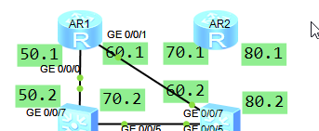

[r1]in g0/0/0

[r1-GigabitEthernet0/0/0]ip add 192.168.50.1 24

[sw5]vlan 50

[sw5-vlan50]in vlan 50

[sw5-Vlanif50]ip add 192.168.50.2 24

[sw5-Vlanif50]in g0/0/7

[sw5-GigabitEthernet0/0/7]port link-type access

[sw5-GigabitEthernet0/0/7]port default vlan 50

[r1]in g0/0/1

[r1-GigabitEthernet0/0/1]ip add 192.168.60.1 24

[sw6]vlan 60

[sw6-vlan60]in vlan 60

[sw6-Vlanif60]ip add 192.168.60.2 24

[sw6-Vlanif60]in g0/0/7

[sw6-GigabitEthernet0/0/7]port link-type access

[sw6-GigabitEthernet0/0/7]port default vlan 60

[r2]in g0/0/0

[r2-GigabitEthernet0/0/0]ip add 192.168.70.1 24

[sw5]vlan 70

[sw5-vlan70]in vlan 70

[sw5-Vlanif70]ip add 192.168.70.2 24

[sw5-Vlanif70]in g0/0/8

[sw5-GigabitEthernet0/0/8]port link-type access

[sw5-GigabitEthernet0/0/8]port default vlan 70

[r2-GigabitEthernet0/0/0]in g0/0/1

[r2-GigabitEthernet0/0/1]ip add 192.168.80.1 24

[sw6]vlan 80

[sw6-vlan80]in vlan 80

[sw6-Vlanif80]ip add 192.168.80.2 24

[sw6-Vlanif80]in g0/0/8

[sw6-GigabitEthernet0/0/8]port link-type access

[sw6-GigabitEthernet0/0/8]port default vlan 80

11，配置动态路由

[sw5]ospf

[sw5-ospf-1]area 0

[sw5-ospf-1-area-0.0.0.0]network 192.168.10.0 0.0.0.255

[sw5-ospf-1-area-0.0.0.0]network 192.168.20.0 0.0.0.255

[sw5-ospf-1-area-0.0.0.0]network 192.168.30.0 0.0.0.255

[sw5-ospf-1-area-0.0.0.0]network 192.168.40.0 0.0.0.255

[sw5-ospf-1-area-0.0.0.0]network 192.168.50.0 0.0.0.255

[sw5-ospf-1-area-0.0.0.0]network 192.168.70.0 0.0.0.255

[sw6]ospf

[sw6-ospf-1]area 0

[sw6-ospf-1-area-0.0.0.0]network 192.168.10.0 0.0.0.255

[sw6-ospf-1-area-0.0.0.0]network 192.168.20.0 0.0.0.255

[sw6-ospf-1-area-0.0.0.0]network 192.168.30.0 0.0.0.255

[sw6-ospf-1-area-0.0.0.0]network 192.168.40.0 0.0.0.255

[sw6-ospf-1-area-0.0.0.0]network 192.168.60.0 0.0.0.255

[sw6-ospf-1-area-0.0.0.0]network 192.168.80.0 0.0.0.255

[r1]ospf

[r1-ospf-1]area 0

[r1-ospf-1-area-0.0.0.0]network 192.168.50.0 0.0.0.255

[r1-ospf-1-area-0.0.0.0]network 192.168.60.0 0.0.0.255

[r2]ospf

[r2-ospf-1]area 0

[r2-ospf-1-area-0.0.0.0]network 192.168.70.0 0.0.0.255

[r2-ospf-1-area-0.0.0.0]network 192.168.80.0 0.0.0.255

12，添加外部网络设备s3700一台，并配置公网ip地址

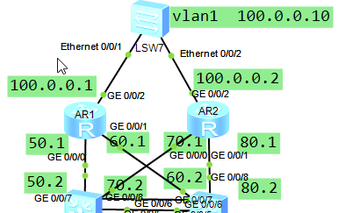

[r1]in g0/0/2

[r1-GigabitEthernet0/0/2]ip add 100.0.0.1 8

[r2]in g0/0/2

[r2-GigabitEthernet0/0/2]ip add 100.0.0.2 8

外网的s3700在vlan1配置ip即可

[Huawei]in vlan 1

[Huawei-Vlanif1]ip add 100.0.0.10 8

直连路由

静态路由

动态路由

默认路由 ，是一种特殊的静态路由，可以匹配任意网段，通常用于企业网关设备，用来访问外部成千上万的网段

13，在2台路由器配置默认路由并在ospf中向外宣告

[r1]ip route-static 0.0.0.0 0 100.0.0.10 配置默认路由，可以找到任意网络，下一跳是100.0.0.10

[r1]ospf

[r1-ospf-1]default-route-advertise 对外宣告刚才配置的默认路由，之后下面的2台三层交换机会自动学习

[r2]ip route-static 0.0.0.0 0 100.0.0.10

[r2]ospf

[r2-ospf-1]default-route-advertise

14，在2台路由器配置nat实现内外互联

[r1]acl 2000

[r1-acl-basic-2000]rule permit source any 放行所有人可以访问外部网络

[r1-acl-basic-2000]in g0/0/2

[r1-GigabitEthernet0/0/2]nat outbound 2000 在出口开启nat功能

[r2]acl 2000

[r2-acl-basic-2000]rule permit source any

[r2-acl-basic-2000]in g0/0/2

[r2-GigabitEthernet0/0/2]nat outbound 2000

最终测试，内部的pc可以ping通外部100.0.0.10即可

另外：明天的课程需要使用linux虚拟机，使用centos7.5系统，并配置好yum，网络（网卡名）配置随意，只要虚拟机可以和真机互通即可