1、Flash the rp2350_mcus_hub.uf2 file to the PICO2 development board. Once completed, you will see that the PICO2's USB interface enumerates as two devices: a USB mass storage device (U-disk) and a USB-to-Serial converter.

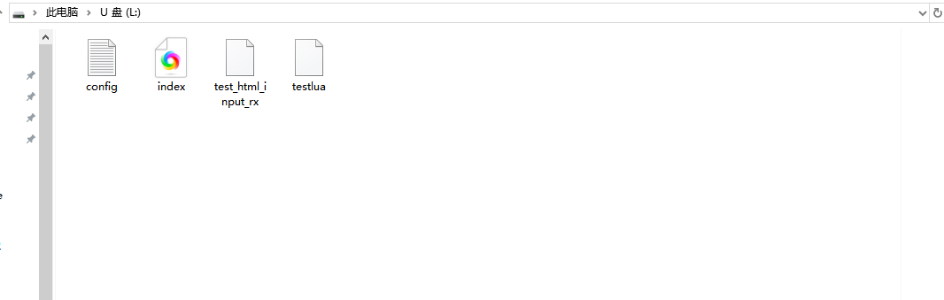

2、Navigate to 192.168.7.1in your web browser to access the hub control UI.Trt to send something to HTML_INPUT_TEST.
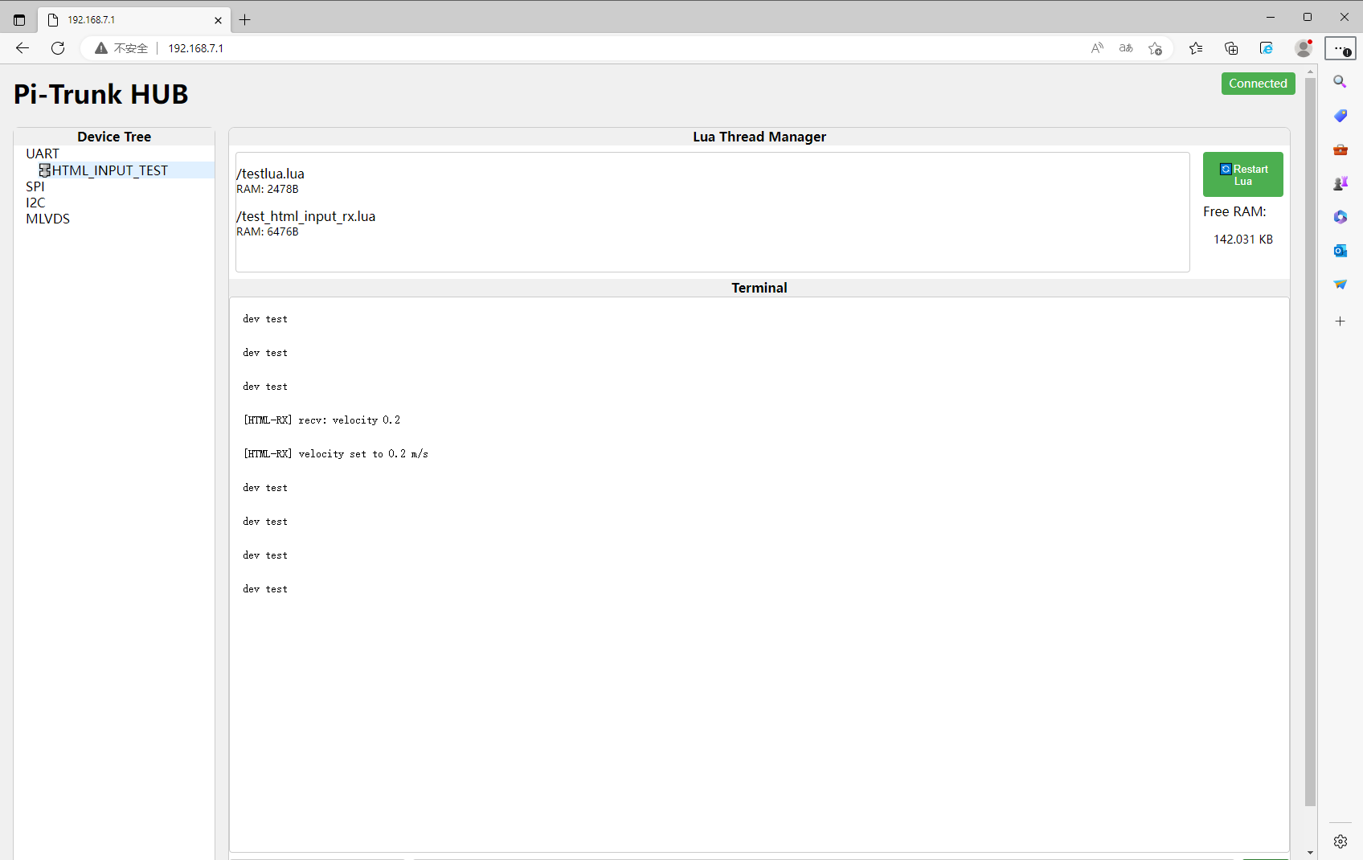

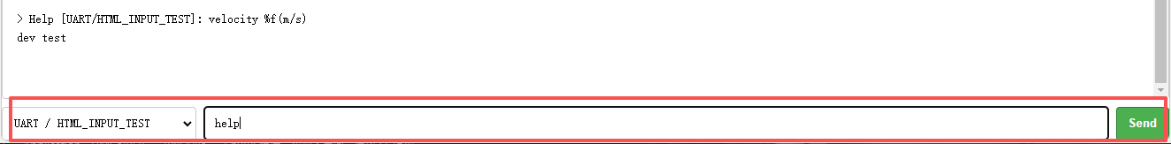

3、Avoid using pins 0, 1, 2, and 3 in your LUA program, as they are reserved for the M-LVDS bus controller.
Terminate only the two ends of the SN65MLVD206DR M-LVDS bus with 100Ω resistors.
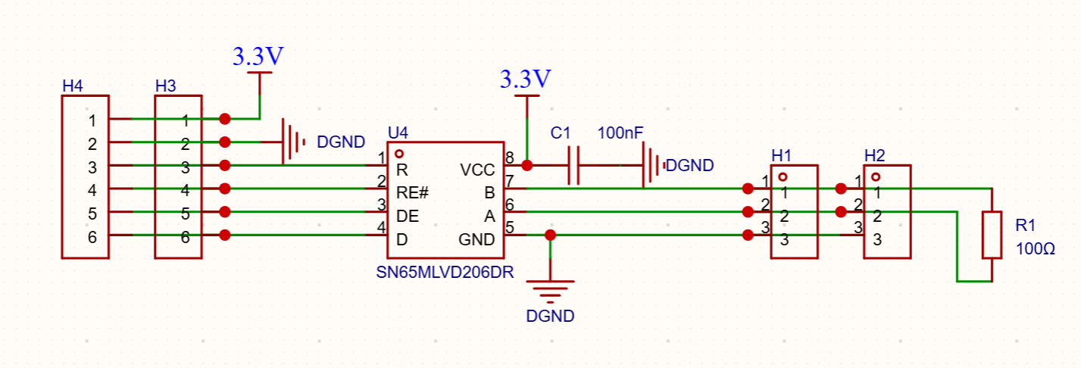
5、Flash the rp2350_mcus_mod.uf2 file to another PICO2 development board.
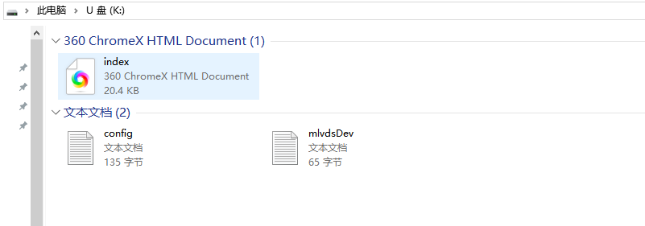

6、Right-click on an M-LVDS slave node to upload .lua and .txt files.
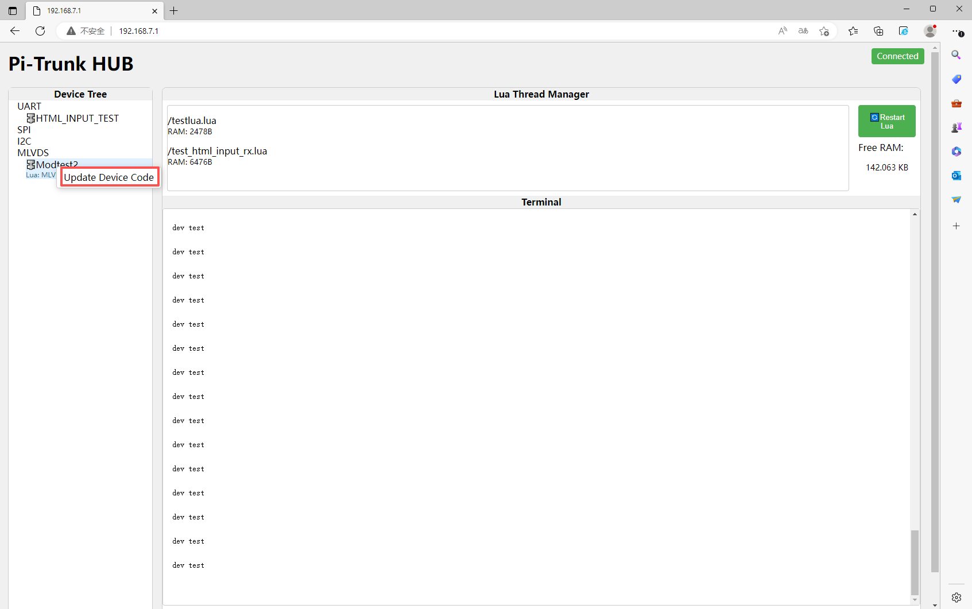

7、Upload .lua/.txtfiles to slaves. Successful config.txtupload restarts all LUA scripts. Hover icon for node info.
