5/23-5/29

In the first few days, I was finishing up all the trainings and other onboarding logistics. I also learned about the company such as iCruise and the Sperry drilling pipeline. It’s so cool to me how mud powers the drill. On 5/29, my project was properly introduced to me. The project is shown below:

Scope:

Accurate downhole hydraulic models are critical for optimized drilling performance. In order to achieve the highest possible accuracy within our models, it’s necessary to properly characterize properties of the fluids in the wellbore. Physical properties such as rheology and density may already be measured with existing equipment, such as the BaraLogix DRU Plus, but thermal properties are often overlooked. Properties such as specific heat capacity may give insight into the makeup of the fluid as well as potential contamination of the fluid with formation material. The goal of this project will be to use existing hardware in the BaraLogix DRU Plus to develop real-time models that characterize the specific heat capacity of processed fluids.

Objectives (min 3):

1. Construct project plan to develop and verify model
2. Build and develop model
3. Integrate in RT program and develop test plan
4. Verify model with fluid testing
5. Compile test data and build report/presentation

Deliverables:

1. Hypothesis for generating specific heat capacity measurements within DRU Plus
2. Documented model
3. Test data to validate model
4. Integrated model within DRU Plus windows app

Creating the thermal/fluid model for this was the first small step. After some troubles with CWI and getting the CAD of the cell assembly, I was able to visualize and obtain the geometries to model the thermal system to approximate the specific heat capacity. For example, I initially thought the heater rods heat the ambient air in the cell and that heats up the mud, which seemed inefficient to me; however, the CAD models and further discussion corrected my understanding. I initially did a lot of background researching first principles of specific heat capacity, which is the energy required to raise 1 kg sample by 1 unit of temperature. It’s basically thermal capacitance. There are only thermal capacitors and resistors.

5/30-6/4

I’m now in the neck of the woods for thermal modeling. I gathered ballpark and sensible values for the mud thermal conductivity, diffusivity, and heat capacity as reference values. The oil-based mud should be between 1000-3000 J/kgK, the thermal conductivity is between 0.1-0.6 W/mk, and the density (which is the last variable to find diffusivity) is ~12.8 ppg. This past week, I also learned the backend of the DRU Plus winapp and how the DRU Plus currently controls the temperature with a PID controller that sets the duty cycle of the heater cartridges since they only take digital inputs. I also started a codebase in Python that encodes the model that I’m working on. I also realized that this project really is mine. It’s a double-edged sword for sure since I’m very eager to be mentored in a technical field, but at the same time, I love the ownership I have over the project.

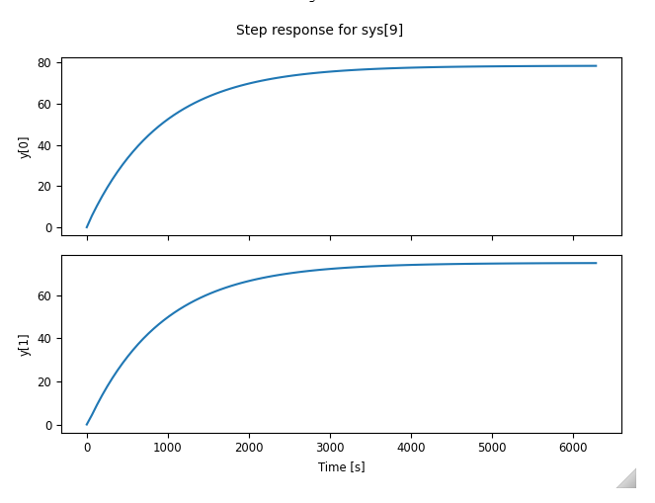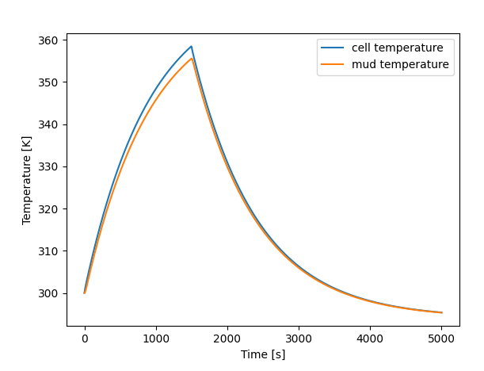

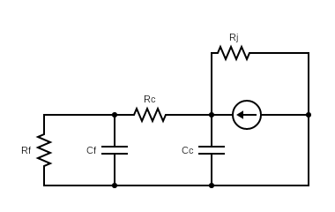

6/5-6/7

The past few days I spent looking over the model again. Whereas before I modeled it as a circuit, I took to first principles this time and modeled it based on control volume of the cell and the fluid inside. After gathering data, the latter model resembled the data much better. I even simulated a PD controller for it. The integral term actually destabilizes the system since the system is type 1 system (we can only control the time derivative of the input with respect to the states observable). I still need to confirm if the B matrix is right as I’m not sure if I should tie the heater input with the time derivative of the fluid energy.

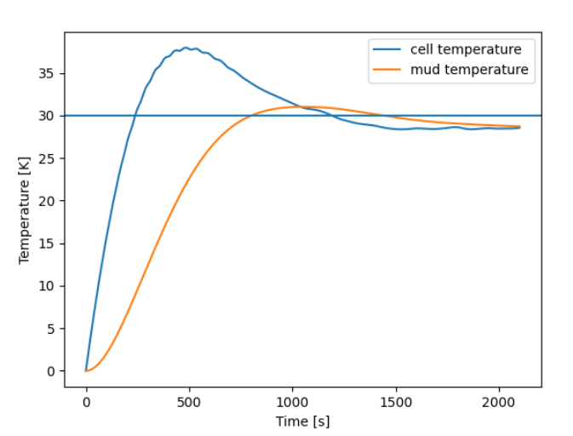

To characterize the thermal resistance of the jacket, I performed a rheology with water. I heated both cell and fluid to the same temperature (~50 C) and simply logged the decay data from there. A graph of different colored lines

This resulted in an equivalent resistance of ~1.861 K/W (Kelvin per Watt), which seems much smaller than I expected, but this resistance, Rj, is extrinsic.

After both technical research and feasibility considerations, the thermal properties characterization should follow the following constraints:

* Ideally should not add any time to the current testing protocols
  + If it does add time, should only add at most 5 minutes
* Estimate the specific heat capacity consistently (std < 100 J/kgK)
* Be able to operate in real-time; it should output estimates in time with the other rheology measurements

As such,

As such, I propose the following most feasible test plans to obtain the specific heat of a fluid in the DRU Plus.

Test plan 1: Comprehensive digital twin of thermal controller

Knowns:

* Fluid mass
* Cell properties (geometry and thermal)
* Input power over time
* Observing: Tcell and Tfluid (2 states)

Unknown: fluid capacity, Cp

6/10

Confirming the cell extrinsic heat capacity, Cc:

* Gather step response of the temperatures with still water inside, this way Rf AND Cf are known
* Though cell temp isn’t homogenous based on the data collected, we will neglect them
  + We know this because the cell temp still rises when the heaters are turned off

6/19/2024

So before this was the 2nd order model used:

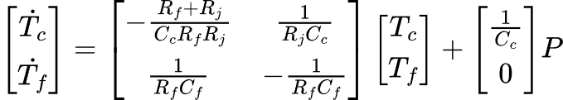

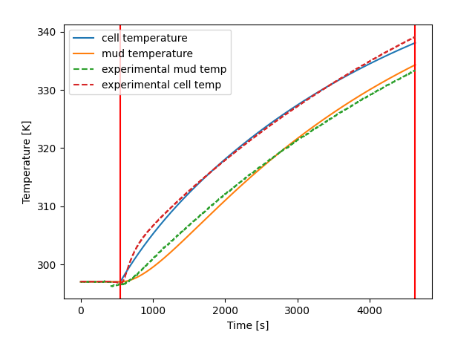

[Rc,Cc,Rf,Cf,Rj]: [0.013, 4482.76, 0.48, 1290.86, 0.57]

Now that I look at a longer profile (water 5% step input)

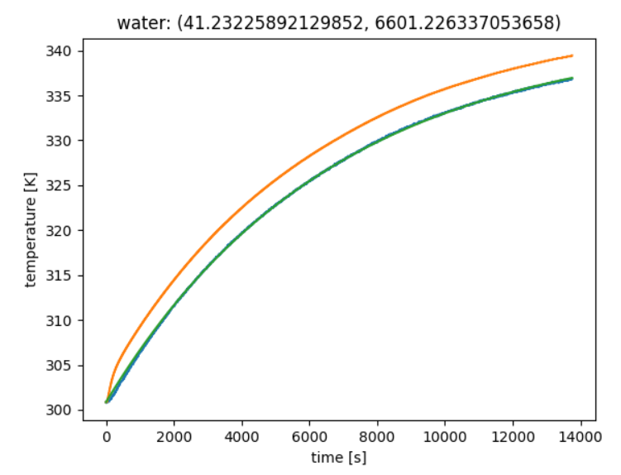

It seems that the gap between cell temperature and mud temperature remains constant to some degree. My intuition tells me that there is some thermal dissipation from the fluid. It makes sense that the gap would asymptotically decrease since the area around the dissipation could be getting warmer, which decreases the heat dissipation rate, which is related to the rate of change in temperature. Below is what the theoretical temperature profile looks like for 2nd order system:

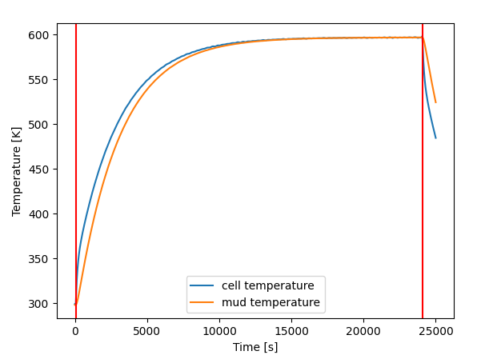

After making that slight modification:

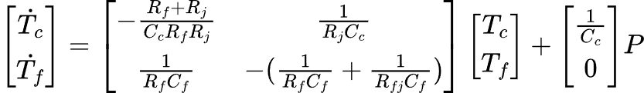

Where Rfj is the thermal resistance between the fluid inside and the outside cell

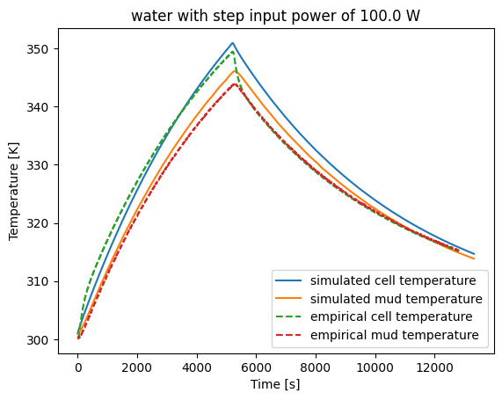

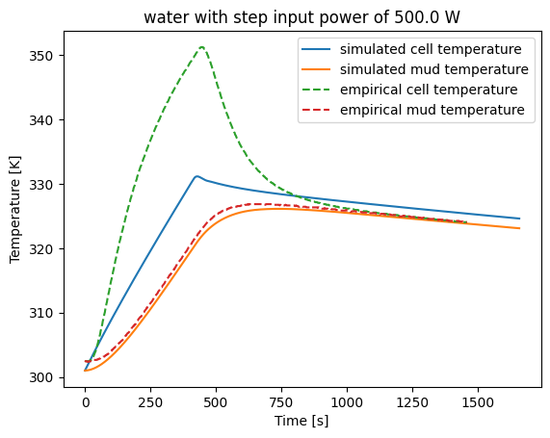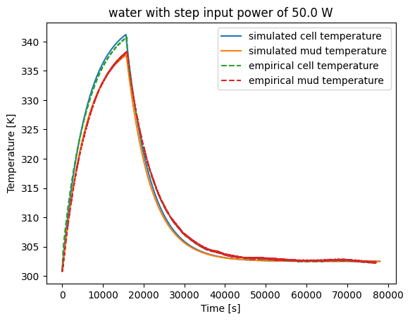

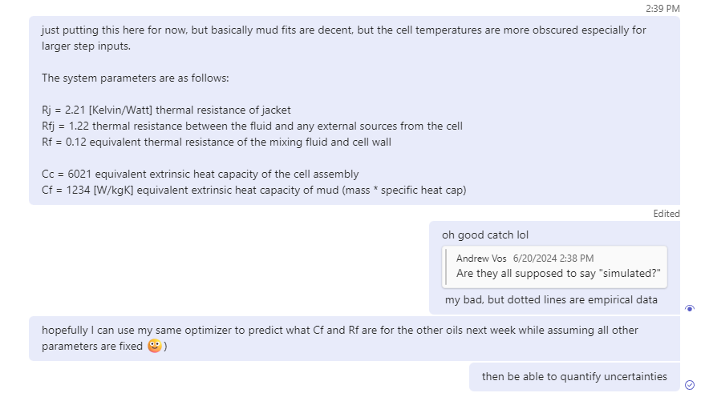

6/26

Using third order model, I got REALLLY close transient profiles shown below. The mud temp transient and the heater temperatures all show very similar profiles especially near the change in input regions (t = 0 and t = 2666). Here’s the model for this. [qiaomein/DRU\_thermal\_estimator (github.com)](https://github.com/qiaomein/DRU_thermal_estimator)

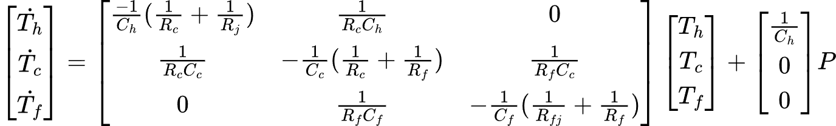

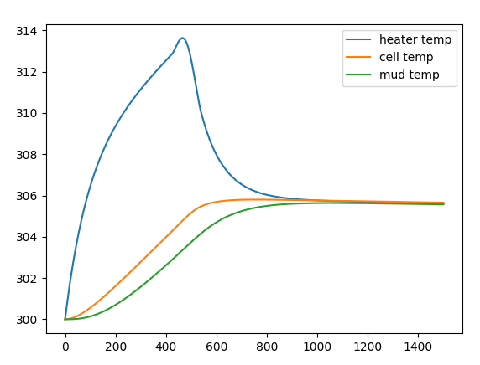

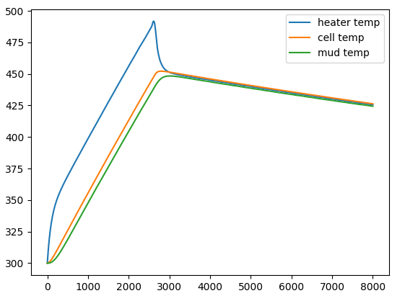

7/1

Fleshed out the recursive least squares algorithm to estimate the system parameters.

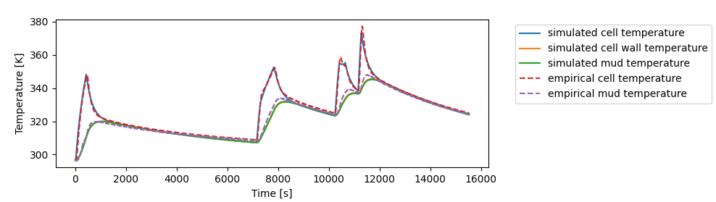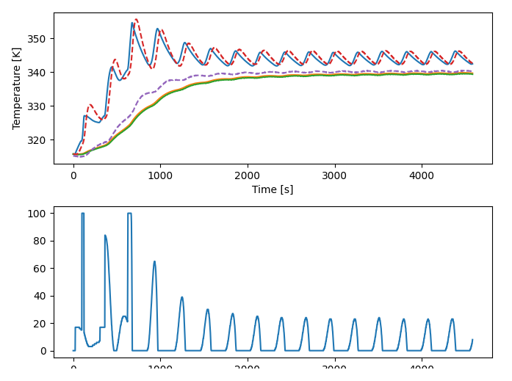

7/3

After comparing RLS algorithms, it seems that the algorithm is doing its job: it’s just that the regressor is not true to the simulation for some reason as shown below.

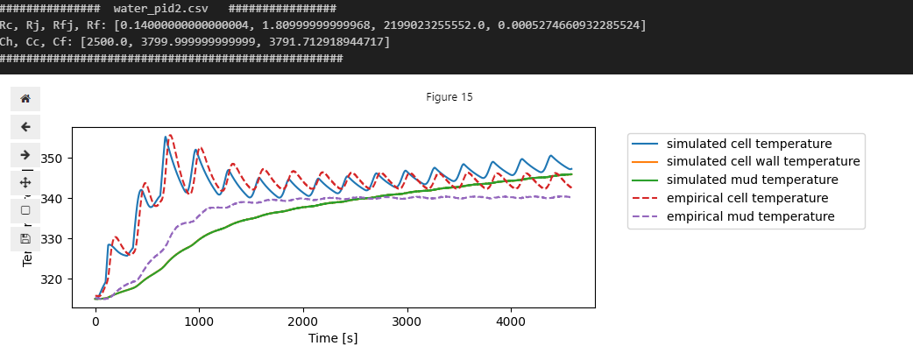

But the internal simulation in the RLS shows this fit against the real data

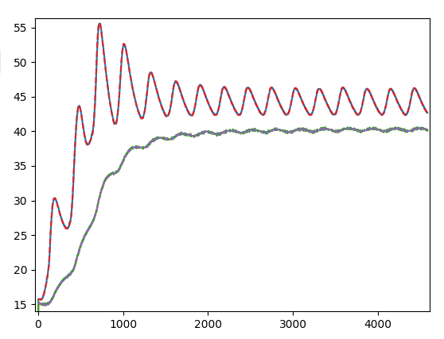

Which is basically exact.

Look into either forgetting factor and discretizing the system properly

7/29/2024

Key phenomena:

* Heater input delay: for usual ranges, there appears to be a ~30 s delay before the cell temperature reading registers that the heater turned on.
  + Heater capacitances?
  + Necessary to model? Good enough to do fixed delay maybe
* When mixing, fluid temp seems to drop a bit and is offset from the cell temp as the cell cools down (validated with calibration oil)
  + The forced convection inside the cell “cools” the probe
* Though, with glycerol (assumingly higher viscosity) mixing gradually heats up the mud temperature, seems like it’s on the order of milliWatts at 600 rpm however. Heats it up at a rate of around 1C per hour.
* The viscosity drops significantly as temperature increases (makes sense)
* Cell purging doesn’t affect any thermal profiles

Heater temp theoretical Bode plot (varying Cf from 400 – 6000)

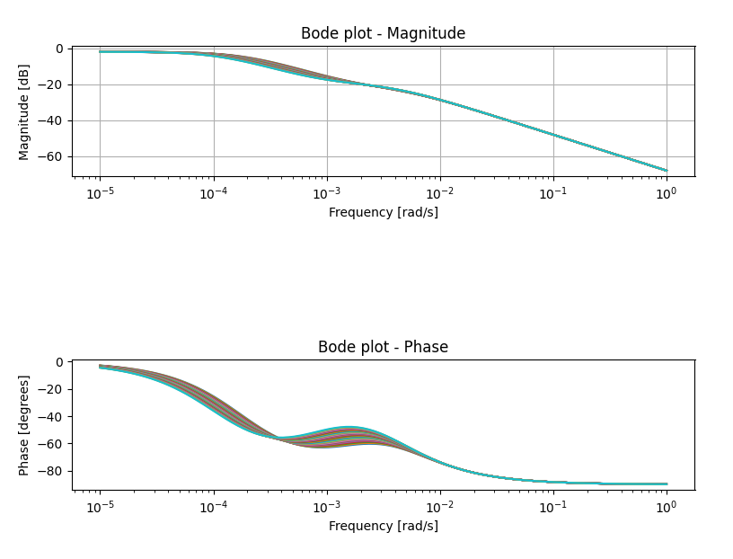

Fluid temp theoretical Bode plot

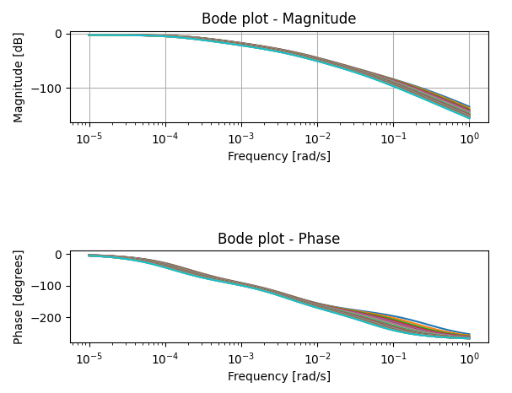

DSC Report

C:\Users\Public\Pictures\HAL_Horz.jpg

**HALLIBURTON TECHNOLOGY – ANALYTICAL SERVICES**

**HOUSTON**

**PROJECT REPORT**

**This report is the property of Halliburton and neither it nor any part thereof nor a copy thereof is to be published or disclosed without first securing the express written approval of laboratory management; it may however, be used in the course of regular business operation by any person or concern and employees thereof receiving such report from Halliburton.**

[Title]**: Specific heat capacity measurement**

***Executive Summary:***

Three data points for the specific heat capacity (SHC) are reported for the submitted samples in the data tables below. Used the standard sapphire values from the ASTM method E1269 and evaluated the samples in the temperature range of 0-80°C.

**Tested by:** Sandeep Kumar Borra

**Approved by:** Draft

**Distribution:** Jack Qiao

***Sample Information:***

|  |  |  |
| --- | --- | --- |
| **Name** | **Testing** | **Comments** |
| Tap Water | DSC | Tap water with traces of drilling fluid; expected 4184 J/kgC |
| Calibration fluid (silicone oil 100cP) | DSC | Expected heat capacity: ~ 1400 J/kgC |
| Glycerol | DSC | Expected heat capacity: ~2400 J/kgC |
| Lab Mud | DSC | BaraECD fluid as common test mud sample in the FANN lab Expected heat capacity: between 1000 - 3000 J/kgC |

***Results:***

**Specific Heat Capacity by DSC**

Submitted samples were analyzed in the temperature range of 0 to 80°C, and reported three data points in the range of interest provided by the requestor.

|  |  |
| --- | --- |
| **Temperature, º C** | **Tap Water SHC, J/Kg ºC** |
| 46.85 | 4529 |
| 56.85 | 4536 |
| 66.85 | 4543 |

|  |  |
| --- | --- |
| **Temperature, º C** | **Calibration fluid (silicone oil 100cP) SHC, J/Kg ºC** |
| 46.85 | 1851 |
| 56.85 | 1898 |
| 66.85 | 1959 |

Note: The submitted Calibration fluid (silicone oil 100cP) sample has different phases, sampled a few milligrams after vigorous shaking.

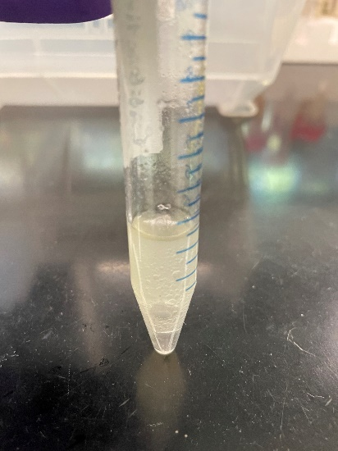

|  |  |
| --- | --- |
| **Temperature, º C** | **Glycerol SHC, J/Kg ºC** |
| 46.85 | 2147 |
| 56.85 | 2187 |
| 66.85 | 2222 |

|  |  |
| --- | --- |
| **Temperature, º C** | **Lab Mud SHC, J/Kg ºC** |
| 46.85 | 1676 |
| 56.85 | 1707 |
| 66.85 | 1751 |

***Experimental:***

|  |  |  |
| --- | --- | --- |
| **Analysis** | **Instrument** | **SOP/Conditions** |
| Specific Heat Capacity | AS-DCS-001 | ASTM E1269; Temperature range: 0-80°C |