**Before the data collection, please check the meaning of the Intentions and actions, do you agree the meanings?**

**Gesture:**

Hold: Grasp, carry, or support with one's hands.

Rub: Apply firm pressure to the surface of (something), using a repeated back and forth motion

Tickle: Lightly touch or prod (a person or a part of the body)

Poke: Jab or prod (someone or something) with one's finger or a sharp object.

Pat: Touch quickly and gently with the flat of the hand.

Tap: To hit something gently, and often repeatedly, especially making short, sharp noises

**Intention:**

Happy: Feeling or showing pleasure or contentment. 1

Sadness: Feeling or showing sorrow 1

Fear: The bad feeling that you have when you are in danger or when a particular thing frightens you 1

Disgust: A strong feeling of dislike or disapproval for someone or something that you feel is unacceptable, or for something that looks, smells, etc 1

Anger: A strong feeling of annoyance, displeasure, or hostility. 1

Surprise： An unexpected or astonishing event, fact, etc. 1

Comfort： A state of physical ease and freedom from pain or constraint.

Attention： Notice taken of someone or something

Calming： Make (someone) tranquil and quiet; soothe.

Confusion： Uncertainty about what is happening, intended, or required.

**Consistency** between different emotions and participants

**variability between different emotions and participants**

Will people try to express emotion in one gestures? (inside participants and between participants)

**Two runs**

Please be ready to demonstrate emotions paired with gestures. After completing each emotion-gesture combination, you will have a break. You may start the next combination whenever you feel ready. Each emotion-gesture pair should be performed twice. Ensure you complete all combinations in the first round before beginning the second round. Thank you for participating.

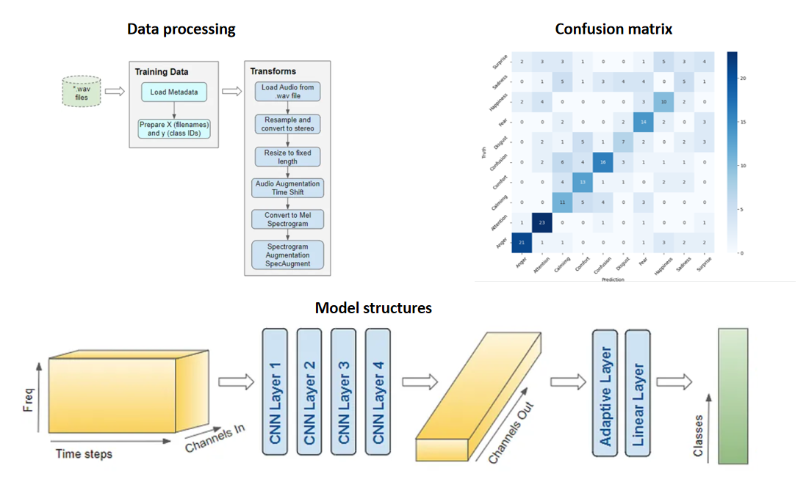

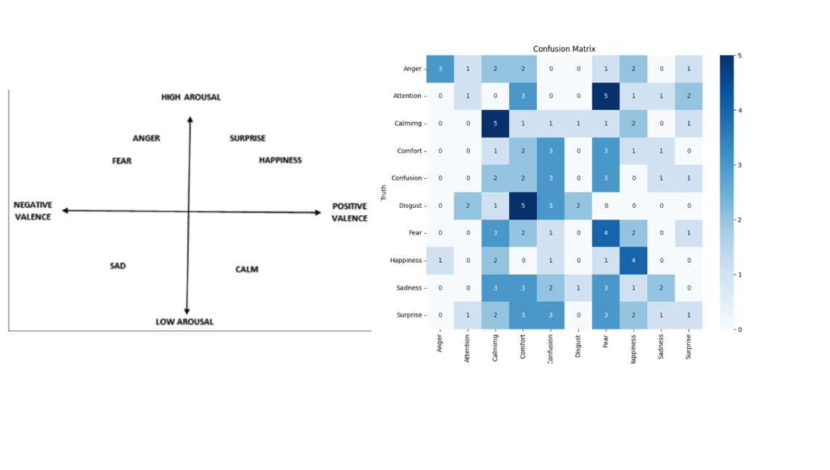

fear -- confusion;

Fear - Anger

Fear and disgust

Fear Surprise

Fear - confusion

fear and disgust

Fear Surprise

attention -- comfort -- surprise

Calming - Comfort

Disgust- anger, surprise-fear, comfort-sadness-calming;comfort-sadness

Disgust- anger, surprise-fear, comfort-sadness

Disgust- anger, comfort-sadness, comfort-sadness

happiness-surprise, sadness-calming, fear-disgust,

Happiness-Surprise

surprise confusion

disgust anger

anger comfort

comfort and calming

happiness -- comfort fear --disgust

happiness - surprise comfort - calming

Comfort Calming

%Happiness surprise% anger disgust%comfort calming%

Happiness - surprise; calming- comfort

Comfort - Calming ; Attention - happiness

Sadness - Calming - Comfort ; Anger - Disgust

Comfort Calming,

comfort calming

Happiness Comfort

happiness-Surprise, Confusion-disgust

happiness-surprise disgust-anger

calming-comfort

anger-disgust