**实验一**

**Part1：**

% Program 2_1

% Generation of the ensemble average

%

R = 50;

m = 0:R-1;

s = 2*m.*(0.9.^m); % Generate the uncorrupted signal

d = rand(R,1)-0.5; % Generate the random noise

x1 = s+d';

stem(m,d);

xlabel('Time index n');ylabel('Amplitude'); title('Noise');

pause

for n = 1:50;

d = rand(R,1)-0.5;

x = s + d';

x1 = x1 + x;

end

x1 = x1/50;

stem(m,x1);

xlabel('Time index n');ylabel('Amplitude'); title('Ensemble average');

**运行结果：**

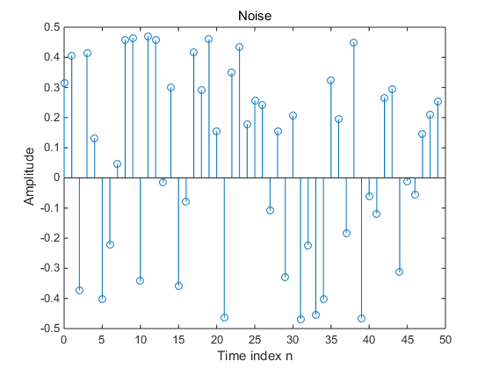

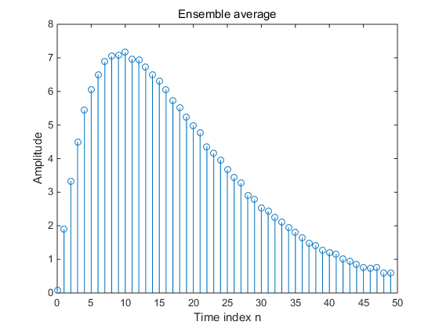

**理解：第一幅图表示的是噪音部分，第二幅图表现的是总体均值，也就是一个信号取五十次再取均值，这样就能降低噪音的影响；这是一种去燥的方法；**

**心得：学会了rand（R，N），表示生成R列0~N的随机数；pause表示暂停，按回车继续执行下面的语句。**

% Program 2_2

% Illustration of Convolution

%

a = input('Type in the first sequence = ');

b = input('Type in the second sequence = ');

c = conv(a, b);

M = length(c)-1;

n = 0:1:M;

disp('output sequence =');disp(c)

stem(n,c)

xlabel('Time index n'); ylabel('Amplitude');

**运行结果：**

Type in the first sequence = [1]

Type in the second sequence = [1 0 0]

output sequence =

1 0 0

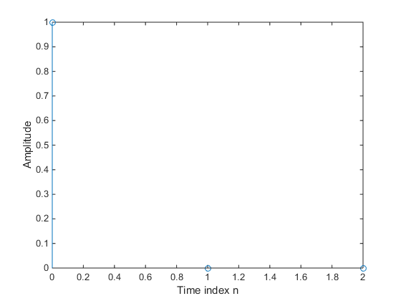

**理解：这是一个求卷积的程序；**

**心得：使用input函数输入，可以增加代码的重复利用率，但需注意的是，若输入的是数列需用中括号；否者会出错；disp函数可以展示你需要展示的东西在命令界面；**

% Program 2_3

% Generation of complex exponential sequence

%

clear;

clc;

a = input('Type in real exponent = ');

b = input('Type in imaginary exponent = ');

c = a + b*i;

K = input('Type in the gain constant = ');

N = input ('Type in length of sequence = ');

n = 1:N;

x = K*exp(c*n);%Generate the sequence

stem(n,real(x));%Plot the real part

xlabel('Time index n');ylabel('Amplitude');

title('Real part');

disp('PRESS RETURN for imaginary part');

pause

stem(n,imag(x));%Plot the imaginary part

xlabel('Time index n');ylabel('Amplitude');

title('Imaginary part');

**运行结果：**

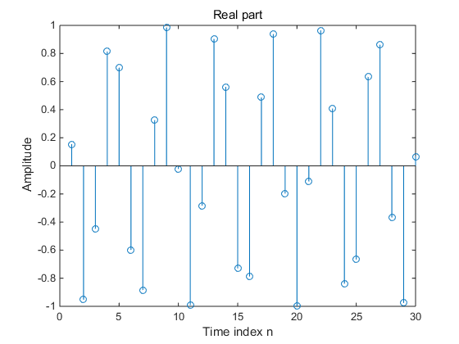

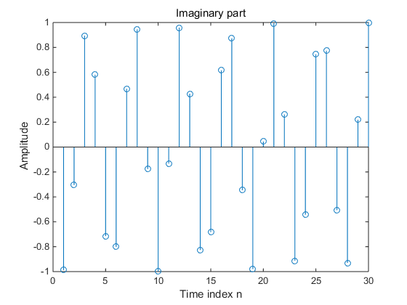

**理解：这是一个复指数序列，a控制增长速度，b控制频率，K控制增益，N控制序列长度。**

**心得：使用input函数输入参数让程序变得灵活。**

% Program 2_4

% Generation of real exponential sequence

%

a = input('Type in argument = ');

K = input('Type in the gain constant = ');

N = input ('Type in length of sequence = ');

n = 0:N;

x = K*a.^n;

stem(n,x);

xlabel('Time index n');ylabel('Amplitude');

title(['\alpha = ',num2str(a)]);

**运行结果：**

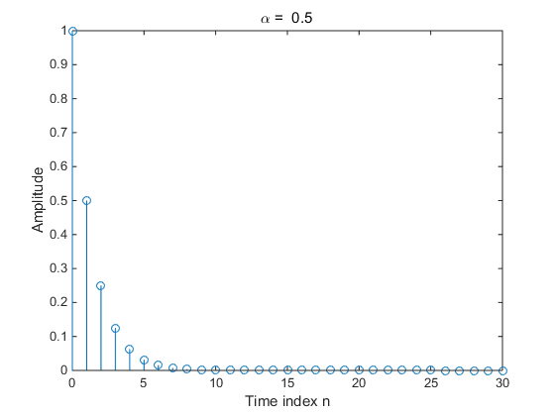

**理解：这是一个指数序列。**

**心得：使用num2str（a）可以以2号字体输出a的值；**

% Program 2_5

% Computation of Cross-correlation Sequence

%

clear;

clc;

x = input('Type in the reference sequence = ');

y = input('Type in the second sequence = ');

% Compute the correlation sequence

n1 = length(y)-1; n2 = length(x)-1;

r = conv(x,fliplr(y));

k = (-n1):n2';

stem(k,r);

xlabel('Lag index'); ylabel('Amplitude');

v = axis;

axis([-n1 n2 v(3:end)]);

**运行结果：**

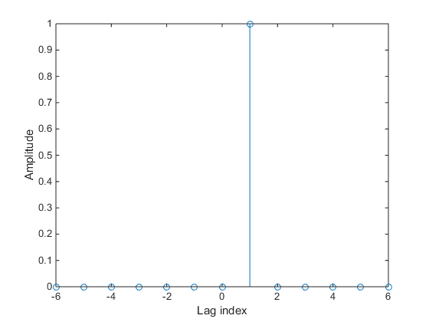

**理解：这是一个求互相关的程序；**

**心得：可以用r = conv(x,fliplr(y))求x,y的互相关，fliplr(y)函数将y序列翻转。**

% Program 2_6

% Computation of Autocorrelation of a

% Noise Corrupted Sinusoidal Sequence

%

clear;

clc;

N = 96;

n = 1:N;

x = cos(pi*0.25*n); % Generate the sinusoidal sequence

d = rand(1,N) - 0.5; % Generate the noise sequence

y = x + d; % Generate the noise-corrupted sinusoidal sequence

r = conv(y, fliplr(y)); % Compute the correlation sequence

k = -28:28;

stem(k, r(68:124));

xlabel('Lag index'); ylabel('Amplitude');

**运行结果：**

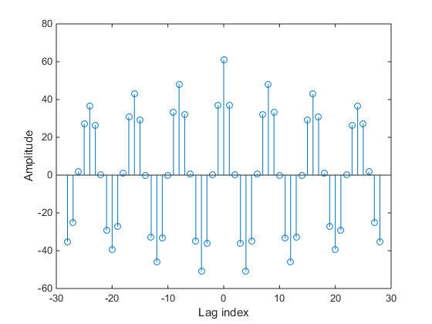

**理解：这是在求自相关的函数。**

**心得：利用r（68:124）可以得到r序列的第69到125个元素。**

**Part2:**

%Malab Exercises in Chapter 2

% M2.1

%Written by Shuangping Huang, SCUT

%Date: 20170413

clc;

clear;

%%input: a for the real part [0 1 -2 4 -5 0 3]

% b for the imaginary part [0 4 3 -2 -6 -2 0]

% K for the gain constant

% N for the length of sequence

%%ouput: xcs for the conjugate symmetric part of sequence x[n]

% xca for the conjugate antisymmetric part of sequence x[n]

a=input('Type in real part =');

b=input('Type in imaginary part =');

% c=a+b*i;

% K=input('Type in the gain constant =');

% N=input ('Type in length of sequence =');

% n=0:N;

n=0:length(a)-1;

%x=K*exp(c*n);

x=a+b*j;

xcs=0.5*(x+conj(fliplr(x)));%conjugate symmetric part of sequence

xca=0.5*(x-conj(fliplr(x)));%conjugate antisymmetric part of sequence

figure,

subplot(2,1,1);

stem(n,xcs);

xlabel('n');ylabel('xca[n]');

title('xca[n]:the conjugate symmetric part of sequence x[n]');

subplot(2,1,2);

stem(n,xca);

xlabel('n');ylabel('xcs[n]');

title('xcs[n]:the conjugate antisymmetric part of sequence x[n]');

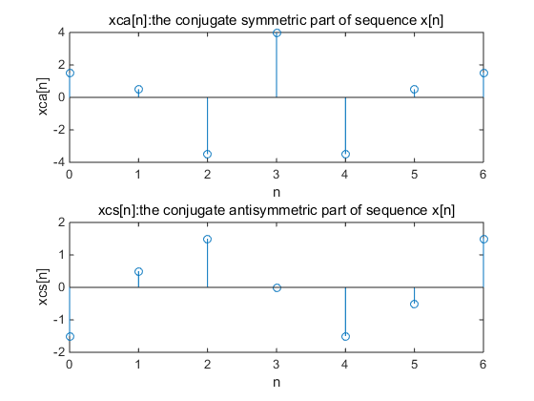

**缺点：仅仅使用了复数的实数部分；其后大部分也是这样的问题。**

**改进：**%Malab Exercises in Chapter 2

% M2.1

%Written by Shuangping Huang, SCUT

%Date: 20170413

clc;

clear;

%%input: a for the real part [0 1 -2 4 -5 0 3]

% b for the imaginary part [0 4 3 -2 -6 -2 0]

% K for the gain constant

% N for the length of sequence

%%ouput: xcs for the conjugate symmetric part of sequence x[n]

% xca for the conjugate antisymmetric part of sequence x[n]

a=input('Type in real part =');

b=input('Type in imaginary part =');

% c=a+b*i;

% K=input('Type in the gain constant =');

% N=input ('Type in length of sequence =');

% n=0:N;

n=0:length(a)-1;

%x=K*exp(c*n);

x=a+b*j;

xcs=0.5*(x+conj(fliplr(x)));%conjugate symmetric part of sequence

xca=0.5*(x-conj(fliplr(x)));%conjugate antisymmetric part of sequence

figure,

subplot(2,2,1);

stem(n,real(xcs));

xlabel('n');ylabel('xca[n]');

title('共轭对称部分实部');

subplot(2,2,2);

stem(n,imag(xcs));

xlabel('n');ylabel('xca[n]');

title('共轭对称虚部');

subplot(2,2,3);

stem(n,real(xca));

xlabel('n');ylabel('xcs[n]');

title('共轭反对称实部');

subplot(2,2,4)

stem(n,imag(xca));

title('共轭反对称虚部');

xlabel('n');ylabel('xcs[n]');

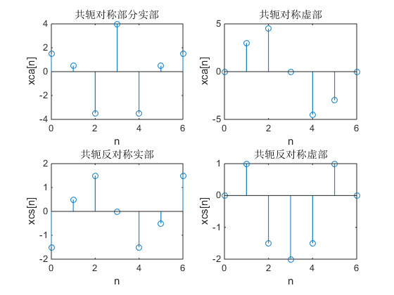

%Matlab Exercises M2.2

%Wirtten by Shuangping Huang,SCUT

%Date:20170413

clc;

clear;

%% Question(a)

%% Figure 2.23

%when:a=-1/12 b=pi/6 K1=1 N=40

%output:the real part and imaginary part of sequence x_a1[n]

a=-1/12;

b=pi/6;

c=a+b*1i;

K1=1;

N=40;

n=1:N;

x_a1=K1*exp(c*n);

figure,

subplot(2,1,1);

%the real part of x_a1[n]

stem(n,real(x_a1));

xlabel('n');ylabel('real(x_a1)');

title('picture2.23(a):real part of sequence x_a1[n]');

subplot(2,1,2);

%the imaginary part of x_a1[n]

stem(n,imag(x_a1));

xlabel('n');ylabel('imag(x_a1)');

title('picture2.23(b):imaginary part of sequence x_a1[n]');

%Figure 2.24(a)

%when:alpha_a=1.2 K2_a=0.2

%output:sequence x_a2_a[n]

alpha_a=1.2;

K2_a=0.2;

x_a2_a=K2_a*alpha_a.^n;

figure,

subplot(2,1,1);

stem(n,x_a2_a);

xlabel('n');ylabel('x_a2_a');

title('picture 2.24(a):sequence x_a2_a[n]');

% Figure 2.24(b)

%when:alpha_b=0.9 K2_b=20

%output:sequence x_a2_b[n]

alpha_b=0.9;

K2_b=20;

x_a2_b=K2_b*alpha_b.^n;

subplot(2,1,2);

stem(n,x_a2_b);

xlabel('n');ylabel('x_a2_b');

title('picture 2.24(b):sequence x_a2_b[n]');

%Question(b)----------------------------

%when:K_b=-2.7 a_b=-0.4 b_b=pi/6 N_b=82

%output:sequence x_b[n]

a_b=-0.4;

b_b=pi/6;

c_b=a_b+b_b*i;

K_b=-2.7;

N_b=82;

n_b=1:N_b;

x_b=K_b*exp(c*n_b);

figure,

stem(n_b,x_b);

xlabel('n');ylabel('x_b');

title('sequence x_b[n]');

**运行结果：**

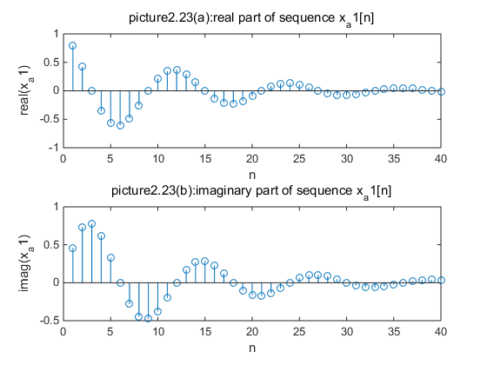

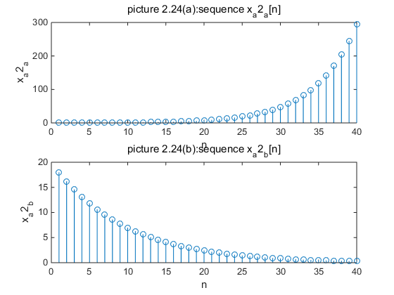

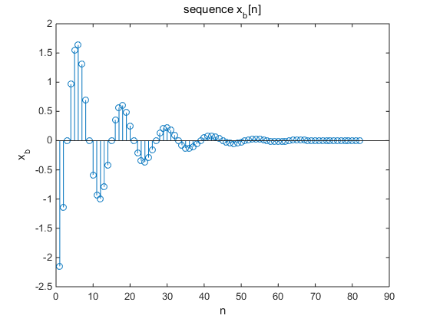

**缺点：仅仅使用了复数的实数部分；问题同上。**

**改进：同上，只需用imag函数把序列的虚部画出来即可。**

%Homework M2_3

%Coded by HuYiwei class4,SCUT-EE

%No.201337251046

clc;

clear;

%when the length of sequence N=100

N=100;

n=0:100;

%Creat the periodic sequence xb[n]

xb=cos(0.6*pi*n+0.3*pi);

subplot(4,1,1);

stem(n,xb);

xlabel('n');ylabel('xb[n]');

title('the periodic sequence xb[n]');

%Creat the periodic sequence xc[n]

xc=real(exp(pi*1i*n/8))+imag(exp(pi*1i*n/5));

subplot(4,1,2);

stem(n,xc);

xlabel('n');ylabel('xc[n]');

title('the periodic sequence xc[n]');

%Creat the periodic sequence xd[n]

xd=6*sin(0.15*pi*n)-cos(0.12*pi*n+0.1*pi);

subplot(4,1,3);

stem(n,xd);

xlabel('n');ylabel('xd[n]');

title('the periodic sequence xd[n]');

%Creat the periodic sequence xe[n]

xe=sin(0.1*pi*n+0.75*pi)-3*cos(0.8*pi*n+0.2*pi)+cos(1.3*pi*n);

subplot(4,1,4);

stem(n,xe);

xlabel('n');ylabel('xe[n]');

title('the periodic sequence xe[n]');

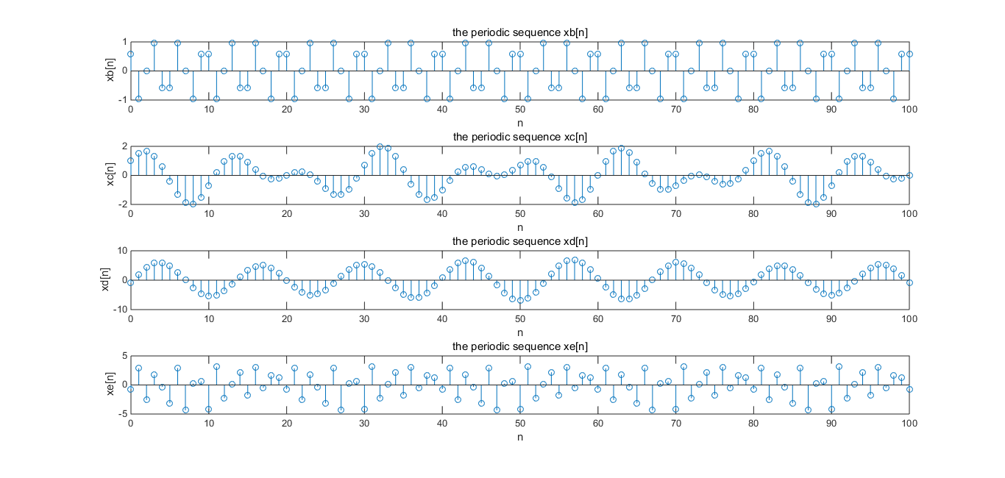

%Matlab Exercise M2.4

%Written by Shuangping Huang,SCUT

%Date: 20170413

clc;

clear;

%% input: A for the amplitude of sequence 1.5

% L for the length of sequence 40

% omega for angular frequency of sequence 0, 0.1*pi, 0.2*pi, 0.8*pi,

% 0.9*pi, pi, 1.1*pi, 1.2*pi

% phi for phase of sequence 0

%% output:sequence x[n]

A=input('Type in amplitude of sequence=');

L=input('Type in length of sequence=');

omega=input('Type in angular frequency of sequence=');

phi=input('Type in phase of sequence=');

n=0:L;

x=A*cos(omega*n+phi);

stem(n,x);

xlabel('n');ylabel('x[n]');

title('sequence x[n]');

**缺点：本题需要生成8幅图，一个一个地输入效率太低；**

**改进：一次输入所有数据，利用for循环一次性生成所有的图。**

**改进后代码如下：**

%Matlab Exercise M2.4

%Written by Shuangping Huang,SCUT

%Date: 20170413

clc;

clear;

%% input: A for the amplitude of sequence 1.5

% L for the length of sequence 40

% omega for angular frequency of sequence 0, 0.1*pi, 0.2*pi, 0.8*pi,

% 0.9*pi, pi, 1.1*pi, 1.2*pi

% phi for phase of sequence 0

%% output:sequence x[n]

A=input('Type in amplitude of sequence=');

L=input('Type in length of sequence=');

I=input('Type in 生成图的幅数');

omega=input('Type in angular frequency of sequence=');

phi=input('Type in phase of sequence=');

for i=1:I

Omega=omega(i);

n=0:L;

x=A*cos(Omega*n+phi);

figure;

stem(n,x);

xlabel('n');ylabel('x[n]');

title(['sequence x[n]',num2str(i)]);

end

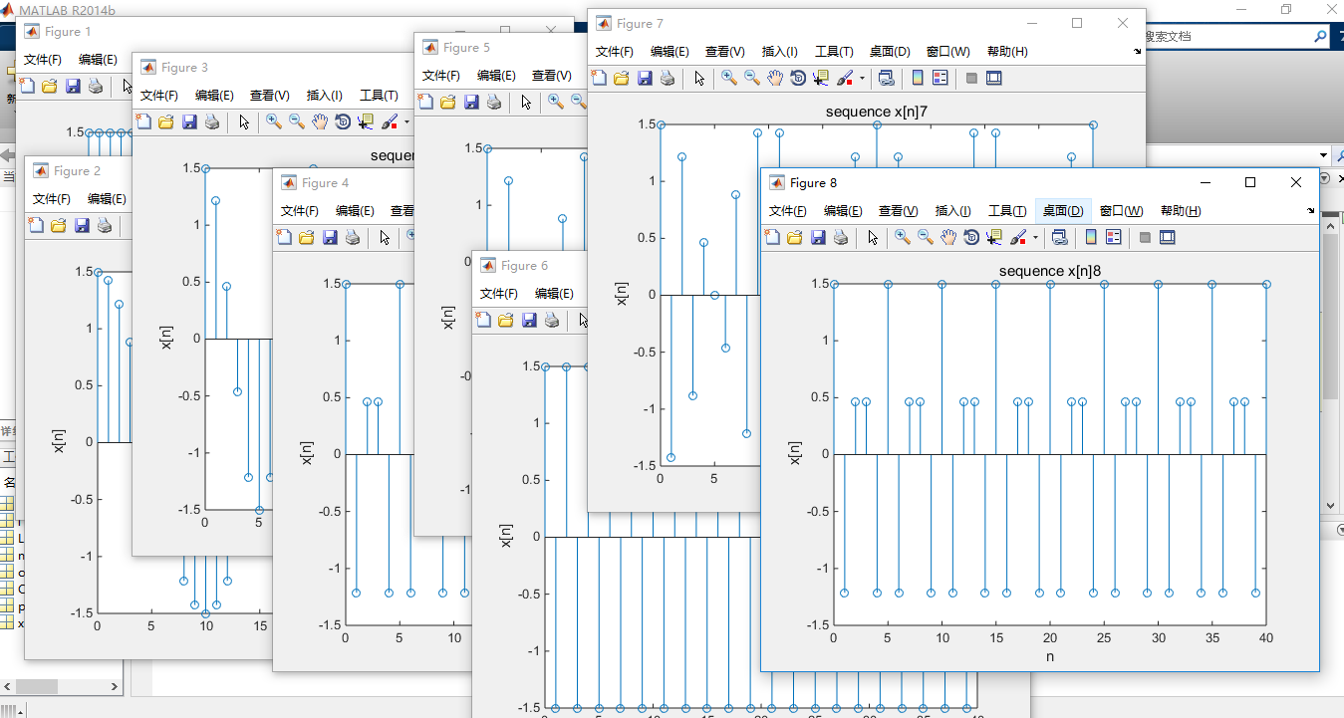

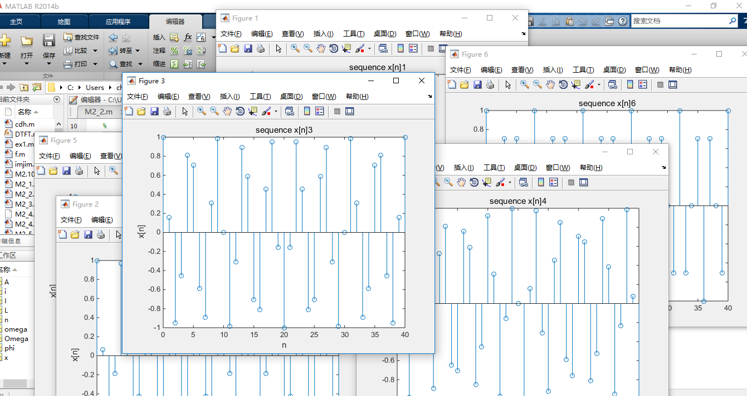

% Matlab Exercises M2.5

% Written by Shuangping Huang,SCUT

% Date: 20170413

clc;

clear;

%% ouput:gx(t)-the cosine funtion

% gx_TS(t)-when gx(t) sampled in Ts=0.1s

t=0:0.001:1;

g1=cos(6*pi*t);

subplot(3,1,1);

plot(t,g1,'r');

hold on;

%sampling

Ts=0.1;%sampling frequency

t1=0:Ts:1;

g1_Ts=cos(6*pi*t1);

stem(t1,g1_Ts,'b');

xlabel('t');ylabel('Amplitude');

title('when the frequency=3Hz:red for g1(t) and blue for g1(t) sampled in 0.1s');

hold off;

g2=cos(14*pi*t);

subplot(3,1,2);

plot(t,g2,'r');

hold on;

g2_Ts=cos(14*pi*t1);

stem(t1,g2_Ts,'b');

xlabel('t');ylabel('Amplitude');

title('when the frequency=7Hz:red for g2(t) and blue for g2(t) sampled in 0.1s');

hold off;

g3=cos(26*pi*t);

subplot(3,1,3);

plot(t,g3,'r');

hold on;

g3_Ts=cos(26*pi*t1);

stem(t1,g3_Ts,'b');

xlabel('t');ylabel('Amplitude');

title('when the frequency=14Hz:red for g3(t) and blue for g3(t) sampled in 0.1s');

hold off;

缺点：

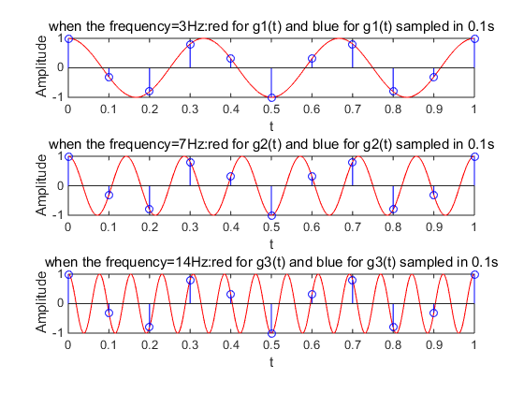

**理解：较高频率的连续正弦信号抽样得到的相同的较低频率的连续正弦序列，这种现象叫做混叠，程序写的很好。**

%Matlab Exercises M2.6

%Written by Shuangping Huang,SCUT

% Date: 20170413

clc;

clear;

%% input:A for amplitude of sequence: 1

% omega for angular frequency of sequence [6*pi 14*pi 26*pi]

% phi for phase of sequence [0 0 0]

% T for length of sequence [1 1 1]

% Ts for sampling frequency [0.1 0.1 0.1]

%% output: x[n] the cosine sequence

% x_Ts[n] the sampling sequence of x[n]

A=input('Type in amplitude of seque1nce=');

phi=input('Type in phase of sequence=');

T=input('Type in length of sequence=');

Ts=input('Type in sampling frequency=');

omega=input('Type in angular frequency vector of sequence=');%omega vector

t=0:0.001:T;

for i=1:length(omega)

x=A*cos(omega(i)*t+phi);

plot(t,x,'r');

hold on;

t1=0:Ts:T;

x_Ts=A*cos(omega(i)*t1+phi);

stem(t1,x_Ts,'b');

xlabel('n');ylabel('amplitude');

title('red for cosine sequence x[n] and blue for sampling sequence x_Ts[n]');

end

**问题：phi相位与omega（i）唯度不一样，需修改为phi（i），如下：**

**修改后代码：**

%Matlab Exercises M2.6

%Written by Shuangping Huang,SCUT

% Date: 20170413

clc;

clear;

%% input:A for amplitude of sequence: 1

% omega for angular frequency of sequence [6*pi 14*pi 26*pi]

% phi for phase of sequence [0 0 0]

% T for length of sequence [1 1 1]

% Ts for sampling frequency [0.1 0.1 0.1]

%% output: x[n] the cosine sequence

% x_Ts[n] the sampling sequence of x[n]

A=input('Type in amplitude of seque1nce=');

phi=input('Type in phase of sequence=');

T=input('Type in length of sequence=');

Ts=input('Type in sampling frequency=');

omega=input('Type in angular frequency vector of sequence=');%omega vector

t=0:0.001:T;

for i=1:length(omega)

x=A*cos(omega(i)*t+phi(i));

plot(t,x,'r');

hold on;

t1=0:Ts:T;

x_Ts=A*cos(omega(i)*t1+phi(i));

stem(t1,x_Ts,'b');

xlabel('n');ylabel('amplitude');

title('red for cosine sequence x[n] and blue for sampling sequence x_Ts[n]');

end

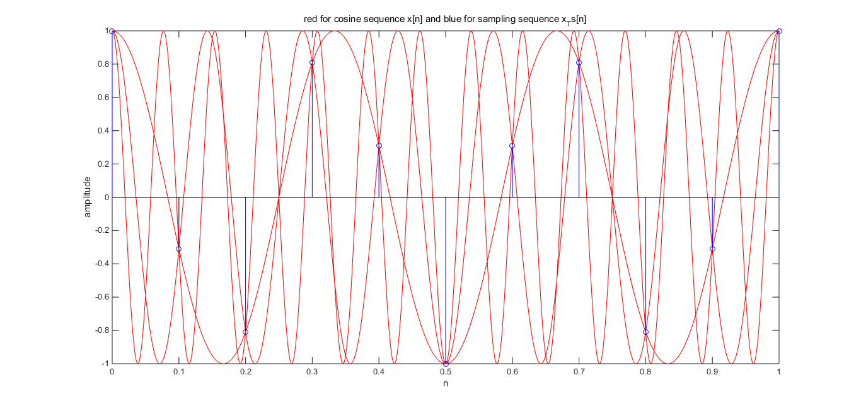

%Homework M2_8

%Coded by HuYiwei class4,SCUT-EE

%No.201337251046

clc;

clear;

%given sequence x[n] y[n] w[n]

%output:autocorrelation sequence rxx[l] ryy[l] rww[l]

% correlation sequence rxy[l] rxw[l]

x=[2 0 -1 6 -3 2 0];

y=[8 2 -7 -3 0 1 1];

w=[3 6 -1 2 6 6 1];

%for the autocorrelation sequence-----------------

rxx=conv(x,fliplr(x));

nxx=-6:6;%when nx ranges from -3 to 3

ryy=conv(y,fliplr(y));

nyy=-10:2;%when ny ranges from -5 to 1

rww=conv(w,fliplr(w));

nww=-4:8;%when nw ranges from -2 to 4

figure,

subplot(3,1,1);

stem(nxx,rxx);

xlabel('l');ylabel('amplitude');

title('rxx[l]');

subplot(3,1,2);

stem(nyy,ryy);

xlabel('l');ylabel('amplitude');

title('ryy[l]');

subplot(3,1,3);

stem(nww,rww);

xlabel('l');ylabel('amplitude');

title('rww[l]');

%for the correlation sequence---------------------

rxy=conv(x,fliplr(y));

nxy=-8:4;%when nx ranges from -3 to 3 and ny ranges from -5 to 1

rxw=conv(x,fliplr(w));

nxw=-5:7;%when nx ranges from -3 to 3 and nw ranges from -2 to 4

figure,

subplot(2,1,1);

stem(nxy,rxy);

xlabel('l');ylabel('amplitude');

title('rxy[l]');

subplot(2,1,2);

stem(nyy,ryy);

xlabel('l');ylabel('amplitude');

title('rxw[l]');

理解：通过对nxx，nyy,nww,nxy,mxw 的设置范围有点问题

改进：通过input输入各个数列的范围来确定nxx ，nyy 等的范围则代码具有更好的可移植性。

改进的代码：

%Homework M2_8

%Coded by HuYiwei class4,SCUT-EE

%No.201337251046

clc;

clear;

%given sequence x[n] y[n] w[n]

%output:autocorrelation sequence rxx[l] ryy[l] rww[l]

% correlation sequence rxy[l] rxw[l]

x=[2 0 -1 6 -3 2 0];

y=[8 2 -7 -3 0 1 1];

w=[3 6 -1 2 6 6 1];

A=input('输入x序列的range左侧=');

B=input('输入x序列的range右侧=');

C=input('输入y序列的range左侧=');

D=input('输入y序列的range右侧=');

E=input('输入w序列的range左侧=');

F=input('输入w序列的range右侧=');

%for the autocorrelation sequence-----------------

rxx=conv(x,fliplr(x));

nxx=A-B:B-A;%when nx ranges from -3 to 3

ryy=conv(y,fliplr(y));

nyy=C-D:D-C;%when ny ranges from -5 to 1

rww=conv(w,fliplr(w));

nww=E-F:F-E;%when nw ranges from -2 to 4

figure,

subplot(3,1,1);

stem(nxx,rxx);

xlabel('l');ylabel('amplitude');

title('rxx[l]');

subplot(3,1,2);

stem(nyy,ryy);

xlabel('l');ylabel('amplitude');

title('ryy[l]');

subplot(3,1,3);

stem(nww,rww);

xlabel('l');ylabel('amplitude');

title('rww[l]');

%for the correlation sequence---------------------

rxy=conv(x,fliplr(y));

nxy=A-D:B-C;%when nx ranges from -3 to 3 and ny ranges from -5 to 1

rxw=conv(x,fliplr(w));

nxw=A-F:B-E;%when nx ranges from -3 to 3 and nw ranges from -2 to 4

figure,

subplot(2,1,1);

stem(nxy,rxy);

xlabel('l');ylabel('amplitude');

title('rxy[l]');

subplot(2,1,2);

stem(nyy,ryy);

xlabel('l');ylabel('amplitude');

title('rxw[l]');

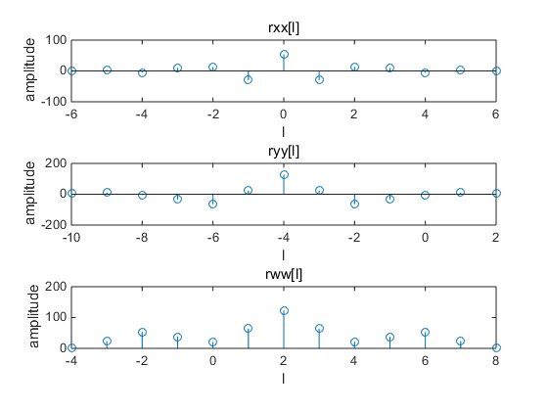

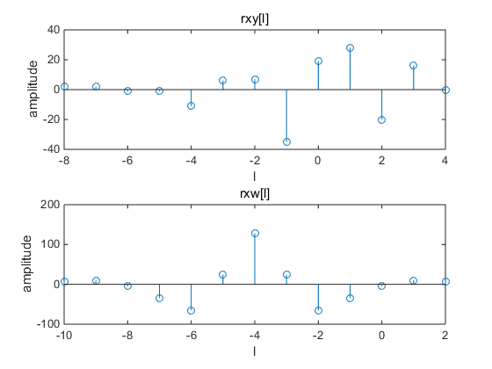

%Matlab Exercises M2.8

% Written by Shuangping Huang,SCUT

% Date: 20170413

clc;

clear;

%% input:x for sequence x[n] [2 0 -1 6 -3 2 0] -3=<n<=3;

%% input:y for sequence y[n] [8 2 -7 -3 0 1 1] -5=<n<=1;

%% input:y for sequence w[n] [3 6 -1 2 6 6 1] -2=<n<=4;

%% output:autocorrelation sequence rxx[l],ryy[l],rww[l,]rxy[l],rxw[l]

x=input('Type in sequence x[n]=');

x_index=[-3:3];

y=input('Type in sequence y[n]=');

y_index=[-5:1];

w=input('Type in sequence w[n]=');

w_index=[-2:4];

subplot(5,1,1);

rxx=conv(x,fliplr(x));%autocorrelation sequence

rxx_index=[min(x_index)-max(x_index):max(x_index)-min(x_index)];

ryy=conv(x,fliplr(x));%autocorrelation sequence

ryy_index=[min(y_index)-max(y_index):max(y_index)-min(y_index)];

rww=conv(x,fliplr(x));%autocorrelation sequence

rww_index=[min(w_index)-max(w_index):max(w_index)-min(w_index)];

rxy=conv(x,fliplr(y));%autocorrelation sequence

rxy_index=[min(x_index)-max(y_index):max(x_index)-min(y_index)];

rxw=conv(x,fliplr(w));%autocorrelation sequence

rxw_index=[min(x_index)-max(w_index):max(x_index)-min(w_index)];

subplot(5,1,1);

stem(rxx_index,rxx);

xlabel('l');ylabel('amplitude');

title('rxx[l]');

subplot(5,1,2);

stem(ryy_index,ryy);

xlabel('l');ylabel('amplitude');

title('ryy[l]');

subplot(5,1,3);

stem(rww_index,rww);

xlabel('l');ylabel('amplitude');

title('rww[l]');

subplot(5,1,4);

stem(rxy_index,rxy);

xlabel('l');ylabel('amplitude');

title('rxy[l]');

subplot(5,1,5);

stem(rxw_index,rxw);

xlabel('l');ylabel('amplitude');

title('rxw[l]');

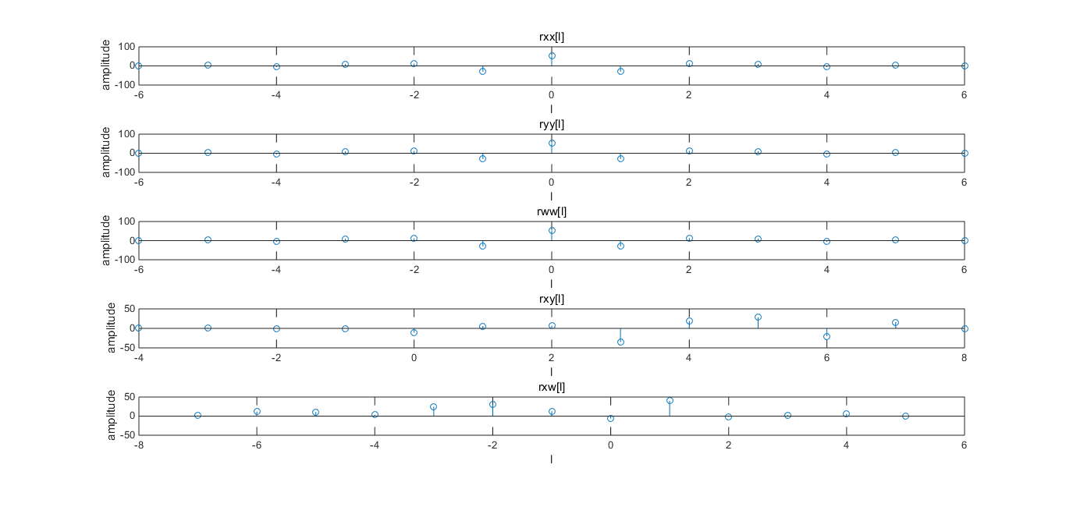

理解：通过rww_index=[min(w_index)-max(w_index):max(w_index)-min(w_index)];

这种方式来确定相关序列的下标很好，简单明了。’

%Matlab Exercises M2.9

% Written by Shuangping Huang,SCUT

% Date: 20170413

clc;

clear;

%% input:x for sequence x[n] [2 0 -1 6 -3 2 0]

%% output:sequence x_d[n] with additive random noise

% and it's autocorrelation sequence rxxd[l]

x=input('Type in sequence x[n]=');

N=size(x);

d=rand(N);%creat a random noise d[n]

xd=x+d;%additive random noise

subplot(2,1,1);

stem(xd);

xlabel('n');ylabel('amplitude');

title('x_d[n]');

rxxd=conv(xd,fliplr(xd));%autocorrelation sequence

subplot(2,1,2);

stem(rxxd);

xlabel('l');ylabel('amplitude');

title('xxxd[l]');

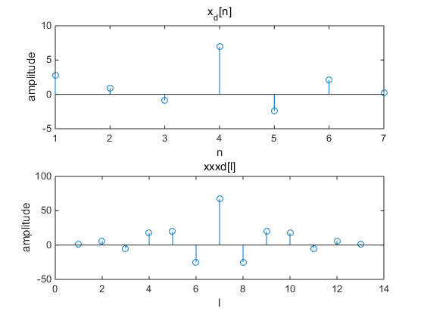

理解：因为噪音对于序列来说太小，影响不大，所以自相关序列在零时滞出现尖峰。

%Homework M2_10

%Coded by HuYiwei class4,SCUT-EE

%No.201337251046

clc;

clear;

%given attenuation index alpha_a=0.6 alpha_b=0.8

%x[n]=(alpha.^n).*u[n]

%output:two autocorrelation sequence rxxa[l] rxxb[l]

alpha_a=0.6;

alpha_b=0.8;

%when x[n] is a casual sequence

n=0:20;%interception part of the unlimited sequence

xa=alpha_a.^n;

rxxa=conv(xa,fliplr(xa));

xb=alpha_b.^n;

rxxb=conv(xb,fliplr(xb));

subplot(2,1,1);

stem(rxxa);

xlabel('l');ylabel('amplitude');

title('rxxa[l]');

subplot(2,1,2);

stem(rxxb);

xlabel('l');ylabel('amplitude');

title('rxxb[l]');

缺点;没有对自相关序列的下标进行处理，明显在0处是最高点才合理。对比可以看出，alpha越接近于1，则自相关序列在0处下降得比较平缓，可以对以上程序参考对上面的处理来处理自相关序列的下标。

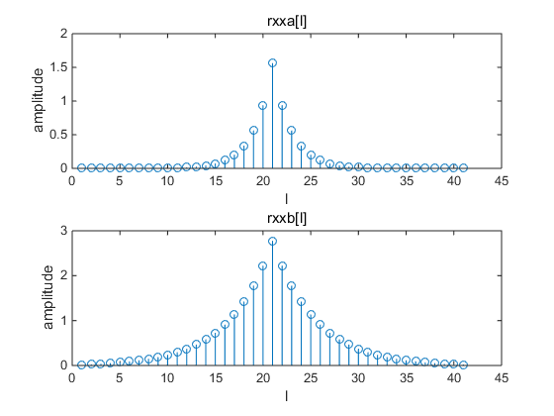

**Part3：**

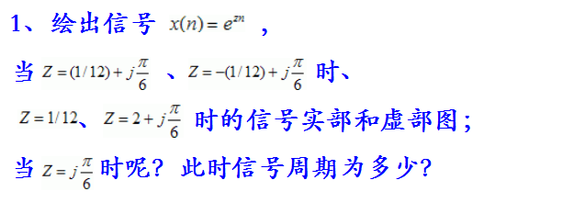

%实验1  
a=input('输入z的实部=');  
b=input('输入z的虚部=');  
N=input('输入序列长度=');  
c=a+b*i;  
n=0:1:N;  
x=exp(c*n);  
stem(n,real(x));  
xlabel('Time index n');ylabel('real part');  
disp('press enter 得到虚部');  
pause;  
stem(n,imag(x));  
xlabel('Time index n');  
ylabel(' imaginary part ');

**Z=1/12+j*pi/6**

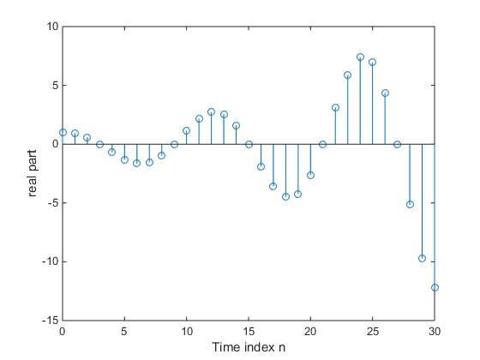

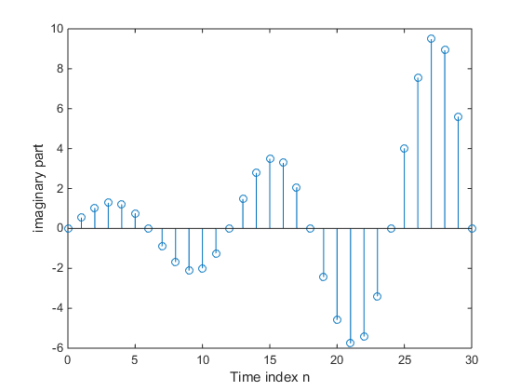

**Z=-1/12+j*pi/6**

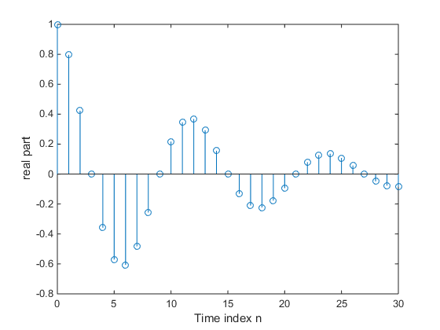

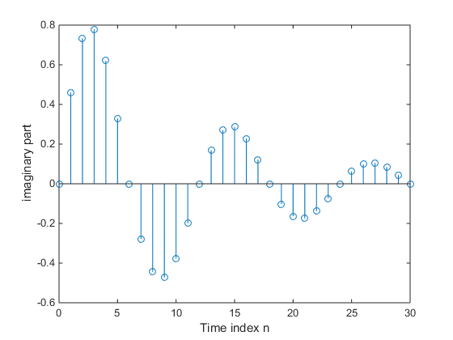

**Z=1/12**

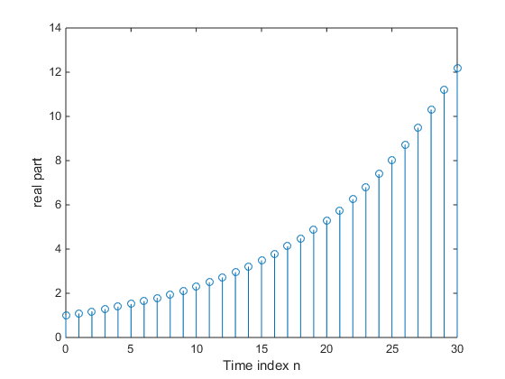

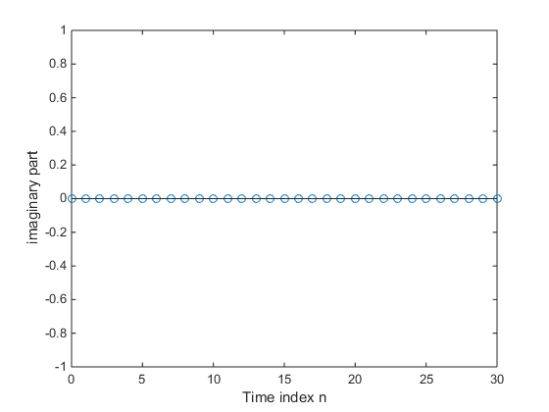

**Z=2+j*pi/6**

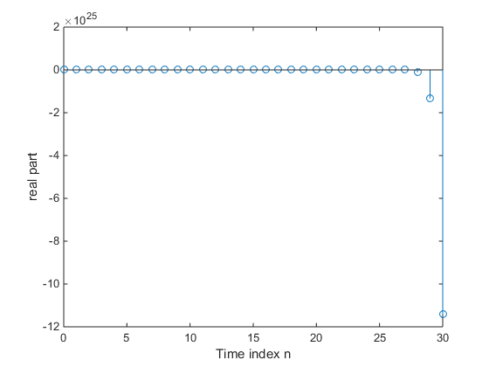

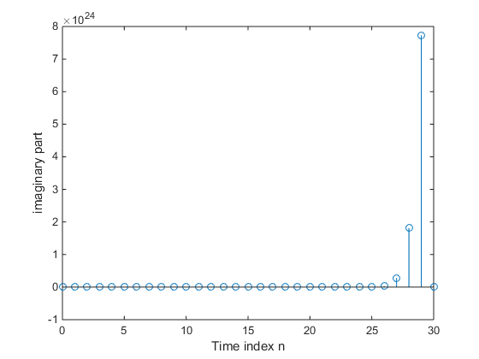

**Z=j*pi/6**

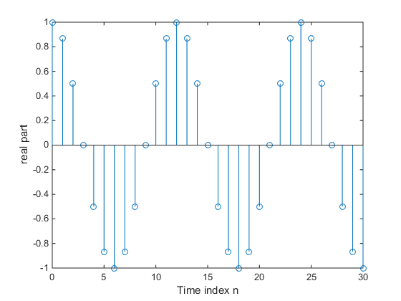

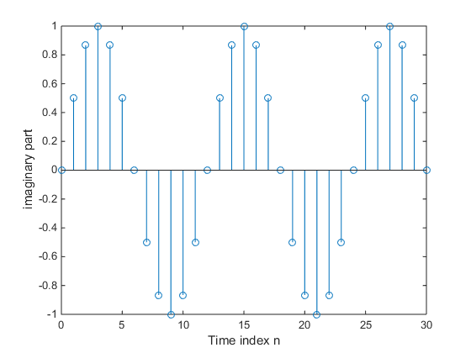

**周期：12.**

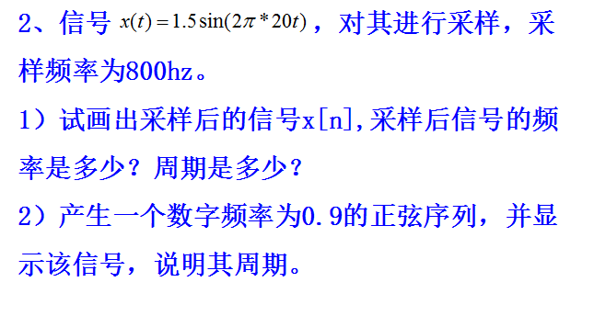

n=0:40;

x1=1.5*sin(2*pi*20*1/800*n);

x2=sin(0.9*n);

subplot(1,2,1);

stem(n,x1);

xlabel ('时间序列n');

ylabel('振幅');

title('正弦序列x1=1.5*sin(2*pi*20*1/800*n)');

subplot(1,2,2);

stem(n,x2);

xlabel ('时间序列n');

ylabel('振幅');

title('正弦序列x2=sin(0.9*n)');

**运行结果：**

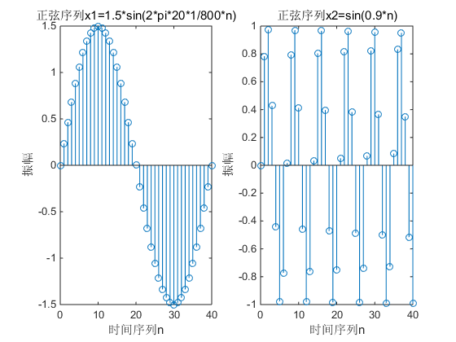

**正弦序列x1=1.5*sin(2*pi*20*1/800*n) 频率是1/40，周期是40.**

**而x2=sin(0.9*n)是非周期的。理论计算中对第一个，N＝2*ｐｉ/（0.1*ｐｉ）＝10，第二个0.9不是pi的倍数，所以不是周期的。因此可以看出，实验结果和理论相符。**

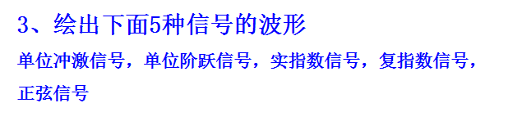

subplot(3,2,1)

t=-10:0.01:10;

x=(t==0); %就是个条件判断，只有x=0的时候，y才为“1”

plot(t,x);

xlabel('t');ylabel('x');

title('冲激响应 ');

subplot(3,2,2)

t=-10:0.01:10;

x=(t>=0); %就是个条件判断，只有x>=0的时候，y才为“1”

plot(t,x);

xlabel('t');ylabel('x');

title('阶跃响应 ');

subplot(3,2,3)

t=-10:0.01:10;

x=0.2*(1.2).^t

plot(t,x);

xlabel('t');ylabel('y');

title('指数信号 ');

subplot(3,2,4)

t=-10:0.01:10;

x=sin(t*pi/2);

plot(t,x);

xlabel('t');ylabel('x');

title('正弦信号 ');

subplot(3,2,5)

t=-10:0.01:10;

Z=exp((0.2+j*2)*t);

ReZ=real(Z); ImZ=imag(Z);

plot(t, ReZ);

xlabel('t');ylabel('x');

title('复指数信号实数部分 ');

subplot(3,2,6)

plot(t,ImZ);

xlabel('t');ylabel('x');

title('复指数信号虚数部分 ');

